**Louisiana Works Career Seeker Website**

(Tentative)

**Architecture**

**Team SAMUS:**

Ian Callaway

Evan Perry

Chet Ransonet

Edward Woods

Sean Hungerford

Contents

ABSTRACT 3

INTRODUCTION 3

ARCHITECTURAL STYLE USED 3

ARCHITECTURAL MODEL 4

TECHNOLOGY, SOFTWARE, AND HARDWARE USED 4

RATIONALE FOR ARCHITECTURAL STYLE AND MODEL 4

EVIDENCE THE DOCUMENT HAS BEEN PLACED UNDER CONFIGURATION MANAGEMENT 5

REFERENCES 5

## ABSTRACT

This document describes architectural aspects of our website and the functionality in servicing clients. We’ll be using a client-server architectural style for the project as well as web-servers, the website and database server at the Louisiana Workforce Commission.

## INTRODUCTION

This document is for describing the architectural requirements of a website to help students find jobs. Requirements pertaining to the structure of the software and its own functional infrastructure. The purpose of this document is to highlight what aspects of an architectural pattern we’ll be using, why the project needs it and what technologies, software and hardware will be needed to implement this project using this architectural style.

## ARCHITECTURAL STYLE USED

The project architecture pattern we'll be using for the site will be the client-server pattern. As a whole the pattern suits our purposes as we'll split the project into modules for web-based clients to use. Among the server-side database functions there will be job-search and resume building tools for web-based clients. We’ll need this architectural style because our users are not one client and services pertaining to our project are distributed across a network of servers and databases.

## ARCHITECTURAL MODEL

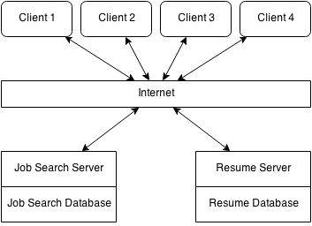

## TECHNOLOGY, SOFTWARE, AND HARDWARE USED

For the project we'll want to use some cutting edge technologies. We'll first need at least a web-server to host our website. Then we'll need some JavaScript to build a website to be hosted by previously mentioned server. The project will lastly need to push its job-search functions onto databases at the Louisiana Workforce Commission.

## RATIONALE FOR ARCHITECTURAL STYLE AND MODEL

We'll want to use this architecture style because we'll have distributed clients working on distributed servers throughout a network, and the client-server architectural pattern was built to handle loads where functions would be requested by clients to be performed on servers at the LA Workforce Commission.

## EVIDENCE THE DOCUMENT HAS BEEN PLACED UNDER CONFIGURATION MANAGEMENT

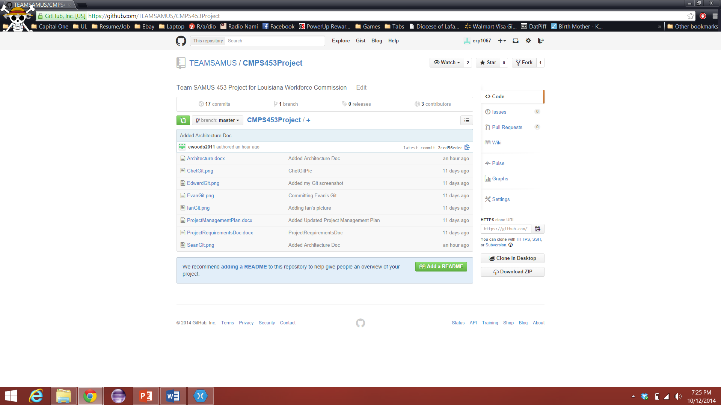

## REFERENCES