**Louisiana Works Career Seeker Website**

(Tentative)

**Detailed Design**

**Team SAMUS:**

Ian Callaway

Evan Perry

Chet Ransonet

Edward Woods

Sean Hungerford

Table of Contents

LIST OF FIGURES 2

ABSTRACT 3

INTRODUCTION 3

GUI (Graphical User Interface) Design 3

STATIC MODEL / CLASS DIAGRAMS 5

DYNAMIC MODEL / SEQUENCE DIAGRAMS 6

RATIONALE FOR YOUR DETAILED DESIGN MODEL 6

TRACEABILITY FROM REQUIREMENTS TO DETAILED DESIGN MODEL 8

EVIDENCE THE DESIGN MODEL HAS BEEN PLACED UNDER 8

CONFIGURATION MANAGEMENT 8

## LIST OF FIGURES

Figure 1 - Main Screen 3

Figure 2 - Resume Builder 4

Figure 3 - Job Search 4

Figure 4 - Search Results 5

Figure 5 - Class Diagram 5

Figure 6 - Sequence Diagram 6

Figure 7 - Github Configuration Management 8

## ABSTRACT

This document describes design of our website and the functionality in servicing clients. Our website features a resume builder and job search. Our website simplifies the job searching process, making it easier for the user to submit a resume and research the job.

## INTRODUCTION

The purpose of this document is to describe the graphical and structural aspects of our 453 project for the Louisiana Workforce Commission. Herein lies the current design of the site and its components i.e. the page structures and couple of models. Without further ado here’s the rest of the document.

## GUI (Graphical User Interface) Design

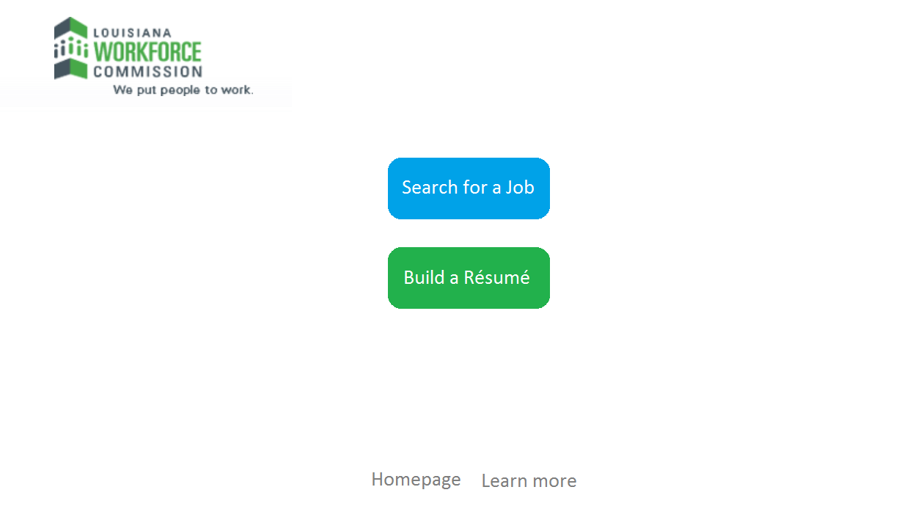

Figure 1 - Main Screen

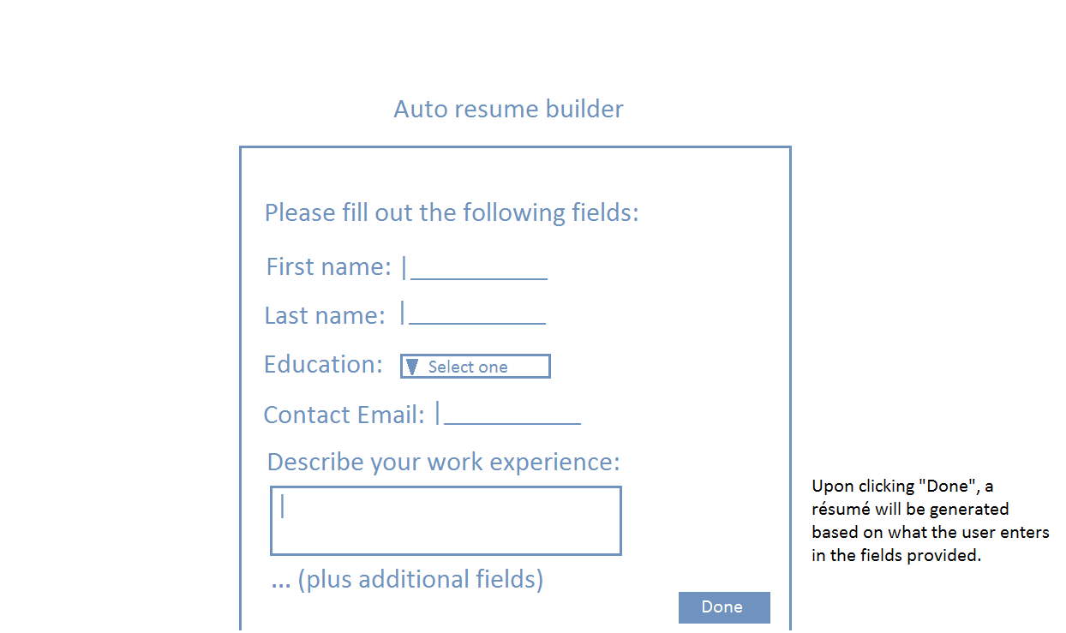

Figure 2 - Resume Builder

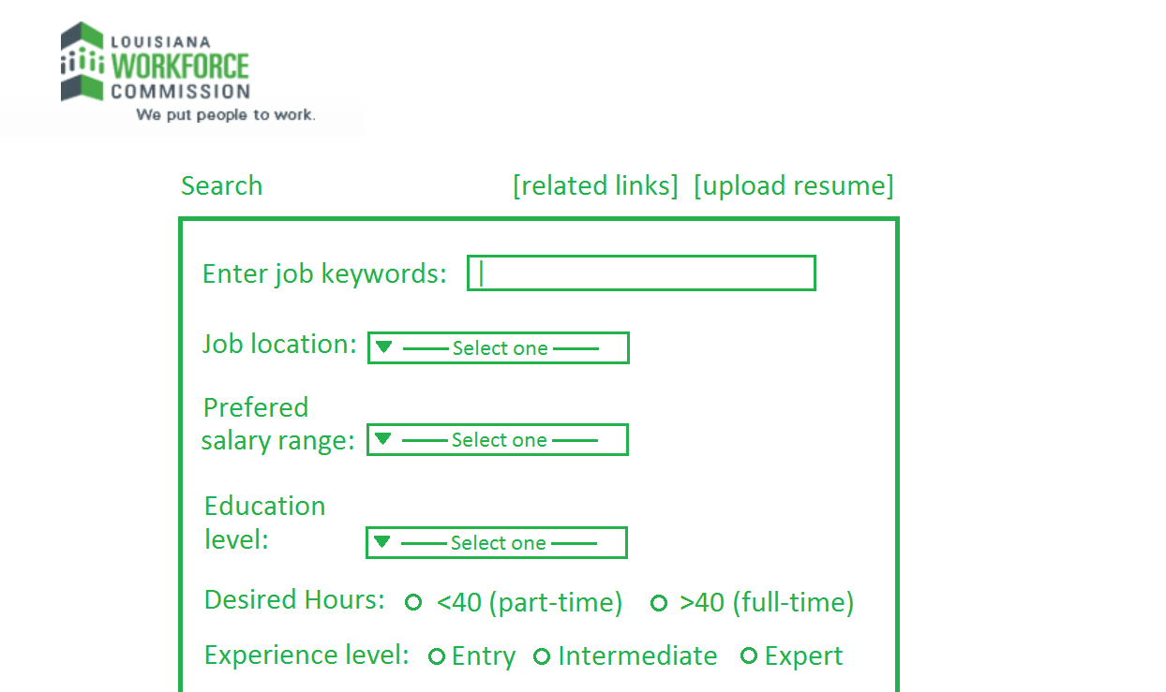

Figure 3 - Job Search

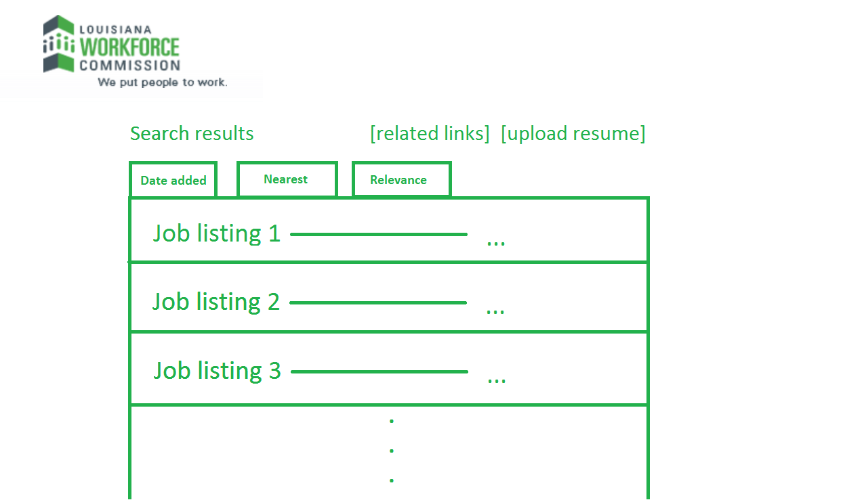

Figure 4 - Search Results

## STATIC MODEL / CLASS DIAGRAMS

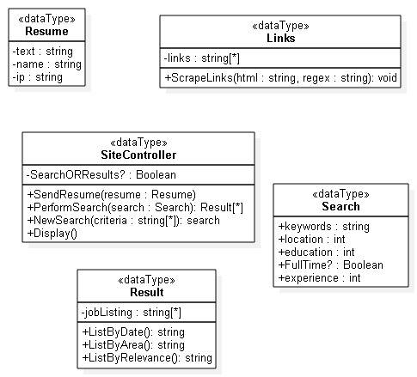

Figure 5 - Class Diagram

## DYNAMIC MODEL / SEQUENCE DIAGRAMS

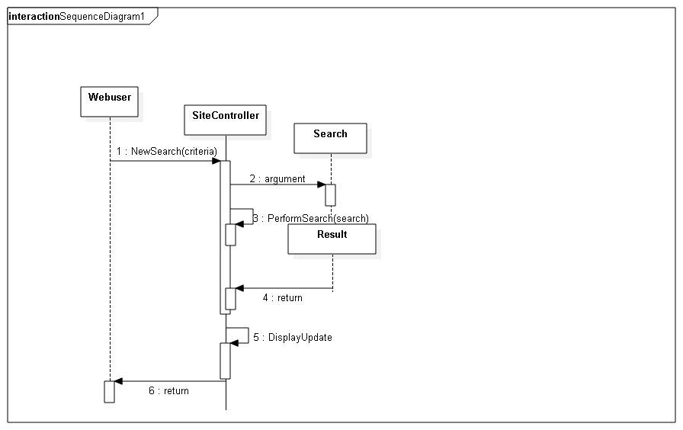

Figure 6 - Sequence Diagram

## RATIONALE FOR YOUR DETAILED DESIGN MODEL

Since the main purpose of the website is to provide users with a quick and easy way to search for jobs and build resumes, we will provide a concise and easy-to-use interface so that job-seekers can accomplish these tasks in the most convenient way possible.

In order to make the process of job searching and resume building as easy as possible, we will make the websites as minimalistic as possible. This way, the user is not overwhelmed with the amount of information shown on the webpage. Upon opening the website, users should have an intuitive sense of what they should do to start the job-seeking process.

For resume building, a large button icon will appear near the center of the screen that reads “Build Your Resume”. This button will be set next to the job search button (described shortly). Upon clicking this, the user will be sent to a different website which contains a template for creating a resume. This template is provided by the LA workforce commission. Alternatively, a more simply resume builder will be created in order to streamline the process.

For job search, the user will be provided with a button placed near the center of the screen that reads “Search for a Job”. Upon clicking the button, the user will be prompted with a search page, which contains six fields. One field will ask for a job keyword. The second field will ask the user for a desired job location. In addition, there will be fields for preferred salary range, education level, desired hours, and education level. Upon searching for a job, the user will be given a search results page. The job results will be sorted in three ways: The date added (most recent job posting), nearest (from the user), and relevance (based on the keyword entered). It also filters (eliminates) results based on preferred salary range, user's education level, users desired hours, and experience level. These jobs may be sorted in a number of different mays, so that the user will more quickly be able to find the type of job that he/she is looking for. The search page and search results page will both contain links for additional information and uploading a resume. LA workforce logos and additional link will be provided at the top and bottom edges of the webpage. This minimalistic design will also be useful if there is a plan to allow mobile access to the website in the near future.

## TRACEABILITY FROM REQUIREMENTS TO DETAILED DESIGN MODEL

We can trace the design aspects from the requirements documents. Our functional requirements were that this product would be marketed towards students and that it would allow them to put their resumes up online for employers and that it would allow them to search through job offers. Our design decisions of making pages dedicated to job searches and building their resume reflects that. Though the design of our project can be traced back to the requirements, the platform of our project has changed from the cross-platform mobile application to the website.

## EVIDENCE THE DESIGN MODEL HAS BEEN PLACED UNDER

## CONFIGURATION MANAGEMENT

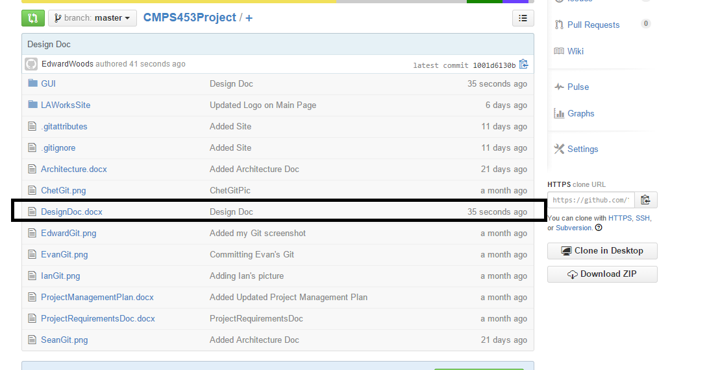

Figure 7 - Github Configuration Management