**Louisiana Works Career Seeker Website**

**Final Report**

**Team SAMUS:**

Ian Callaway

Evan Perry

Chet Ransonet

Edward Woods

Sean Hungerford

Executive Summary

Table of Contents

List of Figures

List of Tables

**1. Introduction**

1.1. Purpose and Scope

We will build a website that simplifies the task of accessing the information about careers that LA workforce offers. It will help students in high school and college locate fields of study that will apply to careers and jobs in the area. The overall purpose of this website is to give UL students an easier way to find out information about the careers available and to connect them to the LA Workforce’s career services.

1.2. Product Overview (including capabilities, scenarios for using the product, etc.)

The website is meant to have the same job search results that one would get if they had searched for jobs on the LA Works site. It is meant for people that don’t want to bother with the main site and just want to dive into the job searching. Preferably, there would be a button on the main LA Works site that linked to our site. One would click there and then search for a job through our site, then link back to the main site if any other services are required.

1.3. Structure of the Document

The document is structured as an outline for efficiency.

1.4. Terms, Acronyms, and Abbreviations

LA Works - Louisiana Workforce Commission

LWCS - Louisiana Works Career Seeker Website

UL - University of Louisiana at Lafayette

**2. Project Management Plan**

2.1. Project Organization

* Ian Callaway - Project Manager / Primary Contact
  + Will contact LAWorks (Client) if any questions arise
  + Will build the scraper to pull from LA Works’ website
* Evan Perry - User Interface Design / Website Developer
  + Manage the look and feel of the website
  + Secondary Website Developer
* Chet Ransonet - Website Developer
  + Will assist in Website Development
* Edward Woods - Lead Developer
  + Will be primary developer of the actual website
  + Will oversee other developers in Web Development
* Sean Hungerford - User Interface Design / Website Development
  + Will assist in Website Development
  + Will assist in User Interface Design
* Rationale: Most of the work to be done, besides documentation, was website development, so that job was divided amongst the group. The rest of the responsibilities were distributed based on personal preference and skill level.

2.2. Lifecycle Model Used

This project used the waterfall lifecycle model. Most of the project’s development was done post-documentation. We did most of our learning of the tools during this time as well. Following development of our project, we will then do testing. After this, we shall hand over the project to the Louisiana Workforce Commission.

2.3. Risk Analysis

* A risk during development that may be encountered is the loss of data. This can put a project far behind and waste a lot of time. We will avoid this by creating backups of any data and work we have done.
* Having the project become too large scale could be another risk. This would cause the project to take too much time to complete. We will focus on small, achievable goals to avoid this.

2.4. Hardware and Software Resource Requirements

(Do not forget to describe what new software or hardware each team member learned during the project)

* Required hardware includes a computer for developing and a device to test the application.
* Required software includes:
  + Microsoft Visual Studio 2013.
  + Github
  + Google Drive

The rationale behind creating a website is that we wanted to create something that would be used by college students, without having to go through the LAWorks’ website, which is quite cluttered.. The website can make it fast and easy to update a resume and look for jobs.

* Ian - I learned to use c# and a few classes related to web-bot and web-scraping, namely WebBrowser and WebClient, I also had to learn a web debugging tool named firebug to find what elements of the LA Hire site needed to be grabbed from the bot and what data types needed to be sent to those elements.
* Edward - I worked with, and learned about the use of Github for version controlling, and Visual Studio for web development. Throughout the process, I also learned a bit about Amazon Web Services, which we were going to use for web hosting.
* Chet - I learned to use Microsoft Visual Studio 2013 for website development and Github for project version control.
* Evan - I learned how to better manage different versions of my projects with the GitHub version control. It’s very useful in keeping projects updated. I was able to practice my C# and experiment with data retrieval processes.
* Sean -

2.5. Deliverables and Schedule

The deliverables take the form of information about job opportunities, which is taken from the main LA Works site and presented by our site.

2.6. Monitoring, Reporting, and Controlling Mechanisms

Our use of Github for version controlling of the project, and Google Docs for collaboration on documentation have aided well in the aspect of monitoring and controlling. Visual Studio 2013 has a feature that allowed us to connect the project to an existing repository for easy syncing the project between members. Google Docs allowed us to easily share documentation files between one another, and simultaneously edit them.

2.7. Professional Standards

Every team member is expected to properly document and use their own code. All members should meet any deadlines presented to them, and act in a respectable manner between each other, the clients, and the teacher, Dr. Kumar. We expect all members to attend all scheduled meetings, and if unable to, provide an acceptable excuse for their absence. We expect this behavior from our members to allow our team to work as efficiently and effectively as possible.

2.8. Evidence all the artifacts have been placed under configuration management

2.9. Impact of the project on individuals and organizations

Our project will streamline the process of students finding jobs on their way out of college. Finding a job right out of college will be easier and more people will hear about this job finding tool. More students will have better jobs than before, and LA Works will have more business.

**3. Requirement Specifications**

3.1. Stakeholders for the system

The stakeholders are LA Works and the employers they work with, for without them our website would not function.

3.2. Use case model

3.2.1. Graphic use case model

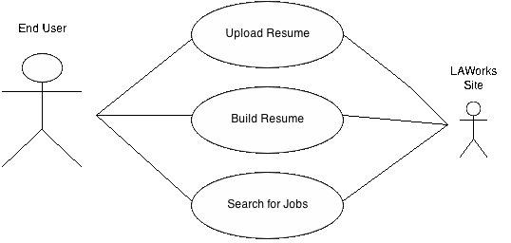

3.2.2. Textual Description for each use case

End user - The user, using the site at their own discretion, typically unemployed college student looking for job listings with or without a resume.

Upload Resume - The user should be able to upload premade resumes to their LAHire account on the LAWorks website. The user should also be able to upload resume’s created in the resume builder through this.

Build Resume - The user should be able to fill out fields with items such as First Name, Work Experience, email, etc. This will allow the user to easily build a resume to be uploaded to their LAHIRE account, for employers to see.

Search For Jobs - The user should be able to search for a job, based on several things, such as keywords, location, salary range, etc. This will allow users to easily be able to find jobs with certain desires in mind.

3.3. Rationale for your use case model

We needed a model that would allow the user to use as many aspects of the current site that the Louisiana Workforce Commission has provided to the general public.. This use case model allows the site to be an interface to the LAWorks website in ways that make sense to bundle and are simple to users. Functions are modular while allowing feedback in the user's search for jobs.

3.4. Non-functional requirements

The website shall be accessible to anyone.. The app shall be reliable enough to store the user's resume and even if terminated incorrectly through backups. The entire site shall follow design guidelines of fonts, colors, and margins specified by the LA Workforce Commission, such as the LA Workforce Commission logos and the . The search and resume building page shall exhibit good ease of use.

**4. Architecture**

4.1. Architectural style(s) used

The project architecture pattern are using for the site is the model-view-controller pattern. We will have singleton classes for each functionality (resume building, job searching), except for the scrapers, which will be made of proxy objects that connect to the actual site, since we don’t have access to LAWorks’ databases.

The singleton classes will be used for the view and the controller, because it is the simplest way to go about everything. The proxy object will be used as the model, since we won’t be connecting to the databases.

4.2. Architectural model

4.3. Technology, software, and hardware used

* Microsoft Visual Studio 2013
* Github
* Google Docs
* Google Drive
* Facebook
* StarUML

4.4. Rationale for your architectural style and model

Initially, we wanted to use a client-server architectural style. However, we found that we would not have access to LAWorks’ databases, and we changed to the Model-View-Controller pattern. Using this pattern, we will be able to use a scraper we have built to pull searches from the LAWorks website when needed. This is our proxy/model object. This will make things a bit simpler for us, without having to worry about having a database to connect to.

**5. Design**

5.1. GUI (Graphical User Interface) design

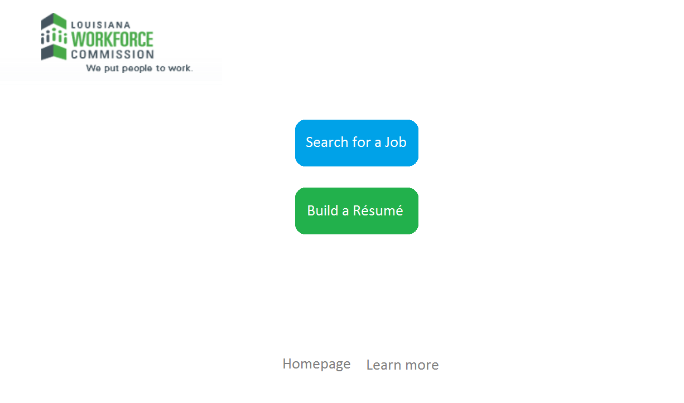

Figure 5-1 - Main Screen

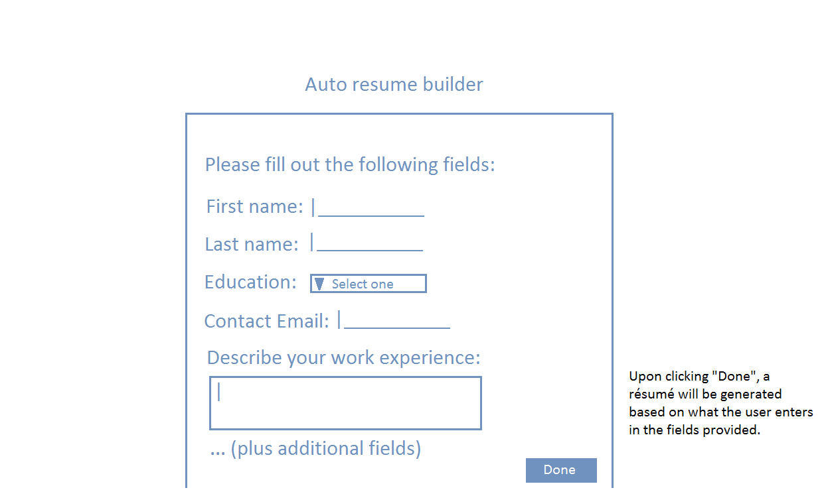

Figure 5-2 - Resume Builder

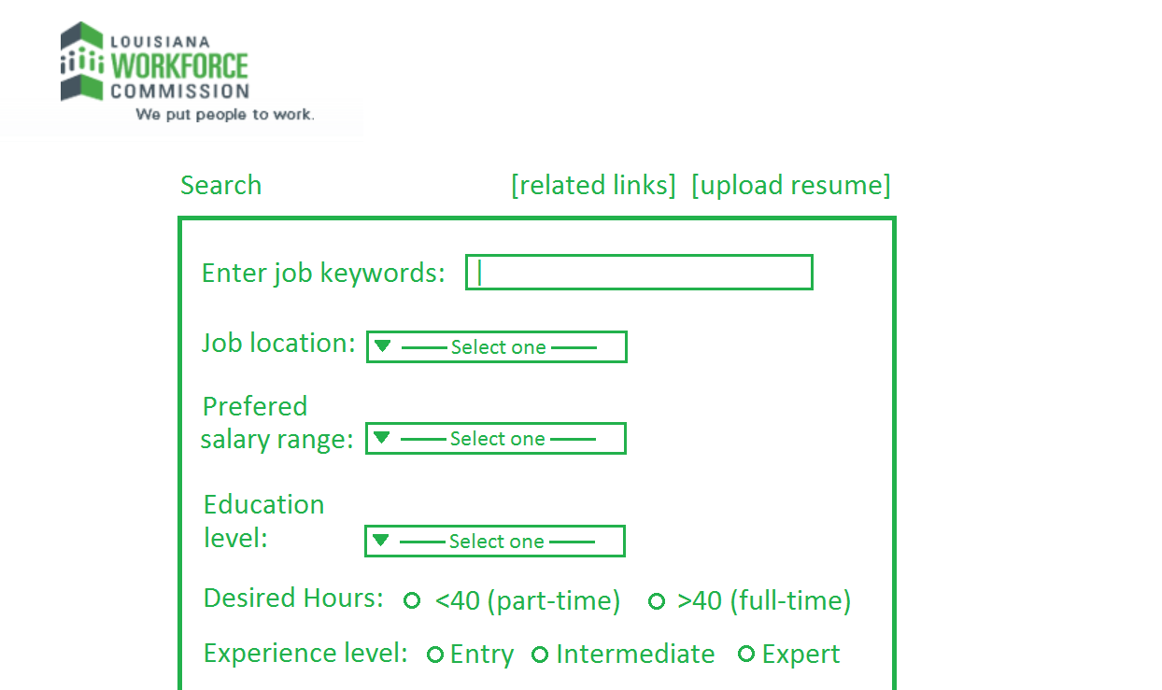

Figure 5-3 - Job Search

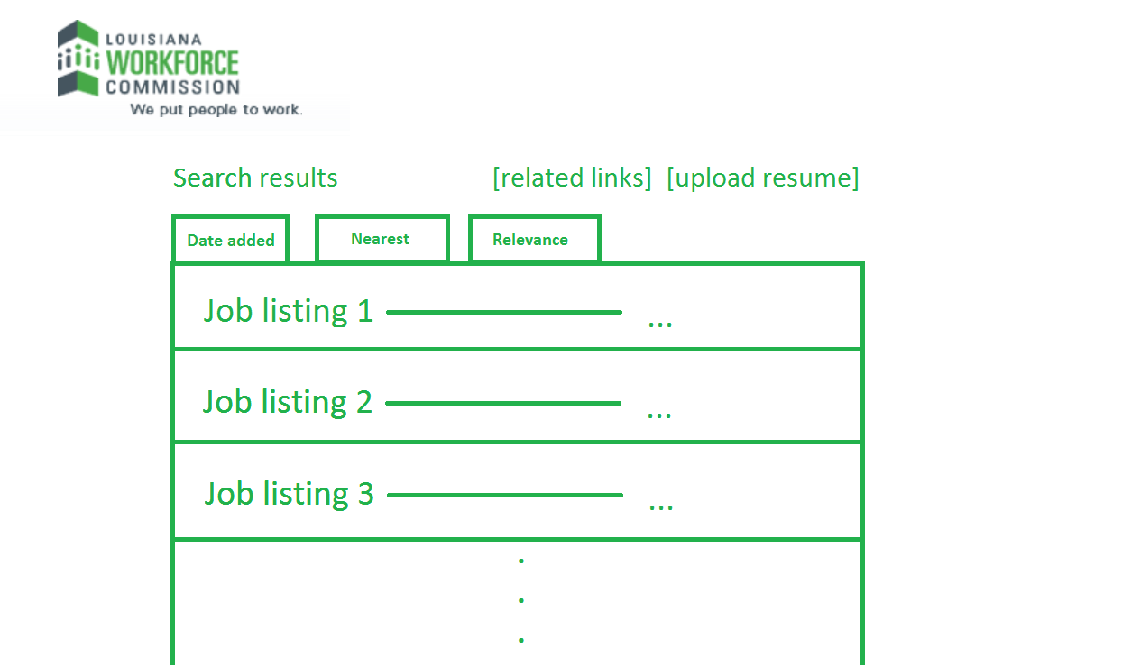

Figure 5-4 - Search Results

5.2. Static model – Class Diagrams

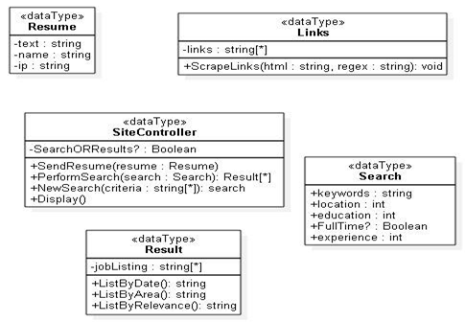

Figure 5-5 - Class Diagram

5.3. Dynamic model – Sequence Diagrams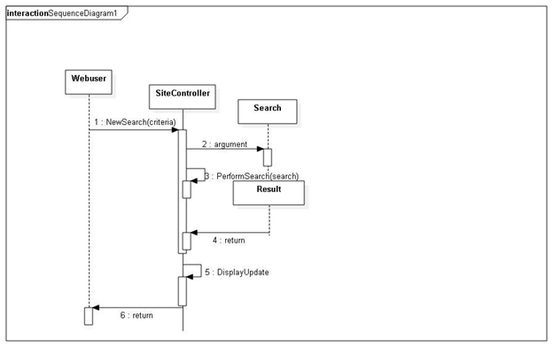

Figure 5-6 - Search Sequence Diagram

5.4. Rationale for your detailed design model

Since the main purpose of the website is to provide users with a quick and easy way to search for jobs and build resumes, we will provide a concise and easy-to-use interface so that job-seekers can accomplish these tasks in the most convenient way possible.

In order to make the process of job searching and resume building as easy as possible, we will make the websites as minimalistic as possible. This way, the user is not overwhelmed with the amount of information shown on the webpage. Upon opening the website, users should have an intuitive sense of what they should do to start the job-seeking process.

The simplicity of the website will hopefully be an alluring factor to college students, and will encourage them to come to the site and use it. This will help more students, both undergrads and grads, to find jobs, and help more employers find new employees. We also hope that this will help keep graduating students in Louisiana post-graduation.

5.5. Traceability from requirements to detailed design model

We can trace the design aspects from the requirements documents. Our functional requirements were that this product would be marketed towards students and that it would allow them to put their resumes up online for employers and that it would allow them to search through job offers. Our design decisions of making pages dedicated to job searches and building their resume reflects that. Though the design of our project can be traced back to the requirements, the platform of our project has changed from the cross-platform mobile application to the website.

**6. Test Plan**

6.1. Requirements/specifications-based system level test cases

The website is the system so testing at system level needs to be done with the end user in mind and through the site. The first site specification is to be able to upload resumes to the site through LAHire accounts. To test the system we’ll have a user with a LAHire account navigate through the site, upload various document files and we’ll verify that those documents were uploaded in their LAHire accounts. A second specification is that users be able to search for jobs using LAWorks search engine. To test the validity of that we’ll have to test a variety of searches and compare and contrast the results on our site versus the results of searches on the LAWorks’ engine.

6.2. Traceability of test cases to use cases

We've based our use case model on the verifiable specifications of the project. The use case model being functions the site user can take to upload their resume to their LAHire account, and search through jobs on the LAWorks site. Those aspects of the application are still relevant to the project and must be accounted for in testing the site. The tools needed to accomplish these functionalities are different than described in the use case model as we are specifically not to access the LAWorks databases directly and instead use scrapers and bots to push resumes to LAHire accounts and gather data from the LAWorks site.

6.3. Techniques used for test generation

We will ask someone to simply click through the links, search a few terms on the search page, and create example resumes with the resume builder to make sure everything works the way it should and is easy to navigate and use.

We will focus on black box testing because the focus of this project is to design an easy-to-use website, so ease of use by someone who has no knowledge of the design is the priority.

The tester must be able to easily and quickly find jobs based on their search criteria and create a resume without issue. This test case will completely and efficiently test the functionality of the website.

6.4. Assessment of the ‘goodness’ of your test suite

A single test case such as this one is an efficient way to fully test the functionality of a project of this scope. Our test case ensures functionality and ease-of-use in all areas of the project.

**Acknowledgment**

**References**

(Must be complete, correctly formatted using the standard for IEEE Conference Proceedings)