**Louisiana Works Career Seeker Application**

(Tentative)

**Requirements Documentation**

**Team SAMUS:**

Ian Callaway

Evan Perry

Chet Ransonet

Edward Woods

Sean Hungerford

**ABSTRACT**

The content and qualities of a good android application (app) are described for such an app that will help users in their career planning. Such an app will help users find which career suits their skill sets, but more importantly which jobs are currently in demand by interfacing with the LA works databases and systems.

**INTRODUCTION**

This document's purpose is to describe the functionality of an app that bridges the gap between the Louisiana Workforce Commission and ULL students and the unemployed in general. This document will describe the functionality of such an app as well as its architecture and uses. We want to help users find jobs suitable for their skills and know what our jobs our community needs. Querying information from the Louisiana Workforce Commission is important to the app, and is imperative that the user have as many tools as possible in finding work.

**CASE MODEL**

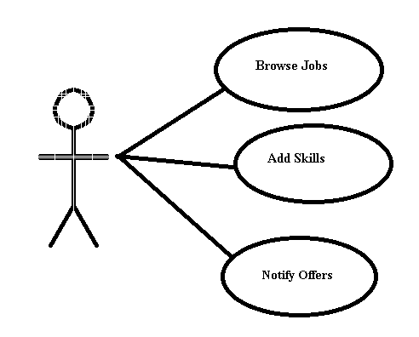

**Browse Jobs:** The user should be able to browse jobs on the app based on their skillset, desired field, or local industry demand. The user should have no trouble searching through all availabilities, and exiting on their whim. Should an error occur, it shouldn’t be a hindrance to restore the user to jobs browsed.

**Add Skills:** The user will be able to add skillsets to the app and be invited to browse jobs best suited for their particular skillset. The user will be able to enter skillsets they have, the app should query the database for those skillsets, and return the results. The user should be able to exit at any time, and if so queries must be terminated.

**Notify Offers:** The app will be able to notify the user when new jobs the user is interested in become available in the database. The user may tailor the notification as well as which jobs trigger notifications.

**RATIONALE FOR USE CASE MODEL**

We needed a model that would allow the user to use as many aspects of the databases that the Louisiana Workforce Commission has provided to the general public. The databases are imperative to what the app can provide to the user as that is who would be using it. This use case model allows the app to be an interface to the database in ways that make sense to bundle and are simple to users. Functions are modular while allowing feedback in the user's search for jobs.

**NON-FUNCTIONAL REQUIREMENTS**

The app shall be accessible to anyone from the Google Play Store for no price and with no other dependencies, and code shall be portable onto iOS devices. The app shall be reliable enough to store the user's resume and skill set even if terminated incorrectly through backups. The notifications the app sends out shall be configurable to the user. The app shall be idiot-proof and perform fast and reliably.

**REQUIREMENTS HAVE BEEN PLACED UNDER CONFIGURATION MANAGEMENT**