**Louisiana Works Career Seeker Website**

**Test Plan**

**Team SAMUS:**

Ian Callaway

Evan Perry

Chet Ransonet

Edward Woods

Sean Hungerford

Table of Contents

ABSTRACT 3

INTRODUCTION 3

REQUIREMENTS/SPECIFICATIONS-BASED SYSTEM LEVEL TEST CASES 3

TRACEABILITY OF TEST CASES TO USE CASES 4

TECHNIQUES FOR TEST GENERATION 4

EVIDENCE THE TEST CASES, DOCUMENT HAVE BEEN PLACED UNDER CONFIGURATION MANAGEMENT 5

## ABSTRACT

This document explains how the website will be tested to ensure that the website and its features are functional. We will have someone with a LAHire account test our website and the features included to ensure that they work as intended.

## INTRODUCTION

The purpose of this document is to explain our plans on testing the functionality of our website.

## REQUIREMENTS/SPECIFICATIONS-BASED SYSTEM LEVEL TEST CASES

The website is the system so testing at system level needs to be done with the end user in mind and through the site. The first site specification is to be able to upload resumes to the site through LAHire accounts. To test the system we’ll have a user with a LAHire account navigate through the site, upload various document files and we’ll verify that those documents were uploaded in their LAHire accounts. A second specification is that users be able to search for jobs using LAWorks search engine. To test the validity of that we’ll have to test a variety of searches and compare and contrast the results on our site versus the results of searches on the LAWorks’ engine.

## TRACEABILITY OF TEST CASES TO USE CASES

We've based our use case model on the verifiable specifications of the project. The use case model being functions the site user can take to upload their resume to their LAHire account, and search through jobs on the LAWorks site. Those aspects of the application are still relevant to the project and must be accounted for in testing the site. The tools needed to accomplish these functionalities are different than described in the use case model as we are specifically not to access the LAWorks databases directly and instead use scrapers and bots to push resumes to LAHire accounts and gather data from the LAWorks site.

## TECHNIQUES FOR TEST GENERATION

We will ask someone to simply click through the links, search a few random terms on the search page, and create example resumes with the resume builder to make sure everything works the way it should and is easy to navigate and use.

We will focus on black box testing because the focus of this project is to design an easy-to-use website, so ease of use by someone who has no knowledge of the design is the priority.

The tester must be able to easily and quickly find jobs based on their search criteria and create a resume.

## EVIDENCE THE TEST CASES, DOCUMENT HAVE BEEN PLACED UNDER CONFIGURATION MANAGEMENT

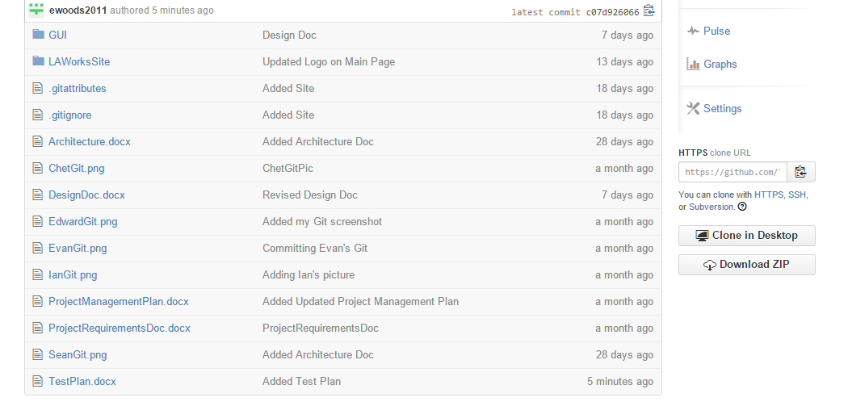

Figure 1 - Github Screenshot