
MINOR PROJECT – SYNOPSIS
Tourist Demand Forecasting for Uttarakhand
Event-aware time-series and machine-learning models, with a Himachal Pradesh comparison and a hotspot-level dashboard
Submitted by: [Student Name 1], [Student Name 2], [Student Name 3]
Roll No.: [Roll Numbers]
Group Number: [Group Number]

Under the Guidance of: [Guide Name], [Designation]

Department of [Department Name]
Shivalik College of Engineering
4th Year – [Academic Session]

1. Introduction
Tourism is one of the largest parts of Uttarakhand's economy. The state recorded about 6.10 crore domestic and foreign tourist visits in 2024, according to the Ministry of Tourism [12]. These visits are highly seasonal: the Char Dham shrines open in late April or May, pilgrim and holiday traffic peaks in May–June and again in October, and the Kanwar Yatra adds a spike in July.
Demand is also hit by large one-off events and shocks. The Haridwar Kumbh draws very large crowds (the next one runs from January to April 2027), while the COVID-19 lockdown cut Uttarakhand's visits from 3.77 crore in 2019 to 0.70 crore in 2020 [13], [14]. After COVID, demand settled at a much higher level than before, which is difficult for standard forecasting models.
Hotels, transport operators, the Char Dham administration and disaster-management agencies need month-wise demand estimates to plan capacity, staffing and safety. This project builds and compares forecasting models that predict monthly tourist visits 1–3 years ahead, with uncertainty ranges, and presents them in an interactive dashboard.

Key points
- Domain: time-series forecasting of tourism demand, applied to the Indian Himalayan states of Uttarakhand and Himachal Pradesh.
- Current scenario / gap: planning relies on yearly totals and past experience; there is no openly available month-wise forecast that accounts for Char Dham seasonality, the Kumbh and the post-COVID level shift.
- Why it matters: better monthly estimates help manage crowding, accommodation, transport and safety in fragile mountain areas.
- Solution in one line: an event-aware forecasting pipeline (SARIMAX, Gradient Boosting and an ensemble, tested against a seasonal-naive baseline) with a Streamlit dashboard and a hotspot-level map.

2. Problem Statement & Objectives

Problem statement
Monthly tourist demand in Uttarakhand is strongly seasonal and is repeatedly disrupted by events (Kumbh, Char Dham season) and shocks (COVID-19), after which it shifted to a permanently higher level. Planners lack a reliable, tested month-wise forecast with uncertainty ranges, and standard models that ignore these events and the structural break produce large errors.

Objectives
- Build a forecasting pipeline that turns a monthly series of tourist visits into forecasts 12–48 months ahead, with 80% uncertainty ranges for each year.
- Engineer event-aware features – Kumbh, COVID-19, a post-COVID structural break, Char Dham and Kanwar seasons – generated automatically from the date.
- Compare statistical and machine-learning models (seasonal naive, SARIMAX, Gradient Boosting, ensemble) on a 24-month hold-out period using MAE, RMSE and MAPE.
- Deliver an interactive dashboard with forecasts, model comparison, seasonality, and a map that splits the forecast across major destinations in Uttarakhand and Himachal Pradesh.

3. Literature Review / Existing System
Tourism demand forecasting has a long research history covering time-series, econometric and machine-learning methods. The works below shaped this project's choice of models, baseline and evaluation.
Author / Source | Title / Focus | Year | Key finding / relevance to this project
Box, Jenkins, Reinsel & Ljung [1] | Time Series Analysis: Forecasting and Control | 2015 | Standard ARIMA / seasonal ARIMA framework. Basis of the SARIMAX model used here; external events are added as regressors.
Song & Li [3] | Review of tourism demand modelling and forecasting | 2008 | No single method is best in every situation; the choice depends on the data and horizon, so several models should be compared.
Song, Qiu & Park [4] | Review of research on tourism demand forecasting | 2019 | Time-series, econometric and AI-based methods are all widely used; combining forecasts is a recurring way to improve accuracy.
Law, Li, Fong & Han [8] | Tourism demand forecasting: a deep learning approach | 2019 | Deep learning can improve accuracy but needs long series and extra inputs; motivates an optional LSTM once real monthly data is available.
Friedman [5] | Gradient boosting machine | 2001 | Builds many small trees, each correcting the previous ones; the basis of the Gradient Boosting model compared here.
Bates & Granger [6] | The combination of forecasts | 1969 | A combined forecast can have lower error than its parts; basis of the SARIMAX + GBM ensemble.
Makridakis, Spiliotis & Assimakopoulos [7] | The M4 Competition | 2020 | Combinations of methods did well, while pure machine-learning methods did not beat statistical benchmarks; supports testing ML against SARIMAX and a naive baseline.
Taylor & Letham [9] | Forecasting at scale (Prophet) | 2018 | Decomposable model with built-in holiday and event effects; a candidate for future comparison.
Hyndman & Athanasopoulos [2] | Forecasting: Principles and Practice | 2021 | Recommends testing on held-out data and comparing with simple benchmarks such as seasonal naive; followed in the evaluation design.

Gap addressed by this project
Most published tourism forecasting studies cover national or international arrivals. We found little openly available work on month-wise forecasting for Uttarakhand that models Char Dham seasonality, the Kumbh and the post-COVID structural break together, tests the models against a naive baseline, and extends the state forecast to destination level. This project addresses that gap.

4. Proposed Methodology / System Design
The system is a six-stage pipeline written in Python. Any monthly data source (estimated, synthetic or real) is converted to the same two-column format (date, visitors), so the stages after it do not change when real data is added.
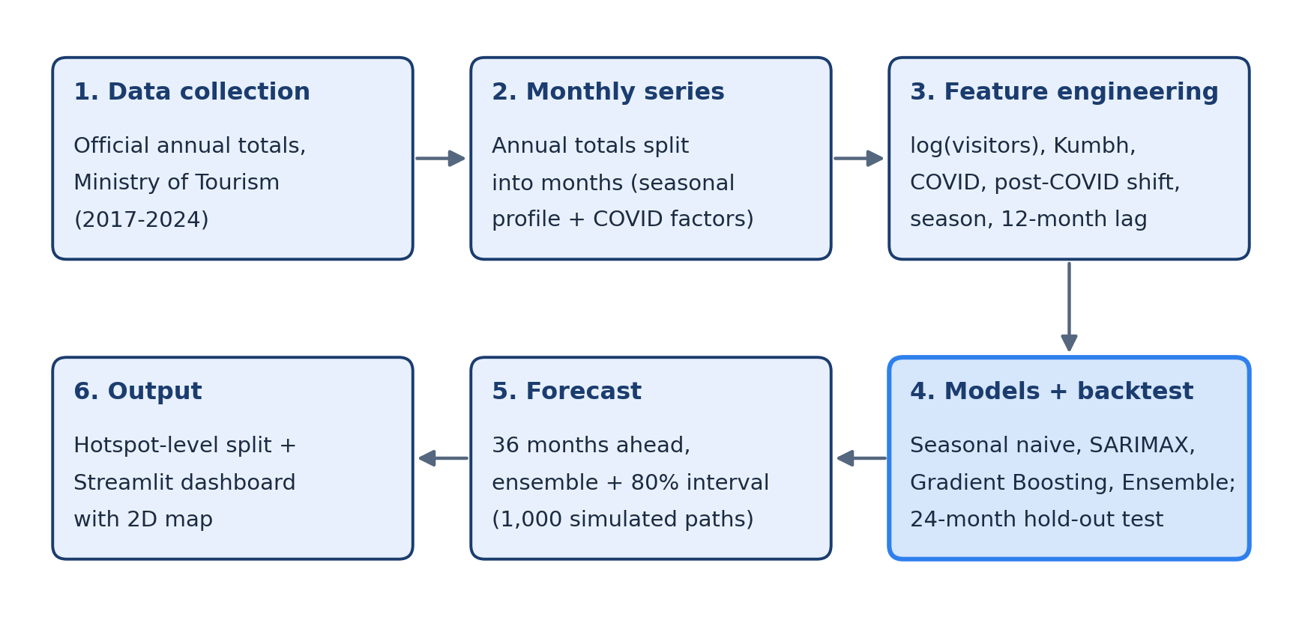
Figure 1. System architecture: from official data to forecasts and the dashboard

Step 1 – Input / data collection
- Official annual totals of domestic and foreign tourist visits for 2017–2024, from the Ministry of Tourism's India Tourism Statistics and India Tourism Data Compendium [12], [13], each figure cited to its table.
- Monthly series: official monthly data is not freely published, so each year's total is split into months using an average seasonal profile, with adjustments for the 2020 lockdown, the 2021 second wave and the 2021 Kumbh. The monthly values add up exactly to the official totals. Real monthly data (indiastat, RTI) will replace this estimate.

Step 2 – Processing / core logic
- Feature engineering: models use log(visitors) so seasonal swings become additive; event dummies for Kumbh and COVID; a post-COVID level-shift dummy from January 2022; cyclic month features (sine and cosine); Char Dham, Kanwar, summer and snow-season flags; and a 12-month lag that skips COVID-hit years.
- Models: (i) seasonal naive baseline; (ii) SARIMAX(1,0,1)(0,1,1)12 with Kumbh, COVID and post-COVID regressors; (iii) Gradient Boosting Regressor (400 trees) forecast recursively; (iv) an ensemble averaging SARIMAX and Gradient Boosting.
- Evaluation: the last 24 months are held out; each model is trained on the earlier data and scored by MAE, RMSE (in lakh visitors) and MAPE.

Step 3 – Output / result generation
- Forecasts for the next 36 months, with yearly 80% ranges taken from 1,000 simulated SARIMAX paths.
- Hotspot split: each state's monthly forecast is divided across 20 major destinations (11 in Uttarakhand, 9 in Himachal Pradesh) using destination-specific seasonal profiles and a Kumbh boost for Haridwar.
- Dashboard: a Streamlit web app with Overview, Hotspots (2D map), Model evaluation, Seasonality and Data tabs, with CSV downloads.

5. Tools, Technologies & Work Plan

Tools & technologies
Category | Used in this project
Language | Python 3.12
Libraries / framework | pandas, NumPy, statsmodels (SARIMAX) [10], scikit-learn (Gradient Boosting) [11], Matplotlib
Dashboard & visualisation | Streamlit, Altair (interactive charts), pydeck (map, CARTO / OpenStreetMap basemap)
Data storage | CSV files (no database needed: about 100 monthly rows per state)
Tools / IDE | VS Code, Windows PowerShell

Tentative work plan
Phase | Activities | Status
Phase 1 | Requirement analysis, literature review, identifying data sources | Completed
Phase 2 | Design of the pipeline, feature set and evaluation method; collection of official annual totals | Completed
Phase 3 | Implementation: models, hotspot split, dashboard; collection of real monthly data; optional Prophet / LSTM models | In progress
Phase 4 | Testing with real data, rolling-origin evaluation, report writing and final presentation | Planned

6. Expected Outcome
The project will deliver a working, tested forecasting system for monthly tourist demand in Uttarakhand, with Himachal Pradesh for comparison:
- Month-wise forecasts 1–3 years ahead, including the 2027 Haridwar Kumbh period, with 80% uncertainty ranges.
- A clear comparison of statistical and machine-learning models against a naive baseline, showing which works best and why.
- Evidence on handling a structural break: in development tests on synthetic data, adding the post-COVID regressor cut SARIMAX's test error from about 20% to about 4%.
- An interactive dashboard and destination-level map that planners can use without writing code.

Preliminary results
First results on the estimated monthly series (test period January 2023 – December 2024). The monthly split is estimated, so these figures will be recomputed once real monthly data is collected.
Model | Uttarakhand MAPE (%) | Himachal Pradesh MAPE (%)
Seasonal naive (baseline) | 7.76 | 11.17
SARIMAX | 3.18 | 26.94
Gradient Boosting | 20.84 | 14.16
Ensemble (SARIMAX + GBM) | 9.57 | 15.59

SARIMAX is the most accurate model for Uttarakhand. Gradient Boosting performs poorly because tree models cannot forecast above the highest values seen in training, and 2023–24 were record years. The ensemble forecast is about 6.19 crore visits for 2025 and 6.41 crore for the Kumbh year 2027.
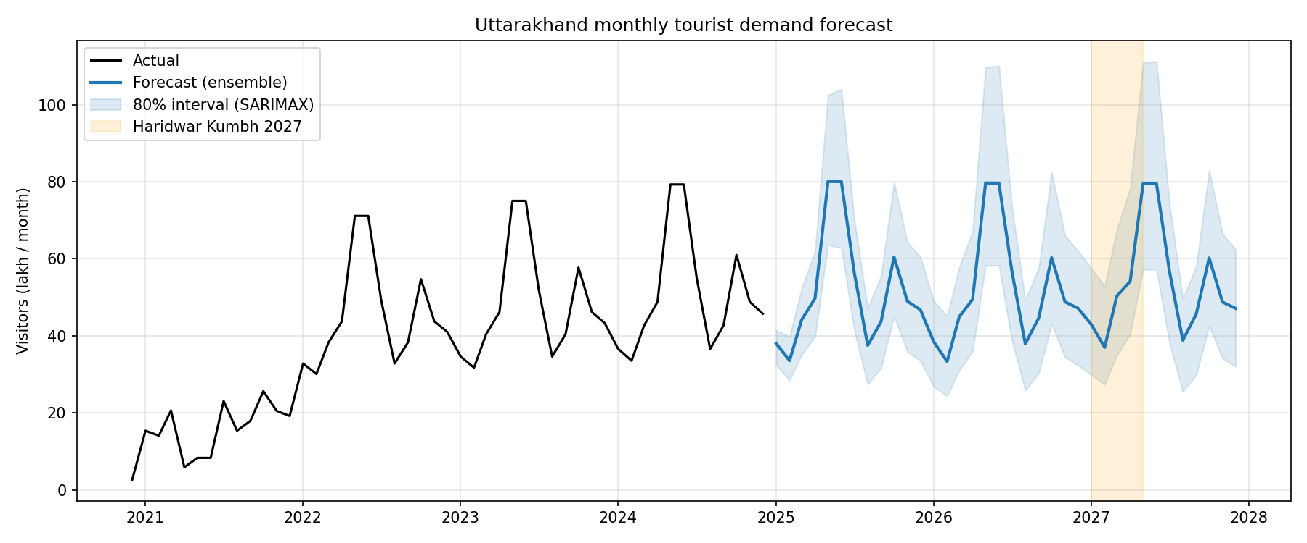
Figure 2. Uttarakhand monthly visits: actual (to Dec 2024) and ensemble forecast with 80% interval

7. References
[1] G. E. P. Box, G. M. Jenkins, G. C. Reinsel, and G. M. Ljung, Time Series Analysis: Forecasting and Control, 5th ed. Hoboken, NJ, USA: Wiley, 2015.
[2] R. J. Hyndman and G. Athanasopoulos, Forecasting: Principles and Practice, 3rd ed. Melbourne, Australia: OTexts, 2021.
[3] H. Song and G. Li, "Tourism demand modelling and forecasting – A review of recent research," Tourism Management, vol. 29, no. 2, pp. 203–220, 2008.
[4] H. Song, R. T. R. Qiu, and J. Park, "A review of research on tourism demand forecasting: Launching the Annals of Tourism Research Curated Collection on tourism demand forecasting," Annals of Tourism Research, vol. 75, pp. 338–362, 2019.
[5] J. H. Friedman, "Greedy function approximation: A gradient boosting machine," Annals of Statistics, vol. 29, no. 5, pp. 1189–1232, 2001.
[6] J. M. Bates and C. W. J. Granger, "The combination of forecasts," Operational Research Quarterly, vol. 20, no. 4, pp. 451–468, 1969.
[7] S. Makridakis, E. Spiliotis, and V. Assimakopoulos, "The M4 Competition: 100,000 time series and 61 forecasting methods," International Journal of Forecasting, vol. 36, no. 1, pp. 54–74, 2020.
[8] R. Law, G. Li, D. K. C. Fong, and X. Han, "Tourism demand forecasting: A deep learning approach," Annals of Tourism Research, vol. 75, pp. 410–423, 2019.
[9] S. J. Taylor and B. Letham, "Forecasting at scale," The American Statistician, vol. 72, no. 1, pp. 37–45, 2018.
[10] S. Seabold and J. Perktold, "Statsmodels: Econometric and statistical modeling with Python," in Proc. 9th Python in Science Conf. (SciPy), 2010, pp. 92–96.
[11] F. Pedregosa et al., "Scikit-learn: Machine learning in Python," Journal of Machine Learning Research, vol. 12, pp. 2825–2830, 2011.
[12] Ministry of Tourism, Government of India, India Tourism Data Compendium 2025 (Table 4.1.2: State/UT-wise domestic and foreign tourist visits, 2023–2024). New Delhi, India, 2025.
[13] Ministry of Tourism, Government of India, India Tourism Statistics 2022 (Table 5.1.2: State/UT-wise domestic and foreign tourist visits, 2020–2021). New Delhi, India, 2022.
[14] Ministry of Tourism, Government of India, State/UT-wise Domestic and Foreign Tourist Visits during 2018 & 2019. New Delhi, India, 2020.

