

VACATION TASKS
SET-1
Multi-meter:- Modes and Functionality

-
Tanush Biju

Multi-meter

- A multi-meter or a multi-tester, also known as a VOM (volt-ohm-milliammeter), is an electronic measuring instrument that combines several measurement functions in one unit. A typical multi-meter can measure voltage, current, and resistance.
- A multi-meter can be a hand-held device useful for basic fault finding and field service work, or a bench instrument which can measure to a very high degree of accuracy. They can be used to troubleshoot electrical problems in a wide array of industrial and household devices such as electronic equipment, motor controls, domestic appliances, power supplies, and wiring systems

.
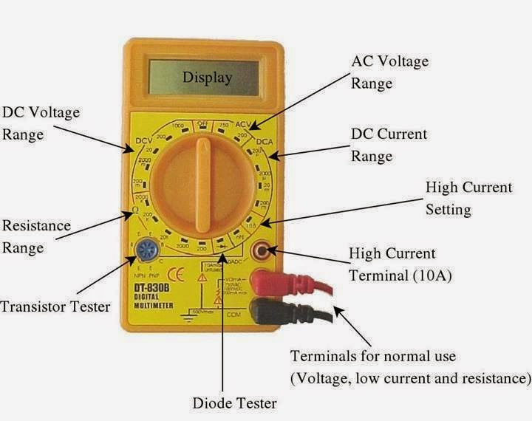
- Two probes are plugged into two of the ports on the front of the unit. COM stands for common and is almost always connected to Ground or ‘-’ of a circuit.
- The COM probe is conventionally black but there is no difference between the red probe and black probe other than color.
- 10A is the special port used when measuring large currents (greater than 200mA). mAVΩ is the port that the red probe is conventionally plugged in to. This port allows the measurement of current (up to 200mA), voltage (V), and resistance (Ω).
- The probes have a banana type connector on the end that plugs into the multi-meter.

Probe Types
There are many different types of probes available for multi-meters. Some of the most common are:
- Banana to Alligator Clips: These are great cables for connecting to large wires or pins on a breadboard. Good for performing longer term tests where you don’t have to have to hold the probes in place while you manipulate a circuit.
- Banana to IC Hook: IC hooks work well on smaller ICs and legs of ICs.
- Banana to Tweezers: Tweezers are useful if you need to test SMD components.
- Banana to Test Probes: They are cheap to replace.

Functions and Quantities measured
Contemporary multi-meters can measure many quantities. The common ones are:
- Voltage, alternating and direct, in volts.
- Current, alternating and direct, in amperes.
The frequency range for which AC measurements are accurate must be specified.
- Resistance in ohms.
Additionally, some multimeters measure:
- Capacitance in farads.
- Conductance in Siemens.
- Decibels.
- Duty cycle as a percentage.
- Frequency in hertz.
- Inductance in henrys.
- Temperature in degrees Celsius or Fahrenheit, with an appropriate temperature test probe, often a thermocouple.
Digital multi-meters may also include circuits for:
- Continuity; beeps when a circuit conducts.
- Diodes (measuring forward drop of diode junctions, i.e., diodes and transistor junctions) and transistors (measuring current gain and other parameters).
- Battery checking for simple 1.5 volt and 9 volt batteries. This is a current loaded voltage scale. Battery checking (ignoring internal resistance, which increases as the battery is depleted), is less accurate when using a DC voltage scale.

How to Use a Multi-meter

How to Measure Voltage
- Power off the circuity/wiring under test if there is a danger of shorting out closely spaced adjacent wires, terminals or other points which have differing voltages
- Plug the black ground probe lead into the COM socket on the meter
- Plug the red positive probe lead into the socket marked V (usually also marked with the Greek letter "omega" Ω and possibly a diode symbol)
- If the meter has has a manual range setting dial, turn this to select AC or DC volts and pick a range to give the required accuracy. So for instance measuring 12 volts on the 20 volt range will give more decimal places than on the 200 volt range.
If the meter is autoranging, turn the dial to the 'V' setting with the symbol for AC or DC
- A multimeter must be connected in parallel in a circuit (see diagram below) in order to measure voltage. So this means the two test probes should be connected in parallel with the voltage source, load or any other two points across which voltage needs to be measured.
- Touch the black probe against the first point of the circuitry/wiring
- Power up the equipment
- Touch the other red probe against the second point of test. Ensure you don't bridge the gap between the point being tested and adjacent wiring, terminals or tracks on a PCB
- Take the reading on the LCD display
Note: A lead with a 4mm banana plug on one end and a crocodile clip on the other end is very handy. The croc clip can be connected to ground in the circuit, freeing up one of your hands
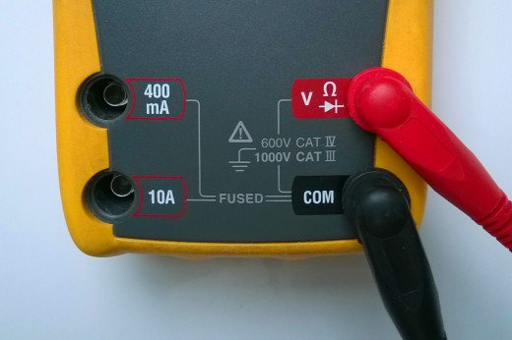

Connecting probe leads to measure voltage
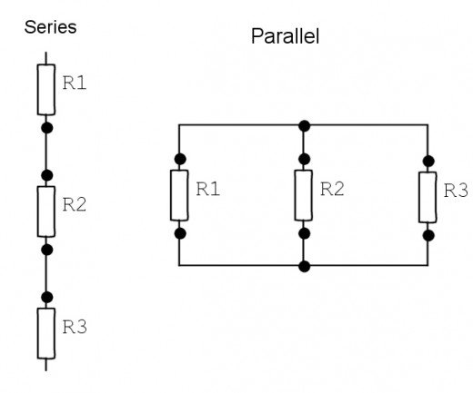

series and parallel connection

How to Measure Current
- Turn off the power in the circuit being measured
- A multi-meter must be inserted in series with the load in a circuit in order to measure current.
Plug the ground probe lead into the COM socket and plug the red positive probe lead either into the mA socket or the high current socket which is usually marked 10A (some meters have a 20 A socket instead of 10A). The mA socket is often marked with the maximum current and if you estimate that the current will be greater than this value, you must use the 10 A socket, otherwise you will end up blowing a fuse in the meter.
- Connect the meter in series as in the diagram below
- Turn the dial on the meter to the highest current range (or the 10A range if the probe is in the 10A socket). If the meter is autoranging, set it to the "A" or mA setting. (See the photo above for an explanation of symbols used).
- Turn on the power
- If the range is too high, you can switch to a lower range to get a more accurate reading
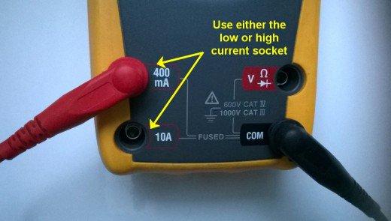
- Remember to return the positive probe to the V socket when finished measuring current. The meter is practically a short circuit when the lead is in the mA or 10 A socket. If you forget and connect the meter to a voltage source when the lead is in this position, you may end up blowing a fuse at best or blowing up the meter at worst! (On some meters the 10A range is un-fused)

Connecting probe leads to measure current

How to Measure Resistance

- Turn off all power to the circuit being measured
- Disconnect one end of the resistance from the circuit. This may involve pulling off spade leads or desoldering a component. This is important as there may be other resistances in parallel with the resistance being measured
- The probes are connected to the meter in the same way as for measuring voltage
- Turn the dial to the lowest Ohm or Ω range. This is likely to be the 200 ohm range or similar.
- Place a probe tip at each end of the resistance being measured
- If the display indicates "I", this means that resistance is greater than can be displayed on the range setting you have selected, so you must turn the dial to the next highest range. Repeat this until a value is displayed on the LCD.
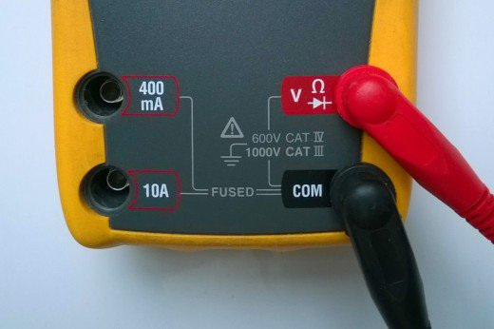

Connecting probe leads to measure resistance

How to Measure Continuity

A multi-meter is useful for checking breaks in flexes of appliances, blown filaments in bulbs and blown fuses, and tracing paths/tracks on PCBs.

- Turn the selecting dial on the meter to the continuity range. This is often indicated by a symbol which looks like a series of arcs of a circle (See the photo showing symbols used on meters above)
- The probe leads are connected to the meter in the same way as for measuring voltage
- If a conductor on a circuit board/ a wire in an appliance needs to be checked, make sure the device is powered down
- Place the tip of a probe at each end of the conductor or fuse which needs to be checked
- If resistance is less than about 30 ohms, the meter will indicate this by by a beep tone or buzzing sound. The resistance is usually indicated on the display also. If there is break in continuity in the device being tested, an overload indication, usually the digit "1", will be displayed on the meter.

How to Check Diodes

A multimeter can be used to check whether a diode is short circuited or open circuited. A diode is an electronic one way valve or check valve, which only conducts in one direction. A multimeter when connected to a working diode indicates the voltage across the component.
- Turn the dial of the meter to the diode test setting, which is indicated by a triangle with a bar at the end (see the photo showing symbols used on meters above)
- The probes are connected to the meter in the same way as for measuring voltage
- Touch the tip of the negative probe to one end of the diode, and the tip of the positive probe to the other end
- When the black probe is in contact with the cathode of the diode (usually indicated by a bar marked on the component) and the red probe makes contact with the anode, the diode conducts, and the meter indicates the voltage. This should be about 0.6 volts for a silicon diode and about 0.2 volts for a Schottky diode. When the probes are reversed, the meter should indicate a "1" because the diode is open circuit and non-conducting.
- If the meter reads "1" when the probes are placed either way, the diode is likely to be faulty and open circuit. If the meter indicates a value close to zero, the diode is shorted circuited.
- If a component is in circuit, resistances in parallel will affect the reading and the meter may not indicate "1" but a value somewhat less.

Connecting probe leads to measure resistance or to check diodes

