

VACATION TASKS

SET-1

Inductive and Capacitive proximity sensors

-

Tanush Biju

Inductive proximity sensor

An inductive proximity sensor can detect metal targets approaching the sensor, without physical contact with the target. Inductive Proximity Sensors are roughly classified into the following three types according to the operating principle:
- High-frequency oscillation type using electromagnetic induction
- Magnetic type using a magnet
- Capacitance type using the change in capacitance.

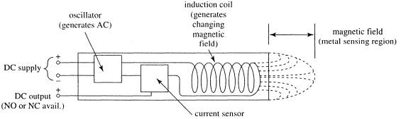

The sensing range of an inductive switch is dependent on the type of metal being detected. Ferrous metals, such as iron and steel, allow for a longer sensing range, while nonferrous metals, such as aluminum and copper, may reduce the sensing range by up to 60 percent.

Since the output of an inductive sensor has two possible states, an inductive sensor is sometimes referred to as an inductive proximity switch.

Working

At the heart of an Inductive Proximity Sensor (“prox” “sensor” or “prox sensor” for short) is an electronic oscillator consisting of an inductive coil made of numerous turns of very fine copper wire, a capacitor for storing electrical charge, and an energy source to provide electrical excitation.

The size of the inductive coil and the capacitor are matched to produce a self-sustaining sine wave oscillation at a fixed frequency. The coil and the capacitor act like two electrical springs with a weight hung between them, constantly pushing electrons back and forth between each other.

Electrical energy is fed into the circuit to initiate and sustain the oscillation. Without sustaining energy, the oscillation would collapse due to the small power losses from the electrical resistance of the thin copper wire in the coil and other parasitic losses.
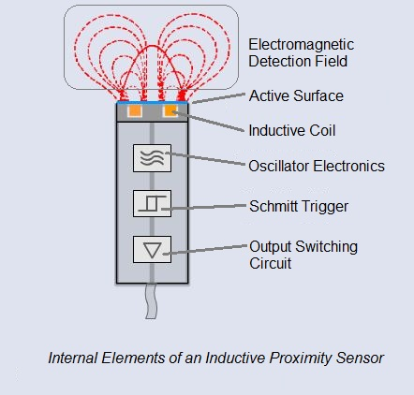

The oscillation produces an electromagnetic field in front of the sensor, because the coil is located right behind the “face” of the sensor. The technical name of the sensor face is “active surface”.

When a piece of conductive metal enters the zone defined by the boundaries of the electromagnetic field, some of the energy of oscillation is transferred into the metal of the target. This transferred energy appears as tiny circulating electrical currents called eddy currents. This is why inductive proxes are sometimes called eddy current sensors.

The flowing eddy currents encounter electrical resistance as they try to circulate. This creates a small amount of power loss in the form of heat (just like a little electric heater). The power loss is not entirely replaced by the sensor’s internal energy source, so the amplitude (the level or intensity) of the sensor’s oscillation decreases.

Eventually, the oscillation diminishes to the point that another internal circuit called a Schmitt Trigger detects that the level has fallen below a pre-determined threshold. This threshold is the level where the presence of a metal target is definitely confirmed. Upon detection of the target by the Schmitt Trigger, the sensor’s output is switched on.

Uses and Applications

Common applications of inductive sensors include metal detectors, traffic lights, car washes, and a host of automated industrial processes. Because the sensor does not require physical contact it is particularly useful for applications where access presents challenges or where dirt is prevalent.

Capacitive proximity sensor

Capacitive proximity sensors can be used to detect metallic and also non metallic targets like paper, wood, plastic, glass, wood, powder, liquid..etc without physical contact. The capacitive proximity sensor works on the capacitor principle. The main components of the capacitive proximity sensor are plate, oscillator, threshold detector and the output circuit.
The plate inside the sensor acts as one plate of the capacitor and the target acts as another plate and the air acts as the dielectric between the plates.
As the object comes close to the plate of the capacitor the capacitance increases and as the object moves away the capacitance decreases. The detector circuit checks the amplitude output from the oscillator and based on that the output switches.

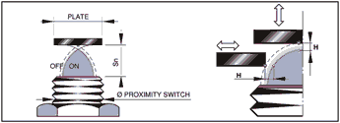

Working

Capacitive proximity sensors sense "target" objects due to the target's ability to be electrically charged. Since even non-conductors can hold charges, this means that just about any object can be detected with this type of sensor.
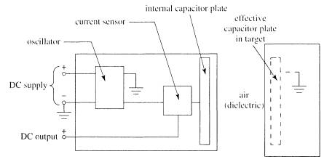

Inside the sensor is a circuit that uses the supplied DC power to generate AC, to measure the current in the internal AC circuit, and to switch the output circuit when the amount of AC current changes. Unlike the inductive sensor, however, the AC does not drive a coil, but instead tries to charge a capacitor.

Remember that capacitors can hold a charge because, when one plate is charged positively, negative charges are attracted into the other plate, thus allowing even more positive charges to be introduced into the first plate. Unless both plates are present and close to each other, it is very difficult to cause either plate to take on very much charge.

Only one of the required two capacitor plates is actually built into the capacitive sensor! The AC can move current into and out of this plate only if there is another plate nearby that can hold the opposite charge.

The target being sensed acts as the other plate. If this object is near enough to the face of the capacitive sensor to be affected by the charge in the sensor's internal capacitor plate, it will respond by becoming oppositely charged near the sensor, and the sensor will then be able to move significant current into and out of its internal plate.

Capacitive proximity sensors use the variation of capacitance between the sensor and the object being detected. A screw placed on the backside of the sensor allows regulation of the operating distance. This sensitivity regulation is useful in applications, such as detection of full containers and non-detection of empty containers. The operating distance of the sensor depends on the actuator shape and size and is strictly linked to the nature of the material

The capacitive sensor can detect any targets whose dielectric constant is more than air

Advantages and Disadvantages

The advantages of capacitive sensor are

- It can detect both metallic and non metallic targets.
- Good stability
- High Speed
- Good Resolution
- Capacitive sensors are good in terms of power usage
- Low cost

The disadvantages of capacitive sensors are

- They are affected by temperature and humidity
- Could be triggered by dust, moisture..etc
- Sensitive to noise
- Difficulties in designing
- Linearity is not good
- Capacitive proximity sensors are not as accurate compare to inductive sensors.

Uses and Applications

Some of the Applications of the Capacitive proximity Sensor are
Proximity Detection

