Multimeter Different modes and whole functionality

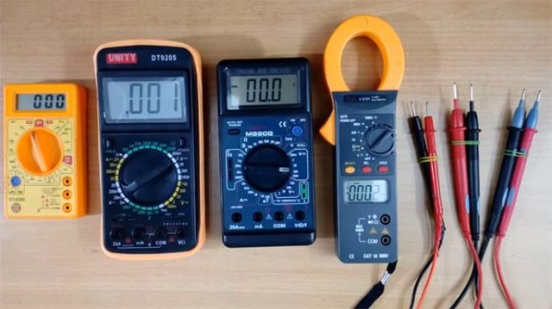

WHAT IS MULTIMETER

A Multimeter is an electronic instrument, every electronic technician and engineers widely used piece of test equipment. Multimeter is mainly used to measure the three basic electrical characteristics of voltage, current and resistance. It can also be used to test continuity between two points in an electrical circuit.
WHY MULTIMETER
Multimeter has multi functionalities like, it acts like ammeter, voltmeter and ohmmeter. It is a handheld device with positive and negative indicator needle over a numeric LCD digital display. Multimeters can be used for testing batteries, household wiring, electric motors and power supplies.
HOW TO USE

- Input Jacks
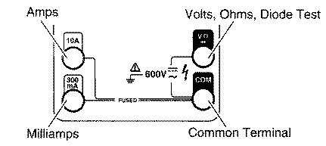

The black lead is always plugged into the common terminal. The red lead is plugged into the 10 A jack when measuring currents greater than 300 mA, the 300 mA jack when measuring currents less than 300 mA, and the remaining jack (V-ohms-diode) for all other measurements.

- Range
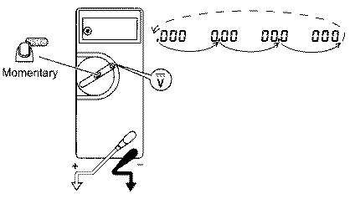
The meter defaults to autorange when first turned on. You can choose a manual range in V AC, V DC, A AC, and A DC by pressing the button in the middle of the rotary dial. To return to autorange, press the button for one second.

- Automatic Touch Hold Mode
The Touch Hold mode automatically captures and displays stable readings. Press the button in the center of the dial for 2 seconds while turning the meter on. When the meter captures a new input, it beeps and a new reading is displayed. To manually force a new measurement to be held, press the center button. To exit the Touch Hold mode, turn the meter off.
Note: stray voltages can produce a new reading.
Warning: To avoid electric shock, do not use the Touch Hold to determine if a circuit with high voltage is dead. The Touch Hold mode will not capture unstable or noisy readings.
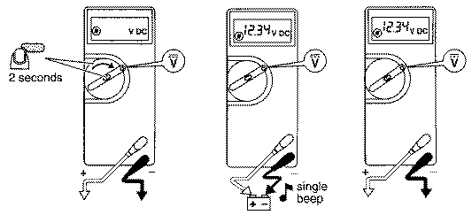
- AC and DC Voltage

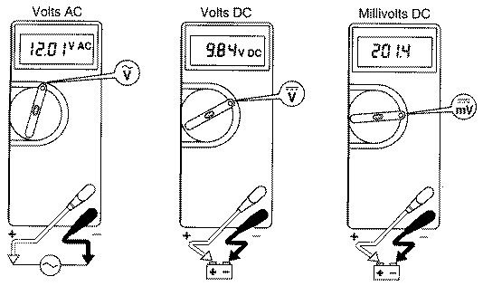
- Resistance
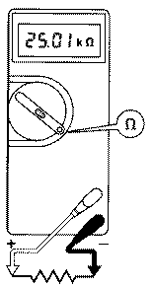
Turn off the power and discharge all capacitors. An external voltage across a component will give invalid resistance readings.
- Diode Test

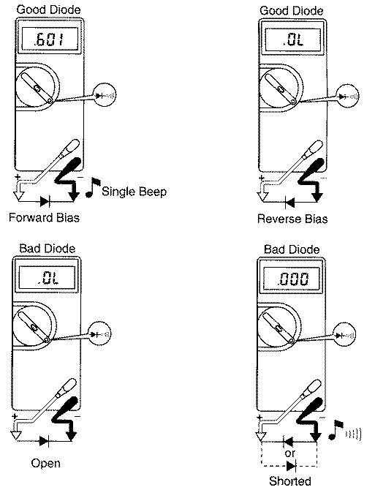
- Continuity Test

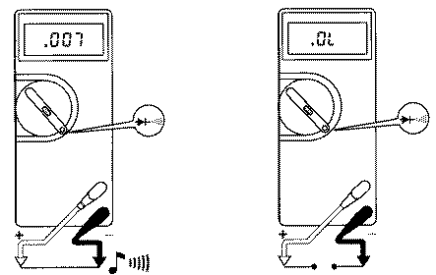
This mode is used to check if two points are electrically connected. It is often used to verify connectors. If continuity exists (resistance less than 210 ohms), the beeper sounds continuously. The meter beeps twice if it is in the Touch Hold mode.

- Current

Warning: To avoid injury, do not attempt a current measurement if the open circuit voltage is above the rated voltage of the meter.
To avoid blowing an input fuse, use the 10 A jack until you are sure that the current is less than 300 mA.
Turn off power to the circuit. Break the circuit. (For circuits of more than 10 amps, use a current clamp.) Put the meter in series with the circuit as shown and turn power on.
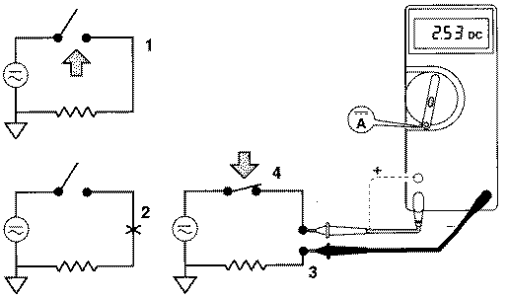

TYPES OF MULTIMETERS
There are different types of multimeters like Analog, Digital and Fluke multimeters.

- Digital Multimeters
- Analog Multimeters
- True RMS Meters
- Smart Multimeters
- Oscilloscopes

- Digital Multimeter:
We mostly used multimeter is digital multimeter (DMM). The DMM performs all functions from AC to DC other than analog. It has two probes positive and negative indicated with black and red color is shown in figure. The black probe connected to COM JACK and red probe connected by user requirement to measure ohm, volt or amperes. The jack marked VΩ and the COM jack on the right of the picture are used for measuring voltages, resistance and for testing a diode. The two jacks are utilized when LCD display that shows what is being measured (volts, ohms, amps, etc.). Overload protection that prevents damage to the meter and the circuit, and protects the user.

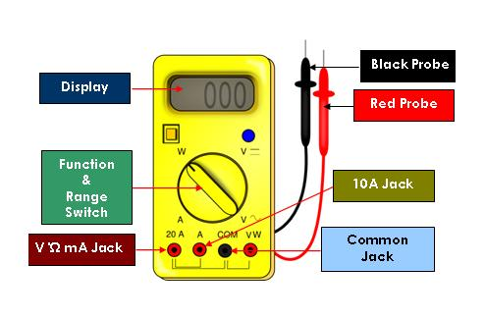
The Digital Multimeter basically consists of a LCD display, a knob to select various ranges of the three electrical characteristics, an internal circuitry consisting of a signal conditioning circuitry, an analog to digital converter. The PCB consists of concentric rings which are connected or disconnected based on the position of the knob. Thus as the required parameter and the range is selected, the section of the PCB is activated to perform the corresponding measurement. To measure the resistance, current flows from a constant current source through the unknown resistor and the voltage across the resistor is amplified and fed to an Analog to Digital Converter and the resultant output in form of resistance is displayed on the digital display. To measure an unknown AC voltage, the voltage is first attenuated to get the suitable range and then rectified to DC signal and the analog DC signal is fed to A/D converter to get the display, which indicates the RMS value of the AC signal. Similarly to measure an AC or DC current, the unknown input is first converted to voltage signal and then fed to analog to digital converter to get the desired output(with rectification in case of AC signal).
Advantages of a Digital Multimeter are its output display which directly shows the measured value, high accuracy and ability to read both positive and negative values.

- Analog Multimeter:
The Analog Multimeter or VOM (Volt-Ohm-Milliammeter) is constructed using a moving coil meter and a pointer to indicate the reading on the scale. The moving coil meter consists of a coil wound around a drum placed between two permanent magnet. As current passes through the coil, magnetic field is induced in the coil which reacts with the magnetic field of the permanent magnets and the resultant force causes the pointer attached to the drum to deflect on the scale, indicating the current reading. It also consists of springs attached to the drum which provides an opposing force to the motion of the drum to control the deflection of the pointer.
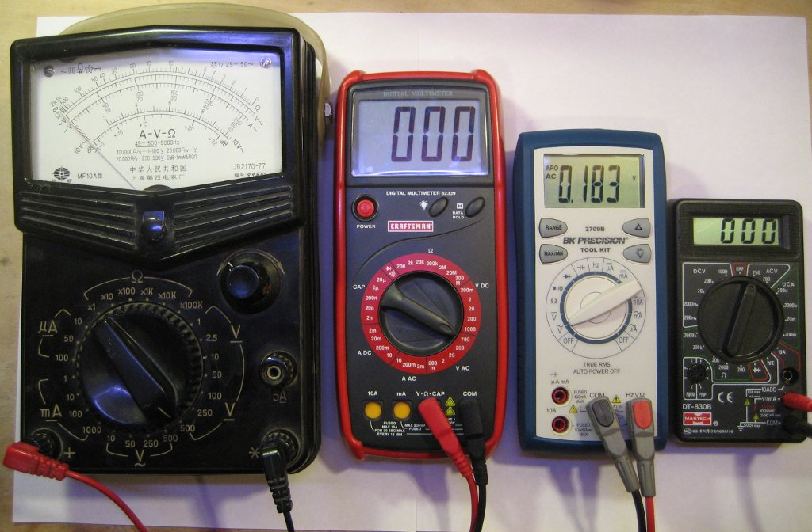
For measurement of DC current, the D Arsonval movement described above can be directly used. However the current to be measured should be lesser than the full scale deflection current of the meter. For higher currents the current divider rule is applied. Using different values of shunt resistors, the meter can also be used for multi range current measurement. For current measurement the instrument is to be connected in series with the unknown current source.
For measurement of DC voltage, a resistor is connected in series with the meter and the meter resistance is taken into account such that the current passing through the resistor is same as the current passing through the meter and the whole reading indicates the voltage reading. For voltage measurement, the instrument is to be connected in parallel with the unknown voltage source. For multirange measurement, different resistors of different values can be used, which are connected in series with the meter.
For measurement of resistance, the unknown resistance is connected in series with the meter and across a battery, such that the current passing through the meter is directly proportional to the unknown resistance.
For AC voltage or current measurement, the same principle is applied, except for the fact that the AC parameter to be measured is first rectified and filtered to get the DC parameter and the meter indicates the RMS value of the AC signal.
Advantages of an Analog Multimeter are that it is inexpensive, doesn’t require a battery, can measure fluctuations in the readings.
The two main factors affecting the measurement are the sensitivity and the accuracy. Sensitivity refers to the reciprocal of the full scale deflection current and is measured in ohms per volt.
- Fluke Multimeter:
The fluke multimeters are protected against the transient voltage. It is a small portable device used to measure voltage, current and test diodes. The multi meter has multi selectors to select the desired function. The fluke MM automatically ranges to select most measurements. This means the magnitude of the signal does not have to be known or determined to take an accurate reading, it directly moved to the appropriate port for the desired measurement. The fuse is protected to prevent the damage, if connected to wrong port.

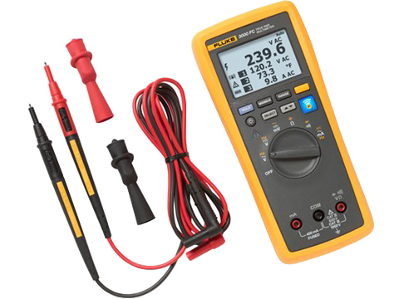

USES AND APPLICATIONS

The applications of ammeter mainly involves in various electrical and electronic projects for the purpose of components testing and also used in different measurement applications in multimeter.
- Temperature and Environmental Applications
  - Low cost weather station
  - DMM internal temperature
- Voltage Measurements
  - High and low value DC measurement
  - Peak to Peak and DC average measurement
- Current Measurements
  - DC current measurement
  - True RMS AC current
- Resistance Measurement
  - Micro ohm meter
  - Measuring resistance with constant voltage
  - Measuring resistance with constant current
- Time and Frequency measurement
  - Fast frequency
  - Time measurement

SAFETY AND PRECAUTIONS

- Be sure the test leads and rotary switch are in the correct position for the desired measurement.
- Never use the meter if the meter or the test leads look damaged.
- Never measure resistance in a circuit when power is applied.
- Never touch the probes to a voltage source when a test lead is plugged into the 10 A or 300 mA input jack.
- To avoid damage or injury, never use the meter on circuits that exceed 4800 watts.
- Never apply more than the rated voltage between any input jack and earth ground (600 V for the Fluke 73).
- Be careful when working with voltages above 60 V DC or 30 V AC rms. Such voltages pose a shock hazard.
- Keep your fingers behind the finger guards on the test probes when making measurements.
- To avoid false readings, which could lead to possible electric shock or personal injury, replace the battery as soon as the battery indicator appears.

DIFFERENT TYPES OF SWITCHES AND CONNECTORS

WHAT IS A SWITCH

Switch is nothing but a device which is used to turn ON and OFF the equipment. Most probably this equipment is electrical equipment like fan, TV etc. To flow current from a circuit it must require a close path (loop). If switch is OFF, that means circuit is open and current cannot flow through the conductor and equipment is de-energize (OFF state). To make it energize, we have to turn ON switch, it makes a complete circuit and close path. So, current can flow through the equipment and it can turn ON. So, function of switch is to make (switch is ON) and break (switch is OFF) the circuit.
.
The circuit symbol of a ON-OFF switch is shown below:



So the switches are the part of a control system and without it, control operation cannot be achieved. A switch can perform two functions, namely fully ON (by closing its contacts) or fully OFF (by opening its contacts).
Switches are of basically two types :-
- Mechanical switches must be activated physically, by moving, pressing, releasing, or touching its contacts.
- Electronic switches do not require any physical contact in order to control a circuit. These are activated by semiconductor action.
Further mechanical and electronic switches subdivided into:-
Mechanical Switches

- Single Pole Single Throw Switch (SPST)
- Single Pole Double Throw Switch (SPDT)
- Double Pole Single Throw Switch (DPST)
- Double Pole Double Throw Switch (DPDT)
- Push Button Switch
- Toggle Switch
- Limit Switch
- Float Switches
- Flow Switches
- Pressure Switches
- Temperature Switches
- Joystick Switch
- Rotary Switches

Electronic Switches

- Bipolar Transistors
- Power Diode
- MOSFET
- IGBT
- SCR
- TRIAC
- DIAC
- Gate Turn-Off Thyristor

Mechanical Switches
Mechanical switches can be classified into different types based on several factors such as method of actuation (manual, limit and process switches), number of contacts (single contact and multi contact switches), number of poles and throws (SPST, DPDT, SPDT, etc.), operation and construction (push button, toggle, rotary, joystick, etc.), based on state (momentary and locked switches), etc.
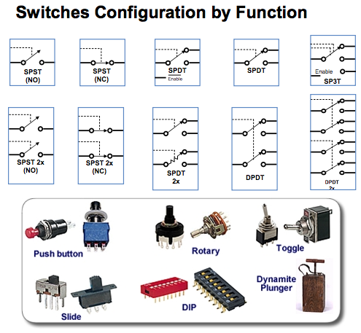
Based on the number of poles and throws, switches are classified into following types. The pole represents the number of individual power circuits that can be switched. Most of the switches are designed have one, two or three poles and are designated as single pole, double pole and triple pole.
The number of throws represents the number of states to which current can pass through the switch. Most of the switches are designed to have either one or two throws which are designated as single throw and double throw switches.

Single Pole Single Throw Switch (SPST)
- 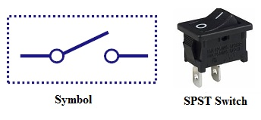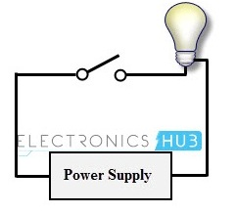This is the basic ON and OFF switch consisting of one input contact and one output contact.
- It switches a single circuit and it can either make (ON) or break (OFF) the load.
- The contacts of SPST can be either normally open or normally closed configurations .

Single Pole Double Throw Switch (SPDT)
- 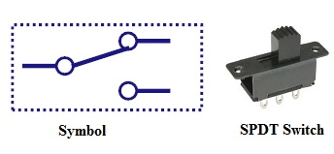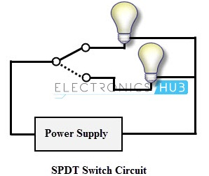
- This switch has three terminals, one is input contact and remaining two are output contacts.
- This means it consist two ON positions and one OFF position.
- In most of the circuits, these switches are used as changeover to connect the input between two choices of outputs.
- The contact which is connected to the input by default is referred as normally closed contact and contact which will be connected during ON operation is a normally open contact.

Double Pole Single Throw Switch (DPST)
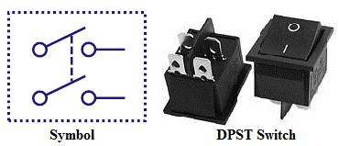
- 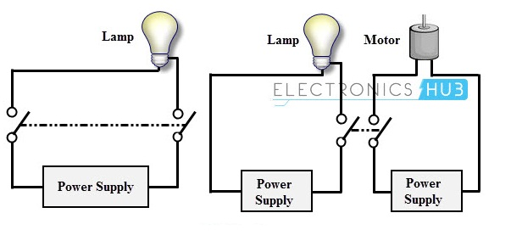This switch consists of four terminals,two input contacts and two output contacts.
- It behaves like a two separate SPST configurations, operating at the same time.
- It has only one ON position, but it can actuate the two contacts simultaneously, such that each input contact will be connected to its corresponding output contact.
- In OFF position both switches are at open state.
- This type of switches is used for controlling two different circuits at a time.
- Also, the contacts of this switch may be either normally open or normally closed configurations.

Double Pole Double Throw Switch (DPDT)
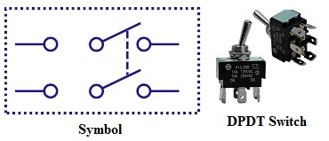
- 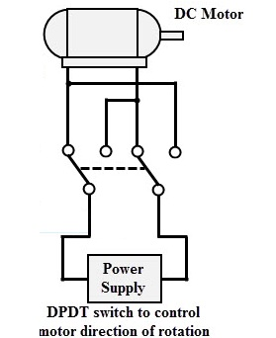This is a dual ON/OFF switch consisting of two ON positions.
- It has six terminals,two are input contacts and remaining four are the output contacts.
- It behaves like a two separate SPDT configuration, operating at the same time.
- Two input contacts are connected to the one set of output contacts in one position and in another position, input contacts are connected to the other set of output contacts.

Push Button Switch
- 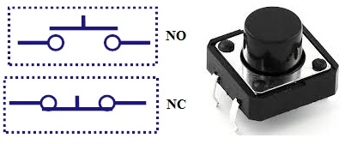It is a momentary contact switch that makes or breaks connection as long as pressure is applied (or when the button is pushed).
- Generally, this pressure is supplied by a button pressed by someone’s finger.
- This button returns its normal position, once the pressure is removed.
- The internal spring mechanism operates these two states (pressed and released) of a push button.
- It consists of stationary and movable contacts, of which stationary contacts are connected in series with the circuit to be switched while movable contacts are attached with a push button.
- Push buttons are majorly classified into normally open, normally closed and double acting push buttons as shown in the above figure.
- Double acting push buttons are generally used for controlling two electrical circuits.

Toggle Switch
- 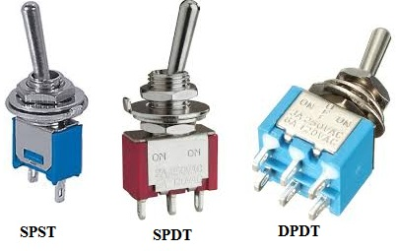A toggle switch is manually actuated (or pushed up or down) by a mechanical handle, lever or rocking mechanism. These are commonly used as light control switches.
- Most of these switches come with two or more lever positions which are in the versions of SPDT, SPST, DPST and DPDT switch. These are used for switching high currents (as high as 10 A) and can also be used for switching small currents.
- These are available in different ratings, sizes and styles and are used for different type of applications. The ON condition can be any of their level positions, however, by convention the downward is the closed or ON position.

Limit Switch
- 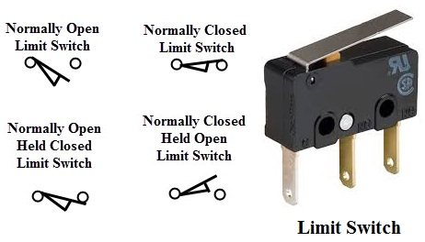The control schemes of a limit switch are shown in above figure , in which four varieties of limit switches are presented.
- Some switches are operated by the presence of an object or by the absence of objects or by the motion of machine instead of human hand operation. These switches are called as limit switches.
- These switches consist of a bumper type of arm actuated by an object. When this bumper arm is actuated, it causes the switch contacts to change position.

Float Switches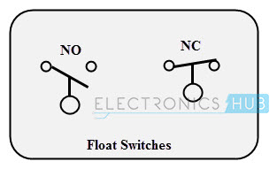
- Float switches are mainly used for controlling DC and AC motor pumps according to the liquid or water in a tank or sump.
- This switch is operated when the float (or floating object) moves downward or upward based on water level in a tank.
- This float movement of rod or chain assembly and counterweight causes to open or close electrical contacts. Another form of float switch is the mercury bulb type switch that does not consist of any float rod or chain arrangement.
- This bulb consist of mercury contacts such that when the liquid level rises or falls, the state of contacts also changes.
- The ball float switch symbol is shown in the above figure. These float switches can be normally open or normally closed type.

Flow Switches
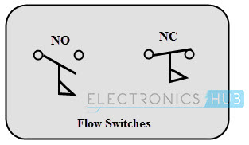
- These are mainly used to detect the movement of liquid or air flow through a pipe or duct. The air flow switch (or a micro switch) is constructed by a snap-action.
- This micro switch is attached to a metal arm .To this metal arm, a thin plastic or metal piece is connected.
- When a large amount of air passes through the metal or plastic piece, it causes the movement of metal arm and thus operates the contacts of the switch.
- Liquid flow switches are designed with a paddle that inserted across the flow of liquid in a pipe. When liquid flows through the pipe, force exerted against the paddle changes the position of the contacts.
- The above figure shows the switch symbol used for both air flow and liquid flow. The flag symbol on the switch indicates the paddle which senses the flow or movement of liquid.
- These switches again normally open or normally closed type configurations.

Pressure Switches
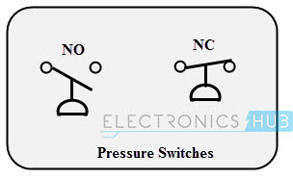
- These switches are commonly used in industrial applications in order to sense the pressure of hydraulic systems and pneumatic devices.
- Depends on the range of pressure to be measured, these pressure switches are classified into diaphragm operated pressure switch, metal bellow type pressure switch and piston type pressure switch.
- In all these types, pressure detection element operates a set of contacts (which can be either double pole or single pole contacts).
- This switch symbol consist a half-circle connected to a line in which flat part indicates a diaphragm. These switches may be either normally open or normally closed type configurations.

Temperature Switches

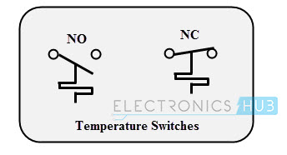
- The most common heat sensing element is the bimetallic strip that operates on the principle of thermal expansion.
- The bimetallic strips are made with two dissimilar metals (that are having different thermal expansion rates) and are bonded with each other.
- The switch contacts are operated when the temperature causes the strip to bend or wrap. Another method of operating the temperature switch is to use mercury glass tube.
- When the bulb is heated, mercury in the tube will expand and then generates pressure to operate the contacts.

Joystick Switch
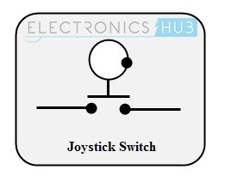
- Joystick switches are manually actuated control devices used mainly in portable control equipments.
- It consists of a lever which moves freely in more than one axis of motion.
- Depending on the movement of the lever pushed, one or more switch contacts are actuated.
- These are ideally suited for lowering, raising and triggering movements to the left and right.
- These are used for building machinery, cable controls and cranes. The symbol for the joystick is shown below.

Rotary Switches
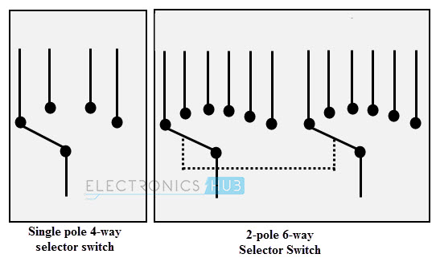
- These are used for connecting one line to one of many lines.
- Examples of these switches are range selectors in electrical metering equipment, channel selectors in communication devices and band selectors in multi-band radios.
- It consists of one or more moving contacts (knob) and more than one stationary contact.
- These switches are come with different arrangement of contacts such as single pole 12-way, 3-pole 4-way, 2-pole 6-way and 4-pole 3-way.

Electronic Switches
The electronic switches are generally called as solid state switches because there are no physical moving parts and hence absence of physical contacts. Most of the appliances are controlled by semiconductor switches such as motor drives and HVAC equipments.
There are different types of solid state switches are available in today market with different sizes and ratings. Some of these solid state switches include transistors, SCRs, MOSFETs, TRIACs and IGBTs.

Bipolar Transistors
A transistor either allows the current to pass or it blocks the current as similar to working of normal switch.
In switching circuits, transistor operates in cut-off mode for OFF or current blocking condition and in saturation mode for ON condition. The active region of the transistor is not used for switching applications.
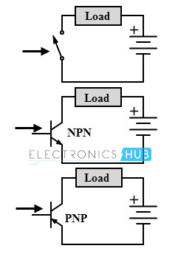
Both NPN and PNP transistors are operated or switched ON when a sufficient base current is supplied to it. When a small current flows though the base terminal supplied by a driving circuit (connected between the base and emitter), it causes to turns ON the collector-emitter path.
And it is turned OFF when the base current is removed and base voltage is reduced to a slight negative value. Even though it utilizes small base current, it is capable to carry much higher currents through the collector- emitter path.

Power Diode
A diode can perform switching operations between its high and low state impedance states. Semiconductor materials like silicon and germanium are used for constructing the diodes.
Usually, power diodes are constructed using silicon in order to operate the device at higher currents and higher junction temperatures. These are constructed by joining p and n type semiconductor materials together to form PN junction. It has two terminals namely anode and cathode.
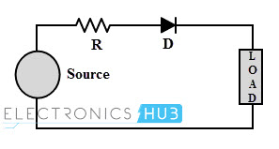
When the anode is made positive with respect to cathode and by the application of voltage greater than the threshold level, PN junction is forward biased and starts conducting (like ON switch). When the cathode terminal is made positive with respect to anode, PN junction reverse biased and its blocks the current flow (like OFF switch).

MOSFET
Metal Oxide Semiconductor Field Effect Transistor (MOSFET) is a unipolar and high frequency switching device. It is a most commonly used switching device is power electronic applications. It has three terminals namely drain (output), source (common) and gate (input).
It is a voltage controlled device, i.e., by controlling input (gate to source) voltage, resistance between the drain and source is controlled which further determines the ON and OFF state of the device.
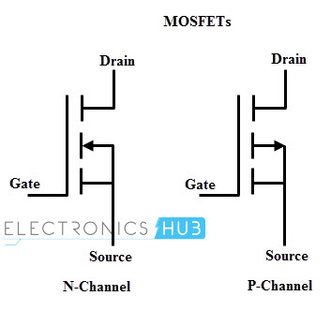
MOSFETs can be a P-channel or N-channel devices. The N-channel MOSFET is tuned ON by applying a positive VGS with respect to the source (provided that VGS should be greater than threshold voltage).
P-channel MOSFET operates in a similar manner of N-channel MOSFET but it uses reverse polarity of voltages. Both VGS and VDD are negative with respect the source to switch ON the P- channel MOSFET.

IGBT
IGBT (Insulated Gate Bipolar Transistor) combines the several advantages of bipolar junction power transistor and power MOSFET. Like a MOSFET, it is a voltage controlled device and has lower ON state voltage drop (less than that of MOSFET and closer to power transistor).
It is a three terminal semiconductor high speed switching device. These terminals are emitter, collector and gate.
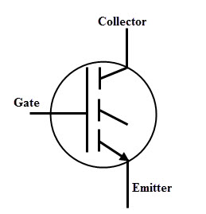
Similar to the MOSFET, IGBT can be turned ON by applying a positive voltage (greater than the threshold voltage) between the gate and emitter. IGBT can be turned by reducing the voltage across the gate-emitter to zero. In most of the case it needs negative voltage to reduce turn OFF losses and safely turn OFF the IGBT.

SCR
A Silicon Controlled Rectifier (SCR) most widely used high speed switching device for power control applications. It is a unidirectional device as a diode, consisting of three terminals, namely anode, cathode and gate.
An SCR is turned ON and OFF by controlling its gate input and biasing conditions of the anode and cathode terminals. SCR consists of four layers of alternate P and N layers such that boundaries of each layer forms junctions J1, J2 and J3.

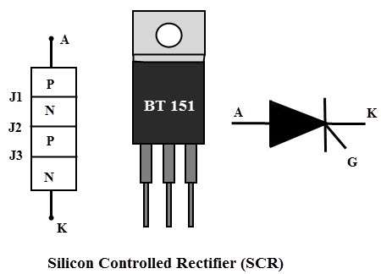

TRIAC
Triac (or TRIode AC) switch is a bidirectional switching device which is an equivalent circuit of two back to back SCRs connection with one gate terminal.
Its capability to control AC power in both positive and negative peaks of the voltage waveform often makes these devices to be used in motor speed controllers, light dimmers, pressure control systems, motor drives and other AC control equipments.
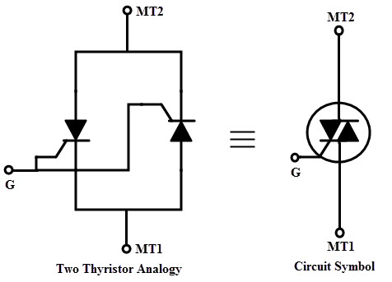

DIAC
A DIAC (or DIode AC switch) is bidirectional switching device and it consists of two terminals which are not named as anode and cathode. It means that a DIAC can be operated in either direction regardless of the terminal identification. This indicates that the DIAC can be used in either direction.
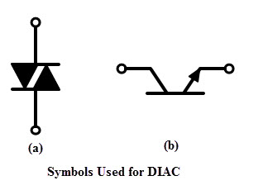
When a voltage is applied across a DIAC, it either operates in forward blocking or reverse blocking mode unless the applied voltage is less than the breakover voltage. Once the voltage is increased more than breakover voltage, avalanche breakover occurs and device starts conducting.

Gate Turn-Off Thyristor
A GTO (Gate Turn off Thyristor) is a bipolar semiconductor switching device. It has three terminals as anode, cathode and gate. As the name implies, this switching device is capable to turn OFF through gate terminal.
A GTO is turned ON by applying a small positive gate current triggers the conduction mode and turned OFF by a negative pulse to the gate. GTO symbol consists of double arrows on the gate terminal which represents the bidirectional flow of current through gate terminal.
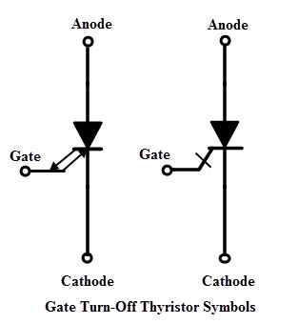
APPLICATIONS

Industrial Controls
AC application like motor control, switching in lights (industrial and domestic)
power regulators and lamp dimming.
heat control circuit.
inverter, traction motor control, induction heating and switched mode power supplies.
voltage regulator, chopper and audio frequency power amplifier,
rectifier, voltage multiplier circuit and voltage clamper circuit, etc.

PRECAUTIONS

May be Fuse is a kind of safety switch
Courtesy :-http://www.ia.omron.com/product/cautions/29/safety_precautions.html
https://talksense.weebly.com/switch-rules.html
Precautions for Safe Use
Always observe the following cautions to ensure safety.
Mounting
Before mounting, dismounting, wiring, or inspecting a switch, be sure to turn OFF the power supply to the switch, otherwise an electric shock may be received or the switch may burn.
Wiring
Do not perform wiring when power is being supplied to a switch. Also, do not touch any of the charged terminals when power is being supplied. Otherwise, electric shock may be received.
Follow the instructions provided in Correct Use for all wiring and soldering work. Using a switch with improper wiring or soldering may result in abnormal heating when power is supplied, possibly resulting in burning.
Contact Load
Select suitable switch ratings after confirming contact load. If the contact load is excessive for the contacts, the contacts may weld or shift, possibly resulting in short-circuits or burning when power is supplied.
Load Types
Some types of loads have a large difference between steady-state current and inrush current, as shown in the following diagram. Select a switch with ratings suitable for the type of load. Select a switch with ratings suitable for the type of load. The higher the inrush current in the closed circuit is, the more the contact abrasion or shift there will be. Consequently, contact welding or shifting may occur, possibly resulting in short-circuits or burning.
Types of Load vs. Inrush Current
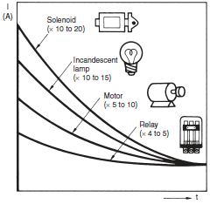
Operating Atmosphere
Do not use switches in atmospheres containing combustible or explosive gases. Arc or heat generated by switching may cause fires or explosions.
Shock on Individual Switches
Do not drop or disassemble switches. Not only will characteristics be jeopardized, but also damage, electric shock, or burning may result.
Durability
The durability of a switch greatly varies with switching conditions. Before using a switch, be sure to test the switch under actual conditions in the actual application and to use the switch within the switching operations causing no problem. If a deteriorated switch is used continuously, insulation failures, contact welding, contact failures, switch damage, or switch burnout may result.

MAINTAINANCE

Rule One: Maintain the switch position
Rule Two: Maintain Switch Style

Rule Three: Label the Switch

Rule Four: Avoid Teaching Fly-swatting

Rule Five: Focus on the POLE

Rule Six: Mount the switch

Rule Seven: POLE should be proximal in space and time

Rule eight: Remove when not in use

Rule Nine: Provide sufficient response time

CONNECTORS

WHAT IS CONNECTOR
An electrical connector is an electro-mechanical device used to join electrical terminations and create an electrical circuit. Electrical connectors consist of plugs (male-ended) and jacks (female-ended). The connection may be temporary, as for portable equipment, require a tool for assembly and removal, or serve as a permanent electrical joint between two wires or devices. An adapter can be used to effectively bring together dissimilar connectors.

INTRODUCTION
Connectors are used to join subsections of circuits together. Usually, a connector is used where it may be desirable to disconnect the subsections at some future time: power inputs, peripheral connections, or boards which may need to be replaced.

Connector Terminology
Before we get started discussing some commonly used connectors, let’s explore the terminology used to describe connectors.
Gender - The gender of a connector refers to whether it plugs in or is plugged into and is typically male or female, respectively (kids, ask your parents for a more thorough explanation). Unfortunately, there are cases where a connector may be referred to as “male” when it would appear to be female; in the examples section, we’ll point a few of those out as we discuss individual component types and explain why that’s the case.
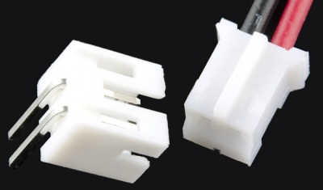
Male (left) and female 2.0mm PH series JST connectors. In this case, gender is determined by the individual conductor.

Polarity - Most connectors can only be connected in one orientation. This trait is called polarity, and connectors which have some means to prevent them being connected wrong are said to be polarized, or sometimes keyed.
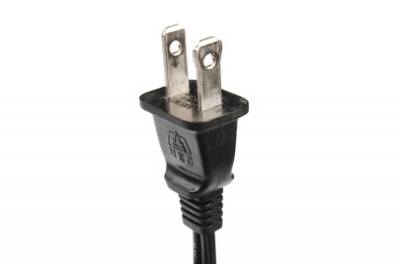
A polarized North American wall plug. By having two different widths for the plug blades, the plug will only go into the outlet one way.
Contact - Contacts are the business portion of the connector. They are the metal parts which touch each other, forming an electrical connection. This is also where problems occur: the contacts can become soiled or oxidized, or the springiness required to hold the contacts together may fade with time.
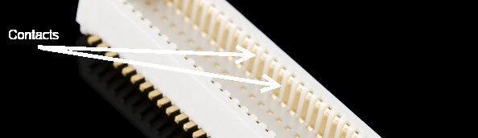
The contacts on this connector are clearly visible.

Pitch - Many connectors consist of an array of contacts in a repeated pattern. The pitch of the connector is the distance from the center of one contact to the center of the next. This is important, because there are many families of contacts which look very similar but may differ in pitch, making it difficult to know that you are purchasing the right mating connector.
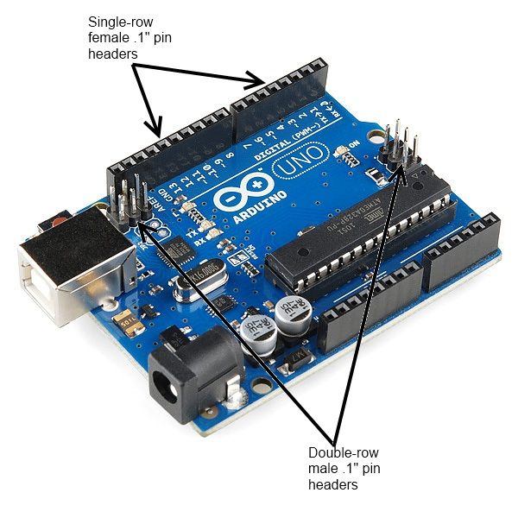
Mating cycles - Connectors have a finite life, and connecting and disconnecting them is what wears them out. Datasheets usually present that information in terms of mating cycles, and it varies widely from one technology to another. A USB connector may have a lifetime in the thousands or tens of thousands of cycles, while a board-to-board connector designed for use inside of consumer electronics may be limited to tens of cycles. It’s important that you select a connector with a suitable life for the application.
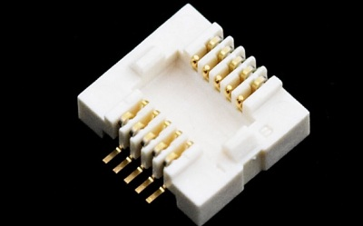
Mating connector for the GS406 GPS module. The connector’s datasheet indicates a maximum of 50 insertion cycles for this part.

Mount - This one has the potential for being confusing. The term “mount” can refer to several things: how the connector is mounted in use (panel mount, free-hanging, board mount), what the angle of the connector is relative to its attachment (straight or right-angle), or how it is mechanically attached (solder tab, surface mount, through hole).
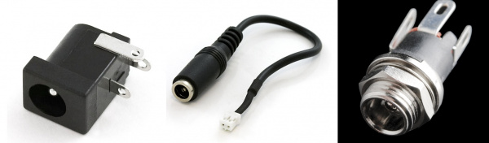
A comparison of three different methods of mounting the same barrel connector: (left to right) board mount, inline cable mount, and panel mount.

USB Connectors
USB connectors come in two flavors: host and peripheral. In the USB standard, there is a difference between the two, and the connectors on cables and devices reflect this. However, all USB connectors will have some things in common:
- Polarization - A USB connector can only nominally be inserted one way. It may be possible to force a connector in wrong, but that will result in damage to the device.
- Four contacts - All USB connectors have at least four contacts (although some may have five, and USB 3.0connectors have even more). These are for power, ground, and two data lines (D+ and D-). USB connectors are designed to transmit 5V, up to 500mA.
- Shielding - USB connectors are shielded, such that a metal shell which is not part of the electrical circuit is provided. This is important to keep the signal intact in environments with a lot of electrical “noise”.
- Robust power connection - It’s important for the power pins to make connection before the data lines, to avoid trying to power the device over the data lines. All USB connectors are designed with this in mind.
- Molded strain relief - All USB cables have plastic overmolding at the connector to prevent strain on the cable that could potentially damage the electrical connections.
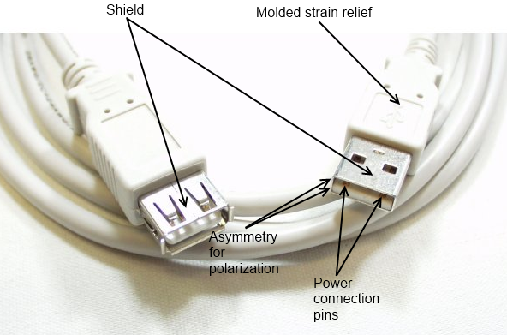
A USB extension cable, with some of the common features of USB connectors labeled.

USB-A Connectors
USB-A female is the standard “host” connector type. This is found on computers, hubs, or any device intended to have peripherals plugged into it. It is also possible to find extension cables with a female A connector and a male A connector on the other end.
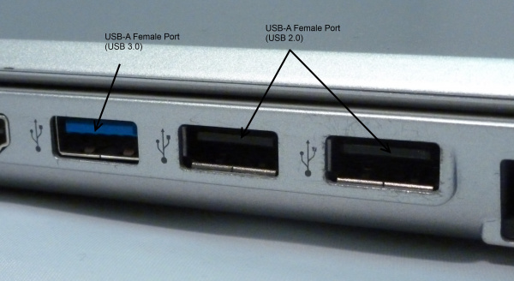
Female USB-A ports on the side of a laptop. The blue connector is USB 3.0 compliant.
USB-A male is the standard “peripheral” connector type. Most USB cables will have one end terminating in a USB-A male connector, and many devices (such as keyboards and mice) will have a built-in cable terminated with a USB-A male connector. It’s also possible to find USB-A male connectors that are board mountable, for devices like USB memory sticks.
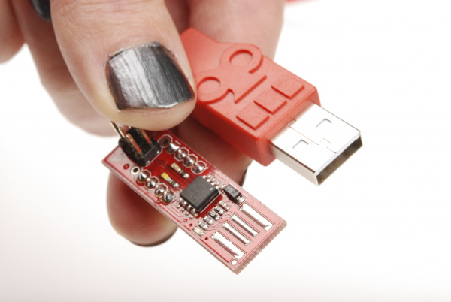

USB-B Connectors
USB-B female is a standard for peripheral devices. It’s bulky, but robust, so in applications where size is not an issue, it’s the preferred means for providing a removable connector for USB connectivity. It is usually a through-hole board mount connector, for maximum reliability, but there are panel-mount options for it as well.
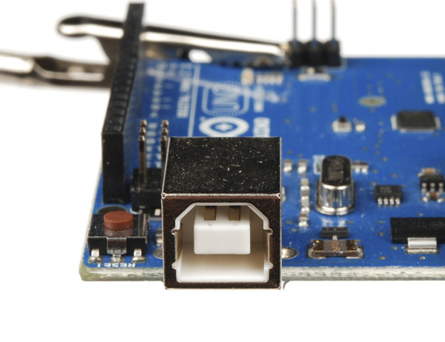
USB-B male is almost exclusively found at the end of a cable. USB-B cables are ubiquitous and inexpensive, which also contributes to the popularity of the USB-B connection.
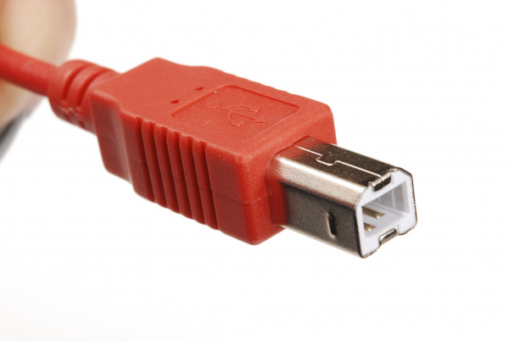

USB-Mini Connectors
The USB-Mini connection was the first standard attempt to reduce the size of the USB connector for smaller devices. USB-Mini female is typically found on smaller peripherals (MP3 players, older cellphones, small external hard drives), and is usually a surface mount connector, trading robustness for size. USB-Mini is slowly being phased out in favor of the USB-Micro connector.
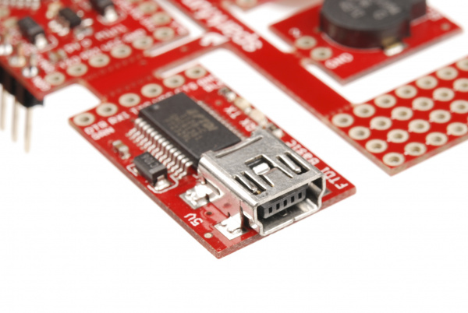
USB-Mini male is another cable-only connector. As with USB-B, it’s extremely common, and cables can be found cheaply almost anywhere.
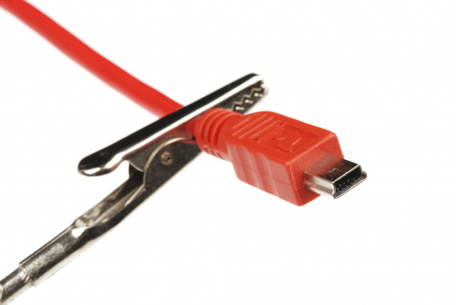

USB-Micro Connectors

USB-Micro is a fairly recent addition to the USB connector family. As with USB-Mini, the primary concern is size reduction, but USB-Micro adds a fifth pin for low-speed signalling, allowing it to be used in USB-OTG (On-the-go) applications where a device may want to operate as either a host or a peripheral depending on circumstances.
USB-Micro female is found on many newer peripherals, such as digital cameras and MP3 players. The adoption of USB-micro as a standard charge port for all new cellular phones and tablet computers means that chargers and data cables are becoming increasingly common, and USB-Micro is likely to supplant USB-Mini in the coming years as the small-factor USB connector of choice.
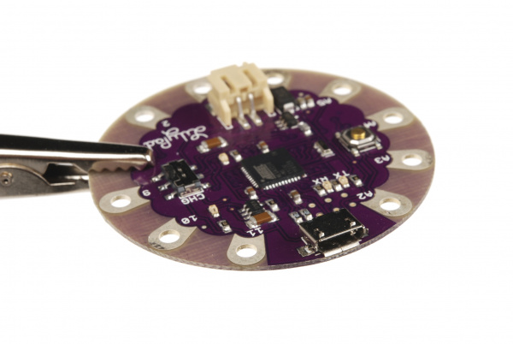
USB-Micro male is also a cable-only connector. There are generally two types of cables with USB-Micro male ends: one for connecting a device with a USB-Micro port as a peripheral to a USB host device and one for adapting the USB-Micro female port to a USB-A female port, to be used in USB-OTG capable devices.
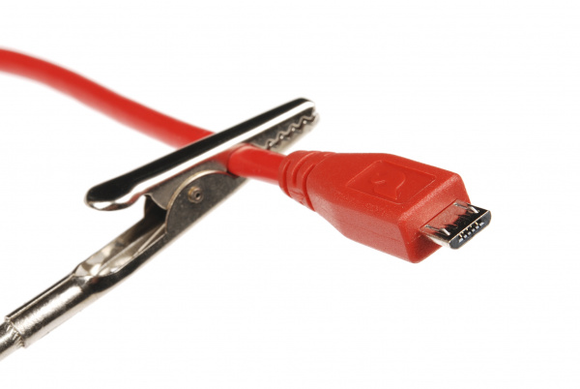
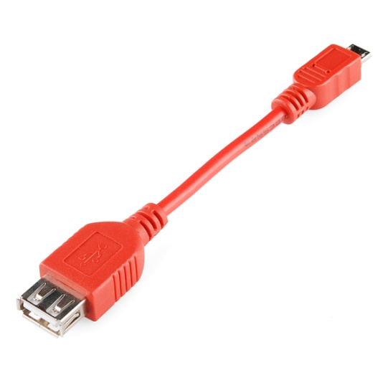
USB-OTG

Audio Connectors
Another familiar connector group are those used for audio-visual applications–RCA and phono. While these can’t truly be considered to be of the same family, as the various USB connectors are, we’ll consider both of them to be in the same vein.

“Phone” Type Connectors
You’ll probably immediately recognize the 1/8" version of this connector as a the plug on the end of a pair of headphones. These connectors actually come in three common sizes: ¼" (6.35mm), 1/8" (3.5mm), and 2.5mm. ¼" size connectors find a lot of use in the professional audio and music community- most electric guitars and amplifiers have ¼" tip-sleeve (TS) jacks on them. 1/8" tip-ring-sleeve (TRS) is very common as the connector for headphones or audio output signals on MP3 players or computers. Some cell phones will provide a 2.5mm tip-ring-ring-sleeve (TRRS) jack for connecting to headphones that also include a microphone for hands-free communications.
The common availability of these connectors and cables makes them a good candidate for general purpose connectivity applications–for instance, long before USB, Texas Instruments graphing calculators used a 2.5mm TRS connector for a serial programming connector. It should be remembered that tip-sleeve connector types are not designed for carrying power; during insertion, the tip and the sleeve can be momentarily shorted together, which may damage the power supply. The lack of shielding makes them poor candidates for high-speed data, but low speed serial data can be passed through these connectors.
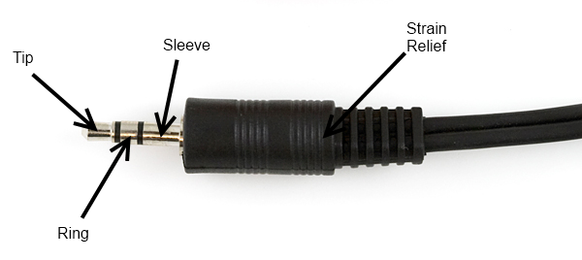
Headphone-type TRS phone plug, 1/8". Typically, tip and ring will carry the stereo audio signals while sleeve will be connected to ground.
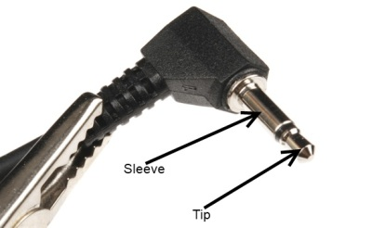
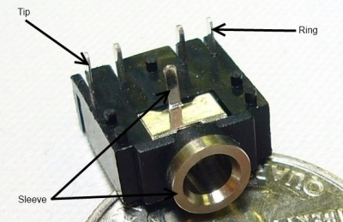

RCA Connectors
Familiar as the home-stereo connector of choice for many decades, the RCA connector was introduced in the 1940s by RCA for home phonographs. It is slowly being supplanted by connections like HDMI in the audio-visual realm, but the ubiquity of the connectors and cables makes it a good candidate for home-built systems. It will be a long time before it is obsolete.
Female RCA connectors are usually found on devices, although it is possible to find extension or conversion cables with female jacks on them. Most RCA connectors are connected to one of four types of signals: component video (PAL or NTSC, depending on where the equipment was sold), composite video, stereo audio, or S/PDIF audio.
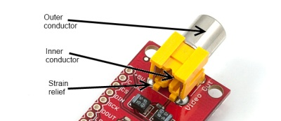
Female RCA connector, for video signals. Typically, NTSC or PAL video signal connectors will be yellow.
Male RCA connectors are usually found on cables.
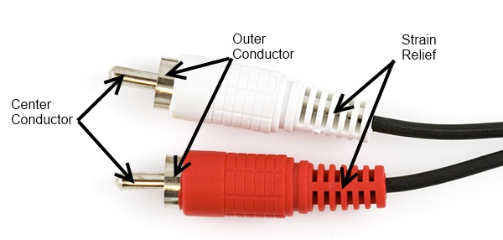
Male RCA plugs. Red and white are usually for audio applications, with red denoting the “right” audio channel.

Power Connectors
While many connectors carry power in addition to data, some connectors are used specifically to provide power connections to devices. These vary widely by application and size, but we will only focus on some of the most common ones here.

Barrel Connectors
Barrel connectors are typically found on low-cost consumer electronics which can be plugged into wall power via bulky AC wall adaptors. Wall adaptors are widely available, in a variety of power ratings and voltages, making barrel connectors a common means for connecting power to small projects.
The female barrel connector, or “jack”, can be purchased in several varieties: PCB mounted (surface mount or through hole), cable mount, or panel mount. Some of these connectors will have an additional contact that allows the application to detect whether a power supply is plugged into the barrel jack or not, thus allowing the device to bypass batteries and save battery life when running on external power.
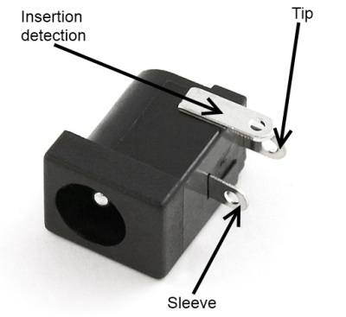
Female barrel connector. When no plug is inserted, the “insertion detection” pin will be shorted to the “sleeve” pin.
The male barrel connector, or “plug”, is usually only found in a wire termination variety, although there are multiple methods of attaching the plug to the end of the wire. It’s also possible to get plugs that come pre-attached to a cable.
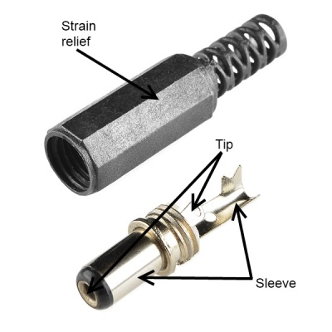
Unattached male barrel plug, for attachment to any power supply. Note that the sleeve connection is designed to be crimped onto the wire for extra strain relief.
Barrel connectors provide only two connections, frequently referred to as “pin” or “tip” and “sleeve”. When ordering, there are three differentiating characteristics of a barrel connection- inner diameter (the diameter of the pin inside the jack), outer diameter (the diameter of the sleeve on the outside of the plug), and polarity (whether the sleeve voltage is higher or lower than the tip voltage).
Sleeve diameter is most commonly either 5.5mm or 3.5mm.
Pin diameter is contingent upon sleeve diameter; a 5.5mm sleeve will have either a 2.5mm or 2.1mm pin. Unfortunately, this means that a plug designed for a 2.5mm pin will fit in a 2.1mm jack, but that the connection will be, at best, intermittent. 3.5mm sleeve plugs usually mate to a jack with a 1.3mm pin.
Polarity is the final aspect to consider; most often, the sleeve will be considered 0V and the tip will be a positive voltage relative to the sleeve. Many devices will have a small diagram indicating the polarity expected by the device; care should be taken to adhere to this, as an improper power supply may damage the device.
Plugs of both sleeve sizes are usually 9.5mm long, but longer and shorter ones do exist. All SparkFun products use a positive polarity 5.5mm sleeve and a 2.1mm pin; we recommend sticking to that standard where possible, as it seems to be the most common flavor found in the wild.
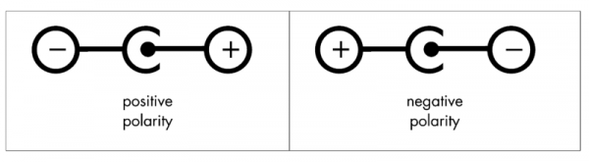
Common polarity diagrams for AC adaptors with barrel plugs. Positive polarity (tip positive, sleeve 0V) is most common. Diagram courtesy Wikipedia user Three-quarter-ten.

“

IEC Connector
IEC connector usually refers to the power supply inlet which is commonly seen on desktop PC power supplies. Strictly speaking, that’s an IEC 60320-1 C13 (female) and C14 (male) connector.
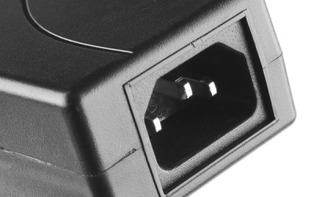
C14 male IEC power inlet, on a DC project power supply. Note that, as with the Molex connector, the gender of the connector is defined by the pins within the hood.
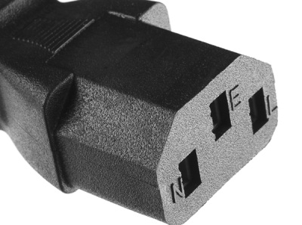
C13 female IEC power connector, on a fairly standard AC power supply cable. Cables with this end can be found all around the world, usually with the dominant local AC connector at the other end.
IEC connectors are used almost exclusively for AC power input. The nice thing about using one on a project is that IEC-to-wall cables are extremely common and available with localized wall plugs for most international locations!

Pin Header Connectors
Pin header connectors comprise several different means of connection. Generally, one side is a series of pins which are soldered to a PCB, and they can either be at a right-angle to the PCB surface (usually called “straight”) or parallel to the board’s surface (confusingly referred to as “right-angle” pins). Such connectors come in a variety of pitches, and may have any number of individual rows of pins.

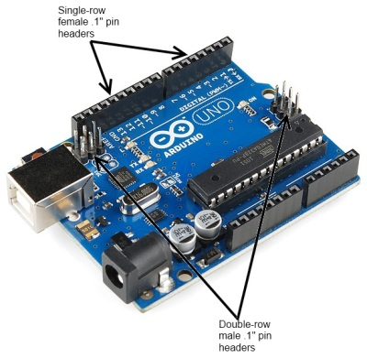
.1" pin header connectors, male and female, on an Arduino Uno board.
A common variation on this part is a “machine pin” version. While the normal version is formed out of stamped and folded sheet metal, machine pin connectors are formed by tooling the metal into the desired shape. The result is a more robust connector, with a better joint and longer life, making it somewhat more expensive.
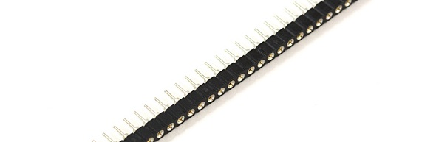
Female machine pin headers. Note that these are designed to be snapped apart into smaller sections, while standard .1" female header pin connectors are not. It’s also important to note that not all non-machine pin header connectors will mate with the machine pin variety.
Cables made to connect to these pin headers are usually one of two types: individual wires with crimp connectors on them or ribbon cables with insulation displacement connectors. These can simply be clamped onto the end of a ribbon cable, which creates a connection to each one of the conductors in the ribbon cable. Generally, cables are only available as female gender and expect a male pin to mate with.
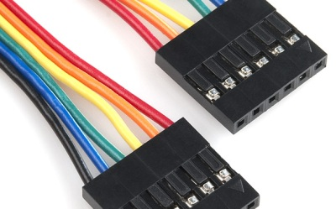
Six-position crimp-type cable. Each wire is individually stripped, a connector crimped to it, and then the connectors are inserted into the plastic frame.
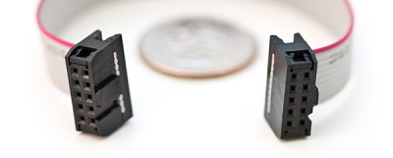
2x5 insulation displacement connectors (IDC) on a ribbon cable. This type of cable can be quickly assembled because it does not require stripping of individual connectors. It also has polarizing tabs on each end, to prevent incorrect insertion in the mating board-side connector.

Temporary connectors

Screw Terminals
In some cases, it may be desirable to be able to connect bare, unterminated wire to a circuit. Screw terminals provide a good solution for this. They are also good for situations in which a connection should be capable of supporting multiple different connecting devices.
The downside of screw terminals is that they can come undone fairly easily, leaving a bare wire waving around in your circuit. A small dab of hot glue can address this without being too difficult to remove later.
Screw terminals are typically designed for a narrow range of wire gauges, and wires that are too small can be as big a problem as wires that are too big. SparkFun carries two types of screw terminal–a .1" pitch version and a 3.5mm version. Most screw terminals are highly modular, and they can easily be extended at the same pitch by simply connecting two or more smaller sections together.
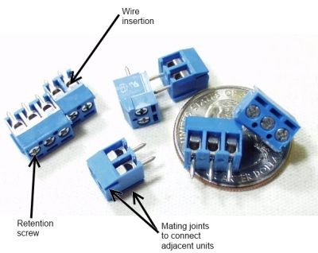
-> 3.5mm pitch screw terminals, showing the insertion point of the wire to be connected, the retention screw which holds the wire in place, and the modular connectors on the sides of the individual units allowing multiple pieces to be ganged together. <-

Banana Connector
Most pieces of power test equipment (multimeters, power supplies) have a very simple connector called a “banana jack” on it. These mate to “banana plugs”, crimped, sprung metal plugs, meant to make a single power connection. They are frequently available in a stackable configuration and can be easily connected to any type of wire. They are capable of carrying several amps of current and are inexpensive.
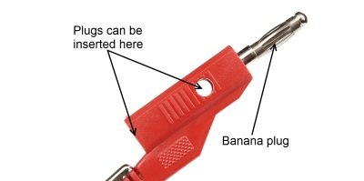
Stackable banana plug. Note that there are two different ways to plug in an additional banana plug.
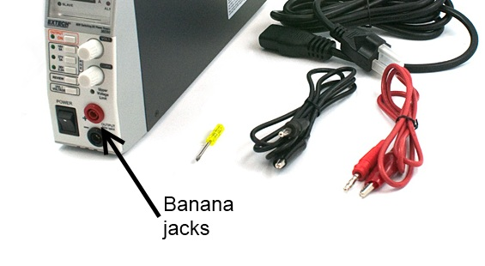
Extech variable bench supply with banana jacks on the front.

Alligator Clip
Named for obvious reasons, alligator clips are good for test connections to posts or bare wires. They tend to be bulky, easily cause shorts to nearby bare metal, and have a reasonably poor grip that can be easily compromised. They are primarily used for low-cost connections during debugging.
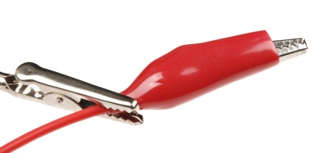
A “third hand” tool, which uses alligator clips to hold work pieces, holding a wire terminated with an alligator clip for electrical test. Note the plastic boot surrounding the alligator clip, to make it less likely to short to other connections.

IC Clip (or IC Hook)
For more delicate probing operations, there are a variety of IC clips on the market. These are sized to allow a user to clip them onto the pins of an IC without contacting adjacent pins; some of them are delicate enough to be clipped onto even fine-pitched SMD component legs. These smaller clips can be found on logic analyzers as well as test leads, which are great for prototyping or troubleshooting circuits.
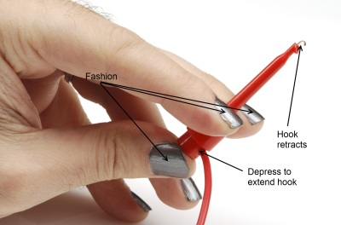
A large IC clip on the end of a wire. This clip is still small enough to be connected to a single leg on a through-hole chip without causing a problem for adjacent pins.

Other Connectors

RJ-type Modular Connectors
Registered jack connectors are standard for telecommunications equipment into a local exchange. The names one normally hears associated with them (RJ45, RJ12, etc) are not necessarily correct, as the RJ designator is a based on a combination of the number of positions, the number of conductors actually present, and the wiring pattern. For example, while the ends of a standard ethernet cable are usually referred to as “RJ45”, RJ45 actually implies not only an 8 position, 8 conductor modular jack, it also implies that it is wired for ethernet.
These modular connectors can be very useful, since they combine ready availability, multiple conductors, moderate flexibility, low cost, and moderate current carrying capacity. While not originally intended to deliver a great deal of power, these cables can be used to deliver data and a couple of hundred milliamps from one device to another. Care should be taken to ensure that jacks provided for applications like this are not connected to conventional ethernet ports, as damage will result.
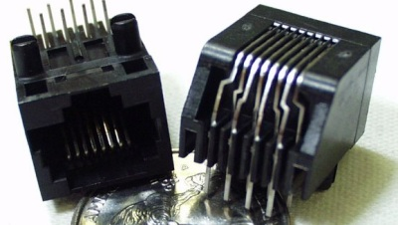
A standard 8p8c (8-position, 8-conductor) “RJ45” modular jack. Be aware that if you intend to use this type of jack to pass DC signals and power, you must avoid using connectors with built-in signal transformers.

D-sub Type Connectors
Named for the shape of their shell, D-subminiature connectors are a classic standard in the computing world. There are four very common varieties of this connector: DA-15, DB-25, DE-15, and DE-9. The pin number indicates the number of connections provided, and the letter combination indicates the size of the shell. Thus, DE-15 and DE-9 have the same shell size, but a different number of connections.
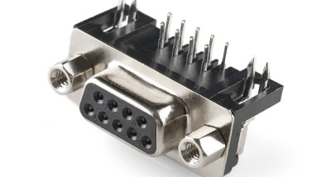
Female DE-9 board-mount connector. Gender is defined by the pins or sockets associated with each signal, not the connector as a whole, making this connector female despite the fact that it effectively inserts into the shell of the mating connector.
DB-25 and DE-9 are the most useful to the hardware hacker; many desktop computers still include at least one DE-9 serial port, and often one DB-25 parallel port. Cables terminated with DE-9 and DB-25 connectors are widely available, too. As with the modular connector above, these can be used to provide power and point-to-point communications between two devices. Again, since the common usage of these cables does not include power transmission, it is very important that any repurposing of the cables be done cautiously, as a non-standard device plugged into a standard port can easily cause damage.

STEP-UP AND STEP-DOWN CONVERTORS

Non-Isolated Converters
Non-isolated converters are used when the change in the voltage is small. The input and output terminals share a common ground in this circuit. The following are the different types of converters in this group.
The disadvantage is cannot give protection from high electrical voltages and has more noise.

Step-Down (Buck) Converter
A step-down circuit is used to generate a lower voltage than the input. It is also called as a buck. The polarities are same as in the input.
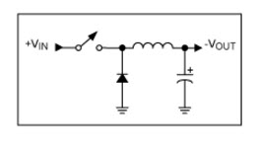

WORKING
A Buck converter steps down a DC voltage from the input to the output. The circuit operation depends on the conduction state of the MOSFET:

Step-Up (Boost) Converter
A step-up circuit is used to generate a higher voltage than the input voltage. It is called as a boost. The polarities are same as in the input.
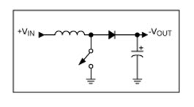
WORKING
A Boost converter steps up a DC voltage from the input to the output. The circuit operation depends on the conduction state of the MOSFET(the switch can be Mosfet ,BJT, or any other type of switch):

Buck-Boost Converter
In Buck-Boost Converter, the output voltage can be increased or decreased than the input voltage. It works to either boosting or bucking the voltage. The common usage of this converter is to reverse the polarity.

Cuk: This type of converter is similar to the Buck-Boost converter. The difference is its name, named after Slobodan Cuk, the man who created it.

Charge Pump: This converter is used to step the voltage up or down in applications that have low power.

Flyback converter
This converter works similar to the buck-boost converter of the non-isolating category. The difference is it uses a transformer to store the energy instead of an inductor.
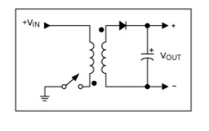

Forward Converter
This converter will use the transformer to send the energy, between the input and output in a single step.

Advantages of DC Converter
- Battery space can be reduced by reducing or increasing the available input voltage.
- A device can be driven by bucking or boosting the available voltage. Thus preventing the damage of the device or breakdown.

PBL CIRCUIT IN PCB

My PBL Project was “SMART GARDEN”

COMPONENETS
RPI
DHT-11
SOIL MOISTURE SENSOR
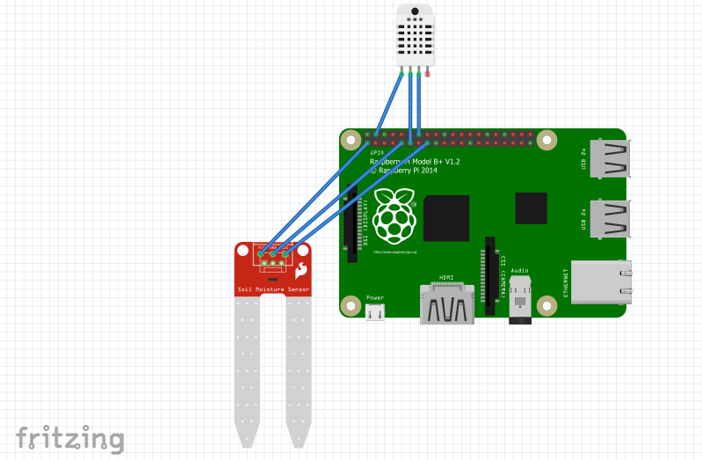
PCB
