

VACATION TASKS

SET-1

Analog to Digital Converters

-

Tanush Biju

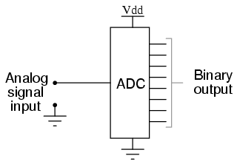
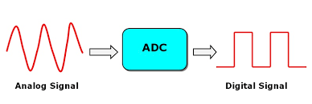
Analog-to-digital converter

In electronics, an analog-to-digital converter (ADC, A/D, or A-to-D) is a system that converts an analog signal, such as a sound picked up by a microphone or light entering a digital camera, into a digital signal.

An ADC may also provide an isolated measurement such as an electronic device that converts an input analog voltage or current to a digital number representing the magnitude of the voltage or current.

Explanation

An ADC converts a continuous-time and continuous-amplitude analog signal to a discrete-time and discrete-amplitude digital signal.

The conversion involves quantization of the input, so it necessarily introduces a small amount of error or noise. Furthermore, instead of continuously performing the conversion, an ADC does the conversion periodically, sampling the input, limiting the allowable bandwidth of the input signal.

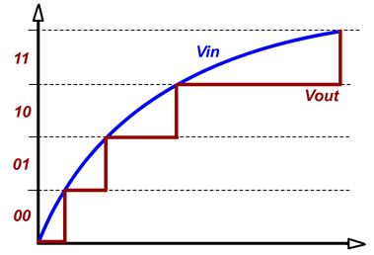
One of the major benefits of ADC converter is high data acquisition rate even at multiplexed inputs. With the invention of a wide variety of ADC integrated circuits (IC’s), data acquisition from various sensors becomes more accurate and faster. Dynamic characteristics of the high performance ADC’s are improved measurement repeatability, low power consumption, precise throughput, high linearity, excellent Signal-to-Noise Ratio (SNR) and so on.

A variety of applications of the ADC’s are measurement and control systems, industrial instrumentation, communication systems and all other sensory based systems. Classification of ADC’s based on factors like performance, bit rates, power, cost, etc.

Importance

Almost every environmental measurable parameter is in analog form like temperature, sound, pressure, light, etc.

Consider a temperature monitoring system wherein acquiring, analyzing and processing temperature data from sensors is not possible with digital computers and processors.

Therefore, this system needs an intermediate device to convert the analog temperature data into digital data in order to communicate with the digital processors like micro-controllers and microprocessors.

Analog to Digital Converter (ADC) is an electronic integrated circuit used to convert the analog signals such as voltages to digital or binary form consisting of 1s and 0s. Most of the ADC’s take a voltage input as 0 to 10V, -5V to +5V, etc. and correspondingly produces digital output as some sort of a binary number.

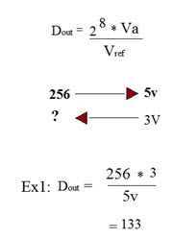
Analog to Digital Conversion Process

Analog to Digital Converter samples the analog signal on each falling or rising edge of sample clock. In each cycle, the ADC gets of the analog signal, measures and converts it into a digital value. The ADC converts the output data into a series of digital values by approximates the signal with fixed precision.

In ADC’s, two factors determine the accuracy of the digital value that captures the original analog signal. These are quantization level or bit rate and sampling rate. Below figure depicts how analog to digital conversion takes place. Bit rate decides decides the resolution of of digitized output and you can observe in below figure where 3-bit ADC is used for converting analog signal.

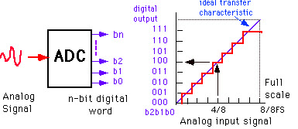

Assume that one volt signal has to be converted from digital by using 3-bit ADC as shown below. Therefore, a total of 2^3=8 divisions are available for producing 1V output. This results 1/8=0.125V is called as minimum change or quantization level represented for each division as 000 for 0V, 001 for 0.125, and likewise up to 111 for 1V. If we increase the bit rates like 6, 8, 12, 14, 16, etc. we will get a better precision of the signal. Thus, bit rate or quantization gives the smallest output change in the analog signal value that results from a change in the digital representation.

Suppose if the signal is about 0-5V and we have used 8-bit ADC then binary output of 5V is 256. And for 3V it is 133 as shown below.

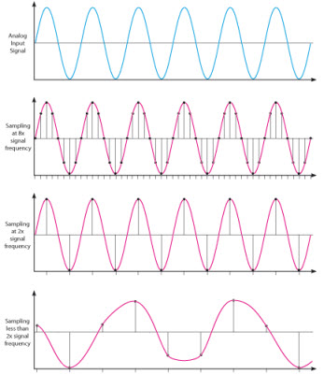
here is an absolute chance of misrepresenting the input signal at output side if it is sampled at different frequency than desired one. Therefore, another important consideration of the ADC is the sampling rate. Niquest theorem states that the acquired signal reconstruction introduces distortion unless it is sampled at (minimum) twice the rate of the largest frequency content of the signal as you can observe in the diagram. But this rate is 5-10 times the maximum frequency of the signal in practical.

Types of Analog to Digital Converters

Some of the types of analog to digital converters include:

- Dual Slope A/D Converter
- Flash A/D Converter
- Successive Approximation A/D Converter

Dual Slope A/D Converter

In this type of ADC converter comparison voltage is generated by using an integrator circuit which is formed by a resistor, capacitor and operational amplifier combination. By the set value of Vref, this integrator generates a saw-tooth waveform on its output from zero to the value Vref.

When the integrator waveform is started correspondingly counter starts counting from 0 to 2^n-1 where n is the number of bits of ADC. When the input voltage Vin equal to the voltage of the waveform, then control circuit captures the counter value which is the digital value of corresponding analog input value. This Dual slope ADC is relatively medium cost and slow speed device.
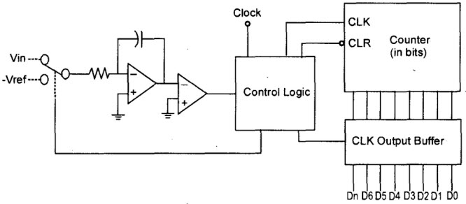

Flash A/D Converter

This ADC converter IC is also called as parallel ADC, which is a most widely used efficient ADC in terms of its speed. This flash analog to digital converter circuit consists of a series of comparators where each one compares the input signal with a unique reference voltage.

At each comparator, the output will be high state when the analog input voltage exceeds the reference voltage. This output is further given to priority encoder for generating binary code based on higher order input activity by ignoring other active inputs. This flash type is a high-cost and high-speed device.

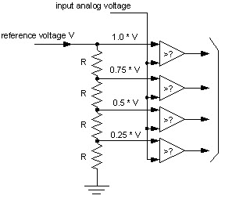

Successive Approximation A/D Converter

The SAR ADC a most modern ADC IC and much faster than dual slope and flash ADC’s since it uses a digital logic that converges the analog input voltage to the closest value. This circuit consists of a comparator, output latches, successive approximation register (SAR) and D/A converter.

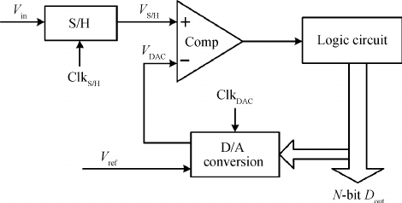

At the start, SAR is reset and as the LOW to HIGH transition is introduced, the MSB of the SAR is set. Then this output is given to the D/A converter that produces an analog equivalent of the MSB, further it is compared with the analog input Vin.

If comparator output is LOW, then MSB will be cleared by the SAR, otherwise the MSB will be set to the next position. This process continues till all the bits are tried and after Q0, the SAR makes the parallel output lines to contain valid data.

