"Forecasting Cybercrime Trends in Pakistan: A Data-Driven Approach"

Abstract
Cybercrime has become one of the most critical digital threats in Pakistan, affecting individuals, businesses, and government institutions through financial fraud, hacking, online harassment, identity theft, and other malicious activities. As technology advances and internet use expands, cybercrime incidents continue to rise, yet proactive forecasting systems remain limited. This study aims to predict cybercrime trends in Pakistan by applying time-series forecasting techniques using the econometric software GRETL, which can help strengthen cybersecurity planning and policy development. Historical cybercrime data from 2018–2021 were analyzed, and forecasts were generated for selected categories up to 2027. Results show that financial fraud remains the most dominant and consistently increasing cybercrime, while cases such as hacking, harassment, fake profiles, and spamming display fluctuating or declining patterns influenced by technological, social, and enforcement-related factors. The forecasting models effectively captured historical movements and provided valuable projections that may assist government agencies, cybersecurity institutions, and policymakers in enhancing preventive strategies, improving resource allocation, and promoting a more secure digital environment for the country.

Introduction
Cybercrime refers to illegal activities conducted through computers, digital networks, or internet-connected devices, typically involving unauthorized access, data breaches, financial scams, identity theft, and cyber harassment. As societies increasingly adopt digital technologies for communication, commerce, governance, and financial transactions, cybercrime has expanded in scale and sophistication. Recent studies describe cybercrime as a rapidly evolving global threat that exploits both technological vulnerabilities and human behavior (Raza & Khan, 2021; Saleem et al., 2022).
In Pakistan, cybercrime has grown significantly over the past several years, driven by increased internet usage, widespread adoption of mobile banking, and heavy reliance on social media. Research indicates substantial surges in cases involving online financial fraud, hacking, identity-based offenses, and social-media exploitation (Ayub & Zubair, 2023; Khan & Ullah, 2021). Despite legislative measures such as the Prevention of Electronic Crimes Act (PECA), the country continues to face several challenges. These include limited forensic capacity, slow investigative procedures, outdated technological systems, low digital literacy among the public, and persistent under-reporting of incidents due to social stigma or lack of awareness (Akhtar et al., 2020; Javed & Arshad, 2022). Furthermore, the complexity and anonymity associated with modern cyberattacks make attribution and prosecution even more difficult.
These conditions highlight a critical research problem: cybercrime cases in Pakistan continue to rise, yet institutions often respond reactively rather than proactively due to the absence of systematic forecasting tools or data-driven early-warning mechanisms. Given the increasing volume and changing nature of cybercrime as observed in the dataset covering 2018–2021, there is a pressing need to analyze historical patterns and develop predictive models that can anticipate future trends.
Forecasting cybercrime is essential because it enables law-enforcement agencies, policymakers, and cybersecurity institutions to allocate resources effectively, strengthen preventive strategies, and prepare for potential increases in specific crime categories. Predictive insights can also guide awareness programs, improve national cybersecurity planning, and support more timely institutional responses.
The scope of this study focuses on analyzing Pakistan’s cybercrime data, identifying major categories of offenses, examining temporal patterns, and developing models capable of forecasting future crime trends. The goal is to create a data-driven foundation that can help stakeholders anticipate emerging threats and prioritize interventions accordingly.
The significance of this research lies in its potential to enhance Pakistan’s cybersecurity ecosystem. By using forecasting to transition from reactive to proactive approaches, the study contributes to improved policy formulation, more efficient investigative processes, and stronger public protection. It also adds to academic literature by demonstrating how data analytics and predictive modeling can be applied to cybersecurity challenges in developing countries.

Review of Related Literature
Cybercrime has increasingly become a global threat as expanding digital platforms enable new forms of fraud, harassment, identity theft, and unauthorized access. Studies show that cybercrime grows alongside technological advancement, exploiting both system vulnerabilities and user behavior (Raza & Khan, 2021; Saleem et al., 2022). In Pakistan, incidents have risen consistently as seen in the 2018–2021 dataset, particularly in financial fraud, hacking, and online harassment. Scholars note that Pakistani citizens face heightened risks due to widespread social-media use and limited cybersecurity awareness (Ayub & Zubair, 2023). Evidence also highlights the persistence of phishing attacks and the need for stronger network-level defenses such as IDS/IPS and authentication protocols (Adil et al., 2020). Despite legislation like the Prevention of Electronic Crimes Act (PECA), challenges in enforcement, investigation, underreporting, and prosecution continue to weaken effective cybercrime response (Javed & Arshad, 2022).
Because cybercrime evolves rapidly, recent studies emphasize the need for predictive and data-driven approaches to anticipate emerging threats. Forecasting models are found to be valuable in identifying future trends, strengthening early-warning systems, and helping law-enforcement agencies allocate resources effectively (Malik & Farooq, 2021). Machine-learning-based prevention strategies also show promise but remain limited by fragmented systems and the lack of integrated analytics (Chinedu et al., 2021). Given the scarcity of empirical research using multi-year datasets in Pakistan, the 2018–2021 cybercrime dataset becomes a crucial resource for conducting trend analysis and forecasting across multiple crime categories. By examining these patterns, the present study aligns with literature calling for proactive detection mechanisms and contributes insights that can support policy development, institutional preparedness, and improved digital-safety measures in Pakistan.

Methodology
This study adopts a quantitative research approach to analyze and forecast cybercrime trends in Pakistan. The research begins with data collection, where cybercrime records are gathered from verified sources such as national cybercrime reporting agencies and official digital crime portals. The dataset includes multiple categories of cybercrime, such as hacking, online fraud, harassment, and identity-related offenses, ensuring that the analysis captures the diversity of cyber threats. Before analysis, the data is carefully cleaned and organized, including removing duplicate entries, correcting inconsistencies, and standardizing crime categories to make it suitable for time-series forecasting in GRETL.
After data preparation, the study applies time-series forecasting techniques using the GRETL software to identify trends and predict future cybercrime occurrences. GRETL is used to build statistical models that capture historical patterns and generate forecasts for different categories of cybercrime. The forecasts are then visually presented through graphs and trend charts to illustrate patterns and expected movements over time. Finally, the results are interpreted to provide insights into the evolving cybercrime landscape and offer practical recommendations for policymakers, law enforcement agencies, and digital safety initiatives. This methodology ensures that the research produces clear, evidence-based insights to support proactive measures against cybercrime in Pakistan.

Results and Discussion
The Gretl software was used to analyze and forecast trends in cybercrime incidents in Pakistan across multiple offense categories using time-series forecasting models. Historical data from 2018–2021 served as the basis for model estimation, while projected values for 2022–2027 were generated for each cybercrime type. The forecasts provide insights into how cyber threats may evolve in the coming years and support proactive planning for cybersecurity agencies, as presented in the corresponding figures for each category.
Due to variations in the quantity and stability of the available data, not all cybercrime categories produced strong model fits. Categories with highly fluctuating or limited observations, such as pornography, identity theft, and stalking, generated wide confidence intervals, indicating lower predictive precision. In contrast, higher-frequency categories such as financial fraud, hacking, harassment, and defamation yielded more stable model estimates, although uncertainty still increased with longer forecast horizons. Similar to other GRETL-based forecasting studies, dataset limitations affected model reliability, and crime categories with very small annual counts produced forecasts with reduced accuracy.

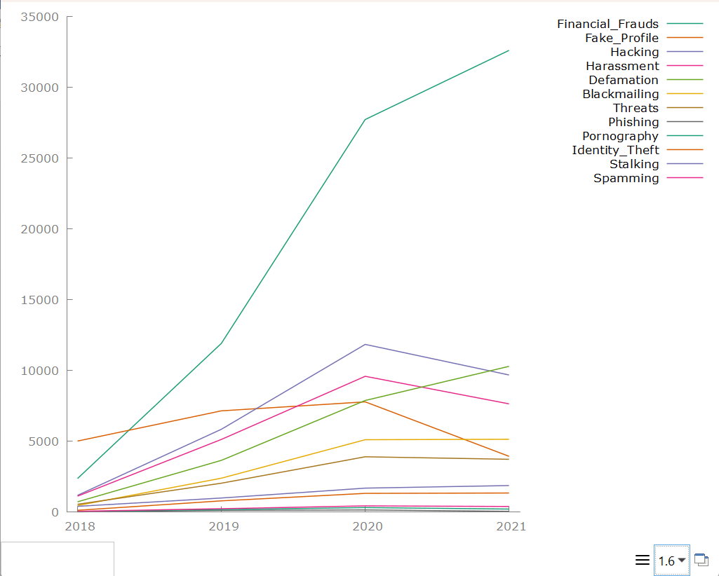

FIGURE 1: TIME SERIES GRAPH OF ALL THE CATEGORIES
The figure shows trends for various cybercrime categories from 2018 to 2021. Financial Frauds dominate throughout the period, showing a steep increase from 2018 and peaking in 2021, making it the most prevalent cybercrime. Hacking rises steadily from 2018 to a peak in 2020 before slightly declining in 2021. Harassment follows a similar pattern, increasing consistently until 2020 and then decreasing slightly in the final year. Defamation shows a continuous upward trend across all years, indicating a steady increase in cases. Fake Profile cases increased from 2018 to 2020 but dropped noticeably in 2021. Phishing and Threats both show gradual increases over time, with slight leveling toward 2021. Blackmailing, Identity Theft, and Stalking remain relatively low but show moderate upward trends. Pornography records minimal growth and stays among the least reported categories, while Spamming increases until 2020 and slightly declines afterward. Overall, Financial Frauds clearly represent the most significant threat, while other categories remain lower but show rising trends over the years.

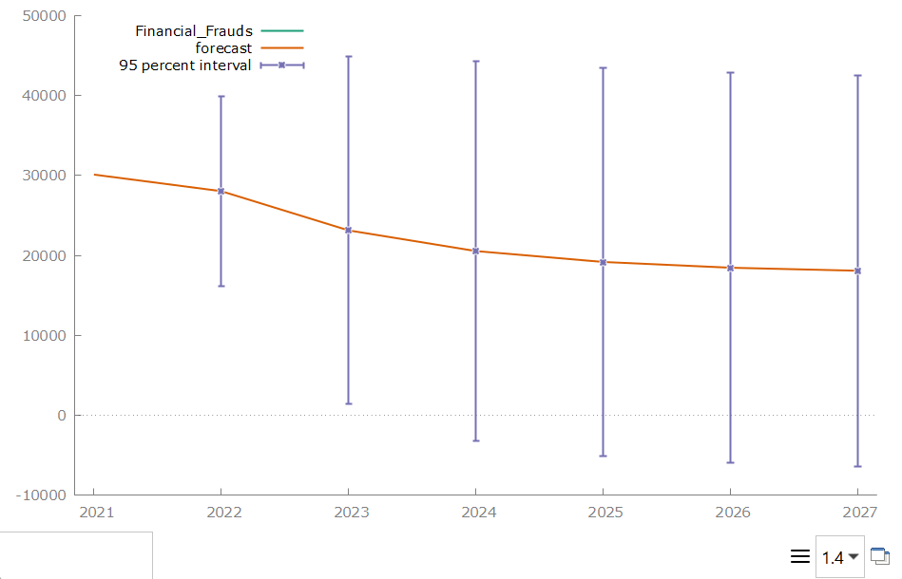
Forecasted

FIGURE 2: FINANCIAL FRAUD
The forecast shows a gradual decline in the number of financial fraud cases from 2021 through 2027. Although the central forecast trend decreases steadily, the wide 95% confidence intervals indicate substantial uncertainty around the predictions, meaning actual values could vary considerably. Overall, the model suggests improvement, but with high variability in potential outcomes.

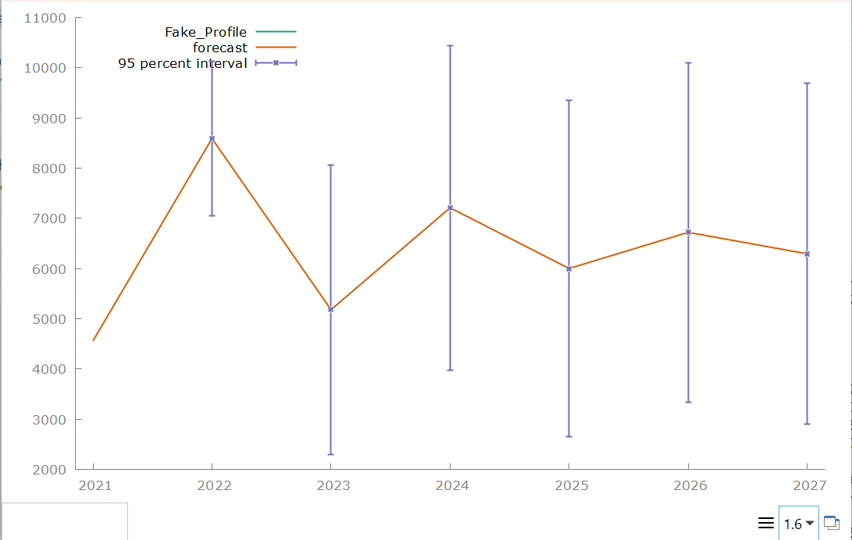

FIGURE 3: FAKE PROFILE
The forecast shows that fake-profile activity is expected to increase sharply from 2021 to 2022, then decrease in 2023, followed by another increase in 2024 and smaller fluctuations afterward. However, despite these forecasted rises and falls, the very wide confidence intervals indicate high uncertainty, meaning actual values could vary greatly from the predicted increases or decreases.
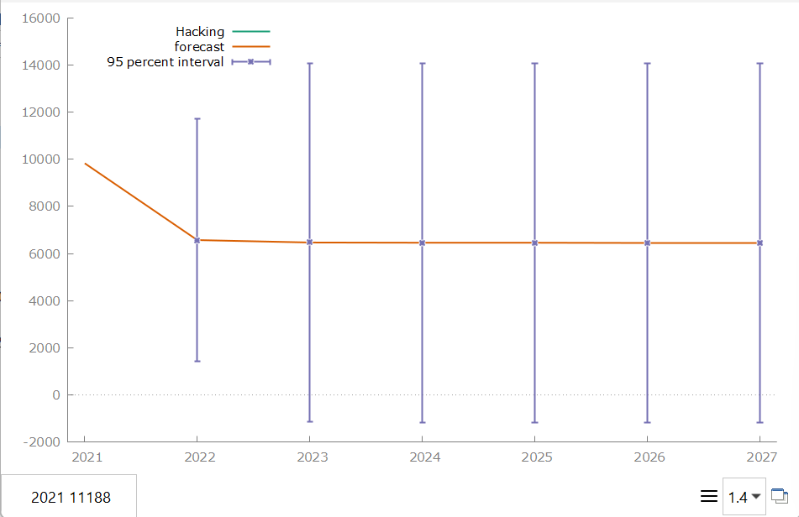

FIGURE 4: HACKING
The forecast shows a clear decrease in hacking incidents from 2021 to 2022, after which the values remain relatively stable through 2027. Although the forecast suggests little change beyond 2022, the extremely wide confidence intervals indicate high uncertainty, meaning actual hacking incidents could end up much higher or lower than the projected trend.
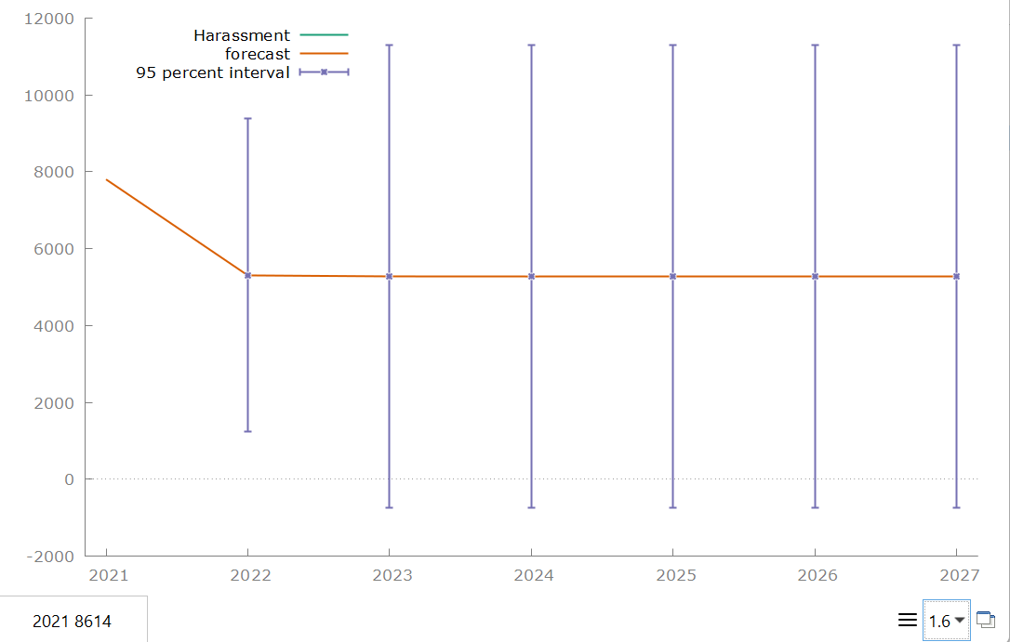

FIGURE 5: HARASSMENT
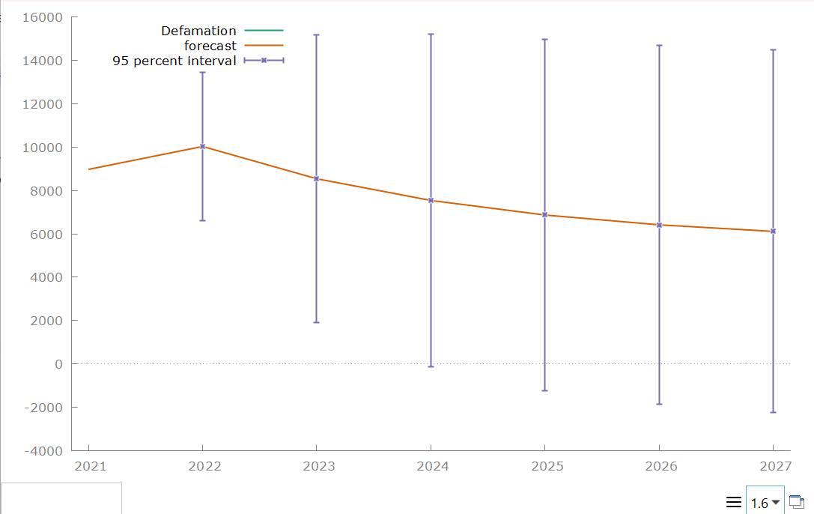
The figure shows reported harassment cases dropping sharply from 2021 to 2022, then leveling off with relatively stable forecasts through 2027. However, the very wide 95% confidence intervals indicate high uncertainty, meaning actual future values could vary substantially from the forecast line. Overall, the model predicts stability but with low confidence in precise numbers.

FIGURE 6: DEFAMATION

The forecast suggests defamation cases may gradually decline from 2022 through 2027, moving from around 10,000 to just above 6,000. However, the extremely wide 95% confidence intervals indicate substantial uncertainty, meaning actual values could be much higher or lower than the trend line. Overall, the model indicates a downward tendency but with low precision in its estimates.
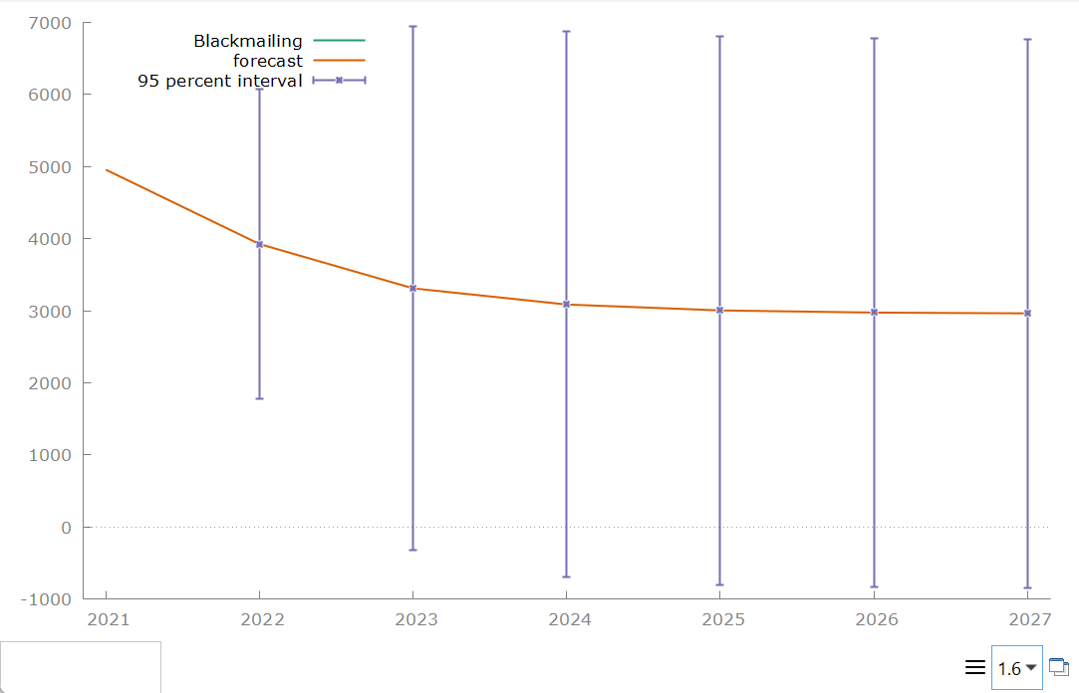

FIGURE 7: BLACKMAILING
The forecast indicates that blackmailing cases are expected to gradually decline from about 5,000 in 2021 to around 3,000 by 2027. Still, the very broad 95% confidence intervals show substantial uncertainty, meaning the true values could differ widely from the forecast line. Overall, the model suggests a downward trend but with limited precision.
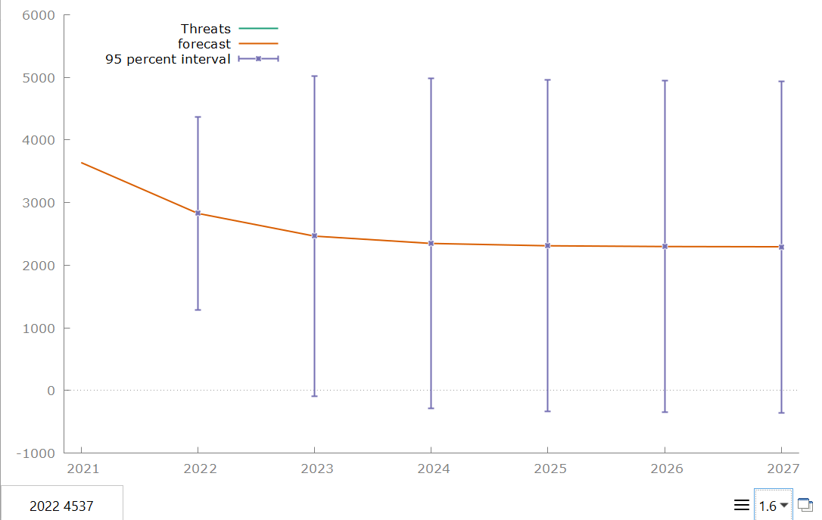

FIGURE 8: THREATS

The forecast shows a continued decline in the number of threats from 2021 through 2027, leveling off around 2,300–2,400 in the later years. However, the very wide 95% confidence intervals indicate high uncertainty, meaning actual threat levels could vary substantially above or below the central forecast.
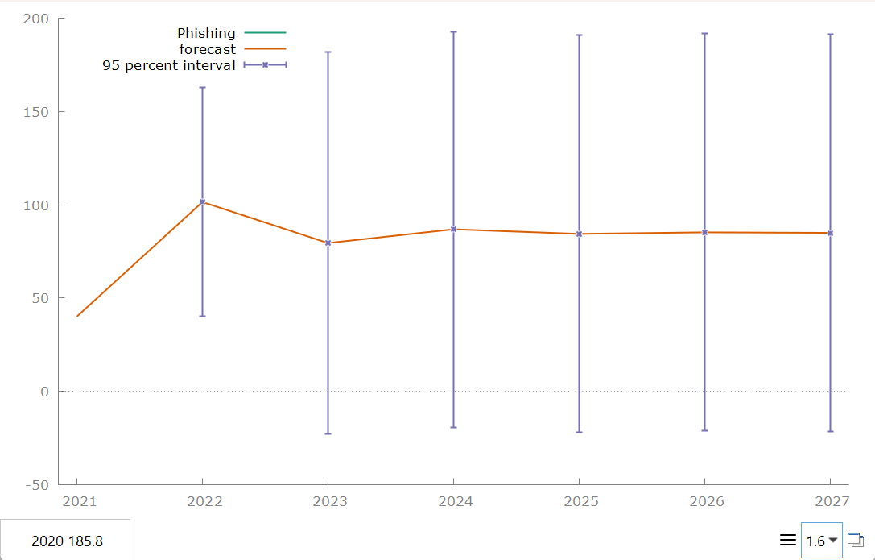

FIGURE 9: PHISHING

The forecast suggests phishing incidents rise sharply in 2022, then stabilize between roughly 80–90 cases per year through 2027. However, the extremely wide 95% confidence intervals indicate substantial uncertainty, meaning actual phishing levels could end up much higher or lower than the central forecast.
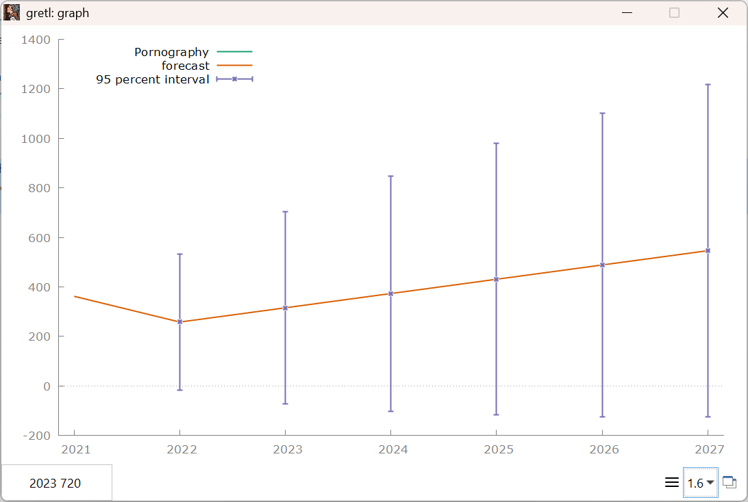

FIGURE 10: PORNOGRAPHY

The model predicts a steady upward trend in the variable labeled Pornography from 2022 through 2027, with forecast values rising gradually each year. However, the 95% confidence intervals widen substantially over time, indicating increasing uncertainty in the long-term forecasts. Overall, while the central forecast suggests growth, the large intervals imply that actual future values could vary widely.
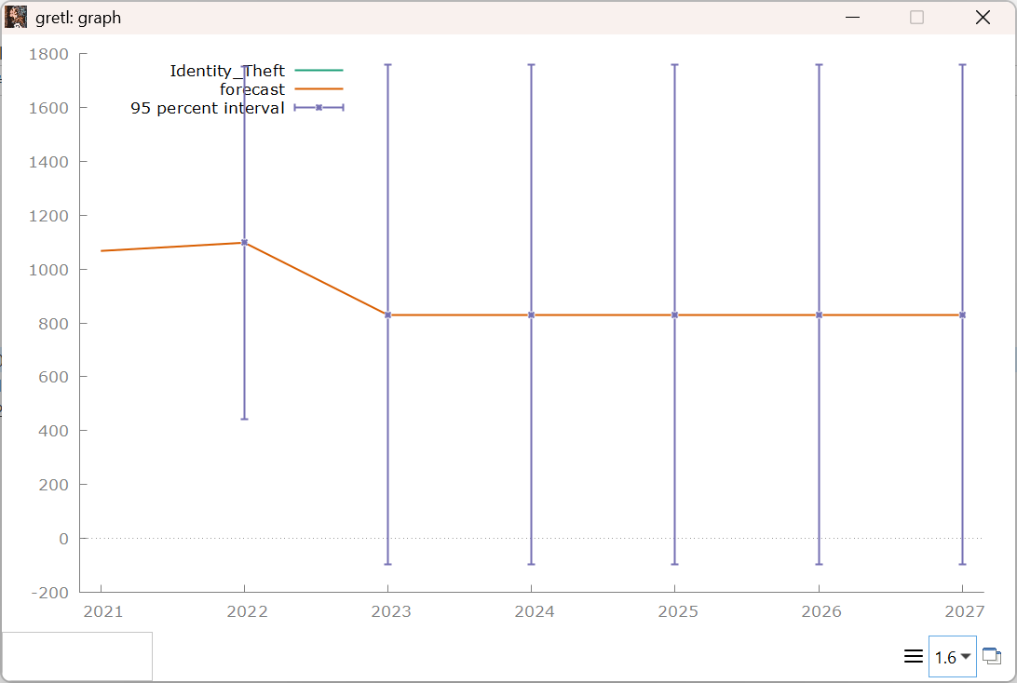

FIGURE 11: IDENTITY THEFT
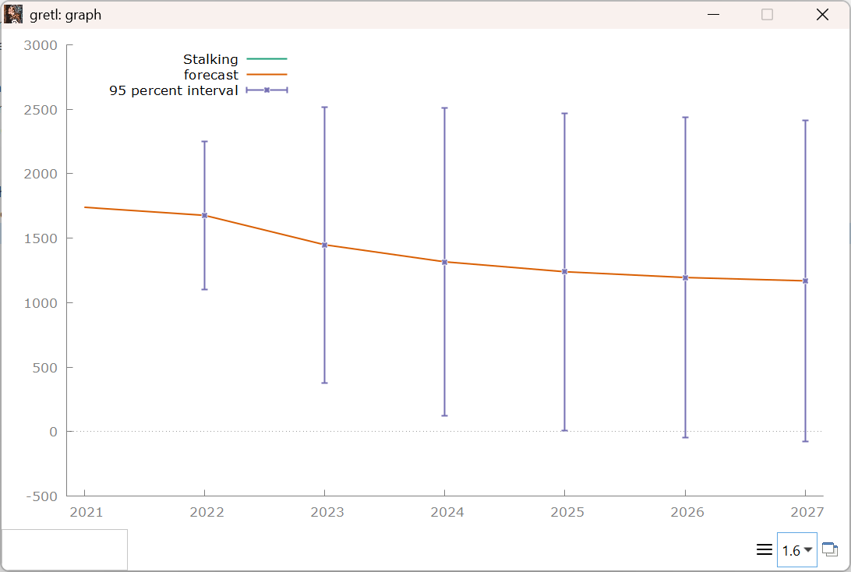
The forecast suggests a drop in identity-theft cases after 2022, followed by a flat, stable projection from 2023 through 2027. However, the extremely wide 95% confidence intervals indicate very high uncertainty, meaning the true values could be much higher or lower than the central forecast. Overall, the model provides a stable point estimate but with limited predictive precision.

FIGURE 12: STALKING
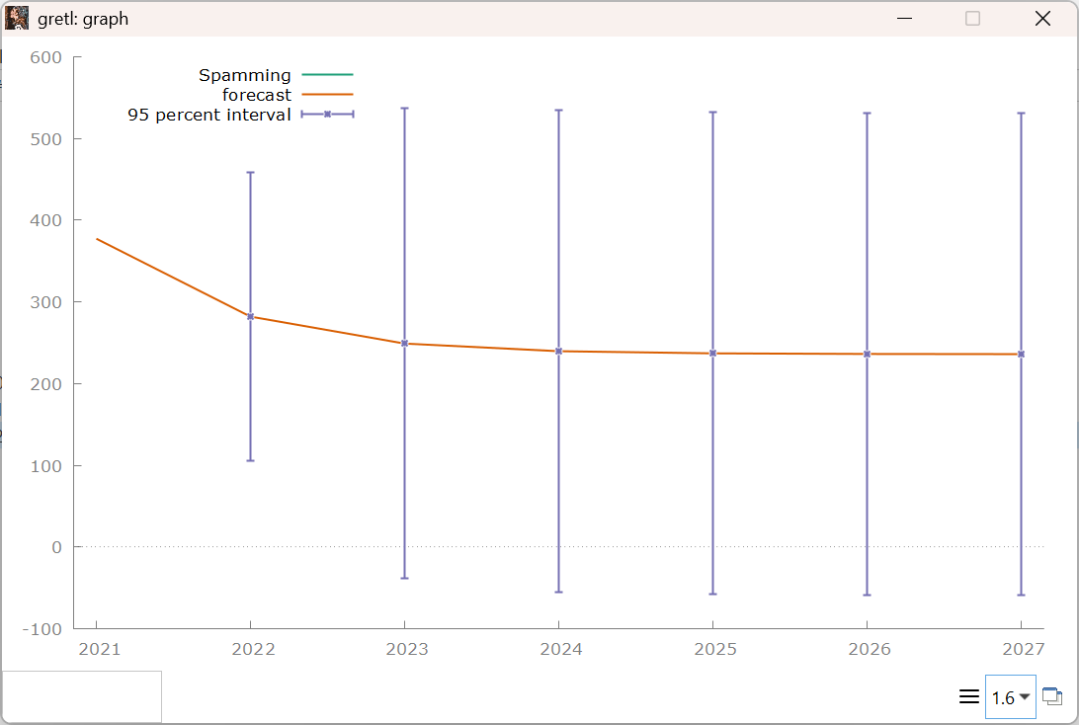
The forecast indicates a gradual decline in stalking cases from 2022 through 2027, with the projected values steadily decreasing each year. At the same time, the very wide 95% confidence intervals show substantial uncertainty, meaning actual outcomes could range far above or below the central forecast. Overall, the model points to a downward trend but with limited predictive reliability.

FIGURE 13: SPAMMING
The forecast indicates that spamming activity is expected to continue decreasing but at a slowing rate, eventually stabilizing around the mid-230s. Despite this downward trend, the extremely wide 95% confidence intervals suggest the model has limited precision in its long-term forecasts, so the true values could end up much higher or lower than the central prediction.

Conclusion
The use of time-series forecasting models in Gretl effectively analyzed and predicted the patterns of cybercrime in Pakistan using recorded data from 2018 to 2021. The generated forecasts for 2022–2027 revealed that financial fraud will continue to dominate the cybercrime landscape, reflecting growing online transactions and persistent digital vulnerabilities. Other categories, such as hacking, harassment, defamation, phishing, and fake profiles, showed fluctuating yet significant patterns shaped by the expansion of social-media use, technological reliance, and varying degrees of enforcement capacity. Meanwhile, offenses with lower reporting levels, including identity theft, stalking, and blackmailing, produced wider confidence intervals, indicating limited data stability and emphasizing the need for more systematic cybercrime documentation.
These findings highlight the importance of adopting data-driven strategies to strengthen cybersecurity planning and national digital resilience. Agencies such as the Federal Investigation Agency (FIA) and the National Cyber Crime Wing (NCCW) should enhance public awareness programs, improve reporting mechanisms, and invest in advanced digital forensics training to address the most critical and fast-evolving threats. Future forecasting efforts can be strengthened by incorporating socioeconomic factors, platform-level policy changes, and larger datasets to improve model accuracy. Overall, the study demonstrates that predictive analytics can guide more proactive and informed decision-making, supporting Pakistan's ongoing efforts to combat cybercrime and protect its increasingly digital society.

References

Abdullah et al. (2025)
Abdullah, M., Nawaz, M. M., Saleem, B., Zahra, M., Ashfaq, E. B., & Muhammad, Z. (2025). Evolution of cybercrime—Key trends, cybersecurity threats, and mitigation strategies from historical data. Analytics, 4(3), 25. https://doi.org/10.3390/analytics4030025

Ombongi et al. (2023)
Ombongi, E. M., Noor, R. M., & Al-Khasawneh, A. (2023). Machine learning techniques for cybercrime detection: A systematic review. PeerJ Computer Science, 9, e1547. https://doi.org/10.7717/peerj-cs.1547

Chinedu et al. (2021)
Chinedu, P. U., Nwankwo, W., Masajuwa, F. U., & Imoisi, S. (2021). Cybercrime detection and prevention efforts in the last decade: An overview of the possibilities of machine learning models. Review of International Geographical Education, 11(7), 956–974. https://doi.org/10.48047/rigeo.11.07.92
Adil, M., Khan, R., Khan, A., Ghani, M. A. N. U., & Ghani, U. (2020). Preventive techniques of phishing attacks in networks.
Agana, M. A., & Wario, R. (2018). A multi-level evidence-based cybercrime prosecution information system.
Chinedu, P. U., Nwankwo, W., Masajuwa, F., & Imoisi, S. (2021). Cybercrime detection and prevention efforts in the last decade: Overview of machine learning models.
Ayub, M., & Zubair, S. (2023). Rising trends of cybercrime in Pakistan: Patterns and policy implications.
Aziz, A., Siraj, M. M., & Rehman, A. (2021). Privacy challenges in digital forensics: A systematic review.
Imran, M., Murtiza, G., & Akbar, M. (2022). The rise of cybercrime in Pakistan: A national security assessment.
Javed, S., & Arshad, M. (2022). Institutional capacity and PECA enforcement in Pakistan.
Malik, A., & Farooq, M. (2021). Predictive modelling for cybersecurity: A machine-learning perspective.
Raza, A., & Khan, M. A. (2021). The evolving landscape of global cyber threats.
Saleem, U., Zahid, M., & Farooq, S. (2022). Cyber threats and digital vulnerabilities in South Asia.

