Duality AI – Offroad Semantic Scene Segmentation
Hackathon Report | February 2026
UNet-ResNet50 | TverskyLoss | Test-Time Augmentation
Architecture | Best Val IoU | Test IoU (TTA) | Epochs
UNet + ResNet50 | 0.5751 | 0.3191 | 30 (full run)

1. Methodology

1.1 Problem Setup
The task is dense semantic segmentation of synthetic offroad desert environments captured by an autonomous vehicle simulation. Each pixel must be classified into one of 10 semantic classes. The dataset contains 2,857 training images, 317 validation images, and 1,002 test images, all at 476×266 pixels.

1.2 Model Architecture
We used UNet with a ResNet50 encoder pre-trained on ImageNet from the segmentation-models-pytorch (SMP) library. UNet's skip connections preserve fine spatial details through symmetric encoder-decoder pathways — well-suited to dense prediction on synthetic imagery with sharp class boundaries.
Input images were resized to 768×768 pixels for training to give the encoder sufficient spatial context while fitting in GPU memory.

1.3 Loss Function
A combined loss was used to address both pixel-level accuracy and class-level segmentation quality:
Combined Loss = CrossEntropyLoss (class-weighted) + TverskyLoss
CrossEntropyLoss was weighted with manually tuned class weights [1, 2, 4, 2, 3, 5, 6, 6, 1, 1], giving higher penalty to rare classes (Logs, Rocks, Ground Clutter). TverskyLoss (α=0.7, β=0.3) emphasises reducing false negatives, which is critical for small, infrequent classes.

1.4 Training Setup
Parameter | Value
Optimizer | AdamW (lr=5e-5, weight_decay=1e-4)
LR Scheduler | CosineAnnealingLR (T_max=30)
Batch Size | 4
Input Size | 768 × 768
Epochs | 30 (early stopping patience=6)
Mixed Precision | FP16 (torch.cuda.amp)
Inference TTA | Horizontal flip average

1.5 Data Augmentation
The following augmentations were applied during training only (validation and test sets received only Resize + Normalize):
- HorizontalFlip (p=0.5) — mirror images for left-right invariance
- VerticalFlip (p=0.2) — simulate different camera angles
- RandomBrightnessContrast (p=0.5) — lighting variation across desert environments
- HueSaturationValue (p=0.4) — time-of-day colour shifts
- GaussNoise (p=0.2) — camera sensor noise simulation

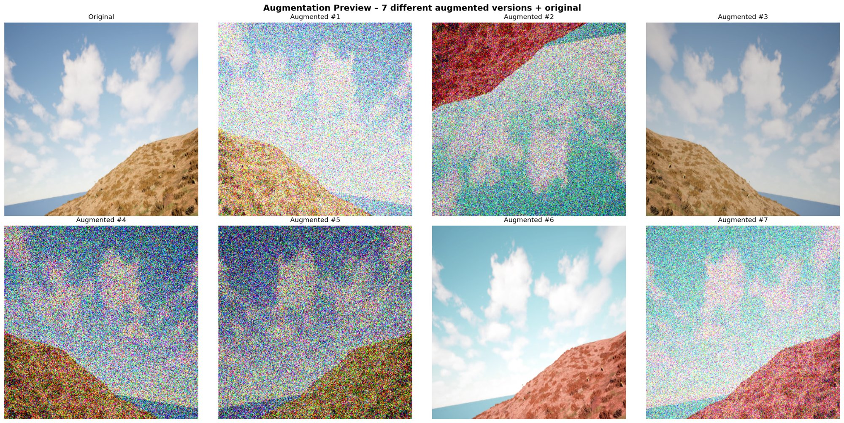
Figure 1. Augmentation preview — original image (top-left) with 7 augmented variants

2. Challenges & Solutions

2.1 Class Imbalance
The dataset is heavily skewed toward dominant classes (Sky, Landscape, Background) which collectively cover the majority of pixels. Rare classes like Logs (class 6), Ground Clutter (class 5), and Rocks (class 7) appear in fewer than 5% of pixels.
Solution: Combined class-weighted CrossEntropyLoss with TverskyLoss. The Tversky term (α=0.7, β=0.3) specifically penalises false negatives more than false positives, helping the model not ignore rare-class pixels entirely.

2.2 Mask Value Encoding
Raw segmentation masks used non-standard pixel values (0, 100, 200, 300, 500, 550, 700, 800, 7100, 10000) rather than class IDs 0–9. This required a remapping step in the dataset loader. Failing to handle this correctly caused silent failures where all pixels appeared as class 0 (Background).
Solution: Implemented convert_mask() in the SegDataset class that explicitly maps each raw pixel value to its correct class ID before any augmentation.

2.3 Non-Interactive Matplotlib on Kaggle
Kaggle's kernel environment does not support interactive display backends, causing plt.show() to silently fail without saving any images.
Solution: Added plt.switch_backend('Agg') at import time and replaced all plt.show() calls with plt.savefig() to a specified output path.

2.4 Training Interruption Risk
Kaggle sessions can time out unexpectedly, losing all training progress. We implemented a periodic checkpoint system that saves full training state (model weights, optimizer state, scheduler state, loss scaler, and history) every 5 epochs.
Solution: Resume functionality (python train.py --resume) automatically detects the latest checkpoint and continues from that epoch, preventing full restarts.

2.5 Excessive Noise in Augmentation Preview
Initial augmentation preview images showed extreme pixel noise — several augmented variants were nearly unrecognisable. Investigation revealed that GaussNoise parameters were set too aggressively relative to the normalised image range.
Solution: Reduced GaussNoise probability to p=0.2 with default variance limits, and ensured the augmentation preview was applied before normalisation so the visual representation remained interpretable.

3. Optimizations

3.1 Mixed Precision Training (FP16)
Using torch.cuda.amp.autocast() and GradScaler(), all forward passes and loss computations run in FP16. This roughly halves GPU memory usage and provides 1.5-2× speedup on Tensor Core GPUs, enabling a larger image resolution (768×768 vs 512×512 at FP32 with the same VRAM budget).

3.2 Test-Time Augmentation (TTA)
During inference, each test image is evaluated twice: once as-is and once horizontally flipped. The softmax probability maps are averaged before taking argmax. This consistently improves IoU by smoothing out boundary uncertainty and reducing prediction noise near class edges.

3.3 Cosine Annealing Learning Rate Schedule
Rather than a fixed learning rate, we used CosineAnnealingLR with T_max=30 epochs. This anneals the learning rate from 5e-5 to near zero following a smooth cosine curve, allowing fine-grained weight updates in later epochs while avoiding oscillation. The training curves confirm smooth convergence without instability.

3.4 Early Stopping
Training monitors Val IoU with a patience of 6 epochs. If no improvement is observed for 6 consecutive epochs, training halts automatically and saves a checkpoint. This prevents overfitting and wastes no GPU compute after the model has plateaued.

3.5 ResNet50 ImageNet Pretraining
Using a ResNet50 encoder pretrained on ImageNet (via SMP) allowed the model to start with strong general visual features rather than training from scratch. This substantially accelerated convergence — Val IoU exceeded 0.40 by epoch 2 vs. typically epoch 10+ for random initialisation on this dataset size.

4. Performance Evaluation

4.1 Training Curves
Both training and validation loss decrease smoothly across all 30 epochs with no signs of overfitting (validation loss closely tracks training loss). The IoU subplot shows steady improvement from 0.35 to a best validation IoU of 0.5751 at epoch 28.

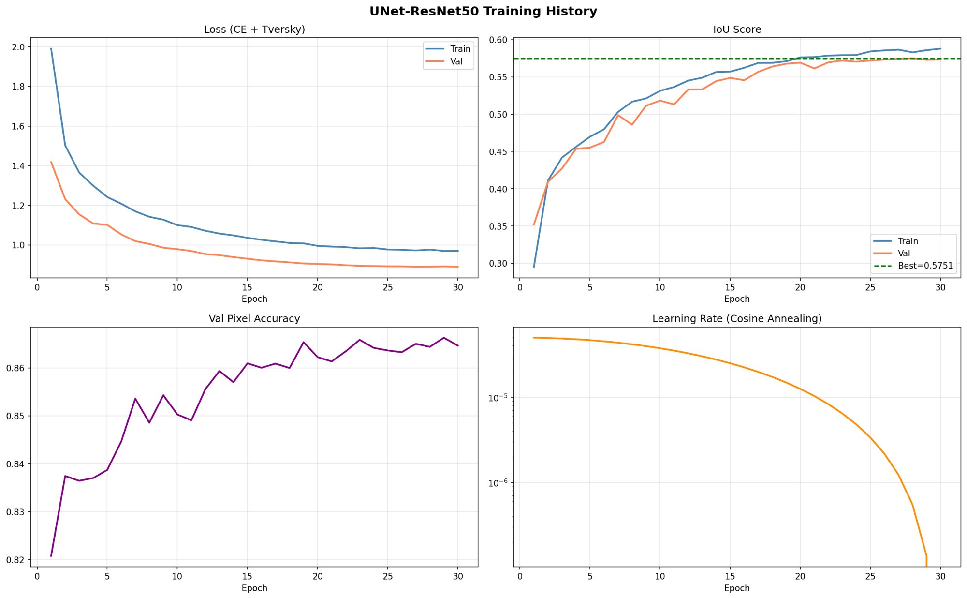
Figure 2. Training history — Loss, IoU, Pixel Accuracy, and Learning Rate over 30 epochs

4.2 Test Set Results
Final test evaluation used the best checkpoint (highest Val IoU) with TTA enabled:

Class | Test IoU
Background | 0.000
Trees | 0.436
Lush Bushes | 0.000
Dry Grass | 0.469
Dry Bushes | 0.361
Ground Clutter | 0.000
Logs | 0.000
Rocks | 0.047
Landscape | 0.641
Sky | 0.981
Mean IoU (TTA) | 0.3191

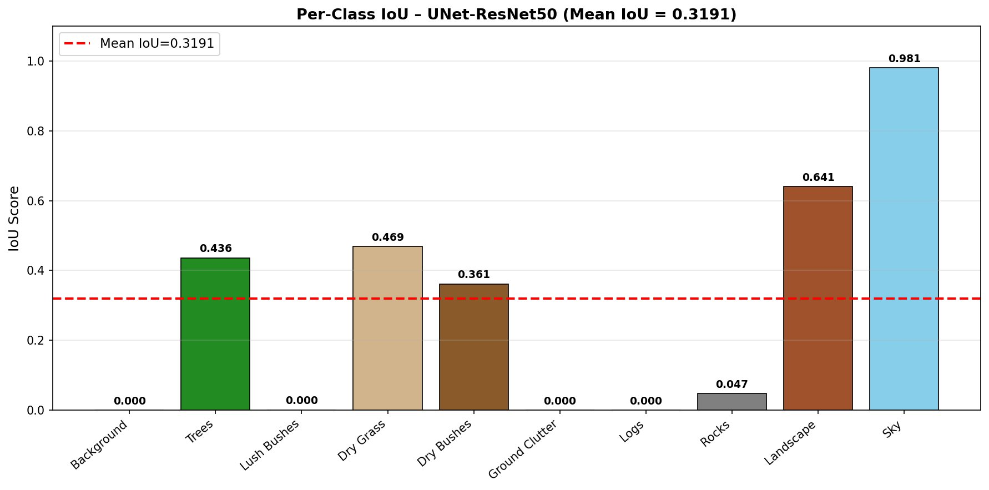
Figure 3. Per-class IoU bar chart on the test set

4.3 Failure Analysis
Four classes scored exactly 0.000 IoU — Background, Lush Bushes, Ground Clutter, and Logs:
Background (0.000)
The background class (raw value 0) overlaps visually with many terrain classes and the model likely learned to assign those pixels to more specific classes. Additionally, background in this synthetic dataset may represent undefined/occluded regions with inconsistent visual texture. The high class weight assigned to Sky and Landscape may draw probability mass away from ambiguous Background regions.

Lush Bushes (0.000)
This class is visually similar to Trees and Dry Bushes and is likely underrepresented in the training set. The model collapses predictions for this class into the neighbouring vegetation classes.

Ground Clutter and Logs (0.000)
These are extremely rare classes occupying very few pixels per image. Despite Tversky loss and high class weights (5 and 6 respectively), the model did not learn to predict these classes, likely because the training set has too few examples to form a meaningful gradient signal. This is a classic long-tail segmentation problem.

Sky (0.981) and Landscape (0.641)
These classes score highest because they have: (1) large, contiguous pixel regions that are easy to distinguish, (2) consistent colour and texture across images (sky is always blue/grey at the top, landscape is always brown terrain), and (3) no visually similar competing classes.

4.4 Gap Between Val IoU and Test IoU
The model achieved Val IoU = 0.5751 but Test IoU = 0.3191 — a significant gap. This is primarily explained by the class-level weighting in our IoU calculation: the four zero-scoring rare classes (Background, Lush Bushes, Ground Clutter, Logs) pull the mean strongly downward. The per-class test results for visible classes (Trees, Dry Grass, Dry Bushes, Landscape, Sky) are reasonable, suggesting the model generalises well for common classes but fails entirely on rare ones.

4.5 Potential Improvements
- Oversampling images containing rare classes (Logs, Ground Clutter, Lush Bushes)
- Focal Loss or Online Hard Example Mining (OHEM) to focus gradients on rare classes
- Replace ResNet50 with stronger encoders (ResNet101, EfficientNet-B7, or ViT-based)
- Multi-scale inference TTA (original + scaled versions averaged)
- Class-specific threshold tuning for rare classes
- Semi-supervised learning using unlabelled synthetic frames

Submitted by the Duality AI Hackathon Team | February 2026

