**Monitoring the phenology of individual flowers using deep learning and automatic tracking**

Hjalte M. R. Mann

Alexandros Iosifidis

Toke T. Høye

januar 11, 2022

ABSTRACT | Often simple variables will be used to describe the flowering phenology of a population of plants, e.g. onset or peak of flowering. Here we show that image-based monitoring of field plots at very high temporal resolution can return information on flowering phenology at the level of indiviuals. Further, we present a framework for automatically tracking, filtering, and visualizing flowers in time-lapse image series. We compare the results of automatic tracking with manual tracking.

# Introduction

For the individual plant, timing of flowering is of utmost importance. Precocious flowering means that the plant has failed to exploit the whole temporal window for accumulating resources before allocating energy to flowering. On the other hand, flowering too late limit the time for reproduction before the end of the growing season (Elzinga et al., 2007). Further, flowering may need to be synchronous with pollinator activity for successful reproduction. Flowering phenology may plastically change as a response to abiotic cues in the environment, such as timing of spring, temperature, and photoperiod, but variation in flowering phenology is partly heritable and shaped by selective forces from the abiotic and biotic environment.

Monitoring of flower phenology at high temporal resolution is laboursome and time-consuming, particularly in logistically challenging environment such as the Arctic. Consequently, simple variables are often used as proxies for the flowering phenology of a population, such as the date for onset of flowering, often derived from weekly observations of sample plots. Such proxies may fail to reveal dynamics in flowering phenology for example caused by changes in climate.

Automatic image-based monitoring of flowering phenology can return phenology data for specific species at very high temporal resolution (Mann et al., in prep), but phenological responses at the individual level may be indiscernible regardless of the temporal resolution of the data at population level. For example, a shortening of individual flower longevity may not be directly obvious at the population level. Many research questions can only be explored on the basis of individual phenology data. For example, investigating the association between reproductive success and timing of flowering and flower longevity requires phenology data at the level of individuals. Similarly, such data is necessary for investigating whether flower visitation rates and/or reproductive success depends on the timing of flowering for the individual flower.

Here, we show that information on phenology at the level of individuals can be derived from image-based monitoring of flower phenology. Further, we present and evaluate an automatic flower tracking and filtering algorithm.

Tracking individual flowers enables the possibility of assigning reproductive success to the individual, for example by observation of seed set. Thereby, it can be explored whether reproductive success is affected by timing and length of flowering. By simultaneously tracking flower visits, these could be assigned to the individual flower and visitation rates per flower could be calculated per flower and related to reproductive success. Further, any information of taxonomic grouping could refine this analyses.

For complex scenes with many flowers in close vicinity to each other, we suggest a conservative filtering approach. The approach may remove correct tracks, but the tracks that remain will have a lower risk of tracking errors. The approach allows for more confidence in upscaling the method. E.g., when running the method on a large number of image series, it is preferable to extract individual high-confidence tracks from each series and ignore the remaining tracks.

# Material and methods

## Study site

Toke, perhaps you can fill in some stuff here.

## The image series

Original time-lapse intervals, explanation and result of sampling scheme and subsequent temporal resolution.

## Flower annotations

We manually annotated all flowers in the sampled image series using the rectangular bounding box tool in the VIA VGG annotation software. Further, we assigned each individual flower a unique ID. These annotations constitute our ground truth tracks.

## Automatic tracking

We built a framework for tracking, filtering, and evaluating tracking of objects in time-lapse image series.

Our algorithm tracks objects based on distances between centroids of bounding boxes.

The tracking algorithm has a set of user adjusted parameters that can optimize tracking accuracy. The parameters are particularly relevant for optimal tracking of objects that are constrained to a specific area such as flowers. It is important to note, however, that the tracking algorithm can be used to track any objects. The tracking algorithm can be applied both offline (on a set of detections/annotations that have already been produced) or online (real-time tracking frame per frame). The speed of the tracking algorithm depends on the computational power available as well as the number of objects that are being tracked. The method is fast, however. Tracking of a series containing 85 objects ran at 0.02 seconds per frame.

As the wind shifts, the flower heads changes direction. This can happen instantaneously (i.e. between two consecutive frames). As they are constrained by their stalk, there is a limit to the distance they can move.

Establishing associations between points based on just the distance between points in the current and the previous frame can cause errors when flowers are in close vicinity of each other.

The flowers move around a center point because of their stalk. We base the tracking on the distance between a point in the current frame and the running mean of the positions of the previous X points in a track.

As winds shift, flowers close to the edge of the frame may move in and out of view. If a flower reappears in the same area as a flower is already being tracked after disappearing in a few frames, it is a reasonable assumption that it is the same individual and not that the old flower wilted/disappeared and a new one developed. The parameter **max disappeared** sets the number of frames a track can be lost before a new track is initiated for points appearing in the same area.

Similarly, this deals with potential false negatives. If a given flower has not been annotated in a single frame, it should not be assigned a new track.

Setting **max disappeared** to 0 tracks objects based on the coordinates of the points in only the previous frame. The counter for number of disappeared frames is reset when a new point is associated with the track within the threshold.

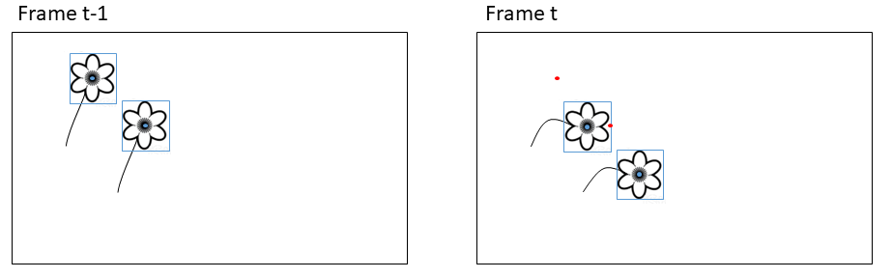

**Figure 1:** Simple centroid tracking may produce erroneous associations when objects move between frames. Blue shows detections in the current frame (bounding box and centroid point). Red shows centroid points for the detections in the previous frame.

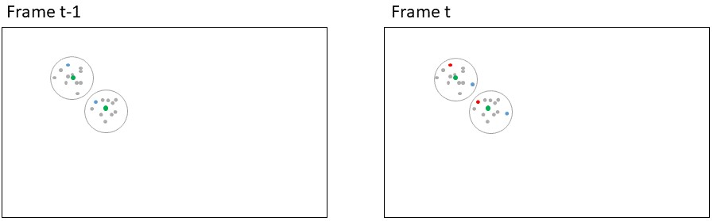

**Figure 2:** Simple centroid tracking may produce erroneous associations when objects move between frames. Basing the association on the running mean of the positions of the previous n number of tracks may alleviate this issue. In this case basing the association on only the previous point would produce a wrong results while basing it on the running mean would produce a correct result. Red points: Centroids for bounding boxes in current frame, blue points: Centroids for bounding boxes in previous frame; grey points: Centroids for bounding boxes in a number of frames before t-1; green points: Running mean of the previous n points. Circles delimit the two individuals.

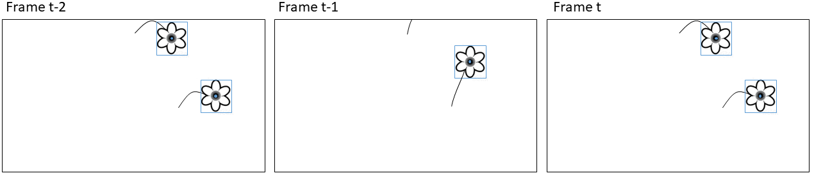

**Figure 3:** Simple centroid tracking may produce erroneous associations when objects disappear periodically from the frame. Here the top flower moves out of frame and the bottom flower would be assigned to the track of the top flower in frame t-1.

### Identifying optimal user parameters

To estimate the optimal values for max_disappeared and max_distance, we analysed the ground truth tracks of the four series.

To estimate the value for max_distance, we calculated the largest distance between any two points within any track for any flower in each of the four series.

The maximum number of frames a flower track was lost and subsequently reappeared were xxx.

To explore the effect of the user parameters and to identify the optimal combination of parameters for our case of tracking flowers, we followed a step wise approach. First, we ran the tracking algorithm on each of the four image series with every combination of the following settings (3.179 combinations):

max_disappeared = [0,10,20,30,40,50,60,70,80,90,100,110,120,130,140,150,160]

running_mean_threshold = [0,10,20,30,40,50,60,70,80,90,100,110,120,130,140,150,160]

max_distance = [0, 100, 200, 300, 400, 500, 600, 700, 800, 900, 1000]

Note that max_distance set to zero. We identified the setting(s) that returned the lowest number of track mismatches and performed a second run with finer scaled settings for each series. Finally, we compare the tracking results between optimal settings and all parameters set to zero.

Depending on the nature of the objects being tracked and the complexity of the scene, the user parameters can be estimated from visual examination of the tracking results. Often it may be preferable to manually annotate a subset of the objects in the image series and derive a set of user parameters from these results.

## Evaluating tracking perfomance

The optimal way of quantifying tracking performance depends on the goal of the tracking. To associate other information obtained in the images to the individual flower, for example flower visits, we want as much as possible of the track to be correct. To derive flowering length in theory we just need to track the most extreme points correctly and don’t care about the intermediate points. Lastly, we may be interested in the number of flowers that existed in a plot, in which case we want the number of tracks obtained by automatic tracking to be as close as possible to the actual number of individuals in the series.

The multiple object tracking accuracy (MOTA) score quantifies tracking performance based on counts of tracking mismatches (Bernardin & Stiefelhagen, 2008). Mismatches occur when objects swap track identity because they are in close vicinity to each other or when an object periodically disappears and is assigned a new track identity when it reappears. Only the shifts in tracking identity are counted as mismatches while the number of points assigned to each track is not considered.

For each series, we calculate the ratio of flowers for which the automatic tracking algorithm returns the correct flowering length compared to the ground truth tracks.

Finally, we compare the number of tracks identified by the automatic tracking with the true number of flowers in a series. These should ideally be equal.

## Filtering tracks

When deploying the automatic tracking algorithm on naive data without ground truth tracks, it is not possible to manually filter for correct tracks. Therefore, we present a conservative filtering method that extracts the most trustworthy tracks from a scene.

For tracks consisting of two points, we establish the straight line between the points. For tracks consisting of three points, we establish the triangle from the points. For tracks consisting of more than three points, we calculate the convex hull of all the points included in the track and derive the polygon from the vertices of the convex hull. Single points are kept.

We then apply the DBSCAN clustering algorithm on these track geometrics to remove tracks in areas with a high density of tracks as these have a high risk of tracking mismatches. The filtering is done in two steps. First, DBSCAN algorithm is run with a conservatively high value for the eps parameter, meaning that tracks in close vicinity to each other will be clustered together. Second, all tracks that were not assigned to a unique cluster are removed. Tracks that are spatially isolated remains.

We evaluate the accuracy of the remaining tracks.

We demonstrate our filtering approach for the image series for which our tracking algorithm did not produce perfect results.

Here we set eps DBSCAN parameter to XXX. Although the value could be fine-tuned for improved results for each image series individually, this value returns good results overall. In a naive setting, a general value could be chosen of the value could be adjusted for each series based on visual examination of performance or testing on a subset of data.

# Results

**Table 1:** Bla bla… # 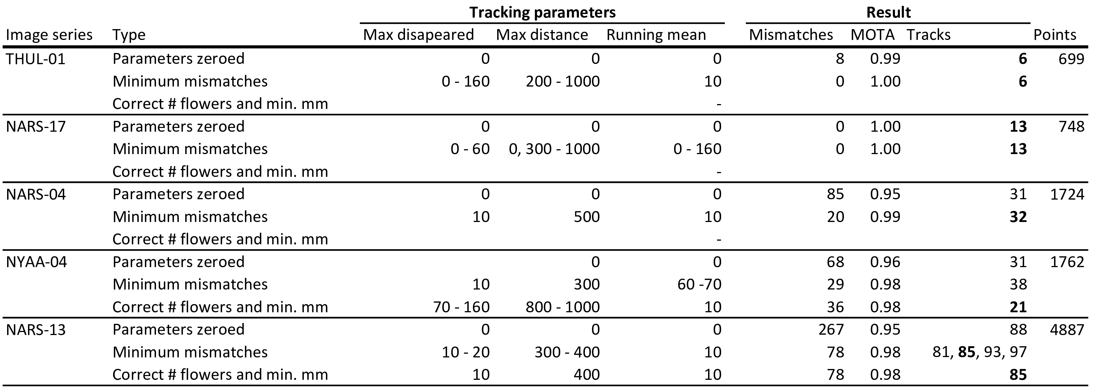

Table 1 shows the performance of the tracking algorithm.

The results of the filtering algorithm on the three series in which our tracking algorithm did not return perfect results are given in table 2 and the pipeline is visualised in fig. 4. Our filtering method successfully extracted 28 tracked flowers with only a single mismatch from the three series with complex scenes using a fixed value of 350 for eps and fixed values for the tracking parameters (10, 10, 10, for running mean, max disappeared and max distance, respectively).

**Table 2:** Results of the filtering algorithm with an eps value of 350 applied across all three series.

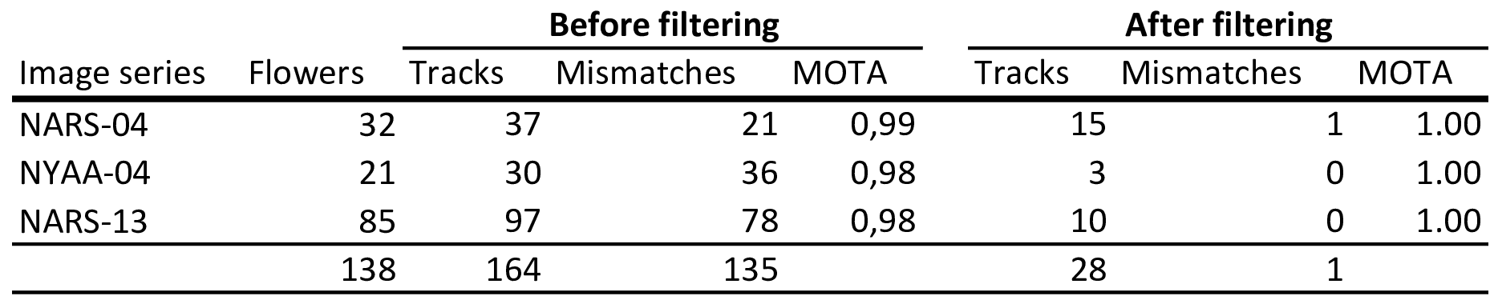

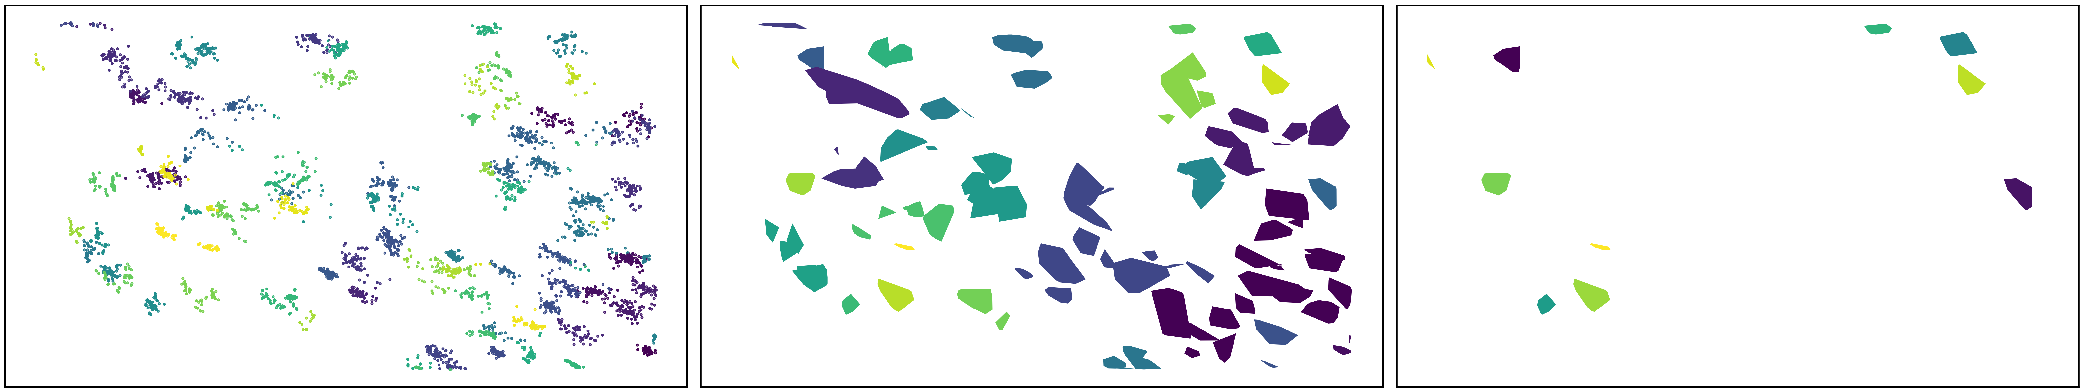 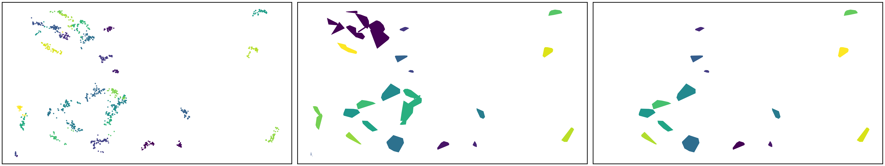 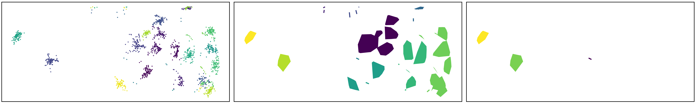 **Figure 4:** Track filtering pipeline. Row 1, 2, and 3 is NARS-13, NARS-04, and NYAA-04, respectively. First column shows the centroid points in the given series, coloured by the track id from the centroid tracking algorithm. Second column shows the polygons calculated from the tracks. The DBSCAN clustering algorithm with eps = 350 was applied to the centroids of these polygons and the polygons are coloured by cluster id. Third row shows the results of the filtering where all tracks that were not assigned a unique cluster whas been removed.

# Discussion

## Tracking

Our tracking algorithm consistently returns high MOTA scores.

A paragraph about the ecological perspectives of being able to track the individual flowers (at scale).

All three parameters make a difference.

In cases where we are tracking perfectly with maxDisap = 0, setting it any value will not make a difference. Not quite right. Explore more…

Applying the technique on detection instead of manual annotations. Detections introduce false positives. Either manual or automatic quality control to remove these before tracking or after.

Our manually tracked data is ground truth, but for example when flowers periodically move out of the frame, this mimics false negatives. Similarly when one flower occludes another.

Our tracking algorithm returned high MOTA scores even with all three parameters set to zero.

Automatically detecting flowers would likely introduce a degree of false negatives which would decrease the MOTA score if max disappeared is set to zero. Introducing a value for this parameter can deal with the problem of false negatives.

We ran our tracking algorithm on 3xxx combination of the three parameters. Using the parameters increased the performance of the tracking substantially. Our steps in parameter values were crude, however, and it is very likely that finer steps in these values would identify combinations that produce even better results. Here we do not perform this analysis, however, as our goal is to show that the parameters can be used for optimizing tracking performance in general.

## Filtering

Extracting tracks that are spatially isolated does not guarantee that the tracks are correct/without errors. However, as spatially isolated objects are easier to track, it increases confidence in the remaining tracks.

We applied a single value for the DBSCAN eps parameter in our tracking algorithm. We note that this value could be finetuned for improved results for the individual series (i.e. more flowers extracted without increased number of mismatches). However, as our goal here was to show that a single conservative value can be applied across series, we do not show those results here.

Our method for filtering tracks using DBSCAN on track centroids ensures that all tracks are given the same weighting in the filtering since each track is represented by a single point. In some cases e.g. if it is given a priori that an object will always appear in a minimum of two frames, then single point tracks can be filtered out. However, when such a priori knowledge is not accessible, a conservative approach as the one we present is preferable.

## The image series

A point on the fact the these series are complex.

# Acknowledgements

# Data availability

The code that supports the results in this paper will be made openly available at <https://github.com/TECOLOGYxyz/FlowerTracking>. A publicly available web application can be accessed from the Github repository through which users can run the tracking algorithm on their own data. Raw data as well as the trained flower detection model will be archived on <https://zenodo.org/>.

**NOTES**

* **Flowering phenology**
  + Importance of studying flowering phenology
  + Responses to climate change
  + Phenology of communities, populations, individuals
  + Traditional methods for studying
  + Onset of flowering says little about true distribution
    - Even true distribition of community says little about flowering lengths of individuals and for example how it varies accross the season.
  + Difficult to study at the individual level - requires high temporal resolution and keeping track of individuals
* **Image based monitoring**
  + Automatic, high temporal resolution, remote sites
  + High temporal resolution means that we can annotate individuals and get phenology of the individual
* **Tracking**
  + Offline and online
  + Online often coupled with CNNs that attempt to distinguish individuals from each other and recognize them through frames
  + Flowers appear very similar and
  + Many methods for offline tracking
  + Hungarian/Kahlmann filter ++ May not be applicable for objects that move weirdly, e.g. change directions between frames.
  + Tracking based on distance.
    - Good but has some problems
    - Two points always associated disregarding absolute distance
    - Tracks lost when objects disappear
    - Objects close to each other may swap tracks
* **Our solution**
  + Here we demonstrate a framework for automatic flower tracking and evaluation of tracking performance
  + Ground truth tracks

Tracking Multiple Moving Objects Using Unscented Kalman Filtering Techniques: “Kalman filtering (KF) [5] is widely used to track moving objects, with which we can estimate the velocity and even acceleration of an object with the measurement of its locations. However, the accuracy of KF is dependent on the assumption of linear motion for any object to be tracked. If an object takes some abrupt turns, the nonlinear movement cannot be well handled by the KF framework (due to the linear movement assumption of the design of KF).” Kalman, R. E. A New Approach to Linear Filtering and Prediction Problems. Journal of Basic Engineering, 1960(82), pp. 35-45.

# References

Bernardin, K., & Stiefelhagen, R. (2008). Evaluating multiple object tracking performance: The clear mot metrics. *EURASIP Journal on Image and Video Processing*, *2008*, 1–10.

Elzinga, J. A., Atlan, A., Biere, A., Gigord, L., Weis, A. E., & Bernasconi, G. (2007). Time after time: Flowering phenology and biotic interactions. *Trends in Ecology & Evolution*, *22*(8), 432–439. <https://doi.org/10.1016/j.tree.2007.05.006>