Clone the repository & create a workspace into your local Your repository is here
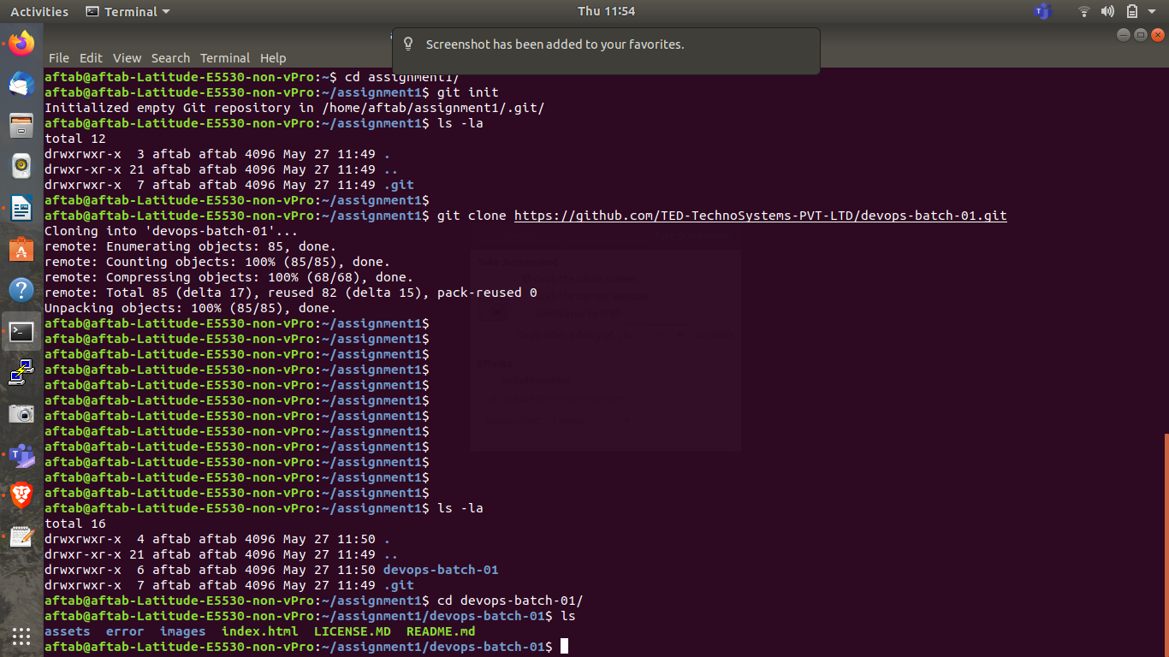

- Open index.html in any editor & search for <h2>Heading Level 2</h2> , Commit message should be adding first name to this commit
- Insert your name between the tags used, don't remove the tag & save the file & commit to your created branch
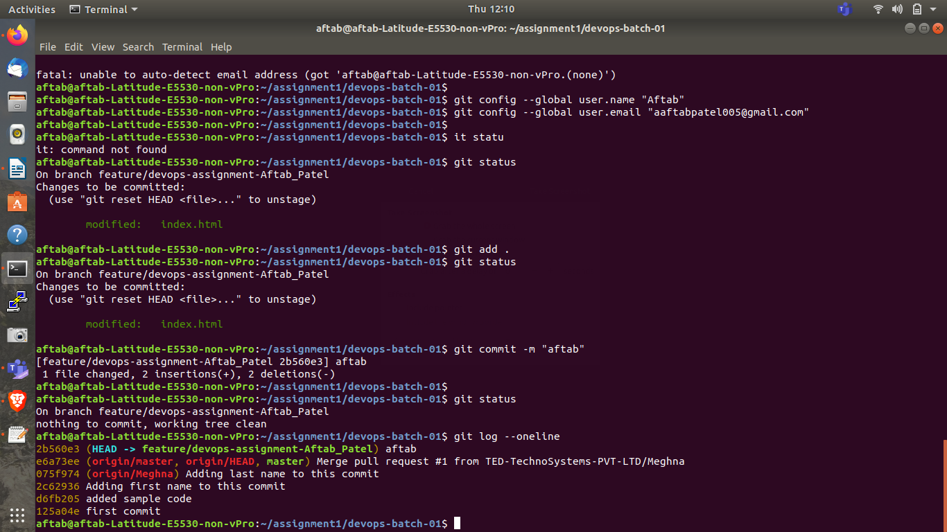

- Insert your name between the tags used, don't remove the tag & save the file & commit to your created branch
- You need again edit index.html & search for <h2>Heading Level 3</h2> & insert your last name & them commit --> Commit message should be adding last name to this commit

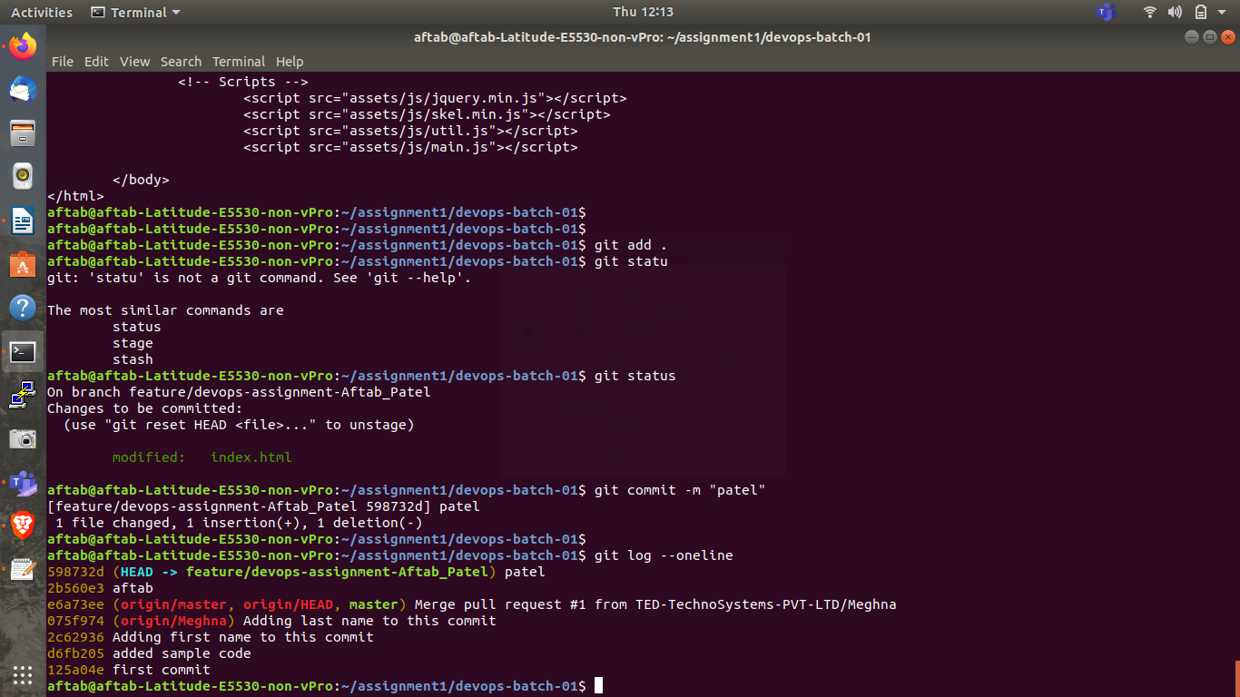

Check the logs

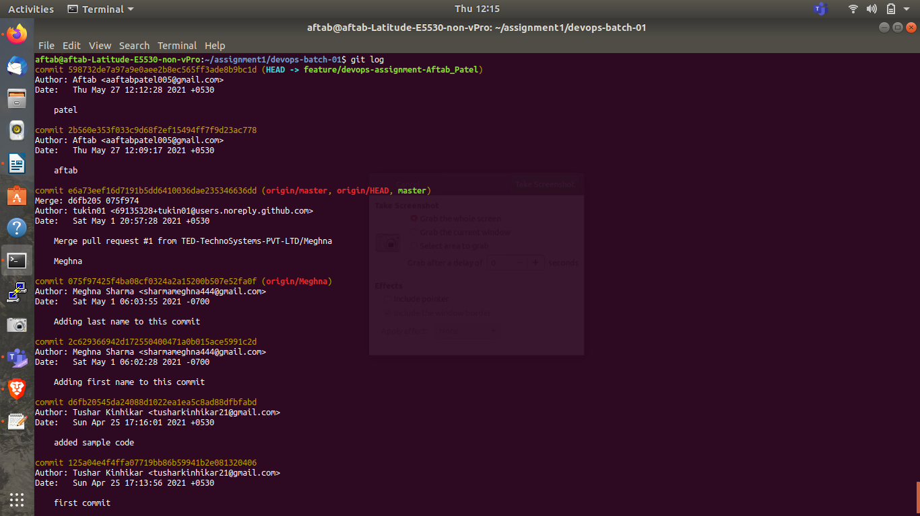

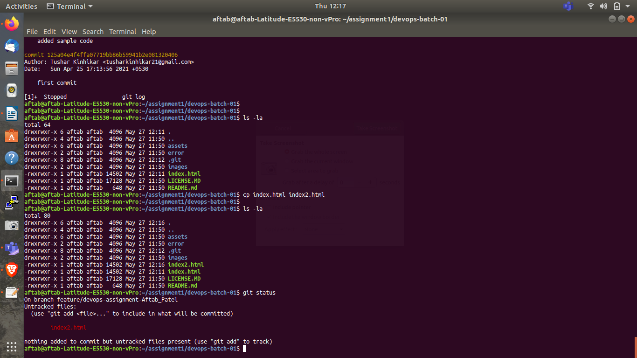

Edit the index.html file & search for <h2>Heading Level 4</h2> , commit the change with commit message "VCS assignment completed"
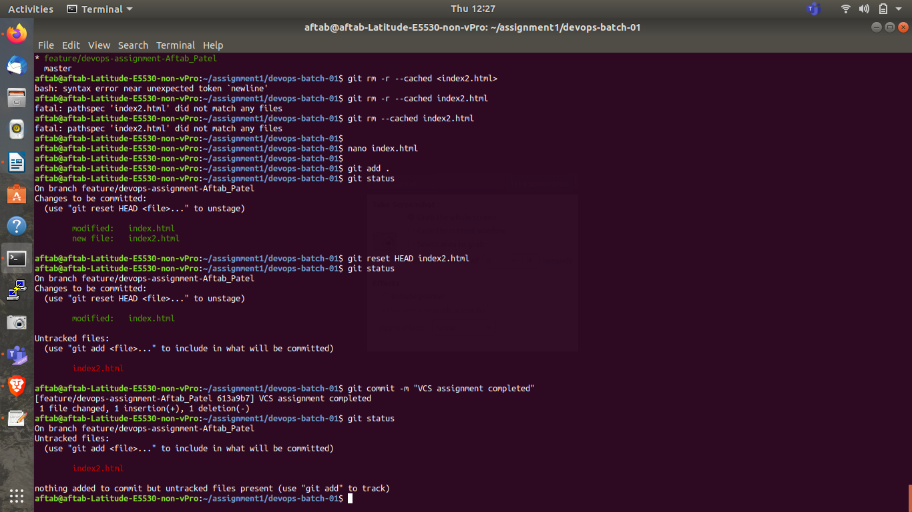

- Check if your git credentials are visible with git global command

