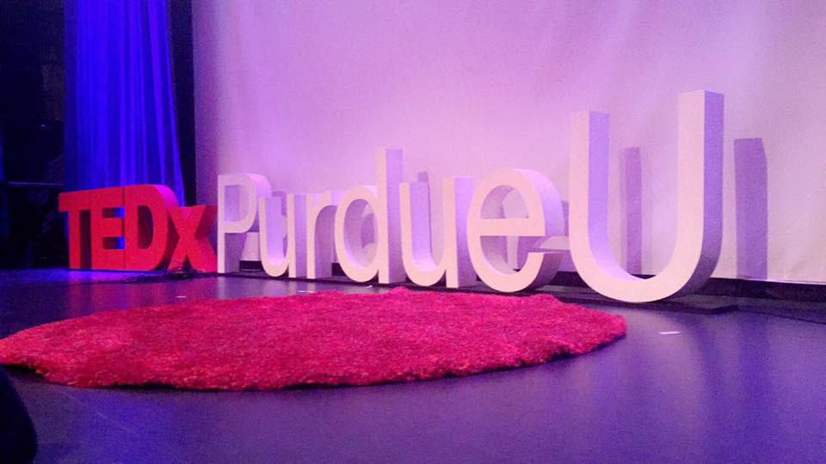  
*Figure 1: TEDxPurdueU’s trademark block letters and red carpet reflect staples of the TED brand.*

TEDxPurdueU, Purdue’s independently run TED organization, will be hosting their second Salon event of the season, “Back to the Future: Tomorrow’s Technology Today,” on November 9th, 6:30 – 7:30 pm, in the Class of 1950 Lecture Hall room 224.

Leaping ten years forward, what will future technology have in store for us? Based on the concept of ideas worth spreading, this upcoming TEDxPurdueUSalon event will feature speakers comprised of outstanding professors, current Purdue students and recent graduates to spark deep discussion about the idea of innovation and how the latest technology will shape our future. Through story-telling, the invited speakers will share with the audience the motivation behind the extraordinary technologies they have developed and how they will transform agriculture, energy infrastructure, and the way we live.

***Austin Deardorff, Co-founder of Aerial Agriculture, LLC***

Deardorff is a senior in mechanical engineering at Purdue. Austin previously worked for Zimmer Biomet, a company which manufactures biomedical devices such as knee and hip replacements, before starting his own company. In May 2015, he co-founded Aerial Agriculture to revolutionize the agriculture industry by building drones in-house to capture specialized multispectral images of the entire crop fields. This technology helps reduce farming-related costs while increases agricultural production.

***Eckhard A. Groll, Reilly Professor of Mechanical Engineering***

Dr. Eckhard A. Groll is the Reilly Professor of Mechanical Engineering and also serves as the Director of the Office of Professional Practice at Purdue University. Prof. Groll received his doctorate degree in Mechanical Engineering from the University of Hannover in Germany. His research focuses on the application of fundamental thermal sciences to energy conversion systems, components, and their working fluids. In this event, Prof. Groll will share with the audience the net-zero energy RENEWW house located near Northwestern Avenue that he and his research team have been working on. The systems in the house are powered by clean and renewable energy by converting heat waste from appliances and “gray water” from showers and sinks.

***Vilas G. Pol, Associate Professor of Chemical Engineering***

Prof. Vilas G. Pol is an Associate Professor at Purdue University’s School of Chemical Engineering. He earned his Ph. D. in Chemistry from Bar-Ilan University of Israel. Prior to Purdue, Prof. Pol worked as a Material Scientist at Argonne National Laboratory focusing on improving electrode materials and designing their surface architecture for superior, long lasting rechargeable batteries. He continues his research work at Purdue where he leads a research team dedicated to advancing the current state of commercial energy storage technology. In this event, Prof. Pol will share with the audience about his team’s work on upcycling, using plastic waste to create valuable carbon nanotubes and spheres for use in batteries and lubricants.

***Everett Berry and Kyle McNulty, Co-founders of Perceive, Inc.***

Berry and McNulty are both recent graduates from Purdue University with bachelor degrees in Computer Engineering and Electrical Engineering respectively. They have both co-authored papers on multimedia systems on large scale video analysis. Together they co-founded Perceive, Inc., a Purdue-based startup which helps retailers to measure and understand more about their in-store shoppers through the use of a concept called deep learning. This deep learning technology will increase safety and efficiency of facilities such as factories, stores, and airports in our daily lives.

The event is free and open to the public. For more information, visit <https://tedxpurdueu.com> or follow us @TEDxPurdueU on Facebook and Twitter.