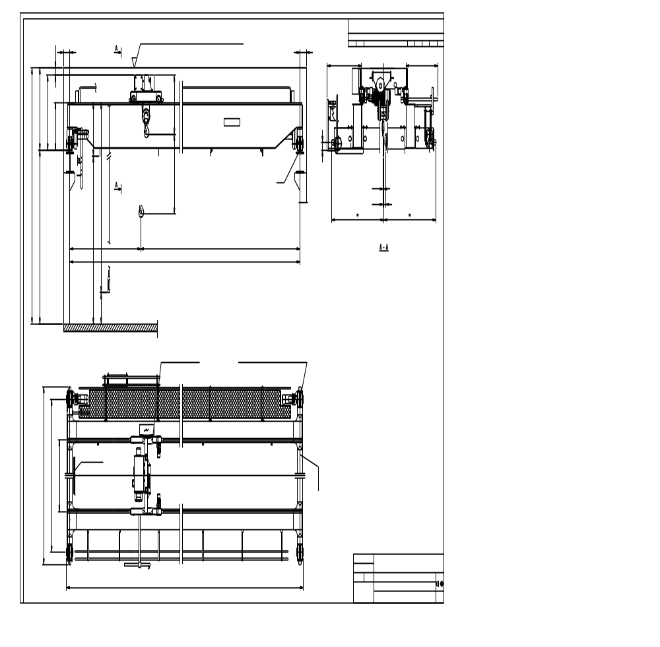

(dim20)
(cralod)t x (span)_HOL (hol2)m
LOAD…………………………………………(cralod)T
SPAN…………………………………………(span)m
LIFTING HEIGHT ……………………….(hol)m（Max.(holmax)m
HOISTING SPEED……………………… (hoispeed)(hoitype)
TRAVERSING SPEED…………………. (trospeed)(trotype)
TRAVELLING SPEED…………………. (brispeed)(britype)
WEIGHT OF TROLLEY………………. (weitro)T
WEIGHT OF BRIDGE………………… (weibri)T
POWER SUPPLY……………………….. (V1)V/(V2)V/50Hz
CRANES GROUP………………………..FEM (cragro)
LIFTING GROUP…………………………FEM (hoigro)
TROLLEY TRAVESING GROUP……..FEM (trogro)
BRIDGE TRAVEL GROUP…………….FEM (brigro)
SUPPLY POWER…………………………(suppow) kw
LENGTH OF RUNWAY………………..(railen) m

Technical Data

(span1)
LOWEST POINT OF ROOF OR OTHER EQUIPMENT (LIGHTS...
(cralod)T
(span2)
MIN.(dim3)
MIN.(dim1)
MIN.(dim2)
MIN.(dim1)
(railtype)
2012-06-14
(sales)
(hoistcode)
MAX. STATIC WHEEL LOAD (maxwheelload)
(dim19)
(dim22)
(dim21)
GTD
1000
(dim11)
(dim10)
(dim7)

(dim15)
(dim6)
(dim4)
(dim8)
(dim13)
(dim14)
(dim12)
(dim5)
(dim16)
(dim17)
(eccode)
(dim18)
MIN.(dim0)
Max.(hol1)

