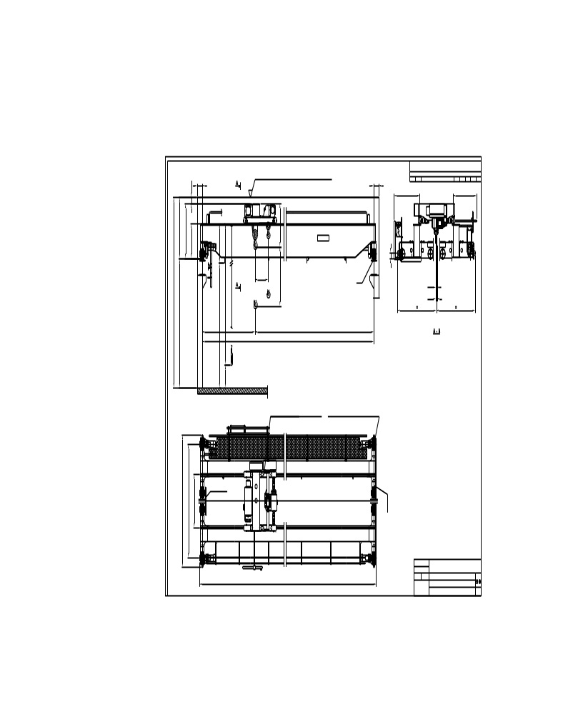
(dim20)
(cralod)t x (span)_HOL (hol)m
LOAD…………………………………………(cralod)T
SPAN…………………………………………(span)m
MAIN HOIST LOAD……………………(hlod1)
AUX HOIST LOAD………………………(hlod2)
MAIN LIFTING HEIGHT …………….(hol)
AUX LIFTING HEIGHT ……………….(hol3)
MAIN HOISTING SPEED………………(hoispeed)
AUX HOISTING SPEED…………………(hoispeed2)
TRAVERSING SPEED…………………. (trospeed)(trotype)
TRAVELLING SPEED…………………. (brispeed)(britype)
WEIGHT OF TROLLEY………………. (weitro)T
WEIGHT OF BRIDGE………………… (weibri)T
POWER SUPPLY……………………….. (V1)V/(V2)V/50Hz
CRANES GROUP…………………….…..FEM (cragro)
MAIN LIFTING GROUP………….……FEM (hoigro)
AUX LIFTING GROUP……………….…FEM (hoigro)
TROLLEY TRAVESING GROUP……..FEM (trogro)
BRIDGE TRAVEL GROUP…………….FEM (brigro)
SUPPLY POWER…………………………(suppow)
LENGTH OF RUNWAY………………..(railen) m


(span1)
LOWEST POINT OF ROOF OR OTHER EQUIPMENT (LIGHTS...

(cralod)T
(span2)
MIN.(dim3)
MIN.(dim1)
MIN.(dim2)
MIN.(dim1)
(railtype)
2012-06-14
(sales)
(hoistcode)
MAX. STATIC WHEEL LOAD (maxwheelload)
(dim19)
CABLE CHANNEL
(dim22)
(dim21)
(contype)
Technical Data
GTD
(dim23)
1000
(dim11)
(dim10)
(dim7)

(dim15)
(dim6)
(dim4)
(dim8)
(dim13)
(dim14)
(dim12)
(dim5)
(dim16)
(dim17)
(eccode)
(dim18)
MIN.(dim0)
Max.(hol1)

