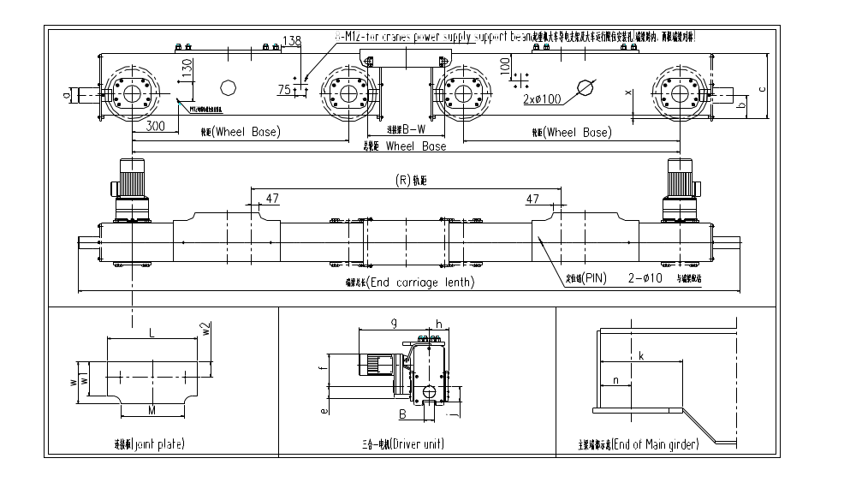
Project Information
Project |  | (projectcode) | Equipment | (equicode) |  | Qty. | (ecunit)
Basic Information(ececcode)
Type |  | (ecec1) | Tube Type | (ecec6) |  | Motor Qty | (ecec11)
Motor Type |  | (ecec2) | Wheel Base1 | (ecec7) |  | EC Length | (ecec12)
Rail Type |  | (ecec3) | Groove | (ecec8) |  | Girder width | (ecec13)
J-P Type |  | (ecec4) | J-P thick | (ecec9) |  | Buffer Type | (ecec14)
Boggie Length |  | (ecec5) | Rail Gauge | (ecec10) |  | Wheel Base2 | (ecec15)
Dimension
a |  | (ecec16) | b | (ecec22) |  | c | (ecec28)
e |  | (ecec23) | f | (ecec29) |  | g | (ecec18)
h |  | (ecec24) | j | (ecec30) |  | k | (ecec19)
L |  | (ecec25) | M | (ecec31) |  | n | (ecec20)
w |  | (ecec26) | w1 | (ecec32) |  | w2 | (ecec21)
x |  | (ecec27)
Customer need to confirm follow data(√ or right value)
Rail Type | (ecec3) |  | Groove |  | (ecec8) | Girder width | (ecec13)
Motor Qty | (ecec11) |  | Rail Gauge |  | (ecec10)
Note： | Fax or Email this sheet after data confirm
 | Fax: 021-51686295 Email:sales@bm-hoist.com

