សាកលវិទ្យាល័យភូមិន្ទភ្នំពេញ

**Royal University of Phnom Penh**

មហាវិទ្យាល័យវិស្វកម្ម

**Faculty of Engineering**

ដេប៉ាតឺម៉ង់ វិស្វកម្មទូរគមនាគមន៍និង​អេឡិចត្រូនិច

Department of Telecommunication and Electronic Engineering

**Component**

សមាជិកក្រុម

កៃ​ ចិត្រា

អៀន​ ស្រីនិច

1. **LED MATRIX**

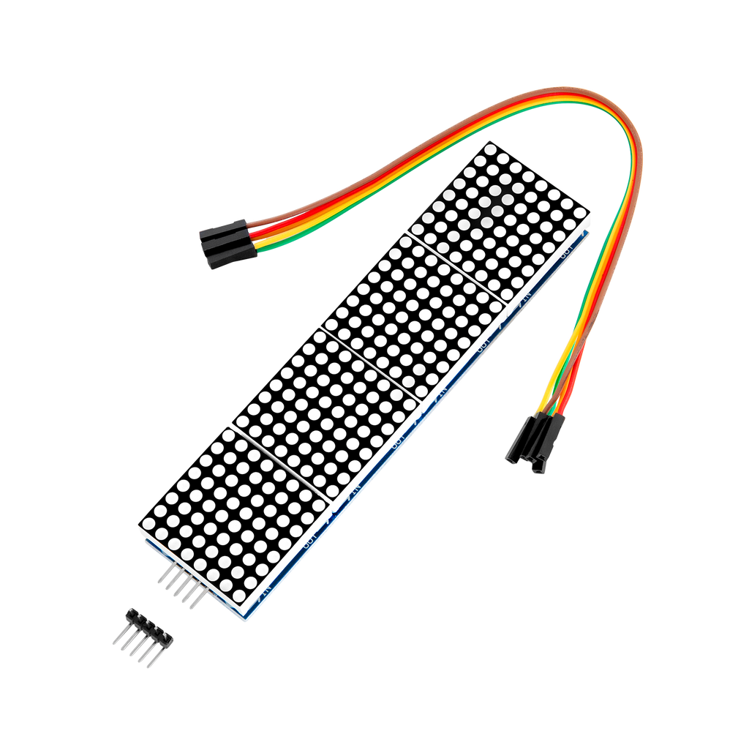

An LED matrix or LED display is **a large, low-resolution form of dot-matrix display, useful both for industrial and commercial information displays as well as for hobbyist human–machine interfaces**. It consists of a 2-D diode matrix with their cathodes joined in rows and their anodes joined in columns (or vice versa).

1. ESP WROOM 32

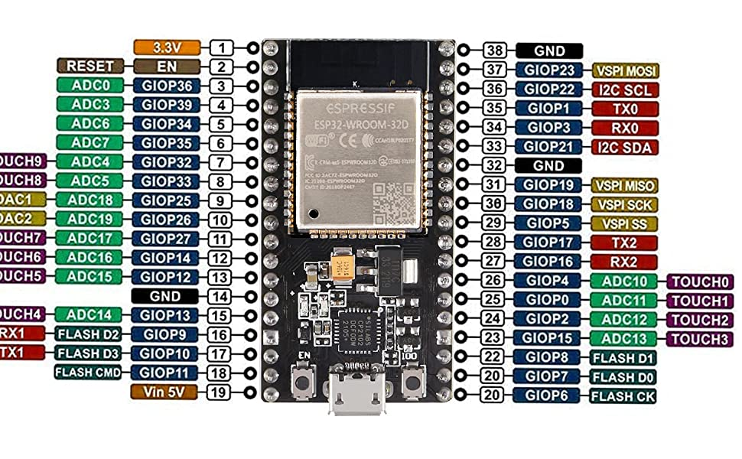

ESP32-WROOM-32 (ESP-WROOM-32) is a powerful, generic Wi-Fi+BT+BLE MCU module that targets a wide variety of applications, ranging from low-power sensor networks to the most demanding tasks, such as voice encoding, music streaming and MP3 decoding.

**Table 1: ESP32-WROOM-32 (ESP-WROOM-32)** **Specifications**

