IIS (DEEMED TO BE UNIVERSITY)
JAIPUR


INTERNSHIP REPORT

IT Services and IT Consulting
Kolkata, West Bengal
(Duration: – 12 July -2024 to 12 August – 2024)

Submitted by:
Ms. Teena Sharma
Enroll no.: IISU/2023/ADM/35803
Roll no.:232025

OFFER LETTER
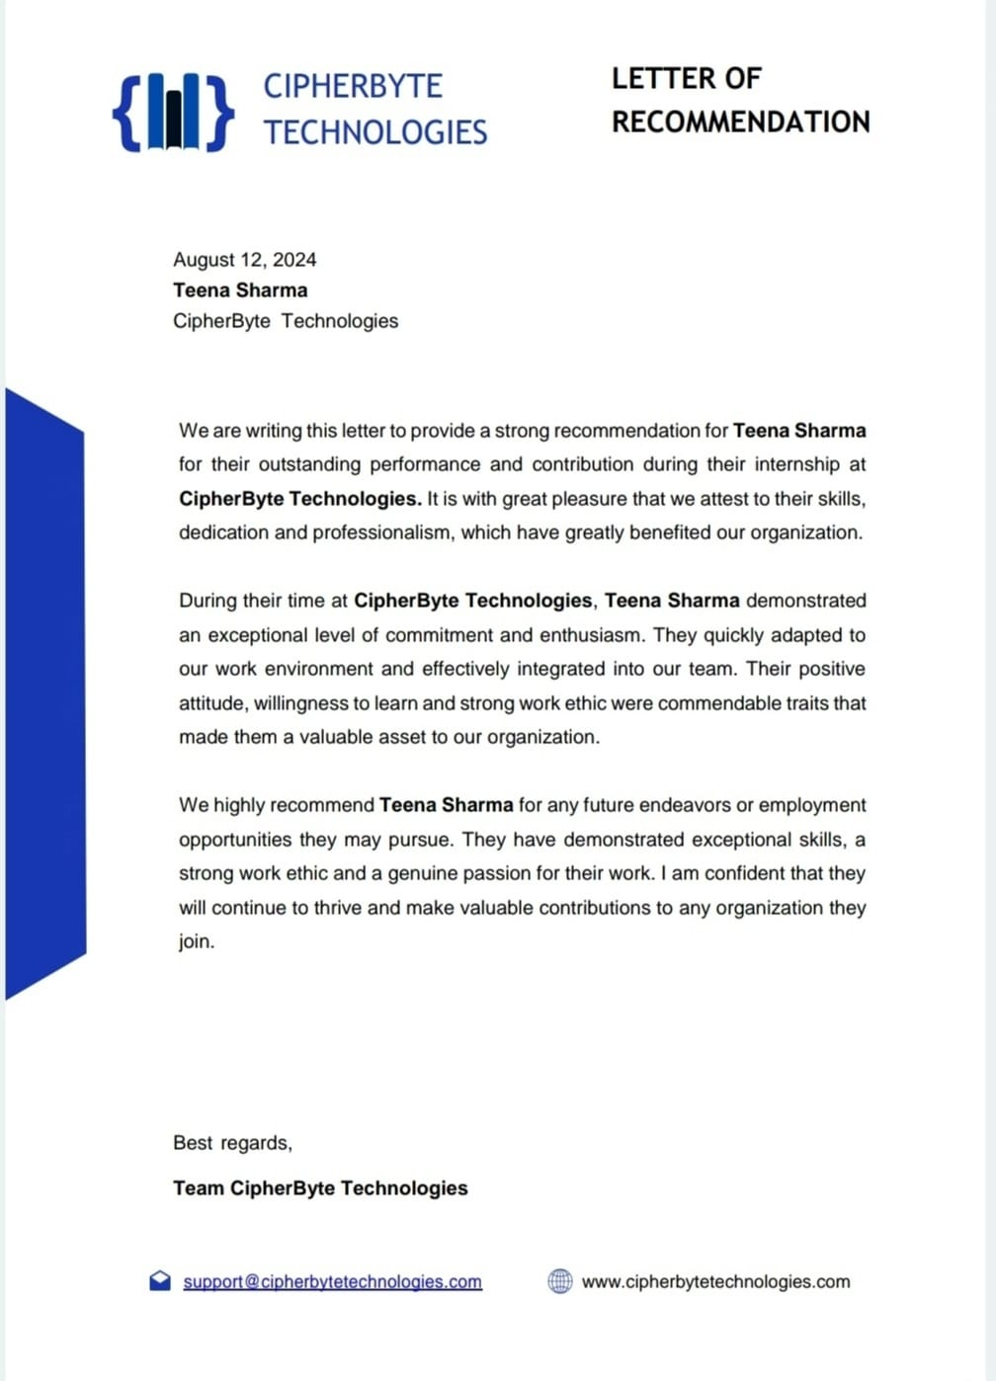

INTERNSHIP CERTIFICATE

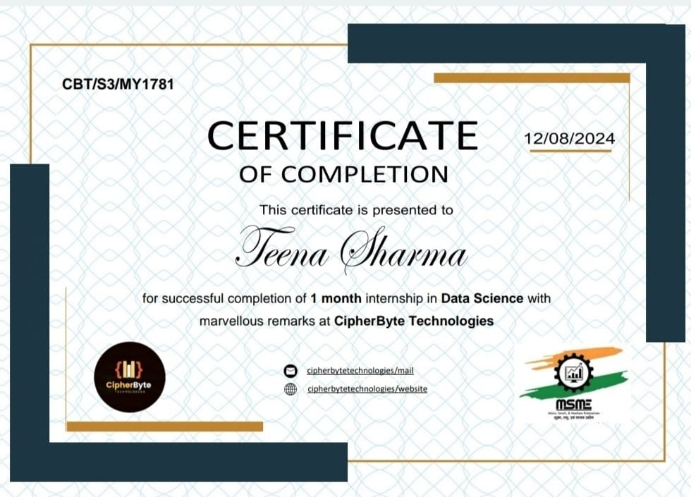
Table of Content

SNo. |  | Page No.
 | Company Profile | i
 | Abstract | ii
1 | Introduction
 | 1.1Problem Statement  1.2Significance of the Problem  1.3Tasks Assigned | 1-2
2 | Tools and Technology | 2-3
3 | Tasks Description
 | 3.1 Explanation of the tasks  3.2 Figures & Screenshots.  3.3 Learning Outcomes | 3-8
4 | Conclusion | 9
 | References | 10
 | Annexure | 11

Company Profile

Cipher Byte Technologies is an IT services company and it is a non-government organization. Its registered office is in Kolkata, West Bengal, India. Cipher Byte helps students gain real-world experience by offering great internships. Their mission is to empower the next generation of talent through hands-on experiences that enhance their skills (i.e. Full Stack Development, Web Development, Android Development, Programming: java, c++ and python etc ), expand networks, and kickstart their careers. Beyond connecting students with internships, Cipher Byte also helps interns grow professionally by providing resume and interview advice, mentorship, networking opportunities, and regular meetings. Cipher Byte connects students and organizations seeking real-world experience to unlock the potential for impactful careers.

Website link: https://www.cipherbytetechnologies.com/
LinkedIn: https://www.cipherbytetechnologies.com/
Facebook: https://www.facebook.com/cipherbytetechnologies?mibextid=ZbWKwL
YouTube: https://www.youtube.com/@cipherbytetechnologies
Instagram: https://www.instagram.com/cipherbyte_tech/?hl=en

Acknowledgement

I would like to express my gratitude to Cipher Byte Technologies for giving me the opportunity to work on a real-world data science project. This one-month internship has provided me with valuable insights into the industry. I am grateful to the company for this experience.
I extend my sincere thanks to the entire team at Cipher Byte Technologies for their warm welcome and supportive work environment. I am especially indebted to my mentors and colleagues who patiently guided me, shared their expertise, and helped me learn and grow together. Their guidance has significantly enhanced my technical skills and problem-solving abilities.
I am grateful to IIS (deemed to be) University for providing me with the strong foundation and practical skills that helped me succeed at Cipher Byte Technologies. I especially want to thanks to Dr. Anubha Jain (Director), Dr. Ruchi Nanda (Head of Department), Dr. Navneet Sharma (Additional Head of Department), Dr. Amita Sharma (Assistant Professor Selection Grade), and Dr. Khushbu Bhardwaj (Placement Officer) for their continuous support and encouragement. Their dedication to teaching and helping students has inspired me to aim high.
Lastly, I would like to acknowledge the unwavering support of my friends and family who have been my constant source of motivation. Their belief in my abilities has propelled me to achieve my best.
This internship has not only deepened my technical skills but has also sparked my interest in data science and its potential to shape the future. I am truly honored to have been part of the Cipher Byte Technologies team and look forward to applying the knowledge and skills gained during this internship to future endeavours.

Abstract

My one-month internship at Cipher Byte Technologies provided valuable hands-on experience in the field of data science. This internship was a crucial part of my 3rd Semester B.Sc. (Hons.) Data Analytics & AI at IIS (deemed to be) University.

The program focused on equipping students with practical skills through real-world applications. During the internship, I participated in a comprehensive training program that covered popular data science methods like clustering and classification. This training significantly enhanced my understanding and practical abilities in these areas. I also learned how to use various data science tools and libraries to clean, preprocess, and analyses data effectively.

Following the training, I undertook a project that challenged me to apply the learned techniques to solve a data science problem.

The internship wasn't just about technical skills. I also gained valuable experience in working on a team, collaborating with mentors, and tackling challenges associated with real-world data analysis. Overall, this internship at Cipher Byte Technologies proved to be an enriching experience that solidified my passion for data science and prepared me for future endeavours in this exciting field.

Introduction

Problem Statement
The objective of this assignment is to train a machine learning model to accurately classify iris flowers into three species: Setosa, Versicolor, and Virginica, based on their measurements.

Significance of the project
The iris flower dataset, a classic benchmark in machine learning, provides a valuable opportunity to explore and implement various classification algorithms. By accurately classifying iris flowers into three distinct species—Setosa, Versicolor, and Virginica—based on their morphological measurements, we can demonstrate the power and versatility of machine learning techniques.
This seems straightforward task holds significant implications. It aids scientists in understanding plant evolution and ecology, contributes to advancements in artificial intelligence by serving as a foundational dataset for machine learning models, and provides a valuable learning resource for students and practitioners to grasp the fundamentals of data analysis and machine learning.
By successfully tackling this classification problem, we can gain insights into the underlying patterns within the dataset, evaluate the performance of different algorithms, and ultimately contribute to the advancement of machine learning and data science. The iris flower dataset, therefore, serves as a stepping stone for exploring more complex machine learning challenges and developing innovative solutions.
Moreover, the iris flower dataset is often used as a starting point for teaching machine learning concepts. Its simplicity and well-defined nature make it an ideal choice for beginners to understand the core principles of classification, feature engineering, and model evaluation. By working with this dataset, learners can gain practical experience and develop a solid foundation in machine learning.

Tasks Assigned:
1 Models:
- Model Name:Iris Flower
Fields:
  - Name: There are Field with a maximum length of 100 characters (stores species name: setosa, versicolor, virginica).
  - Description: Text Field to provide additional details about the iris flower.
  - Sepal Length: float Field to store the sepal length measurement.
  - Sepal Width: float Field to store the sepal width measurement.
  - Petal Length: float Field to store the petal length measurement.
  - Petal Width: float Field to store the petal width measurement.

2. Views:
Implement the following functionalities:
- List All Flowers:
  - Display a list of all iris flowers along with their measurements and classifications.
- Upload Measurements:
  - Allow users to add new measurements to the dataset and specify the flower's species.
- Train the Logistic Regression Model:
  - Use the logistic regression algorithm to train the model on the dataset.
  - Save the trained model for predictions.
- Predict Species:
  - Allow users to input new measurements (sepal and petal dimensions) and predict the species.
- View Metrics:
  - Display model evaluation metrics such as accuracy, precision, and recall.

3. Templates:
Python-related templates for interacting with the dataset:
- Use pandas to load and manage the dataset.
- Use Scikit-learn's Logistic Regression to train the model.
- Store and retrieve data using Python's built-in methods or simple database operations like SQLite or NOSQL.
- Export predictions and dataset updates using Python's csv library.

4. Forms:
Use Python-based functions to process data:
- Accept input measurements for training or testing through Python functions.
- Create forms in Python for:
  - Adding new data to the dataset.
  - Submitting test inputs for predictions.

5. Security:
- Ensure that only authorized users can access the dataset, train the model, or make predictions.
- Use Python's built-in authentication mechanisms to validate user sessions.
6. Styling and Design:
- Formatted Output: Display results (flowers, predictions) in a clear, organized format.
- Exporting Results: Save data in CSV or Excel for easy readability.
- Visualizations: Use charts to represent model performance or data distribution.
7. Filters:
- Pagination: Display data in smaller chunks for easier navigation.
- Filter by Species: View data for specific species (setosa, versicolor, virginica).
- Filter by Measurements: Filter data based on sepal, petal measurements.
- Export Filtered Data: Export filtered results to CSV or Excel for further analysis.

Tools and Technologies for Iris Flower Classification:
The Iris Flower classification project uses a combination of essential tools and technologies to handle the dataset and implement the machine learning model:
- Python: The primary programming language used for data manipulation, model training, and predictions.
- Pandas: A powerful library in Python for data manipulation and analysis. It is used to load, clean, and manage the Iris dataset (CSV or Excel).
- Scikit-learn: A machine learning library in Python used to implement the Logistic Regression model, along with tools for data splitting, training, and evaluating the model.
- NumPy: A library for numerical computing, which supports Scikit-learn and helps with array manipulation during model training.
- Matplotlib/Seaborn: Libraries for visualizing data and model performance, such as generating graphs to plot the accuracy or the distribution of species.
- SQLite or CSV: Used for storing the dataset and results. For simplicity, data can be stored in a CSV file, and model predictions can be exported into CSV format.
- Jupyter Notebooks: A web-based application often used for interactive data analysis, visualizing results, and experimenting with machine learning models.
These tools and technologies are chosen to streamline the data processing, machine learning model implementation, and results visualization in a simple and efficient way.
Task Description
- Explanation of Task
To solve this problem, we will:
- Load the Iris dataset from the provided Excel file.
- Preprocess the dataset, including encoding the species labels and splitting the data into training and testing subsets.
- Use the Logistic Regression algorithm to train a model on the training data.
- Evaluate the model using metrics such as accuracy, precision, recall, and a confusion

Step 1: Import all the important libraries for Explore the Dataset
Import essential libraries to understand the data .
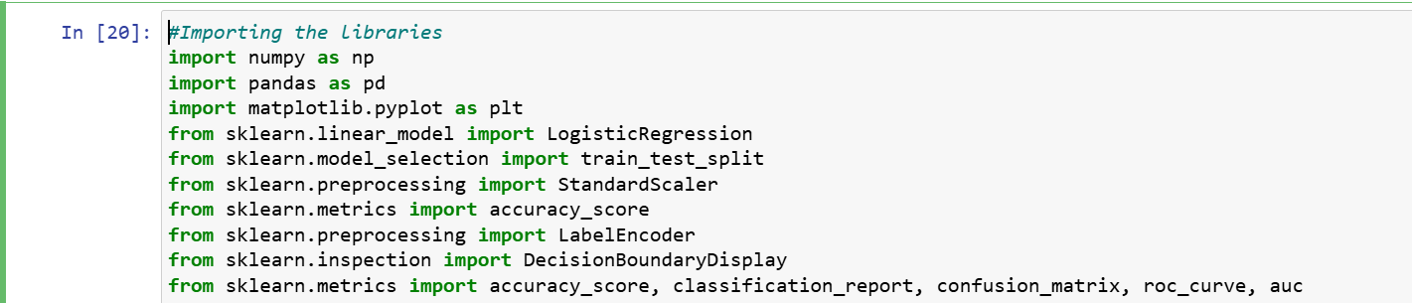
Figure 1. Iris_Flower.py

Step 2: Load and Explore the Dataset
This code reads the dataset using pandas, splits the feature columns (X) and target column (y).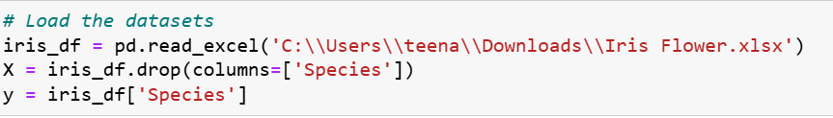
Figure 2.
Step 3: View the features and target variable
Print (X, Y)
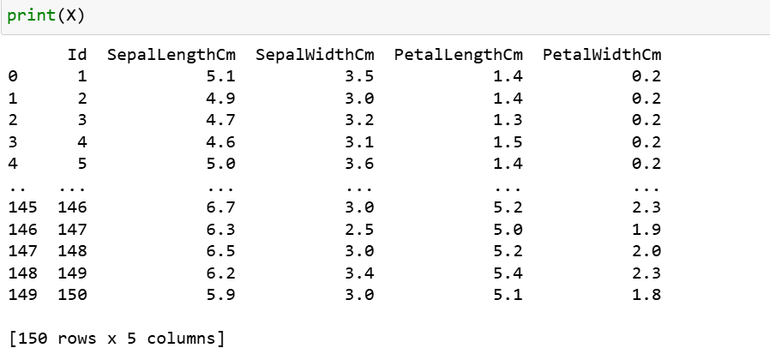
Figure 3.
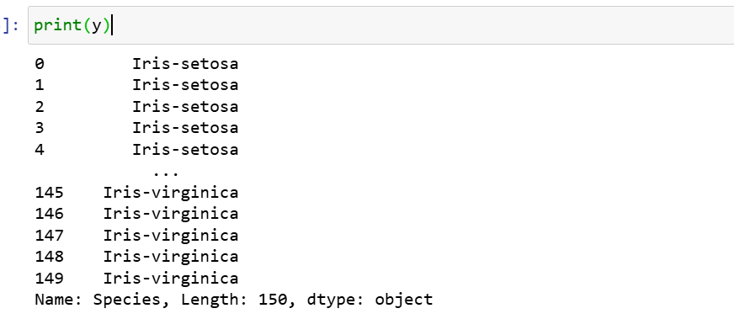
Figure 4.

Step 4: Split the dataset into training and test sets and initialize and train a logistic regression model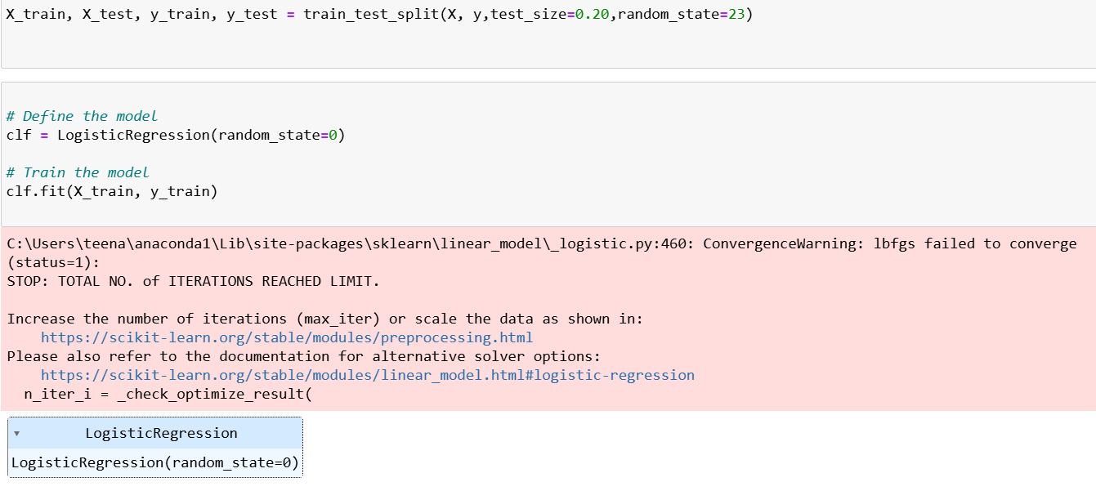
Figure 5

Step 5: Standardize the features 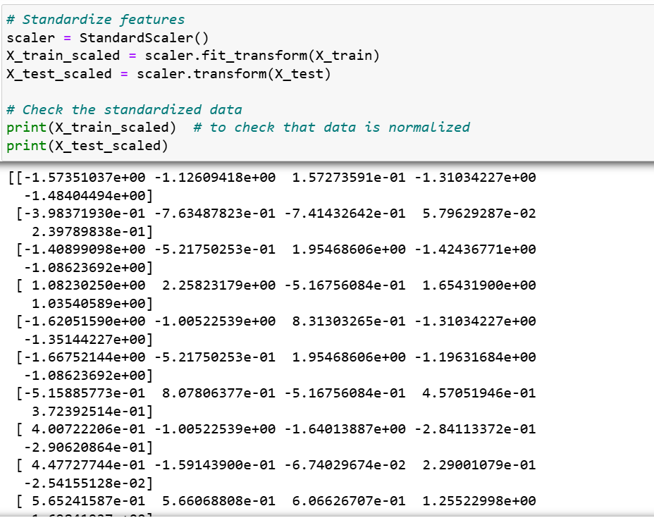
Figure 6
Step 6: Train the model with increased iterations and encode the target variable
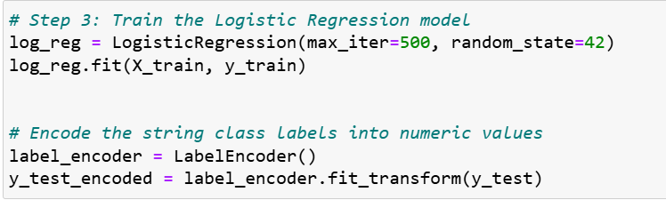
Fig 7
Step 7: Make predictions on the test set
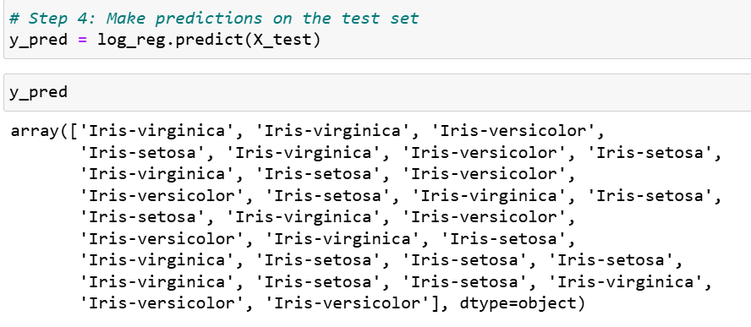
Fig 8
Step 8: Evaluate the model
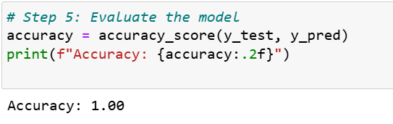
Figure 9

Step 9 : Visualize the results
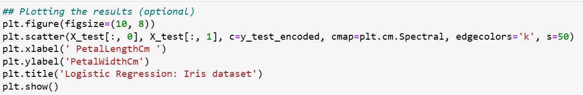
Figure 10

Learning Outcomes
Through the task of applying logistic regression to classify Iris flower species, I have achieved several key learning outcomes in data science and machine learning. By working with the Iris dataset, I have gained a deep understanding of data preprocessing, including data cleaning and feature engineering, which are essential steps in preparing a dataset for machine learning.
I have developed expertise in using Python libraries like Pandas, NumPy, and Scikit-learn for data manipulation and model building. This experience has strengthened my skills in dataset exploration, splitting data for training and testing, and performing basic statistical analysis to ensure the data is suitable for modeling.
Training the logistic regression model has helped me understand model selection, training, and tuning, as well as how to interpret the results using various performance metrics such as accuracy, precision, recall, and F1-score. I also gained hands-on experience with evaluating the model using a confusion matrix to understand its classification performance in more detail.
Additionally, I have learned how to properly evaluate machine learning models using appropriate evaluation metrics and interpret these results in a meaningful way. I now understand the importance of assessing model performance before deploying it to real-world applications.
This project has also reinforced the importance of following a structured process when solving machine learning problems, from data exploration and preprocessing to training, evaluation, and interpretation. The experience has deepened my ability to use machine learning tools to make data-driven decisions and predictions, demonstrating the real-world applications of statistical modeling.
Overall, this project has allowed me to apply theoretical knowledge in a practical setting, further enhancing my skills in data science and machine learning, and has increased my confidence in working with real-world datasets.

Conclusion
My one-month internship at Cipher Byte Technologies, facilitated by IIS University, has been an enriching and insightful experience. As I reflect on this journey, I am grateful for the knowledge, skills, and practical exposure I gained during this time.
Throughout the internship, I had the opportunity to work on the Iris flower classification project, which involved applying logistic regression to classify flower species based on their measurements. This project allowed me to put my theoretical knowledge into practice and helped me understand the entire workflow of machine learning — from data preprocessing to model evaluation. It was a valuable experience that deepened my understanding of how machine learning models are built and tested.
Working with the team at Cipher Byte Technologies has been a great learning experience. They provided constant support and guidance, which helped me grow both professionally and personally. The environment was collaborative and encouraging, allowing me to explore new concepts and solve real-world problems.
As I complete this internship, I feel more confident in my ability to work with data, build machine learning models, and evaluate their performance. I look forward to applying the skills I have learned in future projects and continuing to grow in the field of data science. I would like to express my sincere thanks to Cipher Byte Technologies and IIS University for providing me with this fantastic opportunity.

References
- Fisher, R. A. (1936). The use of multiple measurements in taxonomic problems. Annals of Eugenics, 7(2), 179-188.
This paper introduces the Iris dataset and its application in taxonomic classification problems using various measurements of Iris flowers.
- Brownlee, J. (2017). Logistic Regression for Machine Learning. Machine Learning Mastery.
This resource provides a detailed guide on how logistic regression works, offering practical examples and explanations of its application to classification problems, including the Iris dataset.
- Scikit-learn Documentation. (2024). Logistic Regression.
The official documentation of Scikit-learn's logistic regression model, explaining its functionality, hyperparameters, and how to implement it for classification tasks like the Iris dataset.
- Kaggle. (2020). Iris Species Classification.
This reference includes the Iris dataset available on Kaggle, which is frequently used for classification tasks. Various machine learning models, including logistic regression, are applied to classify the Iris species based on their measurements.

