**01-04-2025 Training Day – 39**

# Topic: Customizing Visualizations

* Added annotations, adjusted figure sizes, and used advanced legends.
* Example: Annotated key points in a scatter plot.

A scatter plot uses dots to represent values for two different numeric variables. In Python, we have a library matplotlib in which there is a function called scatter that helps us to create Scatter Plots. Here, we will use matplotlib.pyplot.scatter() method to plot.

***Syntax :*** *matplotlib.pyplot.scatter(x,y)*

***Parameters:***

* + *x and y are float values and are the necessary parameters to create a scatter plot*
  + *marker : MarkerStyle, default: rcParams[“scatter.marker”] (default: ‘o’)*
  + *cmap : cmapstr or Colormap, default: rcParams[“image.cmap”] (default: ‘viridis’)*
  + *linewidths : float or array-like, default: rcParams[“lines.linewidth”] (default: 1.5)*
  + *alpha : float, default: None → represents the transparency*

Annotation of matplotlib means that we want to place a piece of text next to the scatter. There can be two cases depending on the number of the points we have to annotate :

1. Single point annotation
2. All points annotation

**Single Point annotation**

In single-point annotation we can use matplotlib.pyplot.text and mention the x coordinate of the scatter point and y coordinate + some factor so that text can be distinctly visible from the plot, and then we have to mention the text.

***Syntax:*** *matplotlib.pyplot.text( x, y, s)*

***Parameters:***

* + *x, y : scalars — The position to place the text. By default, this is in data coordinates. The coordinate system can be changed using the transform parameter.*
  + *s : str — The text.*
  + *fontsize — It is an optional parameter used to set the size of the font to be displayed.*

**Approach:**

1. Import libraries.
2. Create data.
3. Make scatter plot.
4. Apply plt.text() method.

**02-04-2025 Training Day – 40**

# Topic: Final Data Analysis

* Conducted descriptive and inferential analyses on the final dataset.
* Example: Analyzed correlations between variables using .corr().

After cleaning and combining datasets, the next critical step in the data analysis process is to conduct both **descriptive** and **inferential analyses** to uncover meaningful insights and relationships within the data. This step helps summarize the data and make predictions or inferences based on it. Below, we'll cover key techniques used in final data analysis.

1. Descriptive Analysis

Descriptive statistics summarize and describe the characteristics of the dataset. This includes measures of central tendency (mean, median, mode), dispersion (variance, standard deviation), and the distribution of variables.

## Key Metrics:

* + - **Mean:** The average of a dataset.
    - **Median:** The middle value when data is sorted.
    - **Mode:** The most frequently occurring value.
    - **Standard Deviation:** Measures the spread of data points around the mean.
    - **Variance:** The square of the standard deviation.
    - **Skewness:** Measures the asymmetry of the distribution.
    - **Kurtosis:** Measures the "tailedness" of the distribution.

## Example: Descriptive Statistics in Python

import pandas as pd # Sample dataset

data = pd.DataFrame({ 'Age': [23, 45, 22, 34, 40],

'Salary': [45000, 54000, 47000, 58000, 60000]

})

# Descriptive statistics descriptive_stats = data.describe() print(descriptive_stats)

**Output:**

shell

Copy code

Age Salary

count 5.000000 5.000000

mean 32.800000 52800.000000

|  |  |
| --- | --- |
| std | 8.460517 5907.926474 |
| min | 22.000000 45000.000000 |
| 25% | 23.000000 47000.000000 |
| 50% | 34.000000 54000.000000 |
| 75% | 40.000000 58000.000000 |
| max | 45.000000 60000.000000 |

## Analyzing Correlations Between Variables

Understanding the relationships between variables is crucial in data analysis. **Correlation** is a statistical measure that expresses the extent to which two variables are linearly related. The correlation coefficient ranges from -1 (perfect negative correlation) to +1 (perfect positive correlation), with 0 meaning no correlation.

* + **Pearson Correlation:** Measures the linear relationship between two continuous variables.
  + **Spearman Rank Correlation:** Used for ordinal data or when the relationship between variables is not linear.

## Example: Correlation Analysis

import pandas as pd # Sample dataset

data = pd.DataFrame({ 'Age': [23, 45, 22, 34, 40],

'Salary': [45000, 54000, 47000, 58000, 60000],

'Experience': [1, 10, 2, 8, 12]}) # Calculate correlation matrix corr_matrix = data.corr() print(corr_matrix)

## Output:

Markdown

Age Salary Experience

Age 1.000000 0.967858 0.822845

Salary 0.967858 1.000000 0.970010

Experience 0.822845 0.970010 1.000000

From the output, we can see:

* + The **Salary** and **Experience** variables are highly positively correlated with each other (0.97).
  + There is a strong positive correlation between **Age** and **Salary** (0.97), indicating that older individuals in this sample tend to have higher salaries.

1. Inferential Analysis

Inferential analysis involves making predictions or inferences about a population based on a sample. This typically involves hypothesis testing, regression analysis, and confidence intervals. Key techniques include:

## Hypothesis Testing:

* + - **Null Hypothesis (H0):** A statement of no effect or no difference.
    - **Alternative Hypothesis (H1):** The statement that there is an effect or difference.
    - **P-value:** Used to assess the strength of the evidence against the null hypothesis (usually, p < 0.05 is considered statistically significant).
    - **t-tests / ANOVA:** Used to compare means between groups.

## Regression Analysis:

* + - **Linear Regression:** Used to predict the value of a dependent variable based on one or more independent variables.
    - **Logistic Regression:** Used when the dependent variable is categorical (e.g., binary classification).

**03-04-2025 Training Day – 41**

# Topic: Creating a Dashboard

* Integrated multiple Matplotlib visualizations into one figure.
* Example: Combined a line chart, bar chart, and pie chart in subplots.

Matplotlib allows you to combine multiple visualizations (such as line charts, bar charts, and pie charts) into a single figure using **subplots**. This is useful when you want to display different types of visualizations side-by-side for comparative purposes or for a more comprehensive view of the data.

# Using Subplots in Matplotlib

Subplots allow you to arrange multiple plots in a grid layout. You can specify the number of rows and columns in the grid, and then plot different visualizations in each grid cell.

1. Example: Combining Line Chart, Bar Chart, and Pie Chart in Subplots In this example, we'll create a figure that contains three different plots:

A **line chart** showing a trend over time.

A **bar chart** representing categorical data.

A **pie chart** showing the proportions of categories. Code Example:

import matplotlib.pyplot as plt

import numpy as np

# Sample data

x = np.arange(1, 6)

y1 = [2, 4, 6, 8, 10] # Line chart data

y2 = [5, 3, 6, 2, 7] # Bar chart data

labels = ['A', 'B', 'C', 'D', 'E'] # Pie chart categories

sizes = [15, 30, 45, 10, 20] # Pie chart data

# Create a figure with 1 row and 3 columns

fig, axs = plt.subplots(1, 3, figsize=(15, 5))

# Line chart in the first subplot

axs[0].plot(x, y1, marker='o', color='b', label='Trend') axs[0].set_title('Line Chart')

axs[0].set_xlabel('X Axis') axs[0].set_ylabel('Y Axis') axs[0].legend()

# Bar chart in the second subplot axs[1].bar(x, y2, color='g', label='Values') axs[1].set_title('Bar Chart') axs[1].set_xlabel('Categories') axs[1].set_ylabel('Values') axs[1].set_xticks(x) axs[1].set_xticklabels(labels)

axs[1].legend()

# Pie chart in the third subplot

axs[2].pie(sizes, labels=labels, autopct='%1.1f%%', startangle=90) axs[2].set_title('Pie Chart')

# Adjust layout to prevent overlap

plt.tight_layout()

# Show the plot

plt.show()

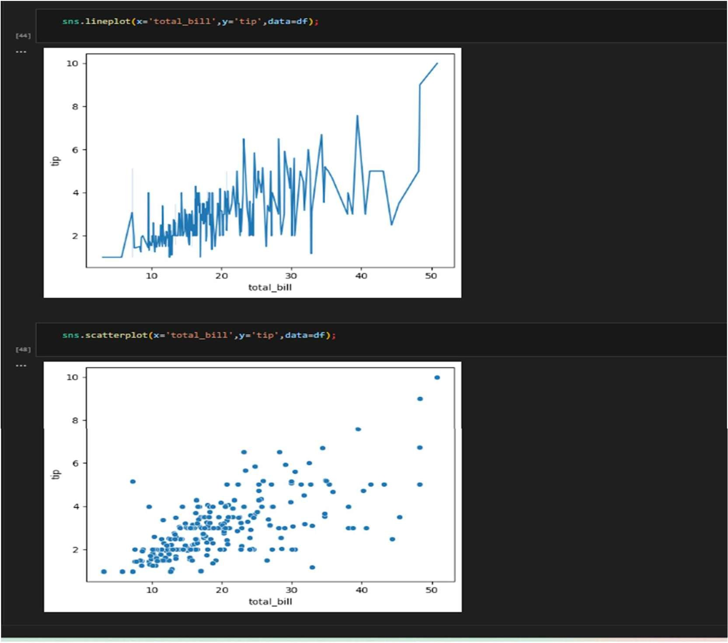

**04-04-2025 Training Day – 42**

# Topic: Summary of Key Learnings

* Documented techniques learned over the past weeks.
* Example: Listed best practices for data cleaning and visualization.

1. ***Data Cleaning Techniques***

## Handling Missing Data:

**Imputation:** Filling missing values using mean, median, or mode (for numerical data) or the most frequent value (for categorical data).

**Removal:** Dropping rows or columns with too many missing values.

**Interpolation:** For time series or sequential data, missing values can be interpolated based on surrounding data points.

## Example:

df.fillna(df.mean(), inplace=True) # Impute missing values with column mean

## Data Transformation:

**Normalization/Standardization:** Scaling numeric data to a standard range, often required for machine learning models.

**Log Transformation:** Used to deal with skewed distributions by applying a logarithmic scale.

**Categorical Encoding:** Converting categorical variables into numeric formats using one-hot encoding or label encoding.

## Example:

from sklearn.preprocessing import StandardScaler scaler = StandardScaler()

df['scaled_column'] = scaler.fit_transform(df[['column']])

## Outlier Detection and Removal:

**Z-Score Method:** Identifying and removing data points that deviate significantly from the mean (e.g., z-scores greater than 3).

**IQR Method:** Removing data points outside the interquartile range (Q1 - 1.5 * IQR, Q3 + 1.5 * IQR).

## Example:

from scipy import stats

df = df[(np.abs(stats.zscore(df['column'])) < 3)] # Remove outliers based on Z- score

1. Combining Multiple Datasets

**Concatenation:** Combining datasets vertically (stacking rows) or horizontally (adding columns) using concat().

**Merging:** Joining datasets based on common columns or indices using merge() (similar to SQL joins).

