10-03-2025 Training Day – 27

# Topic: Bar Charts and Histograms in Matplotlib

* Created bar charts and histograms to visualize data distributions.
* 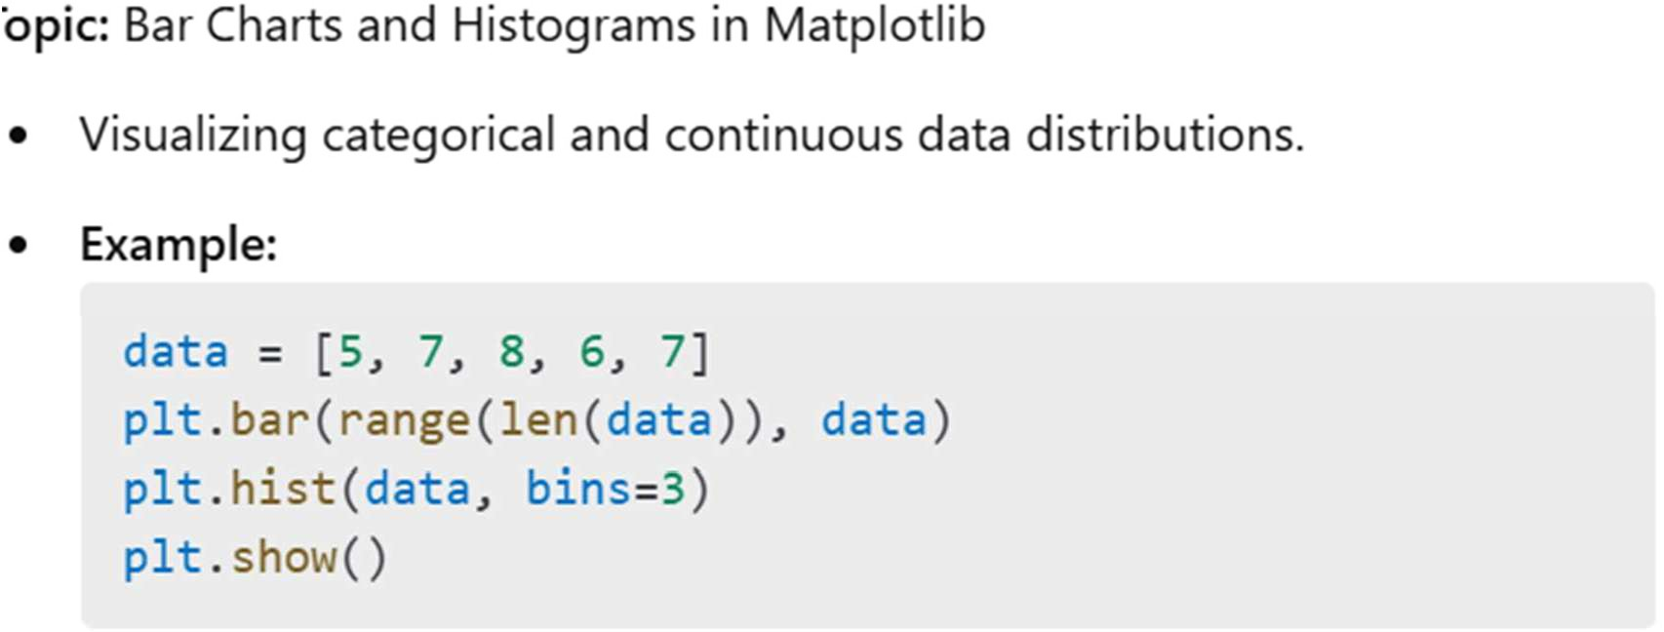Example: Plotted a histogram for a dataset of random integers.
* **In "barplot**" some attributes are practiced to visualize the given data are as follows-

-> color: It help. to change the colour of bars in graph.

-> width: It is used to change the broadness of bars in in the graph.

->.xlabel: It used for naming of the X-axis of the bar graph.

->.ylabel: It used for naming of the Y-axis of the bar graph.

->.barh: This attribute change the direction of bars,

i.e. Vertical to Horizontal.

* + As same like "bar graph" attributes are same in "histogram".
  + In " piechart" some attributes are used to help in the visualization of given data are -

->explode: It help to point out the selected portion of the pie-chart by exploding the part from

the whole chart according to given explode value.

->autopct: It represent the data in percentage automatically and it's value is- "autopct='%1.2f%%' ".

* + In box plot there are some concepts which are important to understand for making visualization easier and identifying outliers easily.

1. IQR: It stand for "inter quartile range", which define as the difference of "third quartile(q3) and first quartile (q0)".
2. Outliers are those value which comes after the last quartile to affect our mean, as well as below the first quartile.
3. Our whole data is divided in four part i.e. 25%, 50%, 75%, 100%, and these percentile values refers to our quartile(q1,q2,q3,q4).
4. The value of lower_limit is extracted by applying formula of lower_limit = q1-1. 5*(IQR).

The value of upper_limit is extracted by applying formula of upper_limit=q3+1.5*(IQR).

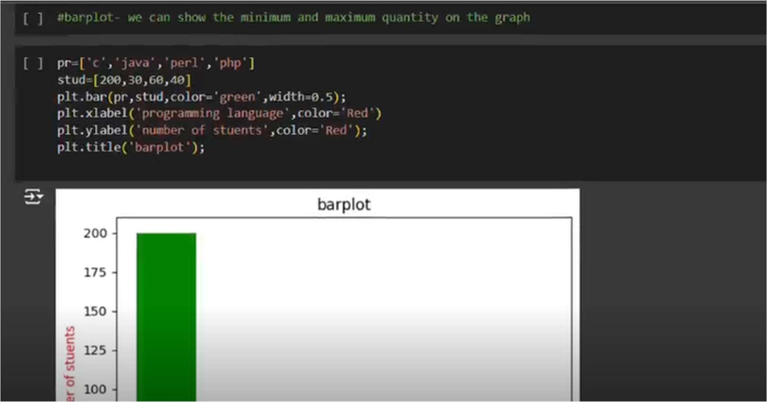

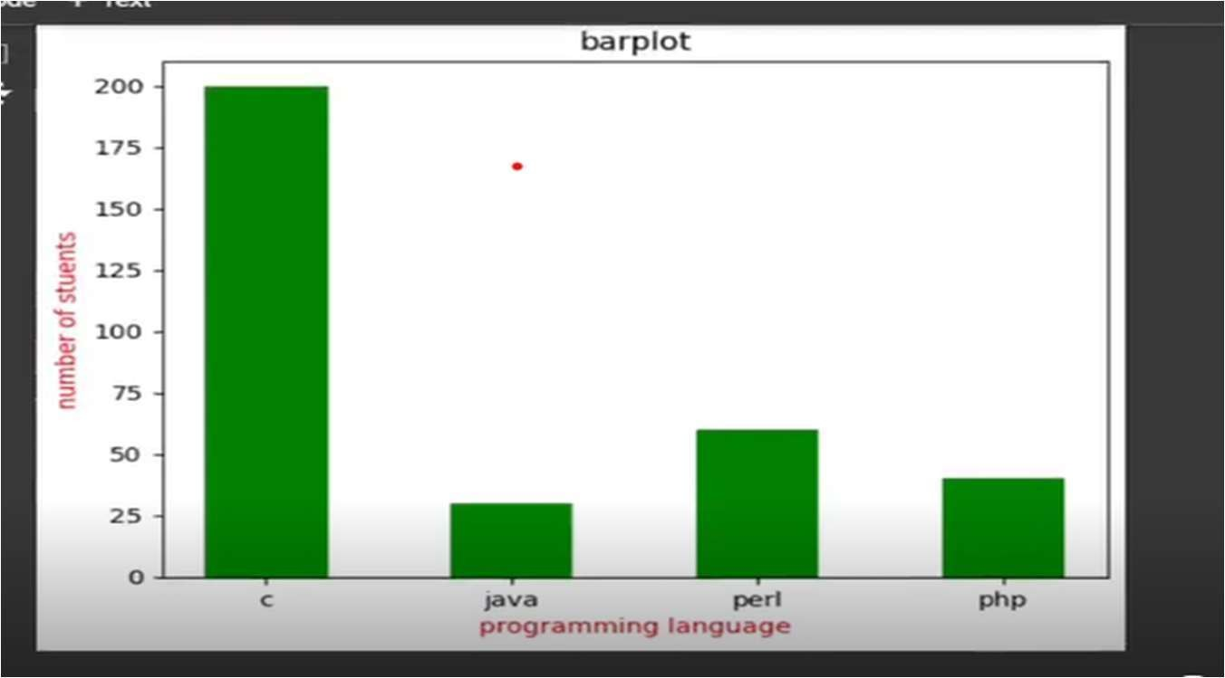

11-03-2025 Training Day – 28

# Topic: Scatter Plots in Matplotlib

* Plotted relationships between two variables.
* 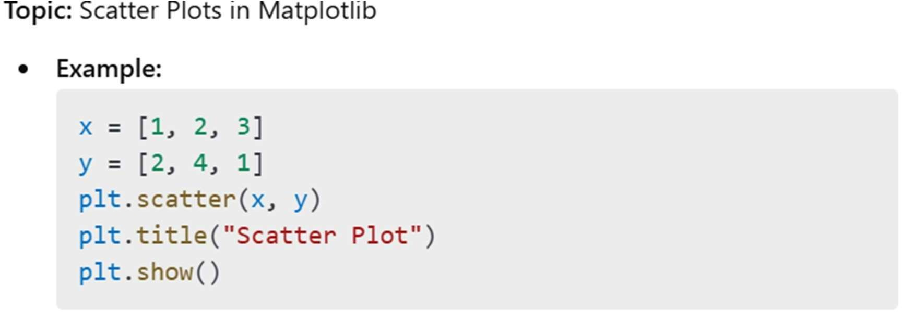Example: Visualized correlation between "Age" and "Height" columns**.**

visualization easier and identifying outliers easily.

* 1. IQR: It stand for "inter quartile range", which define as the difference of "third quartile(q3) and first quartile (q0)".
  2. Outliers are those value which comes after the last quartile to affect our mean, as well as below the first quartile.
  3. Our whole data is divided in four part i.e. 25%, 50%, 75%, 100%, and these percentile values refers to our quartile(q1,q2,q3,q4).
  4. The value of lower_limit is extracted by applying formula of lower_limit = q1-1. 5*(IQR).

The value of upper_limit is extracted by applying formula of upper_limit=q3+1.5*(IQR).

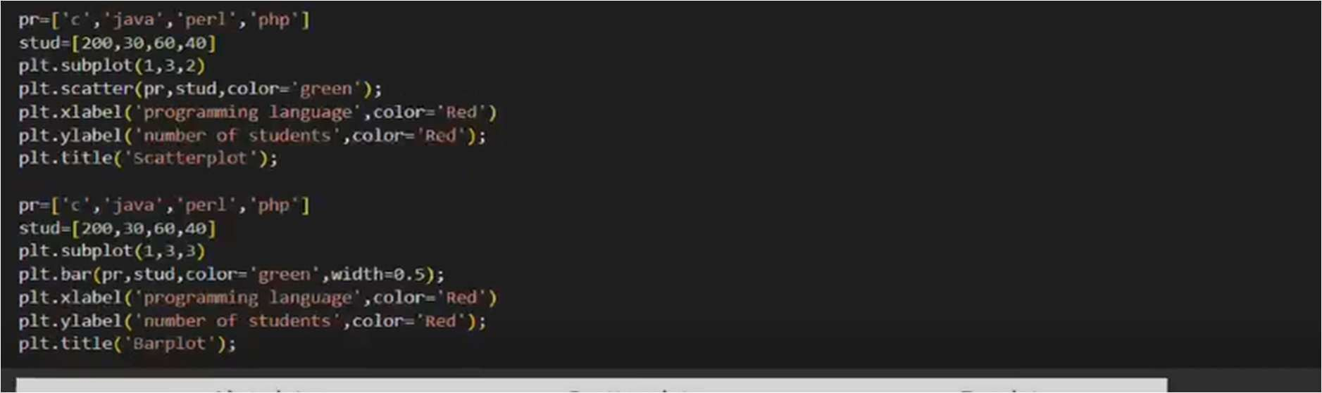

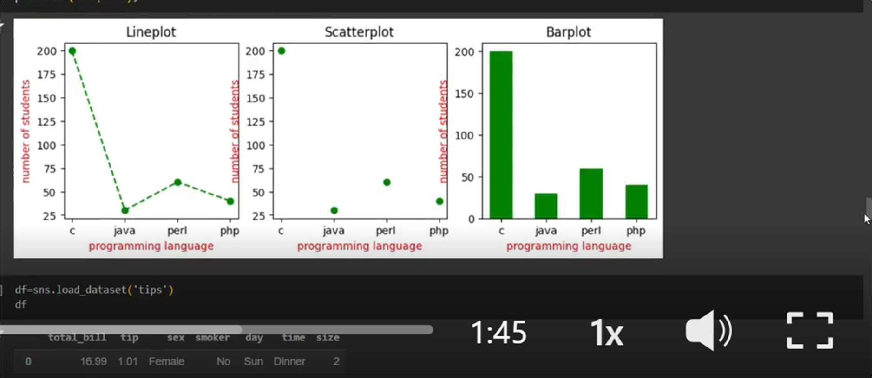

12-03-2025 Training Day – 29

# Topic: Stacked Charts with Legends in Matplotlib

* Created stacked area charts and added legends and titles.
* Example: Visualized cumulative sales over time for different products.

Stacked bar plots represent different groups on the highest of 1 another. The peak of the bar depends on the resulting height of the mixture of the results of the groups. It goes from rock bottom to the worth rather than going from zero to value.

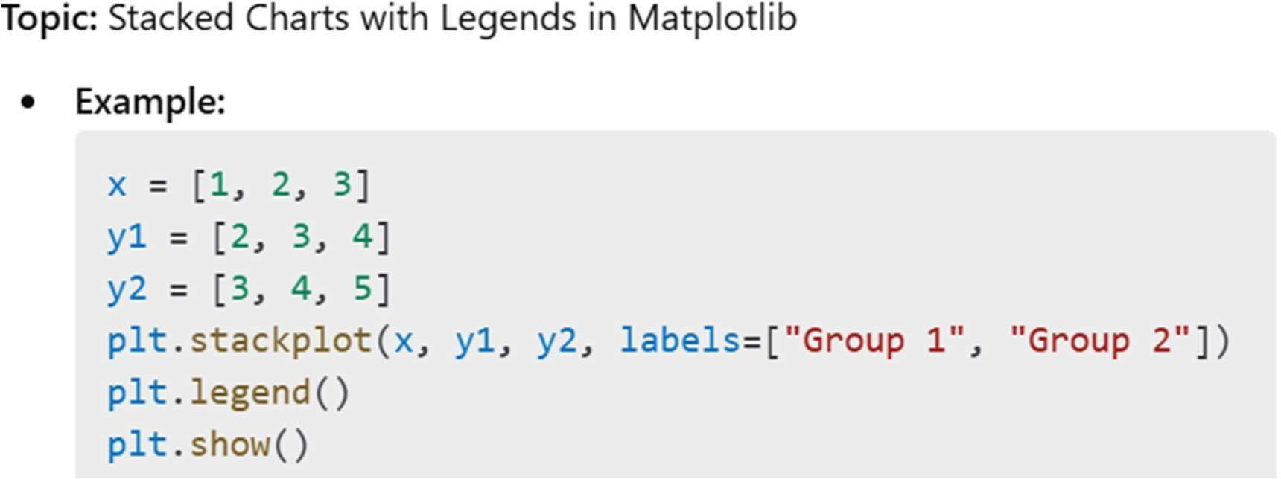

visualization easier and identifying outliers easily.

1. IQR: It stand for "inter quartile range", which define as the difference of "third quartile(q3) and first quartile (q0)".
2. Outliers are those value which comes after the last quartile to affect our mean, as well as below the first quartile.
3. Our whole data is divided in four part i.e. 25%, 50%, 75%, 100%, and these percentile values refers to our quartile(q1,q2,q3,q4).
4. The value of lower_limit is extracted by applying formula of lower_limit = q1-1. 5*(IQR).

The value of upper_limit is extracted by applying formula of upper_limit=q3+1.5*(IQR).

**EXAMPLE**

# importing package

import matplotlib.pyplot as plt # create data

x = ['A', 'B', 'C', 'D']

y1 = [10, 20, 10, 30]

y2 = [20, 25, 15, 25]

# plot bars in stack manner plt.bar(x, y1, color='r')

plt.bar(x, y2, bottom=y1, color='b') plt.show()

