**24-03-2025 Training Day – 34**

# Topic: Visualizing Cleaned Data

* Created histograms and scatter plots for cleaned datasets.
* Example: Visualized the distribution of sales data.

Visualizing cleaned data is an essential step in the data analysis process. Once you've processed and cleaned your data (by removing outliers, handling missing values, normalizing, etc.), visualizations help uncover patterns, trends, and insights. Here are key visualization techniques to consider for cleaned data:

## Histograms

* + **Use:** To visualize the distribution of numerical variables.
  + **Why:** Helps identify skewness, normality, and outliers in the data.
  + **Tools:** Matplotlib, Seaborn, Plotly.

## Box Plots

* + **Use:** To summarize the distribution of a variable and show outliers.
  + **Why:** Provides a five-number summary (minimum, Q1, median, Q3, maximum) and identifies anomalies.
  + **Tools:** Matplotlib, Seaborn.

## Bar Charts

* + **Use:** To compare categorical variables.
  + **Why:** Visualizes the frequency or proportion of categories.
  + **Tools:** Matplotlib, Seaborn, Plotly.

## Scatter Plots

* + **Use:** To visualize relationships between two continuous variables.
  + **Why:** Helps identify correlations or trends.
  + **Tools:** Matplotlib, Seaborn, Plotly.

## Pair Plots

* + **Use:** To visualize relationships between multiple continuous variables.
  + **Why:** Helps identify patterns or trends between variables in a multi-dimensional dataset.

## Line Charts

* + **Use:** To show trends over time.
  + **Why:** Ideal for time-series data to observe changes over time.
  + **Tools:** Matplotlib, Plotly.

## Pie Charts

* + **Use:** To represent proportions of categorical variables.
  + **Why:** Helps quickly understand the composition of a variable.
  + **Tools:** Matplotlib.

## Violin Plots

* + **Use:** To show the distribution of a variable across different categories.
  + **Why:** Combines box plot and density plot to provide a deeper understanding of the data.
  + **Tools:** Seaborn.

## Best Practices for Visualizing Cleaned Data:

* + **Clarity:** Ensure that visuals are easy to understand, avoiding clutter.
  + **Consistency:** Use consistent scales, colors, and labels to ensure comparisons are meaningful.
  + **Appropriate charts:** Choose the chart that best represents the data, and avoid using charts that distort the story.

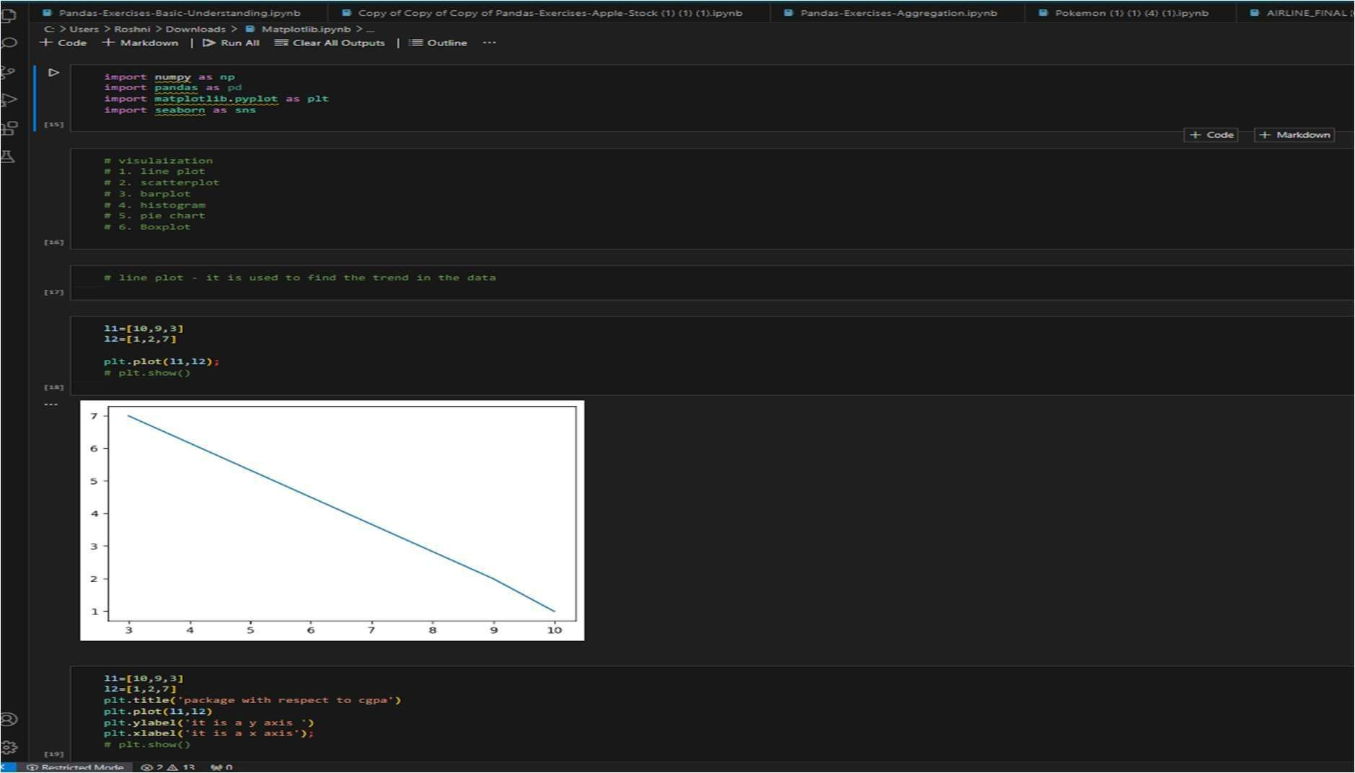

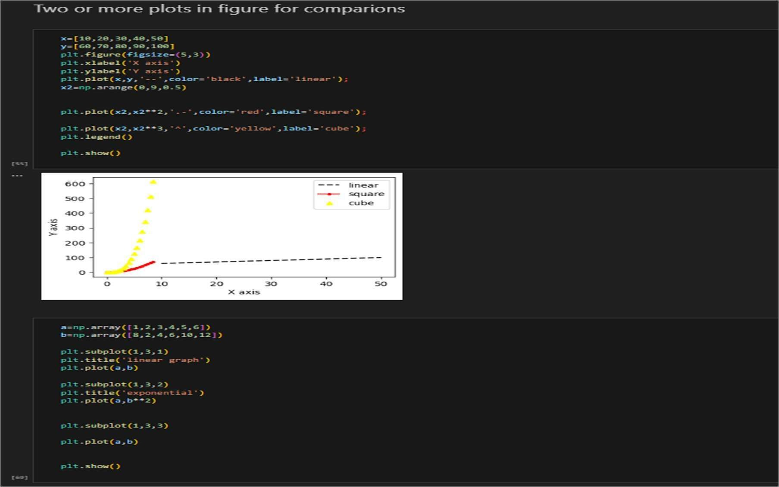

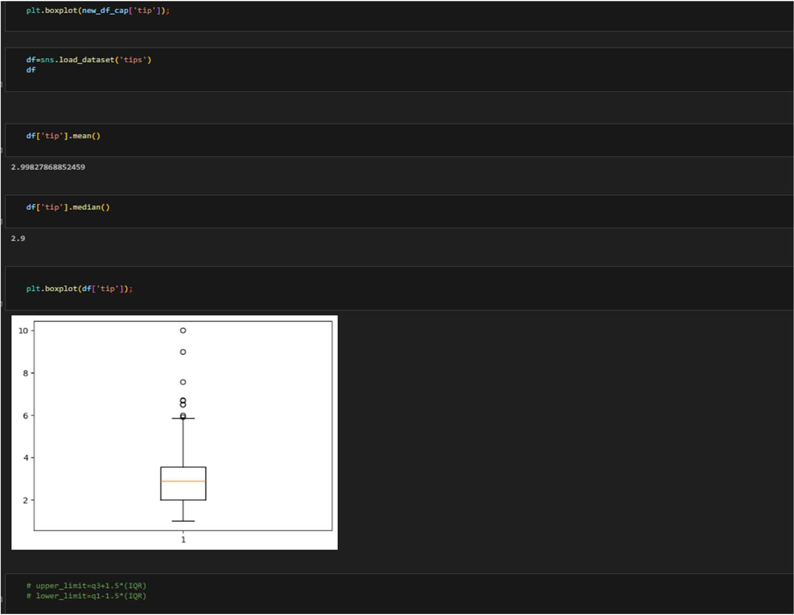

**25-03-2025 Training Day – 35**

# Topic: Exporting Processed Data

* Saved cleaned and processed datasets to CSV and Excel formats.
* Example: Exported a cleaned DataFrame to cleaned_data.xlsx.

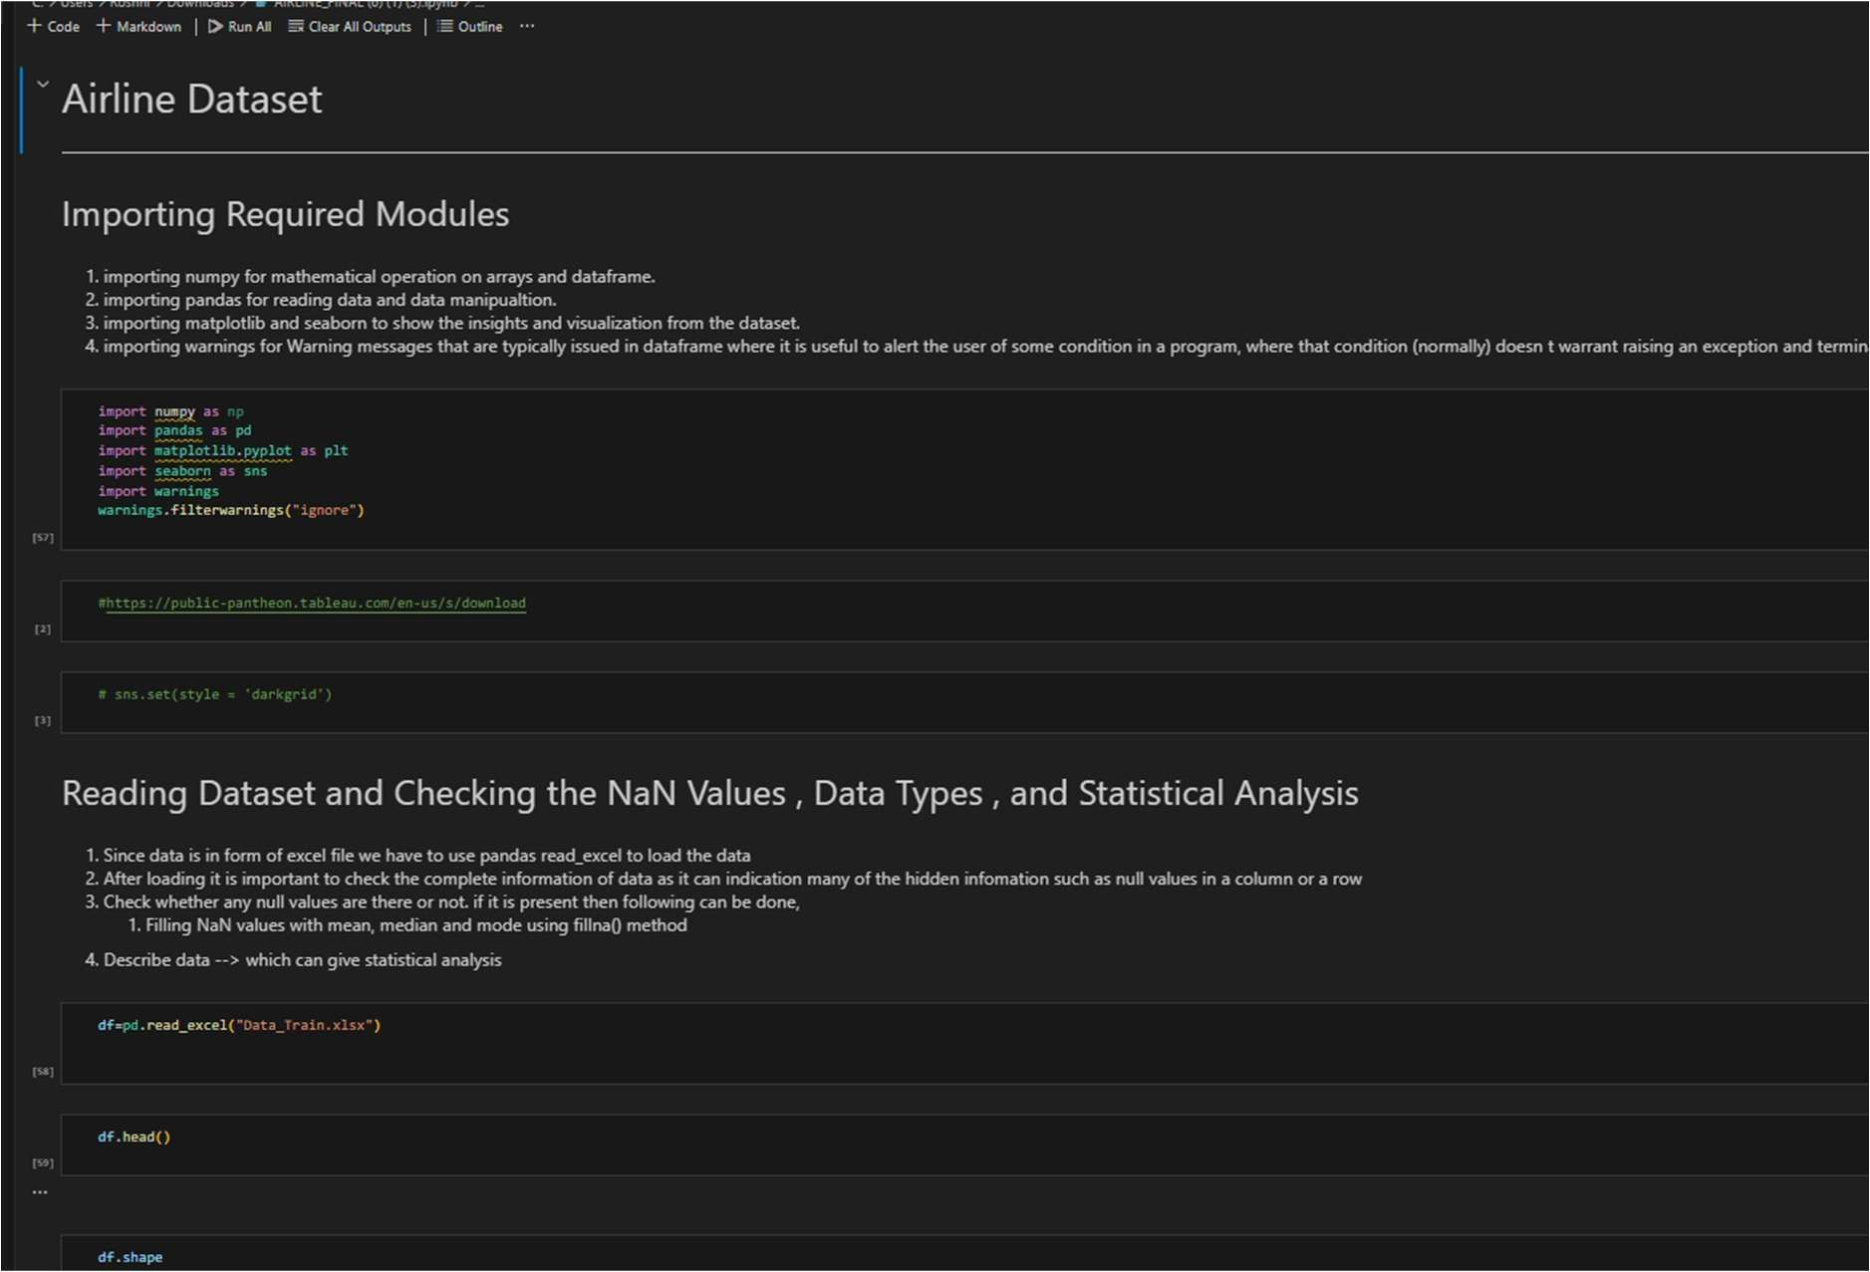

DATA IN XLSX

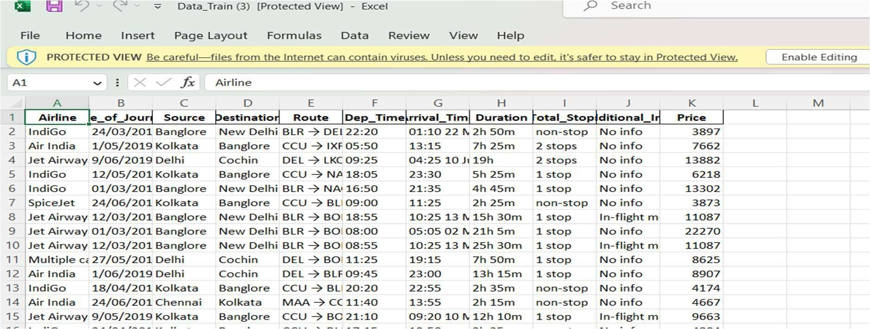

**26-03-2025 Training Day – 36**

# Topic: Revisiting Data Cleaning Techniques

* Practiced handling outliers and formatting columns.
* Example: Removed outliers using the interquartile range (IQR).

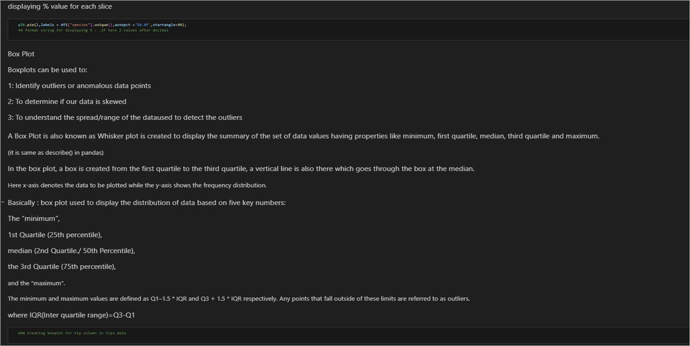

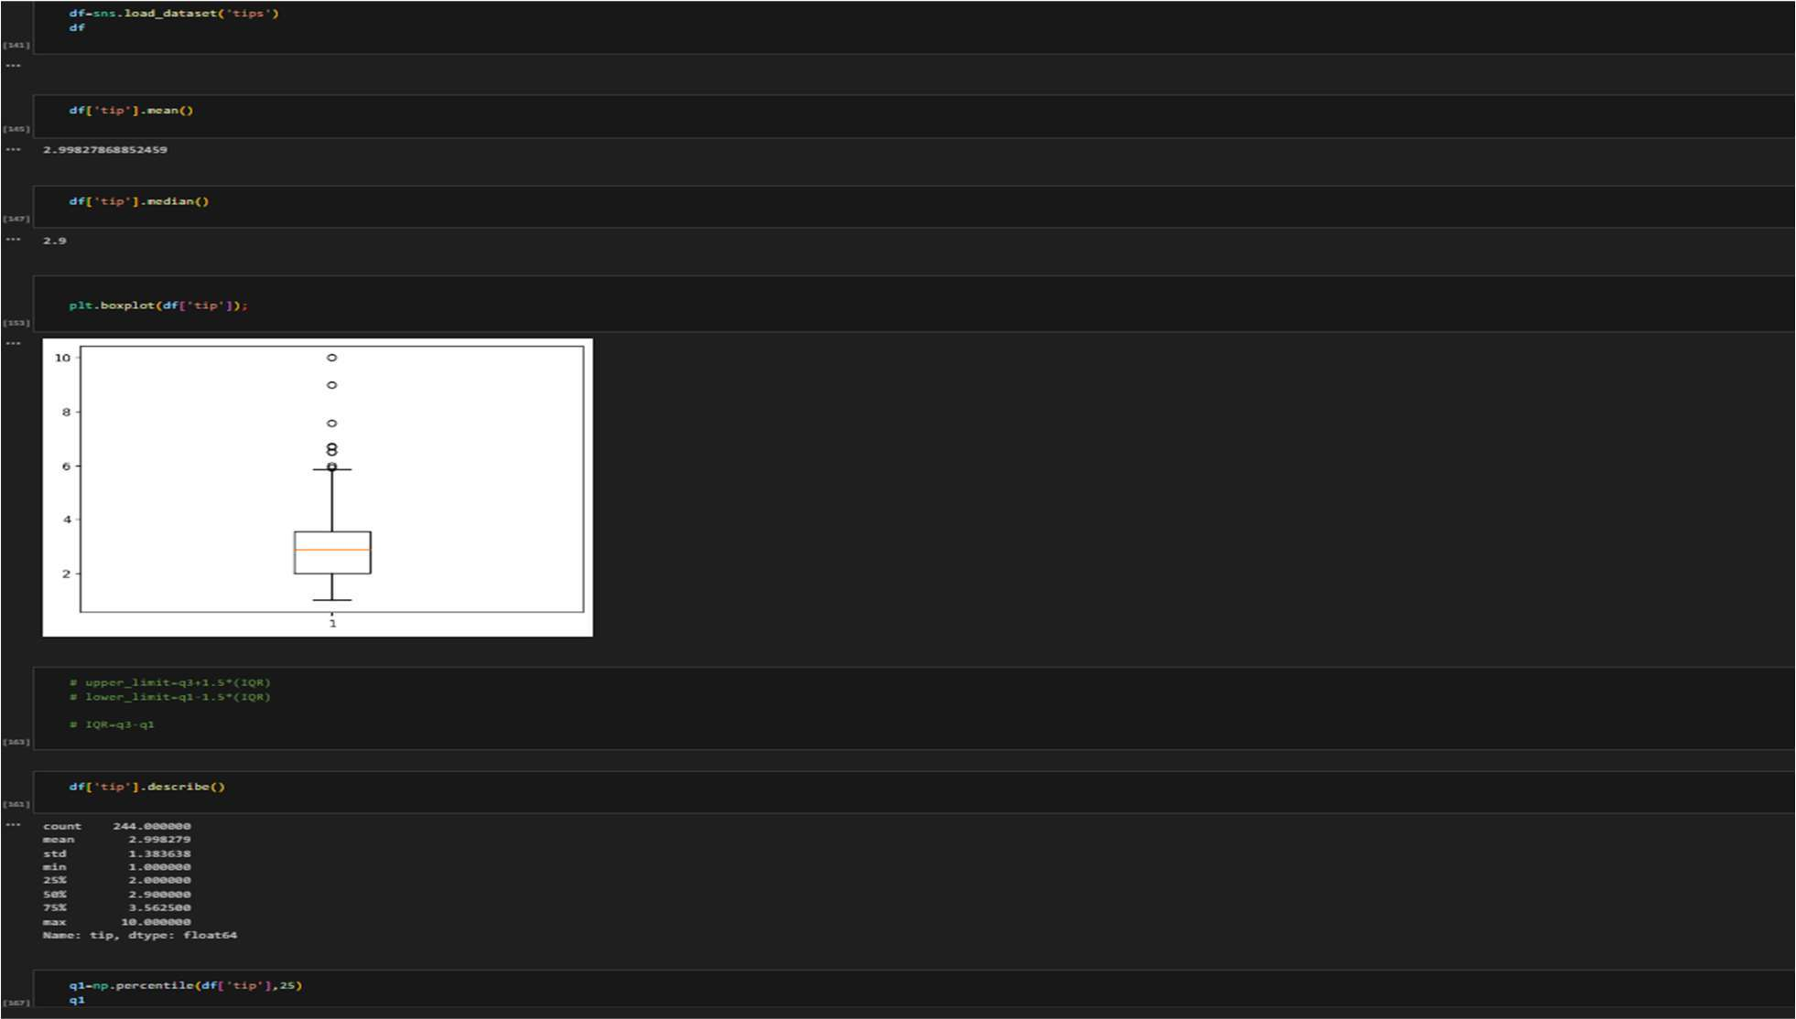

**27-03-2025 Training Day – 37**

# Topic: Combining Multiple Datasets

* Consolidated datasets into a single clean dataset.
* Example: Used a combination of concat() and merge() for integration.

Combining datasets from different sources or files is a common task in data cleaning and analysis. By integrating datasets into one consolidated clean dataset, you can work with a complete set of information for further analysis or modeling. Two commonly used methods for combining datasets are concat() and merge() functions in Python, particularly with the **Pandas** library.

1. Concatenating Datasets with **concat()**

The concat() function is used to combine datasets along a particular axis (rows or columns). It’s useful when datasets have the same structure (e.g., same columns) but come from different sources or time periods.

### Example: Concatenating DataFrames by Rows

Suppose you have two DataFrames with identical columns but different rows (e.g., two sets of data collected over different months).

**import pandas as pd**

# Sample DataFrames df1 = pd.DataFrame({

'ID': [1, 2, 3],

'Value': [10, 20, 30]

})

df2 = pd.DataFrame({ 'ID': [4, 5, 6],

'Value': [40, 50, 60]

})

# Concatenate by rows (axis=0)

df_combined = pd.concat([df1, df2], axis=0, ignore_index=True) print(df_combined)

### Example: Concatenating DataFrames by Columns

If your datasets contain different features (columns), you can concatenate them side by side.

# Concatenate by columns (axis=1) df_combined_columns = pd.concat([df1, df2], axis=1) print(df_combined_columns)

### Output:

Copy code

ID Value ID Value

0 1 10 4 40

1 2 20 5 50

2 3 30 6 60

1. Merging Datasets with **merge()**The merge() function is used when datasets share common columns, and you want to combine them based on matching values. It’s similar to a SQL join (inner, outer, left, or right join).

### Example: Merging DataFrames on Common Columns

If you have two DataFrames with a common column (e.g., "ID"), you can merge them to consolidate their information.

python Copy code

df1 = pd.DataFrame({ 'ID': [1, 2, 3],

'Name': ['Alice', 'Bob', 'Charlie']

})

df2 = pd.DataFrame({ 'ID': [1, 2, 4],

'Value': [100, 200, 300]

})

# Merge on 'ID'

df_merged = pd.merge(df1, df2, on='ID', how='inner') print(df_merged)

### Output:

Copy code

ID Name Value

1. 1 Alice 100
2. 2 Bob 200

**28-03-2025 Training Day – 38**

# Topic: Advanced Visualizations

* + Created multi-line plots to compare trends.
  + Example: Compared monthly sales for different products.

Advanced visualizations go beyond simple charts to provide deeper insights into complex datasets. These visualizations can help reveal patterns, trends, and relationships that are not immediately apparent with basic plots. Below are some advanced techniques and types of visualizations that are commonly used in data analysis and data science.

1. Heatmaps
   * **Use:** To represent data in a matrix format, where individual values are displayed with color gradients. It’s often used to visualize correlation matrices, missing data, or any other form of numerical relationships.
   * **Why:** It quickly shows the relationships and magnitude of values across a two- dimensional space.
   * **Tools:** Seaborn, Matplotlib, Plotly.
   * **Example: Correlation Matrix Heatmap**



