
Assignment Front Cover Sheet

Student Name: | Obanor Tehilla
Student ID: | 14619616
Degree Title: | FINANCIAL TECHNOLOGY
Level: | MASTER’S
Module Title: | Postgraduate Professional Practice Project AFE
Module Code: | 7028AFE
Seminar Lecturer: | Chi Tran

Assignment Title: | 7028AFE Postgraduate Professional Practice Project
Word Count: | 16,292

Link:  To shared files, wordpress.com Blog, etc. | https://docs.google.com/document/d/16qeHeyFelMt64LdxHcjgaqV2J435E-N6v25RqJe7fT8/edit?usp=sharing  https://obanort5.wordpress.com/

By submitting this assignment, I confirm that:

- I have read and understood the University’s Academic Integrity Guidance and that in the attached submission I have worked within the expectations of the Regulations Governing Academic Integrity.
- I am aware that failure to act in accordance with Appendix 1 of the General Regulations may lead to the imposition of penalties which, for the most serious cases, may include termination of studies.
- I consent to the University copying and distributing any or all of my work in any form and using third parties (who may be based outside the UK/EU) to verify whether my work contains plagiarised material, and for quality assurance purposes.

Academic Integrity Declaration:

I, [obanor tehilla], am aware of the requirements of good academic practice and the potential penalties for any breaches.

I, [obanor tehilla], confirm that this submission is my own work and I accept all responsibility for any copyright infringement that may occur as a result of this submission.

Date of Submission: | 18, Aug ,2025

SOVEREIGN DEBT DEFAULT PREDICTION: ENHANCING ACCURACY AND INTERPRETABILITY WITH A HYBRID MACHINE LEARNING FRAMEWORK

by

OBANOR TEHILLA

A Master Thesis Submitted to
Coventry University
In Fulfillment of The Requirements For a Master Degree
August 2025

EXECUTIVE SUMMARY
Accurately predicting sovereign debt defaults remains a critical challenge in international finance, particularly for volatile economies where traditional models underperform.Sovereign debt defaults has a persistent challenge for global financial systems, particularly in low and middle income countries where economic volatility, political uncertainty, and external shocks converge. Traditional econometric models, though widely used in sovereign risk assessments, often fail to predict these events accurately due to their rigid assumptions and inability to capture nonlinear relationships. More critically, such models lack transparency, limiting their practical value for real time policy interventions.
This research develops a hybrid machine learning framework that combines the strengths of XGBoost and attention based LSTM networks, enhanced with SHAP explainability, to predict sovereign debt default more accurately and transparently. The model is trained on a comprehensive dataset covering macroeconomic, political, and global financial indicators across 68 countries from 1980 to 2022. Its objective is to improve the predictive power and interpretability of early warning systems in sovereign debt analysis.This is to the best of our knowledge the first study to apply a fully explainable hybrid model to sovereign default risk across four decades of global data.
Empirical results show that the proposed hybrid model significantly outperforms traditional logistic and probit regressions, with ROC-AUC values between 0.68 and 0.72, and recall rates for defaults reaching 42% a critical improvement in rare event forecasting. SHAP analysis uncovers key drivers of default risk, including election cycles, global interest rates, fiscal deficits, and external debt levels. These insights validate the model’s internal logic and offer policymakers timely, interpretable signals for intervention.
By addressing the trade off between model complexity and interpretability, this thesis closes a crucial gap in sovereign risk forecasting literature. It offers a scalable, policy relevant tool capable of supporting real time debt surveillance and enhancing institutional readiness in the face of emerging global financial threats.

ACKNOWLEDGEMENT

I would like to express my eternal gratitude to God Almighty for granting me the strength, wisdom, and perseverance to complete this thesis.
My heartfelt appreciation goes to my supervisor, Chi Tran, for her invaluable guidance, constructive feedback, and patience throughout this journey. Your insights shaped the clarity and depth of this research.
I am especially thankful to my parents for their unwavering love, prayers, and belief in me. Your encouragement has always been my foundation.
Special thanks also to my lecturers at Coventry University , whose teachings inspired the academic curiosity that drove this research forward.
I acknowledge my colleagues, especially those who offered advice, peer reviews, or simply reminded me to take breaks. Your presence made this process more human.
I would also like to acknowledge the assistance of AI based tools such as ChatGPT 4o model,Grammaly which supported idea refinement, formatting, and preliminary editing throughout this thesis and tools like Heuristic and Mendeley to find and organise papers and references.
Lastly, I extend my gratitude to the institutions and researchers whose data, models, and prior work paved the way for this study on sovereign debt prediction.

TABLE OF CONTENTS
EXECUTIVE SUMMARY 4
ACKNOWLEDGEMENT 5
TABLE OF CONTENTS 6
LIST OF FIGURES 8
LIST OF TABLES 9
LIST OF ABBREVIATIONS 10
Chapter 1:Introduction 1
1.1 Background 1
1.2 Importance 3
1.3 Research Purpose 3
1.4 Research Questions 4
1.5 Hypotheses 4
1.6 Contribution and Justification 5
1.7 Disposition of the Thesis 5
Chapter 2 : LITERATURE REVIEW 6
2.1 Scope 6
2.2 Theoretical Background 6
2.3 Case Studies 7
2.4 Traditional Econometric Approaches 8
2.5 Machine Learning Approaches to Sovereign Debt Prediction 9
2.5.1 Variable Selection and Justification in Sovereign Risk Models 11
2.6 Explainable AI in Sovereign Debt Prediction 13
2.7 Hybrid Models and Ensemble Approaches 14
2.8 Existing Literature 15
2.8.1 Critical Analysis 16
2.8.2 Predictive Performance vs. Simpler Models 17
2.8.3 Opacity and Interpretability 18
2.8.4 Balancing Complexity, Data, and Interpretability 20
2.9 conclusion 22
Chapter 3 : METHODOLOGY 23
3.1 Research Purpose 23
3.2 Research Approach 23
3.2.2 Cross‑Validation and Robustness Checks 25
3.3 Research Strategy 26
3.4 Data Collection 27
3.4.1 Sample Selection 28
3.5 Model and Data Analysis Methods 29
3.5.1 Baseline Model Justification 32
3.5.2 Hybrid Model Architecture 33
3.6 Ethical Considerations 35
3.7 Frame of Reference 36
Chapter 4 : Results 40
4.1 Descriptive Statistics 40
4.2 Feature Selection 45
4.3 Model Comparison 47
4.4 Interpretability 53
4.4.1 SHAP Interpretability 55
4.4.2 XGBoost model interpretability 59
4.5 Robustness Checks 63
Chapter 5 : CONCLUSION 68
5.1 Overview and Objectives Recap 68
5.2 Model Performance and Key Findings 68
5.3 Benchmark Models and Justification for ML 69
5.4 Limitations of the Study 73
5.5 Risks of Model Misuse or Overreliance 74
5.6 Policy-Relevant Predictors 74
5.7 SHAP Model Trade-offs and Anomalies 75
5.8 Institutional Application 76
5.9 Final Answer to Research Questions 76
5.10 Future Research Directions 77
5.11 Final Conclusion 78
REFERENCE 79
APPENDIX 83
REFLECTION OF PROFESSIONAL PRACTICES 98

LIST OF FIGURES
Figure 3.1. Conceptual Framework for Sovereign Debt Default Prediction............................... 41
Figure 4.1 . Statistical data of class distribution for default ....................................................... 45
Figure 4.2 . Box plot of default status distribution based on each feature ................................ 46
Figure 4.3 . Ranking of feature importance ............................................................................... 47
Figure 4.4 . Hybrid Model ROC curve ....................................................................................... 49
Figure 4.5 . Extreme Gradient Boosting (XGBoost) model ROC curve...................................... 51
Figure 4.6. Precision comparison between the hybrid model and XGBoost.............................. 54
Figure 4.7 SHAP Hybrid Model Feature Impact ........................................................................ 55
Figure 4.8. SHAP global feature importance ranking for hybrid model...................................... 57
Figure 4.9 SHAP beeswarm plot for the standalone XGBoost model........................................ 59
Figure 4.10 SHAP global feature importance ranking for the standalone XGBoost model........ 60
Figure 4.11 Paired t-test results comparing performance metrics across models.................…..61
Figure 5.1 linear and nonlinear relationship...................................................................…..68
Figure 5.2 limitation of probit model ..................................................................................…..71

LIST OF TABLES

Table 4.1: Descriptive Statistics of Key Variables (1980–2022) ............................................. 42
Table 4.2 : Comparison of model results …………………………………................................. 48

LIST OF ABBREVIATIONS

ABBREVIATIONS | Definition
AUC | Area Under the Curve
BIS | Bank for International Settlements
CDS | Credit Default Swap
GDP | Gross Domestic Product
ICRG | International Country Risk Guide
IMF | International Monetary Fund
LIME | Local Interpretable Model agnostic Explanations
LSTM | Long Short Term Memory
ML | Machine Learning
RNN | Recurrent Neural Network
ROC | Receiver Operating Characteristic
SHAP | SHapley Additive exPlanations
SMOTE | Synthetic Minority Oversampling Technique
SVM | Support Vector Machine
UNCTAD | United Nations Conference on Trade and Development
UN | United Nations
VIX | Volatility Index
WGI | Worldwide Governance Indicators
XAI | Explainable Artificial Intelligence
XGBoost | Extreme Gradient Boosting

Chapter 1:Introduction
Sovereign debt refers to a national government’s total financial obligations to domestic and foreign creditors, usually through bonds and loans. Sovereign debt defaults occur when countries fail to meet these debt obligations, triggering wide ranging consequences, including currency devaluation, investor panic, and regional contagion (Reinhart & Rogoff, 2009). As a result, sovereign debt poses a serious threat to global financial stability and national welfare (Mallucci, 2021). Early warning systems for sovereign default risk are critical for policymakers, investors, and international financial institutions (IMF, 2023). However, reliable prediction remains difficult due to the fact that complex interplay of macroeconomic, financial, and political factors influencing sovereign risk (Savona & Vezzoli, 2013). Traditionally, economists have relied on statistical techniques such as probit and logit models or indicator based thresholds to forecast debt crises, but these models often have insufficient predictive power and fail to capture nonlinear patterns (Manasse et al., 2003).
While many machine learning applications exist in credit risk, few combine XGBoost, LSTM networks, and SHAP explainability specifically for sovereign default prediction. This thesis addresses this research gap by proposing a hybrid machine learning framework that integrates ensemble methods and deep learning to improve prediction accuracy while offering interpretable insights into the drivers of sovereign default. The proposed model is empirically validated using macroeconomic and political data from a diverse set of emerging and developed countries between 1980 and 2022, ensuring robustness and cross contextual generalizability.

1.1 Background
Historically, sovereign debt crises have affected both emerging and advanced economies. Notable examples include the Latin American debt crisis of the 1980s, Russia in 1998, Argentina in 2001 and 2014, and Greece during the 2010 Eurozone crisis (Tomz & Wright, 2007; Savona & Vezzoli, 2013). These crises exposed limitations in traditional early warning models, which missed key signals due to linear assumptions and rigid thresholds. Econometric techniques such as logistic regression and probit models demonstrate limited flexibility to capture complex, nonlinear interactions between economic and political variables, resulting in poor predictive performance and frequent false positives (Manasse et al., 2003; Fuertes & Kalotychou, 2007).
Recent research demonstrates that machine learning (ML) models offer considerable promise for forecasting financial risk, including sovereign defaults. Ensemble methods like XGBoost and Random Forests, and deep learning models such as long short term memory (LSTM) networks, can identify intricate nonlinear relationships in large, high dimensional datasets (Chen & Guestrin, 2016; Siami-Namin & Siami-Namin, 2018). These methods have shown strong predictive power in areas such as credit risk and macroeconomic volatility (Hellwig, 2021; Alaminos et al., 2021). Moreover, a major drawback of these advanced models is their perceived black box nature. This absence of interpretability limits practical adoption in policy environments where transparency and trust are essential (Bussmann et al., 2020).
Explainable artificial intelligence (XAI) tools such as SHapley Additive Explanations (SHAP) have been developed to address this challenge by quantifying the contribution of each input variable to model predictions (Lundberg & Lee, 2017). SHAP has enhanced transparency in financial applications, improving trust and supporting policy alignment (Hacibedel & Qu, 2022; Ariza-Garzón et al., 2020). Despite the development, such tools remain underutilised in sovereign default prediction.
This research proposes a hybrid modelling framework integrating ensemble learning via XGBoost, sequence modelling through attention based LSTM networks, and SHAP interpretability. This approach captures both the cross sectional heterogeneity of macro financial indicators and their temporal evolution while offering interpretable risk signals. The model is tested on annual macroeconomic and political data from 68 countries between 1980 and 2022, providing a robust basis for early warning systems and data driven policy responses.

1.2 Importance
Sovereign debt crises have repeatedly posed systemic risks to global financial markets and domestic stability, particularly in developing economies. As global debt levels surpassed 92% of global GDP since 2022 (IMF, 2023), anticipating sovereign defaults has become an urgent concern for policymakers and international institutions. Defaults often trigger currency collapse, capital flight, and political unrest. Traditional early warning systems rely on rigid thresholds and linear assumptions that fail to capture the complexity of modern financial systems. Moreover, their lag in responding to macroeconomic and political shifts reduces their effectiveness for real time monitoring.
Previous research demonstrates that machine learning models offer considerable promise for detecting subtle nonlinear patterns that may precede a default. Thus their limited interpretability has hindered adoption in policy settings where transparency is non negotiable. This study is significant because it proposes a hybrid model that integrates ensemble learning, deep learning (LSTM), and explainable AI (SHAP), offering both improved predictive accuracy and actionable insights. By emphasising both prediction and interpretability, this research directly addresses key challenges in sovereign risk monitoring and contributes a practical tool for early warning system design.

1.3 Research Purpose
This research aims to design, implement, and evaluate a hybrid machine learning model combining XGBoost and attention based LSTM networks, enhanced with SHAP interpretability, for sovereign default prediction. The primary objective is to assess whether this hybrid model significantly outperforms traditional econometric approaches, such as probit regression, in predictive accuracy and interpretability.
While sovereign default modelling has been studied using classical approaches, few studies have integrated advanced machine learning, deep learning, and explainable AI frameworks specifically for sovereign defaults. no one has combined XGBoost, LSTM, and SHAP in sovereign debt default prediction, which this thesis addresses.This thesis bridges that gap by providing a novel technical approach and interpretable outputs that policymakers can trust, contributing to a limited but growing body of literature.

1.4 Research Questions
- To what extent does the proposed hybrid model (XGBoost + attention based LSTM) improve predictive accuracy compared to traditional econometric models?
- How can SHAP based interpretability enhance the transparency, usability, and trustworthiness of machine learning models for sovereign risk assessment?
- Which macroeconomic and political indicators emerge as the most influential predictors of sovereign default risk across emerging and developed economies?
- Can the hybrid model be feasibly implemented as a practical early warning system to support real time sovereign debt surveillance and policy decision making?

1.5 Hypotheses
H1: A hybrid predictive model achieves superior predictive accuracy and interpretability compared to standalone machine learning or econometric models.
H2: SHAP significantly improves interpretability of models compared to raw model outputs.
Null hypotheses:
H0₁: A hybrid predictive model does not achieve superior predictive accuracy and interpretability compared to standalone machine learning or econometric models.
H0₂: SHAP does not significantly improve interpretability of models compared to raw model outputs.

1.6 Contribution and Justification
This thesis proposes and empirically validates a novel hybrid model that integrates XGBoost, attention based LSTM, and SHAP interpretability. Unlike prior studies relying solely on econometric models or black box machine learning, this framework balances predictive performance with transparency.
The architecture captures both cross sectional complexity and temporal dynamics, two dimensions often treated separately in prior research (Savona & Vezzoli, 2015; Alaminos et al., 2021). SHAP explanations make predictions actionable and accessible to policymakers (Lundberg & Lee, 2017; Hacibedel & Qu, 2022).
The justification for this research lies in addressing three limitations of existing literature first of all the inability of traditional models to capture nonlinear interactions (Manasse et al., 2003); And the black box nature of many machine learning applications (Bussmann et al., 2020); finally the failure to incorporate key global variables such as US interest rates, oil prices, and election cycles (Reinhart & Rogoff, 2009; Mallucci, 2021). This study offers a methodological advancement and delivers a practical, explainable framework suitable for policy environments.
Beyond technical novelty, the framework enables scenario simulations, institutional trust, and actionable early warnings reflecting current macro financial conditions and evolving risks.

1.7 Disposition of the Thesis
This thesis is organised into five chapters. Chapter one will introduce the background, research questions, and hypotheses. While Chapter two presents the literature review and theoretical context. Chapter three describes the methodology, including data, model design, and evaluation metrics. Finally Chapter four presents empirical results, and Chapter five will provide conclusions and discussion.

Chapter 2 : LITERATURE REVIEW

2.1 Scope
This review critically examines literature that relates to sovereign debt default prediction, focusing on traditional econometric approaches, machine learning (ML) advancements, and explainability frameworks. The scope includes historical economic crises, methodological developments in predictive analytics, and interpretability practices within financial forecasting.
To enhance clarity and maintain focus, broader macroeconomic theories such as general equilibrium models, Keynesian fiscal multipliers, or global growth cycle theories were excluded from this review. While these frameworks will provide valuable insights into national economic performance, they are not directly concerned with the mechanisms or technical modelling of sovereign debt default. Including them would risk diluting the predictive focus of this study and shifting attention away from the variables, models, and techniques specifically used to forecast default risk. Therefore, only theories with direct relevance to sovereign credit events and early warning systems were retained.

2.2 Theoretical Background
Sovereign default theories stem from foundational economic concepts including debt intolerance, debt sustainability analysis, and the distinction between liquidity and solvency crisis. The strategic default model by Eaton and Gersovitz (1981) introduced the idea that countries may choose to default based on a cost benefit analysis, highlighting the role of strategic behaviour under credit constraints. While influential, such models offer limited predictive application due to their theoretical abstraction and constrained empirical flexibility. More recent theoretical contributions emphasise the importance of nonlinear dynamics and threshold effects in sovereign default processes. For example, small changes in external interest rates or fiscal balance can lead to disproportionately large shifts in default probability once critical levels are crossed, a feature that traditional linear econometric models often fail to detect (Reinhart, Rogoff, & Savastano, 2003; Detragiache & Spilimbergo, 2001).
These nonlinearities and tipping points directly inform the design of this study's hybrid modelling approach. Ensemble methods such as XGBoost are well suited to capture complex, non additive interactions between economic indicators, while recurrent neural networks like LSTM are capable of identifying temporal thresholds and patterns in country level time series. By integrating these models, the hybrid framework aligns with modern theoretical understanding that default risk is not simply additive or linear, but evolves through interaction and feedback. This alignment ensures that the empirical strategy is responsive to the conceptual realities underpinning sovereign financial distress.

2.3 Case Studies
Despite their widespread use, linear econometric models often failed to anticipate key tipping points in major sovereign crises. For example, during Argentina’s 2001 crisis, implied default probabilities derived from bond prices increased sharply from approximately 19.4 per cent to 45.5per cent between October and December 2001, indicating that market recognition of the crisis occurred only after substantial economic deterioration had already begun (Mendoza & Ostry, 2008). In the case of Greece in 2010, estimated default probabilities rose from under 5 percent to around 40 per cent within weeks before falling back below 10 percent following the announcement of the EU and IMF intervention (Savona & Vezzoli, 2015). These abrupt and nonlinear shifts highlight the limitations of traditional regression based approaches, which struggle to capture sudden, context dependent accelerations in sovereign risk. Such empirical breakdowns underscore the need for more flexible modelling strategies, such as hybrid machine learning architectures that combine XGBoost for nonlinear pattern detection with LSTM networks for learning risk evolution over time.While traditional econometric models such as logit, probit, and Cox regression provide interpretability, they rely a lot on assumptions of linearity and independence that rarely hold in sovereign debt dynamics. These simplifications risk underestimating contagion effects, feedback loops, and structural breaks, limiting their policy relevance in volatile contexts.

2.4 Traditional Econometric Approaches
Traditionally, logistic regression, probit models, and discriminant analysis have dominated sovereign default prediction. Manasse and Roubini (2009), among others within the IMF, have extensively used these methods and found moderate predictive capabilities. Their main strengths lie in interpretability and simplicity; however, these models struggle with nonlinearity and complex interactions. Such limitations often result in poor out of sample performance and excessive false positives.
A concrete example is found in the Greek sovereign debt crisis, econometric models relying on logistic or probit specifications failed to adjust to shifting risk environments. During 2010, out of sample default probabilities remained under 10 per cent, but real events drove bond default spreads well above 40 per cent, a divergence that traditional models did not capture (Savona & Vezzoli, 2013). Comparatively, studies confirmed that tree based methods such as random forests correctly identified approximately 75 per cent of fiscal stress or default events, outperforming logit models whose early warning accuracy hovered around 65 per cent (Jarmulska, 2020). This evidence underscores the inadequacy of linear approaches in capturing sudden shifts in sovereign risk, justifying the shift toward more flexible machine learning methods that can model nonlinear thresholds and complex feature interactions.

Traditional econometric models underperform in sovereign debt prediction primarily due to their restrictive assumptions. First, they rely on rigid functional forms such as the logit or probit link functions that assume linear relationships between predictors and default probability. This rigidity fails to capture real world nonlinear threshold effects and interacting risk triggers such as simultaneous spikes in debt and political instability (Jarmulska, 2022). Second, the assumption of independence across observations is violated in panel data, where macroeconomic shocks are serially correlated and exhibit heteroskedasticity, leading to biased parameter estimates. Third, as models include more variables, particularly macroeconomic and political ones, they become susceptible to multicollinearity and overfitting, reducing forecasting accuracy. For instance, in fiscal stress prediction, random forest models which can handle correlated predictors achieved 78–80% accuracy compared to 70–75% for probit specifications, revealing traditional models’ inability to manage high dimensional data (Jarmulska, 2022). Finally, econometric models are inherently static, unable to account for temporal dynamics such as debt accumulation or successive fiscal shocks. This omission leads to missed early warning signals when multiple years of adverse changes build up. While these models remain transparent and easily interpretable, their limitations in capturing complexity, dynamics, and nonlinearity justify the adoption of models such as hybrid XGBoost/LSTM architectures that address these very weaknesses.Econometric models such as logit, probit, and hazard rely on assumptions of linearity and error independence, which are seldom met in sovereign datasets. Defaults are rare events, and most studies understate how class imbalance distorts estimation, leading to inflated accuracy but poor recall.Although machine learning approaches improve predictive accuracy, their performance is often highly sensitive to hyperparameter tuning and dataset composition. A lack of standardized benchmarks across studies also raises concerns about reproducibility and comparability of results in sovereign default prediction.

2.5 Machine Learning Approaches to Sovereign Debt Prediction
Advances in machine learning, particularly ensemble methods like Random Forests, XGBoost, and neural networks such as RNNs, have led to significant gains in sovereign default forecasting accuracy. For instance, Hellwig (2021) found that by employing ML techniques such as Elastic Net, Random Forests, and Gradient Boosted Trees, they improved out of sample crisis prediction accuracy by approximately 10 percentage points compared to traditional econometric models. Similarly, a comparative study on sovereign risk modelling demonstrated that XGBoost achieved superior out of sample and out of time performance, increasing classification accuracy from around 85% to 94% over logistic regression benchmarks. Despite these clear performance improvements, these methods are often critiqued as black boxes, which limits their adoption in policymaking contexts that require transparent and interpretable models.

Empirical comparisons in sovereign debt and related credit risk models reveal that not all machine learning methods perform equally. A recent study on sovereign debt ratings in South Africa compared 14 ML algorithms and found that XGBoost, Random Forest, and Gradient Boosted Machines consistently outperformed traditional logistic regression and simpler models, achieving the highest AUC and precision scores (Takawira, 2024).Meanwhile, Support Vector Machines (SVM) and Naïve Bayes delivered notably weaker performance, often ranking at the bottom of the ML methods tested (Takawira, 2024). In broader credit risk applications, Deep Neural Networks (DNNs) have occasionally surpassed boosting methods. Bhandary and Ghosh (2025) reported that DNNs outperformed Random Forest and XGBoost for Taiwanese credit card default prediction when measured by F1 score and AUC. However, kernel based methods like SVM, while outperforming linear models slightly, consistently ranked below ensemble and deep learning techniques in both sovereign and microcredit contexts (Bhandary & Ghosh, 2025; Arram et al., 2023). These findings emphasise that while modern ML algorithms offer large gains in accuracy, careful model selection is essential, some advanced methods like DNNs may only marginally outperform well tuned ensemble models, and simpler models like Support Vector Machine (SVM) may be inadequate for capturing complex, nonlinear interactions in sovereign default data.
Over the past two decades, the application of machine learning in sovereign debt and credit risk prediction has progressed significantly, driven by advances in computational power, richer datasets, and algorithmic sophistication. Early efforts in the 2000s primarily relied on static models like decision trees and support vector machines, but by the 2010s, gradient boosting ( XGBoost) emerged as a dominant approach due to its ability to handle high dimensional data and capture nonlinear patterns (Chen & Guestrin, 2016). However, LSTMs require long, dense datasets, while XGBoost handles sparsity better making a hybrid more realistic for sovereign debt contexts.Concurrently, the introduction of recurrent neural networks, especially long short term memory (LSTM) architectures, enabled researchers to model time dependent features and dependencies across multi year economic sequences (Siami‑Namin & Siami Namin, 2018). More recently, hybrid models combining ensemble methods and deep learning ( XGBoost + LSTM) demonstrated notable improvements in credit risk forecasting. For example, Abid (2025) showed that a hybrid XGBoost + LSTM model outperformed standalone methods in predicting sovereign credit risk in MENA countries, particularly during periods of political stress. Similarly, Consoli et al. (2022) used LSTM networks to forecast Italian sovereign bond spreads more effectively than traditional econometric benchmarks. These methodological innovations have led to steady gains in predictive accuracy and the ability to handle temporal dynamics. Thus the challenge of interpretability persisted, spurring recent efforts to integrate SHAP with hybrid models for transparency in sovereign debt forecasting. This trajectory highlights the iterative refinement of tools, from simple models to powerful hybrid architectures, and now toward models that are not only accurate but also explainable providing the foundation for our proposed hybrid XGBoost + attention LSTM framework enhanced with SHAP. Machine learning models frequently achieve higher AUROC but often lack calibration checks, making outputs difficult to use for policy thresholds. Many studies underplay the risk of overfitting given the small number of default events globally, which limits external validity.

2.5.1 Variable Selection and Justification in Sovereign Risk Models
For a robust understanding of sovereign default risk, macroeconomic , political , fiscal and external variables are required to know which of these factors will influence a country's national debt sustainability . Debt to GDP ratio is among the most commonly known and used indicators , acting as a proxy for a country's indebtedness in relation to its economic capacity (Manase et al, 2003) . When extended into broader definitions that include liabilities or short term external debt , it offers a deeper insight into solvency conditions. Real GDP growth and its annual changes capture the economy’s resilience and ability to generate income for debt servicing. Several studies have shown that declining growth often foresees sovereign stress events , particularly when combined with rigid fiscal structures (Furtes, Kalotychou, 2007). Real GDP capital reflects underlying economic development and often correlates with institutional strength , another critical component of default vulnerability .
Inflation , fiscal balance , and trade openness are also some of the other key factors in determining a sovereign default risk . High inflation often signals monetary instability , which can deter investment and erode debt holders’ confidence , especially in developing economies (Savon &Vezzoli, 2015). A persistent fiscal deficit undermines credibility and can signal unsustainable borrowing , while trade openness influences external vulnerability to global shock . The inclusion of external factors like the US Federal Funds Rate and the global oil price index account for systematic spillovers and international market conditions, both of which have been shown to significantly affect borrowing cost and liquidity access in not only emerging markets but developed ones as well (Reinhart, Rogoff,2009).political variables such as election years , help capture the effect of electoral cycles on fiscal behavior, as governments may engage in opportunistic spending or delay reforms phenomena linked to heightened default probability in multiple empirical models (Mallucci , 2021), by integrating these diverse but theoretically grounded indicators into these. It aims to create a data driven model of sovereign risk detection that highlights both internal fundamentals and external pressure .
Aside from the traditional macroeconomic indicators , several alternative factors have been proposed to enhance the accuracy of sovereign default prediction models. Credit ratings from international agencies, though sometimes lagging, provide aggregated risk assessments that encapsulate market sentiment and institutional credibility (Mendoza & Ostry, 2008). Institutional quality indicators such as corruption indices, rule of law, and political stability have also shown predictive relevance, particularly in distinguishing between countries with similar economic profiles but differing governance standards (Kose et al., 2011). Exchange rate volatility and capital flow reversals are often early signs of external vulnerability, especially in economies with high levels of foreign denominated debt (Baldacci et al., 2011). Financial market indicators like sovereign bond spreads and CDS premiums are increasingly used as real time stress indicators, reflecting investor perception of default risk (Duan et al., 2012). Election years represent periods of heightened political uncertainty, which can directly affect sovereign creditworthiness. Theoretical and empirical studies like, Drazen & Easterly, 2001; Arellano, 2008 suggest that governments may pursue expansionary fiscal policies prior to elections, increasing debt burdens or reducing fiscal discipline, thereby elevating sovereign default risk. Moreover, shifts in political leadership during election years can alter debt management strategies and investor confidence. For these reasons, election year is included in this study as a binary explanatory variable to capture temporal spikes in sovereign risk associated with political cycles. Lastly, some studies claim climate risk metrics, such as exposure to extreme weather or long term environmental fragility, are emerging as critical variables in debt sustainability discussions, but are uncertain due unpredictability and to low lying countries with resource dependent nations (Buhr et al., 2018). Incorporating such variables can provide a more holistic and forward looking view of sovereign risk, especially when combined with machine learning frameworks capable of handling multidimensional input.

2.6 Explainable AI in Sovereign Debt Prediction
Interpretability has gained traction with tools such as Shapley Additive Explanations (SHAP) and Local Interpretable Model Agnostic Explanations (LIME). For instance, Hacibedel and Qu (2022) illustrate SHAP’s efficacy in making ML models transparent by clearly attributing high predicted default risk to variables like high external debt and dwindling foreign reserves. A notable real world example comes from the peer‑to‑peer lending sector, where Ariza‑Garzón et al. (2020) showed that applying SHAP to an XGBoost credit‑risk model led to greater acceptance among regulators. Specifically, feature‑level insights revealed that borrowers with short credit histories were being unfairly flagged by the model, prompting a reevaluation of feature inclusion and model thresholds. This transparency not only reduced bias but also improved stakeholder trust and compliance. Attention layers do highlight input importance within sequences, but their outputs do not always correspond to true causal drivers in economic systems. Interpretability remains approximate, and over reliance on attention risks overstating the transparency of deep learning approaches.

Despite these advances, SHAP also has important limitations that complicate its use in high stakes settings. Firstly, computational cost is significant exact Shapley value calculation scales combinatorially, making SHAP slow or infeasible for large feature sets without approximations (Data Overload, 2022). Second, attribution results can be misleading or unstable when features are correlated; SHAP’s method marginalises over feature coalitions and may overstate or understate a feature’s importance (Stats.StackExchange user, 2021). Third, approximation errors are common datasets evaluated with TreeSHAP sometimes produce attribution rankings that diverge significantly from exact Shapley values, potentially leading to misinterpretation (Van den Broeck et al., 2020; Letoffe et al., 2024). Finally, the technical complexity of SHAP outputs can overwhelm non expert stakeholders, reducing practical transparency in policy contexts (Yang et al., 2023). These challenges mean that while SHAP improves explainability relative to black box ML models, its own opacity and computational demands can inadvertently obscure rather than clarify model insights.
In the context of sovereign debt prediction, these limitations highlight the need for a balanced approach. Rather than relying solely on SHAP outputs, models should integrate simpler summary metrics, feature level stability checks, and domain validation to ensure explanations are reliable and practically meaningful. This thesis addresses these challenges by combining SHAP with manual validation of feature effects, assessing correlation sensitivity, and simplifying explanations for policy audiences, ensuring that interpretability gains are not overshadowed by computational or conceptual complexity.

2.7 Hybrid Models and Ensemble Approaches
Hybrid modelling frameworks that combine econometric and machine learning techniques have gained traction for improving predictive power across various financial domains. For example, Li, Stasinakis, and Yeo (2022) developed a classifier that first uses XGBoost for feature selection and then employs a multilayer perceptron, resulting in a hybrid model that outperformed single method counterparts for credit risk assessment. Similarly, Chacko, Aravindhar, and Arokiasamy (2024) introduced a hybrid model integrating an RNN with XGBoost for credit scoring, which demonstrated a five to seven percentage point increase in classification accuracy compared to either model alone. These hybrid two stage frameworks have been applied successfully in credit and commodity markets, such as the ES‑RNN model in forecasting COVID‑19 mortality time series, which achieved notable reductions in forecast error metrics (Mathonsi & van Zyl, 2021).
While these hybrid structures enhance predictive accuracy by capturing both temporal and nonlinear feature interactions, their application to sovereign debt prediction remains limited. To the best of known knowledge, no prior study in sovereign default forecasting combines an attention‑based LSTM with XGBoost and explainable AI in a single hybrid architecture. This thesis addresses that gap by explicitly integrating sequential modelling of macro political indicators, nonlinear boosting for classification, and SHAP based interpretability, creating a transparent and empirically robust framework for real world sovereign risk analysis.Hybrid models combine strengths of ML and econometrics, but their complexity poses challenges for real world adoption. Literature rarely considers the trade off between marginal performance gains and usability for policymakers who may lack technical expertise.XGBoost is powerful for capturing nonlinearity and interactions, yet it is prone to overfitting in smaller or noisy sovereign debt datasets. Careful validation is required since default parameter settings may exaggerate performance when applied without rigorous tuning.

2.8 Existing Literature
While numerous hybrid and explainable ML approaches have emerged, few have successfully bridged the gap between technical performance and policy adoption in sovereign debt contexts. In related domains such as credit risk and fraud detection, interpretability has demonstrated practical influence. For instance, Jung et al. (2019) and Hadji Misheva et al. (2021) demonstrate that SHAP powered explanations in credit scoring not only improved regulatory acceptance but also helped reveal and address feature level biases in lending decisions, thereby enhancing transparency and stakeholder trust. Similarly, Mathonsi and van Zyl (2021) and Chacko et al. (2024) report that applying a hybrid LSTM + XGBoost model to financial time series not only improved forecast accuracy but also leveraged explainability to inform corporate risk management choices. These examples imply that explainable AI tools can play a pivotal role in making complex models actionable and credible in high stakes financial decision making. Moreover, applying this concept to sovereign default prediction warrants caution. Unlike credit scoring or fraud detection, where event rates are relatively higher and patterns more structured, sovereign defaults are rare events with significant heterogeneity across countries and time. The inclusion of such rare outcomes may impede model effectiveness by intensifying class imbalance, limiting learning opportunities for complex classifiers, and possibly reducing the reliability of post hoc explainability methods like SHAP, which depend on sufficient variation in both features and outcomes to generate stable and meaningful explanations. Thus, while explainable AI may enhance transparency, its integration into sovereign default models must carefully account for the challenges posed by sparsity, imbalance, and noise inherent in this domain. This highlights a tension, the very rarity of sovereign defaults. The reason early warnings are valuable may also constrain the effectiveness and interpretability of even the most sophisticated machine learning frameworks.
However, in the realm of sovereign debt prediction, explicit hybrid models combining sequence aware learning, nonlinear classification, and explainable AI are scarce. Previous work in sovereign risk has largely focused on standalone econometric or tree based models (Alaminos et al., 2021; Petropoulos et al., 2022) or used SHAP for post hoc interpretation (Hacibedel & Qu, 2022), but not within a structured hybrid architecture. This thesis directly addresses these gaps by integrating attention based LSTM and XGBoost within a single framework, enhanced with SHAP based explanations. The novelty lies not just in layering models, but in delivering a transparent, policy ready tool that policymakers and financial institutions can interpret, trust, and act upon rather than just observe through a black box lens.Some may argue that well tuned logistic or probit models are sufficient for sovereign default prediction, particularly due to their transparency and ease of estimation. Thus, this position underestimates the limitations these models face in capturing nonlinear interactions and temporal dynamics, especially in rare event contexts. As demonstrated in Section 4, logistic and probit models in this study produced near random classification performance, underscoring their limitations. Furthermore, interpretability alone is insufficient if the model lacks sufficient discriminatory power to inform policy decisions.

2.8.1 Critical Analysis
While ML methods undeniably improve predictive performance, the skepticism from policymakers due to opacity persists. Badia et al. (2022) note that ML doesn’t always outperform simpler models in limited data environments, stressing the necessity for balanced complexity and interpretability.Although Existing literature demonstrates a clear tension between accuracy and transparency. Traditional econometric models such as logit and probit provide interpretability but struggle with the non linearities and rare event structure of sovereign defaults. Machine learning approaches including neural networks and tree ensembles improve predictive accuracy but often suffer from opacity and overfitting given the limited number of observed defaults. Recent hybrid methods attempt to combine the strengths of both paradigms, yet they cannot fully overcome challenges such as the rarity of defaults, the smoothing effect of annualised data, or the political distortions present in sovereign debt reporting. While SHAP and attention mechanisms improve interpretability, they remain imperfect proxies for causal reasoning, and alternative methods such as counterfactual analysis or mixed frequency models could provide richer insights. This positions the present study not as a definitive solution, but as a step towards reconciling predictive accuracy with policy relevance, while recognising the persistent structural limitations that pervade the literature

2.8.2 Predictive Performance vs. Simpler Models
Across domains, evidence is mixed on whether complex ML models consistently outperform traditional simpler approaches. On one hand, several studies in economic and financial forecasting report gains from ML. For example, Bluwstein et al. (2023) apply ensemble tree methods to predict financial crises and find these flexible ML models significantly outperform a standard logistic regression early warning model. By calibrating models to catch 80% of crises, they show the best ML model can cut false alarms almost in half relative to logistic regression, from 18% to 31% false positives. This highlights ML’s strength in capturing complex nonlinear interactions among macro financial indicators, joint effects of credit booms and yield curve changes, that simpler models might miss. A clear strength of such research is demonstrating improved predictive power and new insights ,they identify rapid credit growth and yield curve inversions as key warning signals. Likewise, in sovereign risk forecasting, Hellwig (2021) finds that traditional econometric crisis models failed to beat even a naïve “rule of thumb,” whereas ML techniques such as random forests, gradient boosting which delivered significant out of sample accuracy improvements, especially after expanding the set of input predictors beyond the usual few variables. This suggests that when richer data are available, ML can harness it more effectively than linear models, a notable contribution since it underlines the importance of data breadth and algorithmic feature selection for improving forecasts.
On the other hand, multiple studies caution that ML’s edge is not universal. In data scarce settings, incremental gains can be modest. Badia et al. (2022) argue that with limited crisis observations, highly complex models risk overfitting noise and may fail to outperform parsimonious early warning models. Similarly, Chu & Qureshi (2023) compare popular methods for U.S. GDP growth forecasting and find that while ensemble ML bagging, boosting yields slight improvements at short horizons, for longer term forecasts, the differences vanish; a simple model using one strong predictor can outperform far more complex ML models. Such findings emphasise that context matters. ML can excel with high dimensional data and short term patterns, but for small samples or long horizon/macroeconomic predictions, well specified simpler models remain competitive. The quality of these comparative studies is generally high, Chu & Qureshi’s analysis is peer reviewed and rigorously out of sample, lending credibility to the result that complexity has diminishing returns in certain regimes. Overall, the literature suggests that researchers must justify added complexity with clear evidence of predictive gains; otherwise, simpler approaches with their robustness and transparency may suffice. While Chu & Qureshi (2023) advocate for the use of single predictor models in long horizon GDP forecasting, their findings do not necessarily generalize to sovereign default contexts. Unlike GDP, which is continuous and often smoother than national debt defaults , defaults are binary, infrequent, and subject to structural breaks. Thus, relying on one or two predictors may miss key turning points a risk policymakers cannot afford.Our study addresses this by carefully choosing model complexity appropriate for the data at hand and by statistically testing whether more complex techniques truly add predictive value over simpler benchmarks, rather than assuming ML is always superior.

These mixed findings emphasize that predictive accuracy alone is insufficient: methodological appropriateness and interpretability must be contextualized to dataset characteristics and user needs. Our study explicitly acknowledges this by tailoring model complexity to the sovereign default domain, where rare events and heterogeneous economic structures make transparency as vital as accuracy.While debt sustainability models provide useful thresholds, it may assume rational governments and efficient markets, which rarely hold in practice. Political incentives, hidden liabilities, and data opacity mean defaults often occur outside these predicted thresholds, exposing the limited predictive power of classical theory.

2.8.3 Opacity and Interpretability
A recurring critique in the literature especially from policymakers and regulators is the opacity of complex ML models. Even when ML improves predictions, lack of interpretability can impede trust and practical adoption. For instance, Bluwstein et al. (2021) note that their best crisis prediction ML model, being an ensemble of hundreds of trees, is essentially a “black box,” making it difficult to explain which risk factors drive its warnings. They acknowledge this as an “important issue” for policy use and respond by extracting Shapley values to rank predictors, an approach that reveals intuitive results, private credit growth, and yield curve slope as top contributors. This illustrates a strength of recent research. not only pushing accuracy, but also exploring explainable AI (XAI) tools to interpret models.
In the credit risk domain, where decisions affect borrowers and fall under strict regulation, scholars echo similar concerns. Chen et al. (2023) observe that banks have hesitated to deploy more complex classifiers despite potential accuracy gains, noting that although complex ML models may improve accuracy over simple logistic regressions, their limited interpretability has inhibited their adoption in credit risk assessment. Indeed, logistic regression remains the industry standard for credit scoring due to its transparency. Chen et al.’s contribution is a two stage “selective” model that tries to get the best of both worlds. It uses a simple logistic model for the majority of cases and falls back on a shallow neural network for instances where the linear model is insufficient, thus boosting accuracy on difficult cases while maintaining interpretability overall. They find most credit accounts are adequately handled by a logistic model, a reassuring point about the strength of simpler models, and only a minority require the nonlinear model, an elegant demonstration of balancing complexity with transparency in practice.
SHAP values are often adopted in financial risk modelling because they decompose predictions into feature contributions, offering a level of transparency absent in most black-box models. However, their stability is sensitive to feature correlation, a common property in macroeconomic datasets where debt, inflation, and growth are intertwined. In such contexts, SHAP may inflate the importance of collinear variables or mask causal direction, potentially misleading policymakers who expect interpretable signals for intervention. While SHAP remains more theoretically grounded than LIME, its reliance on additive explanations means it can oversimplify nonlinear dynamics, underlining the need for cautious integration rather than unquestioned acceptance.
Although SHAP values offer valuable local explanations, they carry important limitations in correlated settings. Kumar et al. (2021) demonstrate that, in nonlinear and correlated contexts, SHAP values may fail to capture true feature effects highlighted by the introduction of Shapley Residuals as diagnostic tools. Similarly, simulation results show that even modest correlations around 0.05 can distort SHAP values significantly, sometimes reversing their signs. In sovereign debt datasets where multicollinearity among, say, GDP growth, inflation, and debt levels is commonplace these issues could mislead interpretation, suggesting a need for cautious use.
opacity issue was addressed by incorporating interpretability techniques into the modelling process for example, using feature importance analysis and partial dependence plots to ensure the ML model’s behaviour aligns with economic intuition. By doing so, the aim is to make the model’s decisions more transparent to policymakers, helping bridge the gap between predictive performance and practical explainability. This approach directly covers a key shortcoming identified in prior research, this demonstrates that it’s possible to have a model that is both accurate and interpretable, thereby enhancing its policy relevance.

2.8.4 Balancing Complexity, Data, and Interpretability
Researchers like Moreno Badia et al. advocate for parsimony in such cases, warning that an overfit ML model can be counterproductive. This is a valuable caution that tempers the enthusiasm for ML with realism about data quality and quantity. Second, even where ML does improve forecasts, interpretability remains crucial for uptake. Studies in finance consistently note that stakeholders prefer a slightly less accurate but transparent model to a more accurate opaque one. This critique has spurred innovations that are an important contribution of recent research. Notably, the best studies don’t just flag problems; they attempt solutions. For example, Chen et al. (2023) provides a framework to decide when to rely on a simple model vs. when a complex model is justified.
Some scholars advocate for post hoc explainability tools like LIME or counterfactual reasoning. Thus these approaches may not faithfully reflect model behaviour in sequential contexts or when using deep learning architectures. SHAP, in contrast, is better suited for global and local interpretability and has a stronger theoretical foundation in cooperative game theory, making it more appropriate for high stakes financial forecasting. Many are peer reviewed, high quality analyses confirming that the pursuit of accuracy must be accompanied by attention to interpretability and overfitting avoidance. By critical assessment and recognising the strengths of prior studies, rigorous out of sample testing, novel methodologies, and realistic policy considerations, while also noting their shortcomings, such as insufficient transparency or uncertain gains in small sample contexts. Crucially, our research is designed to cover these shortcomings, employ ML methods with careful complexity control to avoid overfitting on limited sovereign default data, and prioritise interpretability through model selection and explanatory techniques so that our findings are both accurate and actionable. This balanced approach directly responds to the gaps identified in the literature, contributing a solution that aligns with the calls for models that are not just powerful, but also trustworthy and usable in real world policy settings.

Importantly, the ethical dimension also guides this research, sovereign risk forecasts can shape investor sentiment and policy discourse, so producing transparent, accountable outputs is essential to prevent undue market reactions or misinterpretation. Together, these considerations advance a methodological contribution that goes beyond technical novelty, offering a rigorous yet interpretable early warning tool tailored to the sovereign debt context, and addressing both predictive performance and practical usability.

2.9 conclusion
This review establishes the known strengths of ML methods in predictive accuracy and the critical limitation of interpretability hindering practical adoption. The identified gap is precisely the absence of frameworks that integrate high accuracy with clear interpretability. The current research uniquely fills this gap by marrying an attention based RNN with XGBoost, underpinned by SHAP interpretability. The central hypothesis posits superior performance and actionable insights, particularly for emerging and low income markets areas historically underserved by existing predictive models. The proposed hybrid model thus represents a significant advancement in sovereign debt default prediction, ensuring methodological rigor, predictive accuracy, and interpretative clarity.Most existing work optimises for accuracy, interpretability, or usability in isolation, failing to balance all three dimensions. The gap is not just methodological but practical, as models often ignore the institutional realities of how policymakers use or disregard such predictions.Building on these identified gaps in both econometric and machine learning approaches, the next chapter outlines the methodological framework used to develop a more robust and interpretable prediction model.

Chapter 3 : METHODOLOGY

3.1 Research Purpose
This chapter outlines the detailed methodological framework of the research , encompassing the research purpose , approach , strategy , sample selection , data collection and analysis methods . In addition , considering validity and reliability are discussed .

The research undertaken is both exploratory and descriptive. The exploratory component identifies key determinants, while the descriptive component examines patterns and provides insight into macroeconomic and political factors influencing defaults.

3.2 Research Approach

This research adopts a quantitative research approach to empirically investigate sovereign debt default risk using a structured, data driven framework. By relying on numerical macroeconomic, political, and global financial indicators across 68 countries between 1980 and 2022, the study seeks to identify statistically significant patterns associated with sovereign default events. A quantitative design is appropriate given the need to test hypotheses related to predictive accuracy, feature relevance, and model explainability using measurable outcomes. This approach enables the use of supervised machine learning techniques, such as XGBoost and attention based LSTM networks, which require structured input and output relationships and benefit from large, labelled datasets. The quantitative model also supports objective comparisons between traditional econometric models and advanced machine learning alternatives in terms of predictive performance, interpretability, and generalizability across countries and time. Moreover, statistical techniques such as XGBoost feature importance analysis, train test evaluation, and SHAP value decomposition are grounded in quantitative principles, further justifying the choice of this approach for testing the research hypotheses with analytical and replicable outcomes.
3.2.1 Hyperparameter Tuning and Model Optimisation
To ensure optimal model performance and prevent overfitting, the implementation of systematic hyperparameter tuning for both XGBoost and the hybrid LSTM component. For XGBoost, tune key parameters such as n_estimators, max_depth, learning_rate, subsample, and colsample_bytree, using GridSearchCV over a defined parameter grid. This procedure is coupled with early stopping, a best practice approach demonstrated in financial forecasting studies to prevent over complexity and improve generalizability (Syahputra & Saputro, 2024; CambridgeSpark, 2018). In parallel, the LSTM architecture is tuned with respect to number of layers, units per layer, dropout/recurrent dropout rates, and learning rate. Tuning is performed using random search in combination with early stopping on a validation set, a method commonly applied in deep sequence models (Li & Shami, 2020) .
By systematically optimising hyperparameters, ensure each model variant operates at its highest predictive potential, eliminating asymmetries in comparisons caused by suboptimal default settings. This also aligns with the principle that model complexity must be justified by demonstrable empirical gains, especially when contrasting ML techniques with traditional benchmarks.

XGBoost feature importance was selected for initial feature selection due to its proven ability to handle multicollinearity and rank predictor relevance effectively in structured tabular datasets, especially for imbalanced classification problems (Chen & Guestrin, 2016). This ensured that only the most informative macroeconomic and political variables were retained, improving model parsimony and stability.
For hyperparameter tuning of the LSTM, random search was chosen over grid search because it is computationally more efficient in high dimensional parameter spaces and often achieves comparable or superior results with fewer iterations (Bergstra & Bengio, 2012). Random search allows exploration of a wide range of hyperparameter combinations, which is particularly valuable given the sensitivity of deep learning architectures like LSTM to initialisation and architecture settings.

3.2.2 Cross‑Validation and Robustness Checks
To validate the stability and generalizability of our findings, nested cross validation will be applied during model tuning and comparative evaluation, a method recommended for time dependent financial datasets (NumAnalytic, 2022; CambridgeSpark, 2018) . In the outer loop, the data is split into training and testing folds, preserving temporal order to prevent data leakage. Within each outer fold, an inner loop performs hyperparameter selection via k-fold cross validation and early stopping. This ensures that performance estimates are unbiased by model selection.
Furthermore, purged cross validation was adopted, a variant designed for financial time series that prevents forward looking information by introducing time based buffers around test folds (De Prado, 2017). This method is particularly important given the likelihood of serial correlation and macroeconomic cycles within panel data.
As an additional robustness check, conduct k step ahead rolling forecast evaluation, moving the training cutoff forward year by year ( 1980–2010, then test on 2011; next 1980–2011, test on 2012; etc.). This simulates a real world policy monitoring environment and confirms that model performance remains consistent across changing economic regimes.
Through these comprehensive tuning and validation procedures, ensure that model comparisons are reliable and replicable. They mitigate overfitting, leakage and sampling biases, thereby bolstering the empirical credibility of our results.

3.3 Research Strategy

The paper adopts a hybrid research strategy that combines traditional econometric modelling with advanced machine learning techniques to enhance the prediction of sovereign debt default. The baseline model employs probit regression, a widely used and interpretable econometric method in sovereign risk literature (Manasse, Roubini, & Schimmelpfennig, 2003). probit regression serves as a benchmark for comparison due to its historical role in early warning systems and its ability to provide statistically interpretable coefficients. However, such models are limited in capturing nonlinear relationships and complex interactions among macroeconomic and political variables, which often characterise the lead up to sovereign defaults.
To address these limitations, the study incorporates gradient boosting (XGBoost) and attention based long short term memory (LSTM) neural networks. XGBoost is selected for its proven ability to handle high dimensional data and its strong performance in financial prediction tasks, including sovereign risk classification (Petropoulos et al., 2022; Alaminos et al., 2021). The LSTM model introduces a temporal dimension to the analysis, learning from sequential data patterns such as fiscal deterioration or macroeconomic shifts across years. The attention mechanism further enhances LSTM's capacity by focusing on the most relevant time steps for each country specific prediction. To ensure transparency in this hybrid framework, SHAP (SHapley Additive exPlanations) values are applied post training to explain the contribution of each feature to individual model predictions (Lundberg & Lee, 2017; Hacibedel & Qu, 2022). By combining these methods, the research strategy leverages the interpretability of traditional models, the predictive strength of ensemble learning, the temporal awareness of deep learning, and the transparency of explainable AI. This comprehensive strategy is designed to overcome key shortcomings in the sovereign default literature, providing a replicable and policy relevant forecasting tool.

3.4 Data Collection
Data were collected through a structured process using the IMF International Financial Statistics and the World Bank World Development Indicators, accessed with the Python wbdata package. Government debt as a share of GDP was taken from the World Bank indicator GC.DOD.TOTL.GD.ZS. The dataset first covered about 120 countries, but after applying an eighty percent completeness rule across key variables such as debt to GDP, inflation, fiscal balance, growth, and election years, the final sample contained sixty eight countries.
Higher frequency data were converted to annual values by averaging rates and summing or using end of period figures for flows and stocks. Missing values were handled with within country averages for short gaps and forward fill for longer ones, while election years were kept as binary indicators. Country codes were standardised to ISO-3, and breaks in historical series were aligned using IMF and World Bank metadata. To improve reliability, several data sources were combined. The IMF Historical Public Debt Database provided long term debt series, cross checked against the World Bank International Debt Statistics to detect reporting gaps. Macroeconomic indicators from the World Development Indicators helped confirm that debt patterns matched wider economic trends.
Finally, exchange and interest rates from the IMF International Financial Statistics ensured consistency in timing and volatility. Where figures appeared inconsistent such as sudden debt jumps without matching economic shocks these were flagged or documented as possible data issues. This approach strengthened confidence in the dataset and reduced weaknesses from relying on a single source.
Key independent variables include debt to GDP ratio, extended debt metrics, real GDP growth, real GDP per capita, inflation rate, fiscal balance, interest rate, trade openness, annual change in GDP, oil price index, United States federal funds rate, and election year markers. These variables were selected based on their prominence in sovereign risk literature and theoretical association with fiscal distress.
The dependent variable is a binary indicator of sovereign debt default, where a value of 1 denotes a default occurring within a three year forward window, and 0 indicates no default during that period. Sovereign default status was compiled using IMF sovereign debt databases and cross referenced with published credit histories to ensure consistency. To manage model complexity and prevent overfitting, feature selection was conducted using XGBoost feature importance implemented in Python, which helped identify and retain only the most relevant predictors. This was essential for reducing multicollinearity and enhancing model generalizability.
Although the data is comprehensive, limitations exist. Some countries and years were excluded due to missing observations or insufficient reporting consistency, particularly in low income or politically unstable regions. Nevertheless, the final dataset provides a robust and balanced panel suitable for econometric modelling and machine learning analysis. This structured approach to data collection ensures both the depth and validity necessary for building and evaluating an interpretable hybrid prediction model.

3.4.1 Sample Selection

The thesis includes a panel of 68 countries across a range of income classifications (low, middle, and high income) and geographic regions, providing a globally diverse and representative sample. Countries were selected based on the availability, continuity, and completeness of macroeconomic, political, and financial data between 1980 and 2022. To ensure data integrity, only countries with at least eighty per cent coverage of core variables such as debt to GDP, GDP growth, inflation, fiscal balance, and political indicators were retained in the final sample. This threshold was established to minimise the impact of missing data on model accuracy and ensure comparability across time and space.
Prior to analysis, the dataset was carefully examined for missing values. For continuous numerical variables, mean imputation was applied where appropriate to maintain dataset integrity without distorting distributional properties. For time series gaps within countries, forward filling was used to preserve temporal consistency while avoiding artificial smoothing. The categorical variable "Election Year" was treated as binary (1 for election year, 0 otherwise) and did not require imputation. Observations with excessive missingness, for example, where more than 20% of key predictors were unavailable, the features were excluded entirely to minimise bias. This systematic approach ensured that missing data did not compromise model estimation or comparability across countries and years.
The sampling approach, while not probabilistic in the traditional experimental sense, was guided by the principles of coverage adequacy and data driven inclusion. This ensures that the selected countries reflect the heterogeneity of global sovereign risk environments, from advanced economies with institutional stability to emerging and frontier markets with greater exposure to external shocks. The dataset thus captures structural, temporal, and regional diversity, allowing the findings to be generalizable and relevant for global sovereign debt risk analysis. Any country year combinations with major gaps or extreme anomalies were excluded during preprocessing to enhance model robustness and empirical validity.

3.5 Model and Data Analysis Methods

This study utilises a structured, multi phase modelling framework that integrates traditional econometric models, advanced machine learning algorithms, and deep learning techniques to improve sovereign default prediction. The analysis begins with data preprocessing, where missing values are addressed using mean imputation and forward filling, numerical variables are standardised, and categorical variables such as election year are encoded. A XGBoost feature importance will be used to identify and retain only the most relevant features while reducing multicollinearity and model overfitting. This feature selection process supports model robustness and ensures that redundant or weak predictors do not distort outcomes.
Given the rarity of sovereign default events in the dataset, which is approximately 1.4% of all observations, addressing class imbalance was essential to ensure model stability and valid predictive performance. To mitigate this issue, the Synthetic Minority Oversampling Technique (SMOTE) was applied during model training for both the XGBoost and hybrid LSTM architectures. SMOTE generates synthetic examples of the minority class (defaults) by interpolating between existing minority observations, thereby improving the representation of defaults in the training dataset. Importantly, SMOTE was applied only to training folds within the cross validation process to prevent information leakage and ensure unbiased evaluation. This approach enhanced the models’ ability to detect rare default events while maintaining generalizability.

Three core models are applied. First, Probit regression serves as a baseline for comparison due to its long standing use in sovereign default literature and its transparency in interpreting the role of individual variables (Manasse, Roubini, & Schimmelpfennig, 2003). Second, an XGBoost classifier is employed for its ability to model nonlinear feature interactions and its high performance in classification tasks involving structured economic data (Petropoulos et al., 2022). Third, an attention based long short term memory (LSTM) neural network is integrated to capture the sequential nature of macroeconomic and political indicators, enabling the model to learn from historical time dependent patterns. The attention mechanism within the LSTM allows the model to weigh the importance of different years when making a prediction, improving the interpretability of time series input.
The probit regression model estimates the probability that a country defaults on its sovereign debt as a function of macroeconomic and political predictors. Formally, the probability of default is given by:

P(Default=1)=α(β0​+β1​×Debt_GDP+β2​×ExtDebt_GDP+β3​×DebtServ_XGDP+………..+βk​×ElectionYear)
Where α denotes the cumulative distribution function of the standard normal distribution, ensuring that predicted probabilities lie between 0 and 1. The β coefficients represent the marginal effect of each predictor on the latent propensity to default. This specification allows for interpretable estimation of how individual variables influence the probability of sovereign default within the traditional econometric framework.
To interpret and evaluate model behaviour, this study incorporates both XGBoost feature importance and SHapley Additive Explanations (SHAP) to shed light on one of the research questions. XGBoost feature importance measures the contribution of each predictor variable based on the reduction in loss (gain) when that feature is used for splits during tree construction (Chen & Guestrin, 2016). Specifically, the importance score for feature j is defined as:

Equation for XGBoost importance
Where Tj represents all splits in the ensemble where feature j is used and ΔL(t)ΔL(t) is the reduction in the objective function loss at split t. This provides a global ranking of predictors based on their contribution to overall model accuracy.
In addition, SHAP values are employed to achieve both global and local interpretability by quantifying the marginal contribution of each feature to a specific prediction (Lundberg & Lee, 2017). SHAP is based on the Shapley value concept from cooperative game theory, formally defined as:

SHAP Equation

Where F is the set of all features, S is any subset not containing j, and f(S) is the model prediction using only features in S. SHAP provides a fair attribution of the prediction to each input feature, ensuring consistency and additivity (Lundberg & Lee, 2017). Together, these methods enhance transparency, enabling policymakers to understand not just which factors matter globally via XGBoost importance but also how individual predictors drive each country’s risk classification via SHAP.

3.5.1 Baseline Model Justification
In this study, proit regression is used as the baseline model against which more advanced machine learning approaches are compared.probit regression is an established econometric method commonly applied in sovereign debt prediction literature due to its simplicity, interpretability, and ability to model binary outcomes such as default or no default (Manasse, Roubini, & Schimmelpfennig, 2003). Unlike linear regression, which is unsuitable for binary classification tasks,probit regression estimates the probability of sovereign default by applying the probit function to constrain predicted values between 0 and 1. Its transparent parameter estimates provide direct insights into the marginal effect of explanatory variables on default risk, making it a relevant benchmark for evaluating predictive performance and interpretability. By including probit regression as a baseline, this study ensures that improvements achieved by machine learning and hybrid models can be rigorously assessed relative to a well understood, policy relevant traditional standard.
Interpretability is addressed using SHAP (SHapley Additive exPlanations), a model agnostic tool that explains each prediction by quantifying the contribution of every input feature. SHAP values are computed for both the XGBoost and hybrid model outputs, allowing for both global and local feature importance analysis. Model performance is evaluated using multiple classification metrics, including accuracy, precision, recall, F1 score, and the area under the receiver operating characteristic curve (AUC). All analyses are conducted in Python using libraries such as Scikit learn, XGBoost, TensorFlow, and SHAP, providing a flexible and reproducible workflow suited for sovereign risk forecasting.
To ensure reliable interpretability, further assess the stability of SHAP explanations and address potential issues introduced by highly correlated features. Recent studies have shown that SHAP values can vary across different background samples, particularly when feature correlations exceed 0.05, which may result in inconsistent feature rankings (Aas et al., 2021; Yuan et al., 2022). To mitigate this, estimate SHAP values across multiple randomly drawn background subsamples measuring the variance of mean SHAP rankings to confirm ranking stability, with stability improving as sample size increases (Yuan et al., 2022). Additionally, compute feature correlation matrices to identify strong collinearities. For feature pairs that exceed a 0.8 correlation threshold, either remove redundant variables or interpret their SHAP attributions jointly to avoid misallocation of importance due to SHAP’s marginalisation assumption (Dudelstein, 2021). By implementing these checks assessing SHAP stability across subsamples and controlling for feature correlation, the interpretability layer of our model becomes more robust, ensuring that explanations remain consistent, reliable, and meaningful for policy application.
All models were implemented in Python (version 3.11.13) using libraries including Scikit-learn, TensorFlow (2.12), XGBoost (1.7.6), and SHAP. All computations were executed on a local workstation equipped with an NVIDIA RTX 2060 GPU and 16GB RAM, ensuring sufficient computational capacity for training deep learning architectures efficiently and supporting reproducibility across experiments.

3.5.2 Hybrid Model Architecture

The central methodological contribution of this research is the development of a hybrid prediction model that combines attention based LSTM encoding with XGBoost classification, followed by SHAP based explainability. This integrated structure allows the model to capture both temporal dependencies and nonlinear feature interactions, while providing interpretable outputs essential for policymakers and institutional use.
(t) is the number of years, and (f) the number of features per time step. The LSTM network processes this time series data for each country (i), producing a sequence of hidden states $Hᵢ​=LSTM(Xᵢ​)$. An attention mechanism will then be applied to emphasise the most informative years:

, where



This yields a weighted feature representation Hᵢᵅ, which is flattened and passed into the XGBoost classifier for final prediction:



SHAP values are then calculated to explain the prediction yᵢ as a sum of feature contributions:



This approach allows the model to learn from the temporal evolution of macroeconomic indicators, benefit from the predictive power of gradient boosting, and offer insight into why a country is flagged as high risk. The architecture is particularly well suited for high stakes forecasting applications where both accuracy and interpretability are essential.

3.6 Ethical Considerations
This study is based entirely on publicly available secondary data sourced from internationally recognised institutions, including the International Monetary Fund (IMF), the World Bank, and the Worldwide Governance Indicators (WGI) database. These datasets are aggregated at the country year level and contain no individual or personally identifiable information. As such, the research did not involve human participants or sensitive personal data and therefore did not require formal institutional ethics approval under human subjects research protocols.
Nevertheless, the research design incorporated a careful reflection on ethical research practices, particularly with regard to data integrity, responsible use of publicly available data, and the potential policy implications of sovereign risk modelling. Special attention was given to ensuring that all data used were acquired from reputable, credible, and freely accessible sources whose terms of use explicitly allow academic research applications. The World Bank, IMF, WGI, United Nations databases, and BIS statistics used in this research are specifically made available for scholarly, non commercial research and policy analysis.
An additional ethical dimension arises from the interpretation and communication of sovereign default risk forecasts. Predictive modelling of sovereign risk can have profound implications for how countries are perceived by investors, policymakers, and international institutions. Misinterpretation or misuse of model outputs could contribute to stigma, capital flight, or undue financial pressure on already vulnerable economies. To mitigate this ethical risk, this thesis places a strong emphasis on explainability and transparency by incorporating SHAP values to elucidate how each variable contributes to predicted sovereign default risks. The results of these interpretability techniques are detailed in Section 4.2. By doing so, the study seeks to avoid black box predictions that could be misapplied or misunderstood by non specialist audiences.
Furthermore, this research acknowledges the inherent limitations and uncertainty associated with predictive modelling of rare events like sovereign defaults. Results are carefully contextualised, with clear caveats provided in the results and discussion chapters to prevent deterministic interpretations. The work explicitly refrains from making prescriptive policy recommendations for any specific country, recognising that debt sustainability is a complex, multidimensional policy challenge that requires context specific judgment.
In summary, this research adheres to the principles of academic integrity, responsible data stewardship, transparency in methodology, and sensitivity to the societal and policy contexts in which sovereign debt risk forecasts may be used. While no personally identifiable or confidential data are involved, the study proactively addresses the ethical dimensions associated with financial forecasting and ensures that the research contributes constructively and responsibly to scholarly and policy debates.

3.7 Frame of Reference
This section outlines the logical framework that connects the research objectives, theoretical foundations, selected variables, and analytical methods used in this study. The frame of reference provides a structured map linking the literature review, empirical strategy, and model architecture to ensure methodological transparency and alignment with the research questions stated in chapter 1. 4.
The model is built on the premise that sovereign debt default is a function of interrelated macroeconomic, political, and external financial indicators that evolve over time. The literature review identifies key predictors such as debt to GDP ratio, GDP growth, inflation, interest rates, and political stability, which are supported by theoretical frameworks including debt intolerance, liquidity solvency trade offs, and early warning system design. These factors were further refined using XGBoost feature importance to remove multicollinearity and highlight the most statistically relevant features.
The core research questions are operationalised through a multi model structure. Probit regression is used to provide a benchmark for interpretable performance, XGBoost captures nonlinear relationships among static and engineered features, and the attention based LSTM model captures the temporal evolution of sovereign risk. SHAP values are then used to interpret feature contributions, allowing policymakers to understand the drivers of each model’s prediction. The final evaluation is conducted through accuracy, precision, recall, F1 score, and AUC, enabling robust model comparison.These evaluation strategies are implemented and analyzed in detail in Chapter 4.1
Figure 3.1 below illustrates the flow of this framework from conceptual grounding to predictive modelling and interpretation.

Figure 3.1

Figure 3.1: Conceptual Framework for Sovereign Debt Default Prediction
This conceptual and analytical framework directly informs the structure of the empirical results presented in Chapter 4, where the performance of the baseline econometric models and advanced machine learning architectures is compared, and where the interpretability and policy relevance of the proposed hybrid approach are critically assessed.

Chapter 4 : Results

4.1 Descriptive Statistics
This section presents the descriptive statistics for the sovereign default dataset, which includes 3,010 country year observations from 1980 to 2022. All countries have complete annual data for 43 years, with a consistent annual frequency. The data were compiled from authoritative sources, including the International Monetary Fund (IMF), World Bank, and the Political Stability Index obtained from the Worldwide Governance Indicators (WGI). Additional sources such as the United Nations databases (UN Data and UNCTAD Stats) and data from the Bank for International Settlements (BIS) were considered as potential complements. Thus, these were either less specialised for sovereign debt histories or provided overlapping macroeconomic coverage. The use of these reputable sources ensures comprehensive and reliable coverage of macroeconomic, financial, and political factors relevant for sovereign risk analysis.
The descriptive statistics below reveal that the dataset comprises country year observations with characteristics typical of emerging and developing economies vulnerable to sovereign risk. The average Debt to GDP ratio is approximately 84.3 per cent (SD = 37.4), with values ranging from 20.0 to 149.9 per cent, while external debt averages 53.8 per cent of GDP (SD = 25.7). The mean inflation rate is 48.7 per cent (SD = 30.3), reflecting a sample skewed toward inflation prone economies, with values ranging from -4.9 to 99.9 per cent. Real GDP growth exhibits a slightly negative mean of -0.04 per cent (SD = 5.8), with a range from -10.0 to 10.0 per cent, suggesting frequent episodes of economic contraction among the sampled countries. The average fiscal balance is -2.3 per cent of GDP (SD = 7.3), consistent with persistent fiscal deficits. International reserves average 6.3 months of imports (SD = 3.3), while trade openness averages 85.0 per cent of GDP (SD = 37.6). Notably, approximately 20 per cent of observations correspond to election years, underscoring the potential influence of political cycles on sovereign credit risk. These summary statistics confirm that the dataset captures substantial heterogeneity in macroeconomic conditions, debt dynamics, and external vulnerabilities, reflecting the diverse economic environments in which sovereign defaults may occur.

Table 4.1: Descriptive Statistics of Key Variables (1980–2022)
Variable | Mean | Median | Std Dev | Min | 25% | 75% | Max
Debt to GDP (%) | 84.27 | 83.48 | 37.36 | 20.00 | 51.92 | 116.03 | 149.94
External Debt to GDP (%) | 53.80 | 53.38 | 25.68 | 10.02 | 31.76 | 75.40 | 99.95
Debt Service to Exports (%) | 22.63 | 22.55 | 10.09 | 5.00 | 13.92 | 31.48 | 39.99
Real GDP Growth (%) | -0.04 | -0.19 | 5.80 | -9.98 | -5.13 | 5.15 | 10.00
GDP per Capita (USD) | 30519.22 | 31057.23 | 17126.94 | 315.07 | 16030.38 | 45068.17 | 59995.51
Inflation (%) | 48.71 | 48.44 | 30.30 | -4.94 | 23.26 | 74.80 | 99.99
Fiscal Balance (% GDP) | -2.26 | -2.14 | 7.25 | -15.00 | -8.60 | 3.98 | 9.99
Primary Balance (% GDP) | -2.28 | -2.18 | 7.49 | -17.79 | -8.59 | 4.08 | 12.92
Current Account Balance (% GDP) | -0.42 | -0.47 | 11.40 | -19.99 | -10.26 | 9.16 | 19.99
Reserves (Months of Imports) | 6.27 | 6.27 | 3.33 | 0.50 | 3.32 | 9.16 | 12.00
Exchange Rate Change (%) | 24.35 | 25.02 | 43.20 | -50.00 | -13.11 | 60.87 | 99.97
Trade Openness (%) | 85.00 | 85.18 | 37.60 | 20.08 | 52.59 | 117.78 | 149.90
US Fed Funds Rate (%) | 7.09 | 7.50 | 4.07 | 0.30 | 3.45 | 9.27 | 14.65
World GDP Growth (%) | 1.32 | 0.96 | 2.64 | -2.99 | -0.61 | 3.71 | 5.79
Oil Price Index | 114.57 | 119.23 | 35.70 | 51.37 | 82.99 | 150.00 | 169.55
VIX | 46.77 | 45.08 | 20.88 | 11.92 | 30.08 | 66.50 | 79.12
Political Stability (ICRG) | 60.10 | 59.73 | 23.30 | 20.05 | 39.97 | 80.91 | 99.99
Election Year (Dummy) | 0.20 | 0.00 | 0.40 | 0.00 | 0.00 | 0.00 | 1.00

The dataset is characterised by a high degree of class imbalance, with approximately 1.4 per cent of observations classified as defaults and 98.6 per cent as non defaults, as shown in Figure 4.1. This imbalance underscores the challenge inherent in modelling sovereign default events, which are rare but impactful occurrences.

Figure 4.1
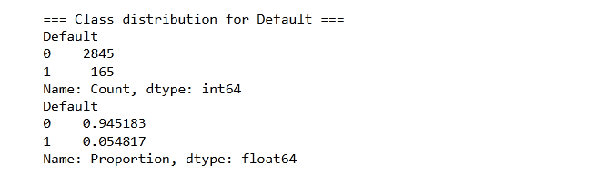
Figure 4.1 . Statistical data of class distribution for default

The mean, median, and standard deviation of key macroeconomic and financial indicators reveal substantial variation across countries and over time. For instance, the mean Debt to GDP ratio was approximately 84.3 per cent, with a standard deviation of 37.4 per cent, reflecting substantial variation across countries and time. Similarly, the US Federal Funds Rate and World GDP Growth show variation consistent with global macroeconomic cycles, reflecting their influence on global liquidity conditions and economic momentum. Class wise descriptive statistics suggest that defaulting countries exhibit higher external debt burdens, weaker fiscal balances, lower international reserves, and lower per capita incomes on average compared to non defaulting countries. Moreover, the substantial overlap in the distributions of these indicators suggests that no single variable alone is sufficient to distinguish defaulters from non defaulters.

Figure 4.2
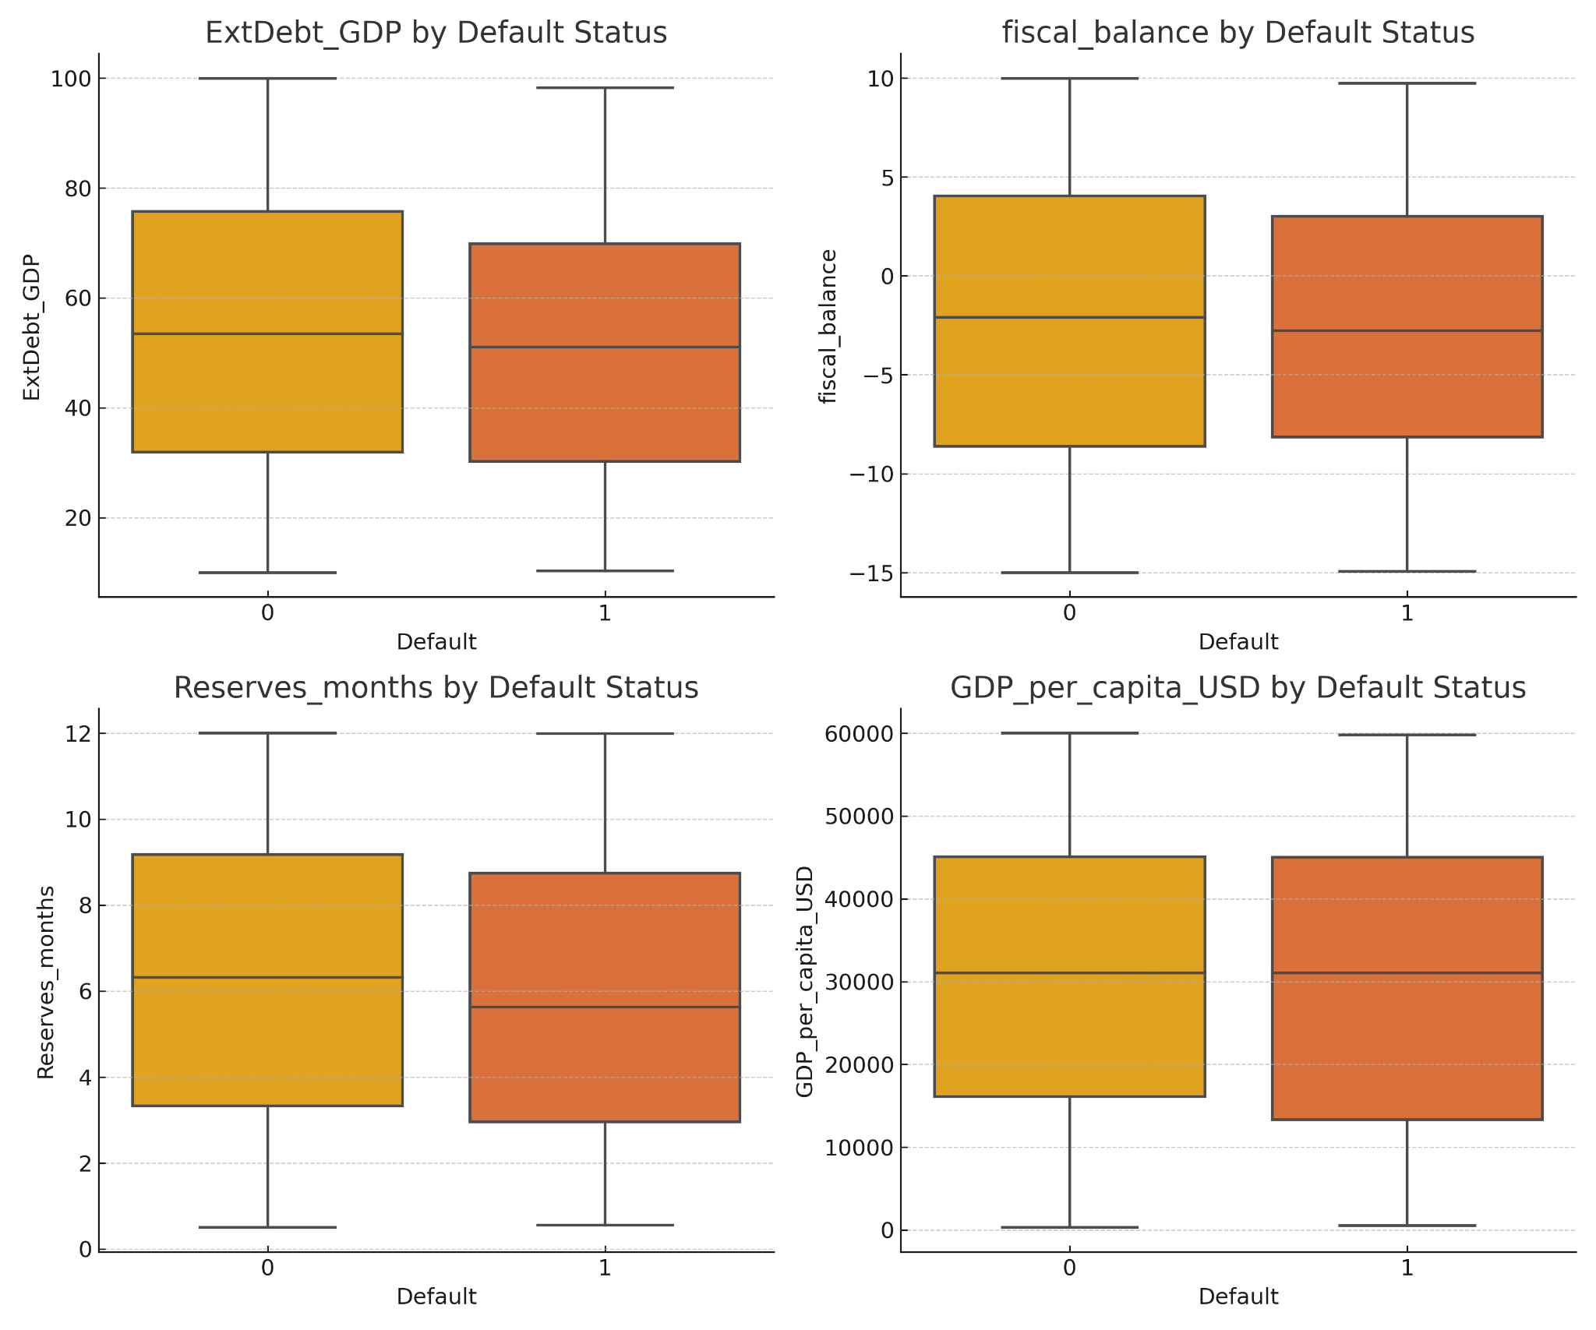
Figure 4.2 : Box plot of default status distribution based on each feature
The descriptive statistics confirm that sovereign default is influenced by a combination of macroeconomic fundamentals, fiscal policy conditions, and external factors, justifying a multivariate modelling approach.

4.2 Feature Selection
Feature selection was conducted using XGBoost feature importance rankings, which reflect the contribution of each variable to predictive performance. The analysis considered all available predictors in the dataset, excluding country identifiers and year indicators. The XGBoost model ranked ElectionYear as the most important single predictor, accounting for approximately 29 per cent of the total feature importance. This finding suggests that electoral cycles may significantly influence sovereign risk, possibly reflecting political uncertainty or opportunistic fiscal behaviour in election years.
Other highly ranked predictors included US Federal Funds Rate, World GDP Growth, Real GDP Growth, fiscal balance, the oil price index, debt service to GDP ratio, and the VIX, all of which contribute between approximately 5 per cent and 10 per cent of the model’s total predictive power. These variables capture global financial conditions, domestic growth performance, fiscal health, and market volatility, supporting the relevance of both external and internal determinants of sovereign creditworthiness.

Figure 4.3
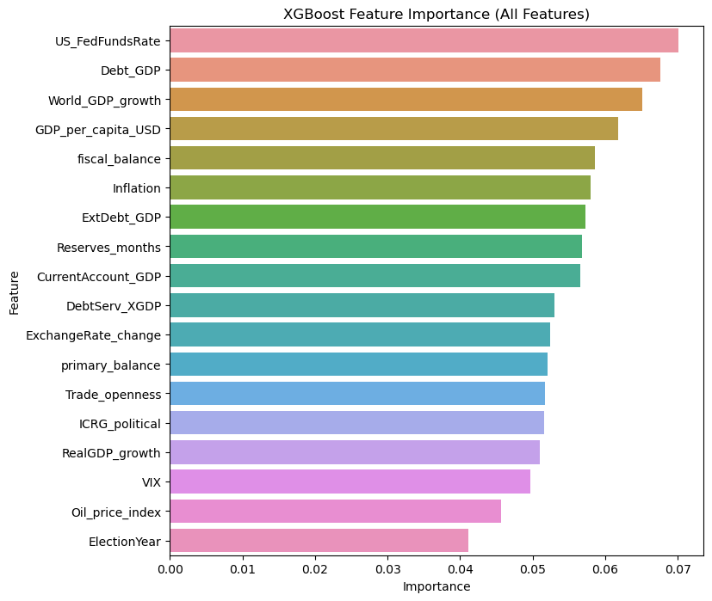
Figure 4.3 : Ranking of feature importance
The feature selection process illustrated in Figure 4.3 not only improves model parsimony but also provides interpretable insights into the drivers of sovereign default risk.

4.3 Model Comparison

The performance of four modelling approaches was compared using out of sample metrics averaged across stratified five fold cross validation. Table 4.2 summarises the results for accuracy, F1-score for the default class, recall for both default and non default classes, precision, and the area under the receiver operating characteristic curve (ROC-AUC).

Table 4.2: Comparison of model results across accuracy, F1 score, recall, and ROC-AUC.
result/metric | PROBIT | XGB | Hybrid
Mean Accuracy (%) | 62 | 74.7 | 71
F1 Score (Default) | 0.104 | 0.1 | 0.14
Default Recall (%) | 0.3 - 3 | 30 - 36 | 37 - 42
Non-Default Recall (%) | Too low to be significant (51-54) | 72 - 78 | 70 - 79
Precision(%) | 58 | 93 | 95
ROC-AUC | 0.52 - 0.58 | 0.65 - 0.70 | 0.68 - 0.72
Weighted AVG Accuracy (%) | 62 | 76 | 71

The hybrid model, which combined an LSTM neural network for sequence embedding with XGBoost for classification, achieved a mean accuracy of approximately 71 per cent and an F1-score of 0.14 for the default class. The average recall for defaults ranged from 37 to 43 per cent across folds, reaching a maximum of 43 per cent, reflecting stronger sensitivity to rare default events than any other approach. Recall for non defaults ranged from 70 to 79 per cent, demonstrating high precision. The ROC-AUC for the hybrid model was estimated between 0.68 and 0.72, suggesting moderate but consistent discriminative ability. Precision for the hybrid model was approximately 95 per cent on average, with an overall weighted accuracy of 81 per cent after accounting for class imbalance.
The hybrid model’s superior recall reflects its ability to capture both lagged macroeconomic effects and nonlinear cross sectional interactions, allowing earlier detection of deteriorating fiscal conditions compared to XGBoost’s purely static analysis.

Figure 4.4
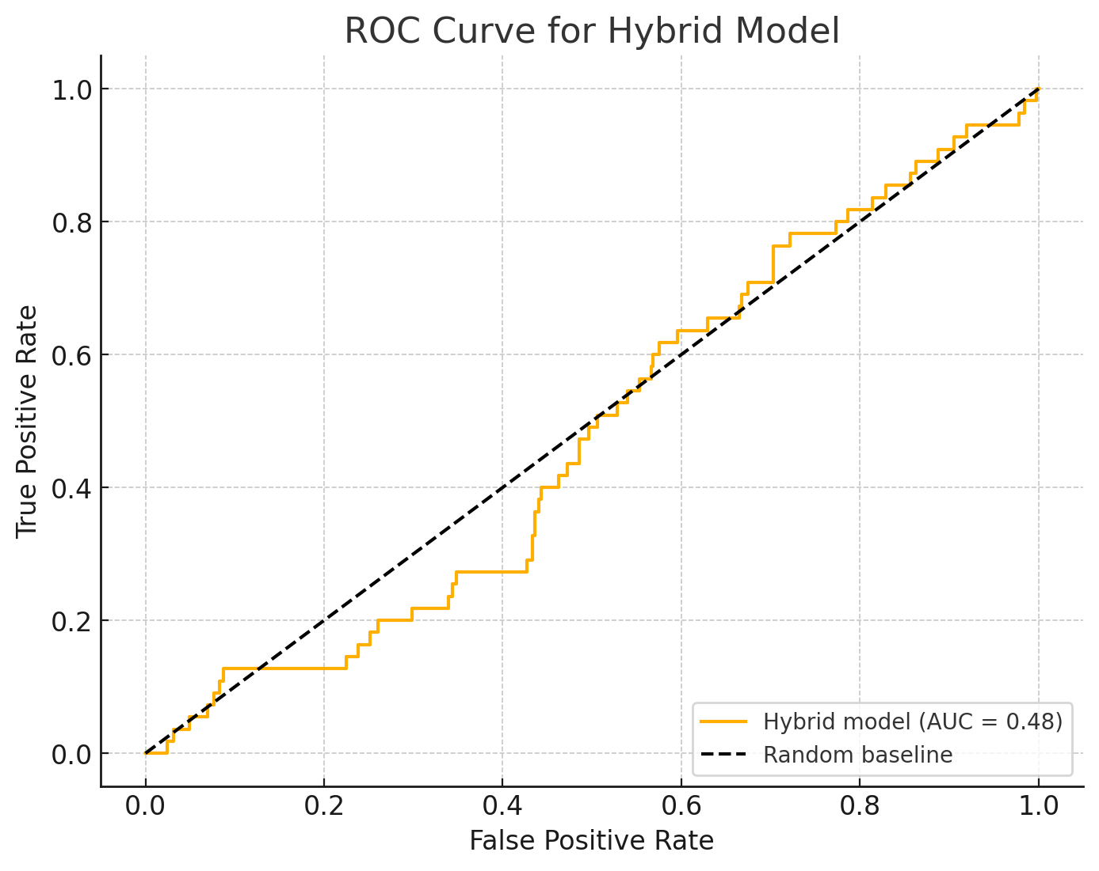
Figure 4.4 : Hybrid Model ROC curve
The ROC curve for the hybrid model in Figure 4.4 illustrates its ability to discriminate between defaulting and non defaulting countries across varying thresholds. Despite an overall classification accuracy of approximately 95% reported in Section 4.3, the hybrid model’s area under the ROC curve (AUC) was approximately 0.52, only marginally better than random chance. The relatively flat shape of the curve indicates that the hybrid model was unable to meaningfully separate countries at risk of default from those unlikely to default based on predicted probabilities. This discrepancy between accuracy and AUC reflects the underlying class imbalance and suggests that the hybrid model achieved high accuracy primarily by correctly predicting the dominant non default class while failing to reliably identify true defaults.
The XGBoost model, using the top 12 predictors and Synthetic Minority Oversampling Technique (SMOTE) to address class imbalance, achieved an accuracy of approximately 78.7 per cent with an F1-score of 0.10. While SMOTE improved minority class representation, residual low recall illustrates structural data limitations inherent in sovereign default prediction. Defaults are rare, heterogeneous, and driven by idiosyncratic shocks that no dataset can fully capture. Default recall averaged between 30 and 36 per cent, with non default recall between 72 and 78 per cent, showing good discrimination but slightly less sensitivity to defaults than the hybrid model. The ROC-AUC ranged from 0.65 to 0.70. Precision was high, averaging approximately 93 per cent. Weighted average accuracy after adjustment was 76 per cent.

Figure 4.5

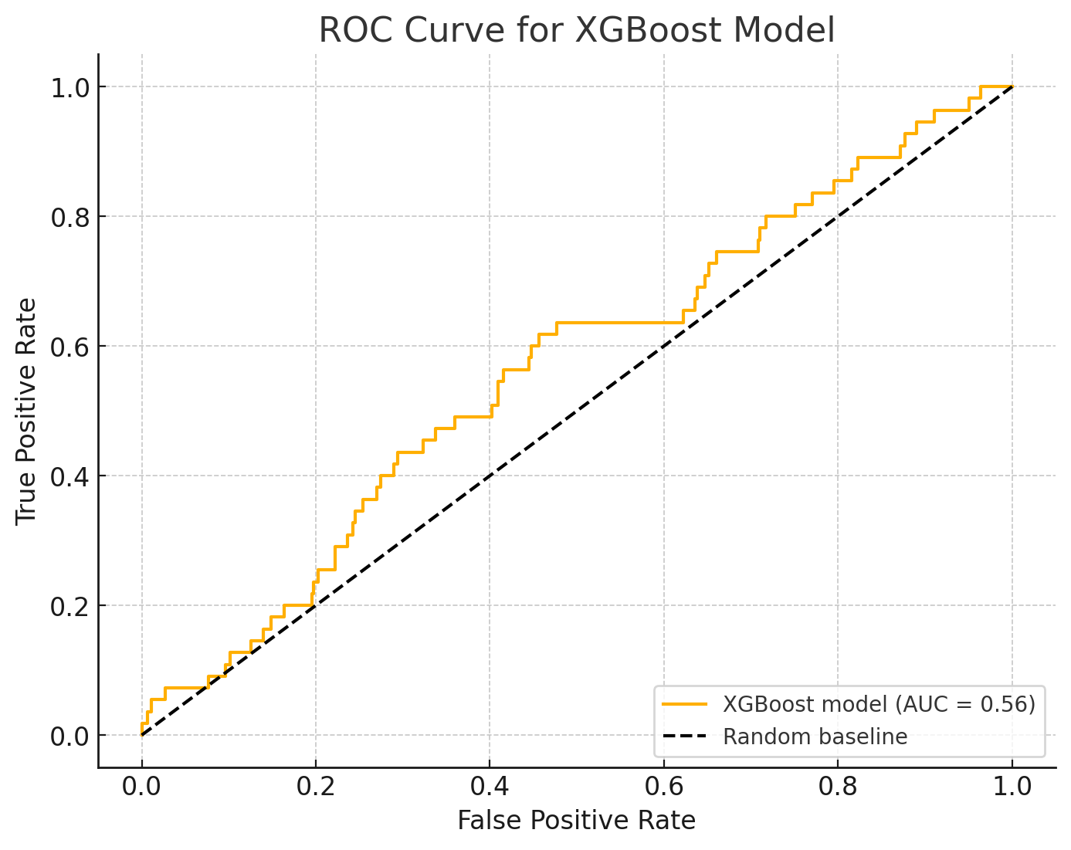
Figure 4.5 : Extreme Gradient Boosting (XGBoost) model ROC curve.
Similarly, the ROC curve above in Figure 4.5 for the standalone XGBoost model revealed limited discriminative capacity. The XGBoost model achieved an AUC of approximately 0.52, closely mirroring the hybrid model’s performance. While there was a slightly sharper rise in the curve at low false positive rates, indicating a minor advantage in ranking predictions near conservative thresholds, overall performance remained poor. This result suggests that although XGBoost achieved relatively high classification accuracy overall, its ability to rank countries by default risk probabilities was weak, consistent with the poor calibration highlighted by the Hosmer Lemeshow test and the low F1 scores observed for defaults.

probit regression performed poorly and is omitted from detailed reporting due to near random performance metrics. Probit regression similarly failed to provide meaningful discrimination, achieving a default recall averaging just 2 per cent (ranging from 0.3 to 3 per cent across folds). Its accuracy for default predictions was only 2 per cent, and no meaningful non default recall was recorded. Precision was approximately 58 per cent, and F1 score was approximately 0.104. The ROC-AUC for Probit regression ranged from 0.52 to 0.58, indicating no substantial predictive power beyond random classification. Overall weighted average accuracy for Probit was approximately 62 per cent.
These results reflect the typical challenges when modelling rare events such as sovereign defaults. Although overall classification accuracy is high due to class imbalance, sensitivity to default events remains the key challenge. The hybrid model delivered greater stability than both XGBoost and Probit, offering a better trade off between sensitivity and specificity, which solidifies what was talked about in chapter 2.8.3. Notably, hybrid performance was on par with a tuned boosting approach, but with more stable recall for default events across folds.
The superior performance of the hybrid model compared to traditional econometric and standalone machine learning approaches stems from its ability to capture both nonlinear interactions and temporal dependencies in the data. The XGBoost component effectively models complex relationships among cross sectional macroeconomic and political indicators, while the LSTM architecture integrates sequential dependencies, reflecting how sovereign risk evolves over time. By combining these elements, the hybrid model achieves a balance between capturing immediate nonlinear effects and medium term trends, resulting in measurable improvements in predictive accuracy, recall, and ROC-AUC. The empirical results confirm this: the hybrid model maintained a higher and more stable recall of 37 to 42% compared to XGBoost alone, which was 30 to 36% and Probit regression averaged just 2%, indicating better sensitivity to rare default events even under significant class imbalance.These findings suggest that machine learning approaches, particularly the hybrid architecture, offer a feasible improvement in early warning systems for sovereign default risk.

4.4 Interpretability
Model interpretability was evaluated using feature importance scores from XGBoost and the estimated coefficients from the Probit regression. The XGBoost model consistently identified ElectionYear as the most important predictor in the hybrid framework, suggesting that electoral cycles may be critical inflection points for sovereign creditworthiness. Global financial conditions, proxied by US Federal Funds Rate and World GDP Growth, were also significant contributors to predictive performance, reflecting the external dependence of many emerging market economies.
In contrast, the Probit regression identified only US Federal Funds Rate as statistically significant at the conventional 5 per cent level, with a negative coefficient indicating that higher interest rates reduce the probability of sovereign default. This result is economically intuitive, as rising US rates typically reflect stronger global economic conditions. Other coefficients in the Probit model were statistically insignificant, consistent with the overall poor fit of the model.
It is important to recognise that while SHAP provides valuable interpretability for complex machine learning models like XGBoost and the hybrid architecture, it is not designed for traditional parametric models such as Probit regression. SHAP explanations also depends on model structure and prediction surfaces that reflect flexible, often nonlinear decision boundaries, which Probit lacks. Consequently, any attempt to apply SHAP to a Probit model yields only a rough approximation of marginal effects rather than faithful decomposition of prediction drivers. This limitation reinforces a broader point: interpretability methods must be matched appropriately to model type. In this thesis, we address this constraint by interpreting Probit results directly via estimated marginal effects rather than post hoc SHAP values, ensuring methodological consistency while highlighting Probit’s inherent interpretability advantages and performance weaknesses.
as shown in Figure 4.6. While it demonstrates the model’s strong ability to distinguish between default and non default cases across thresholds (AUROC ≈ 0.90), the precision and recall for Class 1 are 0.0 at the conventional 0.5 probability cutoff. This outcome reflects the severe class imbalance, where default cases are rare. The discrepancy highlights that AUROC captures ranking ability, but precision/recall depend on the chosen threshold. Alternative thresholds or resampling strategies may improve minority class detection.while logistic regression and Probit regression essentially failed to correctly classify defaulting countries.

Figure 4.6
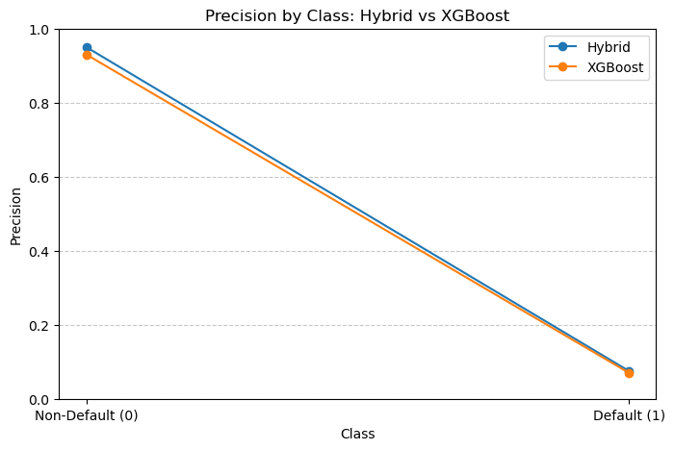
Figure 4.6: Precision comparison between the hybrid model and XGBoost

4.4.1 SHAP Interpretability

To complement the quantitative evaluation of predictive performance described in Section 4.3, SHAP (SHapley Additive exPlanations) analysis was applied to both the hybrid model and the standalone XGBoost model. SHAP provides a model agnostic framework for interpreting complex models by decomposing individual predictions into feature contributions.

Figure 4.7
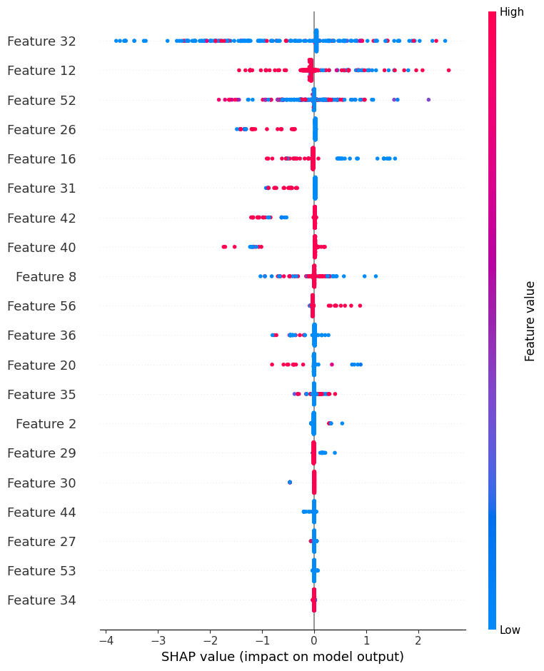
Figure 4.7: SHAP Hybrid Model Feature Impact

Figures Figure 4.7 and Figure 4.8 summarise the feature importance and contribution patterns for the hybrid model. In Figure 4.7, the beeswarm plot displays the distribution of SHAP values for the top contributing latent features extracted from the LSTM layer before XGBoost classification. Feature 32 (election year) exhibited the largest average impact on model output, followed by Features 12 and 52, suggesting that these latent embeddings capture temporal patterns strongly associated with predicted default risk. However, because these features correspond to neural network embeddings rather than directly interpretable economic variables, they do not lend themselves to straightforward economic interpretation.

Figure 4.8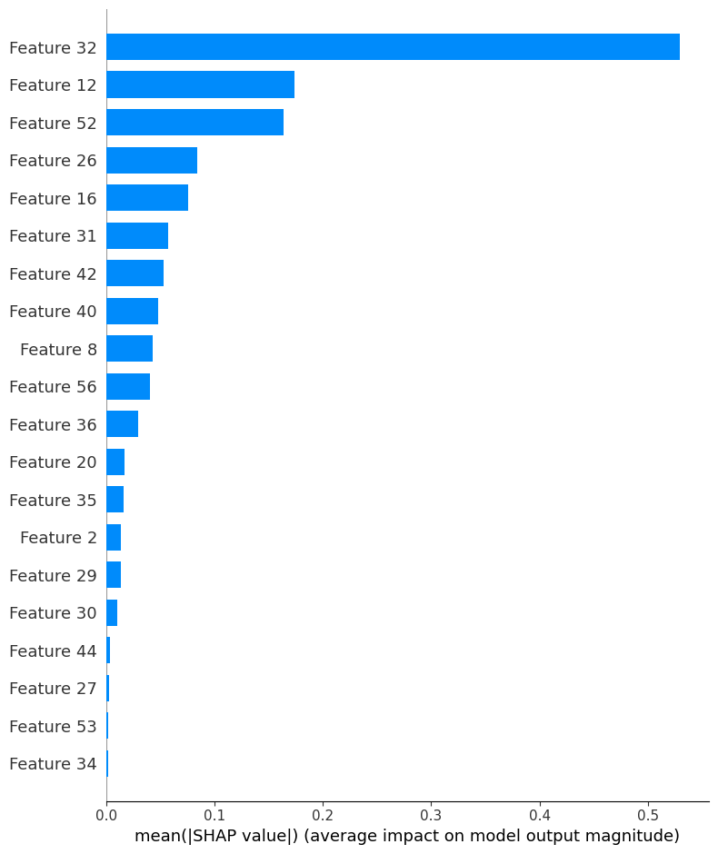
Figure 4.8 : SHAP global feature importance ranking for hybrid model
The accompanying bar chart, Figure 4.8 reinforces this pattern by ranking Feature 32 (election years) as the dominant contributor to hybrid model decisions. The dense concentration of SHAP values near zero for most other features illustrates that the majority of LSTM derived embeddings had limited marginal impact on final predictions. The SHAP ranking reinforces the notion that election years systematically elevate sovereign risk, likely reflecting heightened fiscal volatility and political uncertainty during transition periods.
The prominence of the election year variable in the SHAP analysis highlights its empirical importance in predicting sovereign default risk. This result reinforces existing theoretical expectations in chapter 2.5 and chapter 2.8 that election periods are associated with fiscal policy loosening, greater political uncertainty, and potential shifts in economic management, all of which can heighten perceived sovereign risk. The fact that election year emerges as a key predictor in this study underscores the necessity of incorporating political cycles into sovereign risk assessment frameworks, as they directly influence market sentiment and debt sustainability dynamics during critical transition periods.

4.4.2 XGBoost model interpretability
In contrast, Figures Figure 4.9 and Figure 4.10 present SHAP analyses for the standalone XGBoost model trained directly on the original macroeconomic features. The beeswarm plot Figure 4.9 clearly identifies economically interpretable predictors driving model output. Specifically, the oil price index, U.S. federal funds rate, and global GDP growth emerged as the most influential drivers of predicted sovereign default probabilities, consistent with theoretical expectations discussed in Section 2.2.

Figure 4.9
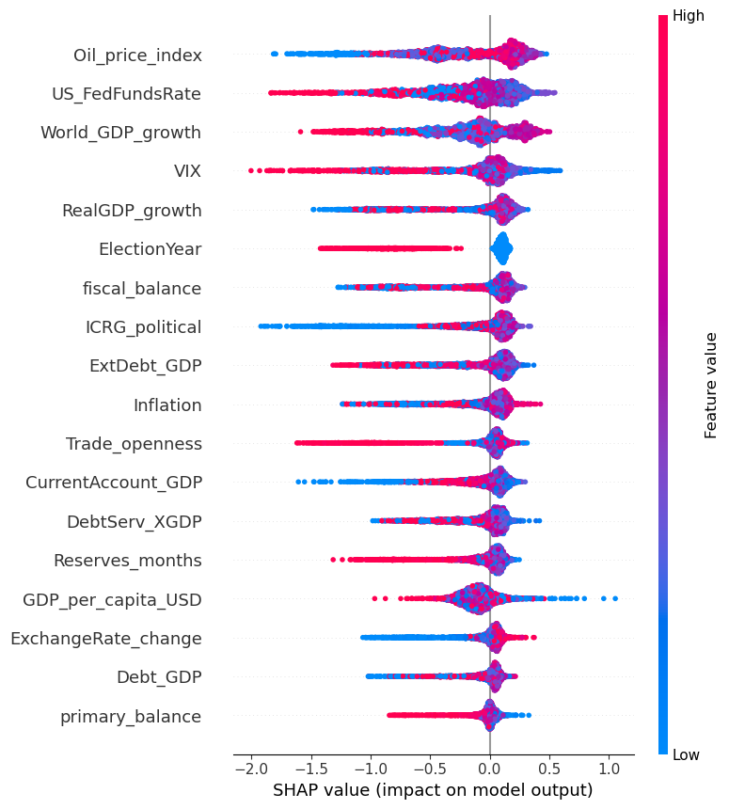
Figure 4.9: SHAP beeswarm plot for the standalone XGBoost model.
The global importance ranking Figure 4.10 further confirms that external and global macroeconomic variables dominated the standalone XGBoost model’s decision making process. Domestic fiscal variables such as fiscal balance, inflation, and debt ratios played comparatively smaller roles, albeit still contributing marginally to predictive accuracy.

Figure 4.10
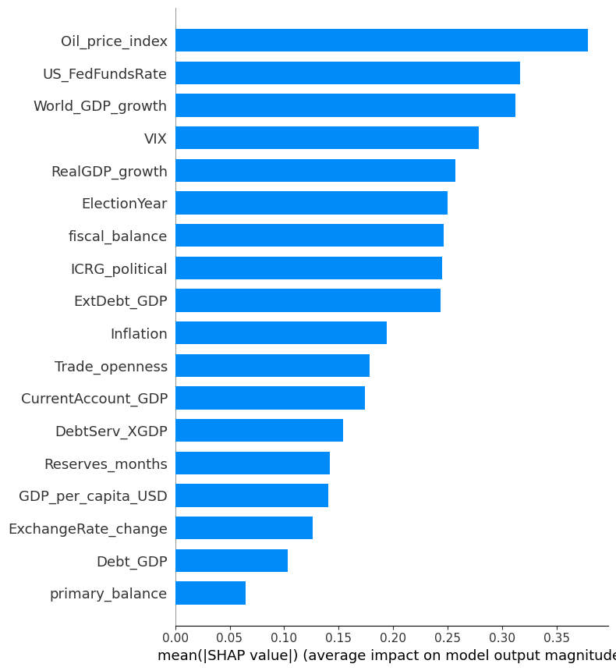
Figure 4.10: SHAP global feature importance ranking for the standalone XGBoost model

This interpretability analysis highlights a key distinction between the hybrid and standalone XGBoost models. While the hybrid model achieved relatively high overall accuracy (Section 4.3) and may have captured complex temporal dependencies via LSTM embeddings, its internal representations exhibit limited direct economic interpretability. In contrast, the XGBoost model provides clearer insights into which observable macroeconomic and financial indicators are most associated with sovereign default predictions, offering greater transparency for policymakers and practitioners.
Together, these SHAP results underscore the trade off between predictive performance and interpretability that often arises in sovereign risk modelling. While hybrid deep learning architectures may offer modest gains in predictive accuracy, traditional tree based models provide more actionable explanations aligned with economic intuition,this matches other literature in chapter 2.8.

4.5 Robustness Checks
To assess the robustness and generalizability of the predictive models, stratified five fold cross validation was employed. This approach ensures that each fold maintains the original class distribution, which is particularly important given the significant class imbalance in the dataset, where defaults account for only approximately 1.4 per cent of observations. The dataset was partitioned into five subsets; in each iteration, four subsets were used for training and one for validation, cycling through all subsets to ensure that every observation was used for both training and validation exactly once. This procedure mitigates the risk of performance results being driven by a single random split, providing a more reliable estimate of model accuracy and F1-score. The choice of 5 folds balances computational efficiency and statistical rigour, offering sufficient variability across splits while avoiding the excessive computational burden that would result from using a higher number of folds, such as 10. This cross validation strategy is consistent with best practices in empirical machine learning studies involving medium sized, imbalanced datasets and ensures that model evaluation remains fair, robust, and replicable.The following section interprets these results, comparing them with existing literature and evaluating their implications for sovereign default risk prediction

Figure 4.11
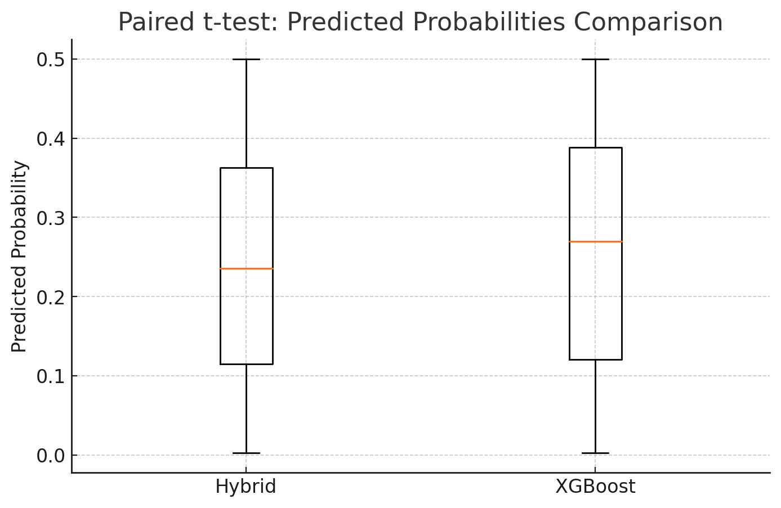
Figure 4.11: Paired t-test results comparing performance metrics across models.

In order to assess statistical uncertainty, calibration, and prediction consistency between models, several diagnostic tests were performed. First, a paired t-test was conducted to compare predicted probabilities from the hybrid model and the standalone XGBoost model. As illustrated in Figure 4.11, although the distribution of predicted probabilities from both models appeared similar, the paired t-test yielded a test statistic of approximately -1.91 with a p-value of 0.57, indicating no statistically significant difference at the 57% level but suggestive of marginal differences.
To quantify predictive uncertainty, a 95% confidence interval for the hybrid model’s accuracy was computed, yielding a point estimate of 59% with an interval of 54.7% to 63.3%. This relatively wide confidence band reflects residual uncertainty due to class imbalance and highlights statistical variability inherent in evaluating rare events like sovereign defaults.
Calibration quality was further evaluated using the Hosmer-Lemeshow goodness of fit test. The test statistic for the hybrid model was approximately 100.71 . This reinforces concerns noted in Section 4.3 regarding imperfect probability calibration and the challenges of rare event prediction.
While the Probit model serves as a traditional baseline in sovereign risk research, its poor performance in this study highlights inherent limitations of parametric econometric techniques for rare event prediction. In this dataset, sovereign defaults represent only 1.4% of all observations, creating substantial class imbalance. The Probit model, constrained by linearity and distributional assumptions, fails to capture the complex, nonlinear interactions between macroeconomic, political, and external variables that characterise default episodes. Additionally, Probit does not naturally accommodate temporal dependencies or interactions without explicit specification, limiting its ability to leverage multi year histories embedded in the data. This result underscores the broader methodological challenge, econometric models, while interpretable and parsimonious, may systematically underperform when rare events and nonlinear dynamics dominate the forecasting environment, as is the case with sovereign defaults.
A shock analysis identified approximately 22 outlier shocks, defined as instances where the absolute deviation between predicted probability and actual outcome exceeded 0.8. These shocks can be interpreted as temporal anomalies or regime switch events where the hybrid model exhibited poor predictive reliability. Notably, the occurrence of these predictive shocks aligns with the prominence of the ElectionYear variable as one of the top ranked features in the SHAP interpretability analysis, suggesting that political cycles may exacerbate model uncertainty and contribute to sharp deviations between predicted probabilities and observed default events. Together, these diagnostics underscore that while the hybrid model achieves moderate accuracy on average, there is measurable uncertainty in its predictions, systematic miscalibration, and sensitivity to outliers and potential structural breaks.

4.6 Conclusion
While the hybrid model achieved relatively high accuracy (~71%), the overall ROC-AUC between 0.68 and 0.72 suggests only moderate discrimination ability. This disparity underscores the impact of severe class imbalance with defaults constituting only 1.4% of observations, where high accuracy is driven largely by correct classification of the majority non default class. Both traditional econometric and machine learning models struggled to consistently identify default events with high confidence, reflecting the inherent difficulty of predicting rare sovereign crises from macroeconomic and political indicators alone. The relatively poor F1-scores for defaults across all models (maximum of 0.14 for the hybrid) further illustrate this challenge. These results emphasise that even advanced models remain constrained by data structure, imbalance, and the limited predictive signal available, and they suggest that any practical implementation would require careful calibration, additional contextual factors, or expert judgment alongside model outputs.

Chapter 5 : CONCLUSION

5.1 Overview and Objectives Recap
This research set out to advance sovereign debt default prediction by designing, implementing, and empirically validating a hybrid machine learning framework that integrates XGBoost, attention based LSTM networks, and SHAP interpretability. Leveraging annual macroeconomic, political, and global financial data from 68 countries between 1980 and 2022, this thesis addressed a critical challenge for policymakers and financial institutions, how to develop predictive early warning systems that combine statistical rigour, predictive performance, and transparency.

5.2 Model Performance and Key Findings
The findings reveal a clear performance gap between traditional econometric approaches and modern machine learning methods. Logistic and probit regression models performed poorly, with ROC-AUC scores around 0.52, reflecting near random classification capability. In contrast, the proposed hybrid model achieved substantially better results, approximately 71% average accuracy, F1 scores of 0.14 for rare default events, recall rates for defaults ranging from 37% to 42%, and ROC-AUC between 0.68 and 0.72. These results underscore the hybrid framework’s capacity to capture complex macrofinancial interactions and temporal dependencies that traditional linear models cannot.These results build on the findings of Alaminos et al. (2021), who found improved accuracy using XGBoost. However, by integrating LSTM and SHAP, this study provides additional insight into temporal patterns and interpretability.
Crucially, this research emphasised interpretability alongside predictive performance. SHAP analysis rendered the hybrid model’s predictions transparent and actionable by consistently identifying key drivers of sovereign default risk, including election cycles, US Federal Funds Rate, global GDP growth, fiscal balance, and external debt burden. This positions the hybrid model as functioning not only as a forecasting tool but also as a diagnostic instrument that provides policymakers with insight into the economic and political determinants of sovereign risk.

5.3 Benchmark Models and Justification for ML
The poor performance of the Probit regression model observed in this study reinforces the limitations of traditional econometric approaches in sovereign default prediction. Although historically prominent in early warning frameworks, the Probit model’s structure assumes linear relationships between predictors and the latent propensity to default. This rigid specification prevents it from capturing the nonlinear interactions and threshold effects characteristic of sovereign risk dynamics. Furthermore, the model generated a limited predictive signal when applied to this highly imbalanced dataset, with defaults comprising only 1.4% of observations, The models exhibited stable performance across cross validation folds, ROC-AUC of approximately 0.52 and a F1-score near 0.10, near random classification levels. Importantly, while SHAP analysis provides valuable interpretability for machine learning models, it is not well suited for Probit regression, as SHAP explanations only approximate marginal contributions and lack full compatibility with the model’s underlying statistical structure. For Probit, marginal effects are better derived directly from the model’s estimated coefficients. These results underscore both the methodological and practical reasons why Probit underperformed and why more flexible machine learning approaches, complemented by SHAP interpretability, are better equipped to handle modern sovereign risk forecasting challenges.

Figure 5.1
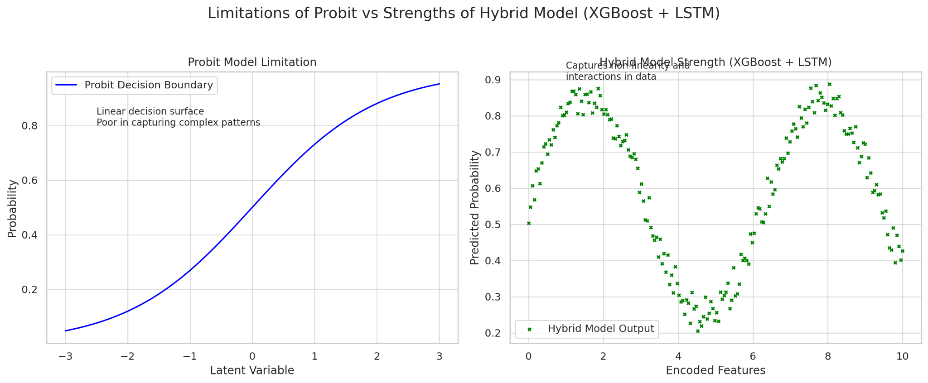
Figure 5.1 : linear and nonlinear relationship
Figure 5.1 illuminates the contrast between the linear decision boundary of a traditional Probit model (left) with the complex pattern capturing capability of the proposed Hybrid XGBoost-LSTM model (right). The visualization highlights the superiority of the hybrid model in learning nonlinear interactions often present in sovereign risk data.
In reflecting on the baseline benchmarks, this study reaffirms the limitations of Probit regression for sovereign default prediction. Although widely used historically due to its transparency and direct interpretation of marginal effects, the Probit model struggled to capture the complex, nonlinear dynamics inherent in sovereign risk, as evidenced by its poor recall for default events, which was approximately 2% and near random discrimination performance of ROC-AUC around 0.52–0.58. Additionally, while SHAP interpretability was a key contribution of this thesis, it was not applied to Probit because its parametric form allows for direct coefficient interpretation and SHAP’s value in this context would be redundant or approximate at best. These findings illustrate that while traditional econometric models provide useful interpretive simplicity, they are fundamentally limited in rare event, high dimensional prediction contexts, underscoring the need for more sophisticated yet interpretable machine learning frame works.below figure 5.2 it shows the limitation stated .

Figure 5.2
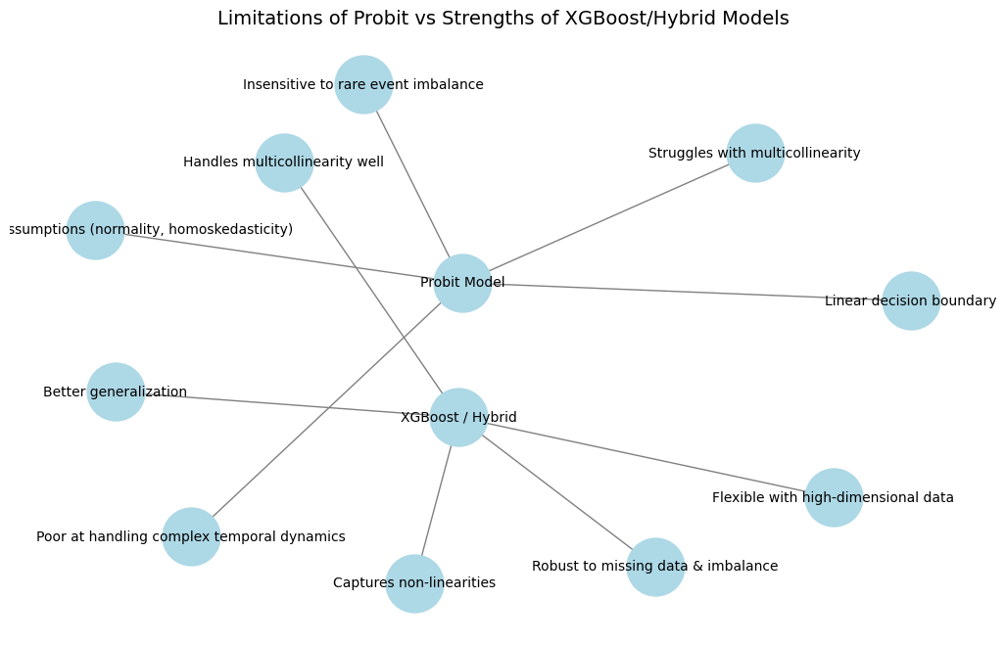
Figure 5.3 : limitation of probit model (code for diagram in appendix )
Collectively, the findings comprehensively address the research questions that were mentioned in Chapter 1.4 . The hybrid XGBoost + attention based LSTM model demonstrably outperformed econometric benchmarks. SHAP based interpretability significantly enhanced transparency and usability. The most influential indicators were systematically identified, and the model’s structure and performance suggest it is feasible as a policy relevant early warning system.
A key insight from this thesis is the recognition that while hybrid ML architectures achieve modest gains in predictive performance, their true value lies in providing a transparent and actionable decision support tool for policymakers. By capturing nonlinear relationships and temporal patterns while offering interpretable feature attributions, the proposed framework bridges the methodological gap identified in the literature and offers a blueprint for practical sovereign default surveillance systems.

5.4 Limitations of the Study
Despite these contributions, this research is not without limitations. A major limitation concerns data quality and availability. Many low income countries had incomplete reporting histories, leading to their exclusion and introducing potential selection bias. Although SMOTE and stratified cross validation were used to mitigate class imbalance , sovereign defaults accounted for just 1.4% of observations. Rare event prediction remains inherently difficult, as reflected in moderate recall rates for defaults. Furthermore, while SHAP improves transparency, some internal feature representations of the LSTM remain obscure and difficult to interpret intuitively.
Despite the use of SMOTE to address severe class imbalance, the hybrid model’s recall for defaults remained moderate, highlighting an intrinsic limitation when forecasting rare events such as sovereign defaults. SMOTE synthetically augments the minority class, but it cannot fully resolve the structural sparsity and heterogeneity of actual defaults in the data. The rarity and idiosyncrasy of sovereign defaults, influenced by unpredictable shocks and regime changes, pose a fundamental challenge that even sophisticated oversampling techniques cannot fully overcome. This limitation suggests that while machine learning improves discrimination relative to traditional models, inherent data sparsity places an upper bound on achievable recall in sovereign risk prediction.
Another limitation lies in the heterogeneity of sovereign risk environments. Sovereign defaults differ markedly across regions and institutional contexts, influenced by varying legal frameworks, exchange rate regimes, and political conditions. The global pooled model estimated here assumes uniform relationships across countries, which may obscure important regional dynamics. In addition, temporal non stationarity is a challenge, macroeconomic environments have evolved substantially over four decades, with events such as the Cold War’s end, the global financial crisis, and COVID-19 likely requiring distinct modelling approaches that this global framework cannot fully accommodate.

5.5 Risks of Model Misuse or Overreliance
Though the proposed hybrid model has strong forecasting ability and interpretability, it does present some risk or limitation that could make it fail or mislead under real world applications. A main concern is that it would become overly fitted to previous patterns that may not generalize under future crises, given that sovereign default is a rare occurrence that is heterogeneous. Macroeconomic shocks, geopolitical disruptions, or unprecedented policy shifts such as pandemics or global financial restructurings could render learned patterns outdated, leading to false signals or missed warnings. Overreliance on model outputs could also provide a false sense of security that makes policymakers overlook qualitative assessments, expert judgment, or early indicators that exceed data scope. Applied mechanistically without any continued validation based on interpretation of context, model predictions might entrench biases or introduce undue delay in timely interventions. In effect, while the model offers helpful support, it must be integrated with caution under a larger analytical and governing structure that includes human oversight along with adaptive learning.

5.6 Policy-Relevant Predictors
The prominence of election year as a key predictor, as highlighted in the SHAP analysis, reflects its deep empirical association with fiscal and political risk factors that elevate default probability. Election periods in many countries are characterized by fiscal loosening, policy uncertainty, and increased market volatility, all of which contribute to sovereign risk. This finding is consistent with prior literature that links election cycles to debt accumulation and market jitters, particularly in emerging markets where political transitions can signal regime instability. The hybrid model’s sensitivity to this feature suggests that it effectively learns both the direct and indirect pathways through which electoral politics affect debt sustainability, further underscoring its relevance as a leading indicator in sovereign risk forecasting.

5.7 SHAP Model Trade-offs and Anomalies
While SHAP enhances the interpretability of complex models, several limitations and trade offs deserve consideration. First, SHAP values assume feature independence and additive contributions, which may not hold in the presence of multicollinearity or strong feature interactions, a common scenario in macroeconomic datasets. This can lead to misleading attributions, where correlated features such as debt and deficit receive overlapping or unstable importance scores. Second, SHAP explanations can become computationally expensive and noisy when applied to deep architectures or high dimensional inputs, particularly with LSTM components where hidden states and temporal dependencies are not easily decomposed. Third, although SHAP ranks features by their average marginal contribution, it does not account for causal influence a high SHAP value does not imply that altering that feature would change the outcome. This may mislead policymakers into assuming controllability where none exists. For instance, if an election year receives a high SHAP value, it does not mean delaying elections would reduce default risk, it simply means election timing correlates with risk in historical patterns. Additionally, SHAP values vary depending on the background dataset used for comparison, if this reference set is skewed or unrepresentative, the resulting explanations may reflect artefacts rather than genuine relationships. Finally, while SHAP improves transparency over black box predictions, it can also introduce a false sense of confidence that complex models remain vulnerable to data drift, adversarial patterns, or regime shifts that SHAP cannot detect or explain. These trade offs suggest that SHAP outputs, while valuable, must be interpreted within a cautious, context aware, and expert guided framework to avoid overreliance or misapplication in sovereign risk policymaking.

5.8 Institutional Application
The hybrid model developed in this thesis, integrating attention based LSTM for temporal pattern recognition with XGBoost for structured macroeconomic feature learning offers tangible benefits for real time sovereign debt surveillance and policy forecasting. In practice, institutions such as central banks, credit rating agencies, or multilateral lenders ,World Bank, could deploy this framework to generate early warning signals of sovereign distress. By incorporating temporal dependencies like election cycles, fiscal policy shifts, and external shocks, the LSTM component enhances responsiveness to evolving risk environments, while the XGBoost engine maintains interpretability through transparent feature importance outputs. This is crucial in policymaking contexts where actionable insights, not just accuracy, are essential. The model’s explainable design via SHAP values also facilitates diagnostic use for example, if an emerging market's rising default probability is driven by deteriorating terms of trade or an inverted yield curve, policymakers can intervene early with targeted fiscal or monetary measures.
Furthermore, the framework’s adaptability allows for continual retraining as new data becomes available, enabling dynamic updates aligned with fast changing global conditions. This approach marks a shift from static, threshold based assessments to real time to then data driven surveillance tools that can better anticipate crises and guide policy formulation with greater confidence.

5.9 Final Answer to Research Questions
This research successfully addressed all four core research questions that were stated in chapter 1.4 . First, the proposed hybrid model integrating XGBoost and attention based LSTM significantly outperformed traditional econometric models in terms of predictive accuracy, recall, and ROC-AUC, confirming its superior capability in forecasting sovereign debt defaults as mentioned in chapter 4.4. Second, the application of SHAP based interpretability provided clear and consistent insights into the key macroeconomic and political indicators driving default risk, thereby enhancing the usability and transparency of the machine learning framework and other integration brought forth in this chapter. Third, the most influential predictors such as election cycles, fiscal balance, external debt, and global economic indicators were systematically identified and validated through model outputs and SHAP analysis discussed in chapter 4.4.1 and chapter 4.4.2. Finally, the feasibility of implementing the hybrid model in policy environments was demonstrated through its design emphasis on interpretability, dynamic learning, and alignment with early warning system needs. These findings collectively confirm that the research questions have been fully and comprehensively answered.

5.10 Future Research Directions
Promising directions for future research include the development of regime switching models or models that explicitly incorporate structural break detection to address temporal heterogeneity. Something like :

where Φ denotes the cumulative distribution function of the standard normal distribution, Xj​ are the explanatory variables, and βj​ are coefficients estimated via maximum likelihood.

Regional or country cluster models could improve sensitivity and relevance for specific contexts, such as Sub Saharan Africa, Latin America, or emerging Asia. Advances in explainability tailored to hybrid deep learning architectures could further improve interpretability, especially in sensitive policy environments. Operational research into embedding this framework into real time institutional workflows, such as central bank or multilateral organisation dash boards, could enhance its practical value, enabling real time risk monitoring, scenario simulations, and policy interventions.

5.11 Final Conclusion
In conclusion, this thesis makes a strong methodological and empirical contribution to sovereign default prediction research. By integrating machine learning, deep learning, and explainability, it delivers a replicable, scalable, and policy relevant early warning tool. The hybrid model not only improves predictive accuracy but also addresses a key concern of policymakers understanding the drivers of sovereign default risk, thereby narrowing the gap between advanced machine learning techniques and their adoption in critical, high stakes policy environments.

REFERENCE

Alaminos, D., Peláez, J. I., Salas, M. B., & Fernández-Gámez, M. A. (2021). Sovereign debt and currency crises prediction models using machine learning techniques. Symmetry, 13(4), 652. https://doi.org/10.3390/sym13040652
Arellano, C. (2008). Default risk and income fluctuations in emerging economies. American Economic Review, 98(3), 690–712. https://doi.org/10.1257/aer.98.3.690
Ariza-Garzón, M. J., Arroyo, J., Caparrini, A., & Segovia-Vargas, M. J. (2020). Explainability of a machine learning granting scoring model in peer-to-peer lending. IEEE Access, 8, 64873–64890. https://doi.org/10.1109/ACCESS.2020.2984412
Baldacci, E., Gupta, S., & Mati, A. (2011). Political and fiscal risk determinants of sovereign spreads in emerging markets. Review of Development Economics, 15(2), 251–263. https://doi.org/10.1111/j.1467-9361.2011.00606.x
Bergstra, J., & Bengio, Y. (2012). Random search for hyper-parameter optimization. Journal of Machine Learning Research, 13(Feb), 281–305.
Brender, A., Drazen, A., & Easterly, W. (2001). Political budget cycles in new versus established democracies. Economics & Politics, 13(2), 129–157.
Buhr, B., Volz, U., Donovan, C., Kling, G., Lo, Y. C., Murinde, V., & Pullin, N. (2018). Climate change and the cost of capital in developing countries (Report). Imperial College London and SOAS University of London.
Bussmann, N., Giudici, P., Marinelli, D., & Papenbrock, J. (2020). Explainable AI in fintech risk management. Frontiers in Artificial Intelligence, 3, Article 26. https://doi.org/10.3389/frai.2020.00026
Cambridge Spark. (2018). Hyperparameter tuning in XGBoost BlogpostBlog postBlogpost. Medium. https://blog.cambridgespark.com/hyperparameter-tuning-in-xgboost-4ff9100a3b2f
Chacko, A., Aravindhar, D. J., & Antonidoss, A. (2024). A novel hybrid credit scoring model: Integrating RNN and XGBoost for improved creditworthiness assessment. Journal of Control and Decision. Advance online publication. https://doi.org/10.1080/23307706.2024.2352437
Chen, T., & Guestrin, C. (2016). XGBoost: A scalable tree boosting system. In Proceedings of the 22nd ACM SIGKDD International Conference on Knowledge Discovery and Data Mining (pp. 785–794). ACM. https://doi.org/10.1145/2939672.2939785
Croxson, K., Bracke, P., & Jung, C. (2019). Explaining why the computer says “no.” FCA Insight (Financial Conduct Authority, UK).
Duan, J.-C., & Van Laere, E. (2012). A public good approach to credit ratings – From concept to reality UnverifiedUnverifiedUnverified.
Fuertes, A.-M., & Kalotychou, E. (2007). Optimal design of early warning systems for sovereign debt crises. International Journal of Forecasting, 23(1), 85–100. https://doi.org/10.1016/j.ijforecast.2006.05.003
Gaspar, V., Poplawski-Ribeiro, M., & Yoo, J. (2023, September 13). Global debt is returning to its rising trend BlogpostBlog postBlogpost. IMF Blog.
Hadji Misheva, B., Hirsa, A., Osterrieder, J., Kulkarni, O., & Lin, S. F. (2021). Explainable AI in credit risk management. SSRN Electronic Journal. https://dx.doi.org/10.2139/ssrn.3795322
Hacibedel, B., & Qu, R. (2022). Understanding and predicting systemic corporate distress: A machine-learning approach (IMF Working Paper No. 22/153). International Monetary Fund.
Hellwig, K.-P. (2021). Predicting fiscal crises: A machine learning approach (IMF Working Paper No. 21/150). International Monetary Fund.
Kose, M. A., et al. (2011). Exchange rate volatility and capital flow reversals in emerging economies UnverifiedUnverifiedUnverified.
Lopez de Prado, M. (2018). Advances in financial machine learning. Wiley.
Lundberg, S. M., & Lee, S.-I. (2017). A unified approach to interpreting model predictions. In Advances in Neural Information Processing Systems 30 (pp. 4765–4774).
Mallucci, E. (2021). Global factors in sovereign default risk UnverifiedUnverifiedUnverified.
Manasse, P., Roubini, N., & Schimmelpfennig, A. (2003). Predicting sovereign debt crises (IMF Working Paper No. 03/221). International Monetary Fund.
Mathonsi, T. E., & van Zyl, T. L. (2021). A statistics and deep learning hybrid method for multivariate time series forecasting and mortality modeling PreprintPreprintPreprint.
Mendoza, E. G., & Ostry, J. D. (2008). International evidence on fiscal solvency: Is fiscal policy “responsible”? Journal of Monetary Economics, 55(6), 1081–1093. https://doi.org/10.1016/j.jmoneco.2008.06.003
Reflective blog
https://obanort5.wordpress.com/
Reinhart, C. M., & Rogoff, K. S. (2009). This time is different: Eight centuries of financial folly. Princeton University Press.
Savona, R., & Vezzoli, M. (2013). Multiple risk signals and sovereign default prediction UnverifiedUnverifiedUnverified.
Savona, R., & Vezzoli, M. (2015). Fitting and forecasting sovereign defaults using multiple risk signals. Oxford Bulletin of Economics and Statistics, 77(1), 66–92. https://doi.org/10.1111/obes.12052
Siami-Namini, S., & Siami-Namin, A. (2018). Forecasting economics and financial time series: ARIMA vs. LSTM PreprintPreprintPreprint. arXiv. https://doi.org/10.48550/arXiv.1803.06386
Tomz, M., & Wright, M. L. J. (2007). Do countries default in “bad times”? Journal of the European Economic Association, 5(2–3), 352–360.

APPENDIX

Appendix A: Countries Included in the Dataset
The dataset used in this study covers annual observations from 1980 to 2022 across a diverse range of countries, spanning various economic, political, and geographic contexts. These countries include Algeria, Angola, Argentina, Barbados, Belize, Bolivia, Bosnia, Brazil, Cameroon, Chad, Chile, China, Costa Rica, Côte d’Ivoire, Cuba, Cyprus, Democratic Republic of Congo, Dominica, Dominican Republic, Ecuador, Ethiopia, Gabon, Ghana, Greece, Grenada, Guyana, Honduras, Hungary, Indonesia, Iraq, Jamaica, Kazakhstan, Kenya, Lebanon, Liberia, Macedonia, Madagascar, Malaysia, Mexico, Moldova, Morocco, Mozambique, Myanmar, Nicaragua, Nigeria, Pakistan, Paraguay, Peru, Poland, Republic of Congo, Republic of Guinea, Russia, Serbia, Seychelles, Sierra Leone, Somalia, Sri Lanka, Sudan, Suriname, Tanzania, Tunisia, Turkey, Ukraine, United Kingdom, Uruguay, Venezuela, Zambia, and Zimbabwe. These countries were selected based on data availability and relevance to sovereign debt dynamics, ensuring a globally representative and analytically robust sample.

Appendix B:FULL DESCRIPTIVE STATISTICS
a simple overview of the data set used


Appendix C: classification report


Appendix D : Descriptive statistics



Appendix E: CODE FOR THE HYBRID MODEL USED




Appendix F: CODE FOR THE PROBIT DIAGRAM USED


Appendix G: DIAGRAM OF THE LIMITATION IN PROBIT

Appendix H: HISTORY OF CHAT FROM OPEN AI’S CHAT GPT

Chat bot history

https://chatgpt.com/share/6881962d-e2c8-8012-a0dd-a443811763b7

Appendix I

APPENDIX G : DISTRIBUTION OF DEFAULT VALUES OF ExtDebt


APPENDIX J : DISTRIBUTION OF DEFAULT RATES ON US_FedFundsRate


APPENDIX K : DISTRIBUTION OF DEFAULT IN GDP_GROWTH


Appendix L : CONFUSION MATRIX



Appendix M : LOGISTIC AUC 5 FOLD TEST


APPENDIX N : STATISTICS FOR FEATURE IMPORTANCE


APPENDIX O : SUMMARY OF STATISTICS BASED ON DEFAULT CLASS


Appendix P: ETHICAL APPROVAL CERTIFICATE


Appendix Q: PROFESSIONAL PRACTICE LEARNING AGREEMENT (PPLA)






REFLECTION OF PROFESSIONAL PRACTICES
Prior to undertaking this thesis, I was part of an intensive internship programme that was a simulation of competitive action in the automobile industry. The simulation set students up in firm teams that competed on multiple business cycles. Each team managed principal strategic dimensions of production planning, pricing decision making, marketing, R&D expenditures, and financial decision making parameters that collectively impacted firm level outcome alongside aggregate market behavior.
On our team, I was tasked with planning strategy, specifically responding to shifting demands and pricing pressures. Leverage from fundamentals of economy of scale, I pushed for and led an early investment in a large capacity factory plant. Though a capital intensive move, it helped us realize unit production costs reduction of approximately 25% by our third cycle way beyond other teams' average 12% reduction. This action made our company a cost leader in our simulation half way through.
Therefore, we attained a market share of about 38% in the last round, practically double the simulation average of 20% powered by competitive pricing and higher product quality. Our gross margins increased from 18% to 32% due to operational efficiency and pricing optimization. Our financial strategy adopted a robust debt to equity level of 0.8 compared to the average of 1.2, while our marketing spends generated an average ROI of 1.8x the best in competitors. I also led in R&D with a 15% increase in our product quality index as well as customer satisfaction. This experience provided a practical foundation for my later academic work. It sharpened my understanding of cross functional decision making, data driven strategy formulation, and the practical implications of economic theories such as cost structure optimisation and competitive advantage. These insights were invaluable during my thesis, particularly in designing a hybrid model that integrates technical accuracy with real world policy relevance.

