Proceedings of the Pakistan Academy of Sciences: Pakistan Academy of Sciences
B. Life and Environmental Sciences 54 (4): 365–374 (2017) Copyright © Pakistan Academy of Sciences
Research Article
ISSN: 2518-4261 (print), ISSN 2518-427X (online)

Socio-economic Damages caused by the 2014 Flood in Punjab Province, Pakistan

Ghani Rahman^{1,*}, Atta-ur-Rahman², Muhammad Mushahid Anwar¹, Mehtab Ahmed¹, Humayun Ashraf¹, and Umayya Zafar¹

¹Department of Geography, University of Gujrat, Gujrat, Pakistan
²Department of Geography, University of Peshawar, Peshawar 25120, Pakistan

Abstract: This study aimed at analyzing impact of the 2014 flood on socio-economic and infrastructural aspects in Punjab province, Pakistan. During the month of September 2014, heavy and prolonged monsoon rainfall was recorded over the north and north-eastern parts of Pakistan which fall in the catchment area of Indus river system. As a consequence, it overflowed natural levees in almost all the rivers flowing through the Punjab province and resulted in a devastating flood. A similar flood in 2010 had brought massive damages in 16 districts of Punjab province; over the past, the province has frequently suffered with such devastating flood events. In order to achieve the study objectives, the relevant data were collected from Pakistan Meteorology Department and Provincial Disaster Management Authority Punjab, and the same were spatially analyzed in the geographic information system (GIS) environment. The analysis revealed that during September 2014, high level of flood discharges were recorded at several gauging stations of Chenab and Jhelum rivers. As a result, this massive flood water overflowed the agricultural lands, destroyed standing crops, and damaged houses and other valuable infrastructures. In addition to heavy damages to agricultural and housing sector, it also incurred loss of 185 precious human lives and displaced
2.3 million people. This study revealed that during the 2014 flood in Punjab province, Jhang was the most severely affected district in terms of agricultural damages, whereas Sialkot district experienced maximum human casualties.
Keywords: Socio-economic damages, flood disaster, human casualties, floodplain, GIS

INTRODUCTION
In Pakistan, flood is a recurrent and devastative disaster. It has been observed that flood has surpassed all other disasters in terms of frequency and magnitude [1]. Climate change, deforestation and change in land use pattern were blamed as the major driving forces behind increasing numbers and intensity of hydrological as well as climatological disasters [2]. Furthermore, flood has close relationship with economic growth and consistent encroachments of human settlement onto the high flood risk areas. In addition to this, poverty is also one of the major intensifying factor that has increased people vulnerability to flood disasters [3, 4]. In Pakistan, flood is a serious environmental challenge and recorded as the most costly and deadliest in all the natural disasters in term of property and human losses [4-6]. As flood
causes wide spread damages to human and their belongings [7, 8]. During past one and a half decade (2001-2015), in Pakistan floods have been reported every year and it has killed over 5,700 people [1]. This indicate that in Pakistan flood is getting serious in term of frequency of occurrences and extent of damages [1, 9].
In Pakistan, the major causes of floods are heavy and prolonged monsoon rain accompanied by excessive snow/glacier melting during summer together with flood intensifying factors of human developments in the flood-prone areas and deforestation in the upper reaches of drainage basins [4, 10]. However, in the upper catchment areas of Indus river and its tributaries, flash flood characteristics dominates and mainly triggers by intense and prolonged rainfall, excessive snow
/glacier melting, steep gradient and rapid

————————————————
Received, May 2017; Accepted, November 2017
*Corresponding author: Ghani Rahman; Email: ghani.rahman@uog.edu.pk

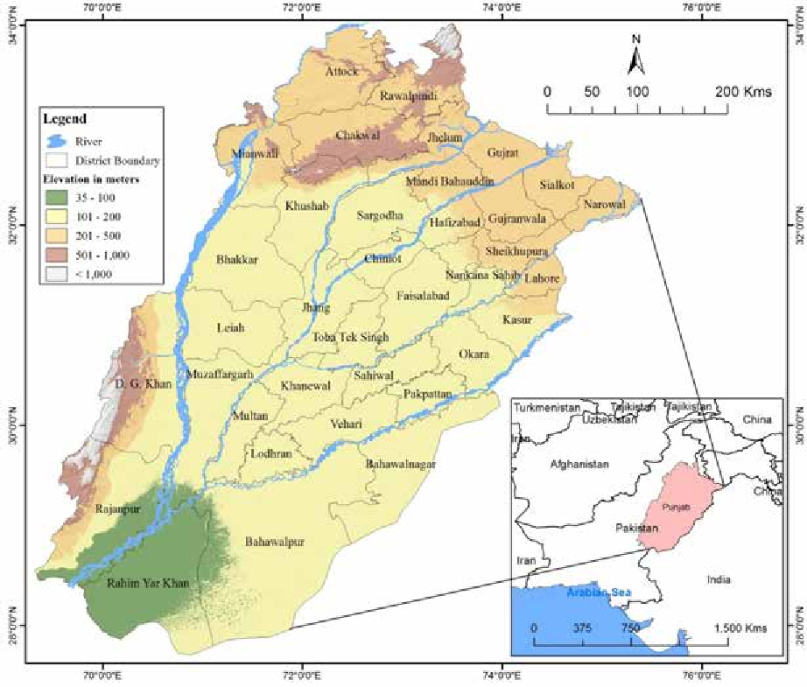
Fig. 1. Physiography (SRTM) of Punjab province.

accumulation of flood water in river basins. This flood water, after reaching relatively flat Indus plain, it overflows the river banks and inundate the adjacent active floodplains [11]. Here, floods are more severe during rainy seasons especially in monsoon [11]. Historically, these catastrophic floods have caused heavy losses to the national economy [1, 4, 10]; therefore, it calls for adequate attention of the decision makers to cope with this problem on priority basis.
In September 2014, monsoon spell has brought unprecedented rainfall in the watershed areas of eastern tributaries of Indus River, which has resulted massive flood in the Northern areas and Punjab province of Pakistan. The eastern tributaries of River Indus especially the Chenab and Jehlum Rivers experienced heavy floods in September 2014 and has caused huge damages in Punjab province. Flood in these two rivers has incurred damages to sixteen districts of Punjab province including districts of Bahawalpur,
Chiniot, Gujranwala, Gujrat, Hafizabad, Jhang, Jhelum, Khanewal, Khushab, Mandi Bahaudin, Multan, Muzaffargarh, Narowal, Sargodha, Sheikhupura and Sialkot. As a result, a total of 367 persons lost their lives, 129,880 houses were damaged and over one million acres of agricultural land was affected [12]. Thus, the main purpose of this study is to assess the impact of 2014 flood on socio-economic and physical infrastructure of Punjab province, Pakistan.

METHODS AND MATERIALS
  - Study Area
This research study was conducted in Punjab province of Pakistan, which is the largest province of the country in terms of population and the second largest in terms of geographical area. This province is also known as the breadbasket of Pakistan [13]. Punjab province is blessed with one of the world’s largest irrigation systems, which

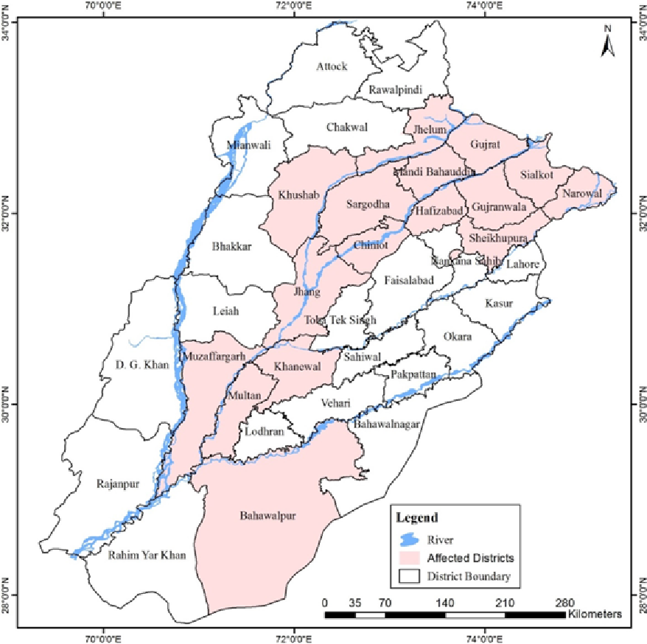
Fig. 2. The 2014 flood–affected districts in Punjab province.

was initially constructed by the British government prior to partition of the Indian Subcontinent and was further expanded after independence of the country. Punjab province has 46 percent of the total cropped land and 76 percent of the total irrigated area in the country [13]. Most parts of the Punjab province comprises of floodplain of Indus River and its eastern tributaries.
Punjab province is known as the land of five rivers, i.e., Indus, Jhelum, Chenab, Ravi and Beas. Its name Punjab also has relation to these five rivers as it is comprised of two words “Punj”, meaning “five”, and “ab” meaning “water”. The land of Punjab province comprises of an extensive alluvial plain with gentle slope. The alluvium is brought by Indus River and its eastern tributaries

(Fig. 1). Although, the existence of these rivers on one hand has made the area as an agricultural hub of the country but on the other side these have made it vulnerable to catastrophic floods. The agricultural activities are practiced in the floodplains of these rivers and a large share of the country population also live in the Indus floodplain. Almost every year, a vast area of the province come under floods and cause human losses and destruction to standing crops and other properties. Similar to the past flood events, the flood of 2014 also brought massive damages and 16 districts of the Punjab province were declared as the most affected districts (Fig. 2). High level flood was recorded at different gauging stations of Chenab and Jhelum rivers. As a consequence, a massive flood damages to socio-economic,

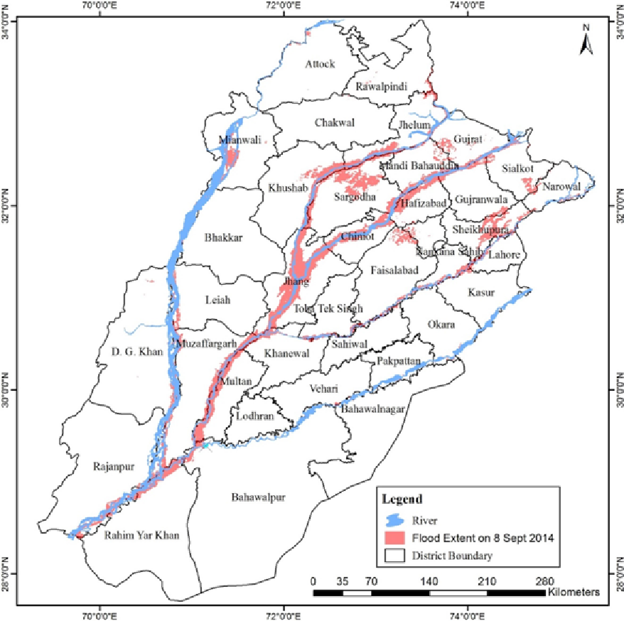

Fig. 3. Extent of the 2014 flood in Punjab province (MODIS image of Sept 8th 2014).

agricultural and housing sectors were recorded throughout the Punjab province.
Although, the climate of the province is not much favorable for agricultural activities yet the extensive network of irrigation channels and topography has made the area favorable for farming and made it a breadbasket for the country. The land of Punjab favorable for growing many crops like wheat, rice, sugarcane, and vegetables, and supplied to other parts of the country. Punjab experiences tropical semi-arid, hot and subtropical monsoon type of climate with cold winter and hot summer. The month of June is the hottest having mean maximum temperature of 45⁰C and in sometimes it touches 50⁰C in extreme cases. The
province receives rainfall mostly during summer season from monsoon, which become part of the river runoff and as a result causes floods.

Data Analysis
The study focused on the extent of flood 2014 damages so the required data was collected from different secondary sources. District-wise map of Punjab province was obtained from survey of Pakistan. Flood extent was extracted from MODIS satellite image downloaded from NASA earth observatory website. The physiographic map of the study area was developed from Shuttle Radar Topographic Mission (SRTM) Satellite data of 90 meter resolution. The data about affected

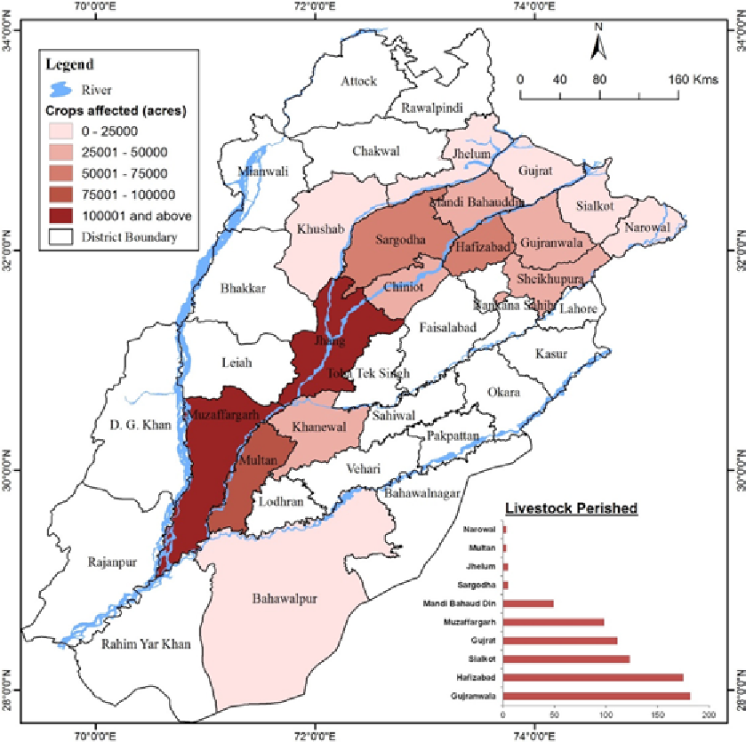

Fig. 4. The 2014 flood damages to agricultural sector in Punjab province.

population, affected villages, human casualties, livestock casualties, houses damages and crops affected was obtained from Provincial Disaster Management Authority (PDMA) of Punjab. The collected data was analyzed through computer- based statistical technique and Geographic Information System (GIS) to find out the extent of flood damages to different sector in the affected districts of Punjab province.

RESULTS AND DISCUSSION
In the first week of September 2014, unprecedented rainfall was recorded in Kashmir, Gilgit Baltistan and many other parts of Pakistan, which has resulted heavy floods in Neelum River at Muzaffarabad, Hunza River at Gilgit, Chenab River at Marala and Jhelum Rivers at Mangla. Parallel to this high discharge, India has also
released 200,000 cusec in Chenab River, which has brought devastating flood in the floodplain of Chenab. As a consequence, it has incurred 185 human losses and approximately 10 million acre cropped land was inundated. During field survey, it was found that on 6th September high floods was reported in the upper part of Punjab especially in the districts of Jhelum, Gujrat and Sialkot and in the lower Indus plain the severely affected districts were Multan, Muzaffargarh and Bahawalpur (Fig. 2). Punjab province comprises of vast plain areas, therefore, the flood smoothly inundated the adjacent areas (Fig. 3).
The analysis reveals that in Punjab province, District Jhang was severely affected in term of damages followed by Muzaffargarh and Multan districts. In the study area, the extent of damages at district Jhang was comparatively high because it

Table 1. Crop damage due to the 2014 flood in Punjab province.

Damaged Crop (Acre) Yield Production Loss

District

Rice Sugarcane Cotton

Rice (Kg/acre)

Sugarcane (Tons/acre)

Cotton (Kg/acre)

Rice (000 Tons)
Sugarcan e (000
Tons)
Cotton (000
Bales)

Bahawalpur | 25 | 99 | 8,821 | 672 | 13 | 305 | 0.02 | 1.29 | 15.83
Chinot | 27,922 | 4,300 | 297 | 775 | 24.7 | 121 | 21.64 | 106.21 | 0.21
Gujranwala | 38,646 | 208 | 0 | 885 | 21 | 0 | 34.2 | 4.37 | 0
Gujrat | 93 | 0 | 0 | 645 | 0 | 0 | 0.06 | 0 | 0
Hafizabad | 57,204 | 272 | 0 | 806 | 20.7 | 0 | 46.11 | 5.63 | 0
Jhang | 63,752 | 7,413 | 24,216 | 653 | 26.1 | 172 | 41.63 | 193.48 | 24.5
Jhelum | 244 | 0 | 0 | 677 | 0 | 0 | 0.17 | 0 | 0
Khanewal | 1,952 | 0 | 27,969 | 694 | 0 | 306 | 1.35 | 0 | 50.34
Khushab | 1,730 | 445 | 0 | 685 | 9.3 | 0 | 1.19 | 4.14 | 0
Mandi B. Din | 26,687 | 3,459 | 0 | 756 | 20.9 | 0 | 20.18 | 72.29 | 0
Multan | 445 | 6,054 | 46,531 | 652 | 22.3 | 300 | 0.29 | 135 | 82.11
Muzaffargar
h | 1,186 | 3,781 | 43,341 | 719 | 27.2 | 246 | 0.85 | 102.84 | 62.72
Narowal | 16,778 | 183 | 0 | 652 | 17.6 | 0 | 10.94 | 3.22 | 0
Sargodha | 5,337 | 2,100 | 0 | 658 | 11.3 | 0 | 3.51 | 23.73 | 0
Shiekhupura | 14,554 | 519 | 0 | 720 | 21.1 | 0 | 10.48 | 10.95 | 0
Sialkot | 18,409 | 128 | 0 | 776 | 14.8 | 0 | 14.29 | 1.89 | 0
Total | 274,964 | 28,961 | 151,175 | 11,425 | 250.0 | 1,450 | 206.91 | 665.04 | 235.71

is the confluence point of river Jhelum and Chenab, where heavy discharge was reported. On the other hand, poor flood mitigation and risk reduction strategies has further aggravated the severity of flood intensity. One of the ill example is that during flood peak, the 18-Hazari dyke was exploded, which as consequence extensively damaged vast agricultural land with standing crops and houses in district Jhang.

Damages to Agricultural Sector
In Punjab, agriculture is the primary economic activity. The floodplain of Indus River and its eastern tributaries along with the extensive network of irrigation canals provide favorable conditions for agricultural activities. In the province, the agricultural products not only fulfilling the needs of Punjab, but also supply to other parts of Pakistan and contribute to the national economy. These rivers have brought developments in agriculture sector, while on the other hand, in summer the high discharge overflow the levees and cause large scale damages to
agricultural land and standing crops.
In 2014, more than 10 million acres of agricultural land were affected by flood and heavy damages recorded at district Jhang followed by Muzaffargarh (Fig. 4). Flood water not only inundate the standing crops but it also remained stagnant for many days in the agricultural fields which has further decreased the chances of crop survival. In Punjab province, landholding is comparatively high and the farmers have high acreage. The analysis reveals that in Punjab province the total affected farmers were 245,116, out of which highest ratio of affected farmers were registered in district Jhang and Muzaffargarh, respectively (Fig. 5). It was found from the analysis that the total perished livestock were 754 with the highest numbers in district Gujranwala and Hafizabad (Fig. 4). Field survey together with the general observations reveals that losses to livestock might be higher as some villages were remote and inaccessibility were the major factor behind the poor reporting to the district government.

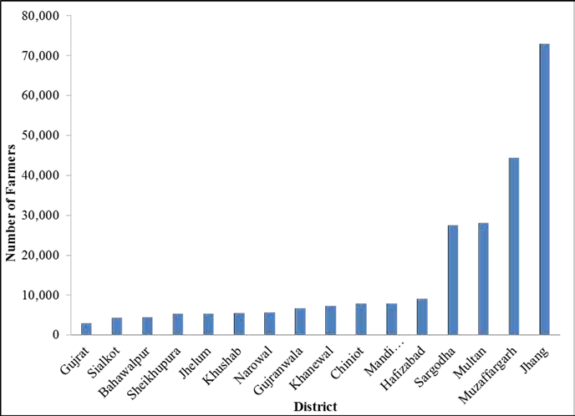
Fig. 5. Number of farmers affected in Punjab province by the 2014 flood.
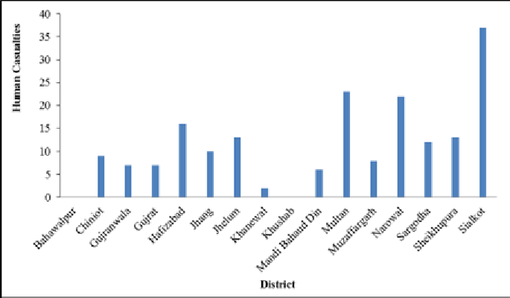
Fig. 6. Human life losses caused by the 2014 flood in Punjab province.

In Punjab, damages to major crops were estimated during flood 2014 from satellite images using GIS. The area under different crops and the affected crop acreage was estimated in acres, whereas yield was calculated in kilogram per acre. As a result, production losses were quantified by comparing the previous year production per acre (Table 1). Among these, rice and cotton were the major affected cash crops and here most of farmers rely on these crops for their livelihood earnings and meet their expenses. After the detail survey of the flood affected areas by PDMA Punjab, it was found that flood affected cropped
area is more than the estimated. It was found from analysis that rice was the most affected crop in terms of acreage followed by cotton. In terms of production losses, sugarcane was on top. The heavy losses to sugarcane was mainly because the flood water remained stagnant for many days and as a consequence severely affected the yield. Contrary to this, there was comparative less adverse impact on rice production (Table 1). To overcome losses due to natural disasters, developed countries of the world have adopted a policy of insurance but in Pakistan such an insurance policy is lacking.

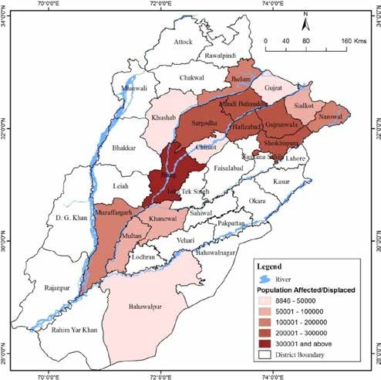

Fig. 7. The 2014 flood-affected population in Punjab province.
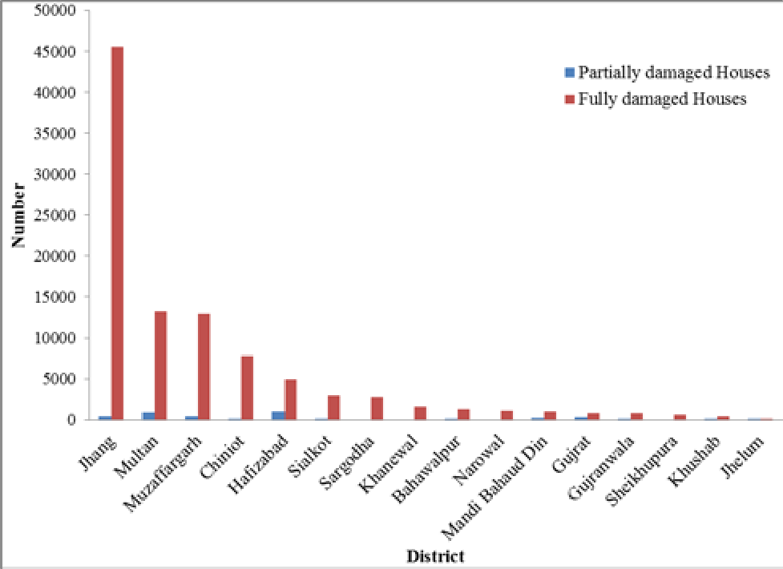
Fig. 8. The 2014 flood caused damages to houses in Punjab province.

Human Casualties and Affected Population
In the study area, a considerable number of human casualties were reported during 2014 flood. It was found from the analysis that in Punjab province total number of human casualties was 185 (Fig. 6), out of which the highest number of casualties (37) was reported from district Sialkot (Fig. 6). It was mainly because the flood water rapidly overflowed the Sialkot city and in effect incurred maximum casualties. Similarly, 23 human casualties was occurred in district Multan and 22 in district Narowal. Over all, the human casualties are reported from 14 districts of Punjab province. It was found from the analysis that the effective flood forecasting and early warning system in the flood prone areas like Punjab province can largely reduce the human losses to a greater extent. In the present scenario, the flood forecasting and early warning system at community level is the utmost need of the day to minimize human sufferings.
The land of Punjab province is mostly fertile floodplain formed by the Indus and its tributaries. During rainy season when water overflow the levees, it inundate to far up areas, which often results population displacement. Same was the case when flood in 2014 has affected sixteen districts of Punjab province, displaced more than
2.3 million people and affected a total of 2,519 villages (Fig. 7). It was found from the analysis that the number of affected population were high in districts Jhang followed by Sargodha, Gujranwala, Sheikhupura and Hafizabad, respectively (Fig. 7).

Damages to Housing Sector
In Punjab province, the 2014 flood caused ravaging damages to the housing sector. According to PDMA Punjab, the number of totally damaged houses was higher than the partially damaged houses. It was estimated that approximately 97,824 houses were fully damaged and 3,691 houses were partially damaged.. The highest number of damaged houses was reported from District Jhang followed by Multan and Muzaffargarh districts (Fig. 8). This devastated situation specifically calls the decision makers to take effective flood risk reduction strategies in the province and minimize the impacts of recurrent flood disasters. To cope with such a menace, in future the government should also implement building regulations and other structural mitigation
strategies to prevent settlement developments in the flood risk areas.

CONCLUSIONS
This study assessed the impact of the 2014 flood on socio-economic and housing sectors of Punjab province, Pakistan. The 2014 flood was one of the most devastating disasters; it had severely affected the socio-economic and housing sectors of Punjab. The flood occurred because of heavy and prolonged rainfall in the catchment areas of all the rivers that drains throughout the province, especially Jhelum and Chenab rivers had recorded the highest discharge beyond the channel capacity. This analysis revealed that the flood of 2014 had brought a wave of destruction in 16 districts of Punjab province and it had devastated socio- economic condition of the entire population. The analysis revealed that in the province more than 10 million acres of agriculture land was affected by the 2014 flood. In Punjab province, the 2014 flood 2014 resulted in displacement of over 2.3 million people and severely affected 2,519 villages. It was found from the analysis that in Punjab province the total affected farmers were 245,116, out of which highest ratio of affected farmers were registered in two districts, i.e., Jhang and Muzaffargarh. The analysis further revealed that maximum damages to agricultural sector occurred in district Jhang, followed by district Muzaffargarh. Additionally, the devastating 2014 flood also severely damaged the housing sector. The analyzed data revealed that approximately 97,824 houses were damaged fully and 3,691 houses were damaged partially. As a consequence, the provincial Disaster Management Authority had declared districts Jhang, Sargodha, Gujranwala, Sheikhupura and Hafizabad as the most severely affected districts. This was mainly because, these districts were seriously suffered by the flood 2014, which displaced millions of people and caused severe damage to agricultural land and housing sector. The analysis further revealed that the 2014 flood had killed 185 people, out of which maximum was reported from district Sialkot. In addition to this, thousands of livestock were also perished and it had caused colossal financial loss worth millions of dollars to the country’s economy. Thus, this devastating incident call for effective flood risk reduction strategies in the province.

- REFERENCES
- Rahman, A. & R. Shaw. Floods in the Hindu Kush region: Causes and socio-economic aspects, In: Mountain Hazards and Disaster Risk Reduction,
H.K. Nibanupudi & R. Shaw (Ed.). Springer, Tokyo, Japan, p. 33-52 (2015).
- Huppert, H.E. & R.S.J. Sparks. Extreme natural hazards: Population growth, globalization and environmental change. Philosophical Transactions of the Royal Society A: Mathematical, Physical and Engineering Sciences 364(1845): 1875-1888 (2006).
- Chan, N.W. & D.J. Parker, Response to dynamic flood hazard factors in peninsular Malaysia. The Geographical Journal 162(3): 313-325 (1996).
- Rahman, A. & A.N. Khan. Analysis of 2010-flood causes, nature and magnitude in the Khyber Pakhtunkhwa, Pakistan. Natural Hazards 66(2): 887-904 (2013).
- Ramos, C. & E. Reis. Floods in southern Portugal: their physical and human causes, impacts and human response. Mitigation and Adaptation Strategies for Global Change 7(3): 267-284 (2002).
- Patro, S., C. Chatterjee, R. Singh, & N.S. Raghuwanshi. Hydrodynamic modelling of a large flood-prone river system in India with limited data. Hydrological Processes 23(19): 2774-2791 (2009).
- Rahman, A. Effectiveness of Flood Hazard Reduction Policies: a Case Study of Kabul Swat Floodplain Peshawar Valey. MPhil Thesis,
Department of Geography, University of Peshawar, Peshawar, 180 pp. (2003).
- Lehner, B., P. Döll, J. Alcamo, T. Henrichs, & F. Kaspar. Estimating the Impact of Global Change on Flood and Drought Risks in Europe: A Continental, Integrated Analysis. Climatic Change 75(3): 273-299 (2006).
- Centre for Research on the Epidemiology of Disasters (CRED). EM-DAT: The International Disaster Database. Centre for Research on the Epidemiology of Disasters, Université Catholique de Louvain, Brussels, Belgium (2014). http://www.emdat.be (Accessed on 20 December 2014).
- Rahman, A., Farzana, G. Rahman, & R. Shaw, Flood disasters and land use planning in Swat valley, Eastern Hindu Kush, In: Land Use Management in Disaster Risk Reduction: Practice and Cases from a Global Perspective, M. Banba &
R. Shaw (Ed.), Springer, Tokyo, Japan, p. 179-195 (2016).
- Chaudhri, S.A. Flood characteristics and problems in Pakistan. Natural Resources Foru, 5(4): 399-407 (1981).
- NDMA. Pakistan floods 2014: Recovery needs assessment and action framework 2014-16. National Disaster Management Authority, Islamabad (2014).
- Mustafa, D. Structural causes of vulnerability to flood hazard in Pakistan. Economic Geography 74(3): 289-305 (1998).

