Welcome to my world

This is a simple ODT file with some core components intended to be converted into TEI.

cats | 3
dogs | 47
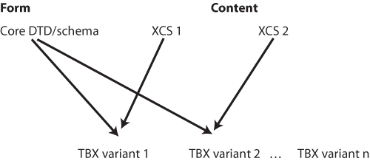

heading 1
text

heading 2
Text

Heading 1
Some text in the first part

Heading 2
Where this is the second part

Heading 3
And this the third

Heading 1
So on to the next heading

Heading 3
Down to 3

Heading 2
Up to two

Heading 6
Down to 6

Heading 2
And ending with level two.
Now some lists:
- cats
- dogs
- chow
- pooch
- hound
- alligators
Whereas we have a gloss list now
- cats
- nice creatures
- dogs
nasty creatures
- lists
- paragraphs
- tables

Dealing with styles
Let us look at italic, bold, bold underline, and red background and green foreground.
A use of the style Emphasis, Internet Link, Quotation, Signature and Variable

Some locally defined styles: sic, date, mentioned
this is the way the wind blows
over the sea to France away away

