**HTML Example(11.html)-**

<html>

<body>

<h1>html version1</h1>

<p>A paragraph (from the Ancient Greek παράγραφος paragraphos, "to write beside" or "written beside") is a self-contained unit of a discourse in writing dealing with a particular point or idea. A paragraph consists of one or more sentences.

</p>

<h2>html version2</h2>

<ul>

<li>teja</li>

<li>madhu</li>

</ul>

<ol>

<li>teja</li>

<li>madhu</li>

</ol>

<button>

<a href="https://www.youtube.com">ok</a>

</button>

<h3>html version3</h3>

<a href="https://www.youtube.com/">youtube link</a>

<br>

<pre>

<t> </t>

<img src="1.jpg"/>

</body>

</html>

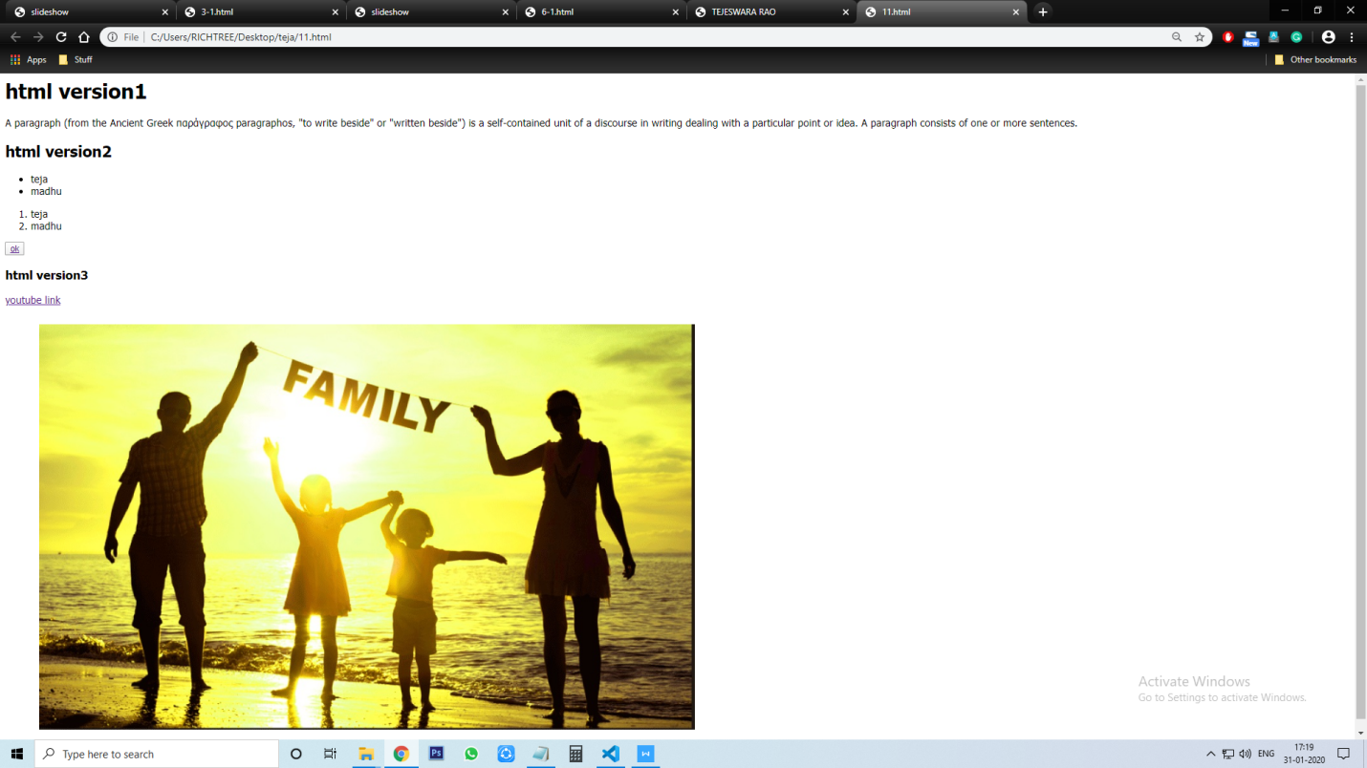

**Frames (12-12.html):**

**Main page-**

<html>

<head><title>frameset</title></head>

<frameset cols="15%,85%">

<frame name="right" src="right.html"/>

<frameset rows="25%,75%">

<frame name="top" src="top.html"/>

<frame name="bottom" src="bottom.html"/>

</frameset>

</frameset>

</html>

**Bottom page** -

<html>

<head>

</head>

<body style="background-color:#000000";>

</body>

</html>

**Right page**-

<html>

<head>

</head>

<body style="background-color:#FFFFFF";>

</body>

</html>

**Top page**-

<html>

<head>

</head>

<body style="background-color:#C0C0C0";>

<marquee><i>Teja Family </i></marquee>

</body>

</html>

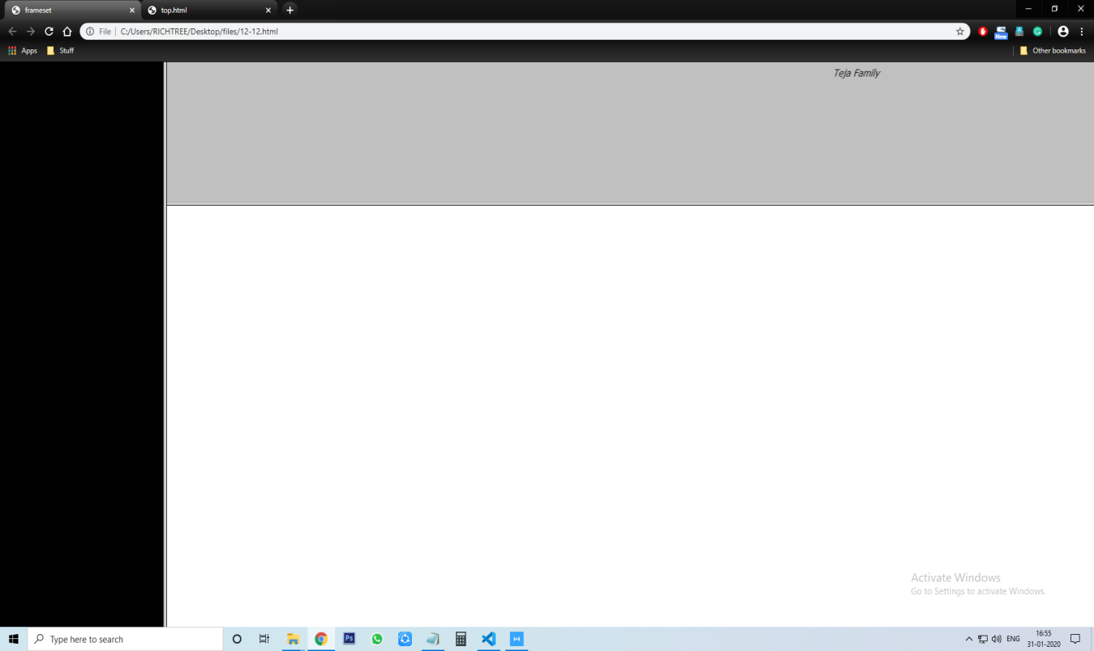

**Alert (13-12.html):**

<html>

<body style="text-align:center">

<form>

First name:<input type="text" value=" "> <br>

Lastname:<input type="text" value=" "><br>

pwd:<input type="password" value=" "><br>

<i>Radio Button </i><br>

<input type="radio" value="car">car<br>

<input type="radio" value="bike">bike<br>

<select>

<option value="bike">bike</option>

<option value="car">car</option>

<option value="bus">bus</option>

</select><br>

<button type="button" onclick="alert('-----ok--------')" value="ok">ok</button><br>

<input type="reset" onclick="alert('u cant')" name=" " value="reset"><br>.

</form>

</body>

</html>

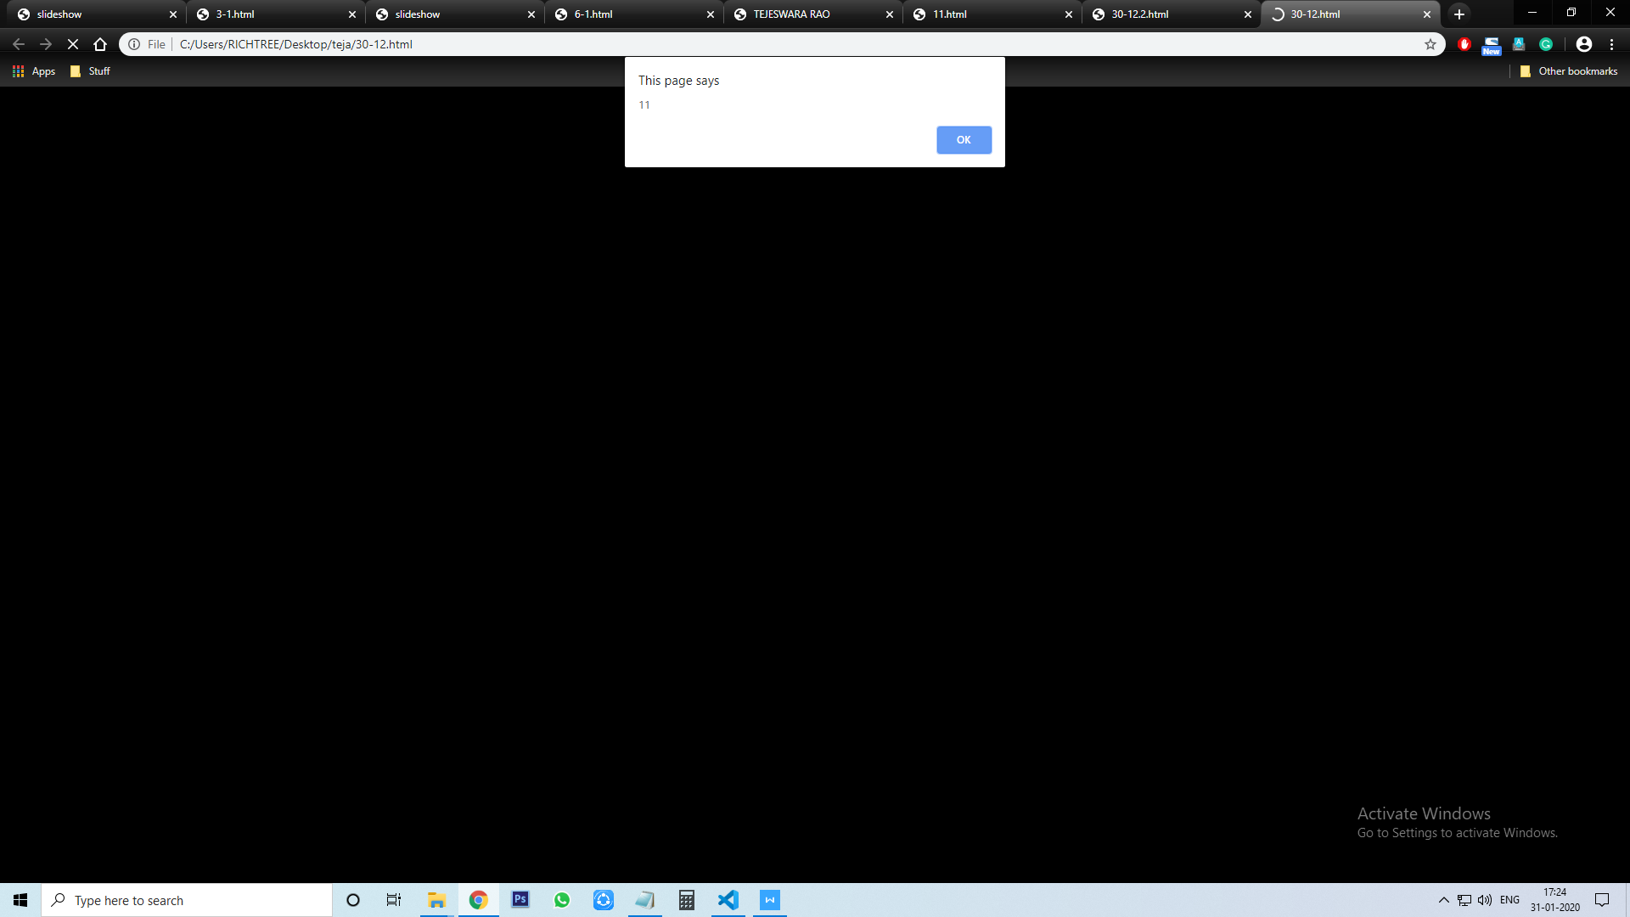

**CSS(css1.html):**

<html>

<head>

<style>

#t {

background-color: lightgrey;

width: 600px;

border: 15px solid green;

padding: 50px;

box-sizing: border-box;

margin: auto;

outline-style:groove;

}

body{ background-color:rgba(255,99,71,0.2);text-align:center;}

h1 {color:rgb(224, 210, 210); text-align:left;border-radius:20px;border-style:dotted solid double dashed}

p{ font-family:verdana;font-size:30px;border-style:dotted dashed solid double}

#teja{text-align:end ; font-size:40px;color:salmon;margin-left:6px;border-radius:12px;}

*{ text-align:center;color:sandybrown;}

h2{outline-style:dotted;font-size:20px;border-radius:40px;padding:20px 20px 20px 20px;background-color:rgb(88, 75, 124);text-emphasis-color:rgb(151, 69, 114);}

</style>

</head>

<body>

<h1>hello teja</h1>

<p>hello teja</p>

<p id="teja">hello teja </p>

<h2>ATMAKURI TEJESWARA RAO</h2>

<p id="t">The CSS box model is essentially a box that wraps around every HTML element.

It consists of: borders, padding, margins, and the actual content.</p>

</body>

</html>

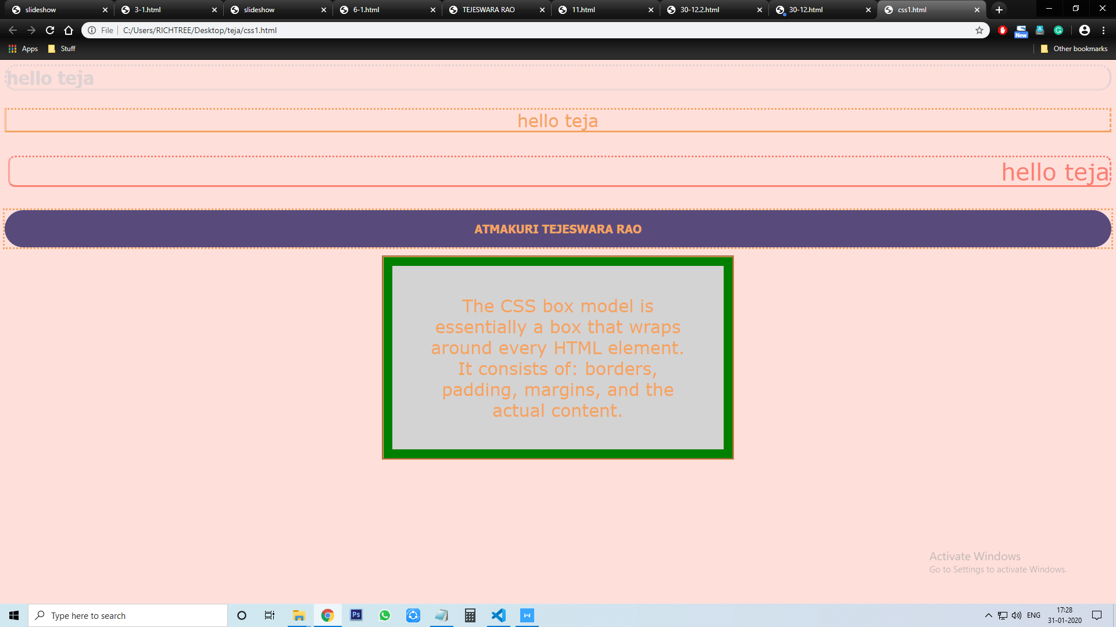

**Transition and transform(css3.html):**

<!DOCTYPE html>

<html>

<head>

<style>

div {

width: 500px;

height: 500px;

background-image:url('1.jpg');

-webkit-transition: width 2s, height 2s, -webkit-transform 2s; /* Safari */

transition: width 2s, height 2s, transform 2s;

}

div:hover {

width: 300px;

height: 300px;

background-image:url('14.jpg');

-webkit-transform: rotate(180deg); /* Safari */

transform: rotate(360deg);

}

</style>

</head>

<body>

<h1>Transition + Transform</h1>

<p>Hover over the div element below:</p>

<div></div>

<br><br><br>

<p><b>Note:</b> This example does not work in Internet Explorer 9 and earlier versions.</p>

</body>

</html>

