**COUNT DOWN IN JS(count.html):**

<!DOCTYPE HTML>

<html>

<head>

<meta name="viewport" content="width=device-width, initial-scale=1">

<style>

p {

text-align: center;

font-size: 60px;

margin-top: 0px;

}

</style>

</head>

<body>

<p id="demo"></p><script>

var countDownDate = new Date("FEB 14, 2020 15:37:25").getTime();

var x = setInterval(function() {

var now = new Date().getTime();

var distance = countDownDate - now;

var days = Math.floor(distance / (1000 * 60 * 60 * 24));

var hours = Math.floor((distance % (1000 * 60 * 60 * 24)) / (1000 * 60 * 60));

var minutes = Math.floor((distance % (1000 * 60 * 60)) / (1000 * 60));

var seconds = Math.floor((distance % (1000 * 60)) / 1000);

document.getElementById("demo").innerHTML = days + "d " + hours + "h "

+ minutes + "m " + seconds + "s ";

// If the count down is over, write some text

if (distance < 0) {

clearInterval(x);

document.getElementById("demo").innerHTML = "EXPIRED";

}

}, 1000);

</script>

</body>

</html>

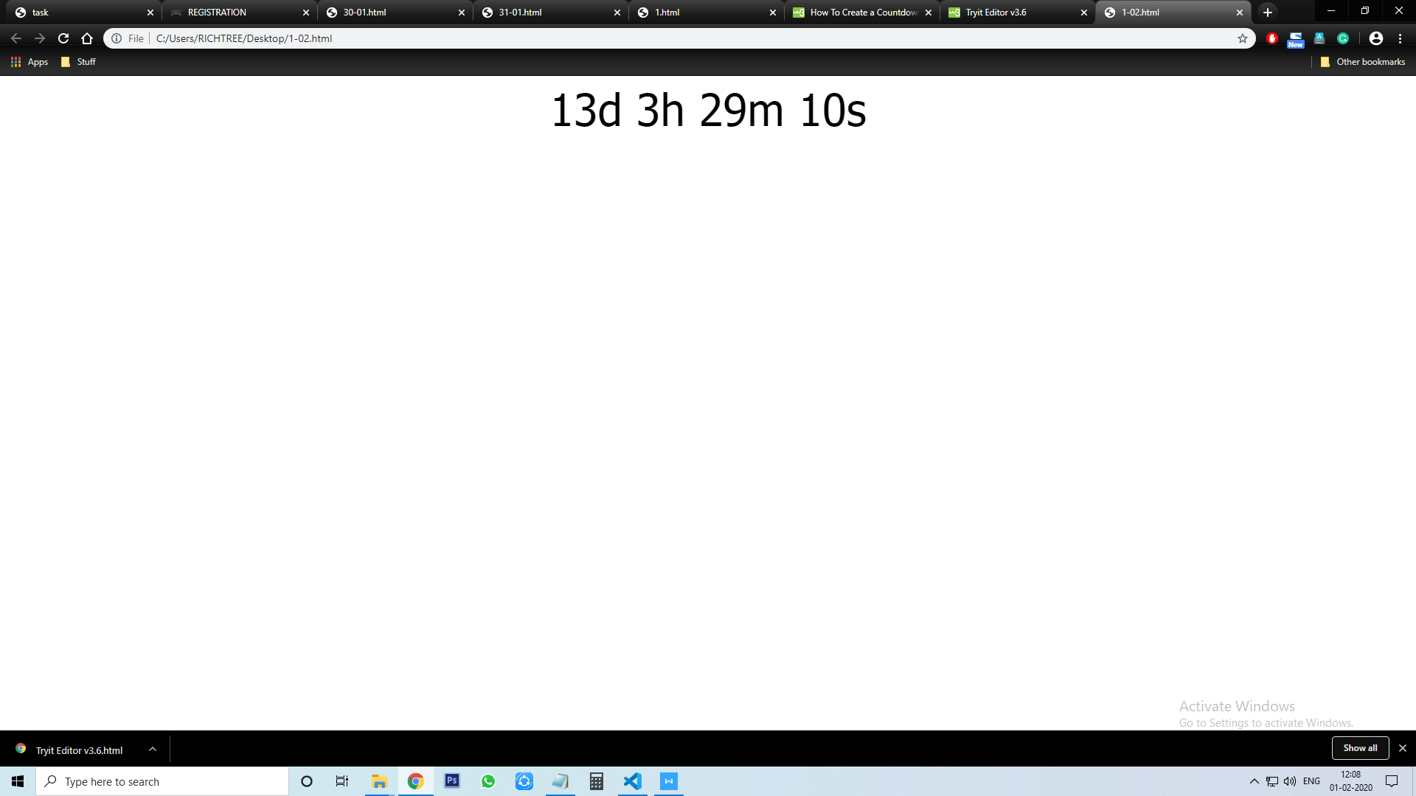

**ANGULARJS(ang.html)**

<html>

<head>

<script src="https://ajax.googleapis.com/ajax/libs/angularjs/1.6.9/angular.min.js"></script>

</head>

<body>

<div>plain text : {{10+30}}</div>

<div ng-app="">sum:{{10.5+30}}</div>

</body>

</html>

