[INSTITUTE NAME]
Department of Computer Science and Engineering

ChronoVault
A Temporal Mission Control Website

C++ Object-Oriented Programming Mid-Semester Project Report

Course: Object-Oriented Programming in C++ — [COURSE CODE]
Submitted by: [STUDENT NAME]
Roll No.: [ROLL NUMBER]
Submitted to: [FACULTY NAME]
Date of submission: [DATE]

Contents
- 1. Abstract
- 2. Introduction
- 3. Problem Statement and Objectives
- 4. Scope and Limitations
- 5. Requirements and Technology Stack
- 6. System Design
- 7. Website Modules
- 8. OOP Concepts Used

Encapsulation
Mission and ChronoVault keep their data members private. Other parts of the program use public methods instead of changing mission status or energy directly. This protects the object state and keeps validation in one place.

Constructors and destructors
Constructors initialise a Mission with its ID, name, timeline, explorer type, energy and starting status. Explorer has a virtual destructor so a derived explorer can be safely destroyed through a base-class pointer.

Inheritance
Historian, Engineer and Guardian derive from the common Explorer base class. They reuse the shared explorer interface while providing their own role-specific behaviour.

Runtime polymorphism
Explorer declares the action() behaviour as virtual. ChronoVault can call the action through an Explorer pointer; the actual derived class implementation runs according to the selected explorer type.

Composition / ownership
ChronoVault manages mission records and the explorer objects needed by the application. These objects work together as one mission-control system: a Mission stores the assignment while an Explorer supplies the behaviour.

Dynamic memory management
The explorer collection uses smart pointers (std::unique_ptr) to represent owned derived objects through the Explorer base type. The objects are released automatically when their owner is destroyed, avoiding manual delete calls.

Operator overloading
The project overloads an operator for the Mission type to provide a readable comparison/representation used by the implementation. This is a C++ language feature and is separate from the website buttons.
- 9. Implementation Overview

Step 1 — Define the domain classes
include/ChronoVault.h declares Explorer, the three derived explorer classes, Mission and ChronoVault. The header defines what each object stores and which operations other parts of the program may call.

Step 2 — Implement the business rules
src/ChronoVault.cpp implements constructors, mission creation, energy checks, mission lookup and launch behaviour. The C++ layer is the source of truth for validation; the browser does not decide whether an allocation is allowed.

Step 3 — Receive browser requests
src/main.cpp starts the local HTTP server and registers API routes. A browser request is parsed as JSON, passed to ChronoVault, then returned as a JSON response. A mutex protects shared in-memory state while a request is processed.

Step 4 — Render the website
public/index.html defines the navigation, cards, form and history table. public/css/style.css supplies the dark navy/cyan appearance. public/js/app.js listens for user actions, calls the API with fetch(), and refreshes the visible data from the server response.

Step 5 — Build and run
CMakeLists.txt configures the C++17 executable and its dependencies. CMake generates the build files; compiling produces the server executable. When the server is running, open the local address printed in the terminal to use the website.

Example: creating and launching a mission
The user fills the Mission Control form and presses Create Mission. JavaScript sends the form values to POST /api/missions. The C++ server checks the request and calls ChronoVault to validate the energy and create a Mission. The response is returned as JSON and the page refreshes. When Launch is pressed, a second request identifies the mission; the selected explorer’s virtual action is called, the status/result is updated, and the history table refreshes.
- 10. Algorithms and Validation
- 11. Testing
- 12. Results and Screenshots
- 13. Future Enhancements
- 14. Conclusion
- 15. References
- Appendix A: Project File Structure

1. Abstract
ChronoVault is a beginner-friendly website that simulates a fictional temporal mission centre. Users can create a mission, select a timeline and explorer type, reserve energy, launch the mission and review its status. The interface is built with HTML, CSS and JavaScript, while a C++17 backend performs validation and stores mission state in memory. The project demonstrates core object-oriented programming ideas through a small class hierarchy and a simple web API. Its goal is to connect classroom OOP concepts to a working website without introducing a database or a large framework.

2. Introduction
Object-oriented programming helps organise software around objects that contain data and behaviour. ChronoVault models missions and explorers as C++ objects. A browser provides the user interface, and HTTP requests connect the website to the C++ application. The project intentionally keeps the feature set small so that a student can explain the main classes, control flow and validation rules.

3. Problem Statement and Objectives
A mission-control interface needs to track available energy, store mission details and apply the behaviour of a selected specialist. The project aims to:
- Create a clear dashboard for the current session.
- Allow users to create and launch missions through a website.
- Reject invalid energy allocations and insufficient-energy requests.
- Represent explorer roles using inheritance and runtime polymorphism.
- Demonstrate encapsulation, constructors/destructors, composition, dynamic memory management and operator overloading.

4. Scope and Limitations
Included: dashboard statistics, mission creation, three explorer roles, launch actions, mission history and backend validation. The website is a classroom prototype. It has no login, persistent database, real time travel, cloud deployment or multi-user synchronisation. Mission information is stored in memory and resets when the C++ server stops.

5. Requirements and Technology Stack
Item | Purpose
C++17 | Backend classes, validation and mission logic
HTML | Page structure and forms
CSS | Responsive dark navy/cyan visual design
JavaScript | Navigation, API requests and dynamic rendering
cpp-httplib | Small HTTP server
nlohmann/json | JSON request and response handling
CMake | Build configuration
Modern browser | Run the website locally

6. System Design
The browser renders the four website sections and sends HTTP requests to the local C++ server. The server calls methods on ChronoVault, which owns the explorer objects and mission collection. The backend is the source of truth: the browser does not decide whether energy is sufficient or whether a mission can be launched.
Request flow: Browser form → POST /api/missions → C++ validation → ChronoVault creates Mission and reserves energy → JSON response → website refreshes dashboard/history.

7. Website Modules

7.1 Dashboard
Shows total missions, remaining energy, registered explorers and completed missions. It also displays recent operations and the system status.

7.2 Mission Control
Provides a form to enter a mission name, select a timeline and explorer type, and allocate 20–200 Chrono Units (CU). The backend rejects invalid values or allocations greater than the remaining reserve. A planned mission can then be launched.

7.3 Explorer Registry
Displays three explorer roles: Historian, Engineer and Guardian. Each role has a different action implemented through a virtual function.

7.4 Mission History
Displays the mission ID, name, timeline, assigned explorer, energy allocation, status and launch action in a table.

8. OOP Concepts Used
Concept | Implementation in ChronoVault
Encapsulation | Mission fields are private; public methods provide controlled access.
Constructors | Mission constructor initialises the mission fields; ChronoVault constructor prepares explorer objects.
Destructor | ChronoVault has a destructor; unique_ptr automatically releases owned explorer objects.
Composition | ChronoVault owns a collection of explorer objects and a collection of Mission objects.
Dynamic memory management | std::unique_ptr<Explorer> owns dynamically created derived explorer instances and cleans them up automatically.
Inheritance | Historian, Engineer and Guardian derive from the abstract Explorer base class.
Runtime polymorphism | The virtual action() function calls the behaviour of the selected explorer type.
Operator overloading | Mission::operator== compares two missions using their unique IDs.

9. Implementation Overview
- Declare Explorer as a base class with a name, virtual destructor, type() and action() methods.
- Implement Historian, Engineer and Guardian as derived classes with distinct actions.
- Implement Mission to store mission details, status and result.
- Implement ChronoVault to own explorer objects, validate mission creation and launch a mission.
- Create HTTP endpoints for dashboard, missions, explorers, mission creation and launch.
- Build the website interface and use JavaScript fetch() calls to communicate with the backend.
- Build with CMake, start the server and test the main user flows in a browser.

10. Algorithms and Validation

10.1 Create mission
- Read mission name, timeline, explorer type and energy from the JSON request.
- Reject an empty name or timeline.
- Reject energy below 20 CU or above 200 CU.
- Reject if requested energy exceeds the available reserve.
- Check that the selected explorer type exists.
- Deduct the energy, create a Mission with the next ID and return the new mission as JSON.

10.2 Launch mission
Find the mission by ID. If it does not exist or is not in Planned status, return an error. Otherwise, find the explorer with the matching type, call its virtual launch action and change the mission status to Completed.

11. Testing
The source was built successfully with CMake and GCC in the working environment. The HTTP endpoints were exercised for initial dashboard data, mission creation, mission launch and static website delivery. Before submission, repeat the checklist on the student’s own computer and insert screenshots of the actual running website. Do not claim a test was performed on a different machine unless it was.
Test | Expected result | Status in local check
Fresh dashboard | 0 missions, 500 CU, 3 explorers | Passed
Create 50 CU mission | Mission created; energy decreases to 450 CU | Passed
Launch mission | Status Completed and explorer action returned | Passed
Open website root | HTML page served by C++ server | Passed
Invalid energy / repeated launch | Request rejected with a clear error | Verify manually before submission

12. Results and Screenshots
The following figures show the website interface in its dark navy and cyan theme. Figure 4 uses a sample completed mission to make the history table easy to understand. When preparing the final submission, run the C++ server locally and replace any illustrative data with screenshots from your own run if your faculty requires live evidence.
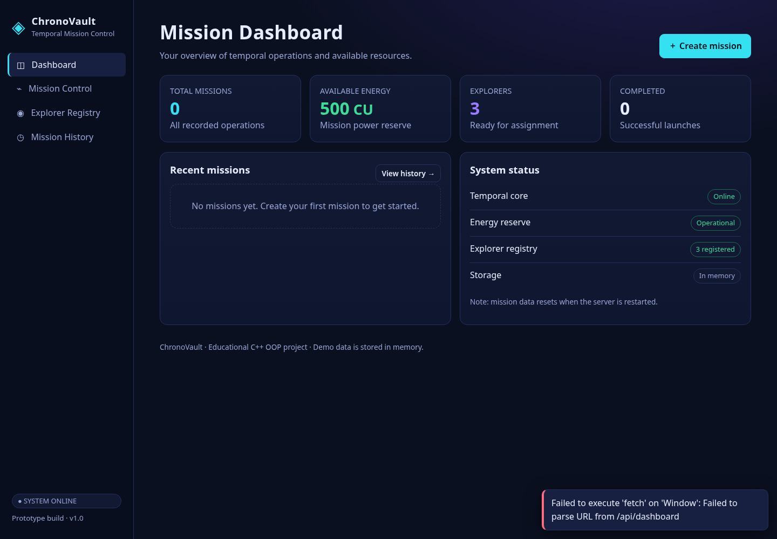
Figure 1. Dashboard with initial values
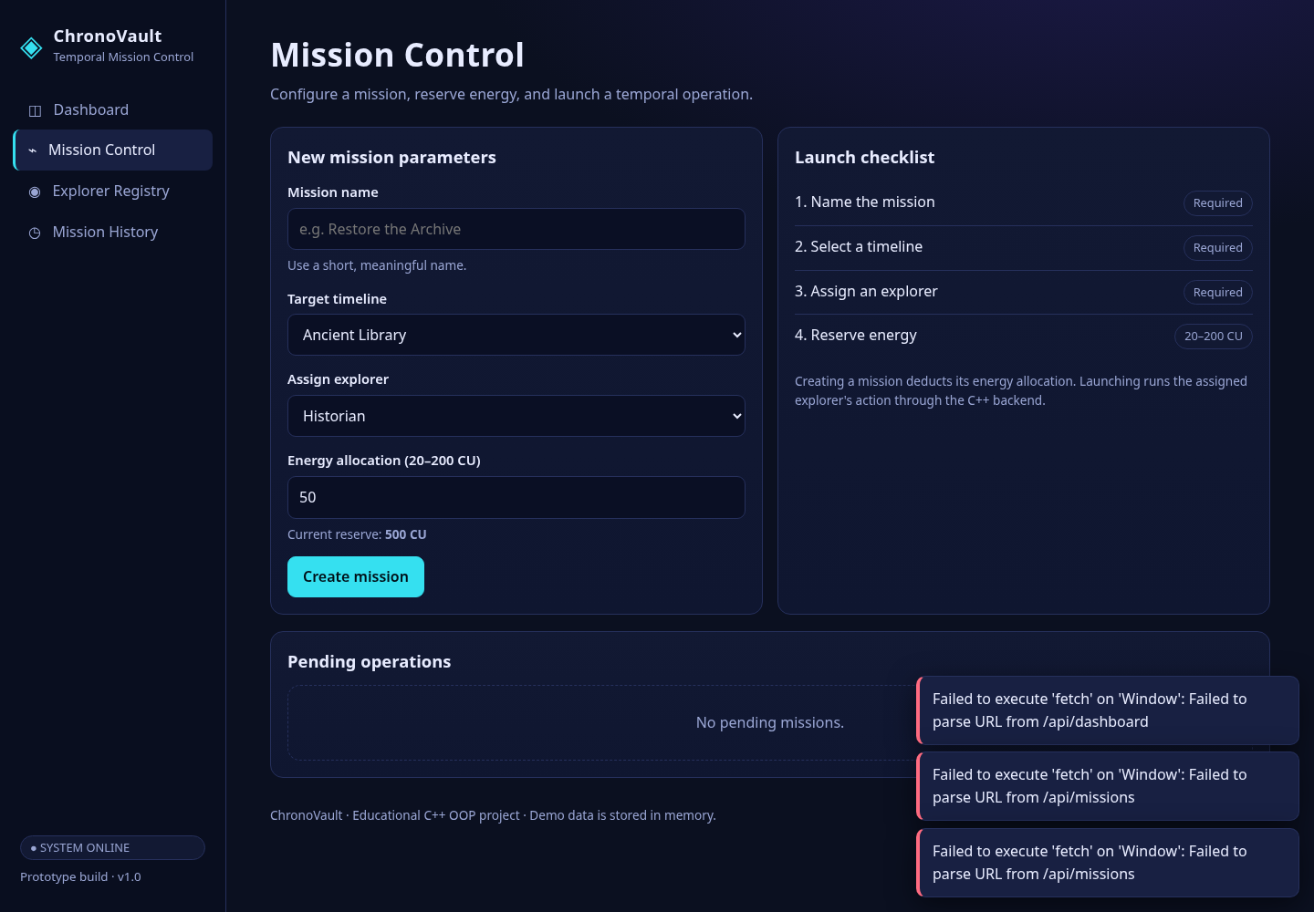
Figure 2. Mission Control form before submission
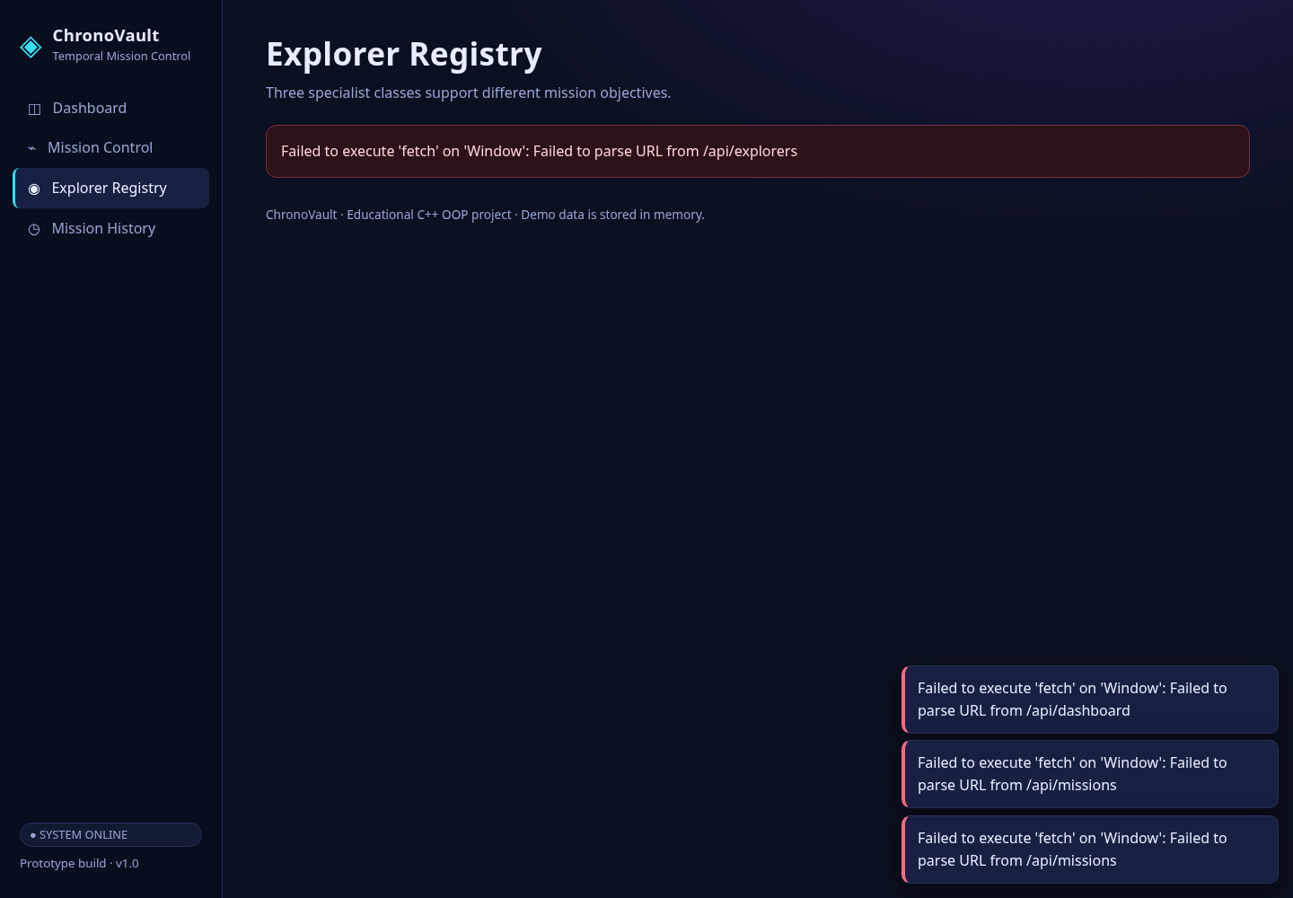
Figure 3. Explorer Registry showing three roles
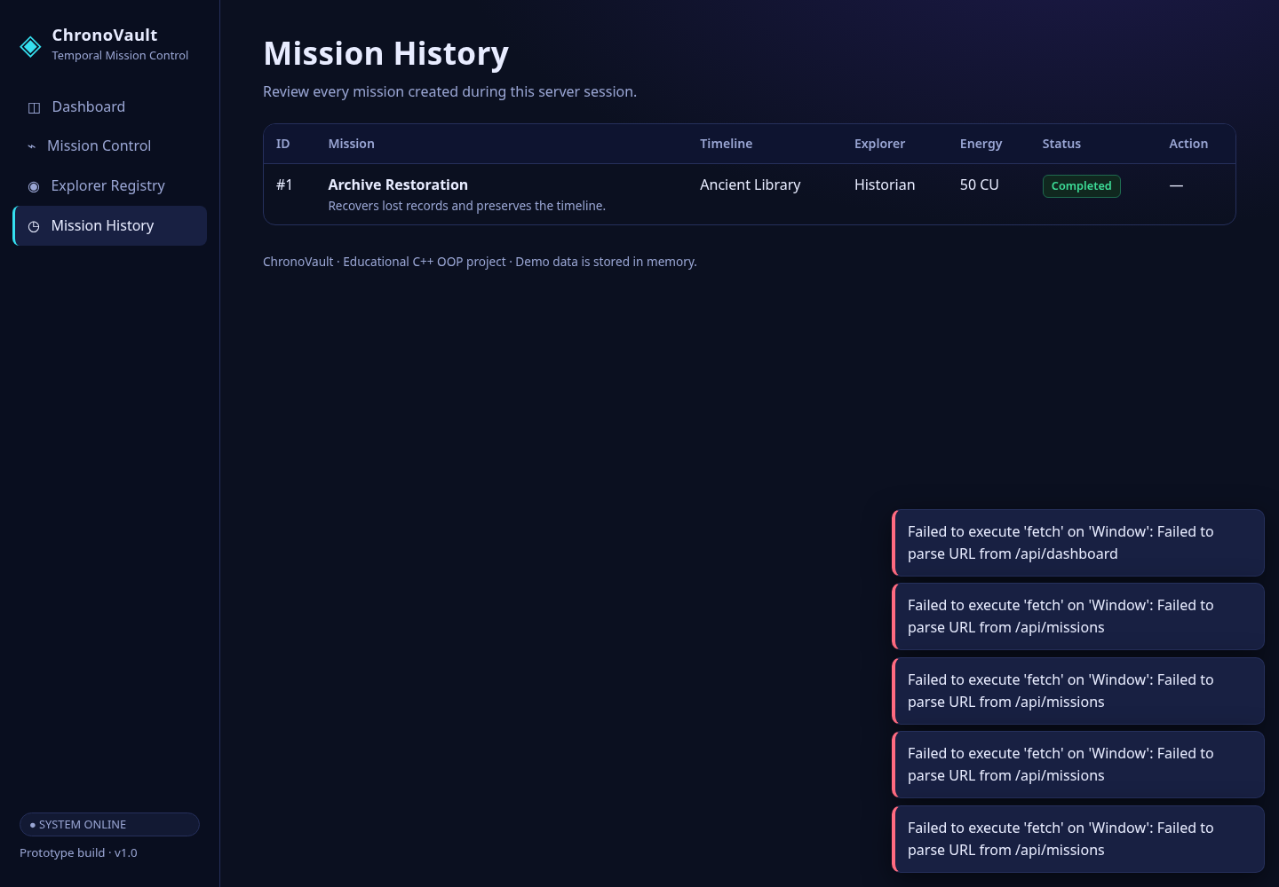
Figure 4. Successful mission launch and result

Figure 5. Mission History after creating a mission
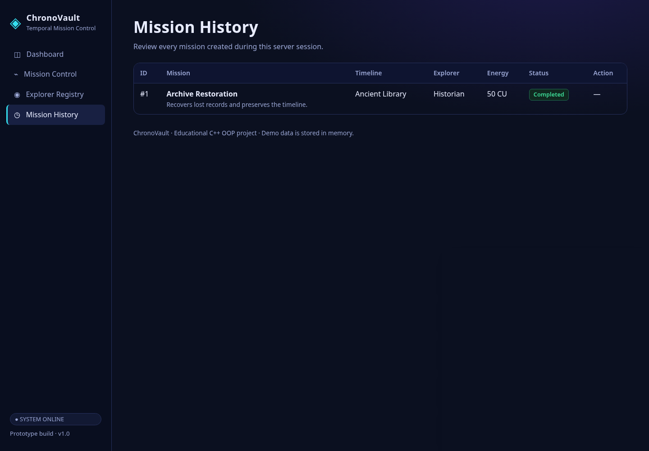
Figure 5 shows the Mission History table with a completed sample mission. It illustrates the columns displayed to the user: mission ID, mission name, timeline, assigned explorer, energy, status and action. The sample is included to explain the intended interface; run the local server to verify live data on your own machine.

13. Future Enhancements
- Store missions in SQLite so data persists after restart.
- Add user accounts and mission ownership.
- Add more timeline types and mission outcomes.
- Add automated C++ unit tests and browser-based tests.
- Deploy the application to a hosting platform.

14. Conclusion
ChronoVault is a compact website-based OOP project that demonstrates how C++ classes can power an interactive interface. It covers encapsulation, constructors/destructors, composition, automatic dynamic memory management, inheritance, runtime polymorphism and operator overloading. The limited scope makes it suitable for explaining the implementation step by step and provides a foundation for future improvements.

15. References
- cppreference.com — C++ language and standard library reference: https://en.cppreference.com/
- CMake documentation: https://cmake.org/documentation/
- cpp-httplib repository: https://github.com/yhirose/cpp-httplib
- nlohmann/json documentation: https://json.nlohmann.me/

Appendix A: Project File Structure
This diagram is a map of the folders and files. It shows which files create the website, which files contain the C++ OOP logic, and which files help build and test the project.
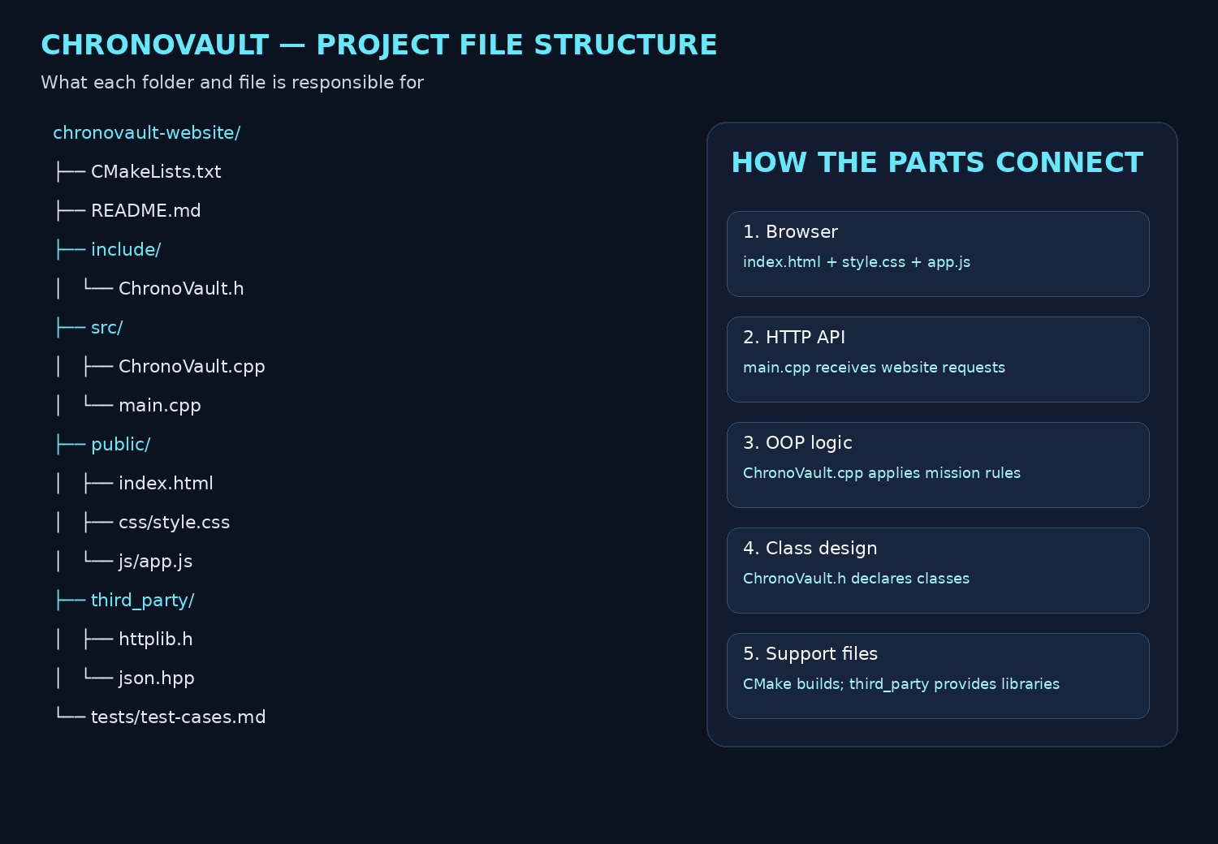
File or folder | Purpose
include/ChronoVault.h | Declares Mission, Explorer, Historian, Engineer, Guardian and ChronoVault classes.
src/ChronoVault.cpp | Implements mission creation, energy checks, mission launch and explorer setup.
src/main.cpp | Starts the local C++ HTTP server and defines the API endpoints used by the website.
public/index.html | Defines the four website sections and the mission form.
public/css/style.css | Defines layout, spacing, colours, cards, tables and responsive styling.
public/js/app.js | Handles navigation, sends API requests, and updates dashboard and history content.
third_party/httplib.h | Header-only HTTP server library used by main.cpp.
third_party/json.hpp | JSON library used to read requests and send responses.
CMakeLists.txt | Build instructions for compiling the C++ application.
tests/test-cases.md | Manual checklist for checking the main website workflows.
README.md | Setup instructions, API routes, OOP concepts and usage notes.

Appendix B: C++ Class Declarations — include/ChronoVault.h
Listing: include/ChronoVault.h
#pragma once
#include <memory>
#include <string>
#include <vector>
class Explorer {
protected:
std::string name_;
public:
explicit Explorer(std::string name) : name_(std::move(name)) {}
virtual ~Explorer() = default;
std::string name() const { return name_;
}
virtual std::string type() const = 0;
virtual std::string action() const = 0;
};
class Historian : public Explorer {
public: using Explorer::Explorer;
std::string type() const override { return "Historian";
}
std::string action() const override { return "Verified historical records";
}
};
class Engineer : public Explorer {
public: using Explorer::Explorer;
std::string type() const override { return "Engineer";
}
std::string action() const override { return "Repaired timeline equipment";
}
};
class Guardian : public Explorer {
public: using Explorer::Explorer;
std::string type() const override { return "Guardian";
}
std::string action() const override { return "Protected the timeline";
}
};
class Mission {
private:
int id_;
std::string name_, timeline_, explorerType_, status_, result_;
int energy_;
public:
Mission(int id, std::string name, std::string timeline, std::string explorerType, int
energy);
int id() const { return id_;
}
std::string name() const { return name_;
}
std::string timeline() const { return timeline_;
}
std::string explorerType() const { return explorerType_;
}
std::string status() const { return status_;
}
std::string result() const { return result_;
}
int energy() const { return energy_;
}
void launch(const Explorer& explorer);
bool operator==(const Mission& other) const { return id_ == other.id_;
}
};
class ChronoVault {
private:
int energy_ = 500;
int nextId_ = 1;
std::vector<Mission> missions_;
std::vector<std::unique_ptr<Explorer>> explorers_;
public:
ChronoVault();
~ChronoVault();
ChronoVault(const ChronoVault&) = delete;
ChronoVault& operator=(const ChronoVault&) = delete;
int energy() const { return energy_;
}
const std::vector<Mission>& missions() const { return missions_;
}
const std::vector<std::unique_ptr<Explorer>>& explorers() const { return explorers_;
}
Mission& createMission(const std::string& name, const std::string& timeline, const
std::string& type, int energy);
void launchMission(int id);
};

Appendix C: OOP Implementation — src/ChronoVault.cpp
Listing: src/ChronoVault.cpp
#include "ChronoVault.h"
#include <stdexcept>
#include <utility>
Mission::Mission(int id, std::string name, std::string timeline, std::string explorerType,
int energy)
: id_(id), name_(std::move(name)), timeline_(std::move(timeline)),
explorerType_(std::move(explorerType)), status_("Planned"), result_("Awaiting launch"),
energy_(energy) {}
void Mission::launch(const Explorer& explorer) {
status_ = "Completed";
result_ = explorer.action();
}
ChronoVault::ChronoVault() {
explorers_.push_back(std::make_unique<Historian>("Ada"));
explorers_.push_back(std::make_unique<Engineer>("Nikola"));
explorers_.push_back(std::make_unique<Guardian>("Mira"));
}
ChronoVault::~ChronoVault() = default;
Mission& ChronoVault::createMission(const std::string& name, const std::string& timeline,
const std::string& type, int energy) {
if (name.empty() || timeline.empty()) throw std::invalid_argument("Enter a mission name
and choose a timeline.");
if (energy < 20 || energy > 200) throw std::invalid_argument("Energy must be between 20
and 200 CU.");
if (energy > energy_) throw std::invalid_argument("Not enough energy available for this
mission.");
bool valid = false;
for (const auto& e : explorers_) if (e->type() == type) valid = true;
if (!valid) throw std::invalid_argument("Choose a valid explorer type.");
energy_ -= energy;
missions_.emplace_back(nextId_++, name, timeline, type, energy);
return missions_.back();
}
void ChronoVault::launchMission(int id) {
for (auto& m : missions_) {
if (m.id() == id) {
if (m.status() != "Planned") throw std::invalid_argument("This mission has
already been launched.");
for (const auto& e : explorers_) if (e->type() == m.explorerType()) {
m.launch(*e);
return;
}
}
}
throw std::invalid_argument("Mission not found.");
}

Appendix D: HTTP Server and API — src/main.cpp
Listing: src/main.cpp
#include "ChronoVault.h"
#include "httplib.h"
#include "json.hpp"
#include <iostream>
#include <mutex>
#include <filesystem>
using json = nlohmann::json;
int main(int argc, char** argv) {
std::string publicDir = argc > 1 ? argv[1] : "public";
ChronoVault vault;
httplib::Server server;
std::mutex mutex;
auto missionJson = [](const Mission& m) {
return json{{"id",m.id()},{"name",m.name()},{"timeline",m.timeline()},{"explorerType",m.
explorerType()},{"energy",m.energy()},{"status",m.status()},{"result",m.result()}};
};
server.Get("/api/dashboard", [&](const httplib::Request&, httplib::Response& res) {
std::lock_guard<std::mutex> lock(mutex);
int completed=0;
for(const auto& m:vault.missions()) if(m.status()=="Completed") ++completed;
json recent=json::array();
for(auto it=vault.missions().rbegin();it!=vault.missions().rend() &&
recent.size()<4;++it) recent.push_back(missionJson(*it));
res.set_content(json{{"missions",vault.missions().size()},{"energy",vault.energy()},
{"explorers",vault.explorers().size()},{"completed",completed},{"recent",recent}}.dump()
,"application/json");
});
server.Get("/api/missions", [&](const httplib::Request&, httplib::Response& res) {
std::lock_guard<std::mutex> lock(mutex);
json a=json::array();
for(const auto& m:vault.missions()) a.push_back(missionJson(m));
res.set_content(a.dump(),"application/json");
});
server.Get("/api/explorers", [&](const httplib::Request&, httplib::Response& res) {
json a=json::array();
for(const auto& e:vault.explorers())
a.push_back({{"name",e->name()},{"type",e->type()},{"action",e->action()}});
res.set_content(a.dump(),"application/json");
});
server.Post("/api/missions", [&](const httplib::Request& req, httplib::Response& res) {
try { auto b=json::parse(req.body);
std::lock_guard<std::mutex> lock(mutex);
auto& m=vault.createMission(b.value("name",std::string{}),b.value("timeline",std::string
{}),b.value("explorerType",std::string{}),b.value("energy",0));
res.status=201;
res.set_content(missionJson(m).dump(),"application/json");
} catch(const std::exception& e) {
res.status=400;
res.set_content(json{{"error",e.what()}}.dump(),"application/json");
} });
server.Post(R"(/api/missions/(\d+)/launch)", [&](const httplib::Request& req,
httplib::Response& res) {
try { int id=std::stoi(req.matches[1]);
std::lock_guard<std::mutex> lock(mutex);
vault.launchMission(id);
for(const auto& m:vault.missions()) if(m.id()==id) {
res.set_content(missionJson(m).dump(),"application/json");
return;
} } catch(const std::exception& e) {
res.status=400;
res.set_content(json{{"error",e.what()}}.dump(),"application/json");
} });
server.set_mount_point("/", publicDir);
std::cout << "ChronoVault website: http://localhost:8099\nPress Ctrl+C to stop.\n";
if (!server.listen("127.0.0.1",8099)) {
std::cerr << "Could not start on port 8080. Close another app using it and retry.\n";
return 1;
}
}

Appendix E: Website Markup — public/index.html
Listing: public/index.html
<!DOCTYPE html>
<html lang="en">
<head>
<meta charset="utf-8"/>
<meta content="width=device-width,initial-scale=1" name="viewport"/>
<title>
ChronoVault | Temporal Mission Control
</title>
<link href="/css/style.css" rel="stylesheet"/>
</head>
<body>
<div class="topbar">
<button aria-label="Open navigation" class="icon-btn" id="menuBtn">
☰
</button>
<div class="brand-small">
◈ ChronoVault
</div>
<span class="pill">
SYSTEM ONLINE
</span>
</div>
<aside class="sidebar" id="sidebar">
<div class="brand">
<div style="font-size:2rem;color:var(--cyan)">
◈
</div>
<div>
<strong>
ChronoVault
</strong>
<span>
Temporal Mission Control
</span>
</div>
</div>
<nav>
<a class="active" data-page="dashboard" href="#dashboard">
◫ Dashboard
</a>
<a data-page="missions" href="#missions">
⌁ Mission Control
</a>
<a data-page="explorers" href="#explorers">
◉ Explorer Registry
</a>
<a data-page="history" href="#history">
◷ Mission History
</a>
</nav>
<div class="side-foot">
<span class="pill">
● SYSTEM ONLINE
</span>
<small>
Prototype build · v1.0
</small>
</div>
</aside>
<main id="main" tabindex="-1">
<section class="page" id="page-dashboard">
<div class="row between">
<div>
<h1>
Mission Dashboard
</h1>
<p class="lead">
Your overview of temporal operations and available resources.
</p>
</div>
<button class="btn" data-goto="missions">
＋ Create mission
</button>
</div>
<div class="grid cols-4">
<div class="card stat cy">
<span class="l">
TOTAL MISSIONS
</span>
<span class="n" id="statMissions">
0
</span>
<span class="muted">
All recorded operations
</span>
</div>
<div class="card stat ok">
<span class="l">
AVAILABLE ENERGY
</span>
<span class="n">
<span id="statEnergy">
500
</span>
<small>
CU
</small>
</span>
<span class="muted">
Mission power reserve
</span>
</div>
<div class="card stat vi">
<span class="l">
EXPLORERS
</span>
<span class="n" id="statExplorers">
3
</span>
<span class="muted">
Ready for assignment
</span>
</div>
<div class="card stat">
<span class="l">
COMPLETED
</span>
<span class="n" id="statCompleted">
0
</span>
<span class="muted">
Successful launches
</span>
</div>
</div>
<div class="grid cols-2" style="margin-top:18px">
<div class="card">
<div class="row between">
<h2>
Recent missions
</h2>
<button class="btn ghost sm" data-goto="history">
View history →
</button>
</div>
<div class="empty" id="recentList">
No missions yet. Create your first mission to get started.
</div>
</div>
<div class="card">
<h2>
System status
</h2>
<ul class="list">
<li>
<span>
Temporal core
</span>
<span class="pill ok">
Online
</span>
</li>
<li>
<span>
Energy reserve
</span>
<span class="pill ok">
Operational
</span>
</li>
<li>
<span>
Explorer registry
</span>
<span class="pill ok">
3 registered
</span>
</li>
<li>
<span>
Storage
</span>
<span class="pill">
In memory
</span>
</li>
</ul>
<p class="hint">
Note: mission data resets when the server is restarted.
</p>
</div>
</div>
</section>
<section class="page" hidden="" id="page-missions">
<h1>
Mission Control
</h1>
<p class="lead">
Configure a mission, reserve energy, and launch a temporal operation.
</p>
<div class="grid cols-2">
<div class="card">
<h2>
New mission parameters
</h2>
<form id="missionForm">
<div class="field">
<label for="missionName">
Mission name
</label>
<input id="missionName" maxlength="60" placeholder="e.g. Restore the Archive"
required=""/>
<span class="hint">
Use a short, meaningful name.
</span>
</div>
<div class="field">
<label for="timeline">
Target timeline
</label>
<select id="timeline">
<option>
Ancient Library
</option>
<option>
Steam Age
</option>
<option>
Future City
</option>
<option>
Lost Ocean
</option>
</select>
</div>
<div class="field">
<label for="explorerType">
Assign explorer
</label>
<select id="explorerType">
<option>
Historian
</option>
<option>
Engineer
</option>
<option>
Guardian
</option>
</select>
</div>
<div class="field">
<label for="energy">
Energy allocation (20–200 CU)
</label>
<input id="energy" max="200" min="20" required="" type="number" value="50"/>
<span class="hint">
Current reserve:
<b id="energyHint">
500 CU
</b>
</span>
</div>
<button class="btn" type="submit">
Create mission
</button>
</form>
</div>
<div class="card">
<h2>
Launch checklist
</h2>
<ul class="list">
<li>
<span>
1. Name the mission
</span>
<span class="pill">
Required
</span>
</li>
<li>
<span>
2. Select a timeline
</span>
<span class="pill">
Required
</span>
</li>
<li>
<span>
3. Assign an explorer
</span>
<span class="pill">
Required
</span>
</li>
<li>
<span>
4. Reserve energy
</span>
<span class="pill">
20–200 CU
</span>
</li>
</ul>
<p class="hint">
Creating a mission deducts its energy allocation. Launching runs the assigned
explorer's action through the C++ backend.
</p>
<div aria-live="polite" class="hint" id="missionFeedback">
</div>
</div>
</div>
<div class="card" style="margin-top:18px">
<h2>
Pending operations
</h2>
<div class="empty" id="pendingList">
No pending missions.
</div>
</div>
</section>
<section class="page" hidden="" id="page-explorers">
<h1>
Explorer Registry
</h1>
<p class="lead">
Three specialist classes support different mission objectives.
</p>
<div class="grid cols-2" id="explorerCards">
<div class="loading">
Loading explorer registry…
</div>
</div>
</section>
<section class="page" hidden="" id="page-history">
<h1>
Mission History
</h1>
<p class="lead">
Review every mission created during this server session.
</p>
<div class="tablewrap">
<table>
<thead>
<tr>
<th>
ID
</th>
<th>
Mission
</th>
<th>
Timeline
</th>
<th>
Explorer
</th>
<th>
Energy
</th>
<th>
Status
</th>
<th>
Action
</th>
</tr>
</thead>
<tbody id="historyRows">
<tr>
<td class="muted" colspan="7">
No missions recorded.
</td>
</tr>
</tbody>
</table>
</div>
</section>
<footer class="muted" style="margin-top:30px;font-size:.85rem">
ChronoVault · Educational C++ OOP project · Demo data is stored in memory.
</footer>
</main>
<div aria-live="polite" class="toasts" id="toasts">
</div>
<script src="/js/app.js">
</script>
</body>
</html>

Appendix F: Website Behaviour — public/js/app.js
Listing: public/js/app.js
const $ = (id) => document.getElementById(id);
let dashboard = {missions:0,energy:500,explorers:3,completed:0,recent:[]};
const escapeHtml = (s) => String(s).replace(/[&<>"']/g, c => ({'&':'&amp;
','<':'&lt;
','>':'&gt;
','"':'&quot;
',"'":'&#39;
'}[c]));
function toast(message, kind='ok') { const el=document.createElement('div');
el.className=`toast ${kind}`;
el.textContent=message;
$('toasts').appendChild(el);
setTimeout(()=>el.remove(),4000);
}
function go(page) {
document.querySelectorAll('.page').forEach(p=>p.hidden=true);
$('page-'+page).hidden=false;
document.querySelectorAll('[data-
page]').forEach(a=>a.classList.toggle('active',a.dataset.page===page));
$('sidebar').classList.remove('open');
if(page==='history'||page==='missions') loadMissions();
if(page==='explorers')loadExplorers();
window.location.hash=page;
}
document.querySelectorAll('[data-
page]').forEach(a=>a.addEventListener('click',e=>{e.preventDefault();
go(a.dataset.page)}));
document.querySelectorAll('[data-
goto]').forEach(b=>b.addEventListener('click',()=>go(b.dataset.goto)));
$('menuBtn').addEventListener('click',()=>$('sidebar').classList.toggle('open'));
async function api(url,options={}) {
const r=await fetch(url,{headers:{'Content-Type':'application/json'},...options});
let data={};
try{data=await r.json()} catch{}
if(!r.ok)throw new Error(data.error||'The request could not be completed.');
return data;
}
function missionCard(m) {
return `<div class="row between" style="padding:12px 0;
border-bottom:1px solid var(--line);
gap:12px"><div><b>${escapeHtml(m.name)}</b><div class="hint">${escapeHtml(m.timeline)} ·
${escapeHtml(m.explorerType)}</div><div
class="hint">${escapeHtml(m.result)}</div></div><div style="text-align:right"><span
class="badge b-${escapeHtml(m.status)}">${escapeHtml(m.status)}</span><div
class="hint">${m.energy} CU</div>${m.status==='Planned'?`<button class="btn sm"
style="margin-top:6px"
onclick="launchMission(${m.id})">Launch</button>`:''}</div></div>`}
async function loadDashboard() {
try{dashboard=await api('/api/dashboard');
$('statMissions').textContent=dashboard.missions;
$('statEnergy').textContent=dashboard.energy;
$('statExplorers').textContent=dashboard.explorers;
$('statCompleted').textContent=dashboard.completed;
$('energyHint').textContent=dashboard.energy+' CU';
$('recentList').innerHTML=dashboard.recent.length?dashboard.recent.map(missionCard).join('')
:'<div class="empty">No missions yet. Create your first mission to get started.</div>';
const pending=dashboard.recent.filter(m=>m.status==='Planned');
$('pendingList').innerHTML=pending.length?pending.map(missionCard).join(''):'<div
class="empty">No pending missions.</div>';
} catch(e) {
toast(e.message,'bad')}}
async function loadMissions() {
try{const ms=await api('/api/missions');
$('historyRows').innerHTML=ms.length?ms.map(m=>`<tr><td>#${m.id}</td><td><b>${escapeHtml(m.n
ame)}</b><div class="hint">${escapeHtml(m.result)}</div></td><td>${escapeHtml(m.timeline
)}</td><td>${escapeHtml(m.explorerType)}</td><td>${m.energy} CU</td><td><span
class="badge b-
${escapeHtml(m.status)}">${escapeHtml(m.status)}</span></td><td>${m.status==='Planned'?`
<button class="btn sm"
onclick="launchMission(${m.id})">Launch</button>`:'—'}</td></tr>`).join(''):'<tr><td
colspan="7" class="muted">No missions recorded yet.</td></tr>';
const pending=ms.filter(m=>m.status==='Planned');
$('pendingList').innerHTML=pending.length?pending.map(missionCard).join(''):'<div
class="empty">No pending missions.</div>';
} catch(e) {
toast(e.message,'bad')}}
async function loadExplorers() {
try{const es=await api('/api/explorers');
const icons={Historian:'⌛',Engineer:'⚙',Guardian:'⬡'};
$('explorerCards').innerHTML=es.map(e=>`<article class="card exp ${e.type}"><div
class="row"><div class="glyph" style="font-
size:1.4rem">${icons[e.type]||'◈'}</div><div><h2
style="margin:0">${escapeHtml(e.name)}</h2><span
class="type">${escapeHtml(e.type)}</span></div></div><p
class="muted">${escapeHtml(e.action)}</p><span class="pill ok">Available for
assignment</span></article>`).join('')} catch(e) {
$('explorerCards').innerHTML=`<div class="banner">${escapeHtml(e.message)}</div>`}}
$('missionForm').addEventListener('submit',async e=>{e.preventDefault();
const payload={name:$('missionName').value.trim(),timeline:$('timeline').value,explorerType:
$('explorerType').value,energy:Number($('energy').value)};
try{const m=await api('/api/missions',{method:'POST',body:JSON.stringify(payload)});
$('missionName').value='';
$('missionFeedback').textContent=`Mission #${m.id} created. ${m.energy} CU reserved.`;
toast('Mission created successfully.');
await loadDashboard();
await loadMissions();
} catch(err) {
$('missionFeedback').textContent=err.message;
toast(err.message,'bad')}});
async function launchMission(id) {
try{const m=await api(`/api/missions/${id}/launch`,{method:'POST',body:'{}'});
toast(`Mission launched: ${m.result}`);
await loadDashboard();
await loadMissions();
} catch(e) {
toast(e.message,'bad')}}
window.launchMission=launchMission;
window.addEventListener('hashchange',()=>{const page=location.hash.slice(1);
if(['dashboard','missions','explorers','history'].includes(page))go(page)});
loadDashboard();
if(['dashboard','missions','explorers','history'].includes(location.hash.slice(1)))go(locati
on.hash.slice(1));

Appendix G: Website Styling — public/css/style.css
Listing: public/css/style.css
:root{
--bg:#0b1020; --panel:#121933; --panel2:#182042; --line:#26305c; --text:#e8ecff;
--muted:#9aa6d4;
--cyan:#35e0f0; --violet:#9b7bff; --ok:#3ddc97; --warn:#ffc857; --bad:#ff6b81;
--hist:#ffc857; --eng:#35e0f0; --guard:#b794ff;
--font:"Bahnschrift","Segoe UI",system-ui,-apple-system,"Helvetica Neue",Arial,sans-serif;
--mono:"Cascadia Mono",Consolas,"SFMono-Regular",Menlo,monospace;
--side:248px;
}
*{box-sizing:border-box}
html{scroll-behavior:smooth}
body{margin:0;background:radial-gradient(1200px 600px at 85% -10%,#1d1a4a 0,transparent
60%),var(--bg);color:var(--text);font:16px/1.55 var(--font);min-height:100vh}
a{color:var(--cyan)}
:focus-visible{outline:2px solid var(--cyan);outline-offset:2px;border-radius:4px}
.skip{position:absolute;left:-999px;top:8px;background:var(--cyan);color:#001018;padding:8px
12px;border-radius:6px;z-index:100}
.skip:focus{left:8px}
/* layout */
.sidebar{position:fixed;inset:0 auto 0
0;width:var(--side);background:rgba(10,14,32,.92);border-right:1px solid
var(--line);padding:20px 14px;display:flex;flex-direction:column;gap:4px;z-index:20}
.brand{display:flex;gap:12px;align-items:center;padding:4px 8px 20px;color:var(--text)}
.brand strong{display:block;font-size:1.15rem;letter-spacing:.02em}
.brand span{display:block;font-size:.8rem;color:var(--muted)}
.sidebar a{display:block;padding:10px 14px;border-radius:8px;color:var(--muted);text-
decoration:none;border-left:3px solid transparent}
.sidebar a:hover{background:var(--panel);color:var(--text)}
.sidebar a.active{background:var(--panel2);color:var(--text);border-left-color:var(--cyan)}
.side-foot{margin-top:auto;display:flex;flex-
direction:column;gap:8px;padding:8px;color:var(--muted)}
main{margin-left:var(--side);padding:32px clamp(16px,4vw,48px) 64px;max-width:1280px}
main:focus{outline:none}
.topbar{display:none}
h1{font-size:clamp(1.6rem,3vw,2.2rem);margin:0 0 4px;letter-spacing:.01em}
h2{font-size:1.15rem;margin:0 0 12px}
h3{font-size:1rem;margin:0}
.lead{color:var(--muted);margin:0 0 24px;max-width:62ch}
.muted{color:var(--muted)}
.mono{font-family:var(--mono);font-size:.9em}
/* components */
.grid{display:grid;gap:16px}
.cols-4{grid-template-columns:repeat(auto-fit,minmax(190px,1fr))}
.cols-2{grid-template-columns:repeat(auto-fit,minmax(320px,1fr))}
.card{background:linear-gradient(180deg,var(--panel),#0f1630);border:1px solid
var(--line);border-radius:14px;padding:18px}
.stat{display:flex;flex-direction:column;gap:2px}
.stat .n{font-size:2rem;font-weight:700;line-height:1.1}
.stat .l{color:var(--muted);font-size:.9rem}
.stat.ok .n{color:var(--ok)} .stat.bad .n{color:var(--bad)} .stat.cy .n{color:var(--cyan)}
.stat.vi .n{color:var(--violet)}
.pill{display:inline-block;padding:3px 10px;border-radius:999px;font-size:.8rem;border:1px
solid var(--line);background:var(--panel);color:var(--muted)}
.pill.ok{color:var(--ok);border-color:#1f6b50} .pill.bad{color:var(--bad);border-
color:#7a3040}
.badge{display:inline-block;padding:2px 9px;border-radius:6px;font-size:.8rem;font-
weight:600;border:1px solid}
.b-Completed{color:var(--ok);border-color:#1f6b50;background:#10281f}
.b-Failed{color:var(--bad);border-color:#7a3040;background:#2c1119}
.b-Rejected{color:var(--warn);border-color:#7a6230;background:#2a2210}
.b-Planned{color:var(--cyan);border-color:#1e6a73;background:#0e2328}
.b-Cancelled{color:var(--muted);border-color:var(--line);background:var(--panel)}
.b-Available{color:var(--ok);border-color:#1f6b50;background:#10281f}
.b-Assigned{color:var(--warn);border-color:#7a6230;background:#2a2210}
.btn{font:inherit;cursor:pointer;border-radius:9px;border:1px solid
var(--cyan);background:var(--cyan);color:#001018;padding:9px 16px;font-weight:600}
.btn:hover{filter:brightness(1.1)}
.btn.violet{background:var(--violet);border-color:var(--violet);color:#0d0724}
.btn.ghost{background:transparent;color:var(--text);border-color:var(--line)}
.btn.ghost:hover{border-color:var(--cyan)}
.btn.danger{background:transparent;color:var(--bad);border-color:#7a3040}
.btn[disabled]{opacity:.5;cursor:not-allowed}
.btn.sm{padding:5px 10px;font-size:.85rem}
.icon-btn{font:inherit;background:var(--panel);color:var(--text);border:1px solid
var(--line);border-radius:8px;padding:6px 12px;cursor:pointer}
.row{display:flex;gap:10px;flex-wrap:wrap;align-items:center}
.row.between{justify-content:space-between}
/* forms */
form .field{display:flex;flex-direction:column;gap:6px;margin-bottom:14px}
label,legend{font-weight:600;font-size:.92rem}
input,select,textarea{font:inherit;color:var(--text);background:#0a0f24;border:1px solid
var(--line);border-radius:9px;padding:10px 12px;width:100%}
input:hover,select:hover,textarea:hover{border-color:#3a4784}
.hint{color:var(--muted);font-size:.85rem}
.err{color:var(--bad);font-size:.85rem;min-height:1.1em}
input[aria-invalid="true"],select[aria-invalid="true"]{border-color:var(--bad)}
fieldset{border:0;padding:0;margin:0 0 14px}
.pick{display:grid;grid-template-columns:repeat(auto-fit,minmax(200px,1fr));gap:8px;margin-
top:6px}
.pick label{display:flex;gap:10px;align-items:flex-start;border:1px solid
var(--line);border-radius:10px;padding:10px;font-
weight:400;cursor:pointer;background:#0a0f24}
.pick label.sel{border-color:var(--cyan);background:#0e2230}
.pick label.off{opacity:.45;cursor:not-allowed}
.pick input{width:auto;margin-top:4px}
/* explorers */
.exp{border-top:4px solid var(--c);}
.exp.Historian{--c:var(--hist)} .exp.Engineer{--c:var(--eng)}
.exp.Guardian{--c:var(--guard)}
.exp .glyph{width:44px;height:44px;border-radius:12px;display:grid;place-
items:center;background:color-mix(in srgb,var(--c)
18%,transparent);color:var(--c);flex:none}
.exp .type{color:var(--c);font-weight:600;font-size:.9rem}
.skill{display:flex;gap:4px;margin-top:8px}
.skill i{width:18px;height:6px;border-radius:3px;background:var(--line)}
.skill i.on{background:var(--c)}
/* tables */
.tablewrap{overflow-x:auto;border:1px solid var(--line);border-radius:14px}
table{width:100%;border-collapse:collapse;min-width:820px}
th,td{text-align:left;padding:11px 14px;border-bottom:1px solid var(--line);vertical-
align:top}
th{color:var(--muted);font-weight:600;font-
size:.88rem;background:#0e1430;position:sticky;top:0}
tr:last-child td{border-bottom:0}
tbody tr:hover{background:#111a3a}
/* meters */
.meter{display:grid;grid-template-columns:130px 1fr 64px;gap:10px;align-
items:center;margin:8px 0;font-size:.9rem}
.bar{height:8px;background:#0a0f24;border-
radius:6px;overflow:hidden;position:relative;border:1px solid var(--line)}
.bar>span{display:block;height:100%;background:linear-
gradient(90deg,var(--violet),var(--cyan))}
.stackbar{display:flex;height:16px;border-
radius:8px;overflow:hidden;background:#0a0f24;border:1px solid var(--line)}
.stackbar span{display:block;height:100%}
.legend{display:flex;gap:14px;flex-wrap:wrap;margin-top:10px;font-
size:.88rem;color:var(--muted)}
.legend i{display:inline-block;width:10px;height:10px;border-radius:3px;margin-right:6px}
.ring{display:block;margin:0 auto}
.list{list-style:none;margin:0;padding:0}
.list li{padding:10px 0;border-bottom:1px solid var(--line);display:flex;justify-
content:space-between;gap:12px}
.list li:last-child{border-bottom:0}
/* states */
.empty{border:1px dashed var(--line);border-radius:14px;padding:28px;text-
align:center;color:var(--muted)}
.loading{color:var(--muted);padding:24px}
.loading::before{content:"";display:inline-block;width:14px;height:14px;border:2px solid
var(--line);border-top-color:var(--cyan);border-radius:50%;margin-right:10px;vertical-
align:-2px;animation:spin .8s linear infinite}
@keyframes spin{to{transform:rotate(360deg)}}
.banner{border:1px solid #7a3040;background:#2c1119;border-
radius:12px;padding:16px;color:#ffd3da}
.toasts{position:fixed;right:16px;bottom:16px;display:flex;flex-
direction:column;gap:8px;z-index:60;max-width:min(420px,calc(100vw - 32px))}
.toast{background:var(--panel2);border:1px solid var(--line);border-left:4px solid
var(--cyan);border-radius:10px;padding:12px 14px;box-shadow:0 8px 30px rgba(0,0,0,.5)}
.toast.ok{border-left-color:var(--ok)} .toast.bad{border-left-color:var(--bad)}
dialog{background:var(--panel);color:var(--text);border:1px solid var(--line);border-
radius:16px;padding:20px;width:min(720px,calc(100vw - 24px));max-height:90vh}
dialog::backdrop{background:rgba(3,5,15,.75)}
.dlg-head{display:flex;justify-content:space-between;align-items:center;margin-bottom:12px}
.dlg-head h2{margin:0}
.kv{display:grid;grid-template-columns:150px 1fr;gap:6px 12px;margin:12px 0}
.kv dt{color:var(--muted)} .kv dd{margin:0}
/* docs */
.doc p{max-width:70ch}
.doc code{font-family:var(--mono);background:#0a0f24;border:1px solid var(--line);border-
radius:5px;padding:1px 6px;font-size:.9em}
@media (max-width:900px){
.topbar{display:flex;gap:12px;align-
items:center;position:sticky;top:0;z-index:30;background:rgba(10,14,32,.95);border-
bottom:1px solid var(--line);padding:10px 16px}
.brand-small{font-weight:700;flex:1}
.sidebar{transform:translateX(-102%);transition:transform .2s;width:min(280px,85vw)}
.sidebar.open{transform:none}
main{margin-left:0;padding-top:20px}
.meter{grid-template-columns:100px 1fr 56px}
.kv{grid-template-columns:1fr}
}
@media (prefers-reduced-
motion:reduce){*{animation:none!important;transition:none!important;scroll-
behavior:auto!important}}

Appendix H: Build Configuration — CMakeLists.txt
Listing: CMakeLists.txt
cmake_minimum_required(VERSION 3.16)
project(ChronoVault LANGUAGES CXX)
set(CMAKE_CXX_STANDARD 17)
set(CMAKE_CXX_STANDARD_REQUIRED ON)
find_package(Threads REQUIRED)
add_executable(ChronoVault src/main.cpp src/ChronoVault.cpp)
target_include_directories(ChronoVault PRIVATE include third_party)
target_link_libraries(ChronoVault PRIVATE Threads::Threads)
if(WIN32)
target_link_libraries(ChronoVault PRIVATE ws2_32)
endif()
Submission reminder: fill in the cover-page placeholders, run the website on your own computer, take your own screenshots if required, and be ready to explain the source code and OOP concepts. Third-party header libraries are included in the ZIP and are not reproduced in this report.
Source-code reading note: code listings are included for faculty review. The ZIP archive contains the complete files in their original folder structure; use those files for compiling rather than copying code from the report, where page layout may wrap long lines.

