Machine learning in Python is widely supported through powerful libraries like scikit-learn, TensorFlow, PyTorch, and Keras
Machine Learning (ML) is categorized into three main types based on how the model learns from data:

1. Supervised Learning
🔹 The model learns from labeled data (input-output pairs).
🔹 It predicts outcomes based on past examples.
Examples:
- Classification (Predict categories)
  - Spam detection (Spam or Not Spam)
  - Disease diagnosis (Cancer or No Cancer)
- Regression (Predict continuous values)
  - House price prediction
  - Stock price forecasting
Algorithms:
- Linear Regression, Logistic Regression
- Decision Trees, Random Forest
- Support Vector Machines (SVM)
- Neural Networks

2. Unsupervised Learning
🔹 The model learns patterns from unlabeled data (without predefined categories).
🔹 It discovers hidden structures or clusters in data.
Examples:
- Clustering (Grouping similar items)
  - Customer segmentation (Grouping customers based on purchasing behavior)
  - Image compression
- Dimensionality Reduction (Reducing data complexity)
  - PCA (Principal Component Analysis)
  - t-SNE (t-Distributed Stochastic Neighbor Embedding)
Algorithms:
- K-Means, DBSCAN
- PCA, Autoencoders

3. Reinforcement Learning (RL)
🔹 The model learns by trial and error, receiving rewards or penalties.
🔹 Used for decision-making in dynamic environments.
Examples:
- Game AI (AlphaGo, Chess AI, Atari Games)
- Robotics (Self-learning robots)
- Self-Driving Cars (Learning optimal driving strategies)
Algorithms:
- Q-Learning
- Deep Q-Networks (DQN)
- Policy Gradient Methods

Other ML Types (Hybrid & Emerging Fields)
- Self-Supervised Learning (Used in NLP & Vision models like ChatGPT, BERT, CLIP)
- Semi-Supervised Learning (Mix of labeled & unlabeled data, used in medical image analysis)

Models: The Mathematical Representation
A machine learning model can be conceptualized as a mathematical representation of the relationship between features and labels. It encapsulates the knowledge and patterns extracted from the training data, enabling it to make predictions or decisions on new, unseen data. A model acts as a bridge between the input features and the desired output labels.
Various types of machine learning models exist, each with its own strengths and weaknesses. Some common examples include:
- Linear regression: Models the relationship between features and a continuous label using a linear equation. It's often used for predicting numerical values like house prices or sales figures.
- Decision trees create a tree-like structure of decisions based on feature values, leading to a predicted label. They're easy to interpret and visualize, making them suitable for understanding the reasoning behind predictions.
- Support vector machines (SVMs) find the best boundary (hyperplane) to separate data points into different classes. SVMs are effective in high-dimensional spaces and can handle complex relationships between features.
- Neural networks: Mimic the human brain's structure with interconnected layers of artificial neurons. They're capable of learning highly complex patterns and are widely used in image recognition, natural language processing, and other challenging tasks.

Algorithms: The Learning Process
Algorithms power machine learning. They provide the instructions and procedures that guide the model's learning process. They also define how the model extracts patterns from the data, adjusts its internal parameters, and makes predictions.

Image Augmentation vs. Data Augmentation
Both image augmentation and data augmentation are techniques used in machine learning to artificially increase the size of a dataset, improve model generalization, and prevent overfitting. However, they have distinct scopes:

1. Image Augmentation
- A subset of data augmentation, specifically applied to image data.
- Involves transforming images while preserving their labels to create variations.
- Common transformations include:
  - Geometric Transformations: Rotation, flipping, scaling, cropping, translation.
  - Color Transformations: Brightness, contrast, hue adjustments.
  - Noise Injection: Adding Gaussian noise, blur, or distortions.
  - Mixing Techniques: Mixup, Cutout, and CutMix.
🔹 Example: Using Albumentations, TensorFlow ImageDataGenerator, or torchvision.transforms to apply random rotations to images during training.

2. Data Augmentation
- A broader concept that applies to any type of data (images, text, audio, tabular data).
- Used to artificially generate more training data to improve model performance.
- Techniques vary based on the data type:
  - Text Augmentation: Synonym replacement, back-translation, random word insertion.
  - Audio Augmentation: Time-stretching, pitch shifting, adding noise.
  - Tabular Data Augmentation: SMOTE (Synthetic Minority Over-sampling), random perturbations.
🔹 Example: For NLP, replacing words with synonyms (e.g., "fast" → "quick") to generate diverse training samples.

Key Differences
Feature | Image Augmentation | Data Augmentation
Scope | Images only | Any data type
Purpose | Increases dataset diversity for vision models | Enhances dataset for various ML tasks
Techniques | Rotations, flips, noise, color jittering | Synonym replacement, SMOTE, time-stretching
____________________________________________________________________________

Confusion Matrix

A confusion matrix is a table used to evaluate the performance of a classification model. It compares the model's predictions with the actual values.

Example:
For a binary classification (e.g., spam vs. not spam), the confusion matrix looks like this:
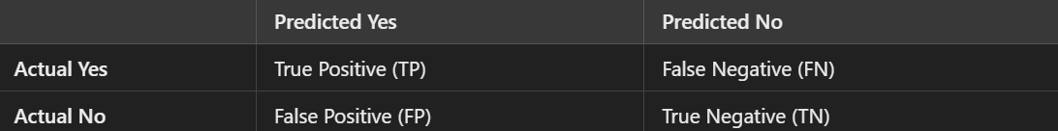

Meaning of the terms:
- True Positive (TP) → Model correctly predicted Yes.
- False Negative (FN) → Model wrongly predicted No (missed a Yes).
- False Positive (FP) → Model wrongly predicted Yes (false alarm).
- True Negative (TN) → Model correctly predicted No.

Why is it useful?
It helps measure accuracy, precision, recall, and F1-score, which tell us how well the model is performing.

1️⃣ Accuracy
👉 Measures overall correctness.
✅ Good when classes are balanced.
❌ Misleading when classes are imbalanced (e.g., rare diseases).

2️⃣ Precision (Positive Predictive Value)
👉 Measures how many predicted positives are actually correct.
✅ Important when false positives are costly (e.g., spam detection).
❌ Low precision means too many false alarms.

3️⃣ Recall (Sensitivity or True Positive Rate)
👉 Measures how many actual positives were correctly identified.
✅ Important when false negatives are costly (e.g., cancer detection).
❌ High recall can lead to more false positives.

4️⃣ F1-Score
👉 Balance between precision & recall (harmonic mean).
✅ Useful when data is imbalanced.
❌ Does not consider true negatives.

When to Use What?
- Accuracy → When false positives & false negatives are equally bad.
- Precision → When false positives are worse (e.g., spam filter).
- Recall → When false negatives are worse (e.g., medical diagnosis).
- F1-Score → When a balance between precision & recall is needed.
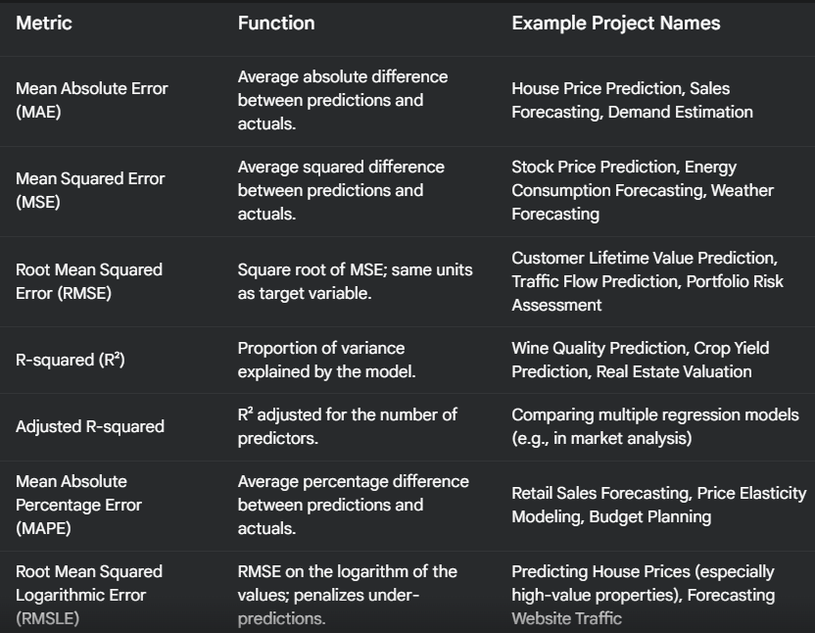

Bias in the context of machine learning and statistics refers to a systematic error that causes a model to consistently make incorrect predictions in a particular direction.

Bias in Machine Learning
- Bias occurs when a model makes overly simplistic assumptions, leading to underfitting.
- Example: A linear model trying to fit non-linear data.

Bias in Neural Networks
- In deep learning, bias refers to a parameter added to neurons to help models learn better.
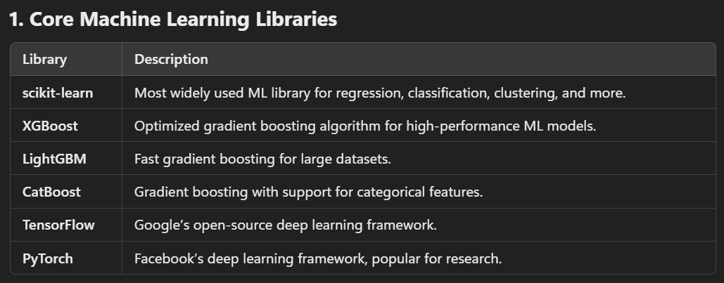
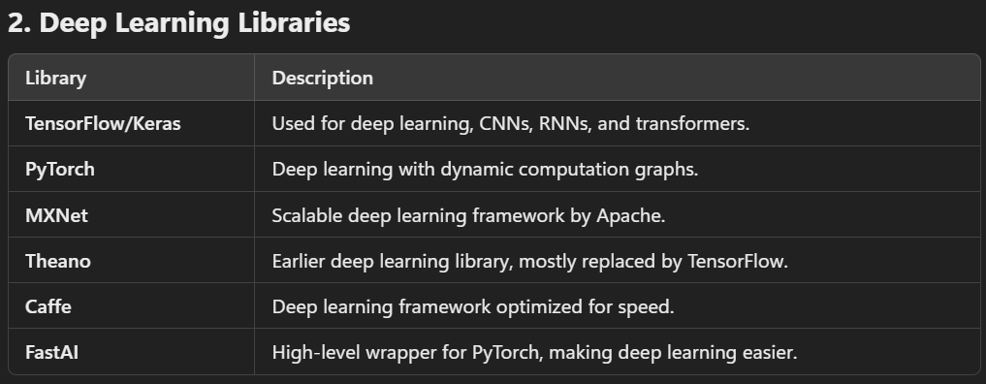
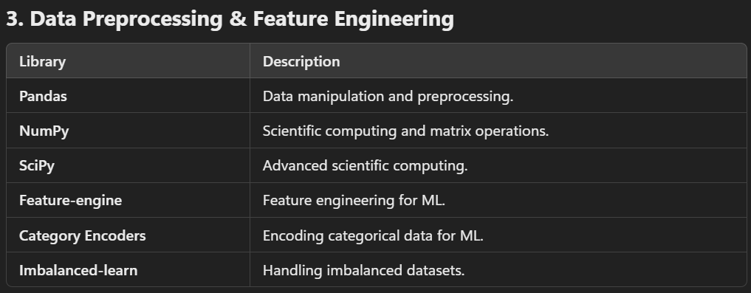
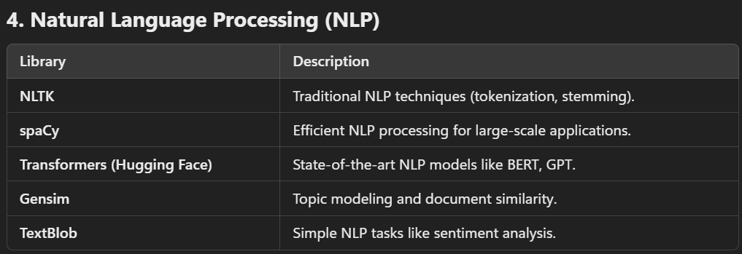
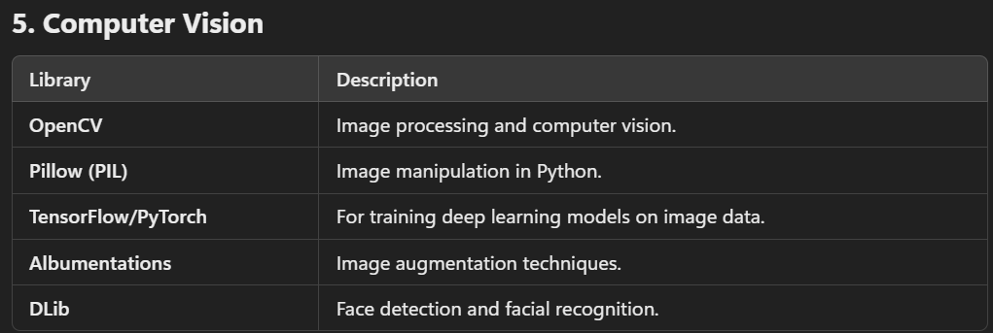
The output of a neuron is calculated as follows:
- The weighted sum of the inputs is computed.
- This sum is passed through the activation function.
- The output of the activation function is the neuron's output.

Real-life applications: Neural networks in action
Image Recognition: Convolutional Neural Networks (CNNs) have revolutionized the field of computer vision. They excel at tasks such as:
- Facial recognition: Used for security systems, photo tagging, and even unlocking smartphones.
- Object detection: Employed in autonomous vehicles, surveillance systems, and image search engines.
- Medical image analysis: Assisting doctors in diagnosing diseases like cancer by analyzing medical images like X-rays, MRIs, and CT scans.
Natural language processing (NLP): Recurrent Neural Networks (RNNs) and Transformer models have significantly advanced NLP capabilities, enabling applications like:
- Language translation: Powering tools like Google Translate to provide real-time translation between languages.
- Sentiment analysis: Used by businesses to gauge customer opinions from social media posts, reviews, and surveys.
- Text generation: Employed in chatbots, content creation tools, and even generating code.
Self-driving cars: Neural networks play a pivotal role in the development of autonomous vehicles. They are responsible for:
- Processing sensor data: Analyzing data from cameras, lidar, radar, and other sensors to perceive the environment.
- Making predictions: Anticipating the behavior of other vehicles, pedestrians, and obstacles on the road.
- Controlling vehicle actions: Steering, accelerating, and braking based on the perceived environment and predicted scenarios.
Recommendation Systems: Neural networks power the recommendation engines that suggest products, movies, music, and content to users on platforms like:
- Video subscriptions: Recommending movies and TV shows based on user viewing history and preferences.
- Online shopping: Suggesting products based on browsing and purchase history.
- Music apps: Creating personalized playlists based on listening habits.

