BOLTPE FINANCIAL PLANNER
Functional Specification Document (FSD)
Independent Financial Planning Engine
Without Policy Planner Runtime Dependency

Document Attribute | Value
Document Version | 1.2
Product | BoltPe Financial Planner
Document Type | Functional Specification Document
Primary Objective | Build BoltPe-owned financial planning logic that reproduces the existing output behavior for the same inputs and assumptions, without calling Policy Planner APIs.
Status | Proposed / Implementation Baseline
Prepared For | BoltPe Financial Planner Product & Engineering Team

Source basis: current BoltPe Financial Planner API documentation and the existing normalized response contract. Exact formula parity for opaque vendor rules must be validated through test cases before production sign-off.

Table of Contents
1. Executive Summary
2. Purpose and Objectives
3. Scope
4. Existing and Target Architecture
5. Functional Overview
6. User Journey
7. Input Data Specification
8. Goal Catalogue and Goal Rules

1. Executive Summary
BoltPe Financial Planner will be an independent financial-planning product in which BoltPe owns the complete calculation and recommendation engine. The system will no longer depend on the Policy Planner API for runtime calculation, scoring, insurance analysis, feasibility, recommendations, or report-generation data.
The first implementation goal is behavioral parity with the current normalized response: when the same customer input, selected goals, timelines, inflation assumptions, return assumptions, insurance inputs and risk profile are provided, the BoltPe engine should produce the same or approved-equivalent calculated values.
Key Principle | Policy Planner is removed from the runtime path. BoltPe becomes the source of truth for all financial calculations. Exact parity is guaranteed only for rules that have been explicitly derived, documented and regression-tested.

2. Purpose and Objectives
- Remove the operational dependency on Policy Planner APIs.
- Keep the existing BoltPe customer journey and normalized report structure as stable as possible.
- Reproduce the same goal-planning outputs using BoltPe-owned calculations.
- Own the formulas, assumptions, scoring logic, insurance rules, feasibility logic and recommendation rules.
- Make calculations testable, auditable, versioned and independent of PDF or email generation.
- Allow future product enhancements without waiting for a third-party vendor.

3. Scope

3.1 In Scope
- Customer and family profile capture
- Cashflow analysis
- Instant, short-term and long-term goal planning
- Inflation-based future corpus calculation
- Lump-sum requirement calculation
- Monthly saving / SIP requirement calculation
- Goal feasibility and achievable timeline analysis
- Financial score and financial status
- Insurance requirement and protection-gap analysis
- Risk-based asset allocation
- Priority roadmap and recommendations
- Structured JSON response
- BoltPe PDF generation
- Database persistence
- S3 / object storage integration and signed links
- Email delivery
- Calculation audit, assumption versioning and regression testing

3.2 Out of Scope for Initial Parity Release
- Real-time market-price recommendations
- Execution of mutual fund, insurance or securities transactions
- Automated tax filing
- Regulated personalized investment advisory beyond approved product rules
- Any undocumented proprietary vendor algorithm that cannot be inferred and validated from available inputs/outputs

4. Existing and Target Architecture

4.1 Current Runtime Flow
Frontend
-> BoltPe API
-> Input Validation
-> Policy Planner API
-> Vendor Calculation
-> Vendor Response
-> BoltPe Normalization
-> Database
-> PDF / S3 / Email

4.2 Target Runtime Flow
Frontend
-> BoltPe API
-> Input Validation
-> BoltPe Planning Engine
-> Profile & Cashflow Engine
-> Goal Calculation Engine
-> Feasibility Engine
-> Score Engine
-> Insurance Engine
-> Investment Allocation Engine
-> Recommendation Engine
-> Structured BoltPe Response
-> Database
-> PDF / S3 / Email

5. Functional Overview
Module | Responsibility
Customer Profile | Personal details, DOB-derived age, city, family state and dependents.
Cashflow | Income, expenses, savings, surplus and ratios.
Goal Engine | Future corpus, lump sum, monthly SIP/saving and timeline calculations.
Feasibility | Checks whether current savings can fund the selected timeline and derives achievable timeline.
Score | Produces financial score and status using BoltPe-owned weighted rules.
Insurance | Calculates recommended cover, existing cover, protection gap and gap status.
Investment | Allocates investable surplus by risk appetite and planning horizon.
Recommendations | Generates deterministic action points from calculated conditions.
Report | Produces normalized JSON and BoltPe PDF using the same calculation object.
Persistence | Stores request, assumptions, calculations, report state and audit fields.

6. User Journey
- Customer enters personal details.
- Customer selects one or more financial goals.
- System captures family information only where relevant.
- Customer enters monthly income, expenses and savings.
- Customer provides risk appetite and investment experience.
- Customer enters existing insurance cover information.
- Customer enters or accepts goal assumptions such as inflation and expected return.
- Backend validates and normalizes all values.
- BoltPe calculation engine calculates each selected goal and the overall financial position.
- System generates score, insurance gap, asset allocation, feasibility and recommendations.
- Structured JSON is stored and returned.
- PDF generation, storage and email may run synchronously or asynchronously depending on endpoint design.

7. Input Data Specification

7.1 Customer and Family Inputs
Field | Type | Required | Rule / Purpose
full_name | string | Yes | Customer name used in report and PDF.
contact | string | Yes | Validated mobile/contact number.
email | string | Conditional | Required when report email delivery is requested.
dob | date | Yes | Age is derived by backend; future DOB not allowed.
city | string | Yes | Used for profile and future location-based rules.
marital_status | enum | Conditional | single / married; may be skipped for instant-only plans if product flow allows.
spouse_age | integer | Conditional | Required for married customer where applicable.
spouse_income | decimal | No | Used in family-income analysis.
children_count | integer | No | Controls child-detail capture.
dependents | integer | No | Used in protection calculations.

7.2 Cashflow Inputs
Field | Type | Validation
monthly_income | decimal | > 0
monthly_expenses | decimal | >= 0 and normally <= monthly income
monthly_savings | decimal | >= 0

Derived metrics include:
- Disposable Income = Monthly Income - Monthly Expenses
- Savings Ratio = Monthly Savings / Monthly Income x 100
- Expense Ratio = Monthly Expenses / Monthly Income x 100
- Unallocated Cashflow = Monthly Income - Monthly Expenses - Monthly Savings

7.3 Risk and Insurance Inputs
Field Group | Values / Examples
risk_appetite | low / medium / high
investment_experience | beginner / intermediate / advanced
existing_life_term | boolean
existing_life_term_cover | amount
existing_health | boolean
existing_health_cover | amount
existing_critical | boolean
existing_critical_cover | amount
existing_personal | boolean
existing_personal_cover | amount

8. Goal Catalogue and Goal Rules

8.1 Instant Goals
Timeline: 6–12 months. Proposed BoltPe assumptions: Inflation 6% p.a.; Expected SIP Return 10% p.a.; Expected Lump Sum Return 10% p.a.
Examples: iPhone, PlayStation, Bike, TV, Fridge, Washing Machine, Vacation and Others.
BoltPe Instant Goals shall use the same inflation-and-return-based calculation framework as Short-Term and Long-Term Goals. Instant Goals support a 6–12 month timeline. The proposed configurable assumptions are 5% p.a. inflation, 6% p.a. expected SIP return and 6% p.a. expected lump-sum return. For month-based goals, Timeline in Years = Timeline Months / 12.

8.2 Short-Term Goals
Timeline: 3–5 years. Proposed BoltPe assumptions: Inflation 6% p.a.; Expected SIP Return 11% p.a.; Expected Lump Sum Return 10% p.a.
Examples: Self Development / Higher Education, Home Purchase / Home Upgrade, Car Purchase and Own Marriage Planning.

8.3 Long-Term Goals
Timeline: 20–25 years. Proposed BoltPe assumptions: Inflation 6% p.a.; Expected SIP Return 12% p.a.; Expected Lump Sum Return 12% p.a.
Examples: Retirement Planning and Wealth Creation.

8.4 Canonical Goal Model
{
"key": "car_purchase",
"label": "Car Purchase",
"type": "short",
"categoryTitle": "Short Term Goals",
"timeline": "Within 3 years",
"amount": 1000000,
"years": 3,
"months": 0,
"customName": ""
}

8.5 Goal Timeline and Assumption Matrix
Goal Type | Timeline | Inflation | Expected SIP Return | Expected Lump Sum Return
Instant Goal | 6–12 months | 6% p.a. | 10% p.a. | 10% p.a.
Short-Term Goal | 3–5 years | 6% p.a. | 11% p.a. | 11% p.a.
Long-Term Goal | 20–25 years | 6% p.a. | 12% p.a. | 12% p.a.

9. Goal Calculation Logic

9.1 Future Corpus
For inflation-based goals:
Future Corpus = Current Goal Cost x (1 + Inflation Rate)^Years

Example aligned with the current response: a car goal of ₹10,00,000 over 3 years at 6% inflation produces approximately ₹11.91 lakh future corpus.

9.2 Lump Sum Required Today
Lump Sum Today = Future Corpus / (1 + Expected Lump Sum Return)^Years

For the sample 3-year car goal, the existing response shows approximately ₹8.95 lakh lump sum required today.

9.3 Monthly SIP / Saving Required
The engine shall calculate the periodic contribution required to reach the future corpus. The contribution timing convention (beginning-of-month or end-of-month), compounding frequency, return conversion method and rounding rules must be explicitly fixed in the calculation specification.
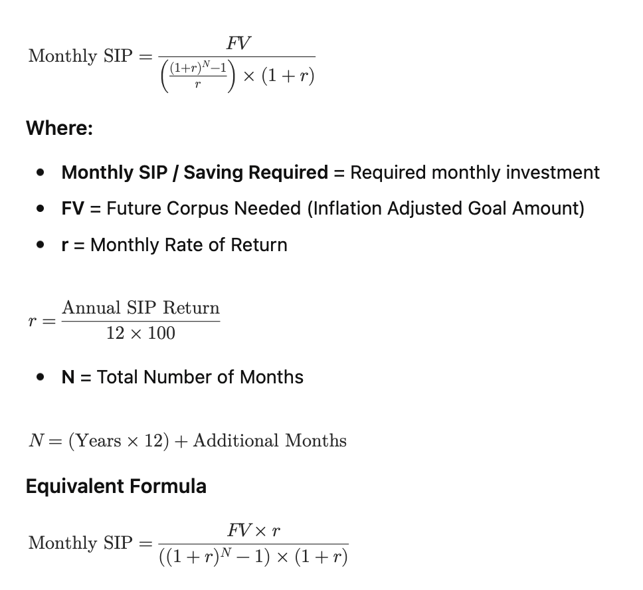

10. Feasibility and Income Gap Analysis
For every goal the engine shall compare the required monthly contribution with available monthly savings. The result should preserve the current response fields.
Output Field | Description
Current Monthly Savings | Savings amount considered for feasibility.
Selected Timeline | Timeline chosen by customer.
Achievable Timeline With Current Savings | Timeline derived from available contribution.
Extra Time Required | Difference where current savings cannot meet the selected timeline.
Required Monthly Income To Keep Same Timeline | Income required under the approved affordability model.
Advisory Note | Human-readable conclusion based on feasibility result.

Parity Rule | The formulas behind achievable timeline and required monthly income are not fully exposed by the response. They must be reverse-engineered from multiple vendor examples and frozen into BoltPe-owned rules before exact-parity sign-off.

11. Insurance and Protection Analysis
The existing response contains separate rows for Life / Term Insurance, Health Insurance, Critical Illness Insurance and Personal Accident Insurance, along with recommended cover, existing cover, protection gap and gap status.
Insurance Type | Required Outputs
Life / Term | Recommended Cover, Existing Cover, Protection Gap, Gap Status, Logic
Health | Recommended Cover, Existing Cover, Protection Gap, Gap Status, Logic
Critical Illness | Recommended Cover, Existing Cover, Protection Gap, Gap Status, Logic
Personal Accident | Recommended Cover, Existing Cover, Protection Gap, Gap Status, Logic

Proposed configurable life-cover model:
Recommended Life Cover = (Annual Family Income x Income Multiple) + Liabilities + Major Family Goals - Eligible Existing Financial Assets

The exact multipliers and health/critical/personal-accident rules used for parity must be calibrated from test responses and approved by the product team.

12. Investment Allocation Engine
The sample response for medium risk appetite contains an allocation of 60% Equity, 30% Debt and 10% Gold / Alternatives. BoltPe should store such allocation policies in configuration rather than hardcode them in report code.
Risk Appetite | Illustrative Allocation
Low | Lower equity, higher debt/liquid exposure
Medium | 60% Equity / 30% Debt / 10% Gold or approved equivalent
High | Higher equity exposure with horizon safeguards

Goal horizon must override or constrain generic risk allocation for very short-term goals.
12.1 Monthly Surplus Allocation Policy
- Emergency Fund: 20%
- Goal Funding SIP: 50%
- Long-Term Wealth Creation: 30%

13. Recommendation and Priority Engine
Recommendations shall be deterministic and generated from calculated conditions.
Condition | Example Recommendation
Required SIP > Current Savings | Extend the timeline or increase monthly surplus/income.
Insurance Gap > 0 | Review protection cover for the affected insurance category.
Emergency reserve below target | Build emergency fund separately from long-term investments.
Income increases | Use annual step-up SIP rather than keeping contribution unchanged.
Goal assumptions are old | Review goal values annually for inflation, income and family changes.

14. Retirement and Wealth Planning
Retirement and Wealth goals are treated as Long-Term Goals, but they may use goal-specific assumptions instead of the default Long-Term assumptions. The current request structure supports retirement inflation, pre-retirement return, post-retirement return, wealth inflation, wealth lump-sum return, and wealth SIP return.
BoltPe_Financial_Planner_FSD_v1.0.docx

Retirement Planning
- Retirement Planning shall use retirement-specific assumptions when values are provided in the request.
- The following request fields shall be used during the retirement corpus accumulation phase:
  - retirement_inflation
  - retirement_pre_return
- The retirement_post_return field is reserved for future retirement income and post-retirement cashflow calculations and is not used in the current corpus calculation model.
- If any retirement-specific assumption is missing, empty, or zero, the system shall use the default Long-Term assumptions:
  - Inflation: 6% p.a.
  - Expected SIP Return: 12% p.a.
  - Expected Lump Sum Return: 12% p.a.

Wealth Creation
- Wealth Creation shall use wealth-specific assumptions when values are provided in the request.
- The following request fields shall be used:
  - wealth_inflation
  - wealth_sip_return
  - wealth_lumpsum_return
- If any wealth-specific assumption is missing, empty, or zero, the system shall use the default Long-Term assumptions:
  - Inflation: 6% p.a.
  - Expected SIP Return: 12% p.a.
  - Expected Lump Sum Return: 12% p.a.

15. Output / Response Contract
The initial BoltPe-owned engine should preserve the normalized structure used by the current application to minimize frontend and PDF changes.
{
"customer": {...},
"score": {...},
"summary": {...},
"priority_roadmap": [...],
"reports": [
{
"type": "...",
"title": "...",
"sub_title": "...",
"summary": {...},
"assumptions": {...},
"table": [...],
"feasibility": {...},
"recommendations": [...]
}
],
"insurance_investment": {...},
"common_recommendations": [...]
}

Vendor-specific company contact fields and AI/vendor branding should be removed or replaced with BoltPe-owned content.

16. Appendix - Sample Calculations
Calculation basis: Future Corpus is inflation-adjusted; Lump Sum Today is discounted at the expected annual lump-sum return; Monthly SIP uses the annuity-due formula with monthly rate = annual SIP return ÷ 12 and N = total months. Values are rounded to the nearest rupee.

16.1 Instant Goal
Input / Output | Value
Goal | iPhone
Present Goal Cost (PV) | ₹90,000
Timeline | 12 months = 1 year
Inflation Rate (i) | 6% p.a.
Future Corpus Formula | FV = PV × (1 + i)^n
Future Corpus Calculation | ₹90,000 × (1 + 0.06)¹ = ₹95,400
Future Corpus Needed (FV) | ₹95,400
Expected Lump Sum Return (R) | 10% p.a.
Lump Sum Formula | PV = FV ÷ (1 + R)^n
Lump Sum Calculation | ₹95,400 ÷ (1 + 0.10)¹ = ₹86,727
Lump Sum Needed Today | ₹86,727
Expected SIP Return | 10% p.a.
Monthly Rate (r) | 10% ÷ 12 = 0.8333% = 0.008333
Total Months (N) | 12
Monthly SIP Convention | Beginning-of-month contribution (Annuity Due)
Monthly SIP Formula | SIP = FV / [((1+r)^N − 1)/r × (1+r)]
Monthly SIP Required | ≈ ₹7,529 per month

16.2 Short-Term Goal
Input / Output | Value
Goal | Car Purchase
Present Goal Cost (PV) | ₹10,00,000
Timeline | 3 years = 36 months
Inflation Rate (i) | 6% p.a.
Future Corpus Formula | FV = PV × (1 + i)^n
Future Corpus Calculation | ₹10,00,000 × (1 + 0.06)³ = ₹11,91,016
Future Corpus Needed (FV) | ₹11,91,016 (Approx. ₹11.91 lakh)
Expected Lump Sum Return (R) | 11% p.a.
Lump Sum Formula | PV₀ = FV ÷ (1 + R)^n
Lump Sum Calculation | ₹11,91,016 ÷ (1 + 0.11)³ = ₹8,70,861
Lump Sum Needed Today | ₹8,71,550 (Approx. ₹8.72 lakh)
Expected SIP Return | 11% p.a.
Monthly Rate (r) | 11% ÷ 12 = 0.9167% = 0.009167
Total Months (N) | 36
Monthly SIP Convention | Beginning-of-month contribution (Annuity Due)
Monthly SIP Formula | SIP = FV / [((1+r)^N − 1)/r × (1+r)]
Monthly SIP Required | ≈ ₹27,820 per month

16.3 Long-Term Goal
Input / Output | Value
Goal | Retirement Planning
Present Target Amount (PV) | ₹2,00,00,000 (₹2.00 Crore)
Timeline | 25 years = 300 months
Inflation Rate (i) | 6% p.a.
Future Corpus Formula | FV = PV × (1 + i)^n
Future Corpus Calculation | ₹2,00,00,000 × (1 + 0.06)^25 = ₹8,58,37,414
Future Corpus Needed (FV) | ₹8,58,37,414 (Approx. ₹8.58 Crore)
Expected Lump Sum Return (R) | 12% p.a.
Lump Sum Formula | PV₀ = FV ÷ (1 + R)^n
Lump Sum Calculation | ₹8,58,37,414 ÷ (1 + 0.12)^25 = ₹50,49,241
Lump Sum Needed Today | ₹50,49,241 (Approx. ₹50.49 Lakh)
Expected SIP Return | 12% p.a.
Monthly Rate (r) | 12% ÷ 12 = 1% = 0.01
Total Months (N) | 300
Monthly SIP Convention | Beginning-of-month contribution (Annuity Due)
Monthly SIP Formula | SIP = FV / [((1+r)^N − 1)/r × (1+r)]
Monthly SIP Required | ₹45,234 per month

