**R. B. Shirke Jr. College, Ratnagiri Website**

**A Project Report**

Submitted in partial fulfilment of the

Requirements for the award of the Degree of

# BACHELOR OF SCIENCE (INFORMATION TECHNOLOGY)

**By**

Mr. Tejas Mahesh Bhide

Seat Number – TT240004

**Under the esteemed guidance of**

**Mr. S. D. Joshi**

# Assistant Professor at Information Technology Department of R. P. Gogate College of Arts & Science and R. V. Jogalekar College of Commerce (Autonomous), Ratnagiri

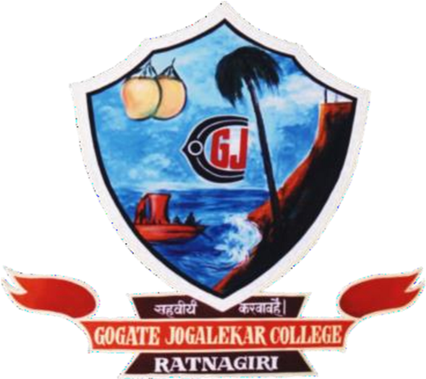

**DEPARTMENT OF INFORMATION TECHNOLOGY**

# R. P. Gogate College of Arts & Science and R. V. Jogalekar College of Commerce (Autonomous), Ratnagiri

**RATNAGIRI, 415612**

**MAHARASHTRA**

**2023-24**

**PROJECT PROPOSAL**

PRN No. : 2021016400645564 Roll: TTA09

1. Name of the Student : Tejas Mahesh Bhide
2. Title of the Project : R.B. Shirke Jr. College, Ratnagiri Website
3. Name of the Guide : Mr. S. D. Joshi
4. Teaching experience of : 02 years
5. Is this your first submission? : Yes / No

Signature of the Student Signature of the Guide

Date : Date :

Signature of the Coordinator/HOD

Date :

# R. P. Gogate College of Arts & Science and R. V. Jogalekar College of Commerce (Autonomous), Ratnagiri

**RATNAGIRI-MAHARASHTRA-415612**

# DEPARTMENT OF INFORMATION TECHNOLOGY

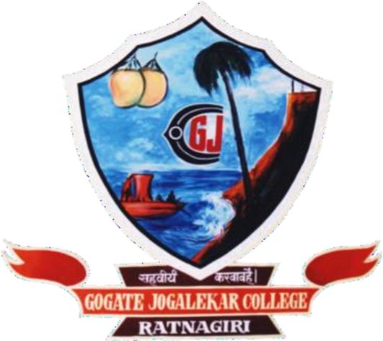

**CERTIFICATE**

This is to certify that the project entitled, **"R. B. Shirke Jr. College, Ratnagiri Website"**, is bona fide work of **Mr. Tejas Mahesh Bhide** bearing Seat. No: (TT240004) submitted in partial fulfilment of the requirements for the award of degree of BACHELOR OF SCIENCE in INFORMATION TECHNOLOGY from R. P. Gogate College of Arts & Science and R. V. Jogalekar College of Commerce (Autonomous), Ratnagiri.

**Internal Guide Coordinator / HOD**

**External Examiner**

**Date: College Seal**

**ABSTRACT**

The “**R.B. Shirke Jr. College, Ratnagiri Website”** project aims to develop a comprehensive online platform for R.B. Shirke College, providing students, faculty, and stakeholders with easy access to information, resources, and services. The R.B. Shirke College Website offers a user-friendly interface with intuitive navigation, enabling visitors to explore various sections and access relevant information effortlessly. The website provides detailed insights into the college's history, vision, and mission, highlighting its commitment to academic excellence and holistic development of students.

The website incorporates essential features and functionalities, including:

1. Academic Programs: The website showcases a wide range of undergraduate and postgraduate programs offered by R.B. Shirke College.
2. Admissions: The admissions section provides comprehensive details about the admission process, application requirements, and important dates.
3. Faculty and Staff: This section features profiles of the college's esteemed faculty and staff members.
4. Facilities and Infrastructure: The website highlights the state-of-the-art facilities and infrastructure available at R.B. Shirke College.
5. Events and Activities: Students and faculty can stay updated on upcoming events and actively participate in the vibrant college community.
6. Student Resources: The website provides a wealth of resources to support students' academic journey, including course materials, study guides, examination schedules, and online learning platforms.
7. Contact and Feedback: The website offers multiple channels for communication, allowing visitors to get in touch with the college administration, faculty, and staff. Feedback forms and contact information facilitate seamless communication, ensuring prompt resolution of queries and concerns.

Overall, the R.B. Shirke College Website project aims to enhance communication, collaboration, and accessibility within the college community.

**ACKNOWLEDGEMENT**

I would like to express my sincere gratitude to several individuals for supporting me throughout the project.

I am grateful to **Dr. P. P. Kulkarni**, Principal and **Dr. A. M. Kulkarni** Vice Principal (Science Faculty) Coordinator **Dr. V. V. Bhide** of R. P. Gogate College of Arts & Science and R. V. Jogalekar College of Commerce (Autonomous), Ratnagiri for providing all the necessary facilities of laboratory and library at R. P. Gogate College of Arts & Science and R. V. Jogalekar College of Commerce (Autonomous), Ratnagiri.

I wish to express my sincere thanks to **Mrs. M. A. Sahasrabuddhe**, Head of the Department of Information Technology for giving me the opportunity to complete the project work by providing valuable guidance to complete the task.

I would also like to express my sincere thanks to our **Respected Teachers** for helping and guiding me throughout the finalization of project.

I would like to thanks my guide **Mr. S. D. Joshi,** for his guidance, enthusiasm, patience, helpful information and practical advice that has helped me a lot in completion of my project.

Last but not the least my special thanks to my parents, my friends and all those people who have encouraged me, helped me to complete this project successfully in time.

**DECLARATION**

I hereby declare that the project entitled, “**R.B. Shirke Jr. College, Ratnagiri Website**” done at **R. P. Gogate College of Arts & Science and R. V. Jogalekar College of Commerce (Autonomous), Ratnagiri** has not been in any case duplicated to submit to any other university for the award of any degree. To the best of my knowledge other than me, no one has submitted to any other university. The project is done in partial fulfilment of the requirements for the award of degree of BACHELOR OF SCIENCE (INFORMATION TECHNOLOGY) to be submitted as final semester project as part of our curriculum.

Mr. Tejas Mahesh Bhide