MINI PROJECT
ON

SMART HELMET

SUBMITTED TO THE
SAVITRIBAI PHULE PUNE UNIVERSITY

THIRD YEAR OF ELECTRONICS AND TELECOMMUNICATION ENGINEERING



SUBMITTED BY: -

Mr. Tejas Desale 72292474H
Mr. Pratik Pawar 72292665M
Mr. Siddhesh Sable 72292695C

UNDER THE GUIDANCE OF: Prof. Namrata Jangale

DEPARTMENT OF ELECTRONICS & TELECOMMUNICATION ENGINEERING
MODERN EDUCATION SOCIETY’S WADIA COLLEGE OF ENGINEERING PUNE-411001
[2023-2024]

SAVITRIBAI PHULE PUNE UNIVERSITY
MODERN EDUCATION SOCIETY’S WADIA COLLEGE OF ENGINEERING PUNE-411001
Department of Electronics & Telecommunication Engineering
C E R T I F I C A T E

This is to certify that the mini project entitled “SMART HELMET” has been submitted by
Mr. Tejas Desale 72292474H
Mr. Pratik Pawar 72292665M
Mr. Siddhesh Sable 72292695C

As a partial fulfillment for the Bachelor of Engineering degree in Electronics & Telecommunication of Savitribai Phule Pune University during the academic year 2023-2024.

Date: 07/05/2024
Place: Pune

Prof. Namrata Jangale Dr. P. P. Mane

Project Guide

ACKNOWLEDGEMENT

Ability and ambition are not enough for success. Many able people fail to achieve anything worthwhile because he or she has not been properly guided and directed. The project on “SMART HELMET” is an outcome of guidance, moral support & devotion bestowed on us throughout our work. First and foremost, we offer our sincere phrases of thanks to Prof. Namrata Jangale for their guidance and constant supervision as well as for providing necessary information during seminar preparation.
Finally, I would like to express my gratitude towards my parents & and all teaching and non-teaching staff members of E&TC department for their kind co-operation and encouragement which help us in completion of this project.

Thanking you,

Mr. Tejas Desale
Mr. Pratik Pawar
Mr. Siddhesh Sable
(TE E&TC-A Engineering)

ABSTRACT

In an era where safety and connectivity are paramount, the need for innovative solutions to protect individuals in hazardous environments while facilitating seamless communication is imperative. This project aims to design and develop a Smart Helmet equipped with advanced features tailored to enhance safety and communication for users, particularly in industrial and outdoor settings.

The Smart Helmet integrates various cutting-edge technologies including IoT (Internet of Things), sensors, wireless communication modules, and real-time data processing capabilities. Key features of the helmet include:

Hazard Detection and Alert System: Utilizing sensors such as accelerometers, gyroscopes, and environmental sensors, the helmet detects potential hazards such as sudden impacts, excessive heat, toxic gases, or low visibility conditions. Upon detection, it issues real-time alerts to the wearer, enabling swift response to mitigate risks.

GPS Navigation and Location Tracking: Equipped with GPS technology, the helmet provides navigation assistance to users, guiding them through complex environments or unfamiliar terrains. Additionally, location tracking capabilities enhance situational awareness, enabling supervisors to monitor the whereabouts of team members in real-time.

Through the development of this Smart Helmet, practical experience in embedded systems design, sensor integration, wireless communication protocols, and software development. The project not only fosters technical skills but also instils a deep understanding of user-centric design principles and the importance of safety engineering in modern technology solutions. Ultimately, the Smart Helmet represents a significant advancement in personal protective equipment, offering a comprehensive solution to enhance safety and communication in hazardous environments.

TABLE OF CONTENTS

ACKNOWLEDGENT ABSTRACT
TABLE OF CONTENTS
LIST OF FIGURES
i ii iii iv

Sr. No. |  | Title Of Chapters | Page No.
01 |  | Introduction | 7
 | 1.1 | Problem Definition | 8
 | 1.2 | Overview | 9
02 |  | Literature Survey | 10
03 |  | Work Done | 11
 | 3.1 | Block Diagram and System Connections | 13
 | 3.2 | Setup/Assembly of the components | 15
 | 3.3 | Description | 16
04 |  | Arduino sketch | 21
 | 4.1 | Code | 22
05 |  | Applications | 23
06 |  | Conclusions | 24
 | 6.1 | Advantages | 24
 | 6.2 | Conclusion | 25
 | 6.3 | Future Work | 26
07 |  | References | 27

iii

LIST OF FIGURES

Figure. No. | Illustration |  | Page No.
01 | Working Flowchart |  | 12
02 | Block Diagram |  | 13
03 | System Connection |  | 14
04 | Esp-32 |  | 16
05 | ADXL-345 |  | 18
06 | NEO-6M |  | 19
07 | SIM800L | 20

iv

CHAPTER 1

INTRODUCTION

In today's rapidly evolving technological landscape, the intersection of innovation and safety has become increasingly crucial, especially in environments where individuals are exposed to various hazards. Industries such as construction, mining, manufacturing, and emergency services often require workers to operate in challenging conditions where safety risks are prevalent. Ensuring the well-being of individuals in such environments demands not only proactive safety measures but also effective communication tools to facilitate coordination and response in real-time.

In response to these challenges, the development of a Smart Helmet emerges as a promising solution to enhance safety and communication for individuals working or engaging in activities within hazardous environments. This project aims to explore and implement advanced technologies to design a Smart Helmet capable of detecting, mitigating, and communicating safety-related information while providing users with essential features for navigation and health monitoring.

The Smart Helmet concept integrates state-of-the-art components such as sensors, GPS navigation systems, and real-time data processing capabilities. By leveraging these technologies, the helmet offers a multifaceted approach to safety, encompassing hazard detection, communication enhancement, navigation assistance, and data analytics.

This project not only addresses the technical challenges of designing and implementing such a complex system but also emphasizes the importance of user-centred design and safety engineering principles. By focusing on the needs and requirements of end-users, the Smart Helmet aims to provide a practical and effective solution that enhances both individual safety and overall operational efficiency in hazardous environments.

1.1Problem Definition

The problem definition for a smart helmet project focusing on accident detection involves identifying and addressing the challenges associated with detecting and responding to accidents in real-time using sensor technology integrated into a helmet. This includes:

1. Accident Detection:Implementing sensors such as accelerometers or gyroscopes to detect sudden changes in acceleration or orientation indicative of a fall or collision.

2. Data Processing:Processing sensor data to distinguish between normal movements and potential accidents, filtering out false alarms, and accurately identifying emergency situations.

3.Alert Mechanism Developing a mechanism to quickly alert relevant parties, such as emergency contacts or medical services, in the event of an accident, utilizing communication technologies such as GSM/GPRS modules to send SMS alerts or make calls.

4. Location TrackingIntegrating GPS modules to track the location of the user in real-time during an accident, facilitating rapid response and rescue operations.

5. User Interface:Designing a user-friendly interface for the smart helmet, including indicators or displays to provide feedback to the wearer and intuitive controls for configuring settings or initiating emergency procedures.

6. Power Management: Ensuring efficient power management to prolong battery life and maintain continuous operation, considering the constraints of wearable devices and the need for reliable performance in emergency situations.

By addressing these aspects, the smart helmet project aims to enhance safety for users engaged in activities such as cycling, motorcycling, or industrial work by providing proactive accident detection and timely assistance in critical situations.

Overview

The design overview for the SMART HELMET involves several components, including hardware, software. Here is a brief overview of each component:

Hardware:

- ESP32 MICROCONTROLLER:
This is the main component of the IOT Based Mining Safety Device which processes the sensor output and gives buzzer beep as output and sends the emergency alert message on IOT cloud
- ADXL-345:
The ADXL345 is a versatile digital accelerometer that provides accurate measurements of acceleration in three axes (X, Y, and Z). It communicates over the I2C or SPI protocol and offers adjustable sensitivity, low power consumption, and built-in tap and activity detection features.
- NEO-6M:
The NEO-6M is a compact and reliable GPS module commonly used for getting location.
- SIM800L:
The SIM800L is a versatile GSM/GPRS module that enables communication over cellular networks, providing functionalities such as SMS, voice calls, and internet connectivity.

Software:

- Arduino IDE:
This is free tool for write code to the Arduino boards and through this we can also upload the codes to Arduino boards.

CHAPTER 2

LITERATURE SURVEY

- “Smart Helmet Integrated with Motorcycles to Support Rider Awareness and Safety Based Internet of Things” by Somantri and Indra Yustiana: The paper highlights the rise of cases of theft and robbery of motorcycles requires vehicle owners to increase vigilance. Various ways have been done to prevent the theft and robbery of motorbikes, for example, by using a lot of locks and alarms. Unfortunately, some of these methods cannot overcome the rampant motorcycle theft today.

- “Analysis of Smart helmets and Designing an IoT based smart helmet: A cost effective solution for Riders” by Divyasudha N. , Arulmozhivarman P. and
Rajkumar E.R. : This paper, we have reviewed the recent trends in developing Smart Helmet system. The smart helmet system is used to prevent the accidents in motor bikes and to identify the bike accidents on time for wellness of human being. Also, the smart helmet system analyzed in this paper is used in mining industry for safeguarding the miners from hazardous events in the mine and to alert the miners from hazardous gas emissions inside it.

- “Smart Helmet and Accident Identification System” by Valpadasu Hema, Allam Sangeetha, Soleti Navya and Ch. Nimisha Chowdary: A helmet is a protecting gear worn to guard the head from wounds and tears. A smart helmet can provide more protection by dividing its system into 3 parts: helmet circuit, automobile circuit and a message alert system. The helmet circuit has transmitter, impact switch, alcohol detection sensor and a button

- “Smart Helmet and Bike Tracking System” by Smriti, Vikas Tiwari, Richa Srivastava and Ms. Swati Sharma: The paper discuss Over speeding is also one of the major factors. The increasing rate of road accidents made us develop a smart helmet using the internet of things, which reduces accidents and the risk of death. It has a feature where the bike starts only if the rider wears a helmet. If the rider is over-drunk or not wearing the helmet, the ignition will automatically switch off. If any accident occurs, the GSM modem and the GPS modem will send the message to the registered contact number by using a SIM card. In addition, if the bike or helmet is stolen, the owner can easily find out the exact location of the bike and the helmet using this device. This feature is necessary for a country like India, where bike theft cases are frequent and high.

CHAPTER 3

WORK DONE

- Requirement Analysis: The first step in the design process involves identifying the specific requirements and objectives of the Smart Helmet project. This includes understanding the operational environment, potential hazards, and desired functionalities such as hazard detection, communication enhancement, navigation, and health monitoring.

- Component Selection: Based on the project requirements, suitable components are selected. The ESP NodeMCU is chosen as the central processing unit for its compatibility with IoT applications and onboard Wi-Fi capabilities. The ADXL sensor is selected for its ability to measure acceleration and detect impacts, while the GPS module provides accurate location tracking. Additionally, the SIM module enables wireless communication for voice calls and data transmission.

- Hardware Integration: The selected components are integrated into the Smart Helmet prototype. The ESP NodeMCU serves as the main controller, interfacing with the ADXL sensor, GPS module, and SIM module via appropriate communication interfaces (e.g., I2C, UART). Careful attention is paid to the physical layout and mounting of components to ensure comfort and usability for the wearer.

- Sensor Calibration and Testing: The ADXL sensor undergoes calibration to ensure accurate detection of accelerations and impacts. Testing procedures are established to validate the sensor's responsiveness and reliability in detecting various types of hazards, including falls, collisions, and sudden movements.

- Software Development: Software development involves writing code to interface with the hardware components, collect sensor data, and implement the desired functionalities. The ESP NodeMCU firmware is programmed using Arduino IDE or a suitable programming environment, incorporating libraries for sensor interfacing, GPS navigation, and wireless communication.

- Algorithm Development: Algorithms are developed to process sensor data and implement features such as hazard detection, navigation assistance, and health monitoring. For example, the accelerometer data from the ADXL sensor may be analyzed to detect falls or abnormal movements, triggering alerts or emergency notifications.

- Integration and System Testing: The hardware and software components are integrated to form the complete Smart Helmet system. System-level testing is conducted to verify the functionality, reliability, and performance of the prototype under simulated real-world conditions. This includes testing communication reliability, GPS accuracy, and overall system responsiveness.

By following this design methodology, the Smart Helmet project aims to deliver a robust and effective solution for enhancing safety and communication in hazardous environments, leveraging the capabilities of ESP NodeMCU, ADXL sensor, GPS module, and SIM module.

Basic Flowchart for The SMART HELMET

Start

1. Initialize System
- Power on the device
- Initialize sensors and microcontroller

2. Read Accelerometer Data
- Read data from ADXL-345 sensor

3. Compare Data with Thresholds

4. GPS Location sending
- If ACCIDENT DETECTED > threshold:
  - Activate GPS to send location

5. Transmit Data
- Transmit location and accident detected message to respective mobile no.

6. End

Block Diagram & System Connections

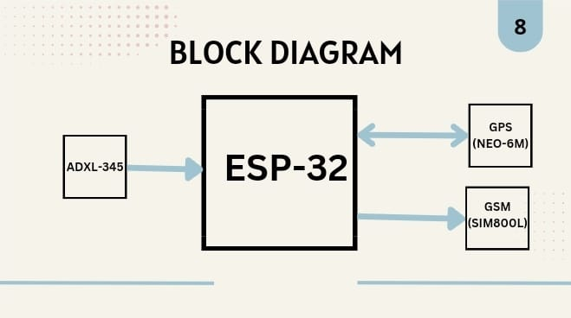

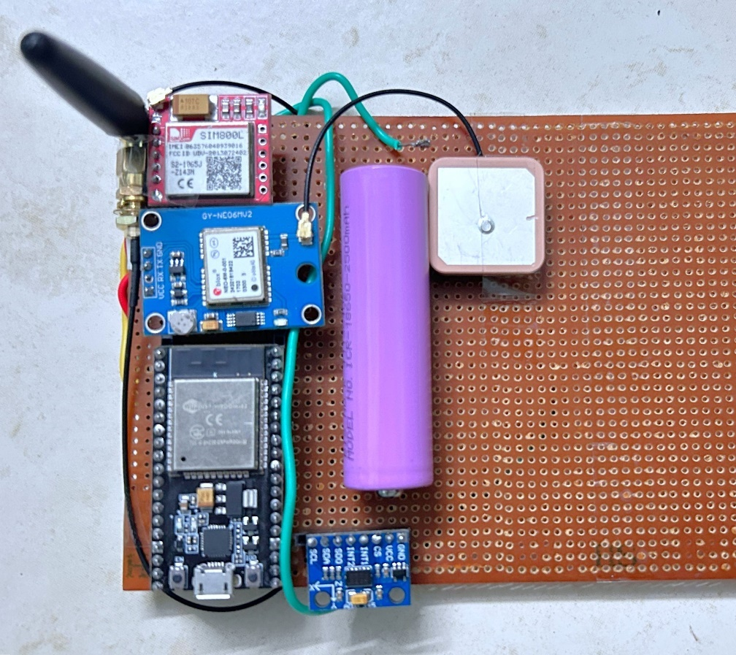

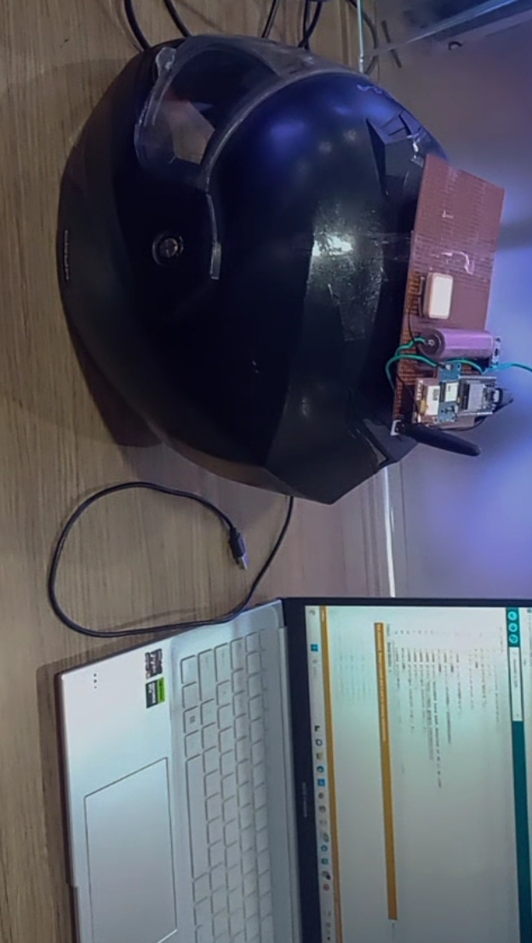

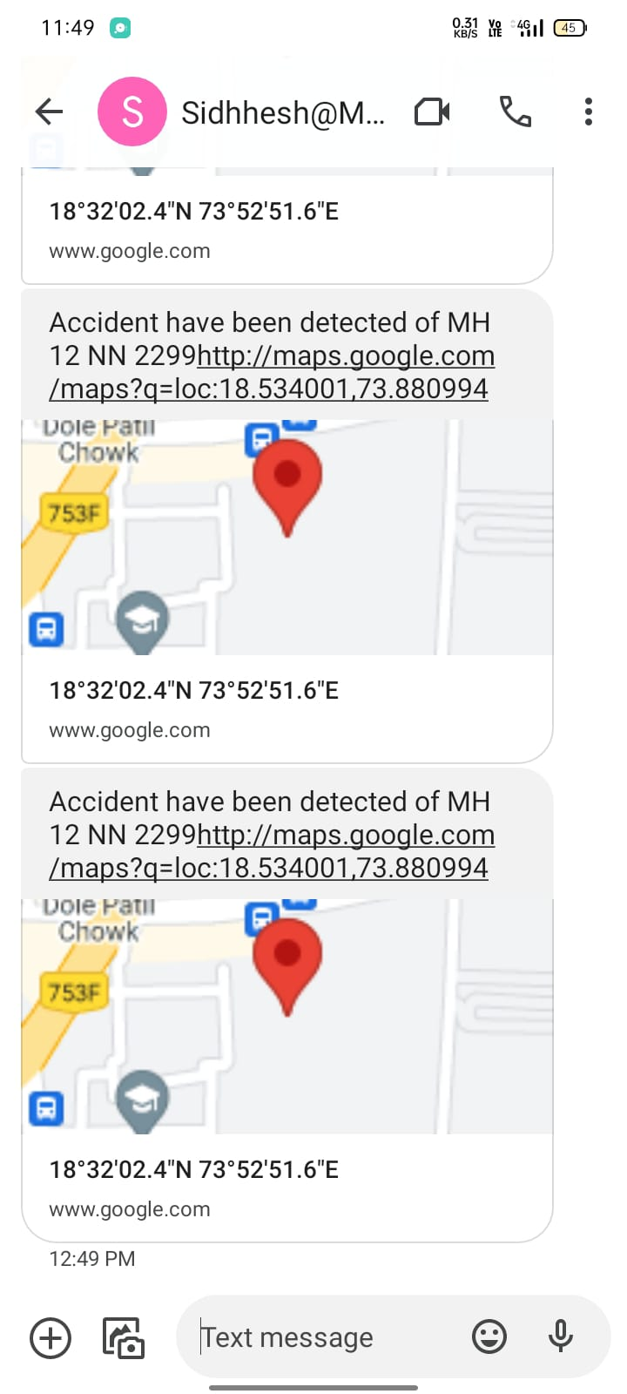

SETUP/ASSEMBLY OF THE COMPONENTS

- NodeMCU: This serves as the central processing unit and facilitates communication between various modules. You'll need to connect the NodeMCU to the other components such as the GPS module, SIM module, and ADXL sensor. Ensure proper power supply and establish communication interfaces (e.g., UART, SPI, I2C) as needed.

- GPS Module: Connect the GPS module to the NodeMCU using serial communication (UART). Configure the baud rate and other settings to establish communication. The GPS module will provide accurate positioning data, including latitude, longitude, and altitude, which can be utilized for navigation and tracking purposes.

- SIM Module: The SIM module enables cellular connectivity, allowing the helmet to send and receive data over the cellular network. Connect the SIM module to the NodeMCU and configure it to establish a cellular connection. You'll need to provide appropriate APN settings and handle SIM card authentication to enable data transmission.

- ADXL Sensor: The ADXL sensor (accelerometer) detects acceleration and changes in motion. Connect the ADXL sensor to the NodeMCU and configure it to measure acceleration along different axes. This sensor plays a crucial role in detecting sudden movements, impacts, and changes in posture, contributing to collision detection and accident prevention.

- Integration and Communication: Once all components are connected and initialized, integrate them within the helmet structure while ensuring user comfort and safety. Implement communication protocols and data processing algorithms to handle sensor data, perform collision detection, navigation, and communication with external servers or mobile applications.

- Testing and Optimization: Test the integrated system thoroughly to ensure proper functionality and reliability. Optimize the code and hardware configurations to improve performance, power efficiency, and user experience. Conduct real-world testing to validate the system's effectiveness in enhancing safety and connectivity for urban commuters.

HARDWARE DISCRIPTION

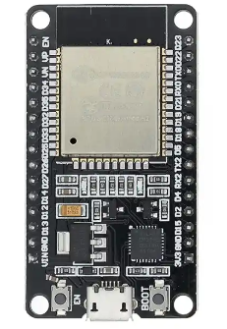
Node MCU:

ESP32 Development board is based on the ESP WROOM32 WIFI + BLE Module. It's a low-footprint, minimal system development board powered by the latest ESP-WROOM-32 module and can be easily inserted into a solderless breadboard.

It contains the entire basic support circuitry for the ESP-WROOM-32, including the USB-UART bridge, reset- and boot-mode buttons, LDO regulator and a micro-USB connector. Every important GPIO is available to the developer.

Features:

- Dual-Core Processor:
- Equipped with two Tensilica LX6 CPUs, the ESP32 offers increased processing power and enables concurrent execution of tasks.
- Wireless Connectivity:
- Supports WIFI and Bluetooth connectivity.
- Rich Set of Peripherals:
- GPIO, SPI, I2C, UART
- Integrated Security Features:
- Secure Boot: Ensures the authenticity and integrity of firmware during the boot process.
- Hardware-based Cryptography: Includes AES, SHA, RSA, and ECC cryptographic accelerators for secure communication and data encryption.
- Secure Storage: Provides mechanisms for securely storing sensitive data, such as keys and certificates.
- Scalability:
- Available in different chip variants with varying amounts of flash memory and RAM, catering to diverse project requirements.
- Supports external flash memory for additional storage capacity.
- Development Framework Support:
- Compatible with popular development frameworks such as Arduino, MicroPython, and Espressif's own ESP-IDF (IoT Development Framework), offering flexibility and ease of development.

SPECIFICATIONS:
- Microcontroller:
- Dual-core Tensilica LX6 microprocessors
- Clock frequency: Up to 240 MHz
- Architecture: 32-bit RISC-V
- Memory:
- Internal RAM: Typically, 520 KB SRAM (some variants may have more)
- Flash Memory: Typically, 4 MB (may vary depending on the module)

- Wireless Connectivity:
- Wi-Fi:
  - Standards: 802.11 b/g/n/e/i (2.4 GHz)
  - Security: WEP, WPA/WPA2 PSK/Enterprise
- Bluetooth:
  - Bluetooth Classic (BR/EDR) and Bluetooth Low Energy (BLE)
- Peripheral Interfaces:
- GPIO: Typically around 36 GPIO pins (may vary depending on the module)
- SPI (Serial Peripheral Interface)
- I2C (Inter-Integrated Circuit)
- UART (Universal Asynchronous Receiver-Transmitter)
- ADC (Analog-to-Digital Converter)
- DAC (Digital-to-Analog Converter)
- PWM (Pulse Width Modulation)
- Security Features:
- Secure Boot
- Hardware-based Cryptography:
- AES, SHA, RSA, ECC
- Secure Storage
- Power Management:
- Low Power Modes: Sleep, Deep Sleep
- Operating Voltage:
  - Typically, 3.3V
- Operating Temperature:
  - Typically -40°C to 125°C
- Package:
- Available in various packages, including QFN, QFN-48, and others depending on the module form factor
- Development Framework Support:
- Arduino IDE
- Micro Python
- ESP-IDF (Espress if IoT Development Framework)

ADXL-345:

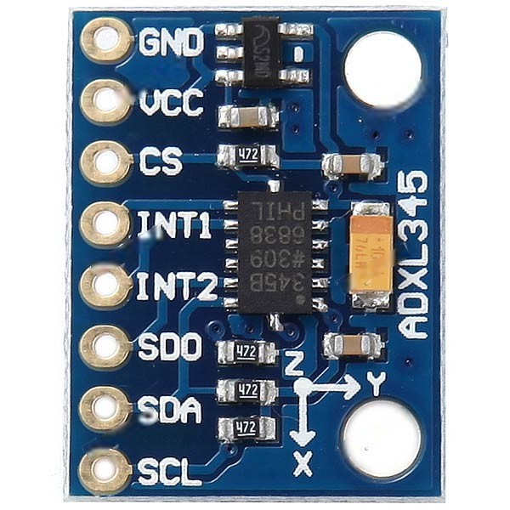
The ADXL sensor, a key component in the Smart Helmet project, plays a critical role in detecting and mitigating potential hazards in hazardous environments. Its primary function is to measure acceleration along multiple axes, enabling the Smart Helmet to detect various types of movements and impacts. One of the main uses of the ADXL sensor is in impact detection. By continuously monitoring acceleration levels, the sensor can detect sudden changes indicative of impacts or collisions. This capability allows the Smart Helmet to promptly alert the wearer or external monitoring systems in the event of a fall, collision, or other safety-critical incidents. Additionally, the ADXL sensor enhances the Smart Helmet's functionality by enabling gesture recognition and user interaction. By detecting specific motion patterns or gestures, the sensor can trigger predefined actions or commands, enhancing the usability and effectiveness of the helmet in various scenarios.

NEO-6M GPS MODULE:

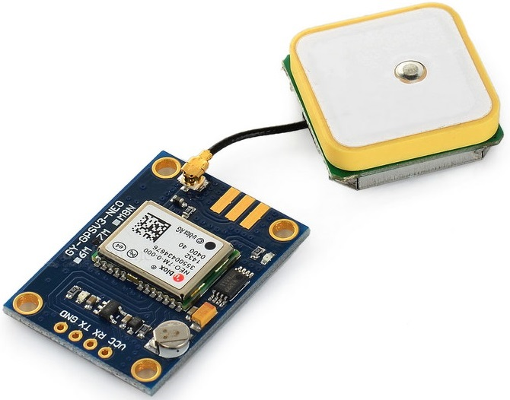

The NEO-6M GPS module is integral to the Smart Helmet project, providing precise positioning and navigation capabilities essential for safety and communication in hazardous environments. By accurately determining the wearer's coordinates in real-time, the module enables efficient location tracking, aiding in rapid response during emergencies and facilitating search and rescue operations. Additionally, the GPS module enhances situational awareness by providing users with their current location relative to predefined points of interest or hazards, enabling informed decision-making and route planning. Furthermore, the module supports geofencing functionality, allowing the Smart Helmet to define virtual boundaries and trigger alerts when the wearer enters or exits designated areas, enhancing safety and security. Overall, the NEO-6M GPS module enriches the Smart Helmet's functionality by providing accurate positioning, navigation assistance, and geofencing capabilities, thereby contributing to enhanced safety and communication effectiveness in hazardous environments.
SIM8OOL GSM MODULE:

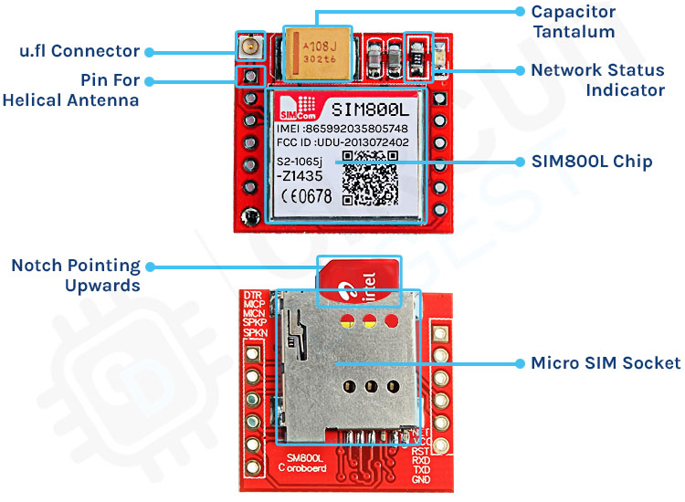
The GSM Module (SIM800L) is a crucial component of the Smart Helmet project, enabling seamless communication capabilities essential for safety and coordination in hazardous environments. With its support for cellular communication, the SIM800L module facilitates voice calls, text messaging, and data transmission, ensuring connectivity even in remote or isolated areas where Wi-Fi may be unavailable. One of the primary uses of the GSM module is in emergency communication. In the event of an accident or safety incident, the Smart Helmet can use the SIM800L module to initiate emergency calls or send distress messages to predefined contacts or emergency services, enabling prompt assistance and intervention. Moreover, the GSM module enhances the Smart Helmet's communication capabilities by enabling real-time data transmission. This allows for remote monitoring of the wearer's vital signs, location tracking, and environmental conditions, providing valuable insights for situational awareness and decision-making. The SIM800L module supports two-way communication, allowing users to receive instructions, updates, or alerts from supervisors or central monitoring systems, enhancing coordination and responsiveness in hazardous environments.
CHAPTER 4

4.1 CODE

Arduino IDE CODE

#include <Wire.h>
#include <Adafruit_Sensor.h> // Adafruit sensor library
#include <Adafruit_ADXL345_U.h> // ADXL345 library
#include <TinyGPS++.h>
#include <SoftwareSerial.h>

#define rxGPS 34
#define txGPS 35
SoftwareSerial neogps(rxGPS,txGPS);
TinyGPSPlus gps;

#define rxGSM 26
#define txGSM 27
SoftwareSerial sim800(rxGSM,txGSM);
Adafruit_ADXL345_Unified accel = Adafruit_ADXL345_Unified(); // ADXL345 Object

void setup()
{
Serial.begin(9600);
neogps.begin(9600);
Serial.begin(9600);
sim800.begin(9600);
if(!accel.begin()) // if ASXL345 sensor not found
{
Serial.println("ADXL345 not detected");
while(1);
}

}

void loop()
{
while (neogps.available() > 0)
{
gps.encode(neogps.read());
if (gps.location.isUpdated()){
Serial.print("Latitude= ");
Serial.print(gps.location.lat(), 6);
Serial.print(" Longitude= ");
Serial.println(gps.location.lng(), 6);
}

}

sensors_event_t event;
accel.getEvent(&event);
Serial.print("X: ");
Serial.print(event.acceleration.x);
Serial.print(" ");
Serial.print("Y: ");
Serial.print(event.acceleration.y);
Serial.print(" ");
Serial.print("Z: ");
Serial.print(event.acceleration.z);
Serial.print(" ");
Serial.println("m/s^2 ");
delay(500);
if(event.acceleration.z<2)
{
sim800.print("AT+CMGF=1\r");
delay(1000);
sim800.println("AT+CMGS=\"+919049261854\"");
delay(1000);
sim800.print("Accident have been detected of MH 12 NN 2299");
sim800.print("http://maps.google.com/maps?q=loc:");
sim800.print(gps.location.lat(), 6);
sim800.print(",");
sim800.print(gps.location.lng(), 6);
delay(100);
sim800.write(0x1A); //ascii code for ctrl-26 //sim800.println((char)26); //ascii code for ctrl-26
delay(1000);
Serial.println("GPS Location SMS Sent Successfully.");

}

}

CHAPTER 5

APPLICATIONS

1. Urban Commuting: The primary application of the Smart Helmet is in urban commuting for cyclists, motorcyclists, and scooter riders. It enhances safety, connectivity, and navigation for commuters navigating through busy city streets, reducing the risk of accidents and improving overall commuting experience.

2. Delivery Services: Delivery companies, such as food delivery or courier services, can equip their riders with smart helmets to improve efficiency, safety, and customer satisfaction. Smart helmets can provide navigation assistance, real-time tracking of delivery personnel, and communication with dispatchers, optimizing delivery routes and ensuring timely deliveries.

3. Emergency Services: Emergency responders, such as paramedics or firefighters, can benefit from smart helmets equipped with advanced sensors and communication capabilities. These helmets can provide real-time monitoring of vital signs, location tracking, and communication with central command, enhancing situational awareness and coordination during emergency response operations.

4. Sports and Outdoor Activities: Smart helmets can be used in various sports and outdoor activities, such as skiing, snowboarding, or mountain biking, to enhance safety and performance. They can provide real-time feedback on speed, acceleration, and technique, as well as navigation assistance for navigating unfamiliar terrain.

6. Military and Defense: Military personnel and law enforcement officers can utilize smart helmets for tactical operations and security missions. These helmets can offer features such as GPS navigation, situational awareness, and communication with command centers, enhancing operational effectiveness and personnel safety in challenging environments.

7. Healthcare and Rehabilitation: Smart helmets can be used in healthcare settings for monitoring patients' movements and activities, particularly in rehabilitation and physical therapy programs. They can track patients' progress, provide feedback on posture and movement patterns, and assist therapists in designing personalized treatment plans.
CHAPTER 6
CONCLUSIONS

5.1 Advantages

- Enhanced Safety: By integrating sensors such as GPS and ADXL, the smart helmet can detect potential collisions, sudden movements, and changes in posture. This enables it to provide timely alerts and notifications to the user, helping to prevent accidents and enhance overall safety during urban commuting.

- Real-time Monitoring: The project allows for real-time monitoring of environmental conditions, user activity, and vehicle proximity. This continuous monitoring provides valuable insights into the user's surroundings, enabling proactive responses to potential hazards or emergencies.

- Connectivity: With the integration of a SIM module and cellular connectivity, the smart helmet can establish communication with external devices, such as smartphones or servers. This connectivity enables features such as emergency alerts, navigation assistance, and remote monitoring, enhancing the user's connectivity and accessibility while on the go.

- Navigation Assistance: By leveraging GPS technology, the smart helmet can provide turn-by-turn navigation guidance to the user, helping them navigate unfamiliar routes or urban environments more effectively. This feature enhances user convenience and reduces the risk of getting lost while commuting.

- User Comfort: Despite its advanced features, the smart helmet is designed with user comfort in mind. Ergonomic design, lightweight construction, and adjustable straps ensure a comfortable fit for extended wear, promoting user acceptance and adoption of the technology.

- Usability: The project aims to provide a user-friendly interface, either through a dedicated mobile application or a heads-up display (HUD) integrated into the helmet. This makes it easy for users to access relevant information, configure settings, and interact with the system, enhancing overall usability and user experience.

- Customizability: The modular nature of the project allows for customization and expansion based on user preferences and specific use cases. Additional sensors or communication modules can be integrated to enhance functionality or adapt the smart helmet for different types of users or environments.

- Promotion of IoT Technology: By implementing an IoT-based solution, the project promotes the adoption and integration of IoT technology in everyday objects, such as protective gear. This highlights the potential of IoT to improve safety, connectivity, and convenience in various domains, including urban mobility.

Conclusion

In conclusion, the Smart Helmet project marks a significant leap forward in urban mobility and safety technology. By integrating advanced sensors, communication modules, and smart features into conventional safety gear, it offers a comprehensive solution to the safety, connectivity, and usability challenges confronting modern commuters. The project's primary achievement lies in its ability to enhance safety through real-time detection of potential collisions, user activity monitoring, and prompt alert systems. Moreover, its connectivity features enable seamless communication with external devices, improving accessibility and functionality for users on the move. Despite its sophisticated technology, the smart helmet prioritizes user comfort and ease of use, ensuring a comfortable fit and intuitive interface for users. Its modular design further enhances versatility, allowing for customization to meet specific user preferences and adapt to various environments and applications. With applications spanning urban commuting, delivery services, emergency response, and beyond, the project demonstrates its potential to revolutionize safety and connectivity across multiple industries. Ultimately, the Smart Helmet project sets a new standard for personal protective gear, signaling a promising future for safer and more connected urban transportation systems.

Future Work

- Advanced Sensor Integration: Future iterations of the smart helmet could incorporate additional sensors, such as LiDAR or ultrasonic sensors, to enhance environmental perception and object detection capabilities. This would further improve collision avoidance and safety features, especially in complex urban environments with dense traffic and obstacles.

- Artificial Intelligence and Machine Learning: Integration of AI and machine learning algorithms could enable the smart helmet to learn from user behavior, predict potential hazards, and adapt its responses accordingly. This would make the helmet more proactive in preventing accidents and providing personalized safety recommendations based on individual riding patterns.

- Augmented Reality (AR) Integration: Incorporating AR technology into the smart helmet could provide users with immersive heads-up displays (HUDs) for navigation, real-time hazard warnings, and contextual information about their surroundings. AR overlays could enhance situational awareness and improve user interaction with the environment without distracting from the primary task of riding.

- Biometric Monitoring and Health Tracking: Future smart helmets could integrate biometric sensors to monitor physiological parameters such as heart rate, respiration, and fatigue levels. This would enable real-time health tracking for users, providing insights into their physical condition and alerting them to potential health risks during prolonged rides or strenuous activities.

- Collaborative Safety Networks: Establishing collaborative safety networks between smart helmet users, vehicles, infrastructure, and city authorities could enable real-time data sharing and cooperative accident prevention strategies. This could include vehicle-to-vehicle (V2V) and vehicle-to-infrastructure (V2I) communication protocols to exchange information about road conditions, traffic patterns, and potential hazards.

CHAPTER 7
REFERENCES

- IEEE Transmitter
https://transmitter.ieee.org › view
Smart helmet - The IEEE Maker Project
- https://www.google.com/url?sa=t&source=web&rct=j&opi=89978449&url=https://www.espressif.com/en/products/modules/esp32&ved=2ahUKEwjykubZ2_mFAxVer1YBHW5hAiMQFnoECGwQAQ&usg=AOvVaw1UU-wIAPIwX5iYkjsVC4HC
- M. Espressif https://www.espressif.com › products
ESP32 Wi-Fi & Bluetooth Modules ...
- M. Nettigo.eu https://nettigo.eu › products › sim...
SIM800L GSM / GRPS module
- IEEE Transmitter
https://transmitter.ieee.org › view
Smart helmet - The IEEE Maker Project

