BIGDATA LAB REPORT

NAME : TEJASHWINI N
USN : 1NT20IS415

1. To Show All Databases:

syntax:
> use admin
switched to db admin
> show dbs;
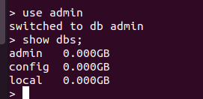

2. Create New Database:

syntax:
> use Teju
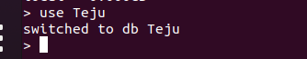
switched to db Teju

3.Current Selected Database:

syntax:
> db
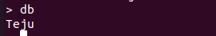
Teju

4.Drop Database:

syntax:
> db.dropDatabase()
{ "ok" : 1 }
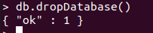

5.Create Collection:
syntax:
> db.createCollection("Student");
{ "ok" : 1 }
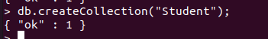

6.To Check Collection List:

syntax:
> show collections
Student

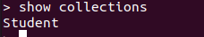

7.Drop Collection:

syntax:
> db.Student.drop()
true

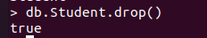

8.Insertion in Mongodb :

(i) InsertOne():

syntax:
> db.Student.insert({name:'std1',address:'mysore'})
WriteResult({ "nInserted" : 1 })

> db.Student.insert({name:'std2',address:'banglore'})
WriteResult({ "nInserted" : 1 })

>

db.Student.insert({name:'std3',address:'hampi'})
WriteResult({ "nInserted" : 1 })

(ii) InsertMany():

> use Teju
switched to db Teju
> db.Student.insertMany([{name:'std4',address:'banglore'},{name:'std5',address:'mysore'}])
{
"acknowledged" : true,
"insertedIds" : [
ObjectId("62494adda3520ea12959a5e5"),
ObjectId("62494adda3520ea12959a5e6")
]
}
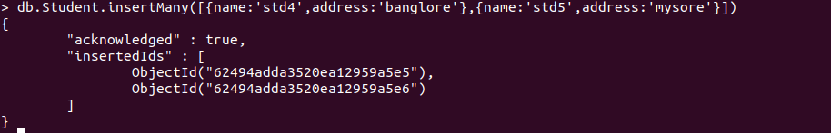

9.Update the inserted values using set( ) & unset ():

(ii)set():[$set operator is used to replace the value of a field to the specified ]

syntax:
> db.Student.update({'name':'std2'},{$set:{'name':'teju'}})
WriteResult({ "nMatched" : 1, "nUpserted" : 0, "nModified" : 1 })

To find the list of inserted and updated list:

syntax:
>> db.Student.find().pretty()

{
"_id" : ObjectId("624948839172a1b04d46068b"),
"name" : "std1",
"address" : "mysore"
}
{
"_id" : ObjectId("624949559172a1b04d46068c"),
"name" : "teju",
"address" : "banglore"
}
{
"_id" : ObjectId("624949659172a1b04d46068d"),
"name" : "std3",
"address" : "hampi"
}
{
"_id" : ObjectId("62494adda3520ea12959a5e5"),
"name" : "std4",
"address" : "banglore"
}
{
"_id" : ObjectId("62494adda3520ea12959a5e6"),
"name" : "std5",
"address" : "mysore"
}

(ii) unset( ):[$unset operator is used to delete a particular field]

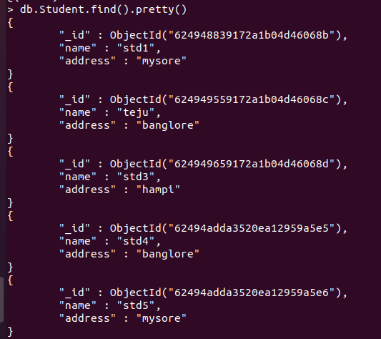

> db.Student.update({'name':'std1'},{$set:{'name':'sohan'}})
WriteResult({ "nMatched" : 1, "nUpserted" : 0, "nModified" : 1 })

>
>db.Student.find().pretty()
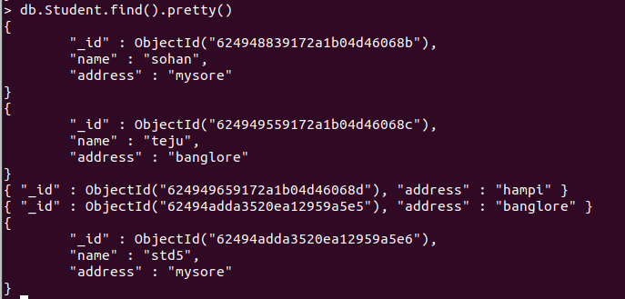
10.Delete the value or document:

syntax:

> db.Student.remove({'name':'sohan'})
WriteResult({ "nRemoved" : 1 })

> db.Student.find().pretty()

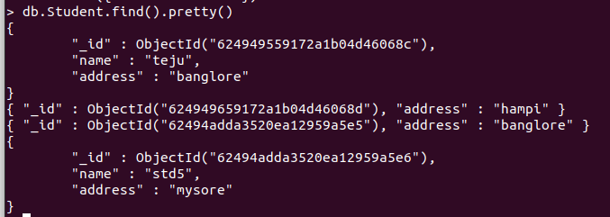
...
11.Save the value or the Document:

syntax:

> db.student.save({ "_id" : ObjectId("624949659172a1b04d46068d"), "address" : "mysore" })

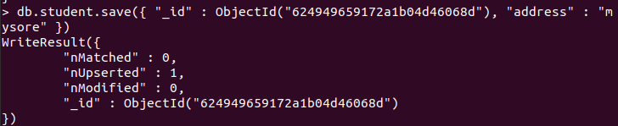
..
> db.Student.find().pretty()

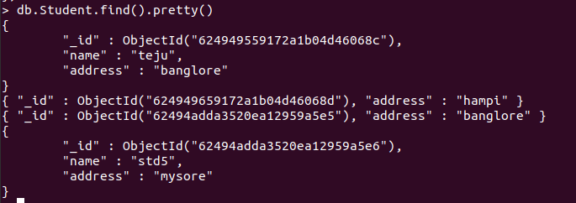
..

12.Replace the value or document in mongodb:

syntax:
> db.Student.replaceOne({'name':'teju'},{'name':'Tejashwini'})
> db.Student.find().pretty()
..



