HDFS COMMANDS

1.creating directory using mkdir command:

hadoop fs -mkdir Tejashwini
hadoop fs -ls

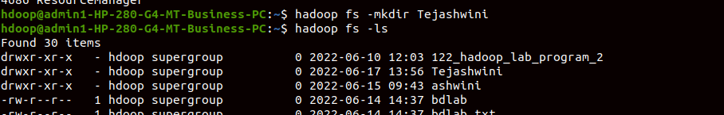

2.

hadoop fs -touch empty.txt
hadoop fs -ls
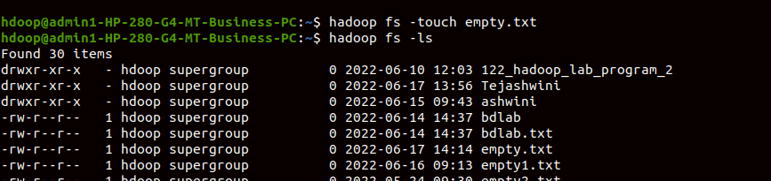

3.
gedit g1.txt
gedit g2.txt
hadoop fs -copyFromLocal g1.txt prog2/g1.txt

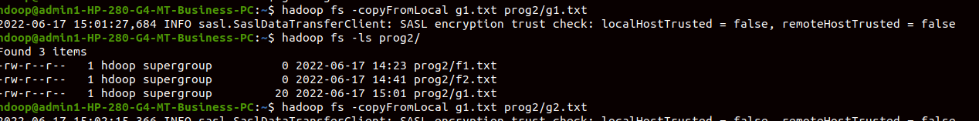
hadoop fs -copyFromLocal g1.txt prog2/g2.txt
hadoop fs -ls prog2/

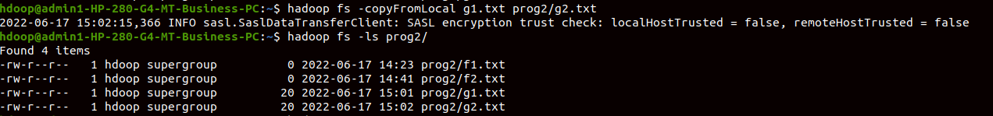

4.

hadoop fs -cat prog2/g1.txt

5.

hadoop fs -copyToLocal prog2/
$ ls
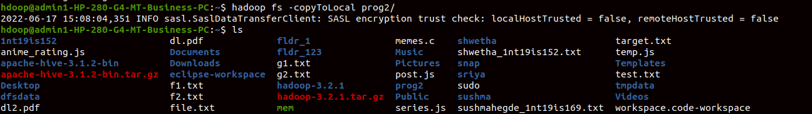
$ cd prog2/
$ ls
