NETWORK PROGRAMMING

1.BIT ORIENTED BY USING SPECIAL DELIMITER FLAG

#include<stdio.h>
#include<string.h>
#include<stdlib.h>

void sender ();
void receiver (int *message, int l2);

int main (void)
{
sender ();
}

void sender ()
{
int i, j, n, count = 0, zerocount = 0, zero = 0;
int msg[50];
int final[50];
printf ("Enter the number of bits of the message\n");
scanf ("%d", &n);
printf ("Enter the bits\n");
for (i = 0; i < n; i++)
{
scanf ("%d", &msg[i]);
}
final[0] = 0;
final[1] = 1;
final[2] = 1;
final[3] = 1;
final[4] = 1;
final[5] = 1;
final[6] = 1;
final[7] = 0;
j = 8;
for (i = 0; i < n; i++)
{
if (msg[i] == 0)
{
final[j] = msg[i];
j++;
zero = 1;
count = 0;
}
else
{
if ((count == 5) && (zero == 1))
{
final[j] = 0;
zerocount++;
j++;
final[j] = msg[i];
j++;
count = 0;
}
else
{
final[j] = msg[i];
j++;
count++;
}
}
}
final[j++] = 0;
final[j++] = 1;
final[j++] = 1;
final[j++] = 1;
final[j++] = 1;
final[j++] = 1;
final[j++] = 1;
final[j++] = 0;
int l1 = 16 + n + zerocount;
printf ("The length is: %d\n", l1);
printf ("The frame is\n");
for (i = 0; i < j; i++)
{
printf ("%d", final[i]);
}
receiver (final, l1);
}

void
receiver (int *result, int l2)
{
int i, j, counter, l3;
int message[100];
l3 = l2 - 8;
j = 0;
for (i = 8; i < l3; i++)
{
if (result[i] == 0)
{
if (counter == 5)
{
i++;
message[j] = result[i];
j++;
counter = 0;
}
else
{
message[j] = result[i];
j++;
counter = 0;
}
}
else
{
message[j] = result[i];
j++;
counter++;
}
}
printf ("\nReciever side message is:");
for (i = 0; i < j; i++)
{
printf ("%d", message[i]);
}
}

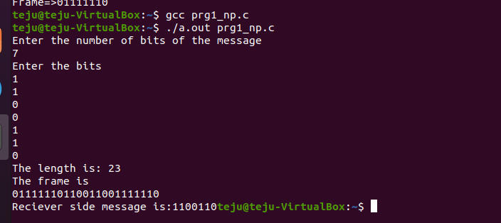

2.BYTE STUFFING :

#include<stdio.h>
#include<string.h>

void reciever ();
char frame[1024];

int main ()
{
int n, len, i;
char buffer[256], length[10];
printf ("Enter number of frames: ");
scanf ("%d", &n);
for (i = 0; i < n; i++)
{
printf ("Enter the frame\n");
scanf ("%s", buffer);
printf ("Length -> %d\n", strlen (buffer));
len = strlen (buffer);
len++;
sprintf (length, "%d", len);
strcat (frame, length);
strcat (frame, buffer);
}
for (i = 0; frame[i] != '\0'; i++)
printf ("%c", frame[i]);
reciever ();
return 0;
}

void reciever ()
{
int i = 0, frame_len, j;
char len_in_char;
printf ("\n\nRecieving end\n");
printf ("\nData recieved -> %s", frame);
while (frame[i] != '\0')
{
len_in_char = frame[i];
frame_len = (int) len_in_char - (int) '0';
printf ("\nLength of this frame is %d\n", frame_len);
printf ("\nFrame=>");
j = i + frame_len;
i = i + 1;
while (i < j)
{
printf ("%c", frame[i++]);
}
printf ("\n");
}
}
