1.What are the two values of the Boolean data type? How do you write them?

>> The two values of Boolean datatype are True and False. True that is 1 and False that is 0.

2. What are the three different types of Boolean operators?

>>The three different types of Boolean operators are **AND, OR** & **NOT**

3. Make a list of each Boolean operator's truth tables (i.e. every possible combination of Boolean values for the operator and what it evaluate ).

>>True = 1, False=0

A (Operator) B Output

1 and 1 = 1

1 and 0 = 0

0 and 1 = 0

0 and 0 = 0

1 or 1 = 1

1 or 0 = 1

0 or 1 = 1

0 or 0 = 0

not True is False

not False is True

4. What are the values of the following expressions?

(5 > 4) and (3 == 5)

not (5 > 4)

(5 > 4) or (3 == 5)

not ((5 > 4) or (3 == 5))

(True and True) and (True == False)

(not False) or (not True)

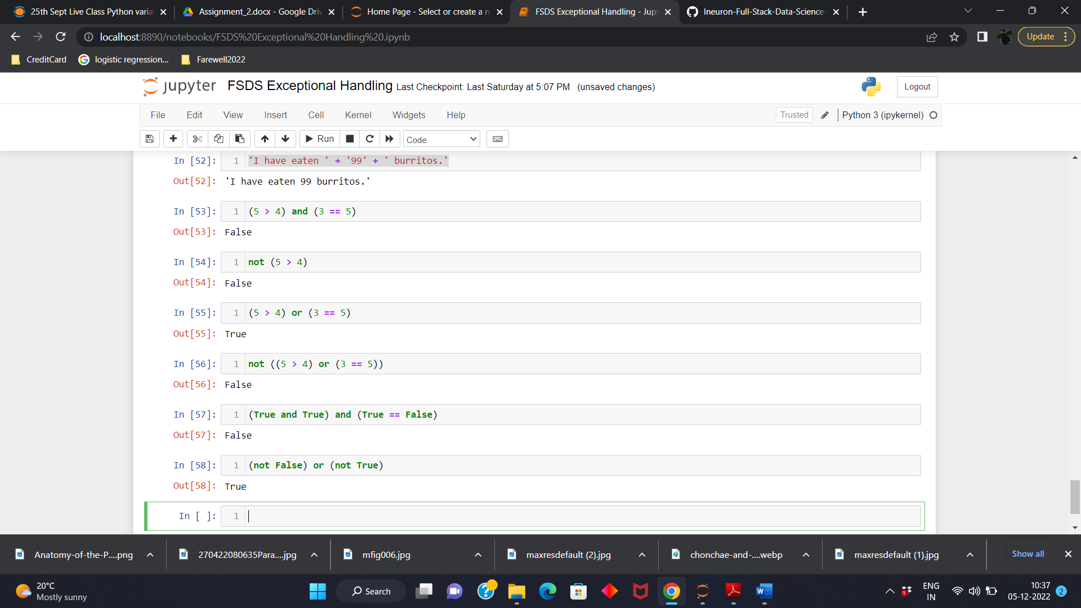

5. What are the six comparison operators?

>>The six Comparison operators are ==, !=, <, >, <=, and >=

6. How do you tell the difference between the equal to and assignment operators? Describe a condition and when you would use one.

>> ‘==’ is the equal to operator that compares two values and evaluates to a Boolean, whereas ‘=’ is assignment operator used to stores any value in a variable.

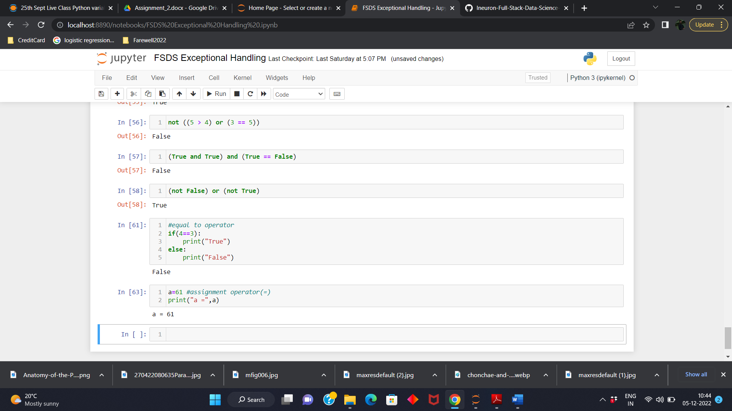

7. Identify the three blocks in this code:

spam = 0

if spam == 10:

print('eggs')

if spam > 5:

print('bacon')

else:

print('ham')

print('spam')

print('spam')

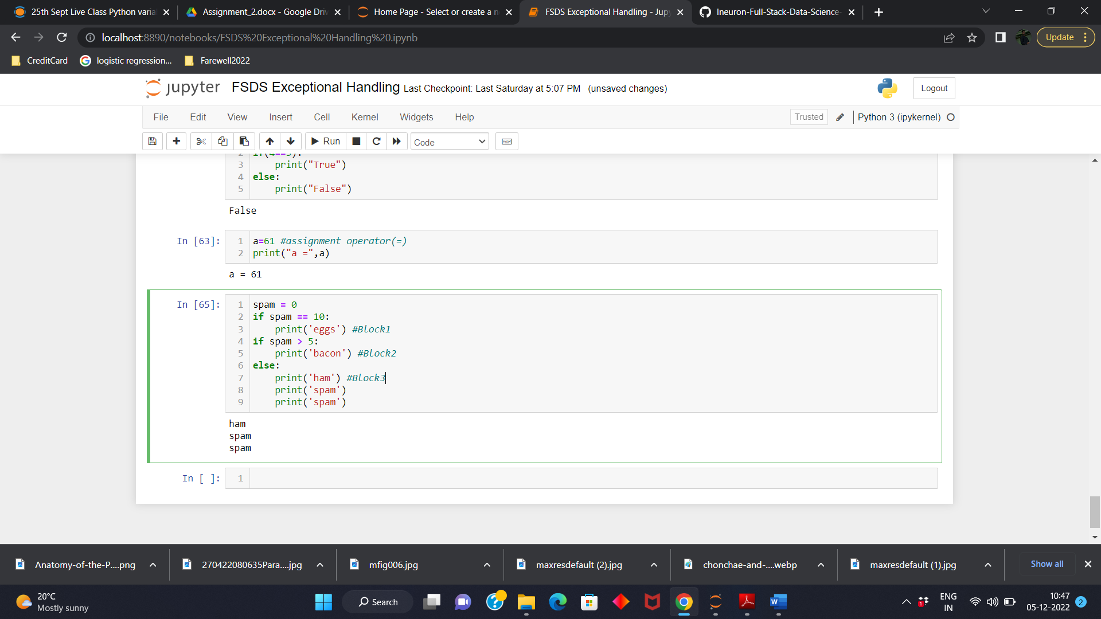

8. Write code that prints Hello if 1 is stored in spam, prints Howdy if 2 is stored in spam, and prints Greetings! if anything else is stored in spam.

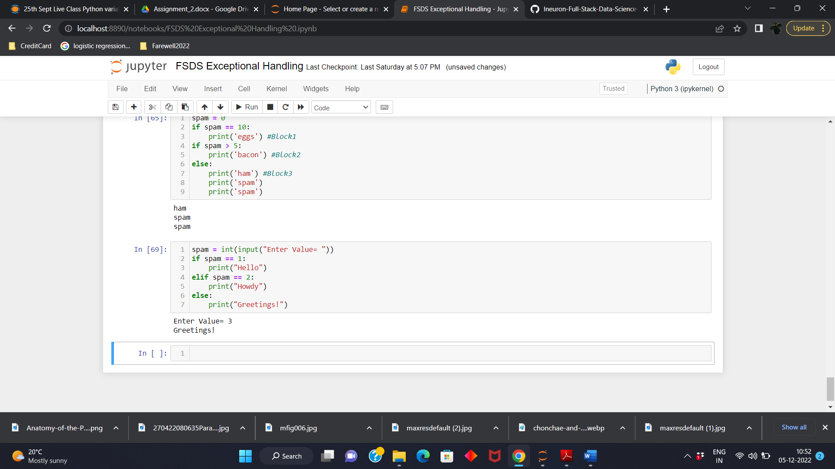

9.If your programme is stuck in an endless loop, what keys you’ll press?

>> If program is stuck in endless loop we will press ctrl+c.

10. How can you tell the difference between break and continue?

>> The break statement will move the execution outside and just after a loop. The continue statement will move the execution to the start of the loop.

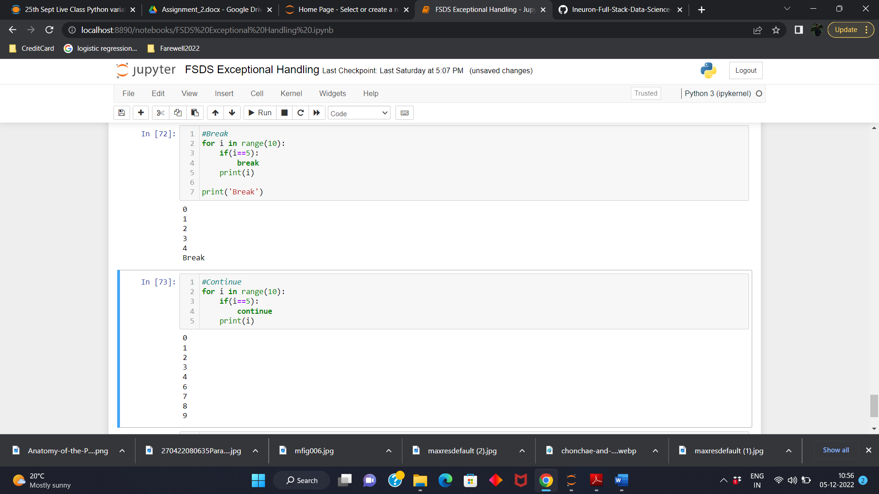

11. In a for loop, what is the difference between range(10), range(0, 10), and range(0, 10, 1)?

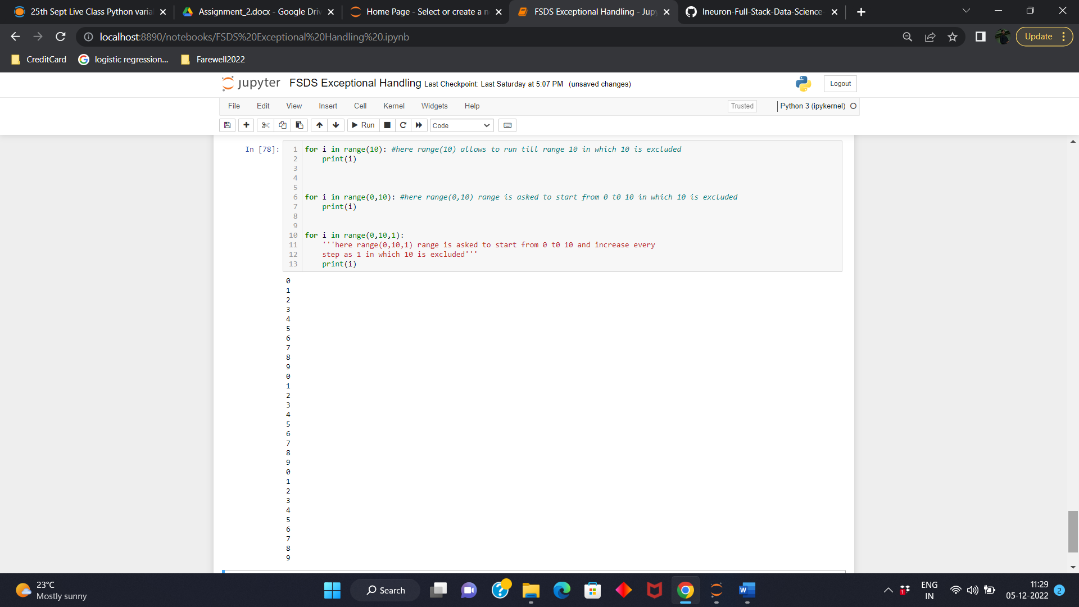

12. Write a short program that prints the numbers 1 to 10 using a for loop. Then write an equivalent program that prints the numbers 1 to 10 using a while loop.

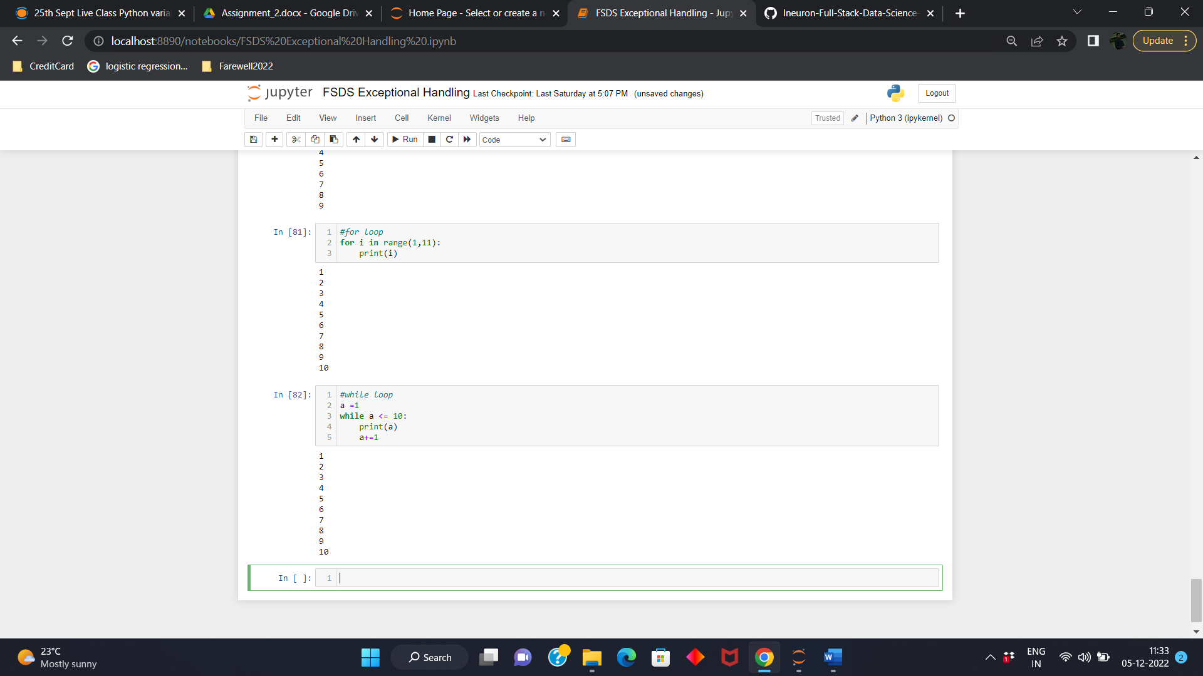

13. If you had a function named bacon() inside a module named spam, how would you call it after importing spam?

>>This function can be called with spam.bacon().