1. What exactly is []?

>> [] represents empty list.

2. In a list of values stored in a variable called spam, how would you assign the value 'hello' as the third value? (Assume [2, 4, 6, 8, 10] are in spam.)

>>

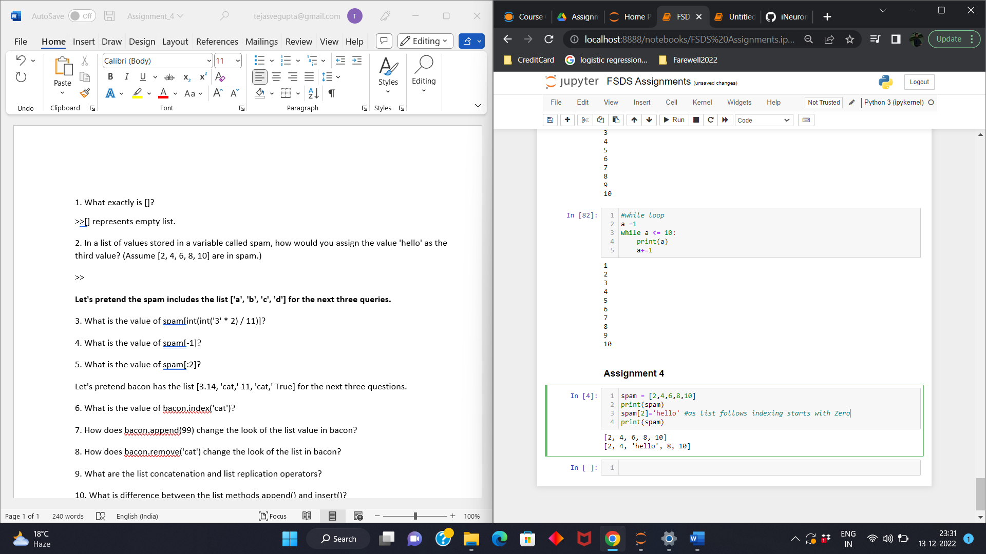

**Let's pretend the spam includes the list ['a', 'b', 'c', 'd'] for the next three queries.**

3. What is the value of spam[int(int('3' * 2) / 11)]?

>>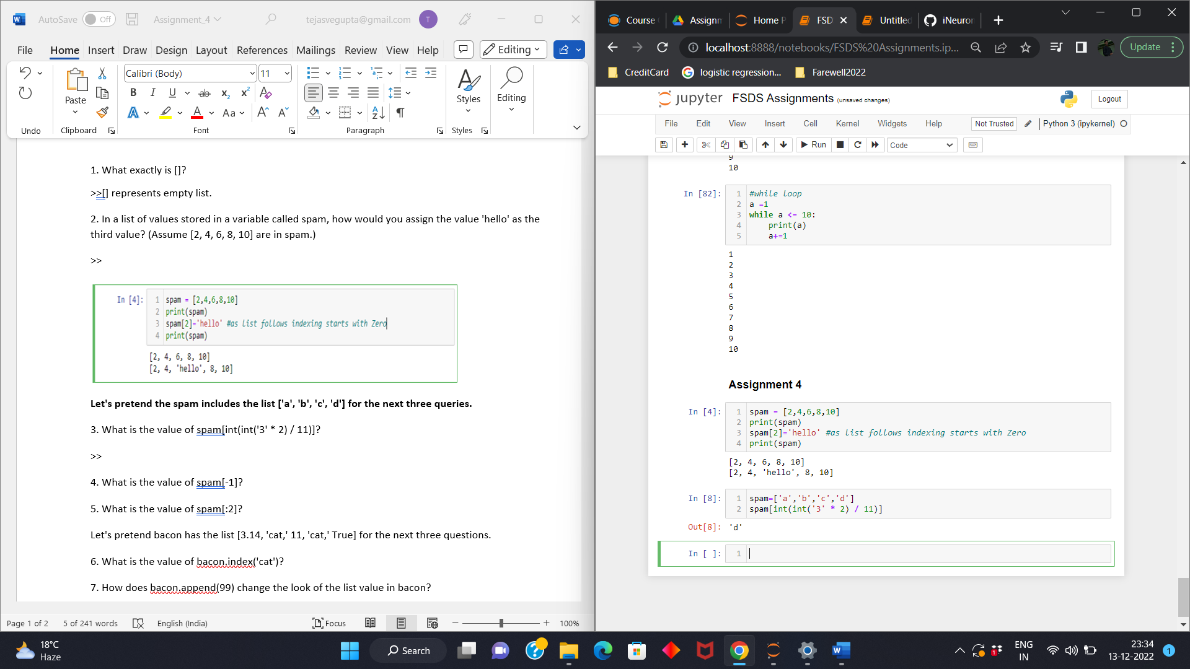

4. What is the value of spam[-1]?

>>Negative indexing in list starts from -1 as reverse in a list.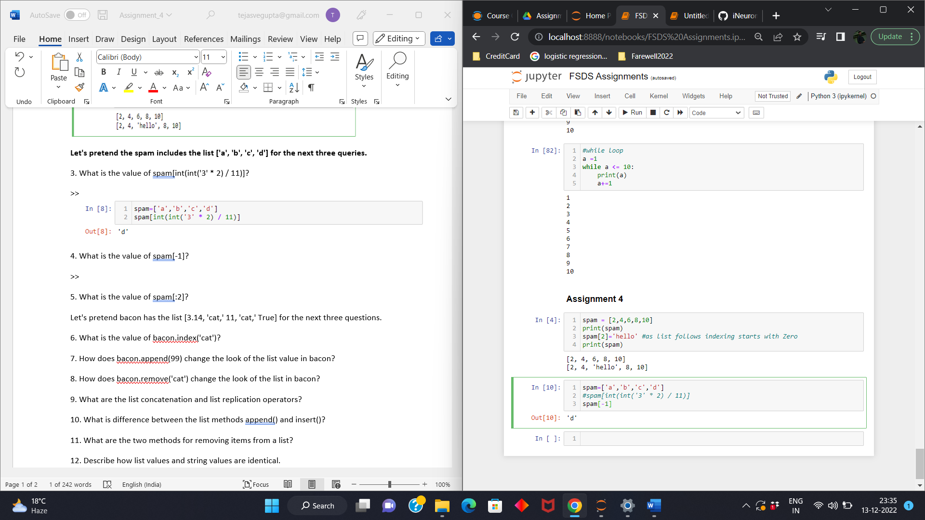

5. What is the value of spam[:2]?

>>

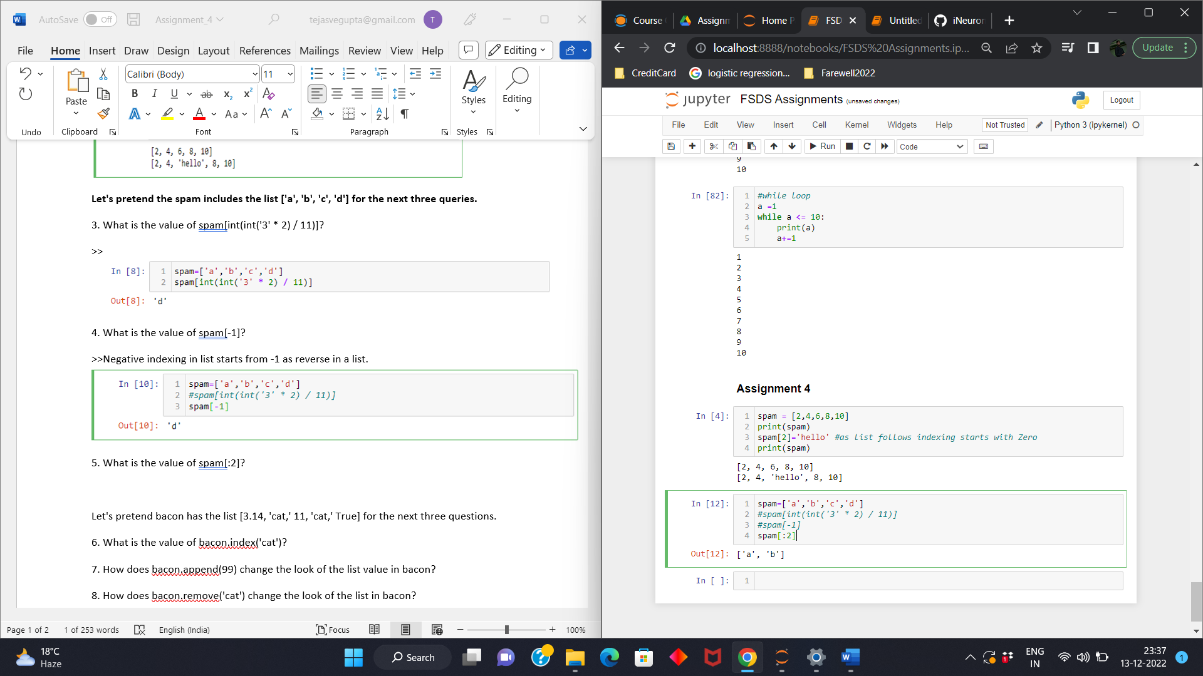

**Let's pretend bacon has the list [3.14, 'cat,' 11, 'cat,' True] for the next three questions.**

6. What is the value of bacon.index('cat')?

>>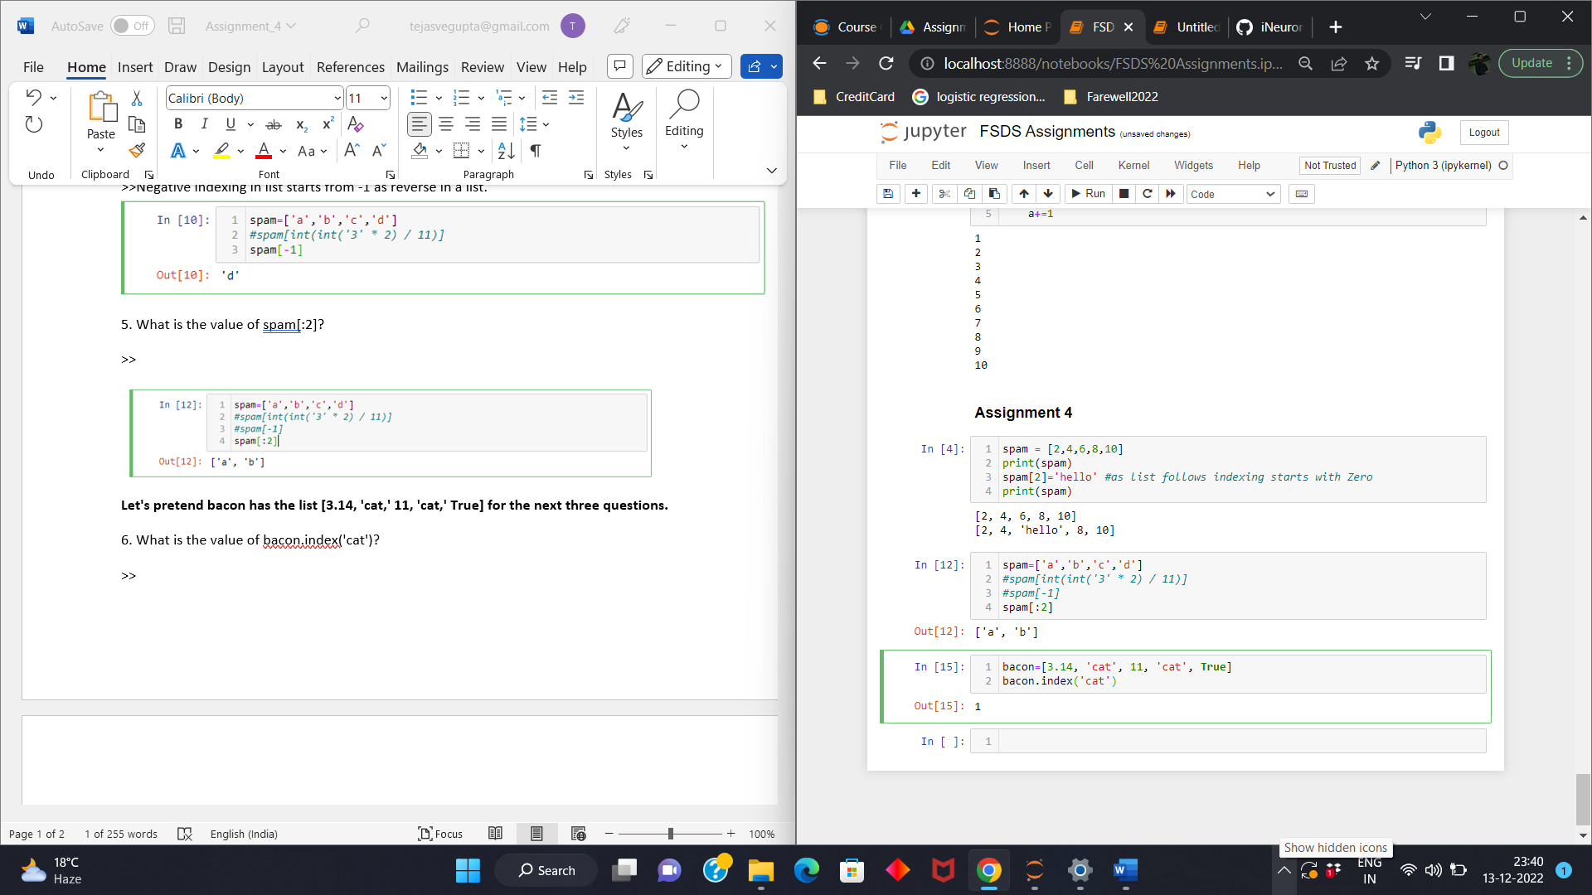

7. How does bacon.append(99) change the look of the list value in bacon?

>> 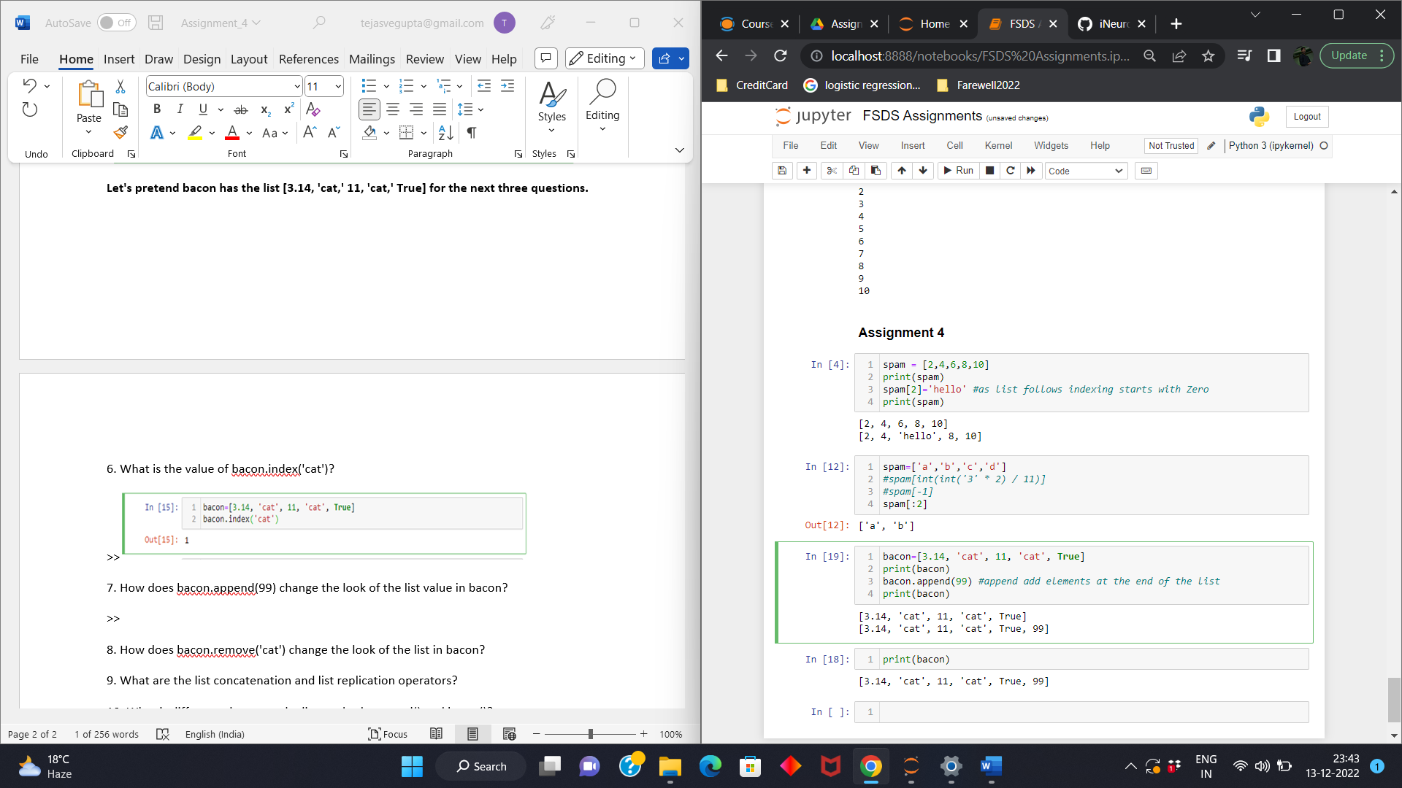

8. How does bacon.remove('cat') change the look of the list in bacon?

>>

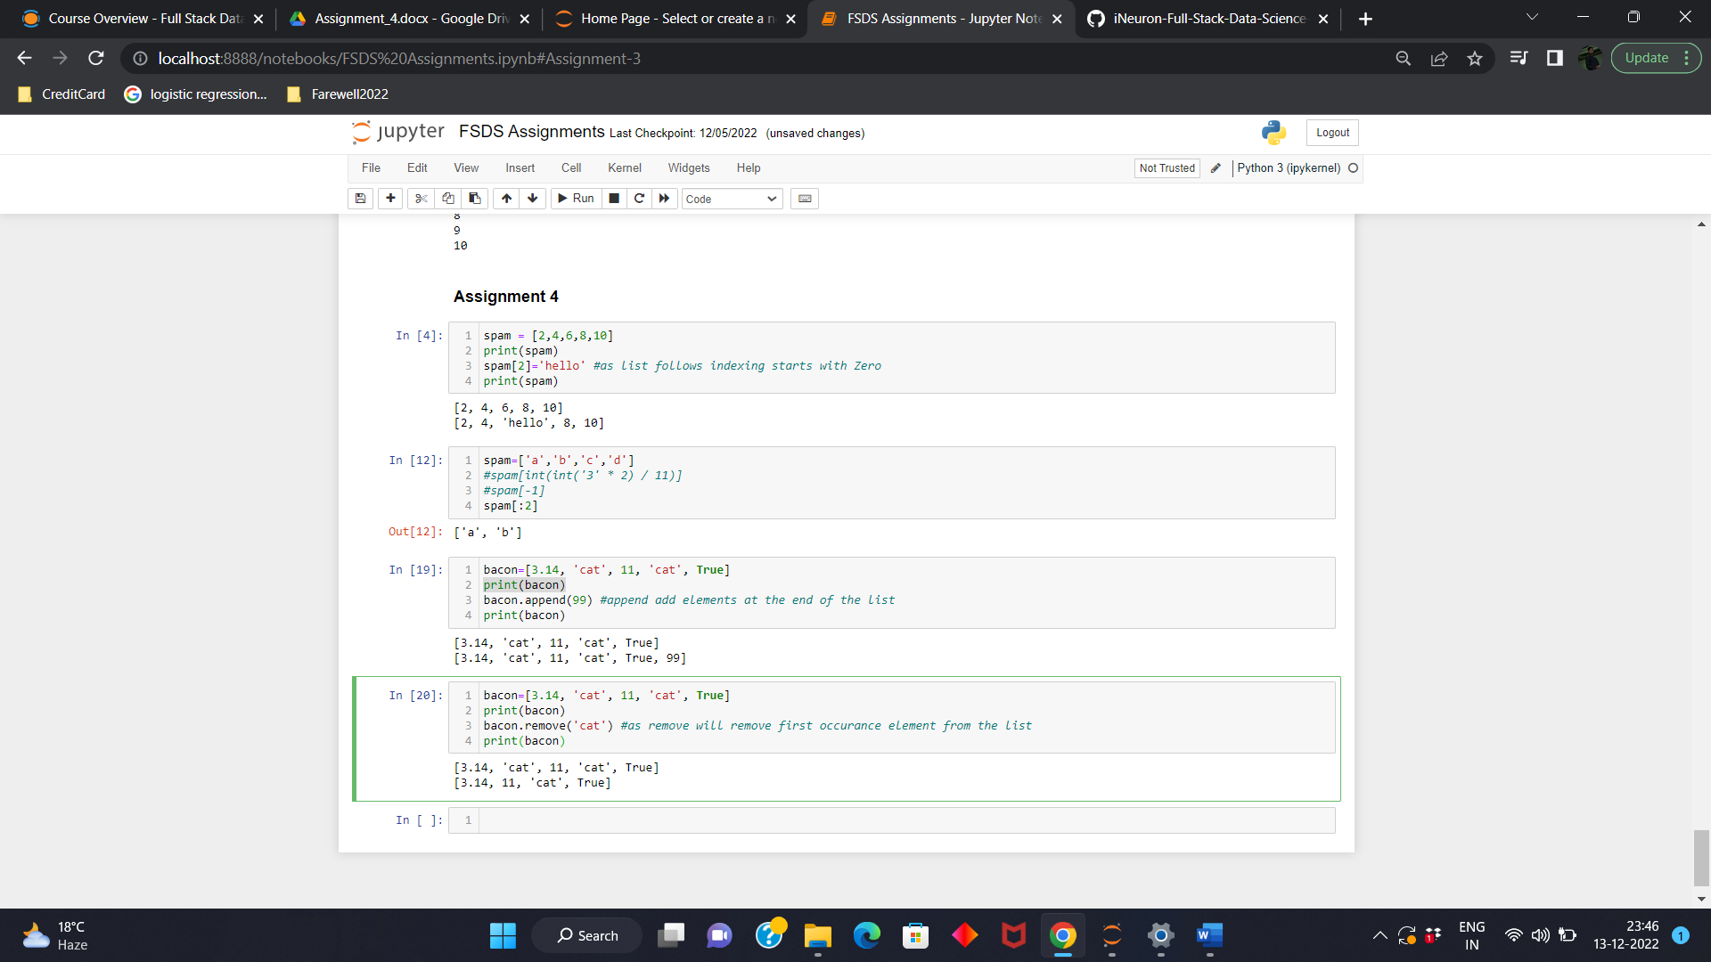

9. What are the list concatenation and list replication operators?

>>list concatenation operator is **+** and list replication operator is **\***

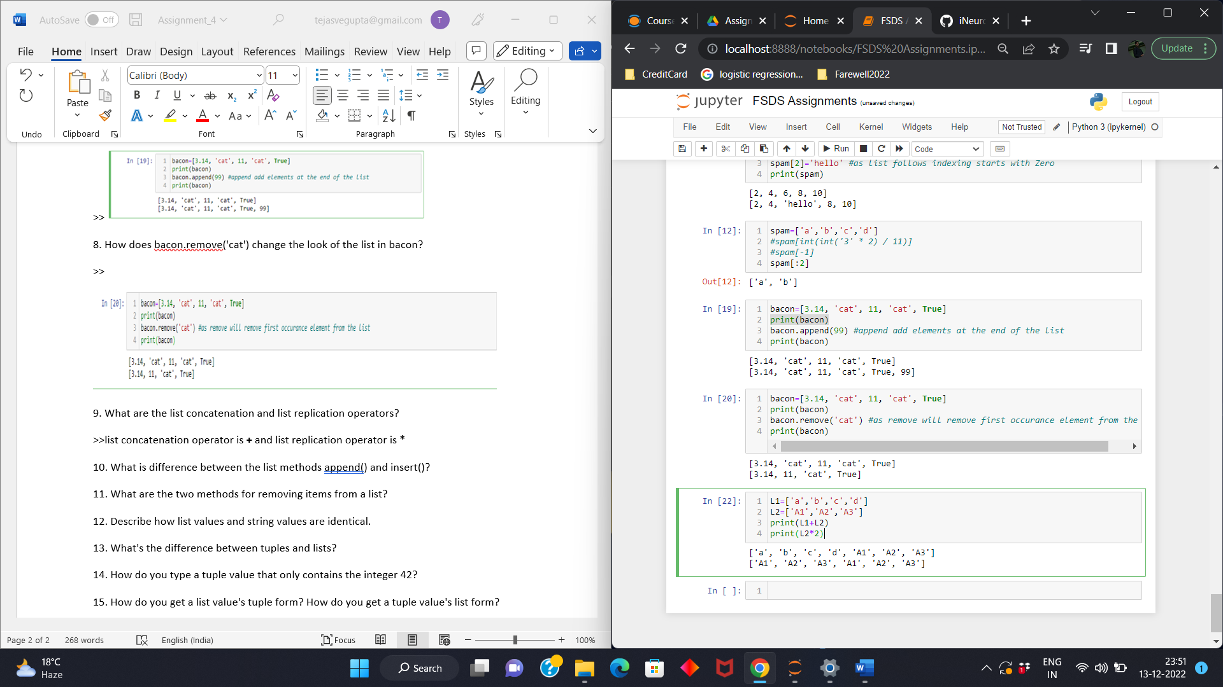

10. What is difference between the list methods append() and insert()?

>>We use append() to add a value or element at the end of any list whereas we use insert() to add value or element anywhere in a list.

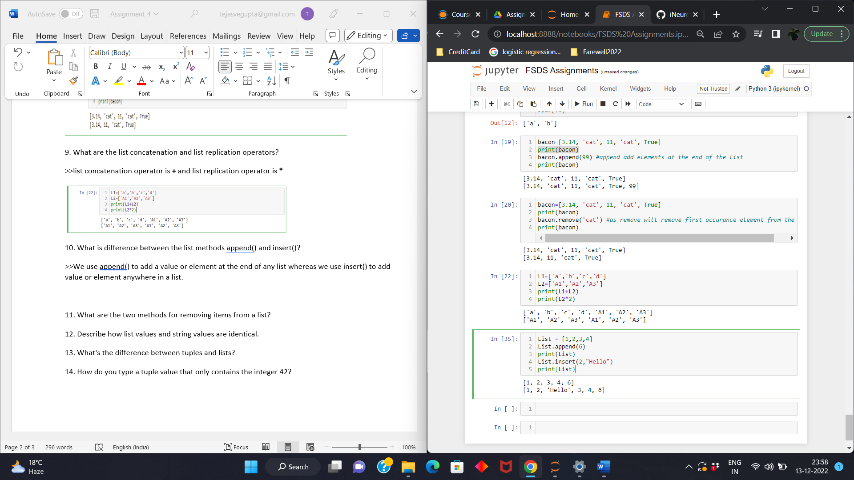

11. What are the two methods for removing items from a list?

>>The two methods of removing items from a list is **del** statement and remove().

12. Describe how list values and string values are identical.

>>Both list and string can be passed to len(), they have indexes and slices, both can be used in **for loops,** be concatenated or replicated, and be used with **in** &  **not** **in** operators.

13. What's the difference between tuples and lists?

>>List are mutable whereas Tuples are immutable. List are represented by **[]** where as tuples are represented by ().

14. How do you type a tuple value that only contains the integer 42?

>>

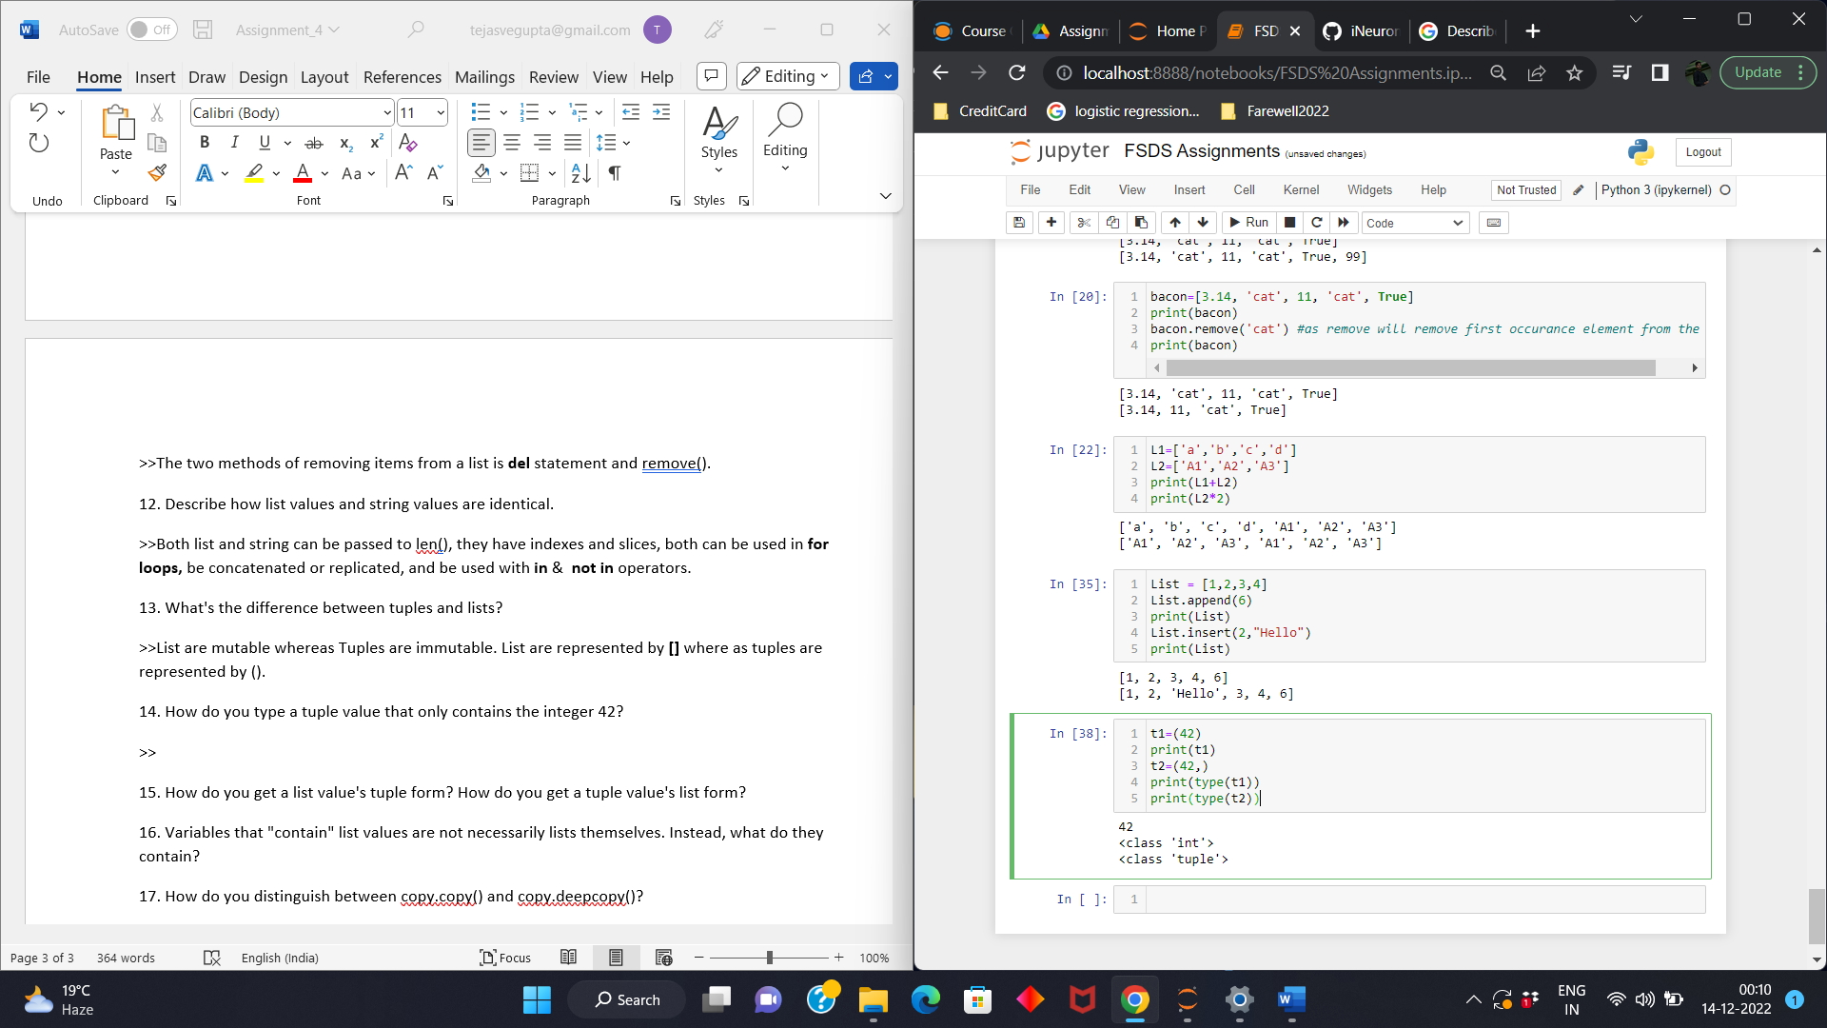

15. How do you get a list value's tuple form? How do you get a tuple value's list form?

>>the tuple() and list() are the two functions which are use to convert list into tuple and tuple into list respectively.

16. Variables that "contain" list values are not necessarily lists themselves. Instead, what do they contain?

>> They contain references to list values.

17. How do you distinguish between copy.copy() and copy.deepcopy()?

>> The **copy.copy()** function will do a shallow copy of a list, while the **copy.deepcopy()** function will do a deep copy of a list. That is, only **copy.deepcopy()** will duplicate any lists inside the list.