1. What does an empty dictionary's code look like?

>>An empty dictionary can be represented by Curly Brackets:

D={} or D=dict()

2. What is the value of a dictionary value with the key 'foo' and the value 42?

>>{‘foo’:42}

3. What is the most significant distinction between a dictionary and a list?

>>dictionary can be represented by {} whereas list can be represented as [].Items in a dictionary can be stored unordered where as list items are ordered.

4. What happens if you try to access spam['foo'] if spam is {'bar': 100}?

>>we will get **KeyError**: 'foo'

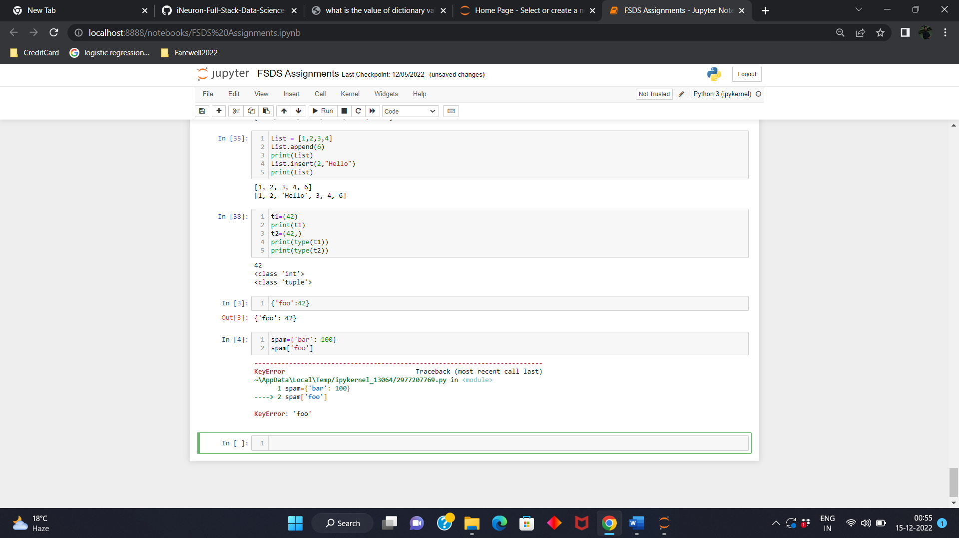

5. If a dictionary is stored in spam, what is the difference between the expressions 'cat' in spam and 'cat' in spam.keys()?

>> There is no difference . The operator checks whether a value exits as a key in the dictionary or not.

6. If a dictionary is stored in spam, what is the difference between the expressions 'cat' in spam and 'cat' in spam.values()?

>> 'cat' in spam checks whether there is a 'cat' key in the dictionary, while 'cat' in spam.values() checks whether there is a value 'cat' for one of the keys in spam.

7. What is a shortcut for the following code?

if 'color' not in spam:

spam['color'] = 'black'

>> 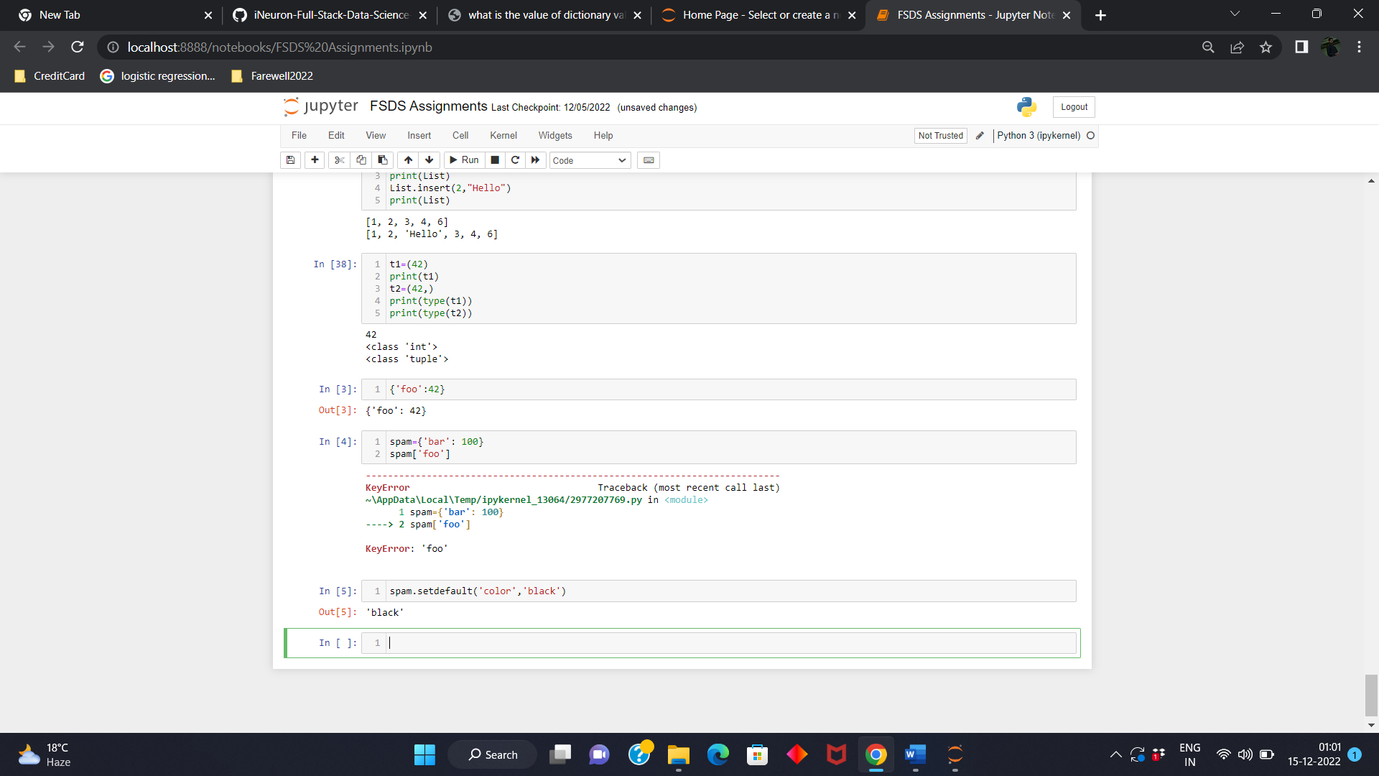

8. How do you "pretty print" dictionary values using which module and function?

>>we can pretty print a dictionary using three functions :-

1. by using pprint() function of pprint module.
   * **Note:** pprint() function doesnot prettyfy nested dictionaries.
2. by using dumps() method of json module.
3. by using dumps() method of yaml module.

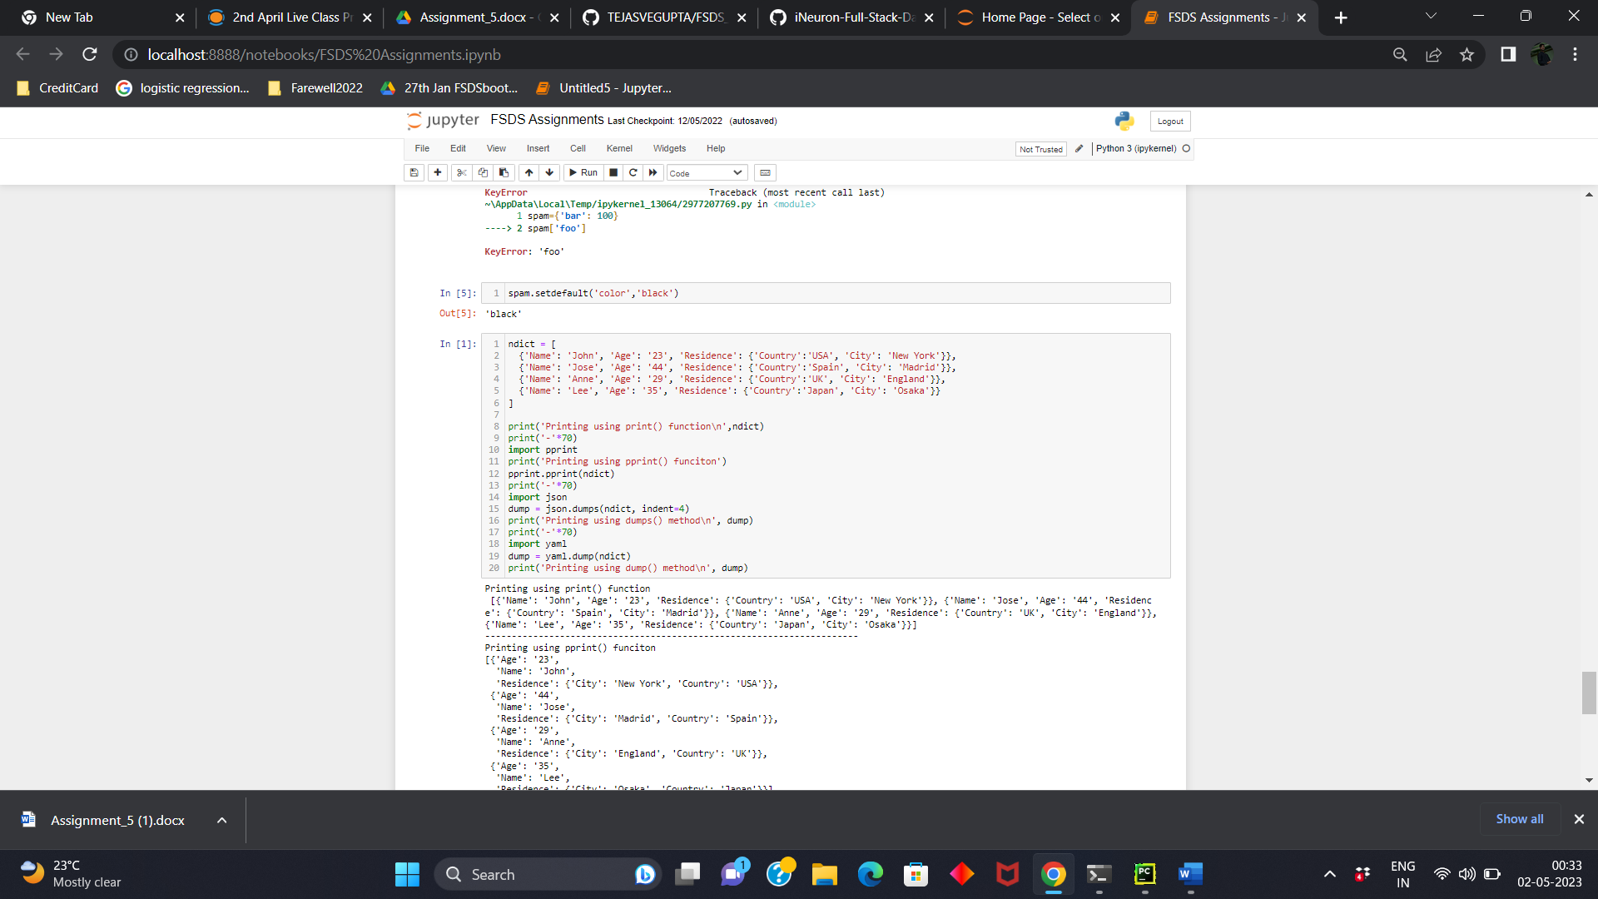

Output:

Printing using print() function

[{'Name': 'John', 'Age': '23', 'Residence': {'Country': 'USA', 'City': 'New York'}}, {'Name': 'Jose', 'Age': '44', 'Residence': {'Country': 'Spain', 'City': 'Madrid'}}, {'Name': 'Anne', 'Age': '29', 'Residence': {'Country': 'UK', 'City': 'England'}}, {'Name': 'Lee', 'Age': '35', 'Residence': {'Country': 'Japan', 'City': 'Osaka'}}]

----------------------------------------------------------------------

Printing using pprint() funciton

[{'Age': '23',

'Name': 'John',

'Residence': {'City': 'New York', 'Country': 'USA'}},

{'Age': '44',

'Name': 'Jose',

'Residence': {'City': 'Madrid', 'Country': 'Spain'}},

{'Age': '29',

'Name': 'Anne',

'Residence': {'City': 'England', 'Country': 'UK'}},

{'Age': '35',

'Name': 'Lee',

'Residence': {'City': 'Osaka', 'Country': 'Japan'}}]

----------------------------------------------------------------------

Printing using dumps() method

[

{

"Name": "John",

"Age": "23",

"Residence": {

"Country": "USA",

"City": "New York"

}

},

{

"Name": "Jose",

"Age": "44",

"Residence": {

"Country": "Spain",

"City": "Madrid"

}

},

{

"Name": "Anne",

"Age": "29",

"Residence": {

"Country": "UK",

"City": "England"

}

},

{

"Name": "Lee",

"Age": "35",

"Residence": {

"Country": "Japan",

"City": "Osaka"

}

}

]

----------------------------------------------------------------------

Printing using dump() method

- Age: '23'

Name: John

Residence:

City: New York

Country: USA

- Age: '44'

Name: Jose

Residence:

City: Madrid

Country: Spain

- Age: '29'

Name: Anne

Residence:

City: England

Country: UK

- Age: '35'

Name: Lee

Residence:

City: Osaka

Country: Japan