Q1) Write a C program to identify different types of Tokens in a given Program.

Code 1:
#include <stdio.h>
#include <ctype.h>
#include <string.h>

// Function to check if a word is a keyword
int isKeyword(char buffer[]) {
char keywords[32][10] = {
"auto","break","case","char","const","continue","default",
"do","double","else","enum","extern","float","for","goto",
"if","int","long","register","return","short","signed",
"sizeof","static","struct","switch","typedef","union",
"unsigned","void","volatile","while"
};

for(int i = 0; i < 32; ++i) {
if(strcmp(keywords[i], buffer) == 0) {
return 1;
}
}
return 0;
}

int main() {
char ch, buffer[15], operators[] = "+-*/%=,;()";
FILE *fp;
int i, j = 0;

// You can replace "program.c" with any text file containing C code
// For lab, we often just read direct input or a dummy file.
// Here we will simulate reading a simple input string for demonstration.
// In actual lab, use: fp = fopen("program.c","r");

printf("Enter the C code string (end with $): ");

while((ch = getchar()) != '$') {

// Check for Operators
for(i = 0; i < 10; ++i) {
if(ch == operators[i])
printf("%c is operator\n", ch);
}

// Check for Alphanumeric (Keywords or Identifiers)
if(isalnum(ch)) {
buffer[j++] = ch;
} else if((ch == ' ' || ch == '\n' || strchr(operators, ch)) && (j != 0)) {
buffer[j] = '\0';
j = 0;

if(isKeyword(buffer) == 1)
printf("%s is keyword\n", buffer);
else {
// Check if it is a number (Constant) or Identifier
if(isdigit(buffer[0]))
printf("%s is constant\n", buffer);
else
printf("%s is identifier\n", buffer);
}
}
}
return 0;
}

Output:

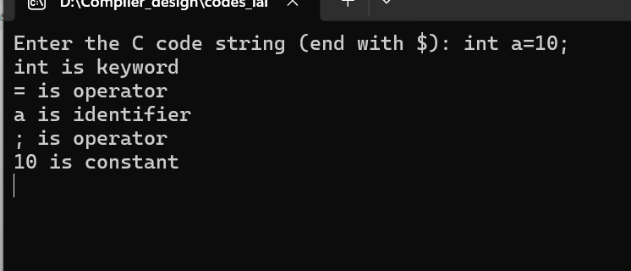

Q2) Write a Lex Program to implement a Lexical Analyzer using Lex tool

%{
#include<stdio.h>
%}

%%
[0-9]+ { printf("Number\n"); }
[a-zA-Z]+ { printf("Identifier\n"); }
"+"|"-"|"*"|"/" { printf("Operator\n"); }
[ \t\n] ;
. { printf("Special Character\n"); }
%%

int main() {
yylex();
return 0;
}

Q4) Write a C program to Simulate Lexical Analyzer to validating a given input String.

Code:
#include <stdio.h>
#include <ctype.h>
#include <string.h>

// Function to check if a word is a keyword
int isKeyword(char buffer[]) {
char keywords[32][10] = {
"auto","break","case","char","const","continue","default",
"do","double","else","enum","extern","float","for","goto",
"if","int","long","register","return","short","signed",
"sizeof","static","struct","switch","typedef","union",
"unsigned","void","volatile","while"
};
int i;
for(i = 0; i < 32; ++i) {
if(strcmp(keywords[i], buffer) == 0) {
return 1;
}
}
return 0;
}

int main() {
char ch, buffer[15], operators[] = "+-*/%=,;()";
FILE *fp;
int i, j = 0;

printf("Enter the input string (end with $): ");

while((ch = getchar()) != '$') {

// 1. Check for Operators
int isOp = 0;
for(i = 0; i < 10; ++i) {
if(ch == operators[i]) {
printf("'%c' is an Operator\n", ch);
isOp = 1;
break;
}
}
if(isOp) continue;

// 2. Build the Token (Alphanumeric)
if(isalnum(ch)) {
buffer[j++] = ch;
}
// 3. Process the Token when a separator (space/newline) is found
else if((ch == ' ' || ch == '\n') && (j != 0)) {
buffer[j] = '\0';
j = 0;

if(isKeyword(buffer) == 1)
printf("'%s' is a Keyword\n", buffer);
else {
// VALIDATION LOGIC:
// Check if it's a Number
if(isdigit(buffer[0])) {
int validNumber = 1;
// Check if the rest are also digits
for(int k=1; k<strlen(buffer); k++) {
if(!isdigit(buffer[k])) {
validNumber = 0;
break;
}
}
if(validNumber)
printf("'%s' is a Constant\n", buffer);
else
printf("'%s' is INVALID (Identifier cannot start with a digit)\n", buffer);
}
// It must be an Identifier
else {
printf("'%s' is a Valid Identifier\n", buffer);
}
}
}
}
return 0;
}

Output:
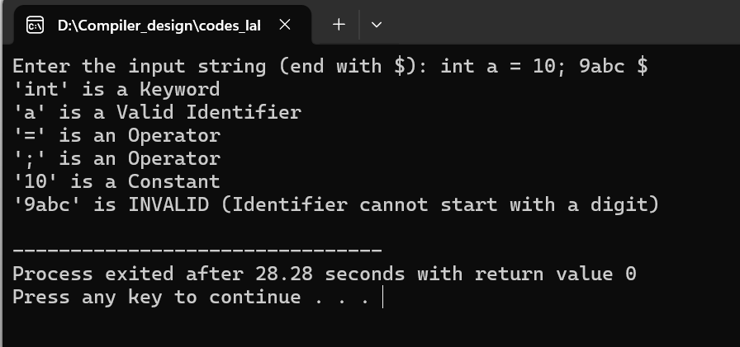

Q4) Write a C program to implement the Brute force technique of Top down Parsing.

Code:
#include <stdio.h>
#include <string.h>

char input[100];
int i = 0; // Input pointer

// Function Prototypes
int S();
int A();

int main() {
printf("Grammar is: \nS -> cAd \nA -> ab | a \n");
printf("Enter the string: ");
scanf("%s", input);

// Call the Start Symbol S
if (S() == 1 && i == strlen(input)) {
printf("\nString is Accepted\n");
} else {
printf("\nString is Rejected\n");
}
return 0;
}

// Function for Non-Terminal S -> cAd
int S() {
// Save current pointer for backtracking (though S has only 1 rule here)
int save = i;

// Attempt: S -> cAd
if (input[i] == 'c') {
i++;
if (A()) { // Call A
if (input[i] == 'd') {
i++;
return 1; // Success
}
}
}

// Backtrack if failed
i = save;
return 0;
}

// Function for Non-Terminal A -> ab | a
int A() {
int save = i; // Save pointer to BACKTRACK later

// Attempt 1: A -> ab
if (input[i] == 'a') {
i++;
if (input[i] == 'b') {
i++;
return 1; // Success with 'ab'
}
}

// FAILURE on Attempt 1 -> BACKTRACK
// Reset pointer to where it was before we tried 'ab'
i = save;

// Attempt 2: A -> a
if (input[i] == 'a') {
i++;
return 1; // Success with 'a'
}

// Both failed
return 0;
}

Output:

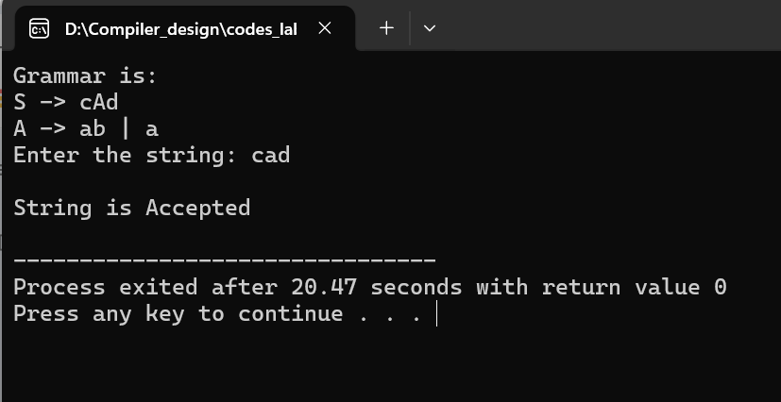

5) Write a C program to implement a Recursive Descent Parser.

Code:
#include <stdio.h>
#include <string.h>
#include <stdlib.h>

char input[100];
int i = 0;

// Function Prototypes
void E();
void Ed();
void T();
void Td();
void F();

void error() {
printf("\nError in parsing string!\n");
exit(0);
}

int main() {
printf("Recursive Descent Parser for Arithmetic Expression\n");
printf("Grammar:\n");
printf("E -> TE'\nE' -> +TE' | epsilon\nT -> FT'\nT' -> *FT' | epsilon\nF -> (E) | i\n");
printf("Enter the input string (use 'i' for identifier, e.g., i+i*i): ");
scanf("%s", input);

E(); // Start Parsing from Start Symbol

// If parsing finished and we reached end of string
if (strlen(input) == i) {
printf("\nString Accepted\n");
} else {
printf("\nString Rejected\n");
}
return 0;
}

// E -> T E'
void E() {
T();
Ed();
}

// E' -> + T E' | epsilon
void Ed() {
if (input[i] == '+') {
i++;
T();
Ed();
}
}

// T -> F T'
void T() {
F();
Td();
}

// T' -> * F T' | epsilon
void Td() {
if (input[i] == '*') {
i++;
F();
Td();
}
}

// F -> ( E ) | i
void F() {
if (input[i] == '(') {
i++;
E();
if (input[i] == ')') {
i++;
} else {
error();
}
} else if (input[i] == 'i') {
i++;
} else {
error();
}
}

Output:

