Create a new React Application with the name “myfirstreact”, Run the application to print “welcome to the first session of React” as heading of that page.

**App.js**

import './App.css';

function App() {

  return (

   <h1 align="center">Welcome to the first session of react </h1>

  );

}

export default App;

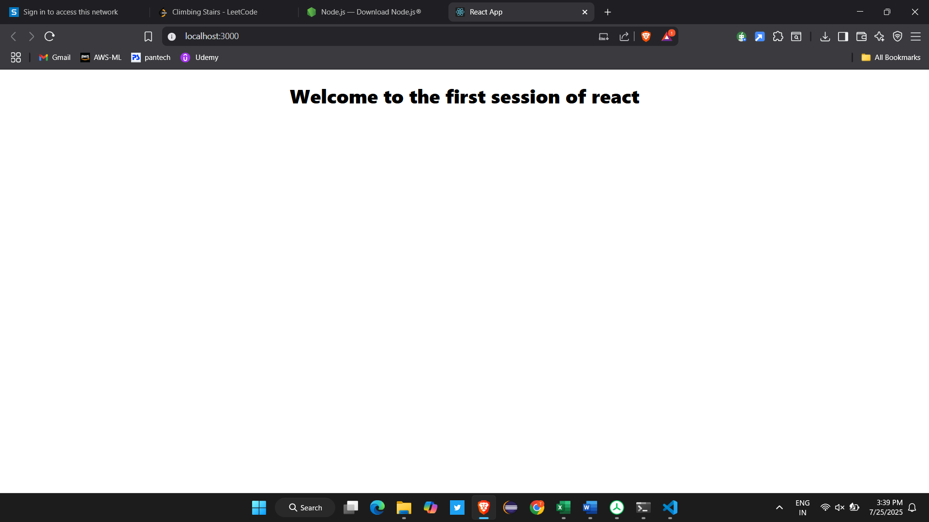

Create a react app for Student Management Portal named StudentApp and create a component named Home which will display the Message “Welcome to the Home page of Student Management Portal”. Create another component named About and display the Message “Welcome to the About page of the Student Management Portal”. Create a third component named Contact and display the Message “Welcome to the Contact page of the Student Management Portal”. Call all the three components

**Code :**

**Home.js**

import React from 'react'

export default function Home() {

  return (

   <div>

    <h3>Welcome to the Home Page of Student Management Portal</h3>

   </div>

  )

}

**About.js**

import React from 'react'

export default function About() {

  return (

    <div>

        <h3>Welcome to the About Page of Student management Portal</h3>

    </div>

  )

}

**Contact.js**

import React from 'react'

export default function Contact() {

  return (

    <div>

         <h3>Welcome to the Contact Page of Student management Portal</h3>

    </div>

  )

}

**App.js :**

import './App.css';

import Home from './Components/Home';

import Contact from './Components/Contact';

import About from './Components/About';

function App() {

  return(

    <div align="center">

    <Home/>

    <Contact/>

    <About/>

    </div>

  );

}

export default App;

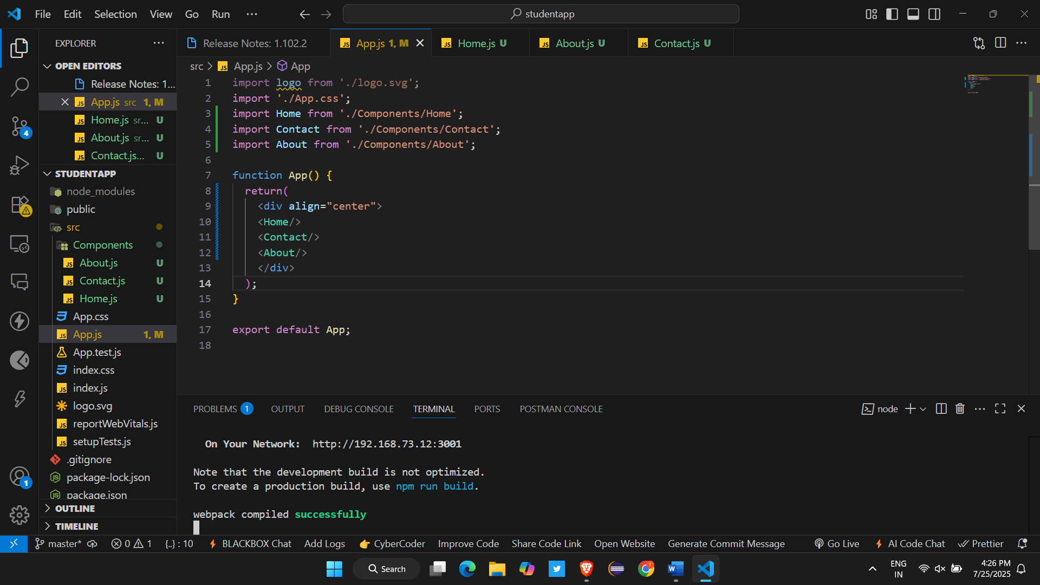

Create a react app for Student Management Portal named scorecalculatorapp and create a function component named “CalculateScore” which will accept Name, School, Total and goal in order to calculate the average score of a student and display the same.

**Code :**

**CalculatorScore.js:**

import React from 'react';

function calcScore(total, goal) {

  return total / goal;

}

const CalculateScore = ({ Name, School, total, goal }) => (

  <div className="formatstyle">

    <h1><font color="Brown">Student Details:</font></h1>

    <div className="Name">

      <b><span> Name: </span></b>

      <span>{Name}</span>

    </div>

    <div className="School">

      <b><span> School: </span></b>

      <span>{School}</span>

    </div>

    <div className="Total">

      <b><span>Total: </span></b>

      <span>{total}</span>

      <span> Marks</span>

    </div>

    <div className="Score">

      <b>Score: </b>

      <span>

        {calcScore(

          total,

          goal

        )}

      </span>

    </div>

  </div>

);

export default CalculateScore;

**mystyle.css :**

.Name {

  font-weight: 300;

  color: blue;

}

.School {

  color: crimson;

}

.Total {

  color: darkmagenta;

}

.formatstyle {

  text-align: center;

  font-size: large;

}

.Score {

  color: forestgreen;

}

**App.js**

import './App.css';

import CalculateScore from './Components/CalculateScore';

function App() {

  return (

    <div align="center">

      <CalculateScore Name={"Steeve"}

      School={"DNV public school"}

      total={284}

      goal={3}

      />

      </div>

  );

}

export default App;



