📄 TEJNAVI STUDIO — WEBSITE MVP DOCUMENTATION
Prepared for: Internal Team Meeting
Date: 20 February 2026
Project: Tejnavi Studio Official Website (MVP Version)

🎯 PROJECT OVERVIEW
Company Name: Tejnavi Studio
Tagline: Custom Tech Solutions for Every Sector and Industry
Website Objective:
Create a bold, fully animated, world-class portfolio website that showcases Tejnavi Studio's services, past projects, and provides an automated quotation system for potential clients.

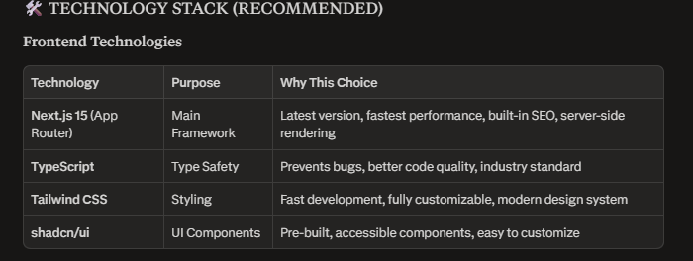
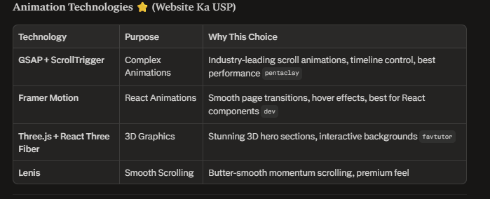

💾 DATABASE DECISION: SUPABASE

📄 WEBSITE PAGES & STRUCTURE
1. Home Page 🏠
Purpose: First impression, showcase everything at a glance
Sections:
- Hero Section (3D animated background, bold tagline, CTA buttons)
- Services Marquee (scrolling animation)
- Featured Services Grid (animated cards)
- Stats Counter (Projects delivered, Clients served, Industries covered)
- Featured Portfolio Projects (filterable)
- Why Choose Tejnavi? (differentiators)
- Client Testimonials (carousel)
- Final CTA Banner

2. Services Pages 🛠️
Purpose: Detailed information about each service
Structure:
- Separate dedicated page for EACH service (8 pages total)
- Each page includes:
  - What we offer
  - How we deliver
  - Technologies we use
  - Related case studies
  - "Get a Quote" CTA

3. Portfolio / Projects Page 💼
Purpose: Showcase our past work
Features:
- Filter by category (Web, App, SaaS, CRM, Shopify, etc.)
- Project cards with hover animations
- Click to open detailed case study page
- Each case study includes:
  - Client problem statement
  - Our solution approach
  - Technologies used
  - Results achieved
  - Screenshots/visuals
  - Live link (if applicable)

4. Get a Quote Page 💰 ⭐ (MOST IMPORTANT)
Purpose: Automated pricing calculator + lead generation
How It Works:
- Client selects Service Type (Website, App, SaaS, etc.)
- Sub-options appear based on selection
- Client selects Industry (E-commerce, Healthcare, Education, etc.)
- Client selects Required Features (checkboxes):
  - User Login System
  - Payment Gateway Integration
  - Admin Panel
  - Custom Dashboard
  - Mobile Responsive
  - API Integration
  - etc.
- Client selects Timeline (Rush / Standard / Relaxed)
- Live price estimate updates as they make selections
- Final form submission:
  - Quote saved in database
  - Email sent to client with estimate
  - Notification sent to our admin panel
  - Follow-up automation
This page will be our biggest lead generator!

5. About Page 👥
Purpose: Build trust and credibility
Sections:
- Company story and mission
- Team members (with animated cards)
- Our values and culture
- Tech stack showcase (animated logo marquee)
- Industries we serve

6. Contact Page 📞
Purpose: Easy communication channel
Features:
- Animated contact form (Name, Email, Phone, Service Interest, Message)
- Submission triggers:
  - Data saved in database
  - Auto-reply email to client
  - Notification to admin
- WhatsApp direct link
- Social media links
- Office location (optional)

7. Blog / Resources 📝 (Optional for MVP)
Purpose: SEO boost and thought leadership
Features:
- Articles on tech trends
- Case study deep-dives
- How we solve industry problems
- Easy to publish via Sanity CMS

8. Admin Dashboard 🔐 (Internal Use Only)
Purpose: Manage website content and view leads
Protected Route: /admin (password-protected)
Features:
- View all quote requests (with client details + budget estimate)
- Manage portfolio projects (add/edit/delete)
- View contact form submissions
- Basic analytics (page visits, popular services)
- Upload images to Supabase Storage

✨ ANIMATION & DESIGN STRATEGY
Goal: Website should feel premium, modern, and unique — not like a template.
Animation Layers:
- GSAP + ScrollTrigger
  - Section reveals as you scroll
  - Parallax effects
  - Text animations (split text effects)
  - Counter animations (numbers counting up)
  - Timeline-based complex animations
- Framer Motion
  - Page transitions (smooth fade/slide between pages)
  - Button hover effects
  - Modal/popup animations
  - Card entrance animations
- Three.js / React Three Fiber
  - 3D animated hero background (particles, geometric shapes, or interactive globe)
  - WebGL-powered visual effects
- Lenis
  - Smooth momentum-based scrolling throughout entire site
  - Gives a premium "Apple-like" feel

- CSS Animations
  - Gradient shifts
  - Glowing effects on CTAs
  - Marquee scrolling text
Design Philosophy:
- Dark mode by default (modern, premium feel)
- Bold typography
- Generous white space
- Micro-interactions everywhere (hover states, button clicks)
- Custom cursor effect (optional but impressive)
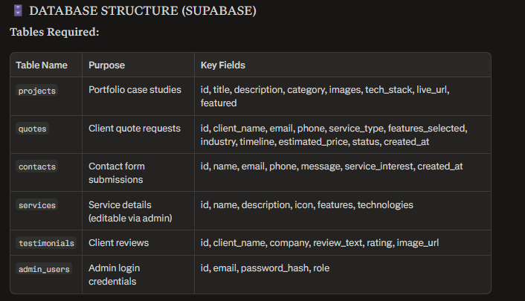

🔄 PROJECT WORKFLOW & PHASES
Phase 1: Foundation & Design
Tasks:
- Design system setup (colors, typography, spacing)
- Supabase project setup (database + storage buckets)
- Next.js project initialization with TypeScript + Tailwind
- Install animation libraries (GSAP, Framer Motion, Three.js)
- Create reusable UI components (buttons, cards, forms)
- Build responsive Navbar & Footer
- Home page development (all sections)
- Services pages (all 8 service pages)
Deliverable: Home page + Services pages fully functional and animated

Phase 2: Portfolio & Quote System
Tasks:
- Portfolio page layout with filtering
- Individual project case study pages
- Supabase integration for fetching projects
- Quote calculator development:
  - Dynamic form with conditional fields
  - Real-time price calculation logic
  - Supabase database integration
  - Email sending setup (quote confirmation)
- Admin dashboard — "Quotes" section
Deliverable: Portfolio showcase + Automated quote system working

Phase 3: Additional Pages & Admin Panel
Tasks:
- About page (team section, company story)
- Contact page with working form
- Email integration (Resend API or similar)
- Admin dashboard development:
  - Authentication (login/logout)
  - View all quotes
  - Manage projects (CRUD operations)
  - View contact submissions
  - File upload to Supabase Storage
- Blog setup with Sanity CMS (optional)
Deliverable: All pages complete + Admin panel functional

Phase 4: Polish, SEO & Deployment
Tasks:
- Animation polish and performance optimization
- Mobile responsiveness testing (all screen sizes)
- SEO setup:
  - Meta tags for all pages
  - Open Graph images
  - Sitemap generation
  - robots.txt
- Performance optimization:
  - Image optimization (Next.js Image component)
  - Code splitting
  - Lazy loading
- Cross-browser testing (Chrome, Safari, Firefox, Edge)
- Final content addition (real text, images, projects)
- Deployment:
  - Frontend: Vercel (automatic deployments)
  - Database: Supabase (already cloud-hosted)
- Domain setup and SSL certificate
- Analytics integration (Google Analytics or Vercel Analytics)
Deliverable: Fully polished, deployed, live website

📊 ADDITIONAL FEATURES (Unique Differentiators)
These features will make Tejnavi Studio stand out from typical agency websites:
- "Build Your Product" Interactive Wizard — Step-by-step flow on homepage where visitors visualize building their product with us
- Industry Selector on Homepage — Visitor selects their industry → relevant case studies show up
- WhatsApp Chat Widget — Floating button for instant queries (very effective in Indian market)
- Dark Mode Toggle — Let users switch between dark/light themes (dark by default)
- Custom Loading Animation — Branded preloader with Tejnavi Studio logo
- Custom Cursor Effect — Animated cursor that follows mouse (very popular in premium agency sites)
- Floating "Get Quote" Button — Always visible on scroll for easy access
- Project Filter Animations — Smooth transitions when filtering portfolio items
- Testimonial Video Integration — Option to add video testimonials (stored in Supabase)
- Download Portfolio PDF — Auto-generate and download company portfolio as PDF

💰 ESTIMATED TIMELINE & RESOURCE ALLOCATION
Total Duration: 3 weeks (25 days)
Team Required:
- 2 Full-Stack Developer (Next.js + Supabase)
- 1 UI Designer (for design system and assets)
- 1 Content Writer (for copywriting and service descriptions)
Development Breakdown:
- Frontend Development: 60%
- Backend Development: 20%
- Animation Implementation: 15%
- Testing & Deployment: 5%

🔒 SECURITY & BEST PRACTICES
Implementation Standards:
- Authentication: Secure admin panel with hashed passwords
- Data Protection: Row-level security policies in Supabase
- API Security: Rate limiting on quote submissions (prevent spam)
- File Upload: Validation for file types and sizes
- HTTPS: SSL certificate for secure connections
- Environment Variables: All API keys stored securely (not in code)
- GDPR Compliance: Privacy policy and cookie consent (if required)

Prepared By: Saad
For: Tejnavi Studio

