Quantitative Trading Strategy for NIFTY 50 Using EMA Crossover and Machine Learning

Tej Raj
Department of Computer Science & Engineering
tej2461.be22@chitkara.edu.in
Shivam Laul
Department of Computer Science & Engineering
shivam824.be22@chitkara.edu.in
Avinash Kumar Jha
Department of Computer Science & Engineering
avinash200.be22@chitkara.edu.in

Abstract— Quantitative trading has reshaped modern financial markets by replacing subjective decision-making with data-driven, rule-based strategies. However, conventional moving average crossover approaches frequently produce misleading signals in range-bound markets and lack the ability to adjust to evolving market dynamics. This paper introduces a regime-aware quantitative trading framework for the NIFTY 50 index that addresses these shortcomings. The proposed system employs a 5/15 Exponential Moving Average crossover mechanism augmented with a three-state Hidden Markov Model for market regime classification, distinguishing between uptrend, sideways, and downtrend phases. Over 86 features are engineered from one year of 5-minute OHLCV data, encompassing technical indicators, Black-Scholes option Greeks, implied volatility metrics, and put-call ratios. XGBoost and LSTM classifiers are trained to forecast trade profitability on a binary level. The full-period backtest yields a profit factor of 3.40, a Sharpe ratio of 4.182, and a maximum drawdown limited to 0.81%. Outlier analysis shows that merely 1.65% of all executed trades account for 26.99% of cumulative profits, and that these exceptional trades are characterized by elevated ATR and EMA gap values rather than favorable entry conditions. These findings underscore the primacy of trade management over entry selection in systematic trading.
Keywords — Quantitative Trading, NIFTY 50, EMA Crossover, Hidden Markov Model, Regime Detection, Machine Learning, XGBoost, LSTM, Options Greeks, Backtesting

1. INTRODUCTION
Financial markets around the world have undergone a substantial shift over the past two decades, driven largely by the proliferation of algorithmic and quantitative trading methodologies. These approaches replace intuition-driven decision-making with systematic strategies grounded in mathematical models and statistical inference [1]. In India, the NIFTY 50 index—a capitalization-weighted benchmark representing fifty blue-chip equities on the National Stock Exchange—offers a liquid and well-tracked instrument ideally suited for the development and evaluation of such strategies.
Classical technical analysis techniques, including moving average crossovers, have long been employed by market participants to identify trend reversals and potential entry points [2]. Despite their widespread adoption, these methods exhibit well-documented weaknesses. Chief among them is the tendency to produce whipsaw signals during periods of consolidation, where repeated false crossovers erode trading capital. Furthermore, standard crossover strategies treat all signals uniformly; they do not account for the prevailing market environment and cannot distinguish between a genuine trend breakout and a transient fluctuation within a range-bound phase.
Recent advances in statistical modeling and machine learning have opened the door to more adaptive trading frameworks. Hidden Markov Models, for example, have demonstrated considerable promise in capturing the latent structure of financial time series by identifying discrete market regimes that are not directly observable from price alone [3]. Simultaneously, gradient boosting algorithms such as XGBoost and recurrent architectures like Long Short-Term Memory networks have been applied to predict the directional outcome of trades with varying degrees of success [4], [5].
This paper presents a comprehensive quantitative trading system that marries these approaches. The framework's core engine is a 5/15 EMA crossover strategy enhanced by a three-state HMM-based regime filter that suppresses trade execution during sideways markets. The system further incorporates over 86 engineered features derived from spot, futures, and options data, and leverages XGBoost and LSTM models for predicting the probability of individual trade profitability. Finally, rigorous outlier analysis using Z-score methods reveals that a tiny fraction of trades contribute disproportionately to overall returns, and that these high-impact trades are distinguishable by volatility and momentum characteristics rather than entry-level conditions.
The principal contributions of this work are fourfold: (1) a complete end-to-end data pipeline for ingesting and processing multi-frequency NIFTY 50 data; (2) a regime detection layer that significantly reduces false signals; (3) a machine learning module for probabilistic trade filtering; and (4) an empirical demonstration that position management, not entry timing, drives outsized performance in systematic strategies.
The rest of this paper is organized as follows. Section II surveys related work. Section III describes the system design and methodology. Section IV covers the implementation details. Section V presents the experimental results and their analysis. Section VI draws conclusions and outlines avenues for future research.

2. Literature Review
2.1. Technical Analysis and Moving Averages
Technical analysis relies on the premise that historical price and volume patterns contain extractable information about future price movements [2]. Among the most widely used tools are moving averages, which smooth raw price data to reveal the underlying trend direction. The Exponential Moving Average assigns exponentially decreasing weights to older observations, thereby responding more quickly to recent price changes compared to its simple counterpart. Mathematically, the EMA at time *t* is given by:
EMA_t = P_t × k + EMA_{t−1} × (1 − k)
where P_t is the current price and k = 2 / (N + 1) for a window of length N.
A crossover strategy generates a buy signal when a short-period EMA crosses above a longer-period EMA and a sell signal on the reverse crossing. While straightforward and easy to implement, this mechanism is prone to generating excessive signals in trendless environments, leading to frequent small losses that compound over time [6].
2.2. Hidden Markov Models in Finance
Hidden Markov Models provide a probabilistic framework for modeling sequential data in which the observed variables are assumed to be generated by an underlying process whose states are not directly visible [3]. In the financial domain, HMMs have been applied to identify latent market regimes—such as bull, bear, and neutral phases—from observable quantities including returns, volatility, and volume metrics. Each hidden state is associated with a distinct emission distribution, and the Baum-Welch algorithm is used to estimate model parameters. The Viterbi algorithm then decodes the most likely sequence of hidden states across the observation period. Research by Hassan and Nath [7] demonstrated the viability of HMM-based approaches for stock price forecasting, while subsequent studies extended the framework to regime-conditional portfolio construction.
2.3. Machine Learning for Trade Prediction
The application of machine learning to financial prediction has expanded significantly since the early 2000s. XGBoost, introduced by Chen and Guestrin [4], constructs an ensemble of decision trees in a sequential, gradient-boosted fashion and incorporates L1 and L2 regularization to mitigate overfitting. Its ability to handle mixed feature types and missing values, combined with computational efficiency, has made it a popular choice for tabular financial data.
Long Short-Term Memory networks, proposed by Hochreiter and Schmidhuber [5], address the vanishing gradient problem inherent in standard recurrent neural networks by introducing gating mechanisms that control information flow across time steps. This architecture is particularly well suited for learning temporal dependencies in high-frequency financial data, although its effectiveness is contingent on the availability of sufficient training samples.
2.4. Options Greeks and the Black-Scholes Framework
The Black-Scholes model [8] remains a foundational tool for pricing European-style options and for computing sensitivities—collectively termed the Greeks. Delta quantifies the rate of change of the option price with respect to a unit move in the underlying, Gamma measures the convexity of that relationship, Theta captures time-decay, and Vega reflects sensitivity to changes in implied volatility. In the context of a quantitative trading system, these metrics serve as informative features that capture market participants' expectations about future price dispersion and directional bias.

3. METHODOLOGY
3.1. Overall Architecture
The proposed system is organized into six interconnected modules: data acquisition, data cleaning, feature engineering, regime detection, strategy execution, and machine learning prediction. Data flows sequentially through these stages, beginning with raw OHLCV records and culminating in trade signals that are evaluated through a comprehensive backtesting engine.

3.2. Data Pipeline
Three categories of market data are ingested: NIFTY 50 spot prices sampled at five-minute intervals (19,912 records spanning one calendar year), corresponding NIFTY futures data at the same frequency including open interest and contract rollover information, and NIFTY options data at hourly resolution covering at-the-money plus or minus two strike prices for both call and put sides (15,650 records). The cleaning module handles missing values through forward-fill interpolation, removes obvious outliers, and aligns timestamps across all three data sources.

3.3. Feature Engineering
A total of 86 features are constructed, spanning several analytical categories. Six EMA-based indicators capture short-term momentum and medium-term trend, including the raw EMA(5) and EMA(15) values, their difference, crossover direction, and trend strength. Ten features are derived from Black-Scholes Greeks computed for at-the-money options: Delta, Gamma, Theta, Vega, and Rho for both call and put legs. Three implied volatility features—average IV, IV spread between calls and puts, and IV percentile rank—capture expectations of future price dispersion. Two put-call ratio features based on open interest and traded volume summarize directional sentiment. Additional derived features include Gamma Exposure, spot returns, and a futures basis measure that reflects the cost-of-carry relationship between spot and derivatives.

3.4. Regime Detection with Hidden Markov Models
A Gaussian HMM with three hidden states is fitted to a selected subset of features: implied volatility, put-call ratio, options Greeks, futures basis, and spot returns. The model is trained on the first 70% of the data and applied to the full dataset. After fitting, each state is labeled as Uptrend (+1), Sideways (0), or Downtrend (−1) based on the average return observed within that state. The resulting transition matrix reveals high persistence probabilities—98.5% for Downtrend, 70.7% for Sideways, and 98.1% for Uptrend—indicating that once the market enters a particular regime, it tends to remain there for extended periods.

3.5. Trading Strategy
The core trading logic is defined as follows. A long position is initiated when EMA(5) crosses above EMA(15) and the current regime is classified as Uptrend. A short position is initiated when EMA(5) crosses below EMA(15) and the current regime is Downtrend. No trades are permitted during Sideways periods. Exits occur upon the next opposite crossover signal. All entries and exits are executed at the opening price of the candle immediately following the signal to avoid look-ahead bias.

3.6. Machine Learning Models
The machine learning component frames trade prediction as a binary classification task: given the engineered features at the time of signal generation, predict whether the resulting trade will be profitable (label 1) or not (label 0). The dataset consists of 182 trade samples split 70/30 for training and testing, preserving temporal order to prevent data leakage.

XGBoost is configured with a maximum tree depth of 6, a learning rate of 0.05, 200 boosting rounds, and five-fold time-series cross-validation. The LSTM model uses a bidirectional layer with 128 units, a sequence length of 10 candles, 40% dropout for regularization, and approximately 40,000 trainable parameters.

3.7. Machine Learning for Trade Filtering
The prediction task is framed as binary classification: given the feature vector at the moment a trade signal is generated, the goal is to estimate whether the trade will be profitable. The complete dataset of 182 trades is split 70/30 in chronological order.

**XGBoost** is configured with 200 estimators, a maximum depth of 6, a learning rate of 0.05, and five-fold walk-forward cross-validation. **LSTM** employs a bidirectional architecture with 128 hidden units, an input sequence length of 10, 40% dropout, and approximately 40,000 parameters.

4. Results and Discussion
4.1. Backtest Performance
The strategy is evaluated across three windows: a training period (first 70% of data), a testing period (remaining 30%), and the combined full period.
Table 1: Backtest Performance Metrics
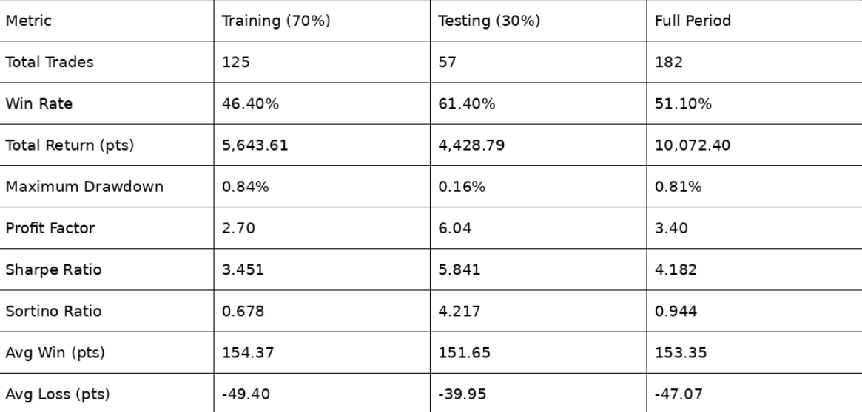
A notable observation is that the out-of-sample testing period outperforms the training window on nearly every risk-adjusted metric—the win rate improves from 46.40% to 61.40%, and the profit factor nearly doubles from 2.70 to 6.04. This suggests that the regime filter generalizes well and does not merely overfit to the historical data used for HMM training.
The equity curve (Fig. 2 in report) shows a steady, upward-trending trajectory across the full period with shallow and short-lived drawdowns. The largest single drawdown of 892 points occurs during the training window around mid-2024 and is quickly recovered.
4.2. Trade Distribution Analysis
The distribution of individual trade outcomes exhibits positive skewness. The mean trade return is 55.34 points, with winning trades averaging 153.35 points and losing trades averaging only −47.07 points, yielding a favorable reward-to-risk ratio of approximately 3.26:1. This asymmetry is a direct consequence of the regime filter, which curtails trades in uncertain environments and allows trend-aligned positions to run.
Short positions collectively generate 6,845.79 points across 95 trades, compared to 3,226.61 points from 87 long trades. This asymmetry aligns with the generally recognized observation that equity downturns tend to be sharper and more directional than upswings, enabling short-side trades to accumulate larger per-trade gains when conditions are favorable.
4.3. Regime Analysis
The HMM identifies distinct statistical signatures for each regime. Uptrend periods exhibit higher average spot returns and stronger EMA momentum, while Downtrend periods are characterized by elevated implied volatility and widened IV spreads. Sideways regimes, which the strategy avoids entirely, show compressed distributions across nearly all features, consistent with low-conviction, range-bound price action.
The transition probability matrix reveals that Downtrend and Uptrend regimes are highly persistent (98.5% and 98.1% self-transition probabilities, respectively), while the Sideways state is comparatively less sticky at 70.7%. This pattern indicates that the model rarely oscillates between states in rapid succession, lending stability to the regime-based filtering mechanism.

4.4. Machine Learning Model Performance
Table 2: Machine Learning Model Comparison
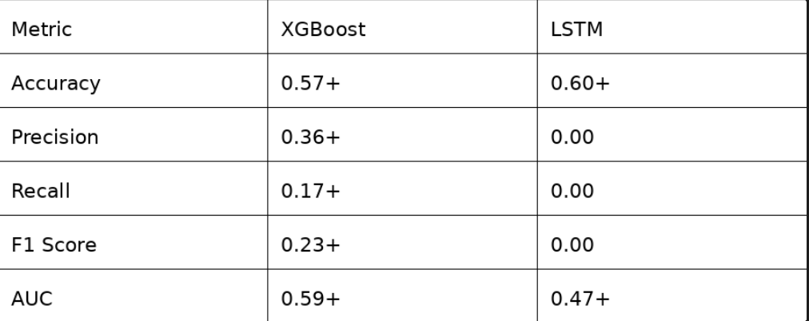
XGBoost demonstrates meaningful, though modest, discriminative ability, achieving an AUC of 0.59 and producing a small number of high-confidence predictions. When used as a secondary filter on top of the regime-aware crossover, the XGBoost model is highly selective—filtering approximately 99% of candidate signals—but achieves a 100% win rate on the four trades it approves. This extreme selectivity limits practical utility but confirms that the model captures some genuine signal.

The LSTM model, by contrast, predicts all samples as a single class, resulting in zero precision and recall for the minority class. This collapse is attributable to the extremely small dataset: 182 total samples is insufficient for training a deep recurrent architecture with approximately 40,000 parameters, even with aggressive dropout regularization. This outcome is consistent with the broader literature suggesting that deep learning models require substantially larger datasets to outperform gradient-boosted tree methods on structured tabular data [9].

4.5. Outlier Analysis and Statistical Testing
Three trades, representing just 1.65% of the total, are flagged as outliers using a Z-score threshold of 3. These three positions collectively contribute 2,718.87 points—26.99% of total cumulative profit—with an average gain of 906.29 points, which is 7.07 times the average return of the remaining profitable trades.
Table 3: Statictical Comparison: Outlier Vs Normal Profitable Trades
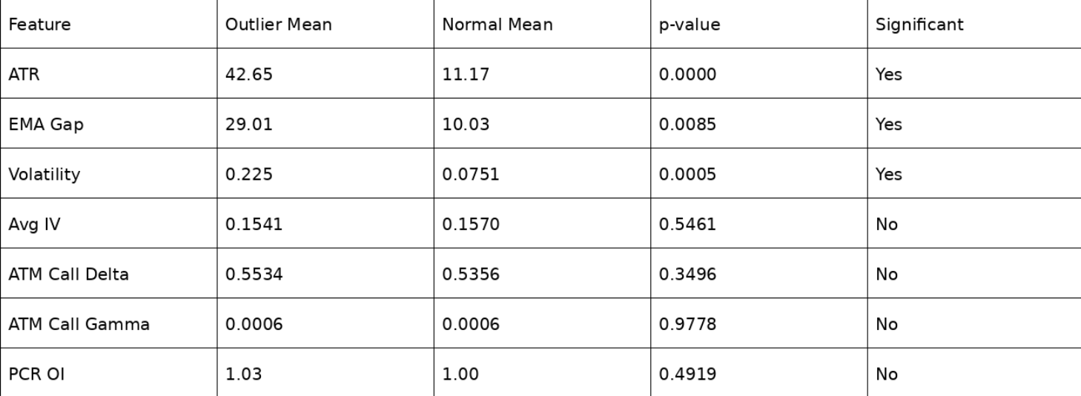
The statistical tests reveal a striking pattern. ATR, EMA gap, and realized volatility all show highly significant differences between outlier and normal profitable trades (p < 0.01 in each case). Outlier trades occur in environments where ATR is 3.8 times higher, the EMA gap is 2.9 times wider, and spot volatility is 3.0 times greater compared to typical winning trades. In sharp contrast, entry-level features such as implied volatility, Delta, Gamma, and PCR show no statistically significant difference whatsoever. This evidence strongly supports the conclusion that it is the market environment and subsequent price movement—not the quality of the entry signal—that distinguishes exceptional trades from ordinary ones.
4.6. Time-of-Day Patterns
Analysis of trade entry times reveals a pronounced time-of-day effect. The mid-morning window from 10:15 to 12:00 yields the strongest performance, with a 70% win rate and an average per-trade profit of 79.09 points. The initial trading hour (9:15–10:15) captures the majority of trades (48.35%) but produces a lower win rate of 45.45%. Afternoon sessions from 12:00 onward show declining performance, with the last hour exhibiting both negative average returns and the lowest win rate of 11.11%.
6. CONCLUSION
This paper has presented a regime-aware quantitative trading system for the NIFTY 50 index that integrates exponential moving average crossovers, Hidden Markov Model-based market regime classification, and machine learning trade prediction. The strategy achieves a profit factor of 3.40 with a maximum drawdown of only 0.81% across 182 trades spanning one year of 5-minute data.
Several findings emerge from the analysis. First, regime filtering is effective at suppressing false signals during sideways markets, as evidenced by the strong out-of-sample generalization—win rate improves from 46.40% in training to 61.40% in testing. Second, a very small fraction of trades (1.65%) generates a disproportionate share of total profits (26.99%), and these outlier trades are statistically distinguished by higher ATR and EMA gap values, not by options Greeks or implied volatility at entry. This finding implies that trade management—allowing positions to run in high-volatility trending environments—matters considerably more than entry selection. Third, XGBoost outperforms LSTM for this problem setting, primarily because the dataset of 182 samples is too limited to train a deep recurrent network effectively.
Future work should incorporate volatility-based position sizing (e.g., ATR-scaled lot sizes) to more fully capitalize on high-volatility regime periods, implement trailing stop-loss mechanisms to protect accumulated gains during regime transitions, extend the framework to a multi-instrument portfolio to diversify risk, and integrate real-time data feeds for live deployment and forward testing.

7. REFERENCES
[1] E. Chan, *Quantitative Trading: How to Build Your Own Algorithmic Trading Business*, 2nd ed. Hoboken, NJ, USA: Wiley, 2021.
[2] J. J. Murphy, *Technical Analysis of the Financial Markets: A Comprehensive Guide to Trading Methods and Applications*. New York, NY, USA: New York Institute of Finance, 1999.
[3] L. R. Rabiner, "A tutorial on hidden Markov models and selected applications in speech recognition," *Proceedings of the IEEE*, vol. 77, no. 2, pp. 257–286, Feb. 1989.
[4] T. Chen and C. Guestrin, "XGBoost: A scalable tree boosting system," in *Proc. 22nd ACM SIGKDD Int. Conf. Knowledge Discovery and Data Mining*, San Francisco, CA, USA, 2016, pp. 785–794.
[5] S. Hochreiter and J. Schmidhuber, "Long short-term memory," *Neural Computation*, vol. 9, no. 8, pp. 1735–1780, Nov. 1997.
[6] B. G. Malkiel, *A Random Walk Down Wall Street*, 12th ed. New York, NY, USA: W. W. Norton, 2019.
[7] M. R. Hassan and B. Nath, "Stock market forecasting using hidden Markov model: a new approach," in *Proc. 5th Int. Conf. Intelligent Systems Design and Applications (ISDA)*, Wroclaw, Poland, 2005, pp. 192–196.
[8] F. Black and M. Scholes, "The pricing of options and corporate liabilities," *Journal of Political Economy*, vol. 81, no. 3, pp. 637–654, May–Jun. 1973.
[9] R. Shwartz-Ziv and A. Armon, "Tabular data: Deep learning is not all you need," *Information Fusion*, vol. 81, pp. 84–90, May 2022.
[10] A. Géron, *Hands-On Machine Learning with Scikit-Learn, Keras, and TensorFlow*, 3rd ed. Sebastopol, CA, USA: O'Reilly Media, 2022.
[11] M. M. Dacorogna, R. Gençay, U. A. Müller, R. B. Olsen, and O. V. Pictet, *An Introduction to High-Frequency Finance*. San Diego, CA, USA: Academic Press, 200
[12] J. Hull, Options, Futures, and Other Derivatives, 11th ed. Pearson, 2022.
[13] A. Fama, "Efficient Capital Markets: A Review of Theory and Empirical Work," Journal of Finance, vol. 25, no. 2, pp. 383–417, 1970.
[14] R. Tsay, Analysis of Financial Time Series, 3rd ed. Wiley, 2010.
[15] P. J. Brock, J. Lakonishok, and B. LeBaron, "Simple Technical Trading Rules and the Stochastic Properties of Stock Returns," Journal of Finance, vol. 47, no. 5, pp. 1731–1764, 1992.
[16] J. Welles Wilder, New Concepts in Technical Trading Systems. Trend Research, 1978.
[17] T. Bollerslev, "Generalized Autoregressive Conditional Heteroskedasticity," Journal of Econometrics, vol. 31, no. 3, pp. 307–327, 1986.
[18] R. Engle, "Autoregressive Conditional Heteroskedasticity with Estimates of Variance of UK Inflation," Econometrica, vol. 50, no. 4, pp. 987–1007, 1982.
[19] Y. LeCun, Y. Bengio, and G. Hinton, "Deep Learning," Nature, vol. 521, pp. 436–444, 2015.
[20] I. Goodfellow, Y. Bengio, and A. Courville, Deep Learning. MIT Press, 2016.
[21] Z. Zhang, S. Zohren, and S. Roberts, "Deep Learning for Portfolio Optimization," Journal of Financial Data Science, vol. 2, no. 4, pp. 8–20, 2020.
[22] B. Fischer and J. Krauss, "Deep Learning with Long Short-Term Memory Networks for Financial Market Predictions," European Journal of Operational Research, vol. 270, no. 2, pp. 654–669, 2018.
[23] K. Kim, "Financial Time Series Forecasting Using Support Vector Machines," Neurocomputing, vol. 55, pp. 307–319, 2003.
[24] H. Patel, S. Shah, P. Thakkar, and K. Kotecha, "Predicting Stock Market Index Using Fusion of Machine Learning Techniques," Expert Systems with Applications, vol. 42, no. 4, pp. 2162–2172, 2015.
[25] A. Shenfield, D. Day, and A. Ayesh, "Intelligent Trading Systems: A Review," Knowledge-Based Systems, vol. 124, pp. 32–41, 2017.

