1

Hybrid Cloud-Edge Augmented Reality System for Real-Time 360° Vehicular Awareness
Tej Singh Deepti Pamula Victor Salcedo Sunitha Kosireddy

Master of Science in Applied Artificial Intelligence
Master of Science in Applied Artificial Intelligence
Master of Science in Applied Artificial Intelligence
Master of Science in Applied Artificial Intelligence

Shiley Marcos School of Engineering / University of San Diego
Shiley Marcos School of Engineering / University of San Diego
Shiley Marcos School of Engineering / University of San Diego
Shiley Marcos School of Engineering / University of San Diego

tejbahadursingh@sandiego.edu lpamula@sandiego.edu vsalcedo@sandiego.edu skosireddy@sandiego.edu

GENERAL WRITING GUIDELINES DELETE THIS SECTION BEFORE FINAL SUBMISSION
This report should be written in a formal style, similar to an academic article or a professional white paper. You should write for an audience of semi-technical stakeholders, such as a VP of engineering or a CTO. You can assume some technical knowledge, but keep the details at a level that would be interesting to this group. For example, in describing your model architecture, you should give details about the number of hidden layers, nodes, and activation functions used, but not the specific lines of code or names of function calls used to build it.
Under each section of this template, and in the weekly assignment instructions in Canvas, you will find a list of questions that are meant to guide you in terms of what information should be included in each section. DO NOT SUBMIT A LIST OF QUESTIONS AND ANSWERS. A
reader should be able to answer these questions after reading your text if they are relevant to your project; they do not need to be answered explicitly, and you should avoid repeating information in your report just for the sake of answering each question independently.
A selection of formatting examples can be found in Section 7 of this document. Please refer to these examples for the proper way to include figures, tables, equations, and in-text citations, along with other general formatting guidelines.

ABSTRACT
The abstract should be the last piece of your report that you write and will be a 1-2 paragraph overview of your entire project. As a rough guide, you should expect to have 1-2 sentences introducing the problem and your chosen dataset, 3-4 sentences describing your chosen methods, and 1-2 sentences summarizing your project results.

KEYWORDS
Insert Applicable Keywords Here. Insert Applicable Keywords Here.

Introduction
This section should be used to introduce your project at the highest level. The reader should be able to answer the following questions:
- What question are you answering or what problem are you solving with your project?
- Why is this project important or useful?
- Who is the end user of your AI product/model?
- What data will you be using in your project? Where does this data come from? If your project is meant to simulate a live AI product, where would the data come from in the live system?
What is the ultimate goal of your project? If you are answering a question, what is your (high level) hypothesis? If you are solving a problem, what would the final product look like?
“OmniView AI addresses a critical safety problem of vehicle blind spots and limited driver situational awareness. Even with the latest advancements in driver-assistance technologies, many accidents continue to occur due to drivers being unable to perceive hazards and road signs outside their field of view. OmniView AI seeks to answer whether a hybrid cloud/edge artificial intelligence architecture can provide real-time 360-degree object and road sign detection and blind-spot detection with low latency to enhance driver safety. Specifically, the project investigates whether distributing inference tasks between an
edge device for immediate safety alerts and the cloud for heavy analytics and retraining can achieve both performance and scalability in a realistic automotive context.
This project is important because blind spot related collisions are common in modern vehicles equipped with sensors and cameras. Traditional mirror systems and standard alerts do not provide full environmental awareness and fails to prioritize threats effectively. OmniView AI introduces an awareness system that processes multi-camera inputs and highlights critical objects in real time through an augmented reality interface. By demonstrating a scalable hybrid AI architecture, the project contributes to broader development of intelligent transportation systems that can reduce accidents, improve driver confidence and extend advanced safety features to vehicles that may not be equipped with the latest factory installed systems.
The end user of OmniView AI is the everyday vehicle driver who seeks enhanced situational awareness and improved safety. This includes urban commuters, rideshare drivers, commercial fleet operators and automotive manufacturers interested in integrating augmented reality-based safety systems. Ultimately, the AI model is designed to function as a real-time driver assistance tool that delivers visual alerts through augmented-reality (AR) glasses or a heads-up display. This supports safer decision-making during complex driving situations.
The project will utilize established automaker computer vision datasets, including the KITTI Vision Benchmark Suite. the Berkeley DeepDrive (BDD100K) and LISA dataset. These datasets contain annotated driving scenes with labeled vehicles, pedestrians, and environmental conditions under diverse weather and lighting scenarios. Additionally, pretrained weights

derived from the COCO dataset will support transfer learning for the YOLOv8 object detection model. These datasets provide bounding boxes and contextual driving data necessary for fine-tuning the detection system to blind-spot and road signs. In a live deployment scenario, the data would originate directly from multi-camera arrays mounted on a vehicle, including front, rear, and side mounted cameras. These video feeds would be processed locally by an edge device for low latency inference. Critical alerts would be generated immediately on-device, while non-critical metadata and logs would be transmitted to a cloud infrastructure for storage, analytics, and model retraining. This simulated architecture reflects how the system would operate in a real driving environment.
The goal of OmniView AI is to design and validate a hybrid cloud/edge augmented reality system capable of delivering real-time 360-degree vehicle awareness. The final product would consist of an object detection model based on YOLOv8, deployed on an edge device to identify road signs, vehicles, pedestrians and hazards in real time. A road sign and blind spot prioritization layer would determine which objects pose immediate risk and highlight them in an AR display to avoid driver distraction. Simultaneously, a cloud component would manage model storage, logging and performance analytics for continuous improvement. The project is that of a hybrid architecture in which latency sensitive detection runs at the edge and heavy analytics are handled in the cloud. The goal is to achieve real-time safety performance without sacrificing scalability or model accuracy. This approach could potentially demonstrate a practical pathway toward commercial augmented reality safety systems for future safety features in automobiles.”

Data Summary
Dataset Description and Exploratory Analysis
Variables Present in the Dataset:
The dataset used in this project is the LISA Traffic Sign Dataset, which contains images captured from a vehicle-mounted camera in real-world driving environments. Each image contains one or more traffic signs that are annotated with bounding boxes and class labels. The primary variables present in the dataset include
1. Image Frame
Each observation consists of a digital image frame captured from a forward-facing vehicle camera. These images contain road scenes with traffic signs appearing at different distances, angles, lighting conditions, and levels of occlusion.
2. Traffic Sign Category
Each labeled object in the dataset is assigned to a traffic sign category. For this project, the classes used include:
- Go
- Go Forward
- Go Left
- Stop
- Stop Left
- Warning
- Warning Left
These classes represent different types of traffic signs the model must detect.
3. Bounding Box Coordinates
Each labeled traffic sign has a bounding box annotation specifying the location of the sign within the image. The bounding box defines the region of the image containing the traffic sign and is typically represented by coordinates that describe the position and size of the box.
4. Implicit variables- Image Metadata
Although not directly used as model inputs, each image implicitly contains additional information such as lighting conditions (daytime vs nighttime), background context, distance and scale of objects and camera viewpoint. These factors introduce variability in the dataset and help the model learn more robust detection under real-world driving conditions.
Several challenges were identified during exploratory analysis of the dataset. One of the primary issues was class imbalance, where certain traffic signal classes such as Stop and Go appeared significantly more frequently than others, while rare classes such as Go Forward and Warning Left had very limited representation. Fig 1.1 shows the class imbalance with go and stop having higher occurrences and goforward and warning left with least occurrences. This imbalance can bias the model toward dominant classes and reduce performance on underrepresented categories.

Fig 1.1
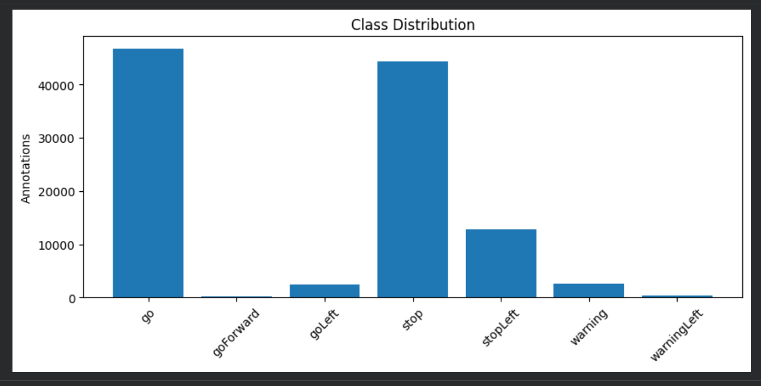

Another important consideration was dataset scale and diversity. Early experiments conducted on a smaller subset of approximately 500 images resulted in overly optimistic performance due to limited variation. Expanding the dataset to over 30,000 images significantly improved diversity and reduced the risk of overfitting. As shown in Figure 1.2, most images contain between 2–4 annotated objects, indicating moderate scene complexity.

Fig 1.2
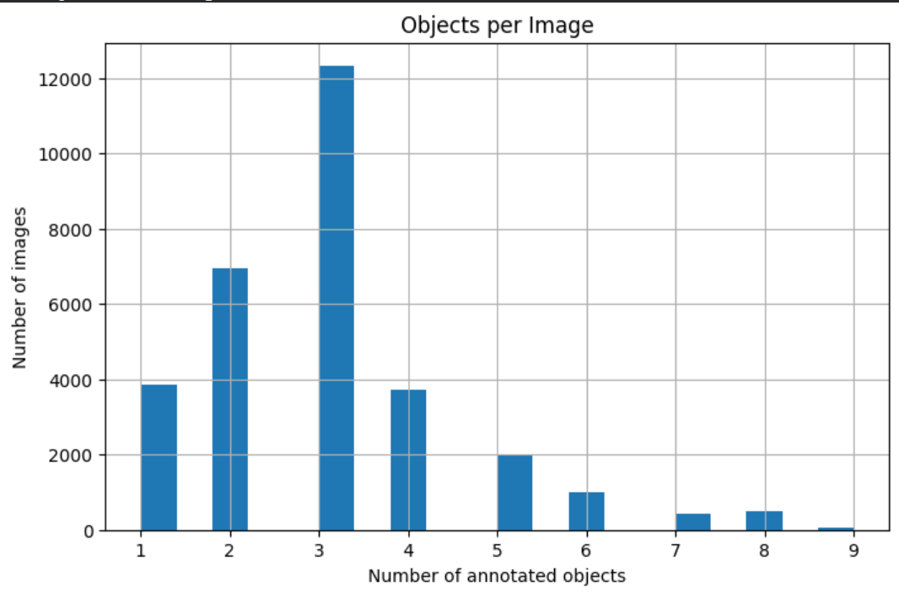

The dataset also exhibits substantial variability in real-world conditions, including differences in lighting, object distance, occlusions, motion blur, and perspective distortion. These factors increase detection complexity but also improve the model’s robustness when handled appropriately. To address these challenges and improve generalization, data augmentation techniques were applied during training. These included random scaling, horizontal flipping, color space adjustments using HSV augmentation, and mosaic augmentation, all of which are commonly used in object detection tasks to improve robustness under varying environmental conditions. Fig 1.3 shows the output after applying the mentioned techniques.

Fig 1.3
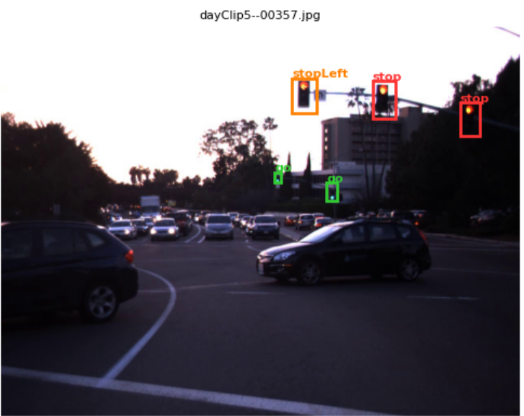

The goal of the project is to develop a real-time traffic sign and blind spot detection system capable of identifying and localizing traffic signs and blind spots in video streams from a vehicle-mounted camera. The dataset variables directly support this objective: Image frames serve as the input data for the detection model. Bounding box coordinates provide supervision for object localization. Traffic sign categories serve as classification labels that allow the model to distinguish between different types of signs.
Exploratory analysis revealed several patterns in the dataset. Larger traffic signals that appear closer to the camera are generally easier for the model to detect, while smaller and more distant signals present greater challenges. Additionally, rare classes are more likely to be underrepresented in predictions if not explicitly addressed during training. These observations informed the use of oversampling and augmentation strategies.

Relationships between variables also play an important role in model performance. Classes with higher frequency in the dataset tend to achieve better detection accuracy, as the model has more examples to learn from. In contrast, rare classes are more difficult to detect due to limited training data.

Bounding box size is another important factor influencing detection performance. Larger bounding boxes typically correspond to nearby objects and are easier to detect, while smaller bounding boxes represent distant objects that are more challenging for the model. This relationship affects how the model learns spatial features across different scales.

Literature Review

This section of your final report should give background information about your project application/research question and the machine learning method(s) that you have chosen to use. This section should be completely focused on existing work, rather than on your own methods and choices. For example, instead of writing “We chose method x for application y because it has benefit z”, you would write “(Citation) developed method x for application y and found that it had benefit z”. Then, you can reference this shown benefit when you introduce your own methods in the next section.

The reader should be able to answer the following questions:
- What other methods/technologies exist that attempt to solve the same problem/answer the same question that your project will address? This can include academic research or commercial projects.
- How was your machine learning method/system developed and what are its benefits (especially those relevant to your project)?
- What existing work demonstrates that these method(s) are appropriate (or particularly well-suited) to use in your project?
- What are some examples of similar projects that use the method(s) that you have chosen? Again, you can include either academic research or commercial projects.

Problem background
Real-time perception of road environments is a critical component of autonomous driving platforms. These systems must accurately detect and classify objects such as vehicles, pedestrians, and traffic signals from continuous video streams captured by vehicle-mounted cameras. Reliable detection enables applications such as collision avoidance, blind spot monitoring, and traffic signal awareness.

Existing Methods and Technologies
Object detection in road environments has been extensively studied, with modern approaches increasingly emphasizing real-time performance for applications such as autonomous driving and advanced driver assistance systems. YOLO (You Only Look Once) has emerged as one of the most widely adopted object detection frameworks due to its ability to perform object localization and classification in a single forward pass, enabling high-speed inference while maintaining competitive accuracy (Redmon et al., 2016). Its architecture, which combines feature extraction, multi-scale representation, and detection into a unified model, makes it particularly well-suited for dynamic driving scenarios where objects appear at varying distances and scales.
In parallel, NVIDIA DeepStream has been developed as a high-performance streaming analytics platform that enables efficient deployment of deep learning models on edge devices such as Jetson systems. DeepStream integrates video ingestion, inference, and visualization into a unified pipeline, allowing multiple models to run in parallel and process live video streams with low latency (NVIDIA, 2023). Together, YOLO-based detection models and DeepStream deployment frameworks form the foundation of many real-time perception systems used in modern intelligent transportation and edge-based vision applications.

YOLO-Based Detection Systems
The YOLO family of models has evolved significantly, with newer versions such as YOLOv5 and YOLOv8 introducing improved architectures for feature extraction, multi-scale detection, and training stability. YOLOv8 follows a one-stage detection architecture that includes a feature extraction component, a feature aggregation layer that combines information across multiple scales, and a detection component that predicts bounding boxes and class probabilities. This architecture is particularly effective for detecting objects of varying sizes, which is important in road scenes where objects may appear at different distances. Prior research has shown that YOLO-based models achieve strong performance in real-time object detection tasks, including traffic object detection, pedestrian detection, and autonomous driving perception systems.

Multi-Model Perception Systems
In real time applications, many systems adopt a modular multi-model approach rather than relying on a single unified detector. For instance, autonomous driving systems often use one model for general object detection (vehicles, pedestrians) and another specialized model for traffic signals or signs. This modular design improves performance because each model can be trained on a dataset specifically tailored to its task. Studies have shown that specialized models trained on domain-specific datasets outperform generalized models when detecting fine-grained categories such as traffic signal states.
Platforms such as NVIDIA DeepStream support parallel inference pipelines, allowing multiple models to run simultaneously and combine their outputs into a unified perception layer. DeepStream provides a high-performance pipeline for video ingestion, inference, and visualization, enabling deployment of deep learning models in embedded and automotive environments (NVIDIA, 2023).

Traffic Signal Detection

Traffic signal detection presents unique challenges due to small object size, varying lighting conditions and signal state classification such stop, go etc.
Datasets such as the LISA Traffic Sign Dataset have been developed specifically to address this problem by providing annotated traffic signal states in real-world driving conditions. Research using LISA and similar datasets has demonstrated that object detection models can effectively classify traffic signal states when trained on sufficiently diverse data and when augmentation techniques are applied to improve generalization.

Handling Class Imbalance and Data Variability

Class imbalance is a well-known challenge in object detection tasks, particularly when certain classes appear far less frequently than others. Prior research has explored several techniques to address this issue, including oversampling underrepresented classes, applying data augmentation, and using weighted loss functions to reduce bias toward dominant classes. These approaches have been shown to improve detection performance for rare classes while maintaining overall model accuracy.

In addition to class imbalance, variability in real-world data presents further challenges for detection models. Data augmentation techniques such as scaling, horizontal flipping, color adjustments, and mosaic augmentation are commonly used to improve robustness under varying environmental conditions. These methods help models generalize better to differences in lighting, object scale, and perspective, which are common in autonomous driving datasets.

Similar Applications and Systems
Several real-world and research systems use similar approaches. For example, Autonomous driving perception systems use YOLO or similar detectors for real-time object detection. Blind spot detection systems rely on vehicle detection models trained on datasets like COCO or BDD100K. Traffic signal recognition systems use specialized datasets like LISA to classify signal states. These systems often combine multiple detection models into a single pipeline demonstrating the effectiveness of a modular approach for complex perception tasks.

Existing research and commercial systems indicate that YOLO-based object detection models, when combined with modular multi-model architectures, are effective for real-time perception in driving environments. The use of specialized datasets for different object categories, along with data augmentation and class imbalance handling techniques, has been shown to enhance detection accuracy and improve robustness under real-world conditions.

Methodology
This section of your final report should describe the final model architecture or pipeline choices that you have made, as well as the training and optimization procedures that you follow. Training results should be saved for the Results section of the paper—any discussion of modeling iterations and optimization should be brief, without any mention of the resulting performance. For example: “During model optimization, we explored hyperparameters a, b, and c with values [d,e,f], [g,h,i], and [j,k,l], respectively. Our final model architecture was...” If the comparative results over your hyperparameter search are interesting enough to be included, these should be discussed in the results section.
The reader should be able to answer the following questions after reading your methodology:
What type of machine learning model(s) are you using?
- What are the notable architectural or system design choices that you have made and why? E.g., number of nodes, hidden layers, activation functions, etc.
- What is your model training procedure or machine learning pipeline? E.g., How did you split your data? How many epochs/iterations did you use during training? What was your batch size? What loss function/training metrics were used?
- How did you optimize your model? E.g., Which hyperparameters and/or architectural elements did you adjust?

Model Architecture and System Design

The system uses a YOLOv8-based object detection model for traffic signal detection, combined with a modular multi-model architecture for real-time perception (Jocher et al., 2023; Redmon et al., 2016). YOLOv8 is a one-stage detection model that performs object localization and classification in a single forward pass, making it suitable for real-time applications where low inference latency is critical (Jocher et al., 2023; Yaseen, 2024). The architecture consists of a CSPNet-based backbone for feature extraction, a multi-scale feature aggregation stage using a feature pyramid network with path aggregation network neck, and a decoupled detection layer that independently predicts bounding boxes and class probabilities (Jocher et al., 2023; Yaseen, 2024). This architecture is particularly effective for detecting objects at varying distances and scales, a common challenge in real-world driving environments where traffic signs may appear at different sizes depending on proximity (Møgelmose et al., 2012; Yaseen, 2024).

In addition to the traffic signal detection model, a separate pretrained YOLOv8n model trained on the Microsoft COCO dataset (Lin et al., 2014), which contains 80 object categories across 330,000 images, was deployed in parallel for general object detection, including vehicles and pedestrians. This design choice allows each model to specialize in its respective task, improving overall system performance and flexibility (Jocher et al., 2023; Yaseen, 2024). Both models are deployed within an NVIDIA DeepStream pipeline, which enables parallel inference and combines outputs into a unified perception layer for visualization (NVIDIA, 2023; Jeong et al., 2022).

Training Procedure and Pipeline

The traffic signal detection model was trained using the LISA dataset, which contains annotated traffic signal states. The dataset was preprocessed and converted into YOLO format, and then split into training and validation sets to support model evaluation during training.

To improve generalization, data augmentation techniques were applied during training. These included scaling, horizontal flipping, color space adjustments using HSV augmentation, and mosaic augmentation. These transformations introduce variability in object appearance and positioning, helping the model learn robust feature representations.

The initial training phase was conducted on a subset of 500 images using 100 epochs, a batch size of 64, an image size of 640, and a learning rate of 0.01. This setup provided a baseline model but was limited to a smaller set of dominant classes. The model was subsequently fine-tuned using the full dataset after applying an oversampling strategy to address class imbalance. The final training configuration used 50 epochs, a batch size of 64, an image size of 640, and a reduced learning rate of 0.001 to support stable convergence across all classes.

Training was performed over multiple epochs using mini-batch gradient descent. Key training parameters included a fixed image size, a defined batch size, and a specified number of training epochs. The model was trained using standard YOLO loss functions, which combine bounding box regression, classification, and distribution focal loss components.

Training Procedure and Pipeline

The traffic signal detection model was trained using the LISA Traffic Sign Dataset (Møgelmose et al., 2012), which contains annotated traffic signal states captured from vehicle-mounted cameras in real-world driving conditions. The dataset was preprocessed and converted into YOLO format, and then split into training and validation sets to support model evaluation during training (Jocher et al., 2023; Møgelmose et al., 2012).

To improve generalization, data augmentation techniques were applied during training, including scaling, horizontal flipping, color space adjustments using HSV augmentation, and mosaic augmentation, which composites four images into a single training sample (Jocher et al., 2023; Lee et al., 2023). These transformations introduce variability in object appearance and positioning, helping the model learn robust feature representations that generalize to real-world variability in lighting, object scale, and perspective (Shorten & Khoshgoftaar, 2019; Lee et al., 2023).

The initial training phase was conducted on a subset of 500 images using 100 epochs, a batch size of 64, an image size of 640, and a learning rate of 0.01. This setup provided a baseline model but was limited to a smaller set of dominant classes due to the class imbalance inherent in the LISA dataset (Møgelmose et al., 2012). The model was subsequently fine-tuned using the full dataset after applying an oversampling strategy to address class imbalance. The final training configuration used 50 epochs, a batch size of 64, an image size of 640, and a reduced learning rate of 0.001 to support stable convergence across all classes (Jocher et al., 2023). The model was trained using standard YOLO loss functions, which combine bounding box regression, classification, and distribution focal loss components to jointly optimize localization and classification performance (Jocher et al., 2023; Yaseen, 2024).

Handling Class Imbalance

The LISA dataset exhibits significant class imbalance, with stop and go classes appearing far more frequently than goLeft, warningLeft, and stopLeft (Møgelmose et al., 2012). Class imbalance is a well-documented challenge in object detection tasks, where models trained on skewed distributions tend to develop a prediction bias toward majority classes, reducing detection performance on underrepresented categories (Vargas et al., 2023; Kishanthan & Hevapathige, 2025). To address this, oversampling was applied to images containing underrepresented classes, increasing the frequency of rare classes during training and allowing the model to learn more balanced representations across all categories (Vargas et al., 2023; Kishanthan & Hevapathige, 2025). Oversampling was implemented by duplicating images that contained rare traffic signal classes, ensuring that these examples appeared more frequently in the training data and that gradient updates reflected a more uniform class distribution (Kishanthan & Hevapathige, 2025).

Model Optimization

During model optimization, several hyperparameters were explored to improve training stability and model performance, including the number of training epochs, batch size, learning rate, and data augmentation parameters (Jocher et al., 2023; Yaseen, 2024). Augmentation-related parameters such as scaling, translation, and color adjustments were tuned to better reflect real-world variability in driving environments, following established practices for YOLO-based detection pipelines (Jocher et al., 2023; Lee et al., 2023). Training duration was adjusted to balance convergence and overfitting, with early stopping mechanisms used to prevent unnecessary training beyond convergence (Jocher et al., 2023). The final model configuration reflects a balance between training efficiency and generalization capability suited to the constraints of real-time edge deployment (Jeong et al., 2022; NVIDIA, 2023).

Deployment Pipeline

For deployment, the system is designed to run on an NVIDIA Jetson edge device using the NVIDIA DeepStream SDK (NVIDIA, 2023), which provides a hardware-accelerated streaming analytics framework for real-time video inference on embedded GPU platforms. The trained YOLOv8 traffic signal detection model was exported to ONNX format, converted to a TensorRT inference engine using FP16 half-precision quantization, and integrated into the DeepStream pipeline for real-time inference (Jeong et al., 2022; Shi et al., 2022). In addition, a pretrained YOLOv8 model trained on the COCO dataset was used in parallel to detect general objects such as vehicles and pedestrians (Lin et al., 2014; Jocher et al., 2023).

Both models operate on the same video input stream and perform inference simultaneously within the DeepStream pipeline. The detection outputs from each model are combined into a unified perception layer and rendered through a single heads-up display that overlays bounding boxes, class labels, and confidence scores onto the video stream, enabling real-time visualization of both traffic signals and surrounding objects (NVIDIA, 2023; Fathiazar et al., 2023). This deployment approach enables low-latency inference on edge hardware and supports modular scalability, allowing additional detection models to be incorporated into the system as needed (NVIDIA, 2023; Jeong et al., 2022).

DeepStream Inference Pipeline

The inference pipeline was implemented using NVIDIA DeepStream SDK 7.0 (NVIDIA, 2023), a GStreamer-based streaming analytics framework that provides hardware-accelerated plugins for video ingestion, decoding, inference, and visualization on NVIDIA GPU hardware. Both trained YOLOv8 models were exported from PyTorch to ONNX format and subsequently converted to TensorRT inference engines using FP16 half-precision quantization, which reduces memory footprint and increases throughput without significant loss in detection accuracy (Jeong et al., 2022; Shi et al., 2022). TensorRT engine construction applies layer fusion, kernel auto-tuning, and memory reuse optimizations specific to the target GPU architecture, enabling substantially lower inference latency than standard deep learning framework inference (Jeong et al., 2022; Shi et al., 2022). The pipeline processes video input through a sequential chain of GStreamer elements: a file source feeds into a hardware decoder, frames are batched by the stream multiplexer, passed to the primary inference plugin running the LISA model, then to a parallel inference stage running the COCO model, and finally to the on-screen display plugin for bounding box rendering. Detection metadata is extracted at each inference stage using DeepStream's Python bindings via GStreamer pad probes, which provide access to per-frame bounding box coordinates, class identifiers, and confidence scores without interrupting the pipeline's real-time processing flow (NVIDIA, 2023).

Blind Spot Detection Logic

Blind spot zones were defined geometrically as regions covering the lower 52% of the frame height and the outermost 22% of the frame width on each side, corresponding to the peripheral areas of a forward-facing vehicle camera where lane-adjacent hazards are most likely to appear. For each frame, the center coordinates of every COCO model detection are evaluated against these zone boundaries, and detections falling within the defined regions trigger alert flags propagated downstream to the HUD module (NVIDIA, 2023; Fathiazar et al., 2023). Alert severity is tiered by detection confidence: objects detected with confidence between 0.25 and 0.50 produce a yellow visual indicator, while detections above 0.50 trigger a red alert, reflecting the greater certainty of hazard presence at higher confidence values (Jocher et al., 2023; Yaseen, 2024). A minimum confidence threshold of 0.40 was applied to all COCO model detections to reduce false positives from low-confidence vehicle detections in distant or partially occluded scenes (Jocher et al., 2023; Yaseen, 2024).

Metadata Output and HUD Integration

Per-frame detection results from both models are serialized into a structured JSON payload and transmitted over UDP to port 5055 for consumption by the augmented reality HUD module (NVIDIA, 2023). Each payload includes a schema version, Unix timestamp in milliseconds, frame sequence number, and a list of per-detection records containing the class identifier, confidence score, normalized bounding box coordinates relative to frame dimensions, source camera identifier, frame number, class label, blind spot zone assignment, and originating model identifier. Normalized bounding box coordinates were chosen to decouple the pipeline output from input video resolution, allowing the HUD module to render overlays independently of camera resolution (Fathiazar et al., 2023; NVIDIA, 2023). The HUD module receives these payloads over the live UDP stream and overlays bounding boxes, class labels, confidence scores, blind spot zone indicators, and estimated relative velocity derived from bounding box positional changes across consecutive frames, providing the driver with a real-time augmented view of the surrounding environment (Fathiazar et al., 2023).

Velocity Tracker

The velocity tracker module estimates the relative speed of each detected object by measuring the displacement of bounding box center coordinates between consecutive inference frames. For each tracked detection, the Euclidean distance between the current and previous frame centroid positions is computed and scaled by the pipeline’s inference frame rate to produce a velocity estimate expressed in pixels per second. This raw pixel-space velocity is normalized relative to the frame diagonal to reduce sensitivity to varying object sizes and distances, yielding a dimensionless relative speed index that indicates whether a detected object is approaching, receding, or maintaining a roughly constant distance from the host vehicle.

To improve temporal stability and reduce noise from frame-to-frame bounding box jitter inherent in single-stage detectors, a lightweight exponential moving average filter is applied to each tracked object’s velocity estimate across frames. Objects are associated across frames using a nearest-centroid matching strategy with a maximum displacement threshold, preventing false velocity spikes from spurious detections or brief occlusions. When a tracked object exceeds a configurable velocity index threshold while positioned within a blind spot zone, the alert tier is escalated from the standard confidence-based color coding to a pulsing red indicator, combining positional hazard awareness with dynamic motion context.

The velocity estimates are serialized into the per-frame JSON telemetry payload alongside existing bounding box and classification metadata, and rendered on the HUD overlay as a relative speed label adjacent to each bounding box. While camera-based velocity estimation cannot achieve the absolute accuracy of radar or lidar systems, this approach provides meaningful ordinal motion cues—distinguishing closing, static, and receding objects—without requiring additional sensing hardware, making it a cost-effective enhancement to the overall situational awareness layer (Fathiazar et al., 2023).

Jetson Deployment

For edge deployment, the pipeline was adapted for the NVIDIA Jetson Orin Nano, a compact embedded computing platform with an integrated Ampere GPU designed for real-time AI inference workloads (Jeong et al., 2022; NVIDIA, 2023). The trained ONNX models were converted to Jetson-specific TensorRT engines directly on the device, as TensorRT engines are architecture-specific and cannot be transferred across GPU platforms (Jeong et al., 2022; Shi et al., 2022). The pipeline was modified to accept live video input from a Raspberry Pi Camera Module V2 connected via CSI interface, replacing the file-based input used during development, to support real-time inference from a vehicle-mounted camera during drive testing (NVIDIA, 2023). Tej Singh led the Jetson integration, adapting the pipeline for the edge hardware and validating live inference performance on vehicle-mounted camera feeds (Jeong et al., 2022; NVIDIA, 2023).

Results
This section of your final report should describe how your model/system performed and provide evidence for how your work did or did not support your experimental hypothesis or solve your chosen problem. The reader should be able to answer the following questions:
- How effective was your machine learning model at learning the task? e.g. Did the model overfit/underfit the training data? What does the training accuracy/loss curve look like for your model?
- If your project is focused on answering a research question, what evidence do you have to support or disprove your hypothesis?
- If your project is focused on solving a problem, how will your model performance affect the application of your model to that problem?
- If your project is focused on implementing a complete machine learning system, what is the user experience? Are there any delays or remaining bugs that affect your

model output either in common or edge use cases?

Conclusion
This section of your final report should provide a very brief summary of your entire project. It should highlight the most interesting or significant results and discuss any future work that you or another researcher might do. The reader should be able to answer the following questions:
- What was the main hypothesis or goal of the project, and how did your models perform in relation to this hypothesis/goal?
- What was the most interesting or significant result of your project?
- Did your model training or performance bring about any unexpected results?
- If you were to continue this project, what would your next steps be? For example, would you continue to optimize your model or try other model architectures? Would you change or expand the data used in your model? What steps need to be taken to “productionize” your model?

FORMATTING EXAMPLES
DELETE THIS SECTION BEFORE FINAL SUBMISSION

General Formatting
A formal report of this type should be primarily in paragraph form, with minimal subheadings, bullet points, or numbered lists. For most of your required report sections, no subheadings will be necessary, and the information can be presented as a single, cohesive discussion of the content relevant to that section. As a general rule of thumb, bulleted or numbered lists are only appropriate in this kind of report if the list items are less than one sentence, but are too long/detailed to be presented in a table.
If you feel strongly that your content would benefit from subheadings or bulleted/numbered lists, they should follow the formatting examples used in this section.

In-text Citations
A report of this type should be heavily supported by in-text citations. You should include a new supporting citation in each section for:
- The first time that you mention a specific code library or dataset,
- The first time that you introduce a pre-trained model or model architecture,
- Any information that is not your own original thought/idea, even if you didn't need to look it up.
When in doubt, it is always better to over-cite than to under-cite.
Formatting rules for in-text citations can be found in the APA guidelines, but examples of the three most common uses are discussed in the following paragraphs.
Parenthetical citations at the end of a sentence should be used when the information from the entire sentence comes from the cited source (American Psychological Association, 2025).
Parenthetical citations mid-sentence should be used when only a part of the sentence comes from the cited source, or when you are providing a citation for something specific such as a company, model architecture/method, or technique. See the following examples for a sentence with multiple mid-sentence citations and a sentence with a specific mid-sentence citation below:
  - The transformer model was introduced in 2017 for the application of machine translation (Vaswani et al., 2017) and quickly became the most common backbone for today’s large language

models (Devlin et al., 2019; Radford et al., 2019).
  - As one of the first transformer-based generative text models, OpenAI’s GPT (Radford et al., 2019) quickly became the standard large language architecture used for generative tasks.

Narrative in-text citations can be used when you want to include the name of the author(s) in your main text, as shown in the following example:
Vaswani et al. (2017) originally developed the transformer architecture for the application of machine translation.

Figures, Tables, and Equations
Most of your supporting content should be included in the main text of the report, rather than at the end. While the in-line formatting can be a headache, this makes it easier for your reader to reference your figures and tables while reading, without having to scroll back and forth too much. See Section 7.5 for more details about how to properly use appendices for supplemental information.
    - Figures
Figures should be numbered sequentially below the image and referred to directly in your text (e.g. “As seen in Figure 7.1 [...]”, “Figure 7.1 shows [...]”). If your figure is important enough to include in your report, then it deserves at least one sentence of discussion in the text.
Each figure should also have a corresponding caption that briefly describes the content of the figure and can be used to highlight important details. If your figure is too complex to be limited to a single column width, you can include it as a full-width image at the top of the page.


Figure 7.1
Example text: Model accuracy for our six models during training. The best performing model is shown in red.
    - Tables
Tables should be numbered sequentially above the table and should have an in-text mention and a descriptive caption, like the figure examples given above.
Feel free to improve the default MS Word table formatting shown here for aesthetic appeal (e.g. change cell size, border width, font size, etc.). If you have a favorite table formatting tool (e.g. LaTeX, Pandas pretty print, etc.), feel free to use that and include the output as an image. However, please ensure that the image quality is legible and the formatting generally matches the rest of the report, and DO NOT include screenshots of raw code output—it is not professional to include dark mode or Courier New code output, or screenshots of your console window.
Table 7.1
Example text: Results for all three models over the standard benchmarking metrics. Highlighted cells show the best performance for each metric.

A table is often a better alternative to a bulleted list for communicating information that may

otherwise seem redundant (e.g. variable details or model hyperparameter choices), or to make information easier to compare across categories (e.g. model performance). If you have a very complex table, think about how you might use bold or italic font to highlight notable cells, such as the best performing model.
    - Equations
Think carefully about whether including an equation is appropriate for your semi-technical stakeholder audience—most of the time that level of detail will be too technical, and equations should either be left out or included in a separate appendix.
If you decide that you do want to include an equation, they should be on a separate line, indented, and numbered sequentially to the right of the equation. As with figures and tables, equations should be referenced directly in your text with a short description (e.g. “Equation 7.1 shows the basic linear regression equation, where y is the target variable, x is the model input, a is the learned coefficent, and b is the model intercept.”) You DO NOT need to include a separate caption for your equations.
𝑦 = 𝑎𝑥 + 𝑏 (7.1)
As with tables, if you have a favorite tool for formatting your equations, feel free to include the formatted equation as an image, as long as it matches the formatting shown in the example above.

Works Cited
References should be alphabetically ordered using APA 7 formatting. You can refer to the APA guidelines on how to format citations from different types of sources. There are also online tools that can be used to create citations for you, though these will occasionally produce errors, so be sure to double check these. If you are citing an
academic paper, the Google Scholar listing for the paper will also have a properly formatted APA citation that you can copy into your report. Several example citations are shown in the works cited included in this template.

Appendices
Appendices can be used to include information that you feel is important to the communication of your project but may be too technical or too detailed for the intended semi-technical stakeholder audience. This may include items like a detailed description of data transformations, feature engineering, or architectural choices, or complete results over a hyperparameter grid search or a series of experimental architectures.
Appendices are not included in the page count but should not be used to get around the report page limits. Information included in the appendices should not be necessary for a basic understanding of your project and should instead provide deeper detail for an interested reader. You can assume that your stakeholder audience would not read most of the content in an appendix, and as such, your appendix content may not contribute to your final report grade.
Appendices should be labeled alphabetically (Appendix A, Appendix B, etc.) and should be referred to directly in your text (e.g. “A complete table of results over all hyperparameters can be found in Appendix A”). Each appendix should start on a new page and does not need to be in the two-column format if full page width makes more sense for your content (e.g. detailed figures or large tables).

ACKNOWLEDGMENTS
These are optional, but might mention any external contributors to your project, such as professors or mentors who provided data or consultation.

Works Cited
American Psychological Association. (2025). In-Text Citations. https://apastyle.apa.org/style-grammar-guidelines/citations
Devlin, J., Chang, M. W., Lee, K., & Toutanova,
K. (2019, June). Bert: Pre-training of deep bidirectional transformers for language understanding. In Proceedings of the 2019 conference of the North American chapter of the association for computational linguistics: human language technologies, volume 1 (long and short papers) (pp. 4171-4186).
Radford, A., Wu, J., Child, R., Luan, D., Amodei, D., & Sutskever, I. (2019). Language models are unsupervised multitask learners. OpenAI blog, 1(8), 9.
Vaswani, A., Shazeer, N., Parmar, N., Uszkoreit, J., Jones, L., Gomez, A. N., ... & Polosukhin, I. (2017). Attention is all you need. Advances in neural information processing systems, 30.
Fathiazar, E., Wortelen, B., & Kühl, Y. (2023). Using eye tracking to guide driver's attention on augmented reality windshield display. In H. Krömker (Ed.), HCI in Mobility, Transport, and Automotive Systems. HCII 2023. Lecture Notes in Computer Science (Vol. 14049). Springer. https://doi.org/10.1007/978-3-031-35908-8_2
Jeong, E., Kim, J., & Ha, S. (2022). TensorRT-based framework and optimization methodology for deep learning inference on Jetson boards. ACM Transactions on Embedded Computing Systems, 21, 1–26. https://doi.org/10.1145/3508391
Jocher, G., Chaurasia, A., & Qiu, J. (2023). Ultralytics YOLOv8 (Version 8.0.0) [Software]. Ultralytics. https://github.com/ultralytics/ultralytics
Kishanthan, S., & Hevapathige, A. (2025). Deep learning meets oversampling: A learning framework to handle imbalanced classification. arXiv preprint arXiv:2502.06878. https://arxiv.org/abs/2502.06878
Lee, H., Kang, S., & Chung, K. (2023). Robust data augmentation generative adversarial network for object detection. Sensors, 23(1), 157. https://doi.org/10.3390/s23010157
Lin, T.-Y., Maire, M., Belongie, S., Hays, J., Perona, P., Ramanan, D., Dollár, P., & Zitnick, C. L. (2014). Microsoft COCO: Common objects in context. In D. Fleet et al. (Eds.), Computer Vision – ECCV 2014. Lecture Notes in Computer Science (Vol. 8693, pp. 740–755). Springer. https://doi.org/10.1007/978-3-319-10602-1_48
Møgelmose, A., Trivedi, M. M., & Moeslund, T. B. (2012). Vision-based traffic sign detection and analysis for intelligent driver assistance systems: Perspectives and survey. IEEE Transactions on Intelligent Transportation Systems, 13(4), 1484–1497. https://doi.org/10.1109/TITS.2012.2209421
NVIDIA. (2023). DeepStream SDK developer guide. NVIDIA Corporation. https://docs.nvidia.com/metropolis/deepstream/dev-guide/
Redmon, J., Divvala, S., Girshick, R., & Farhadi, A. (2016). You only look once: Unified, real-time object detection. Proceedings of the IEEE Conference on Computer Vision and Pattern Recognition, 779–788.
Shi, Y., et al. (2022). Accelerating native inference model performance in edge devices using TensorRT. IEEE Conference on Embedded Systems. https://ieeexplore.ieee.org/document/10690032/
Shorten, C., & Khoshgoftaar, T. M. (2019). A survey on image data augmentation for deep learning. Journal of Big Data, 6(1), 60. https://doi.org/10.1186/s40537-019-0197-0
Vargas, V. W., Aranda, J. A. S., Costa, R. S., Pereira, P. R. S., & Barbosa, J. L. V. (2023). Imbalanced data preprocessing techniques for machine learning: A systematic mapping study. Knowledge and Information Systems, 65(1), 31–57. https://doi.org/10.1007/s10115-022-01772-8
Yaseen, M. (2024). What is YOLOv8: An in-depth exploration of the internal features of the next-generation object detector. arXiv preprint arXiv:2408.15857. https://arxiv.org/abs/2408.15857

