AksharabyasaAI

Knowledge Transfer (KT) Document
Version: 1.0
Project Name: AksharabyasaAI – AI-Powered Adaptive Literacy & Handwriting Learning Platform

Table of Contents

Chapter 1 – Introduction
Section | Title | Page No.
1.1 | Purpose of the Document
1.2 | Project Overview
1.3 | Objectives
1.4 | Scope
1.5 | Intended Audience
1.6 | Document Organization

Chapter 2 – Project Overview
Section | Title | Page No.
2.1 | Introduction
2.2 | Background
2.3 | Problem Statement
2.4 | Project Objectives
2.5 | Target Users
2.6 | Project Scope
2.7 | Key Features
2.8 | Expected Outcomes

Chapter 3 – Functional & Non-Functional Requirements
Section | Title | Page No.
3.1 | Introduction
3.2 | Functional Requirements
3.3 | Non-Functional Requirements
3.4 | System Constraints
3.5 | Assumptions
3.6 | Dependencies

Chapter 4 – System Architecture
Section | Title | Page No.
4.1 | Introduction
4.2 | High-Level Architecture
4.3 | Architectural Layers
4.4 | Presentation Layer
4.5 | API Layer
4.6 | Business Logic Layer
4.7 | AI & Machine Learning Layer
4.8 | Database Layer
4.9 | Infrastructure Layer
4.10 | Data Flow
4.11 | Request Processing Workflow
4.12 | Architectural Advantages

Chapter 5 – Technology Stack
Section | Title | Page No.
5.1 | Introduction
5.2 | Overall Technology Stack
5.3 | Frontend Technologies
5.4 | Backend Technologies
5.5 | Database Technologies
5.6 | Artificial Intelligence & Machine Learning
5.7 | Authentication
5.8 | API Communication
5.9 | Deployment Technologies
5.10 | Development Tools
5.11 | Advantages of Technology Stack

Chapter 6 – Source Code Structure
Section | Title | Page No.
6.1 | Introduction
6.2 | Project Directory Structure
6.3 | Backend Source Code
6.4 | Frontend Source Code
6.5 | Database Migration
6.6 | Configuration Files
6.7 | Audio Resources
6.8 | Datasets
6.9 | Documentation
6.10 | Scripts
6.11 | Testing Directory
6.12 | Root-Level Files
6.13 | Coding Standards

Chapter 7 – Backend Module Design
Section | Title | Page No.
7.1 | Introduction
7.2 | Backend Architecture
7.3 | Authentication Module
7.4 | Session Management Module
7.5 | Studio Module
7.6 | Analytics Module
7.7 | Recommendation Module
7.8 | AI/ML Module
7.9 | Audio Module
7.10 | Database Layer
7.11 | Error Handling
7.12 | Logging
7.13 | Backend Request Lifecycle
7.14 | Backend Design Principles
7.15 | Advantages

Chapter 8 – Database Design
Section | Title | Page No.
8.1 | Introduction
8.2 | Database Architecture
8.3 | Database Technologies
8.4 | Entity Relationship Overview
8.5 | Table Design
8.6 | Relationships
8.7 | Database Normalization
8.8 | Constraints
8.9 | Database Migration
8.10 | Database Security
8.11 | Database Advantages

Chapter 9 – REST API Documentation
Section | Title | Page No.
9.1 | Introduction
9.2 | API Architecture
9.3 | Authentication APIs
9.4 | Session APIs
9.5 | Studio APIs
9.6 | Analytics APIs
9.7 | Recommendation APIs
9.8 | Response Format
9.9 | Authentication
9.10 | HTTP Status Codes
9.11 | API Testing
9.12 | API Best Practices

Chapter 10 – AI & Machine Learning Pipeline
Section | Title | Page No.
10.1 | Introduction
10.2 | AI/ML Architecture
10.3 | AI Components
10.4 | AI Workflow
10.5 | Recommendation Engine
10.6 | Analytics Integration
10.7 | AI Libraries Used
10.8 | Model Deployment
10.9 | Advantages
10.10 | Future Enhancements

Chapter 11 – Installation & Setup Guide
Section | Title | Page No.
11.1 | Introduction
11.2 | System Requirements
11.3 | Repository Setup
11.4 | Backend Installation
11.5 | Frontend Installation
11.6 | Database Configuration
11.7 | Environment Variables
11.8 | Database Migration
11.9 | Running the Backend
11.10 | Running the Frontend
11.11 | Project Startup Sequence
11.12 | Troubleshooting
11.13 | Verification

Chapter 12 – User Manual
Section | Title | Page No.
12.1 | Introduction
12.2 | User Roles
12.3 | Application Workflow
12.4 | Registration
12.5 | Login
12.6 | Dashboard
12.7 | Practice Module
12.8 | Studio
12.9 | Analytics Dashboard
12.10 | Recommendation Module
12.11 | User Profile
12.12 | Logout
12.13 | Common User Scenarios
12.14 | FAQ
12.15 | Best Practices

Chapter 13 – Testing & Validation
Section | Title | Page No.
13.1 | Introduction
13.2 | Testing Strategy
13.3 | Functional Testing
13.4 | API Testing
13.5 | Database Testing
13.6 | Frontend Testing
13.7 | AI/ML Validation
13.8 | Integration Testing
13.9 | Performance Validation
13.10 | Test Environment
13.11 | Validation Summary

Chapter 14 – Known Issues & Future Enhancements
Section | Title | Page No.
14.1 | Introduction
14.2 | Known Issues
14.3 | Future Enhancements
14.4 | Scalability Recommendations

Chapter 15 – Lessons Learned & Recommendations
Section | Title | Page No.
15.1 | Introduction
15.2 | Lessons Learned
15.3 | Recommendations
15.4 | Best Practices for Future Developers
15.5 | Project Outcomes
15.6 | Final Conclusion

Chapter 1 – Introduction

1.1 Purpose of this Document
This Knowledge Transfer (KT) document provides a comprehensive technical and functional overview of the AksharabyasaAI project. Its primary objective is to enable developers, testers, project managers, mentors, and future contributors to understand, operate, maintain, and extend the system with minimal dependency on the original development team.
The document consolidates all essential information related to the project, including business objectives, software architecture, technology stack, source code organization, database design, API documentation, deployment process, AI/ML pipeline, testing strategy, and future enhancement plans.
This KT document serves as the primary technical reference for project handover and long-term maintenance.

1.2 Project Overview
AksharabyasaAI is an AI-powered adaptive literacy and handwriting learning platform designed to improve children's handwriting quality, literacy development, motor coordination, and learning confidence through intelligent educational technologies.
Unlike traditional handwriting applications that simply evaluate whether a letter is written correctly, AksharabyasaAI focuses on understanding the learner's complete educational journey by analyzing behavioral patterns, emotional responses, handwriting characteristics, and long-term learning progress.
The platform integrates Artificial Intelligence, Machine Learning, Behavioral Analytics, Real-Time Guidance, Adaptive Curriculum Planning, Emotional Coaching, and Educational Analytics into a unified learning ecosystem.
The system evolved from a standalone handwriting analysis tool into a full-stack educational intelligence platform capable of supporting personalized learning experiences and scalable educational deployments.

1.3 Objectives
The primary objectives of the project are:
- Improve handwriting quality through real-time tracing assistance.
- Support literacy development using structured educational activities.
- Deliver personalized learning experiences based on learner behavior.
- Track long-term learning progress and mastery.
- Provide meaningful insights to parents and educators.
- Generate educational telemetry for AI-driven recommendations.
- Build a scalable, modular, production-ready architecture.

1.4 Scope of the Project
The current implementation includes:

Frontend
- Interactive handwriting practice interface
- Guided tracing canvas
- Free-writing canvas
- Analytics dashboard
- Adaptive user interface
- Audio-assisted learning

Backend
- Secure user authentication
- Session lifecycle management
- Analytics engine
- Recommendation engine
- AI inference services
- Curriculum orchestration
- REST API services

Database
- User management
- Practice sessions
- Free-writing sessions
- Learning analytics
- Recommendation feedback
- Educational telemetry

AI/ML
- Handwriting feature analysis
- Behavioral analytics
- Recommendation generation
- Confidence estimation
- Performance prediction

1.5 Intended Audience
This document is intended for:
- Software Developers
- Backend Engineers
- Frontend Engineers
- Database Administrators
- QA Engineers
- AI/ML Engineers
- Project Maintainers
- Mentors and Reviewers
- Future Development Teams

1.6 Document Structure
This KT document is organized into the following chapters:
- Introduction
- Project Overview
- Business Requirements
- Functional & Non-Functional Requirements
- System Architecture
- Technology Stack
- Source Code Structure
- Module-wise Design
- Database Design
- API Documentation
- Installation & Setup Guide
- Deployment Guide
- AI & Machine Learning Pipeline
- Testing & Validation
- User Manual
- Known Issues
- Future Enhancements
- Lessons Learned
- Appendix

Chapter 2 – Project Overview

2.1 Introduction
AksharabyasaAI is an AI-powered adaptive literacy and handwriting learning platform designed to transform conventional handwriting education into an intelligent, personalized, and engaging learning experience.
Traditional handwriting learning applications primarily focus on evaluating whether a learner has written a character correctly. Such systems often fail to understand the learner's behavior, emotional state, confidence level, or long-term educational progress.
AksharabyasaAI addresses these limitations by combining Artificial Intelligence (AI), Machine Learning (ML), Behavioral Analytics, Real-Time Guidance, Adaptive Curriculum Management, and Educational Intelligence into a unified educational ecosystem.
The platform enables children to receive immediate handwriting guidance while simultaneously collecting educational telemetry that allows the system to personalize future learning sessions and provide meaningful progress insights to parents.

2.2 Background
The project originated as a handwriting analysis application intended to evaluate tracing accuracy.
During development, the project evolved significantly into a complete adaptive learning platform capable of:
- Real-time handwriting guidance
- Personalized learning experiences
- Behavioral analytics
- Emotional coaching
- Curriculum progression
- Parent analytics dashboard
- Recommendation engine
- Free-writing intelligence
- Audio-assisted literacy learning
This transformation enabled the platform to support continuous educational growth rather than evaluating isolated handwriting exercises.

2.3 Problem Statement
Traditional handwriting learning systems suffer from several limitations that reduce learner engagement and educational effectiveness.

Educational Challenges
- Delayed or no real-time handwriting feedback.
- Static worksheets that cannot adapt to individual learning styles.
- Lack of behavioral understanding during learning.
- Limited motivation and learner engagement.
- Absence of long-term progress tracking.

Technical Challenges
- Minimal personalization.
- No adaptive recommendation system.
- Lack of emotional learning support.
- Limited analytics for parents and educators.
- No structured educational telemetry for future AI improvements.
These limitations create learning environments that focus primarily on correctness rather than helping learners improve through guided practice and personalized educational experiences.

2.4 Project Objectives
The primary objectives of AksharabyasaAI are:

Educational Objectives
- Improve handwriting quality through intelligent tracing assistance.
- Develop literacy skills using structured educational content.
- Encourage learner confidence through adaptive coaching.
- Reduce frustration by providing supportive real-time guidance.
- Build long-term mastery through curriculum progression.

Technical Objectives
- Design a scalable full-stack educational platform.
- Implement secure authentication and user management.
- Maintain persistent educational data using PostgreSQL.
- Provide real-time analytics and reporting.
- Support AI-driven recommendations.
- Enable future expansion with modular architecture.

2.5 Target Users
The platform serves multiple categories of users.

Early Learners (3–6 Years)
Primary requirements:
- Guided tracing
- Visual assistance
- Audio coaching
- Positive reinforcement
- Simplified user interface

School-Age Children (6–12 Years)
Primary requirements:
- Letter and word practice
- Adaptive difficulty
- Literacy progression
- Skill mastery
- Personalized recommendations

Parents
Primary requirements:
- Progress monitoring
- Learning analytics
- Engagement insights
- Behavioral understanding
- Educational recommendations

Teachers (Future Expansion)
Future capabilities include:
- Classroom analytics
- Student performance monitoring
- Curriculum tracking
- Learning intervention recommendations

2.6 Project Scope
The current implementation covers the following functional areas.

Frontend
- User Authentication
- Dashboard
- Guided Practice
- Free Writing Interface
- Analytics Dashboard
- Recommendation Display
- Responsive User Interface

Backend
- REST APIs
- JWT Authentication
- Session Management
- Recommendation Engine
- Analytics Engine
- Curriculum Management
- AI Integration
- Audio Services

Database
- User Management
- Practice Sessions
- Free Writing Sessions
- Educational Analytics
- Recommendation Feedback
- Learning Metadata

Artificial Intelligence
- Handwriting Analysis
- Behavioral Analytics
- Recommendation Generation
- Learning Profile Detection
- Confidence Evaluation

2.7 Key Features
The major features implemented in the system include:
- Secure user registration and authentication.
- Adaptive handwriting practice sessions.
- Real-time handwriting guidance.
- Free-writing analysis.
- Audio-assisted literacy learning.
- Recommendation engine.
- Behavioral analytics.
- Educational dashboard.
- Progress tracking.
- Curriculum progression.
- Learning history.
- Personalized user experience.

2.8 Expected Outcomes
Upon successful deployment, the system is expected to:
- Improve handwriting accuracy.
- Enhance learner engagement.
- Increase literacy confidence.
- Provide actionable educational insights.
- Support adaptive personalized learning.
- Enable scalable educational deployments.
- Generate educational data for future AI enhancements.

Chapter 3 – Functional and Non-Functional Requirements

3.1 Introduction
This chapter defines the functional and non-functional requirements of the AksharabyasaAI platform. Functional requirements describe the services and capabilities provided by the system, while non-functional requirements specify the performance, security, scalability, reliability, and usability characteristics that the platform must satisfy.
These requirements serve as the foundation for system design, implementation, testing, and future enhancements.

3.2 Functional Requirements
The AksharabyasaAI platform is divided into multiple functional modules. Each module provides a specific set of services to support adaptive literacy learning.

3.2.1 User Authentication Module

Description
The authentication module manages user registration, login, authorization, and profile management while ensuring secure access to system resources.

Functional Requirements
The system shall:
- Allow new users to register.
- Validate email uniqueness before registration.
- Store passwords securely using hashing algorithms.
- Authenticate registered users.
- Generate JWT access tokens after successful login.
- Protect secured APIs using token-based authentication.
- Allow users to update their profile information.
- Support multiple learner profiles.

3.2.2 User Profile Management

Description
This module maintains learner information and educational preferences.

Functional Requirements
The system shall:
- Store learner profile information.
- Maintain preferred learning mode.
- Maintain preferred language.
- Track learner level.
- Store experience points (XP).
- Maintain learning streaks.
- Support parent-child association.
- Generate adaptive UI configuration.

3.2.3 Practice Session Module

Description
This module manages guided handwriting practice sessions.

Functional Requirements
The system shall:
- Start new handwriting practice sessions.
- Retrieve educational content.
- Capture handwriting strokes.
- Record guidance events.
- Store session results.
- Support session completion.
- Support session abandonment.
- Maintain complete session history.

3.2.4 Free Writing Module

Description
Provides unrestricted handwriting practice without predefined tracing paths.

Functional Requirements
The system shall:
- Allow unrestricted handwriting.
- Capture handwriting telemetry.
- Generate writing thumbnails.
- Store free-writing sessions.
- Analyze writing confidence.
- Evaluate handwriting smoothness.
- Record behavioral metrics.

3.2.5 Real-Time Guidance Module

Description
Provides intelligent visual assistance while learners practice handwriting.

Functional Requirements
The system shall:
- Detect tracing deviations.
- Detect incorrect stroke direction.
- Display real-time guidance.
- Trigger contextual hints.
- Provide ghost replay demonstrations.
- Monitor learner hesitation.
- Adapt guidance intensity dynamically.

3.2.6 Analytics Module

Description
Processes educational data and generates meaningful learning insights.

Functional Requirements
The system shall:
- Generate learner progress reports.
- Calculate engagement metrics.
- Track learner streaks.
- Analyze confidence trends.
- Identify learning difficulties.
- Generate educational insights.
- Provide dashboard statistics.
- Maintain historical learning data.

3.2.7 Recommendation Engine

Description
Provides personalized educational recommendations based on learner performance.

Functional Requirements
The system shall:
- Analyze learner behavior.
- Detect learning styles.
- Recommend suitable practice sessions.
- Suggest adaptive difficulty levels.
- Collect recommendation feedback.
- Improve recommendations over time.

3.2.8 Curriculum Management

Description
Manages educational progression using adaptive learning principles.

Functional Requirements
The system shall:
- Organize learning content.
- Enforce prerequisite relationships.
- Unlock new skills.
- Track learner mastery.
- Schedule spaced repetition.
- Prevent premature advancement.

3.2.9 Audio Assistance Module

Description
Supports pronunciation and coaching audio.

Functional Requirements
The system shall:
- Generate pronunciation audio.
- Play coaching messages.
- Cache generated audio.
- Control playback sequencing.
- Prevent overlapping audio.
- Support adaptive coaching.

3.2.10 Dashboard Module

Description
Provides visual analytics for learners and parents.

Functional Requirements
The system shall display:
- Progress statistics.
- Learning trends.
- Engagement metrics.
- Recommendation cards.
- Confidence indicators.
- Session history.
- Module-wise performance.
- Achievement summaries.

3.3 Non-Functional Requirements
Non-functional requirements define the operational characteristics of the system.

3.3.1 Performance Requirements
The system shall:
- Provide real-time handwriting guidance with minimal latency.
- Respond to standard API requests within acceptable response times.
- Support smooth canvas interactions.
- Handle concurrent user requests efficiently.
- Minimize frontend rendering delays.

3.3.2 Reliability Requirements
The system shall:
- Maintain data consistency.
- Recover gracefully from failures.
- Prevent duplicate session creation.
- Preserve educational records.
- Ensure stable analytics generation.

3.3.3 Security Requirements
The system shall:
- Use JWT-based authentication.
- Hash user passwords securely.
- Validate all user inputs.
- Prevent unauthorized API access.
- Protect sensitive educational data.
- Restrict access to authenticated users only.

3.3.4 Scalability Requirements
The architecture shall support:
- Additional educational modules.
- Teacher dashboards.
- Classroom analytics.
- Larger user populations.
- Future AI model upgrades.
- Cloud deployment.

3.3.5 Maintainability Requirements
The system shall:
- Follow modular architecture.
- Maintain separation of concerns.
- Use reusable service components.
- Support future feature extensions.
- Maintain clear API interfaces.
- Support database migrations.

3.3.6 Availability Requirements
The platform shall:
- Support continuous operation.
- Minimize downtime during deployment.
- Maintain database availability.
- Recover after service interruptions.

3.3.7 Usability Requirements
The user interface shall:
- Be responsive across supported devices.
- Provide intuitive navigation.
- Minimize cognitive load.
- Offer child-friendly interactions.
- Present educational information clearly.

3.4 System Constraints
The current implementation operates under the following constraints:

Technical Constraints
- Browser-based handwriting input.
- Dependency on PostgreSQL database.
- Internet connectivity required for backend services.
- JWT-based authentication mechanism.
- Modern web browser compatibility.

Product Constraints
- OCR-based handwriting evaluation is not included in the current release.
- Teacher dashboard functionality is planned for future releases.
- Classroom deployment features are currently outside the project scope.
- Multilingual curriculum support is limited.

3.5 Assumptions
The following assumptions were considered during development:
- Users have internet connectivity.
- Learners primarily use tablets or touch-enabled devices.
- PostgreSQL is available for persistent storage.
- Audio playback is supported by the client device.
- AI models are available before backend startup.

3.6 Dependencies
The successful operation of the platform depends on:

Backend
- FastAPI
- SQLAlchemy
- Alembic
- Pydantic
- JWT Authentication

Frontend
- React
- TypeScript
- Vite
- Tailwind CSS
- Axios

Database
- PostgreSQL

AI/ML
- OpenCV
- XGBoost
- Joblib

Infrastructure
- Docker
- Docker Compose
- Nginx

Chapter 4 – System Architecture

4.1 Introduction
The AksharabyasaAI platform follows a modular, layered architecture that separates presentation, business logic, artificial intelligence, and data persistence into independent components. This architectural approach improves maintainability, scalability, testability, and future extensibility.
The application is implemented as a full-stack web platform where the frontend communicates with the backend through REST APIs. The backend orchestrates business workflows, AI/ML services, analytics processing, and database operations. PostgreSQL serves as the primary persistent data store, while AI models provide intelligent handwriting analysis and adaptive educational recommendations.

4.2 High-Level Architecture
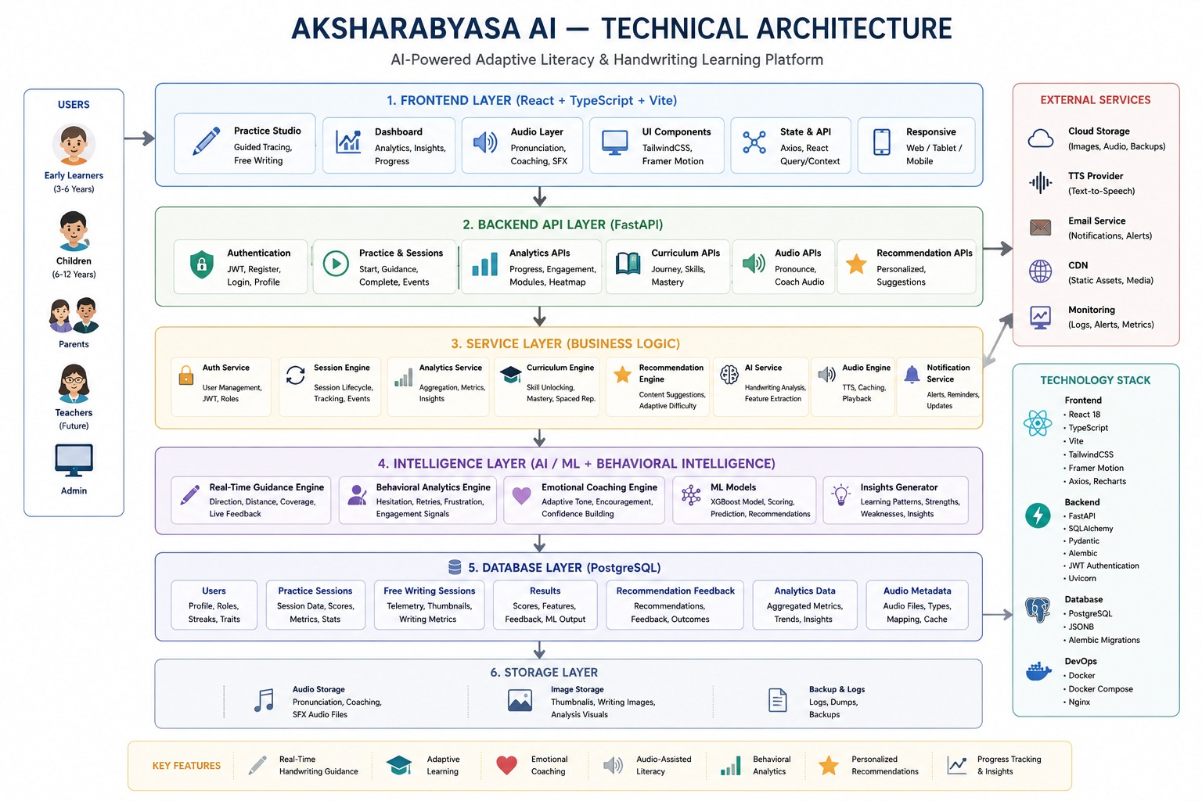
The overall architecture of AksharabyasaAI is shown below.

4.3 Architectural Layers
The application consists of six major architectural layers.
- Presentation Layer
- API Layer
- Business Logic Layer
- AI & Analytics Layer
- Database Layer
- Infrastructure Layer
Each layer is explained below.

4.4 Presentation Layer

Purpose
The Presentation Layer provides the graphical user interface through which learners and parents interact with the system.

Technology Stack
- React
- Vite
- TypeScript
- Tailwind CSS
- Axios
- Recharts
- Framer Motion

Responsibilities
The frontend is responsible for:
- User authentication
- Dashboard rendering
- Practice canvas
- Free-writing interface
- Stroke capture
- API communication
- Recommendation display
- Analytics visualization
- Audio playback
- Responsive user interface
The frontend performs lightweight validation and delegates all business logic to the backend.

4.5 API Layer

Purpose
The API Layer acts as the communication gateway between the frontend and backend.

Technology
- FastAPI
- REST APIs
- Pydantic Validation

Responsibilities
The API layer:
- Receives HTTP requests
- Validates request data
- Authenticates users
- Calls appropriate services
- Returns JSON responses
- Handles exceptions
- Manages API versioning
Major API groups include:
- Authentication APIs
- Session APIs
- Analytics APIs
- Recommendation APIs
- Audio APIs
- Curriculum APIs

4.6 Business Logic Layer

Purpose
The Business Logic Layer contains the core application logic and coordinates interactions between services.

Core Services

Authentication Service
Responsible for:
- User registration
- User login
- Password hashing
- JWT generation
- Token validation
- Profile management

Session Service
Responsible for:
- Practice session lifecycle
- Free-writing sessions
- Session completion
- Session abandonment
- Guidance events

Analytics Service
Responsible for:
- Progress analysis
- Engagement analysis
- Module statistics
- Educational insights
- Dashboard metrics

Recommendation Service
Responsible for:
- Personalized recommendations
- Difficulty prediction
- Learning style detection
- Recommendation feedback

Curriculum Service
Responsible for:
- Skill progression
- Mastery tracking
- Educational dependencies
- Spaced repetition

4.7 AI & Machine Learning Layer

Purpose
The AI layer provides intelligent educational analysis using trained machine learning models.

Components

Handwriting Analysis
Evaluates:
- Stroke quality
- Writing smoothness
- Alignment
- Confidence
- Motor control

Behavioral Analytics
Analyzes:
- Hesitation
- Retry frequency
- Session abandonment
- Confidence trends
- Replay dependence

Recommendation Engine
Generates:
- Personalized practice sessions
- Difficulty adjustments
- Curriculum recommendations

Audio Intelligence
Generates:
- Pronunciation audio
- Coaching prompts
- Encouragement messages

4.8 Database Layer

Purpose
The Database Layer provides persistent storage for educational and operational data.

Database Technology
- PostgreSQL

ORM
- SQLAlchemy

Migration Tool
- Alembic

Major Tables
- Users
- Practice Sessions
- Free Writing Sessions
- Results
- Recommendation Feedback
The database maintains referential integrity through primary keys, foreign keys, and normalized relationships.

4.9 Infrastructure Layer
The infrastructure layer supports deployment and runtime management.

Components
- Docker
- Docker Compose
- Nginx
- PostgreSQL Container

Responsibilities
- Containerization
- Service orchestration
- Health checks
- Environment configuration
- Static asset hosting

4.10 Data Flow
The following sequence illustrates a typical handwriting practice session.
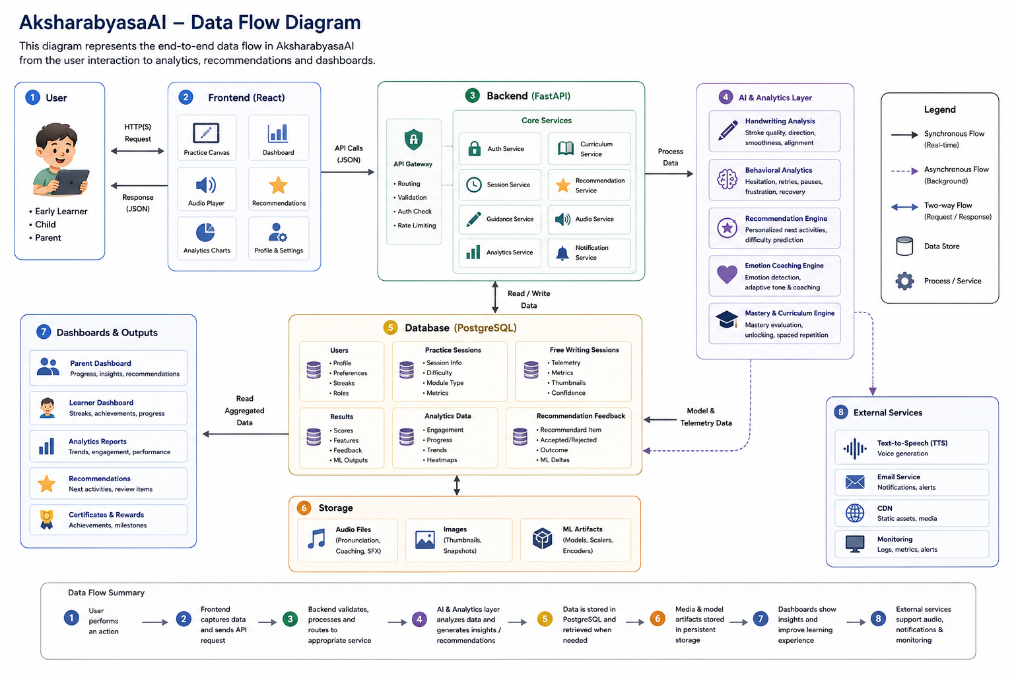

4.11 Request Processing Workflow
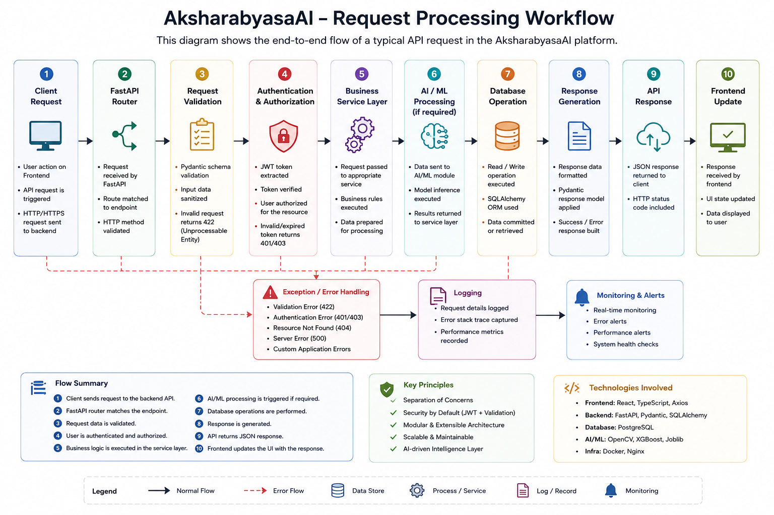
The lifecycle of a typical API request is as follows:

4.12 Architectural Advantages
The chosen architecture provides several benefits:

Scalability
- Independent modules
- Easy feature addition
- Future cloud deployment

Maintainability
- Modular services
- Clear separation of responsibilities
- Reusable components

Security
- JWT Authentication
- Password hashing
- Input validation
- Protected APIs

Performance
- Efficient database access
- Lightweight REST APIs
- Optimized frontend rendering

Extensibility
The architecture supports future enhancements such as:
- Teacher Dashboard
- Classroom Analytics
- Advanced OCR
- AI Lesson Generation
- Multilingual Support

Chapter 5 – Technology Stack

5.1 Introduction
AksharabyasaAI is built using a modern full-stack technology stack designed to provide scalability, maintainability, security, and high performance. The platform integrates frontend technologies, backend frameworks, database systems, AI/ML libraries, and containerization tools to deliver a production-oriented adaptive educational platform.
Each technology has been selected based on its suitability for building modular, scalable, and efficient software systems.

5.2 Overall Technology Stack
Layer | Technology
Frontend | React, Vite, TypeScript, Tailwind CSS
Backend | FastAPI, SQLAlchemy, Pydantic, Alembic
Database | PostgreSQL
AI / ML | OpenCV, XGBoost, Joblib
Authentication | JWT (JSON Web Token)
API Communication | REST APIs, Axios
Visualization | Recharts
Deployment | Docker, Docker Compose, Nginx
Version Control | Git &amp; GitHub

5.3 Frontend Technologies
The frontend provides the user interface for learners, parents, and future educators.

React
Purpose
React is used for developing reusable and component-based user interfaces.
Why React?
- Component-based architecture
- Virtual DOM for efficient rendering
- Large ecosystem
- Easy state management
- High maintainability
Usage in Project
- Login & Registration
- Dashboard
- Practice Canvas
- Analytics Dashboard
- Recommendation Cards
- User Profile

Vite
Purpose
Vite is used as the frontend build tool and development server.
Advantages
- Extremely fast startup
- Instant Hot Module Replacement (HMR)
- Optimized production builds
- Better development experience than traditional bundlers

TypeScript
Purpose
TypeScript adds static typing to JavaScript.
Advantages
- Type safety
- Better code completion
- Easier debugging
- Improved maintainability
- Reduced runtime errors

Tailwind CSS
Purpose
Tailwind CSS is used for styling the application.
Advantages
- Utility-first approach
- Responsive design
- Consistent UI
- Faster development
- Highly customizable

Axios
Purpose
Axios is used to communicate with backend REST APIs.
Responsibilities
- Authentication requests
- Session APIs
- Analytics APIs
- Recommendation APIs
- Error handling
- Request interceptors

Recharts
Purpose
Recharts is used for visualizing learner analytics.
Charts Implemented
- Progress graphs
- Learning trends
- Engagement metrics
- Performance analysis
- Dashboard statistics

Framer Motion
Purpose
Provides smooth animations and transitions.
Used For
- Page transitions
- Card animations
- Dashboard interactions
- Learning experience enhancements

5.4 Backend Technologies
The backend handles business logic, authentication, analytics, AI integration, and database interactions.

FastAPI
Purpose
FastAPI is the primary backend framework.
Advantages
- High performance
- Automatic Swagger documentation
- Type-safe APIs
- Asynchronous request handling
- Easy dependency injection
Responsibilities
- REST API development
- Authentication
- Session management
- Analytics processing
- Recommendation APIs
- AI integration

SQLAlchemy
Purpose
SQLAlchemy is used as the Object Relational Mapper (ORM).
Responsibilities
- Database models
- CRUD operations
- Relationships
- Query generation
- Transaction management

Alembic
Purpose
Database schema migration tool.
Responsibilities
- Database version control
- Schema upgrades
- Schema rollback
- Migration history

Pydantic
Purpose
Data validation and serialization.
Responsibilities
- Request validation
- Response models
- Type checking
- Data conversion

5.5 Database Technology

PostgreSQL
Purpose
Primary relational database management system.
Why PostgreSQL?
- ACID compliance
- High reliability
- Foreign key support
- JSONB support
- Scalability
- Excellent SQL performance
Stores
- Users
- Practice Sessions
- Free Writing Sessions
- Analytics
- Recommendation Feedback
- Learning Metadata

5.6 Artificial Intelligence & Machine Learning

OpenCV
Purpose
Image processing and handwriting feature extraction.
Used For
- Image preprocessing
- Stroke processing
- Feature extraction
- Writing analysis

XGBoost
Purpose
Machine learning model for handwriting evaluation.
Responsibilities
- Confidence prediction
- Performance scoring
- Recommendation support

Joblib
Purpose
Model serialization.
Responsibilities
- Load trained ML models
- Save trained models
- Efficient inference

5.7 Authentication

JSON Web Token (JWT)
Purpose
Secure authentication and authorization.
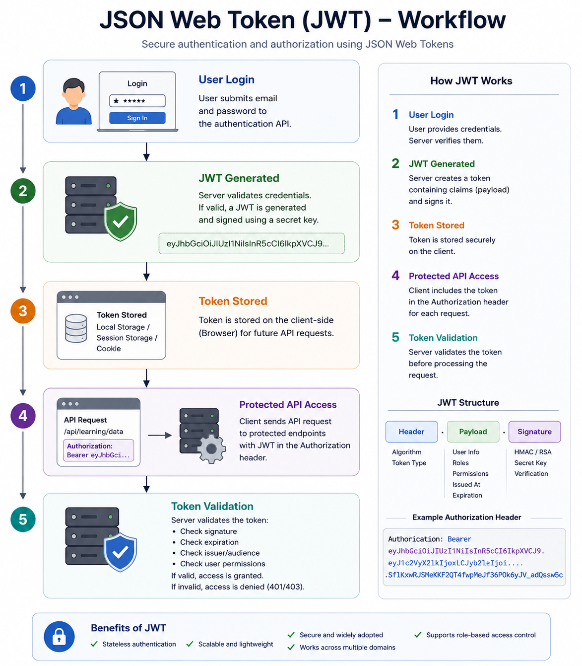
Advantages
- Stateless authentication
- Secure API access
- Lightweight
- Scalable

5.8 API Communication
The frontend communicates with the backend using REST APIs.

Communication Flow
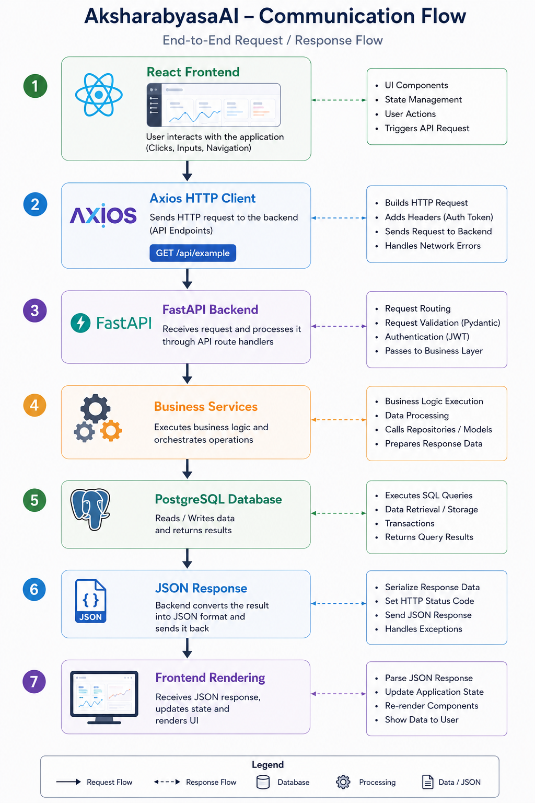

5.9 Deployment Technologies

Docker
Containerizes application components.

Containers
- Backend
- Frontend
- PostgreSQL

Docker Compose
Manages multi-container deployment.
Responsibilities:
- Service orchestration
- Network configuration
- Environment variables
- Volume management

Nginx
Used as a reverse proxy server.
Responsibilities
- Static file serving
- Reverse proxy
- Request routing
- Performance optimization

5.10 Development Tools
Tool | Purpose
Git | Version Control
GitHub | Source Code Repository
VS Code | Development Environment
pgAdmin | PostgreSQL Administration
Swagger UI | API Testing &amp; Documentation
Postman | REST API Testing

5.12 Advantages of the Technology Stack
The selected technologies provide several advantages:

Scalability
- Modular architecture
- Independent services
- Easy feature expansion

Performance
- FastAPI asynchronous processing
- PostgreSQL optimization
- Vite fast builds

Security
- JWT Authentication
- Password hashing
- Input validation

Maintainability
- Component-based frontend
- Modular backend services
- ORM-based database access
- Version-controlled schema migrations

Future Readiness
The technology stack supports future enhancements including:
- Classroom deployment
- Cloud hosting
- AI model upgrades
- Teacher dashboards
- Multilingual support

Chapter 6 – Source Code Structure

6.1 Introduction
The AksharabyasaAI project follows a modular and layered directory structure to ensure maintainability, scalability, and ease of development. The project is divided into independent modules, separating frontend, backend, database, AI/ML components, documentation, datasets, configuration, and deployment resources. This organization enables developers to quickly locate files, understand the project architecture, and extend existing functionality without affecting other components.

6.2 Project Directory Structure
AksharabyasaAI/
│
├── alembic/ # Database migrations
├── app/ # FastAPI backend source code
├── audio/ # Audio assets and generated speech
├── config/ # Configuration files
├── datasets/ # Training and educational datasets
├── docs/ # Project documentation
├── frontend/ # React + Vite frontend
├── scripts/ # Utility and automation scripts
├── tests/ # Unit and integration tests
│
├── .gitignore
├── .dockerignore
├── alembic.ini
├── backend.Dockerfile
├── frontend.Dockerfile
├── docker-compose.yml
├── nginx.conf
├── requirements.txt
├── README.md
├── dataset.csv
├── model.pkl
├── run_pipeline.py
└── alter_db.py

6.3 Backend Source Code
The app/ directory contains the complete backend implementation developed using FastAPI. It is organized into multiple modules following a layered architecture where API endpoints, business logic, database models, schemas, and utilities are separated into independent components.

6.3.1 API Layer (app/api/)

Purpose
The api directory contains all REST API endpoints exposed by the backend.

Responsibilities
- User Authentication APIs
- User Profile APIs
- Session Management APIs
- Analytics APIs
- Recommendation APIs
- Studio APIs
- Audio APIs

Example Endpoints
POST /auth/register
POST /auth/login
GET /auth/profile
POST /sessions/start
POST /sessions/{id}/complete
GET /analytics/summary
GET /analytics/progress
GET /recommendations/full

6.3.2 Core Module (app/core/)

Purpose
The core module contains the application's infrastructure and global configuration.

Responsibilities
- Database Connection
- Environment Variables
- JWT Configuration
- Password Hashing
- Security
- Logging

Important Files
config.py
database.py
security.py

6.3.3 Database Models (app/models/)

Purpose
Contains SQLAlchemy ORM models representing PostgreSQL tables.

Responsibilities
- Database Schema
- Table Relationships
- Foreign Keys
- Constraints
- ORM Mapping

Major Models
User
PracticeSession
FreeWritingSession
Submission
Result
RecommendationFeedback

6.3.4 Schemas (app/schemas/)

Purpose
Contains Pydantic models used for request validation and response serialization.

Responsibilities
- Request Validation
- Response Models
- Type Checking
- Data Serialization

Example Schemas
- UserCreate
- UserResponse
- Token
- SessionResponse
- AnalyticsResponse
- RecommendationResponse

6.3.5 Business Services (app/services/)

Purpose
Contains the core business logic of the application.
Business logic is separated from API routes to improve modularity, reusability, and maintainability.

Major Services
- Authentication Service
- Session Service
- Analytics Service
- Recommendation Service
- Curriculum Service
- ML Service
- Audio Service
- Profile Service

6.3.6 Utility Module (app/utils/)

Purpose
Contains reusable helper functions used throughout the project.

Responsibilities
- Common Utility Functions
- Image Processing Helpers
- Data Preprocessing
- Mathematical Calculations
- File Handling

6.3.7 Application Entry Point

File
app/main.py

Responsibilities
- Initialize FastAPI
- Register API Routers
- Configure Middleware
- Configure CORS
- Start Application
- Load Environment Configuration

6.4 Frontend Source Code
The frontend is developed using React, Vite, and TypeScript. It provides the graphical user interface through which users interact with the platform.

Major Responsibilities
- Login
- Registration
- Dashboard
- Guided Practice
- Free Writing
- Analytics Dashboard
- Recommendation Display
- User Profile

Typical Frontend Structure
frontend/
src/
│
├── components/
├── pages/
├── services/
├── hooks/
├── context/
├── assets/
└── styles/

Components
Reusable UI components such as:
- Navigation Bar
- Sidebar
- Cards
- Buttons
- Charts
- Dialog Boxes

Pages
Represents complete application screens.
Examples include:
- Login
- Dashboard
- Practice
- Analytics
- Profile

Services
Contains Axios-based API communication logic.
Examples include:
- authService
- analyticsService
- sessionService
- recommendationService

Context
Used for global state management.
Examples include:
- Authentication Context
- User Context
- Theme Context

6.5 Database Migration (alembic/)

Purpose
Alembic is used for database version control and schema migration.

Responsibilities
- Create Database Tables
- Upgrade Schema
- Rollback Schema
- Maintain Migration History

Common Command
alembic upgrade head

6.6 Configuration (config/)
Stores application configuration files.

Responsibilities
- Environment Configuration
- AI Settings
- Application Parameters
- Curriculum Configuration

6.7 Audio Resources (audio/)
Contains all audio resources used by the platform.

Includes
- Pronunciation Audio
- Coaching Messages
- Generated Speech
- Learning Prompts

6.8 Datasets (datasets/)
Stores datasets required for machine learning and educational content.

Includes
- Training Dataset
- Evaluation Dataset
- Educational Content
- Curriculum Data

6.9 Documentation (docs/)
Contains all project documentation.

Includes
- Business Requirements Document (BRD)
- Product Requirements Document (PRD)
- Software Requirements Specification (SRS)
- Technical Architecture Document
- Project Completion Report
- Knowledge Transfer Document

6.10 Scripts (scripts/)
Contains automation and utility scripts.

Responsibilities
- Data Preprocessing
- Model Training
- Database Utilities
- Batch Processing
- Automation Tasks

6.11 Testing (tests/)
Contains project testing resources.

Includes
- API Testing
- Backend Testing
- Integration Testing
- Validation Testing
- Future Unit Tests

6.12 Root-Level Files

requirements.txt
Lists all Python packages required by the backend.

docker-compose.yml
Defines the multi-container deployment environment.
Services include:
- Backend
- Frontend
- PostgreSQL

backend.Dockerfile
Docker build instructions for the FastAPI backend.

frontend.Dockerfile
Docker build instructions for the React frontend.

nginx.conf
Configuration file for the Nginx reverse proxy server.

model.pkl
Serialized machine learning model used for handwriting evaluation and prediction.

dataset.csv
Training and evaluation dataset used by the machine learning pipeline.

run_pipeline.py
Executes the complete AI/ML inference pipeline.

alter_db.py
Utility script for database maintenance and schema modifications.

README.md
Provides project overview, installation instructions, and usage guidelines.

6.14 Coding Standards
The project follows modern software engineering best practices.

Development Practices
- Modular Architecture
- Layered Design Pattern
- RESTful API Design
- Object-Oriented Programming (OOP)
- SQLAlchemy ORM
- Pydantic Validation
- Alembic Database Migrations
- JWT-Based Authentication
- Environment-Based Configuration
- Git Version Control

Chapter 7 – Backend Module Design

7.1 Introduction
The AksharabyasaAI backend is developed using the FastAPI framework and follows a modular service-oriented architecture. The backend is responsible for handling authentication, business logic, AI/ML integration, session management, analytics generation, recommendation processing, and database interactions.
The backend is organized into independent modules, each responsible for a specific functionality. This modular design promotes maintainability, scalability, and ease of future enhancements.

7.2 Backend Architecture
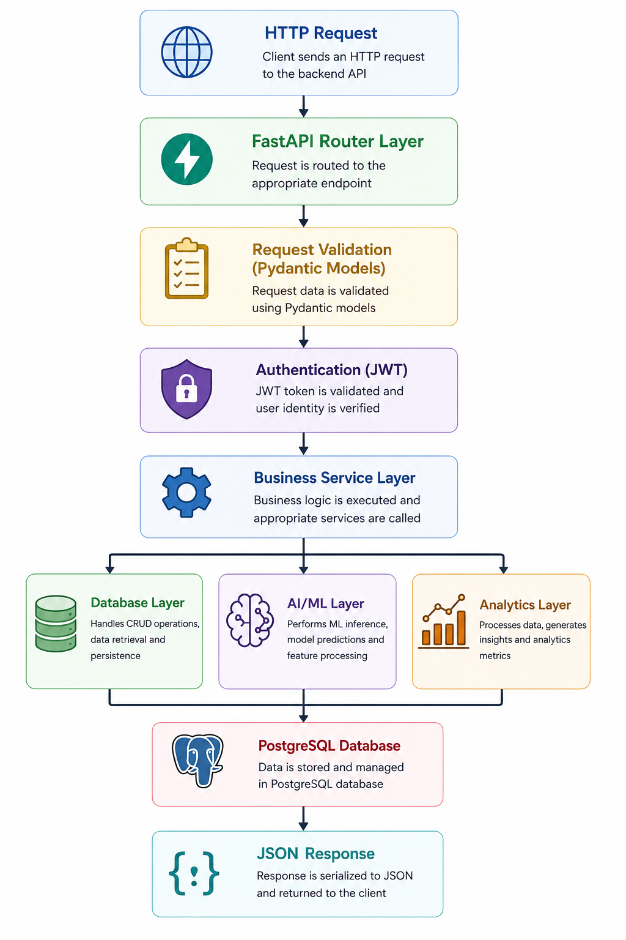
The backend follows a layered architecture where requests pass through multiple layers before interacting with the database.

This architecture ensures separation of concerns between request handling, validation, business logic, AI processing, and data persistence.

7.3 Authentication Module

Purpose
The Authentication Module provides secure user registration, login, and authorization.

Responsibilities
- User Registration
- User Login
- Password Hashing
- JWT Token Generation
- JWT Validation
- User Profile Management
- Secure API Authorization

APIs
Endpoint | Method | Description
/auth/register | POST | Register new user
/auth/login | POST | Authenticate user
/auth/profile | GET | Retrieve user profile
/auth/profile | PATCH | Update profile
/auth/me/ui-config | GET | Retrieve adaptive UI configuration

Workflow
User Registration
│
Validate Request
│
Hash Password
│
Store User
│
Registration Success

7.4 Session Management Module

Purpose
Manages the complete lifecycle of handwriting practice sessions.

Responsibilities
- Create Practice Session
- Load Learning Content
- Record Guidance Events
- Track Session Progress
- Complete Session
- Abandon Session
- Store Results

APIs
POST /sessions/start
GET /sessions/modules/{module}/item
GET /sessions/modules/{module}/data/{id}
POST /sessions/{id}/guidance-event
POST /sessions/{id}/complete
POST /sessions/{id}/abandon

Session Lifecycle
Start Session
↓
Load Activity
↓
Capture Strokes
↓
Guidance Events
↓
Evaluation
↓
Store Results
↓
Complete Session

7.5 Studio Module

Purpose
Supports free writing and AI-assisted handwriting evaluation.

Responsibilities
- Start Studio Session
- Capture Writing
- Generate Features
- Run ML Model
- Calculate Confidence Score
- Store Results

APIs
POST /studio/start
POST /studio/{session_id}/complete

Processing Flow
Create Studio Session
↓
Capture Handwriting
↓
Extract Features
↓
Run ML Model
↓
Generate Score
↓
Store Analytics

7.6 Analytics Module

Purpose
Processes educational data and generates learner insights.

Responsibilities
- Progress Analysis
- Engagement Analysis
- Module Statistics
- Learning Insights
- Performance Tracking
- Dashboard Metrics

APIs
Endpoint | Method
/analytics/summary | GET
/analytics/progress | GET
/analytics/engagement | GET
/analytics/modules | GET
/analytics/insights | GET

Workflow
Retrieve Sessions
↓
Calculate Metrics
↓
Generate Analytics
↓
Return Dashboard Data

7.7 Recommendation Module

Purpose
Provides personalized learning recommendations based on learner performance.

Responsibilities
- Analyze User Progress
- Predict Difficulty
- Suggest Next Activities
- Generate Personalized Learning Path
- Collect Recommendation Feedback

APIs
GET /recommendations/full
POST /recommendations/feedback

Recommendation Flow
Collect User Data
↓
Analyze Performance
↓
Generate Recommendation
↓
Return Suggested Activities

7.8 AI / Machine Learning Module

Purpose
Provides handwriting evaluation and prediction using machine learning models.

Responsibilities
- Load Trained Model
- Feature Extraction
- Handwriting Analysis
- Prediction
- Confidence Scoring

Components
- OpenCV
- XGBoost
- Joblib
- Feature Extraction Pipeline

Workflow
Image Input
↓
Image Preprocessing
↓
Feature Extraction
↓
ML Prediction
↓
Confidence Score
↓
Return Result

7.9 Audio Module

Purpose
Provides pronunciation and coaching audio.

Responsibilities
- Audio Generation
- Pronunciation Support
- Coaching Messages
- Audio Playback Support
- Audio Caching

APIs
GET /audio/pronunciation

GET /audio/coaching

7.10 Database Layer

Purpose
Provides persistent storage for application data.

Responsibilities
- CRUD Operations
- Transactions
- Relationship Management
- Session Storage
- Analytics Storage

Main Tables
- Users
- Practice Sessions
- Free Writing Sessions
- Results
- Recommendation Feedback

7.11 Error Handling Module
The backend implements centralized exception handling to ensure consistent API responses.

Handles
- Validation Errors
- Authentication Errors
- Database Exceptions
- Business Logic Exceptions
- Internal Server Errors

Standard Response Format
{
"success": false,
"message": "Description of the error",
"status_code": 400
}

7.12 Logging
The application maintains detailed logs for monitoring and debugging.

Logged Information
- API Requests
- Authentication Events
- Session Creation
- Analytics Generation
- Recommendation Processing
- ML Predictions
- Error Logs

7.13 Backend Request Lifecycle
The following sequence describes how a typical API request is processed.
Client Request
↓
FastAPI Router
↓
Pydantic Validation
↓
JWT Authentication
↓
Business Service
↓
Database / AI Processing
↓
Response Serialization
↓
JSON Response

7.14 Backend Design Principles
The backend follows the following software engineering principles:
- Modular Architecture
- Layered Design
- Separation of Concerns
- Dependency Injection
- RESTful API Design
- JWT Authentication
- ORM-Based Database Access
- Reusable Business Services
- Centralized Error Handling

7.15 Advantages of the Backend Design
The implemented backend architecture provides:
- High scalability
- Modular development
- Easy maintenance
- Secure authentication
- Efficient database management
- Reusable business logic
- Simplified testing
- Future-ready architecture

Chapter 8 – Database Design

8.1 Introduction
The AksharabyasaAI platform uses PostgreSQL as its primary relational database management system. The database is designed to efficiently manage user information, handwriting practice sessions, learning analytics, recommendation feedback, and AI-generated insights while ensuring data integrity through normalization and relational constraints.
The database schema is implemented using SQLAlchemy ORM, while schema versioning and migration management are handled using Alembic.
The database follows a normalized relational design with primary keys, foreign keys, and referential integrity constraints.

8.2 Database Architecture
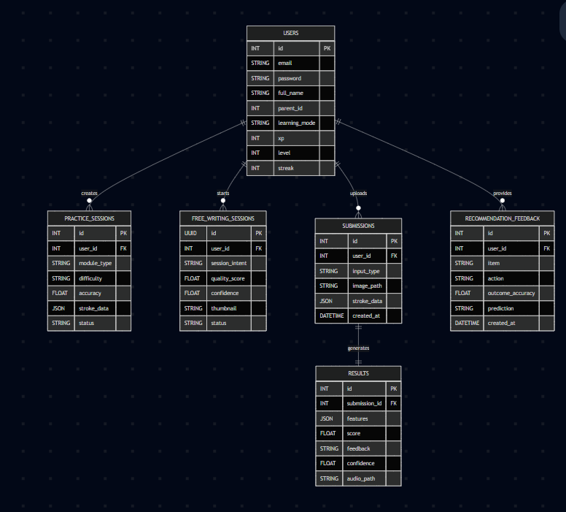

8.3 Database Technologies
Technology | Purpose
PostgreSQL | Primary Database
SQLAlchemy | ORM
Alembic | Schema Migration
pgAdmin | Database Administration

8.4 Entity Relationship Overview
The major entities implemented in the database are:
- Users
- Practice Sessions
- Free Writing Sessions
- Submissions
- Results
- Recommendation Feedback
Each entity is related through foreign key constraints to maintain referential integrity.

8.5 Table Design

8.5.1 Users Table

Purpose
Stores user account information and learning profile.

Important Columns
Column | Type | Description
id | Integer | Primary Key
email | String | User Email
hashed_password | String | Encrypted Password
full_name | String | User Name
preferred_learning_mode | String | Learning Mode
preferred_language | String | Preferred Language
xp_points | Integer | Experience Points
level | Integer | User Level
user_streak | Integer | Learning Streak

Relationships
Users
↓
Practice Sessions
↓
Free Writing Sessions
↓
Recommendation Feedback

8.5.2 Practice Sessions

Purpose
Stores guided handwriting practice.

Important Fields
- Session ID
- User ID
- Module Type
- Difficulty
- Start Time
- End Time
- Completion Status
Foreign Key
user_id → Users.id

8.5.3 Free Writing Sessions

Purpose
Stores unrestricted handwriting sessions.
Fields
- Session UUID
- User ID
- Intent
- Goal
- ML Score
- Confidence

8.5.4 Submission Table
Stores handwriting submissions generated during practice.
Contains
- Stroke Data
- Image
- Timestamp
- User Reference

8.5.5 Result Table
Stores ML evaluation results.
Contains
- Prediction
- Confidence
- Feedback
- Smoothness Score
- Accuracy

8.5.6 Recommendation Feedback
Stores recommendation engine feedback.
Contains
- User ID
- Recommendation ID
- Accepted
- Ignored
- Timestamp

8.6 Relationships

One User
↓
Many Practice Sessions
↓
Many Submissions
↓
Many Results
Similarly
One User
↓
Many Free Writing Sessions

8.7 Database Normalization
The database follows normalization principles.

First Normal Form- Atomic values

Second Normal Form- Partial dependency removed

Third Normal Form- Transitive dependency removed

8.8 Constraints
Implemented constraints include
- Primary Keys
- Foreign Keys
- Unique Email
- NOT NULL Constraints
- Default Values

8.9 Database Migrations
Database versioning is managed using Alembic.
Common commands
alembic revision --autogenerate -m "message"

alembic upgrade head

alembic downgrade -1

8.10 Database Security
Security measures
- Password hashing
- JWT Authentication
- SQLAlchemy ORM
- Input Validation
- Parameterized Queries

8.11 Database Advantages
- ACID Compliance
- Scalable
- Highly Reliable
- Fast Queries
- Strong Relationship Support

Chapter 9 – REST API Documentation

9.1 Introduction
The backend exposes RESTful APIs developed using FastAPI.
The APIs enable communication between the React frontend and backend services while ensuring secure access through JWT-based authentication.
All APIs exchange data in JSON format.

9.2 API Architecture
React
↓
Axios
↓
FastAPI Router
↓
Business Services
↓
Database
↓
JSON Response

9.3 Authentication APIs

Register User

Endpoint
POST /auth/register

Description
Creates a new user account.

Request
{
"email":"user@gmail.com",
"password":"password",
"full_name":"John Doe",
"date_of_birth":"2004-08-20",
"preferred_learning_mode":"early_learner"
}

Response
{
"id":2,
"email":"user@gmail.com",
"profile_type":"early_learner"
}

Login
POST /auth/login
Purpose
Authenticates user.
Response
{
"access_token":"JWT_TOKEN",
"token_type":"bearer"
}

Get Profile
GET /auth/profile
Authorization
Bearer Token Required

Update Profile
PATCH /auth/profile

UI Configuration
GET /auth/me/ui-config

9.4 Session APIs

Start Session
POST /sessions/start
Creates handwriting session

Get Practice Item
GET /sessions/modules/{module}/item

Get Character Data
GET /sessions/modules/{module}/data/{id}

Guidance Event
POST /sessions/{id}/guidance-event

Complete Session
POST /sessions/{id}/complete

Abandon Session
POST /sessions/{id}/abandon

9.5 Studio APIs

Start Studio
POST /studio/start

Complete Studio
POST /studio/{id}/complete

9.6 Analytics APIs

Summary
GET /analytics/summary

Progress
GET /analytics/progress

Engagement
GET /analytics/engagement

Modules
GET /analytics/modules

Insights
GET /analytics/insights

9.7 Recommendation APIs

Full Recommendation
GET /recommendations/full

Feedback
POST /recommendations/feedback

9.8 Response Format
Successful Response
{
"success":true,
"data":{}
}

Error Response
{
"success":false,
"message":"Invalid credentials"
}

9.9 Authentication
Protected APIs require
Authorization:

Bearer <JWT_TOKEN>

9.10 HTTP Status Codes
Code | Meaning
200 | Success
201 | Created
400 | Bad Request
401 | Unauthorized
403 | Forbidden
404 | Not Found
422 | Validation Error
500 | Internal Server Error

9.11 API Testing
Tools
- Swagger UI
- Postman
- FastAPI Interactive Docs

9.12 API Best Practices
Implemented practices
- RESTful Design
- JWT Authentication
- Pydantic Validation
- Standard JSON Responses
- Proper HTTP Status Codes
- Modular Routing
- Version Ready

Chapter 10 – AI & Machine Learning Pipeline

10.1 Introduction
The AksharabyasaAI platform integrates Artificial Intelligence (AI) and Machine Learning (ML) to provide intelligent handwriting evaluation, adaptive learning recommendations, confidence scoring, and learner behavior analysis. The AI pipeline processes handwriting data captured during practice sessions and generates personalized feedback to enhance the learner's experience.
The ML components are designed to operate as backend services and interact seamlessly with the FastAPI application and PostgreSQL database.

10.2 AI/ML Architecture
The AI pipeline consists of multiple stages, beginning with user input and ending with personalized recommendations and analytics.
Handwriting Input
│
Image / Stroke Capture
│
Image Preprocessing
│
Feature Extraction
│
Machine Learning Model
│
Prediction & Confidence Score
│
Store Results in PostgreSQL
│
Analytics & Recommendations

10.3 AI Components
The AI subsystem consists of the following components:

Image Acquisition
Captures handwriting strokes or uploaded handwriting images from the frontend canvas.

Image Preprocessing
Prepares raw handwriting data for analysis.
Processing includes:
- Noise reduction
- Image normalization
- Thresholding
- Stroke enhancement
- Scaling

Feature Extraction
Relevant handwriting features are extracted from the processed image.
Typical features include:
- Stroke smoothness
- Stroke continuity
- Character alignment
- Pressure consistency (if available)
- Writing speed
- Shape consistency
These features are converted into numerical vectors that can be processed by the machine learning model.

Machine Learning Model
The extracted features are passed to a trained XGBoost model.
The model predicts:
- Writing quality
- Confidence score
- Performance band
- Improvement suggestions
The trained model is stored as:
model.pkl
and loaded into memory using Joblib during backend startup.

Prediction Output
The ML model generates:
- Quality Score
- Confidence Score
- Performance Band
- Personalized Feedback
These predictions are returned to the backend and stored in the database for future analytics.

10.4 AI Workflow
The following workflow illustrates the AI prediction process.
User Writes Character
│
Frontend Captures Stroke
│
FastAPI Receives Data
│
Image Preprocessing
│
Feature Extraction
│
XGBoost Model Prediction
│
Confidence Calculation
│
Store Prediction
│
Return Feedback

10.5 Recommendation Engine
The recommendation engine analyzes learner performance and suggests personalized practice activities.

Inputs
- Historical performance
- Confidence scores
- Learning progress
- Difficulty level
- Session history

Outputs
- Next practice activity
- Recommended difficulty
- Personalized learning path

10.6 Analytics Integration
AI-generated predictions are integrated with the analytics engine to generate meaningful educational insights.
Metrics include:
- Progress tracking
- Engagement score
- Confidence trends
- Module performance
- Learning consistency

10.7 AI Libraries Used
Library | Purpose
OpenCV | Image Processing
XGBoost | Prediction Model
Joblib | Model Loading
NumPy | Numerical Operations
Pandas | Data Processing

10.8 Model Deployment
The trained ML model is deployed within the backend service.
Deployment process:
- Load model during FastAPI startup.
- Receive handwriting features.
- Perform inference.
- Return prediction.
- Store prediction in PostgreSQL.

10.9 Advantages
- Fast inference
- Personalized learning
- Scalable architecture
- Real-time feedback
- Easy model replacement

10.10 Future Enhancements
Future AI improvements may include:
- Deep Learning models
- OCR-based handwriting recognition
- Transformer-based recommendations
- Multilingual handwriting evaluation
- Personalized AI tutors

Chapter 11 – Installation & Setup Guide

11.1 Introduction
This chapter provides step-by-step instructions for setting up the AksharabyasaAI project in a local development environment. It covers backend installation, frontend setup, database configuration, migrations, and application startup.

11.2 System Requirements
Component | Version
Operating System | Windows / Linux / macOS
Python | 3.11 or later
Node.js | 18+
npm | 9+
PostgreSQL | 15+
Git | Latest
Docker | Latest

11.3 Clone the Repository
git clone <https://github.com/dev-sji/Aksharabyasa-AI>

cd AksharabyasaAI

11.4 Backend Setup

Step 1 – Create Virtual Environment
python -m venv venv

Step 2 – Activate Environment
Windows
venv\Scripts\activate

Linux / macOS
source venv/bin/activate

Step 3 – Install Dependencies
pip install -r requirements.txt

11.5 Frontend Setup
Navigate to the frontend directory.
cd frontend
Install frontend dependencies.
npm install
Start the frontend.
npm run dev

11.6 PostgreSQL Configuration
Create a PostgreSQL database.
Example:
CREATE DATABASE aksharabyasa;

11.7 Environment Variables
Create a .env file in the project root.
Example:
DATABASE_URL=postgresql://postgres:<password>@localhost:5432/aksharabyasa

SECRET_KEY=your_secret_key

ACCESS_TOKEN_EXPIRE_MINUTES=30

Replace <password> with the PostgreSQL user password.

11.8 Database Migration
Run Alembic migrations.
alembic upgrade head

This command creates all required database tables.

11.9 Running the Backend
Start the FastAPI server.
uvicorn app.main:app --reload

The backend will be available at:
http://127.0.0.1:8000

Swagger Documentation:
http://127.0.0.1:8000/docs

11.10 Running the Frontend
From the frontend directory:
npm run dev

The application will be available at:
http://localhost:5173

11.11 Project Startup Sequence
Clone Repository
│
Create Virtual Environment
│
Install Python Dependencies
│
Install Frontend Dependencies
│
Configure PostgreSQL
│
Create .env
│
Run Alembic Migrations
│
Start Backend
│
Start Frontend
│
Access Application

11.12 Troubleshooting

Common Issues
Database Connection Error
- Verify PostgreSQL is running.
- Check the DATABASE_URL.

Alembic Migration Error
alembic upgrade head
Ensure the database exists and the environment variables are correct.
Frontend Error
npm install
Install missing frontend dependencies.
Backend Error
pip install -r requirements.txt
Verify all required Python packages are installed.

11.13 Verification
After successful installation:
- Backend accessible at http://127.0.0.1:8000
- Swagger UI available at /docs
- Frontend running on http://localhost:5173
- PostgreSQL connected
- Login, practice sessions, analytics, and recommendations functioning correctly

Chapter 12 – User Manual

12.1 Introduction
This chapter provides a comprehensive user guide for the AksharabyasaAI platform. It describes the workflow for learners, parents, and administrators (future scope) and explains how users interact with the application, from account creation to handwriting practice, analytics, and personalized recommendations.
The user manual is intended to help end users understand the application's functionality and effectively use its features.

12.2 User Roles
The platform currently supports the following user roles:
User Role | Description
Learner | Primary user who performs handwriting practice and learning activities.
Parent | Monitors learner progress through analytics and reports.
Teacher (Future) | Classroom management and learner monitoring.

12.3 Application Workflow
The overall user workflow is shown below.
User Registration
│
User Login
│
Dashboard
│
Choose Learning Module
│
Start Practice Session
│
Complete Activity
│
AI Evaluation
│
Analytics Dashboard
│
Recommendations

12.4 User Registration

Purpose
Allows new users to create an account.

Steps
- Open the application.
- Navigate to the Register page.
- Enter:
  - Full Name
  - Email Address
  - Password
  - Date of Birth
  - Preferred Learning Mode
- Click Register.
- The account is successfully created and stored in the PostgreSQL database.
Screenshot: Registration Page

12.5 User Login

Purpose
Authenticates registered users.

Steps
- Open the Login page.
- Enter the registered email and password.
- Click Login.
- A JWT access token is generated.
- The user is redirected to the dashboard.
Screenshot: Login Page

12.6 Dashboard
The dashboard serves as the main interface after successful login.

Dashboard Features
- User Profile
- Learning Level
- Experience Points (XP)
- Learning Streak
- Practice Modules
- Analytics Summary
- Personalized Recommendations
Screenshot: Dashboard

12.7 Practice Module
The guided practice module helps learners improve handwriting through structured exercises.

Steps
- Select a learning module.
- Choose the desired difficulty level.
- Start the handwriting session.
- Follow on-screen tracing guidance.
- Receive real-time visual feedback.
- Complete the activity.
Screenshot: Guided Practice

12.8 Free Writing (Studio)
The Studio module allows unrestricted handwriting practice.

Steps
- Open Studio Mode.
- Select a writing goal.
- Start the free-writing session.
- Write naturally on the canvas.
- Submit the writing.
- Receive AI-generated evaluation.
Screenshot: Studio

12.9 Analytics Dashboard
The Analytics Dashboard provides insights into learner performance.

Available Analytics
- Progress Summary
- Learning Trends
- Module Performance
- Engagement Metrics
- Confidence Score
- Session History
- Performance Insights
Screenshot: Analytics Dashboard

12.10 Recommendation Module
The recommendation engine suggests personalized learning activities.

Information Displayed
- Recommended Practice
- Suggested Difficulty
- Personalized Learning Path
- Areas for Improvement
- Skill Progression
Screenshot: Recommendation Dashboard

12.11 User Profile
Users can manage their personal information through the profile page.

Editable Information
- Full Name
- Preferred Learning Mode
- Preferred Language

Read-Only Information
- Level
- XP Points
- Learning Streak
- Profile Type
Screenshot: Profile Page

12.12 Logout
Users can securely log out of the application.

Process
- Click the Logout button.
- The JWT token is removed from local storage.
- The user is redirected to the Login page.

12.13 Common User Scenarios

Scenario 1 – New User Registration
- Register a new account.
- Log in using registered credentials.
- Complete the first practice session.
- View analytics and recommendations.

Scenario 2 – Returning User
- Log in.
- Continue the next recommended activity.
- Complete the session.
- Review updated analytics.

Scenario 3 – Parent Monitoring
- Log in using the linked account.
- Open the Analytics Dashboard.
- Review learner progress and engagement.
- Identify areas requiring additional practice.

12.14 Frequently Asked Questions (FAQ)

Q1. I cannot log in.
Verify:
- Correct email address
- Correct password
- Backend server is running

Q2. The practice session does not start.
Check:
- Internet connection
- Backend availability
- Database connectivity

Q3. Analytics are empty.
Complete at least one practice session to generate analytics data.

Q4. AI evaluation is unavailable.
Ensure:
- The ML model is successfully loaded.
- Required dependencies (e.g., XGBoost) are installed.

12.15 Best Practices
To achieve the best learning outcomes:
- Complete practice sessions regularly.
- Review analytics after each session.
- Follow personalized recommendations.
- Maintain an updated learner profile.
- Practice consistently to improve handwriting quality and literacy skills.

Chapter 13 – Testing and Validation

13.1 Introduction
Testing and validation ensure that the AksharabyasaAI platform functions correctly, meets the specified requirements, and provides reliable performance. The application was tested at multiple levels, including backend APIs, database operations, frontend functionality, authentication, analytics generation, and AI model integration.
The testing process focused on validating both functional and non-functional requirements while ensuring seamless interaction between all system components.

13.2 Testing Strategy
The following testing strategy was adopted during development:
Testing Type | Purpose
Functional Testing | Verify application features work correctly
API Testing | Validate REST API endpoints
Database Testing | Verify database operations and integrity
Integration Testing | Test interaction between frontend, backend, AI, and database
User Interface Testing | Validate frontend functionality
Authentication Testing | Verify JWT-based authentication
AI/ML Validation | Validate handwriting evaluation and prediction
Performance Testing | Assess application responsiveness

13.3 Functional Testing
The core application features were tested individually.
Feature | Test Scenario | Result
User Registration | Register a new user | Passed
User Login | Login with valid credentials | Passed
JWT Authentication | Access protected APIs | Passed
Profile Update | Update user information | Passed
Practice Session | Start and complete session | Passed
Studio Session | Free-writing evaluation | Passed
Analytics Dashboard | Display learner metrics | Passed
Recommendation Engine | Generate personalized recommendations | Passed

13.4 API Testing
REST APIs were tested using FastAPI Swagger UI and Postman.

APIs Tested
- Authentication APIs
- Session APIs
- Analytics APIs
- Recommendation APIs
- Studio APIs

Validation
- Request validation
- Response format
- Authentication
- Error handling
- Status codes

13.5 Database Testing
Database validation included:
- Table creation using Alembic
- CRUD operations
- Foreign key constraints
- Data consistency
- Transaction validation

Verified Tables
- users
- practice_sessions
- free_writing_sessions
- submissions
- results
- recommendation_feedback

13.6 Frontend Testing
The frontend was tested for:
- Login flow
- Registration
- Dashboard rendering
- Session management
- Analytics visualization
- Recommendation display
- Navigation between modules

13.7 AI/ML Validation
The AI module was validated by verifying:
- Model loading
- Feature extraction
- Prediction generation
- Confidence score calculation
- Result storage
The trained XGBoost model successfully produced handwriting evaluation scores for test inputs.

13.8 Integration Testing
The interaction between different modules was validated.
React Frontend
│
FastAPI Backend
│
Business Services
│
AI Model
│
PostgreSQL Database

All major workflows executed successfully.

13.9 Performance Validation
The following aspects were evaluated:
- API response time
- Database query execution
- Frontend rendering
- Session creation
- Analytics generation
The application performed satisfactorily under normal development workloads.

13.10 Test Environment
Component | Environment
Frontend | React + Vite
Backend | FastAPI
Database | PostgreSQL
API Testing | Swagger UI
IDE | Visual Studio Code
Browser | Google Chrome

13.11 Validation Summary
The testing process confirmed that:
- User authentication functions correctly.
- Practice sessions are stored successfully.
- AI predictions are generated as expected.
- Analytics are displayed accurately.
- Recommendations are generated correctly.
- Database operations are reliable.
- Frontend and backend communicate successfully.

Chapter 14 – Known Issues and Future Enhancements

14.1 Introduction
Although the AksharabyasaAI platform provides a functional and scalable solution for adaptive handwriting learning, certain limitations remain. These limitations present opportunities for future improvements and feature expansion.

14.2 Known Issues

1. Limited AI Training Dataset
The current machine learning model has been trained using a limited dataset. Increasing the dataset size would improve prediction accuracy and generalization.

2. Browser Compatibility
The application has primarily been tested on modern Chromium-based browsers. Additional testing on Safari and Firefox is recommended.

3. Internet Dependency
The frontend requires connectivity to the backend server for analytics and recommendation generation.

4. Limited User Roles
Currently, the platform focuses on learners and parents. Dedicated teacher and administrator interfaces are not yet implemented.
5. Single AI Model
The handwriting evaluation currently relies on a single XGBoost model. Multiple specialized models could improve prediction quality.

14.3 Future Enhancements
The following enhancements are recommended for future versions:

Educational Features
- Teacher Dashboard
- Classroom Management
- Assignment Creation
- Progress Reports
- Student Comparison

Artificial Intelligence
- Deep Learning-based handwriting recognition
- OCR integration
- Transformer-based recommendation engine
- Personalized AI tutor
- Adaptive difficulty prediction

Platform Improvements
- Offline learning mode
- Mobile application
- Push notifications
- Cloud synchronization
- Multi-device support

Analytics
- Advanced learning analytics
- Predictive performance analysis
- Behavioral insights
- Long-term progress forecasting

Security
- Multi-factor authentication
- Role-based access control
- Audit logging
- Secure cloud deployment

14.4 Scalability Recommendations
Future deployments may include:
- Microservice architecture
- Kubernetes deployment
- Load balancing
- Distributed caching
- Cloud-native infrastructur

Chapter 15 – Lessons Learned and Recommendations

15.1 Introduction
The development of AksharabyasaAI provided valuable experience in designing, implementing, and deploying a full-stack AI-enabled educational platform. The project highlighted both technical and organizational lessons that can guide future development efforts.

15.2 Lessons Learned

Full-Stack Development
Developing an integrated frontend and backend requires careful planning of APIs, data models, and communication protocols.

Database Design
A well-designed relational database simplifies data management and improves maintainability. Early planning of entities and relationships reduces future migration complexity.

API Design
A modular REST API architecture enables independent development of frontend and backend components while improving code reuse.

AI Integration
Separating machine learning logic from business services simplifies maintenance and allows future model upgrades without affecting the rest of the application.

Version Control
Using Git throughout development enabled collaborative work, change tracking, and easier issue resolution.

Documentation
Maintaining comprehensive documentation significantly reduces onboarding time for future developers and simplifies knowledge transfer.

15.3 Recommendations
For future development, the following recommendations are proposed:
- Expand the handwriting dataset to improve AI model accuracy.
- Introduce automated testing and continuous integration.
- Implement role-based access control for teachers and administrators.
- Enhance analytics with predictive insights.
- Improve deployment using cloud infrastructure and container orchestration.
- Regularly update project dependencies and security patches.
- Maintain detailed documentation for every new feature.

15.4 Best Practices for Future Developers
- Follow the existing layered architecture.
- Keep business logic inside the service layer.
- Use Alembic for all database schema changes.
- Validate all API inputs using Pydantic.
- Maintain consistent coding standards.
- Document new APIs and modules.
- Write unit and integration tests for new features.

15.5 Project Outcomes
The project successfully achieved the following outcomes:
- Developed a scalable full-stack educational platform.
- Integrated AI/ML for handwriting evaluation.
- Implemented secure JWT-based authentication.
- Built analytics and recommendation modules.
- Designed a normalized PostgreSQL database.
- Established a modular architecture suitable for future expansion.

15.6 Final Conclusion
The AksharabyasaAI platform demonstrates how modern web technologies, machine learning, and data analytics can be combined to create an adaptive educational system. The modular architecture, comprehensive documentation, and scalable design provide a strong foundation for future development and deployment. Continued improvements in AI models, analytics, and user experience will further enhance the platform's effectiveness as an intelligent handwriting learning solution.

