Assignment Submission
Name: Sanjay Sajnani
Registration Number: 22bce8541

1. SQL & Data Familiarity
Q1. What steps would you take to review this data before importing it into a system?
Answer: I would first check for missing or duplicate values and ensure consistency in key fields. Then, I’d confirm formats like dates and IDs are correct before cleaning and standardizing the data for import.

Query: Display all customers from the city 'Delhi'.
SQL Query:
USE xeno
SELECT * FROM customers WHERE city=’Delhi’ ;
Screenshot:
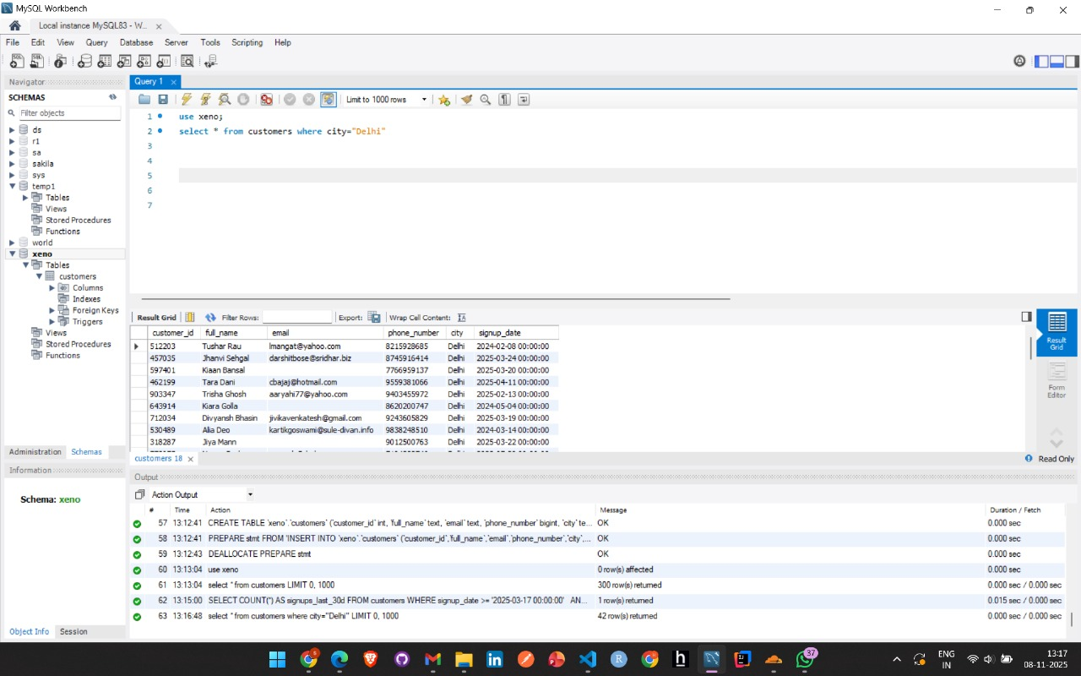
Query: Count the number of signups in the last 30 days (Assume today is 16th April 2025).
SQL Query:
USE xeno
SELECT COUNT(*) AS signups_last_30d
FROM customers
WHERE signup_date >= '2025-03-17 00:00:00'
AND signup_date < '2025-04-16 00:00:00';
Screenshot:
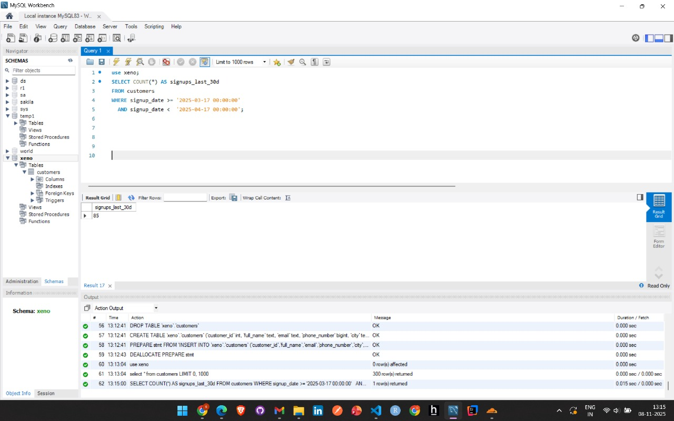

Query: List unique cities where customers are based.
SQL Query:
USE xeno
SELECT DISTINCT city FROM customers ORDER BY city;
Screenshot:
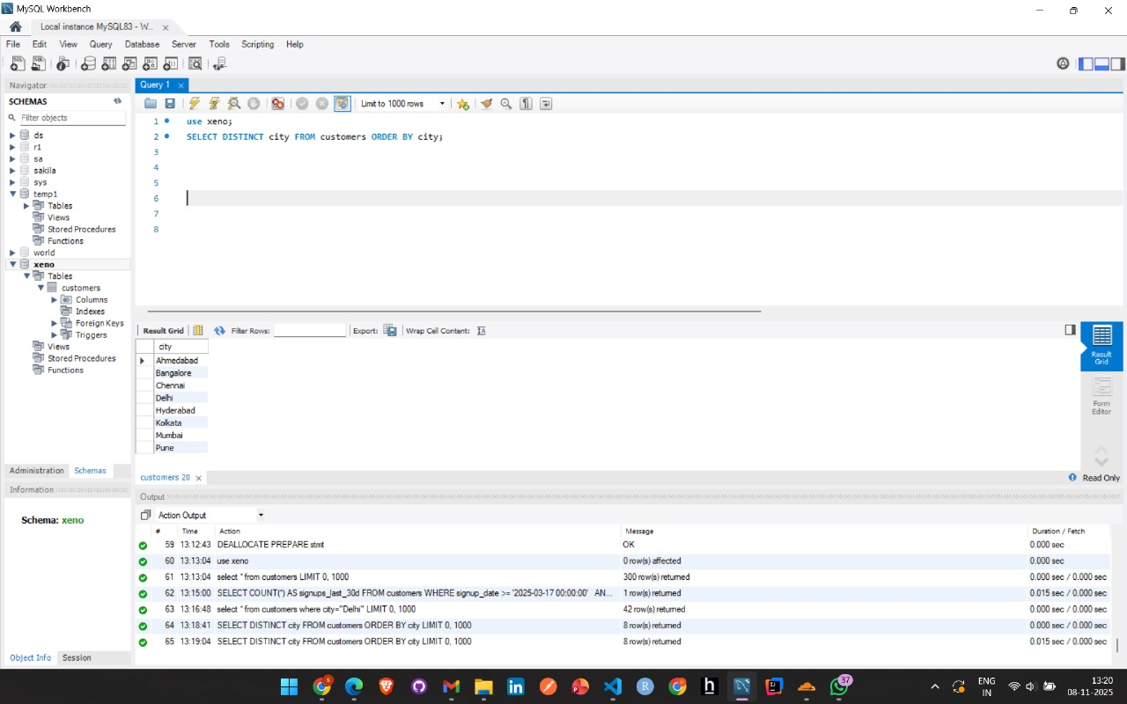
Query: List the top 3 cities by number of signups.
SQL Query:
USE xeno
SELECT city,COUNT(*) AS signups
FROM customers
GROUP BY city
ORDER BY signups
DESC LIMIT 3;
Screenshot:
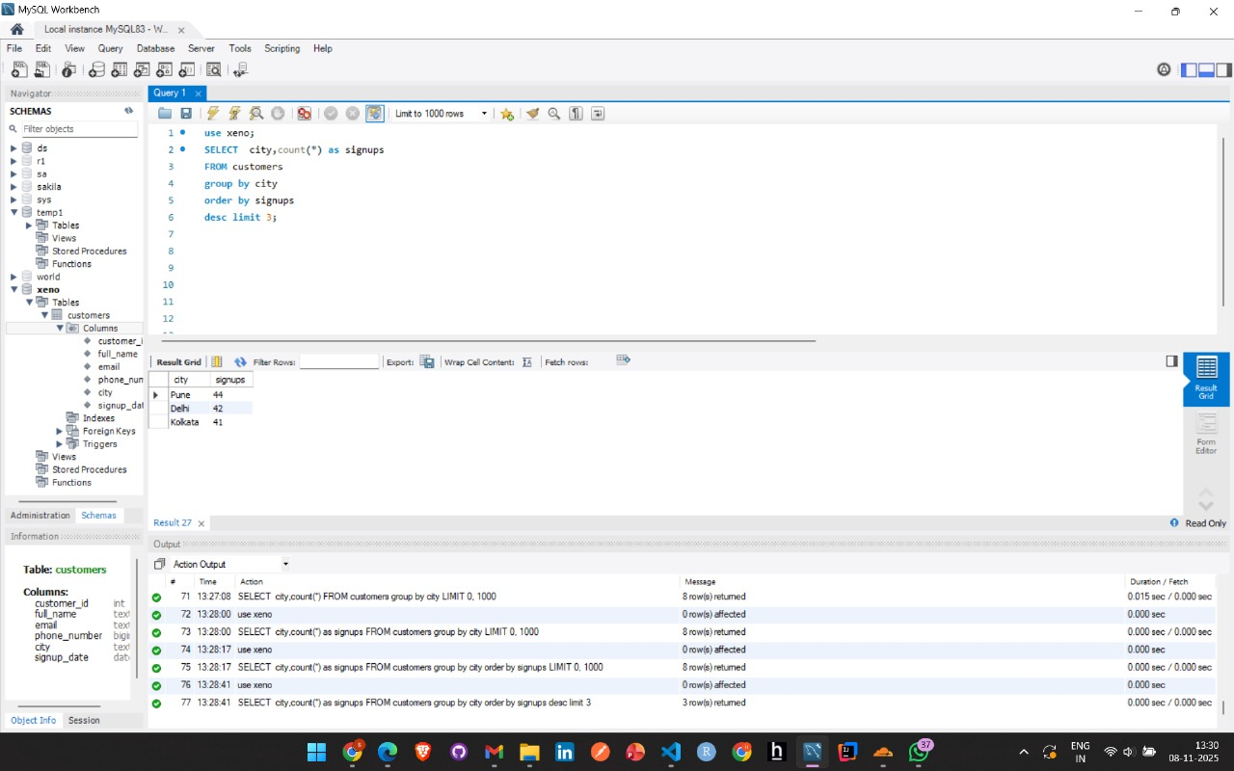

Query: Find customers who have never placed an order (Assume orders table exists: orders(customer_id, order_id, amount)).
SQL Query:
SELECT *
FROM customers
LEFT JOIN orders
ON customers.customer_id = orders.customer_id
WHERE orders.customer_id IS NULL;
Thought Process:
I used a LEFT JOIN and filtered where the order side is NULL, which means the customer has never placed any order.

2. Data Transformation & Enrichment
Task: Add a new column to show if the email domain is ‘gmail.com’ or not.
SQL Query:
USE xeno;
ALTER TABLE customers
ADD COLUMN is_gmail VARCHAR(3);
SET SQL_SAFE_UPDATES = 0;
UPDATE customers
SET is_gmail = CASE
WHEN SUBSTRING_INDEX(email, '@', -1) = 'gmail.com' THEN 'Yes'
ELSE 'No'
END;
SET SQL_SAFE_UPDATES = 1;
SELECT * FROM customers;
Screenshot:
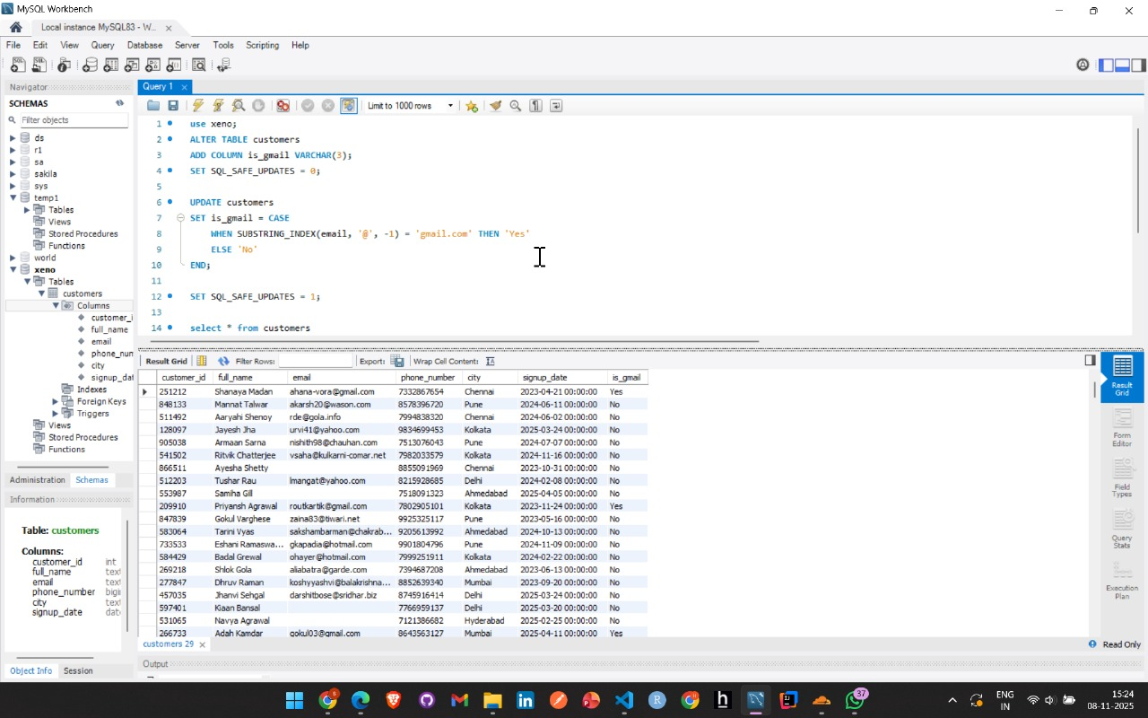
Task: Extract the first name from the name column into first_name.
SQL Query:
use xeno;
ALTER TABLE customers
ADD COLUMN first_name VARCHAR(100);
SET SQL_SAFE_UPDATES = 0;
UPDATE customers
SET first_name = SUBSTRING_INDEX(full_name, ' ', 1)
WHERE full_name IS NOT NULL;
SET SQL_SAFE_UPDATES = 1;
SELECT * FROM customers;
Screenshot:
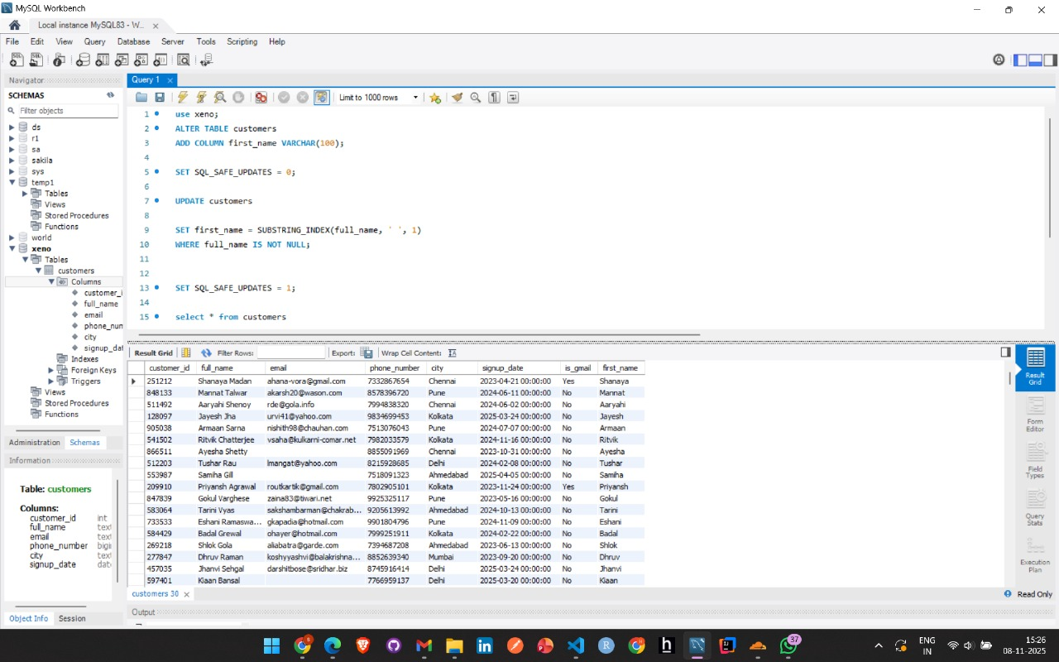

Task: Add a column signup_month capturing month name.
SQL Query:
USE xeno;
ALTER TABLE customers
ADD COLUMN signup_month VARCHAR(20);
SET SQL_SAFE_UPDATES = 0;
UPDATE customers
SET signup_month = MONTHNAME(signup_date);
SET SQL_SAFE_UPDATES = 1;
SELECT * FROM customers;
Screenshot:
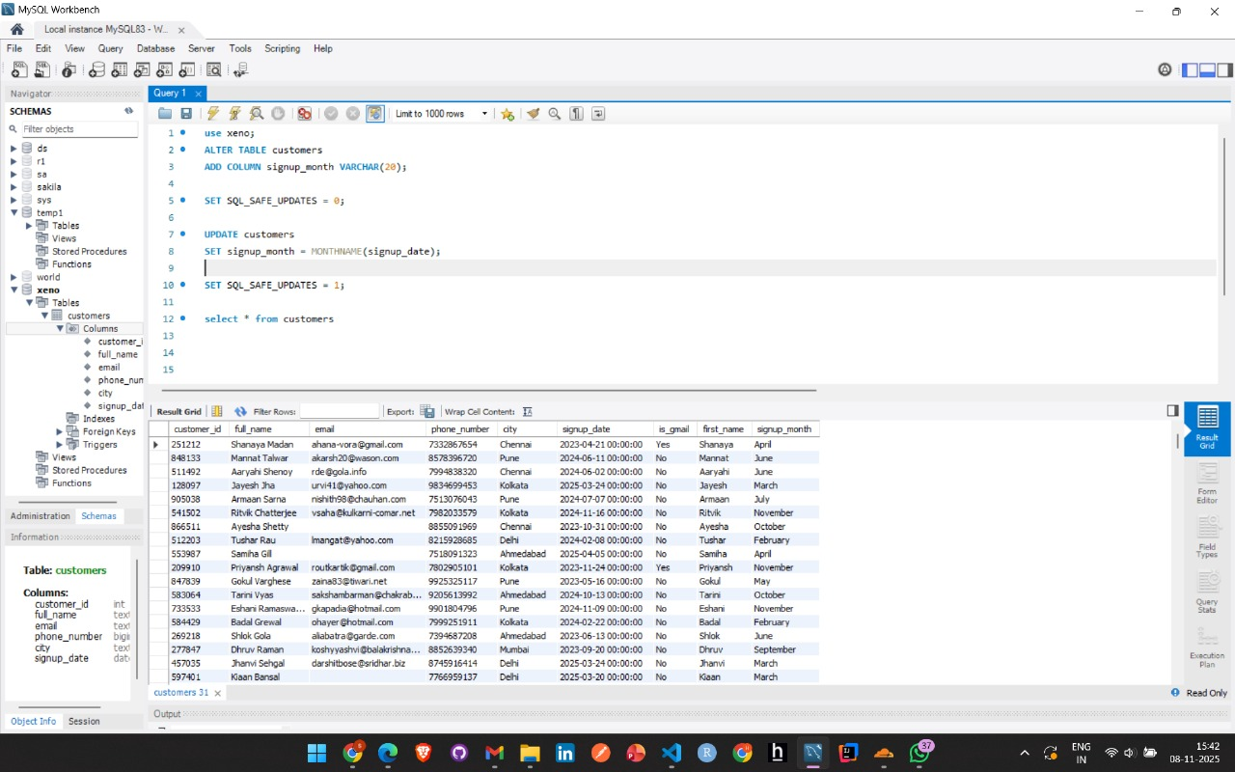

Task: Report: number of Gmail customers signed up on each weekday.
SQL Query:
use xeno;
SELECT
DAYNAME(signup_date) AS signup_day,
COUNT(*) AS gmail_customers_count
FROM customers
WHERE email LIKE '%gmail.com'
GROUP BY signup_day
ORDER BY FIELD(signup_day, 'Monday','Tuesday','Wednesday','Thursday','Friday','Saturday','Sunday');
Screenshot:
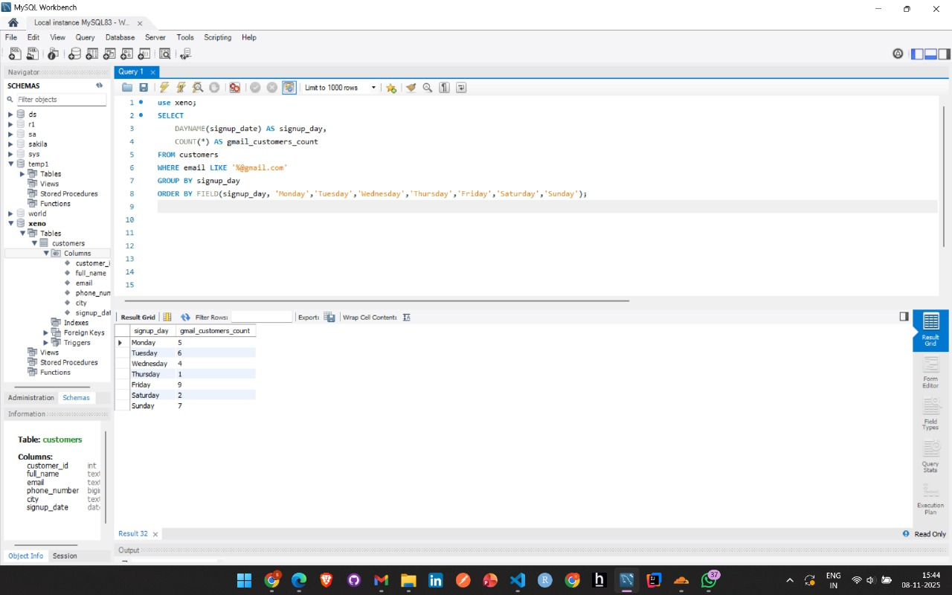
Task: Create vip_customers table with customers from Delhi, Mumbai, Bangalore who signed up in last 60 days from 16 April 2025.
SQL Query:
use xeno;
CREATE TABLE vip_customers AS
SELECT *
FROM customers
WHERE city IN ('Delhi', 'Mumbai', 'Bangalore')
AND signup_date >= DATE('2025-04-16') - INTERVAL 60 DAY
AND signup_date <= DATE('2025-04-16');
SLECT * FROM vip_customers;
Screenshot:
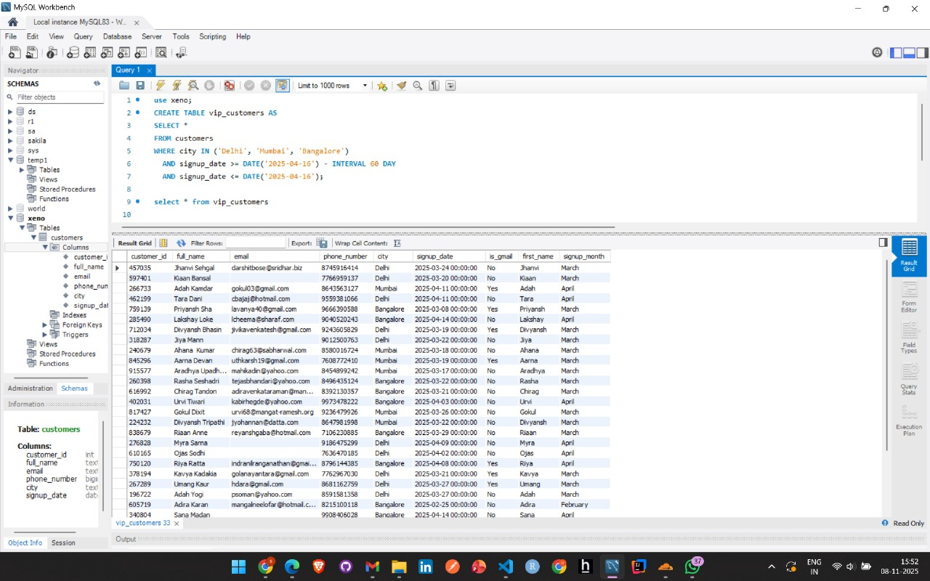

3. Analytics & Reporting
Task: Show monthly signup count for past 6 months.
SQL Query:
use xeno;
SELECT
DATE_FORMAT(signup_date, '%Y-%m') AS month,
COUNT(*) AS signup_count
FROM customers
WHERE signup_date >= DATE('2025-04-16') - INTERVAL 6 MONTH
AND signup_date <= DATE('2025-04-16')
GROUP BY month
ORDER BY month;
Screenshot:
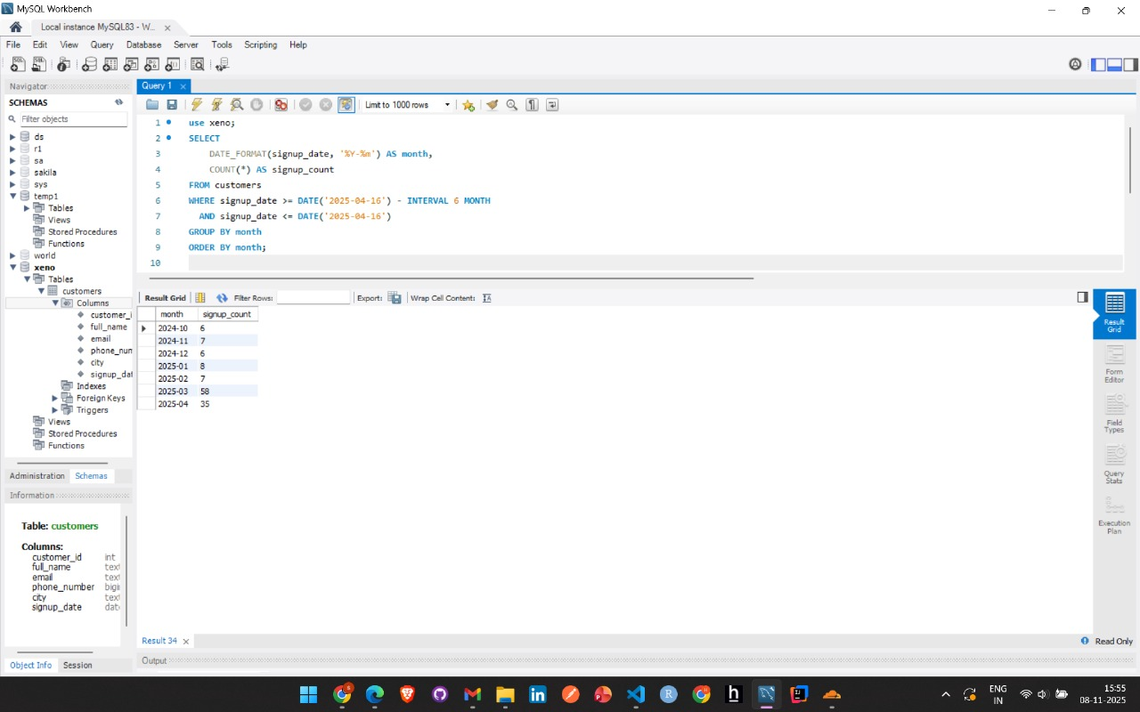
Task: Cities with more than 20 customers.
SQL Query:
use xeno;
SELECT city, COUNT(*) AS customer_count
FROM customers
GROUP BY city
HAVING COUNT(*) > 20
ORDER BY customer_count DESC;
Screenshot:
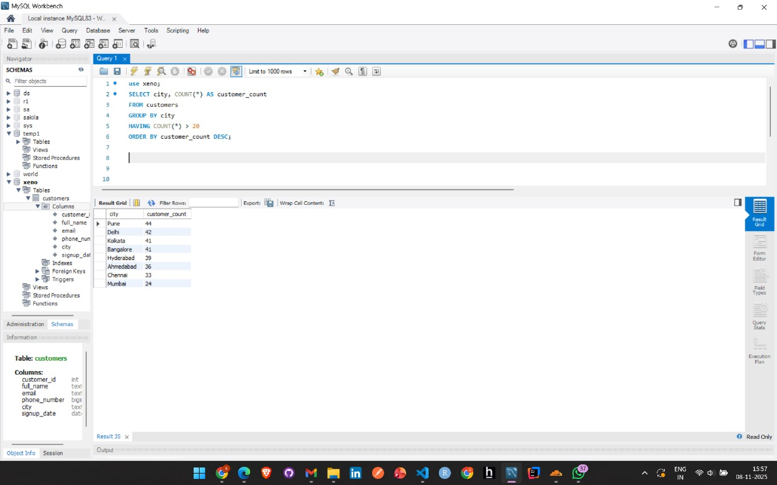

Task: Date with highest number of signups.
SQL Query:
use xeno;
SELECT DATE(signup_date) AS signup_day, COUNT(*) AS signups
FROM customers
GROUP BY signup_day
ORDER BY signups DESC
LIMIT 1;
Screenshot:
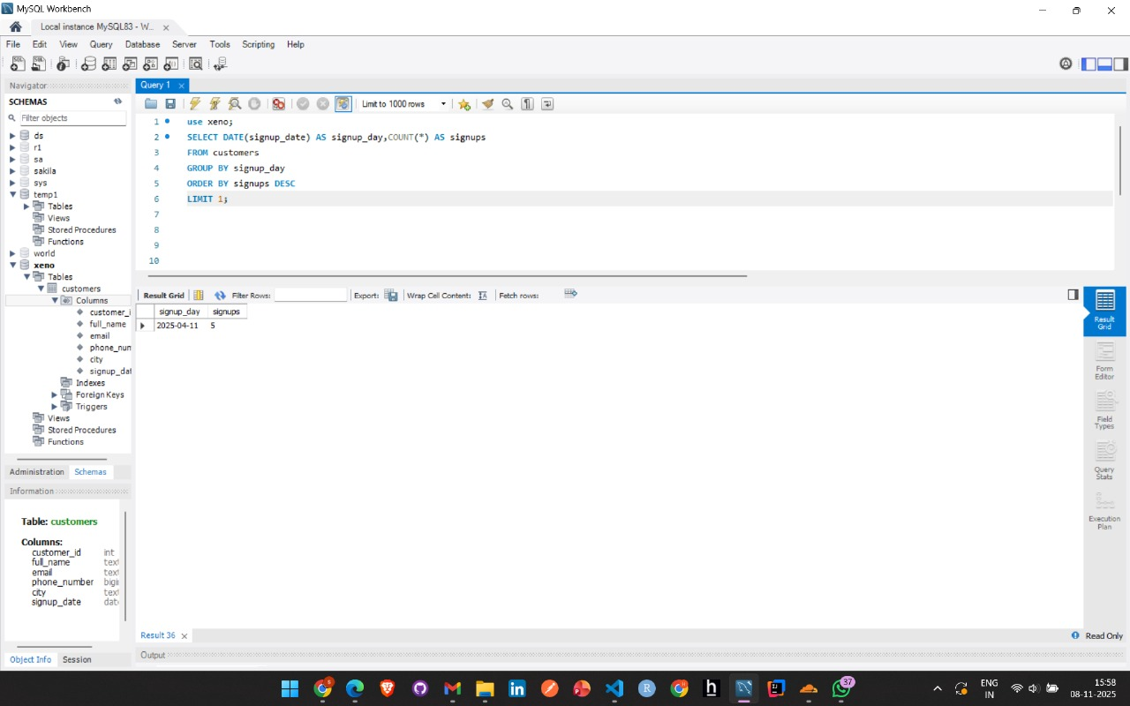

Task: Add column showing day of signup and find day with highest signups.
SQL Query:
use xeno;
ALTER TABLE customers
ADD COLUMN signup_dayname VARCHAR(10);
SET SQL_SAFE_UPDATES = 0;
UPDATE customers
SET signup_dayname = DAYNAME(signup_date)
WHERE signup_date IS NOT NULL;
SET SQL_SAFE_UPDATES = 1;
Screenshot:

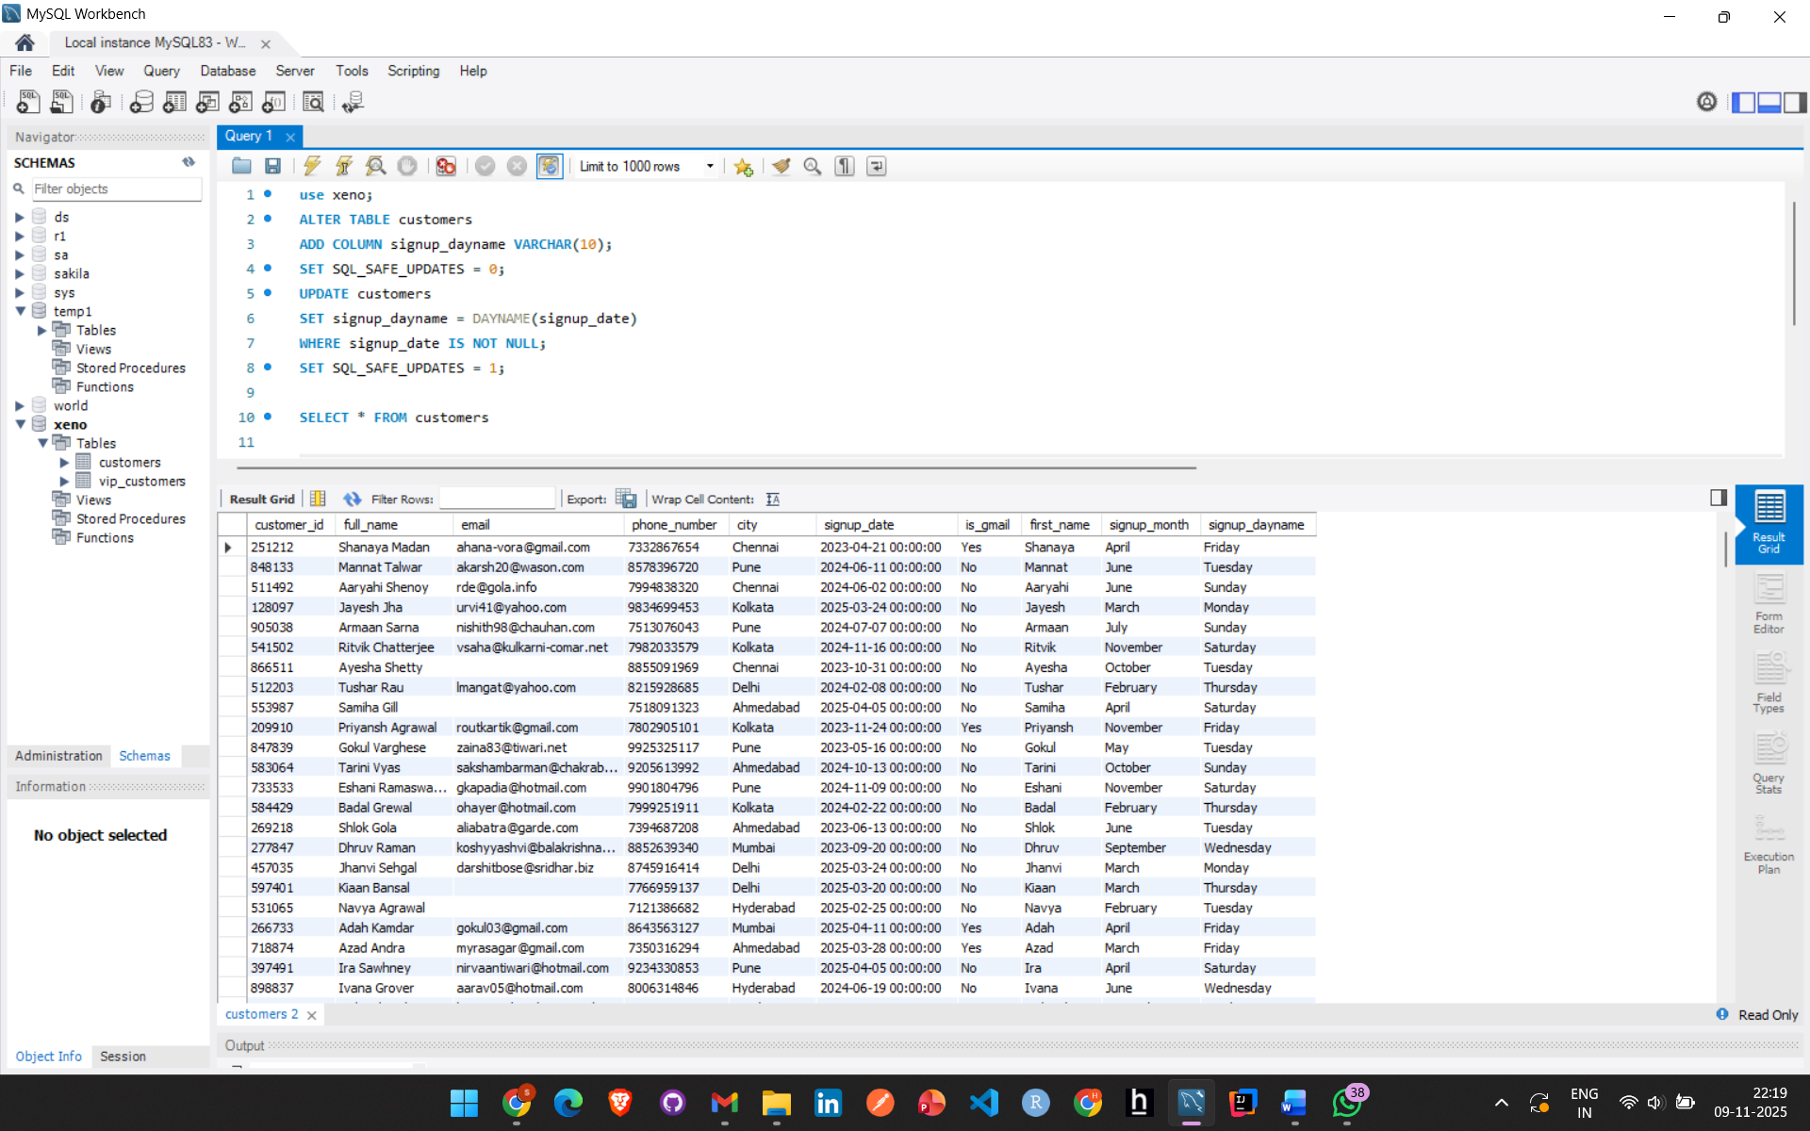

SELECT signup_dayname AS day, COUNT(*) AS signups
FROM customers
GROUP BY signup_dayname
ORDER BY signups DESC;
Screenshot:
