Computer Networks Final Project Report

Group 18 : b03902049 陳力宇b03902051 賴岳群b03902061 林庭宇

* Protocol Specification: \*see “Protocol.md” file

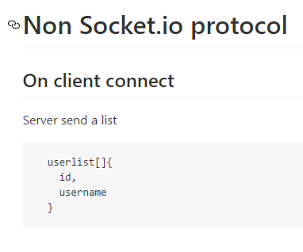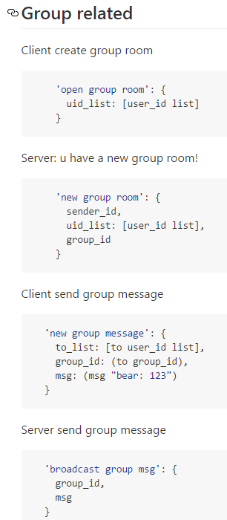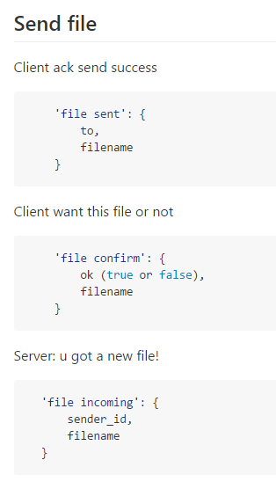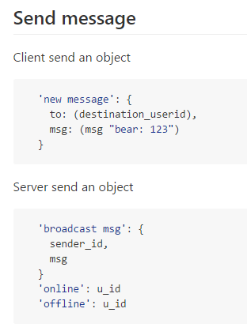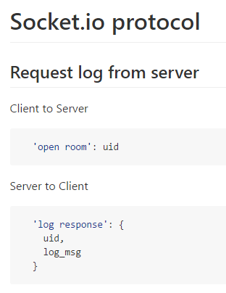

* Guide

Operator:

Install server: npm install

Run server: npm start

User:

輸入網址: http://(serverIP):3000/login

輸入帳密登入或按註冊

左邊欄位選取聊天對象或左下”lobby”按鈕進入大廳與所有人聊天

聊天或選檔案傳送(檔案限單人且對方上線)

右上角按鈕登出

* How to run server: npm start

How to run client: Use browser to connect to server’s hostname or IP, port 3000, /login. For example: http://oasis2.csie.ntu.edu.tw:3000/login

* System & Program Design:

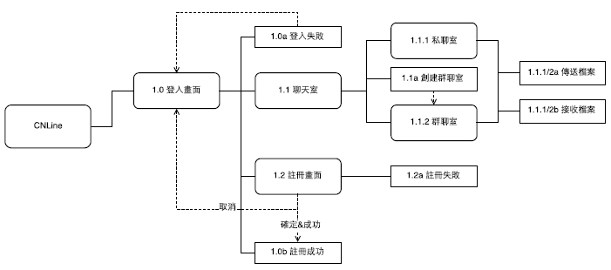UI flow:

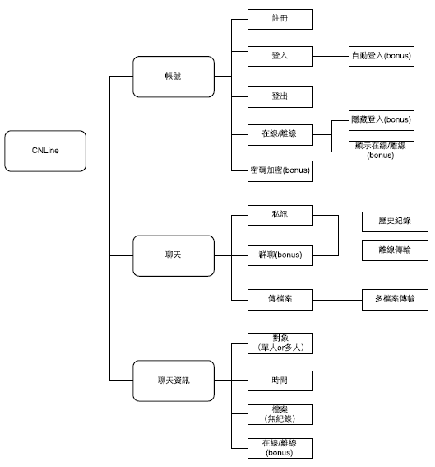Functional map:

Server:

‘express’ for routing and session

‘socket.io’ for client-server communication

‘sqlite3’ for database

‘delivery’ for file sending

* Bonus features:

1. Confirm password when registering.
2. Show user online/offline status real-time.
3. Bubble hint for incoming message from whom you are not talking to.
4. A lobby where everyone can chat to everyone.
5. Password hashed for security in database.