電通二乙微處理器實驗 實驗結報

實驗名稱 | Arduino_Lab01
組別 | 5 | 組員 | 黃俊翔 邱川瑞

- 實驗目的
使用 circuits.io 模擬 Arduino UNO 電路及程式
繪製電路圖
觀察 Arduino UNO 之輸出
學習將程式碼及實驗報告上傳至 Github

- 實驗步驟
填寫分組表單
啓動 Arduino IDE, 載入 Blink 程式碼
至 circuits.io 註冊帳號，啟動 Arduino 模擬器
接上 LED 電路
修改程式，將 LED 輸出改為 Pin 9
觀察 LED 之閃爍間隔
修改程式, 使 LED 閃爍間隔分別增加為 2 倍及 ½ 倍, 重新量測並截圖
畫出電路圖

- 程式碼
void setup() {
// initialize digital pin LED_BUILTIN as an output.
pinMode(LED_BUILTIN, OUTPUT);
}
// Pin 13 has an LED connected on most Arduino boards.
// give it a name:
int led = 13;
// the setup routine runs once when you press reset:
void setup() {
// initialize the digital pin as an output.
pinMode(led, OUTPUT);
}
// the loop routine runs over and over again forever:
void loop() {
digitalWrite(led, HIGH); // turn the LED on (HIGH is the voltage level)
delay(1000); // wait for a second
digitalWrite(led, LOW); // turn the LED off by making the voltage LOW
delay(1000); // wait for a second
}

- 實驗結果及分析
利用circuits.io，啟動 Arduino 模擬器，修改程式來觀察燈泡的閃爍頻率
並做出電路圖
使 LED 閃爍間隔分別增加為 2 倍及 ½ 倍
- 心得討論
今天學到如何利用github上傳與修改文件，以及如何使用circuits.io來模擬出電路圖，並帶著愉快的心情度過今天。
- 修正電路圖

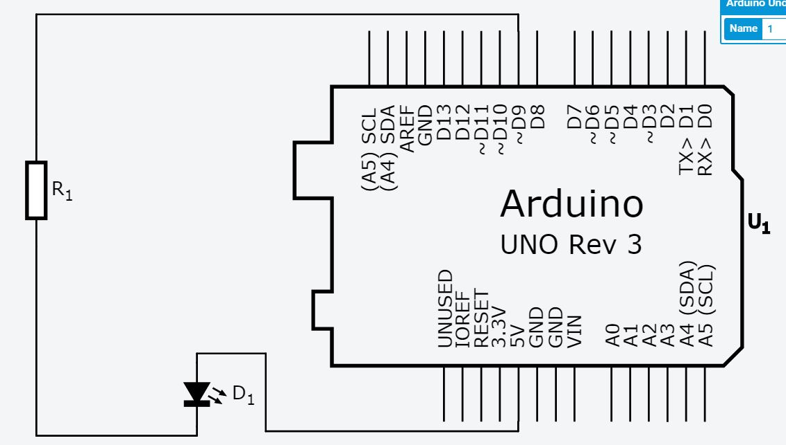
- 修正程式碼

void setup() {
// initialize digital pin LED_BUILTIN as an output.
pinMode(LED_BUILTIN, OUTPUT);
}
// Pin 13 has an LED connected on most Arduino boards.
// give it a name:
int led = 9;
// the setup routine runs once when you press reset:
void setup() {
// initialize the digital pin as an output.
pinMode(9, OUTPUT);
}
// the loop routine runs over and over again forever:
void loop() {
digitalWrite(9, HIGH); // turn the LED on (HIGH is the voltage level)
delay(500); // wait for a second
digitalWrite(9, LOW); // turn the LED off by making the voltage LOW
delay(2000); // wait for a second
}

