電通二乙微處理器實驗 實驗結報

實驗名稱 | Lab02_走馬燈
組別 | 第五組 | 組員 | 邱川瑞04053026 黃俊翔04052634

- 實驗目的
Arduino UNO D1 – D8 分別接到 LED，實作跑馬燈展 示。
- 實驗步驟
1. LED 向左及向右執行花色展示
2. 執行自定花色展示: 所有LED亮滅兩次 -> 左移八次 -> 所有LED亮滅兩次 -> 右移八次
3.Arduino 接上一個開關
開關 OFF -> LED 向左及向右執行花色展示
開關 ON -> 執行自定花色展示
- 程式碼
第一題
const byte startPin = 1;
const byte endPin = 8;
void setup() {
for (byte i = startPin; i<= endPin; i++)
{
pinMode(i, OUTPUT);
}
}
byte i,j;
byte lightPin = startPin;
void loop()
{
lightPin = startPin;
for(j=1;j<=8;j++){
for (i=startPin; i<= endPin; i++) {
digitalWrite(i,LOW);
}
digitalWrite(lightPin, HIGH);
delay (300);
if (lightPin < endPin) {
lightPin ++;
} else {
lightPin = startPin;
}
}
lightPin = endPin;
for(j=1;j<=8;j++){
for (i=endPin; i>= startPin; i--) {
digitalWrite(i,LOW);
}
digitalWrite(lightPin, HIGH);
delay (300);
if (lightPin > startPin) {
lightPin --;
} else {
lightPin = endPin;
}
}
}

第二題
const byte startPin = 1;
const byte endPin = 8;
void setup() {
for (byte i = startPin; i<= endPin; i++)
{
pinMode(i, OUTPUT);
}
for (byte i = startPin; i<= endPin; i++)
{
digitalWrite(i,LOW);
}
}
void loop()
{
////////////////////////////
{
for (int i=startPin; i<=endPin ; i++) {
digitalWrite(i,HIGH);
delay (300);
digitalWrite(i,LOW);
}
for (int i=startPin; i<= endPin; i++) {
digitalWrite(i,HIGH);}
delay (300);
for (int i=startPin; i<= endPin; i++) {
digitalWrite(i,LOW);
}
delay (300);
for (int i=startPin; i<= endPin; i++) {
digitalWrite(i,HIGH);}
delay (300);
for (int i=startPin; i<= endPin; i++) {
digitalWrite(i,LOW);
}
delay (300);
for (int i=endPin; i>= startPin; i--) {
digitalWrite(i, HIGH);
delay (300);
digitalWrite(i,LOW);
}
for (int i=startPin; i<= endPin; i++) {
digitalWrite(i,HIGH);}
delay (300);
for (int i=startPin; i<= endPin; i++) {
digitalWrite(i,LOW);
}
delay (300); for (int i=startPin; i<= endPin; i++) {
digitalWrite(i,HIGH);}
delay (300);
for (int i=startPin; i<= endPin; i++) {
digitalWrite(i,LOW);
}
delay (300);
}
}

第三題
const byte SW = 13;
const byte startPin = 1;
const byte endPin = 8;
void setup() {
pinMode(SW,INPUT);
for (byte i = startPin; i<= endPin; i++) {
pinMode(i, OUTPUT);
}
}
byte i,j;
byte lightPin = startPin;
void loop()
{
boolean val = digitalRead(13);
if(val)
{
for (i=startPin; i<= endPin; i++) {
digitalWrite(i,HIGH);}
delay (500);
for (i=startPin; i<= endPin; i++) {
digitalWrite(i,LOW);}
delay (500);
for (i=startPin; i<= endPin; i++) {
digitalWrite(i,HIGH);}
delay (500);
for (i=startPin; i<= endPin; i++) {
digitalWrite(i,LOW);}
delay (500);
lightPin = startPin;
for(j=1;j<=8;j++)
{
for (i=startPin; i<= endPin; i++) {
digitalWrite(i,LOW);
}
digitalWrite(lightPin, HIGH);
if (lightPin < endPin) {
lightPin ++;
} else {
lightPin = startPin;
}
delay (500);
}
for (i=startPin; i<= endPin; i++) {
digitalWrite(i,HIGH);}
delay (500);
for (i=startPin; i<= endPin; i++) {
digitalWrite(i,LOW);}
delay (500);
for (i=startPin; i<= endPin; i++) {
digitalWrite(i,HIGH);}
delay (500);
for (i=startPin; i<= endPin; i++) {
digitalWrite(i,LOW);}
delay (500);
lightPin = endPin;
for(j=1;j<=8;j++)
{
for (i=endPin; i>=startPin; i--) {
digitalWrite(i,LOW);
}
digitalWrite(lightPin, HIGH);
if (lightPin > startPin) {
lightPin --;
} else {
lightPin = endPin;
}
delay (500);
}
}
else
{
lightPin = startPin;
for(j=1;j<=8;j++)
{
for (i=startPin; i<= endPin; i++) {
digitalWrite(i,LOW);
}
digitalWrite(lightPin, HIGH);
if (lightPin < endPin) {
lightPin ++;
} else {
lightPin = startPin;
}
delay (500);
}
lightPin = endPin;
for(j=1;j<=8;j++)
{
for (i=endPin; i>=startPin; i--) {
digitalWrite(i,LOW);
}
digitalWrite(lightPin, HIGH);
if (lightPin > startPin) {
lightPin --;
} else {
lightPin = endPin;
}
// 點亮 LED
delay (500);
}
}
}
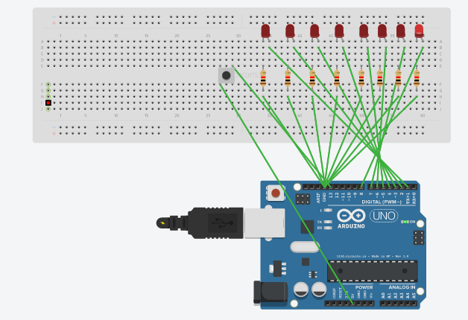
- 實驗結果及分析
第一題
讓led可以從左跑到右從右跑到左
第二題
讓led可以閃爍兩次再從左跑到右在閃爍兩次從右跑到左
第三題
可以藉由開關控制結合一二題的內容
- 心得討論
我們真的學到很多東西，學到如何用程式碼來控制led的燈閃爍變化，再結合開關

