1



Proceedings of the Technical Expertise in Stock Assessment (TESA) national workshop on 'Best pratices in age estimation', 31 January, 01-02 February 2023 in Moncton, New Brunswick

Daniel Ricard, Aaron Adamack, Jacob Burbank, Peter Comeau, Abby Daigle, Allan Debertin, Kim Emond, Tracey Loewen, Andrea Perreault, Gregory Puncher, Nicolas Rolland, Meredith Schofield, Andrew Smith, François-Étienne Sylvain and Stephen Wischniowski

Science Branch Gulf Region

Fisheries and Oceans Canada

Moncton, New Brunswick, E1C 5K4, Canada

2023

Canadian Technical Report of Fisheries and Aquatic Sciences ####

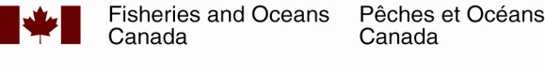

**Canadian Technical Report of Fisheries and Aquatic Sciences**

Technical reports contain scientific and technical information that contributes to existing knowledge but which is not normally appropriate for primary literature. Technical reports are directed primarily toward a worldwide audience and have an international distribution. No restriction is placed on subject matter and the series reflects the broad interests and policies of Fisheries and Oceans Canada, namely, fisheries and aquatic sciences.

Technical reports may be cited as full publications. The correct citation appears above the abstract of each report. Each report is abstracted in the data base *Aquatic Sciences and Fisheries Abstracts*.

Technical reports are produced regionally but are numbered nationally. Requests for individual reports will be filled by the issuing establishment listed on the front cover and title page.

Numbers 1-456 in this series were issued as Technical Reports of the Fisheries Research Board of Canada. Numbers 457-714 were issued as Department of the Environment, Fisheries and Marine Service, Research and Development Directorate Technical Reports. Numbers 715-924 were issued as Department of Fisheries and Environment, Fisheries and Marine Service Technical Reports. The current series name was changed with report number 925.

**Rapport technique canadien des sciences halieutiques et aquatiques**

Les rapports techniques contiennent des renseignements scientifiques et techniques qui constituent une contribution aux connaissances actuelles, mais qui ne sont pas normalement appropriés pour la publication dans un journal scientifique. Les rapports techniques sont destinés essentiellement à un public international et ils sont distribués à cet échelon. II n'y a aucune restriction quant au sujet; de fait, la série reflète la vaste gamme des intérêts et des politiques de Pêches et Océans Canada, c'est-à-dire les sciences halieutiques et aquatiques.

Les rapports techniques peuvent être cités comme des publications à part entière. Le titre exact figure au-dessus du résumé de chaque rapport. Les rapports techniques sont résumés dans la base de données *Résumés des sciences aquatiques et halieutiques.*

Les rapports techniques sont produits à l'échelon régional, mais numérotés à l'échelon national. Les demandes de rapports seront satisfaites par l'établissement auteur dont le nom figure sur la couverture et la page du titre.

Les numéros 1 à 456 de cette série ont été publiés à titre de Rapports techniques de l'Office des recherches sur les pêcheries du Canada. Les numéros 457 à 714 sont parus à titre de Rapports techniques de la Direction générale de la recherche et du développement, Service des pêches et de la mer, ministère de l'Environnement. Les numéros 715 à 924 ont été publiés à titre de Rapports techniques du Service des pêches et de la mer, ministère des Pêches et de l'Environnement. Le nom actuel de la série a été établi lors de la parution du numéro 925.

Canadian Technical Report of Fisheries and Aquatic Sciences nnn

2023

PROCEEDINGS OF THE TECHNICAL EXPERTISE IN STOCK ASSESSMENT (TESA) NATIONAL WORKSHOP ON BEST PRATICES IN AGE ESTIMATION, 31 JANUARY, 01-02 FEBRUARY 2023 IN MONCTON, NEW BRUNSWICK

by

Daniel Ricard1, Aaron Adamack2, Jacob Burbank1, Peter Comeau3, Abby Daigle1, Allan Debertin4, Kim Emond5, Tracey Loewen6, Andrea Perreault2, Gregory Puncher3, Nicolas Rolland1, Meredith Schofield2, Andrew Smith5, Francois-Étienne Sylvain1 and Stephen Wischniowski7

1Gulf Fisheries Centre

Fisheries and Oceans Canada, 343 Université Avenue Moncton, New Brunswick, E1C 5K4, Canada 2Nortwest Atlantic Fisheries Centre

Fisheries and Oceans Canada, 80 E White Hills Rd

St. John’s, Newfoundland and Labrador, A1A 5J7, Canada

3Bedford Institute of Oceanography Fisheries and Oceans Canada, 1 Challenger Dr.

Dartmouth, Nova Scotia, B2Y 4A2, Canada

4Saint Andrews Biological Station

Fisheries and Oceans Canada, 125 Marine Science Dr.

St. Andrews, New Brunswick, E5B 0E4, Canada

5Institut Maurice Lamontagne

Fisheries and Oceans Canada, 850 Rte de la Mer Mont-Joli, Québec, QC G5H 3Z4, Canada 6Freshwater Institute

Fisheries and Oceans Canada, 501 University Avenue Winnipeg, Manitoba, R3T 2N6, Canada

7Pacific Biological Station

Fisheries and Oceans Canada, 3190 Hammond Bay Road Nanaimo, British Columbia, V9T 6N7, Canada

© His Majesty the King in Right of Canada, 2023 Cat. No. Fs97-6/nnnE-PDF ISBN ISSN 1488-5379

Correct citation for this publication:

Ricard, D., Adamack, A., Burbank, J., Comeau, P., Daigle, A., Debertin, A., Emond, K., Loewen, T., Puncher, G., Rolland, N., Schofield, M., Smith, A., Sylvain, F.-É. and Wischniowski, S. 2023. Proceedings of the Technical Expertise in Stock Assessment (TESA) national workshop on Best pratices in age estimation, 31 January, 01-02 February 2023 in Moncton, New Brunswick. Can. Tech. Rep. Fish. Aquat. Sci. nnn: vi + 13 p.

|  |  |
| --- | --- |
| **CONTENTS** |  |
| **ABSTRACT** | **v** |
| **RÉSUMÉ** | **vi** |
| **1 Introduction** | **1** |
| 1.1 Motivations . . . . . . . . . . . . . . . . . . . . . . . . . . . . . . . . . . . . . . . . . | 1 |
| 1.2 Objectives . . . . . . . . . . . . . . . . . . . . . . . . . . . . . . . . . . . . . . . . . . | 2 |
| 1.3 Format . . . . . . . . . . . . . . . . . . . . . . . . . . . . . . . . . . . . . . . . . . . . | 2 |
| **2 Day 1 - Basics of age estimation** | **2** |
| **3 Day 2 - Digital imaging of ageing structures** | **3** |
| **4 Day 3 - Analysis of age estimates** | **3** |
| **5 Remarks from external experts** | **4** |
| **6 Discussion** | **4** |
| **7 Recommendations** | **4** |
| 7.1 Institutional . . . . . . . . . . . . . . . . . . . . . . . . . . . . . . . . . . . . . . . . . | 4 |
| 7.2 Ageing structure cataloguing, storage and inventory . . . . . . . . . . . . . . . . . . | 5 |
| 7.3 Reference collection . . . . . . . . . . . . . . . . . . . . . . . . . . . . . . . . . . . . | 5 |
| 7.4 Laboratory operations . . . . . . . . . . . . . . . . . . . . . . . . . . . . . . . . . . . | 5 |
| 7.5 Training . . . . . . . . . . . . . . . . . . . . . . . . . . . . . . . . . . . . . . . . . . . | 6 |
| 7.6 Digital imaging of ageing structures . . . . . . . . . . . . . . . . . . . . . . . . . . . . | 6 |
| 7.7 Analysis of age estimates . . . . . . . . . . . . . . . . . . . . . . . . . . . . . . . . . | 6 |
| 7.8 Preparing for changes associated with a warming climate . . . . . . . . . . . . . . . | 7 |
| 7.9 Research and development . . . . . . . . . . . . . . . . . . . . . . . . . . . . . . . . | 7 |
| **8 Acknowledgements** | **7** |

1. References 8
2. Figures 8

APPENDICES 8

A List of workshop participants 10

# ABSTRACT

Ricard, D., Adamack, A., Burbank, J., Comeau, P., Daigle, A., Debertin, A., Emond, K., Loewen, T., Puncher, G., Rolland, N., Schofield, M., Smith, A., Sylvain, F.-É. and Wischniowski, S. 2023. Proceedings of the Technical Expertise in Stock Assessment (TESA) national workshop on Best pratices in age estimation, 31 January, 01-02 February 2023 in Moncton, New Brunswick. Can. Tech. Rep. Fish. Aquat. Sci. nnn: vi + 13 p.

Here is the abstract text.

# RÉSUMÉ

Ricard, D., Adamack, A., Burbank, J., Comeau, P., Daigle, A., Debertin, A., Emond, K., Loewen, T., Puncher, G., Rolland, N., Schofield, M., Smith, A., Sylvain, F.-É. and Wischniowski, S. 2023. Proceedings of the Technical Expertise in Stock Assessment (TESA) national workshop on Best pratices in age estimation, 31 January, 01-02 February 2023 in Moncton, New Brunswick. Can. Tech. Rep. Fish. Aquat. Sci. nnn: vi + 13 p.

Voici le résumé.

# Introduction

The purpose of the Technical Expertise in Stock Assessment (TESA) program is to promote stock assessment excellence through organizing national activities that contribute to the development of expertise in stock assessment across Fisheries and Oceans Canada (DFO).

TESA was created in 2009, in response to a loss of stock assessment expertise in DFO owing to retirements. Each year, TESA organises three or four training courses and one or two topical workshops on stock assessment issues. TESA is a national program with one or two

representatives in each region – for more details see the [GCpedia website](http://www.gcpedia.gc.ca/wiki/DFO_Science_TESA_ETES) (only accessible from the DFO network).

This report provides a written record of the TESA workshop on “Best practices in age estimation” that was held in Moncton, NB, on January 31, February 01 and 02 2023. The list of participants can be found in Table A.1 and all resources related to the workshop were stored in a [git](https://github.com/TESA-workshops/ageing-best-practices-2023) [repository maintained by TESA](https://github.com/TESA-workshops/ageing-best-practices-2023).

# Motivations

The use of an age-based population model is often lauded as the “gold standard” in stock assessment. Age-based models are favored over simpler population models because of their ability to convey biological realism and to provide a more nuanced understanding of population dynamics, including the effects of fishing on harvested populations. As the name implies, an age- based model requires information about the age of individuals in the population, which provides scientists with a foundation for analyzing the demographics of a population as it evolves over time. Ageing information, in conjunction with other observations, can inform us on the growth of individuals, on the age-at-maturation of individuals, on the age structure of a population and on other vital factors necessary to understand variations in numbers and biomass.

All DFO regions collect structures from marine organisms that are used in estimating their age. The procedures associated with collecting these samples, cataloguing them, storing them, and using them to obtain age estimates vary from lab to lab. It is important to follow best practices when estimating age from hard structures and not all personnel are aware of these.

While the use of age-based models is common and the software available to implement such assessments are available and evolving, the manipulation of the input data that feeds into those models is often done in an ad-hoc fashion particular to the lab or agency in charge of the assessment. While these ad-hoc methods are most likely defensible and appropriate, the details that go into the computation of catch-at-age matrices are often poorly documented making results hard to reproduce by someone outside a given lab or agency. This workshop provided an opportunity for DFO scientists using age-based assessments, and those involved in the analyses of age and length information to share ideas and develop better methods to use ageing data in assessments.

# Objectives

The objectives of this workshop were to create a forum for discussion and for exchanging ideas among DFO scientists that use age-based models and that are involved in ageing activities. In particular, the workshop should provide:

* + - guidance on ageing structures collection and on the sampling design for collecting ageing structures
    - guidance on age determination using ageing structures, best practices for annuli validation, reference collections, ager calibration, archival of ageing structures and data warehousing
    - guidance on digital imaging of ageing structures
    - guidance on going from length frequency samples and age-length keys to catch-at-age matrices that feed into age-based population models

# Format

A hybrid meeting was held on Tuesday January 31 2023, Wednesday February 01 2023 and Thursday February 02 2023. The list of participants and the attendance can be found in

Table A.1. A total of 76 participants attended the event (30 in person and 46 virtually), and two external experts joined the meeting virtually. The workshop was attended by a wide variety of DFO personnel ranging from research scientists, to biologists, to fisheries technicians and also included two students from a local university.

# Day 1 - Basics of age estimation

The first day covered the basics of ageing.

Peter Comeau gave a presentation on the history and realities of age estimation of marine organisms.

Julie Coad Davies gave an overview of the age estimation activities that she is involved in, in her role as lab manager for DTU Aqua and also through her chairing the ICES Working Group on SmartDots Governance (WGSMART) and the ICES Working Group on Biological Parameters (WGBIOP).

Stephen Wischniowski shared his experience of running an age estimation laboratory at the Pacific Biological Station and being involved in the COmmunity of Age Reading Experts (CARE) .

Sylvie Robichaud and Karen Robertson presented the procedures associated with age estimation of Atlantic Herring in the Gulf Region.

Kim Emond and Hélène Dionne presented the procedures associated with age estimation of Atlantic Herring in the Québec Region.

Tania Davignon-Burton gave a talk of reconciling expectations and realities in a production ageing environment.

Tracey Loewen and Rick Wastle presented their work on estimating ages of Greenland Halibut in the Arctic.

# Day 2 - Digital imaging of ageing structures

The second day of the workshop focused on topics related to the capture of digital images of ageing structures and how to annotate them.

The day started with a tour of the laboratory facilities used in age estimations at the Gulf Fisheries Centre.

Presentation about SmartDots from external expert Julie Coad Davies. Talk by Karen Robertson on taking good images.

David Fishman presented options for developing a storage solution for otolith images. Discussion about DFO Dots.

SmartDots reporting features and use for obtaining growth increments.

# Day 3 - Analysis of age estimates

The third day of the workshop focused on what is done with age estimates, namely the use of such data in fitting growth models and in computing catch-at-age matrices.

Growth models presentations by Daniel Ricard and Andrea Perreault

Lisa Ailloud from NOAA NMFS gave a presentation about age-length keys.

catch-at-age calculations presentation by Andrew Smith from the Quebec Region desscribed his experience with trying to replicate catch-at-age calculations that were previously done in a bespoke software called *catch.exe*.

Kim Emond from the Quebec Region presented the methodologies used in the herring stock assessment to compute catch-at-age matrices from commercial landings and from hydroacoustic surveys.

Christopher Corriveau and Ellie Weise from Dalhousie University presented their work on using DNA methylation to estimate ages.

A group discussion finally took place to draft the recommendations that appears in section 7.

# Remarks from external experts

Remarks from Julie Coad Davies from DTU Aqua:

The workshop has been an excellent forum for those working with age reading and the age data resulting from their work. With such a variety of expertise across labs and regions under the DFO it is important that a community is formed to facilitate knowledge sharing on best practices. There are opportunities for age reading calibration across labs who are age reading the same stocks, cooperation on updating reference collections and knowledge sharing on image acquisition and method testing. Future plans to have a DFO version of SmartDots will facilitate this and will support an overall improvement in the quality of the age data coming from the age reading labs and how the data is subsequently used in the stock assessment process. Forming a working group who meet annually will foster the communication required to sustain the community.

Remarks from Lisa AIlloud from NOAA NMFS:

What Lisa said.

# Discussion

Over and over during the workshop, it was emphasized that while otoliths are the most common structure used for estimating ages, other ageing structures are also used, and the best practices used for otoliths are applicable to other structures.

It was discussed how age estimation using ageing structures is more than just “counting the rings” and requires a wealth of experience in order to interpret the patterns observed on ageing structures.

The workshop attendees identified the need to develop and foster a community of DFO scientists whose tasks involve age estimation.

# Recommendations

The working group formulated the following recommendations for how to deal with physical collections of structures used for age estimation.

# Institutional

1. Foster a community of DFO scientists whose mandated tasks include sampling of ageing structures, age estimation using ageing structures or analysis of age estimates data
2. Emulate the Pacific Ocean’s Community of Age Reading Experts (CARE) for the Atlantic and Arctic Oceans
3. Creation of a DFO working group that meets regularly to ensure that age estimations practices in different labs follow shared best practices
4. Provide support for inter-regional ageing structure exchanges and secondary reader testing
5. Achieve Canadian representation on appropriate ICES working groups related to quality assurance of age estimation as input for stock assessment (WGBIOP) or those developing the SmartDots platform (WGSMART).
6. Recognise the fact that the skills required to obtain unbiased age estimates from ageing structures are unique and take time and dedication to acquire

# Ageing structure cataloguing, storage and inventory

1. Ensure that physical collections of ageing structures follow the DFO "Policy on Collection, Storage, Management and Use of Physical Samples for Science Research"
2. Ageing structures should be stored in an environment that minimizes degradation and that maintains readability
3. Clearly label ageing structures so they can be traced back to their collection, implement good bookkeeping of your ageing structures
4. An electronic inventory of the physical ageing structures available should be documented and updated regularly
5. A subset of ageing structures should be preserved in their unaltered state for future unforeseen usage (i.e. not in resin or glycerin)

# Reference collection

1. Actively curate reference collections so that old ageing structures that have lost their readability are replaced by new ageing structures, this includes renewing ageing structures
2. Ensure that the age structures in the reference collection are representative of what will be available to age estimation technicians (the structures should cover wide spatial and temporal ranges, both annual and inter annual, all ages used in the stock assessment and both easy and difficult to read ageing structures ...)
3. Ensure reference collections are updated with samples from recent years

# Laboratory operations

1. Strive to obtain unbiased age estimates. Carry out regular QC checks for each species/stock (both within and across laboratories).
2. Develop and publish Standard Operating Procedures for each lab
3. Develop standardized protocols to validate age estimates (add to your regional SOP)
4. Favour age estimation in a “blind” setting, where no prior knowledge (except date of capture) is used when interpreting patterns in ageing structures, don’t let outside information influence your age estimates
5. Establish a quality-control process to identify mistakes made during data entry (e.g. a typo)
6. Document the uncertainty associated with age estimates by means of a standardized quality assurance scale.
7. Generate an age-error matrices as part of your standard procedures

# Training

1. Develop a document that details the steps to train new agers, and/or add it to your regional SOP
2. Establish procedures that integrate current practices (e.g. labels that have been used for many year) into improved practices

# Digital imaging of ageing structures

1. Ensure that a correctly calibrated scale bar is present in the image so that the image scale in pixels per mm can be determined
2. The file naming convention to use when taking images of ageing structures should uniquely identify each ageing structure, a recommended nomenclature would be as follows: individual ID_speciesname_preparation method
3. When practical, promote the capture of digital images of ageing structures
4. Digital images (.jpg format) of ageing structures should be stored in enterprise-level infrastructure where proper backups are in place
5. A DFO-led app to store and retrieve digital images of ageing structures should be implemented to facilitate the management of these images and to provide integration with the SmartDots software

# Analysis of age estimates

1. When computing catch-at-age matrices, the sampling design used in the collection of data should be accounted for.
2. Analyses that compute catch-at-age matrices from length samples and age estimates should strive to be fully documented and reproducible
3. Contemporary procedures that reduce bias in age structure estimates should be used
4. Assessment methods would ideally incorporate ageing errors into the assessment framework

# Preparing for changes associated with a warming climate

1. s
2. Regularly revisit the pattern in the growth structures used for estimating ages to identify periods of weaker or stronger growth and/or changes in the timing of annuli formation.
3. Continued inter-regional communication and events that promote collaborations
4. Northward migration of species will shift stock boundaries and change the species that will require science advice
5. Establish a process so that “cheat sheets” and guides used for training agers, and the associated laboratory processes for age estimation are updated regularly

# Research and development

1. Pursue further studies in sclerochronology that will support the identification of changes in patterns used in estimating ages
2. Investigate the trade-offs involved between taking images and annotate them versus just estimating a single age-length pair

These recommendations were formulated at the workshop and further revised by all authors. They represent procedures that should be followed by all DFO personnel involved in age estimations.

# Acknowledgements

The authors would like to acknowledge all the workshop participants for their attendance and their active participation in discussions. Karen Robertson and Joeleen Savoie helped with workshop organisation and logistics. Lisa Leblanc from the ASEC was extremely generous with her time and hospitality during the workshop. We thank the Gulf Region publication coordinator Jeffery Clements for his help in handling this report submission.

# References

# Figures

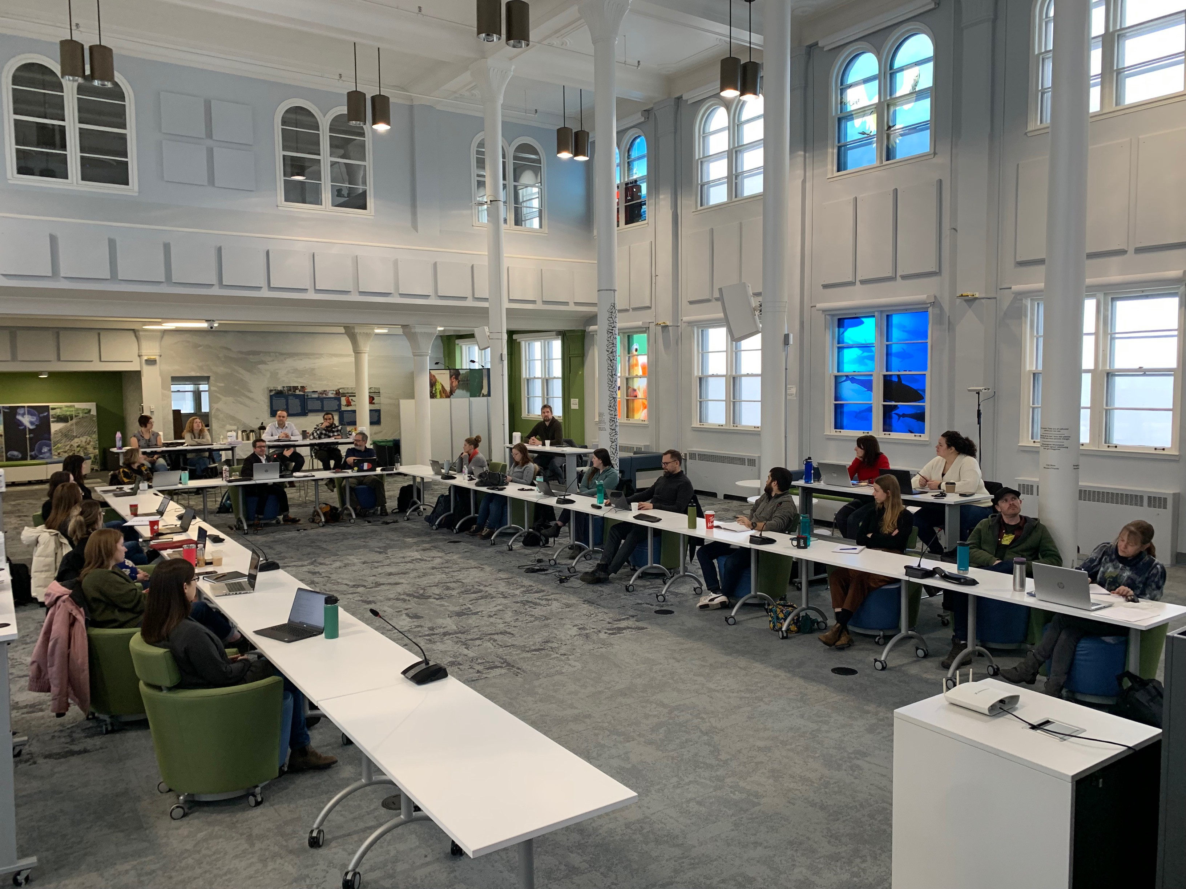

Figure 1. Day 1 of the TESA workshop “best practices in age estimation” held at the Atlantic Science Enterprise Center in Moncton, NB.

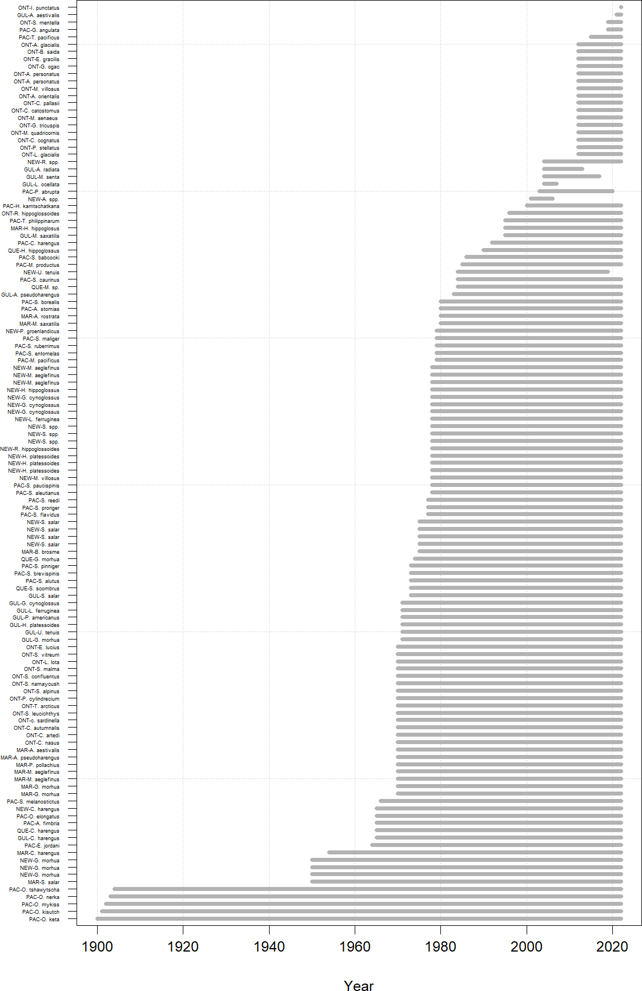

Figure 2. Timespan of ageing structure collections for marine stocks assessed by Fisheries and Oceans Canada. 9

# APPENDIX A List of workshop participants

Table A.1. List of participants to the TESA worskhop on best practices in age estimation.

|  |  |  |  |  |  |
| --- | --- | --- | --- | --- | --- |
| Name | Affiliation | Attendance | Day 1 | Day 2 | Day 3 |
| Aaron Adamack | DFO Science - | Virtual | ✓ | ✓ | ✓ |
|  | Newfoundland and Labrador |  |  |  |  |
|  | Region |  |  |  |  |
| Lisa Ailloud | NOAA NMFS - Southeast | Virtual |  |  | ✓ |
|  | Fisheries Science Center |  |  |  |  |
| Laura Alsip | DFO Science - Central and | Virtual | ✓ | ✓ | ✓ |
|  | Arctic Region |  |  |  |  |
| Kelly Antaya | DFO Science - | Virtual | ✓ | ✓ | ✓ |
|  | Newfoundland and Labrador |  |  |  |  |
|  | Region |  |  |  |  |
| Mark Billard | DFO Science - Maritimes | Virtual | ✓ | ✓ | ✓ |
|  | Region |  |  |  |  |
| Jacob Burbank | DFO Science - Gulf Region | In person | ✓ | ✓ | ✓ |
| Lauren Burke | DFO Science - Central and | Virtual | ✓ | ✓ | ✓ |
|  | Arctic Region |  |  |  |  |
| Barbara | DFO Science - Pacific | Virtual | ✓ | ✓ | ✓ |
| Campbell | Region |  |  |  |  |
| Karalea Cantera | DFO Science - Pacific | Virtual | ✓ | ✓ | ✓ |
|  | Region |  |  |  |  |
| Lynn Collier | DFO Science - Maritimes | Virtual | ✓ | ✓ | ✓ |
|  | Region |  |  |  |  |
| Peter Comeau | DFO Science - Maritimes | In person | ✓ | ✓ | ✓ |
|  | Region |  |  |  |  |
| Chelsea Cooke | DFO Science - Pacific | Virtual | ✓ | ✓ | ✓ |
|  | Region |  |  |  |  |
| Christopher | DFO Science - Dalhousie | In person | ✓ | ✓ | ✓ |
| Corriveau | University Region |  |  |  |  |
| Abby Daigle | DFO Science - Gulf Region | In person | ✓ | ✓ | ✓ |
| Andrew Darcy | DFO Science - Gulf Region | In person | ✓ | ✓ |  |
| Guillaume | DFO Science - Gulf Region | In person | ✓ | ✓ | ✓ |
| Dauphin |  |  |  |  |  |
| Julie Davies | DTU Aqua | Virtual | ✓ | ✓ | ✓ |
| Tania | DFO Science - Maritimes | Virtual | ✓ | ✓ | ✓ |
| Davignon-Burton | Region |  |  |  |  |
| Allan Debertin | DFO Science - Maritimes | Virtual | ✓ | ✓ | ✓ |
|  | Region |  |  |  |  |
| Nell den Heyer | DFO Science - Maritimes | Virtual | ✓ | ✓ | ✓ |
|  | Region |  |  |  |  |
| Mathieu | DFO Science - Quebec | Virtual | ✓ | ✓ | ✓ |
| Desgagnés | Region |  |  |  |  |

*Continued on next page ...*

*... Continued from previous page*

|  |  |  |  |  |  |
| --- | --- | --- | --- | --- | --- |
| Name | Affiliation | Attendance | Day 1 | Day 2 | Day 3 |
| Hélène Dionne | DFO Science - Quebec | In person | ✓ | ✓ | ✓ |
|  | Region |  |  |  |  |
| Dwight Drover | DFO Science - | Virtual | ✓ | ✓ | ✓ |
|  | Newfoundland and Labrador |  |  |  |  |
|  | Region |  |  |  |  |
| Kim Emond | DFO Science - Quebec | In person | ✓ | ✓ | ✓ |
|  | Region |  |  |  |  |
| Gillian Forbes | DFO Science - | In person | ✓ | ✓ | ✓ |
|  | Newfoundland and Labrador |  |  |  |  |
|  | Region |  |  |  |  |
| Isabelle Forest | DFO Science - Gulf Region | In person | ✓ | ✓ | ✓ |
| Danni Harper | DFO Science - Maritimes | Virtual | ✓ | ✓ | ✓ |
|  | Region |  |  |  |  |
| Sarah Hawkshaw | DFO Science - Pacific | Virtual | ✓ | ✓ | ✓ |
|  | Region |  |  |  |  |
| Victoria Healey | DFO Science - | Virtual | ✓ | ✓ | ✓ |
|  | Newfoundland and Labrador |  |  |  |  |
|  | Region |  |  |  |  |
| Erin Herder | DFO Science - Pacific | Virtual | ✓ | ✓ | ✓ |
|  | Region |  |  |  |  |
| Kendra Holt | DFO Science - Pacific | Virtual | ✓ | ✓ | ✓ |
|  | Region |  |  |  |  |
| Matthew | DFO Science - Gulf Region | In person | ✓ | ✓ | ✓ |
| Horsman |  |  |  |  |  |
| Mary-Jane | DFO Science - Pacific | Virtual | ✓ | ✓ | ✓ |
| Hudson | Region |  |  |  |  |
| Samantha | DFO Science - Gulf Region | Virtual | ✓ | ✓ | ✓ |
| Hudson |  |  |  |  |  |
| Yeongha Jung | DFO Science - Pacific | Virtual | ✓ | ✓ | ✓ |
|  | Region |  |  |  |  |
| Kelly Kraska | DFO Science - Maritimes | In person | ✓ | ✓ | ✓ |
|  | Region |  |  |  |  |
| Madeline Lavery | DFO Science - Pacific | Virtual | ✓ | ✓ | ✓ |
|  | Region |  |  |  |  |
| Michael Legge | DFO Science - Central and | In person | ✓ | ✓ | ✓ |
|  | Arctic Region |  |  |  |  |
| Marc Legresley | DFO Science - | Virtual | ✓ | ✓ | ✓ |
|  | Newfoundland and Labrador |  |  |  |  |
|  | Region |  |  |  |  |
| Lingbo Li | DFO Science - Maritimes | Virtual | ✓ | ✓ | ✓ |
|  | Region |  |  |  |  |
| Tracey Loewen | DFO Science - Central and | In person | ✓ | ✓ | ✓ |
|  | Arctic Region |  |  |  |  |

*Continued on next page ...*

*... Continued from previous page*

|  |  |  |  |  |  |
| --- | --- | --- | --- | --- | --- |
| Name | Affiliation | Attendance | Day 1 | Day 2 | Day 3 |
| Ellen | DFO Science - Maritimes | In person | ✓ | ✓ | ✓ |
| MacEachern | Region |  |  |  |  |
| Colin | DFO Science - Gulf Region | In person | ✓ | ✓ | ✓ |
| MacFarlane |  |  |  |  |  |
| Brendan K | DFO Science - Central and | Virtual | ✓ | ✓ | ✓ |
| Malley | Arctic Region |  |  |  |  |
| Kiana Matwichuk | DFO Science - Pacific | Virtual | ✓ | ✓ | ✓ |
|  | Region |  |  |  |  |
| Mackenzie Mazur | DFO Science - Pacific | Virtual | ✓ | ✓ | ✓ |
|  | Region |  |  |  |  |
| Judy McArthur | DFO Science - Pacific | Virtual | ✓ | ✓ | ✓ |
|  | Region |  |  |  |  |
| Kelsey McGee | DFO Science - Gulf Region | In person | ✓ | ✓ | ✓ |
| Jessie Mcintyre | DFO Science - Maritimes | Virtual | ✓ | ✓ | ✓ |
|  | Region |  |  |  |  |
| Liz Miller | DFO Science - Maritimes | Virtual | ✓ | ✓ | ✓ |
|  | Region |  |  |  |  |
| Maya Miller | DFO Science - Pacific | Virtual | ✓ | ✓ | ✓ |
|  | Region |  |  |  |  |
| Kirby Morrill | DFO Science - Gulf Region | In person | ✓ | ✓ | ✓ |
| George Nau | DFO Science - Maritimes | Virtual | ✓ | ✓ | ✓ |
|  | Region |  |  |  |  |
| Andrea Perreault | DFO Science - | Virtual | ✓ | ✓ | ✓ |
|  | Newfoundland and Labrador |  |  |  |  |
|  | Region |  |  |  |  |
| Hannah Polaczek | DFO Science - | Virtual | ✓ | ✓ | ✓ |
|  | Newfoundland and Labrador |  |  |  |  |
|  | Region |  |  |  |  |
| Gregory Puncher | DFO Science - Maritimes | In person | ✓ | ✓ | ✓ |
|  | Region |  |  |  |  |
| Catriona | DFO Science - Maritimes | Virtual | ✓ | ✓ | ✓ |
| Regnier-McKellar | Region |  |  |  |  |
| Daniel Ricard | DFO Science - Gulf Region | In person | ✓ | ✓ | ✓ |
| Kierstyn Rideout | DFO Science - | In person | ✓ | ✓ | ✓ |
|  | Newfoundland and Labrador |  |  |  |  |
|  | Region |  |  |  |  |
| Karen Robertson | DFO Science - Gulf Region | In person | ✓ | ✓ | ✓ |
| Sylvie Robichaud | DFO Science - Gulf Region | In person | ✓ | ✓ | ✓ |
| Nicolas Rolland | DFO Science - Gulf Region | In person | ✓ | ✓ | ✓ |
| Chelsea Rothkop | DFO Science - Pacific | Virtual | ✓ | ✓ | ✓ |
|  | Region |  |  |  |  |

*Continued on next page ...*

*... Continued from previous page*

|  |  |  |  |  |  |
| --- | --- | --- | --- | --- | --- |
| Name | Affiliation | Attendance | Day 1 | Day 2 | Day 3 |
| Meredith Schofield  Andrew Smith | DFO Science - Newfoundland and Labrador Region  DFO Science - Quebec | In person  Virtual | ✓  ✓ | ✓  ✓ | ✓  ✓ |
| Jolene Sutton | Region  DFO Science - Gulf Region | In person | ✓ | ✓ | ✓ |
| François-Étienne | DFO Science - Gulf Region | In person | ✓ | ✓ | ✓ |
| Sylvain  Jaime Thomson | DFO Science - | In person | ✓ | ✓ | ✓ |
| François Turcotte | Newfoundland and Labrador Region  DFO Science - Gulf Region | Virtual |  |  | ✓ |
| Audrey Ty | DFO Science - Pacific | Virtual | ✓ | ✓ | ✓ |
| Kari Underhill | Region  DFO Science - Gulf Region | In person | ✓ | ✓ | ✓ |
| Lenore J  Vandenbyllaardt Rick J Wastle | DFO Science - Central and Arctic Region  DFO Science - Central and | Virtual  Virtual | ✓  ✓ | ✓  ✓ | ✓  ✓ |
| Emily Way-Nee | Arctic Region  DFO Science - Maritimes | Virtual | ✓ | ✓ | ✓ |
| Ellie Weise | Region  DFO Science - Dalhousie | In person | ✓ | ✓ | ✓ |
| Gabrielle Wilson | University Region  DFO Science - Maritimes | Virtual | ✓ | ✓ | ✓ |
| Stephen | Region  DFO Science - Pacific | Virtual | ✓ | ✓ | ✓ |
| Wischniowski Emily Yungwirth | Region  DFO Science - Pacific Region | Virtual | ✓ | ✓ | ✓ |